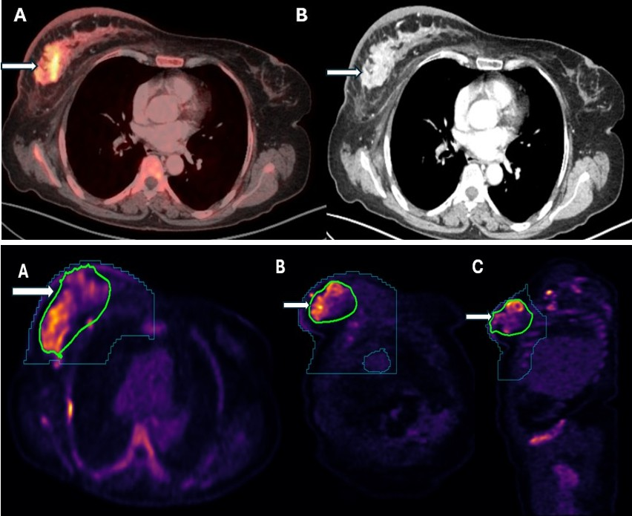

Image 2. Upper panel: Axial fused PET/CT (A) and corresponding CECT images (B) showing the FDG avid enhancing primary right breast tumour (white arrow). Lower panel: Right breast primary tumour processed and segmented from whole body FDG PET/CT scans using Random Walker, total segmentor and nnU-Net algorithms. Primary breast tumor for all calculations is enclosed within green ROI (white arrow), A) axial view); B) coronal view and C) sagittal view). The breast and thoracic cage constraint is shown by dark green contour lines.

