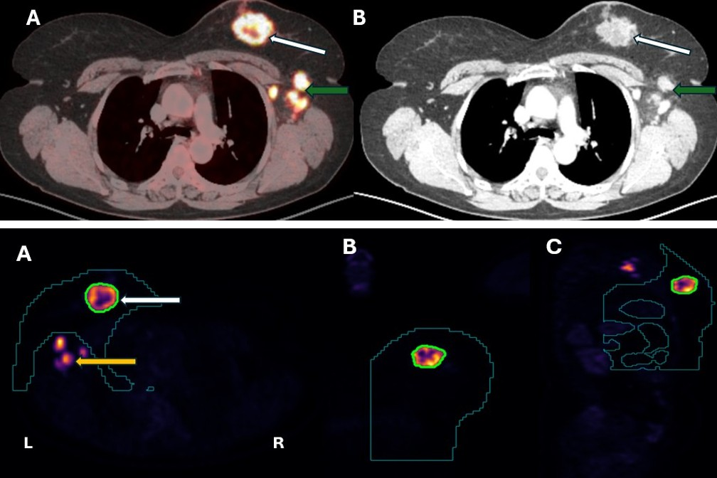
Image1. Upper pane: (A) Axial fused FDG/PET CT show the FDG avid primary left breast tumor (white arrow) and corresponding CECT images (B) show the tumor having irregular marginsm enhancement and some necrosis. In addition, left axillary lymph nodes are seen (green arrow). Botton Panel: Segmented primary breast tumour processed from whole body FDG PET/CT scans using Random Walker, total segmentor and nnU-Net algorithms. Primary breast tumor for all calculations is enclosed within green ROI (white arrow), where as axillary nodes (seen as orange pink hot spots; yellow arrow) are excluded from breast tumor metabolic and shape metrics. A) axial view); B) coronal view and C) sagittal view). The breast and thoracic cage constraint is shown by dark green contour lines.

