A AIE probe for visual monitoring of endogenous and exogenous H₂S and food freshness

Rongqi Wang^{a,d,#} Si Chen^{b,#} Ymin Li^{e}, Tuotuo Fang^{d}, Zhan-Bin Jin^{c}, Ting-Ting Wei^{c}, Jia-Ping Li^{c}, Hai-Xian Ren^{c}, Zi-Ao Zong^{b,*}, Na-Na Li^{b, c,*}
ª Center for Medical Laboratory Science, Affiliated Hospital of Youjiang Medical University for Nationalities, Baise, Guangxi, 533000, China
^{b} Modern Industrial College of Biomedicine and Great Health, Youjiang Medical University for Nationalities, Baise, 533000, Guangxi, PR China
^{c} Department of Chemistry, Xinzhou Normal University, Xinzhou, Shanxi 034000, PR China
^{d} ZhongKe (Guangdong) Refinery & Petrochemical Company Limited, Zhanjiang, Guangdong 524000, PR China
^{e} College of Chemistry and Environment, Guangdou Ocean University, Zhanjiang, Guangdong 524088, PR China
#Rongqi Wang and Si Chen are co-first authors
Corresponding author: zongziao@126.com (Z.-A Z); lmt13643562571@126.com (N.-N L)

Fig. S1. ¹H NMR (DMSO-d₆, 600 MHz) spectra of EHAT.

Fig. S2. ¹³C NMR (DMSO-d₆, 600 MHz) spectra of EHAT.

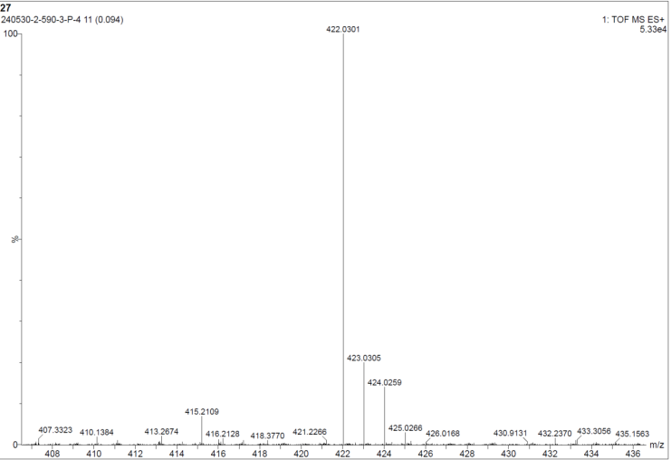
[EHAT+H⁺]
Fig. S3. ESI-MS spectrum of EHAT.

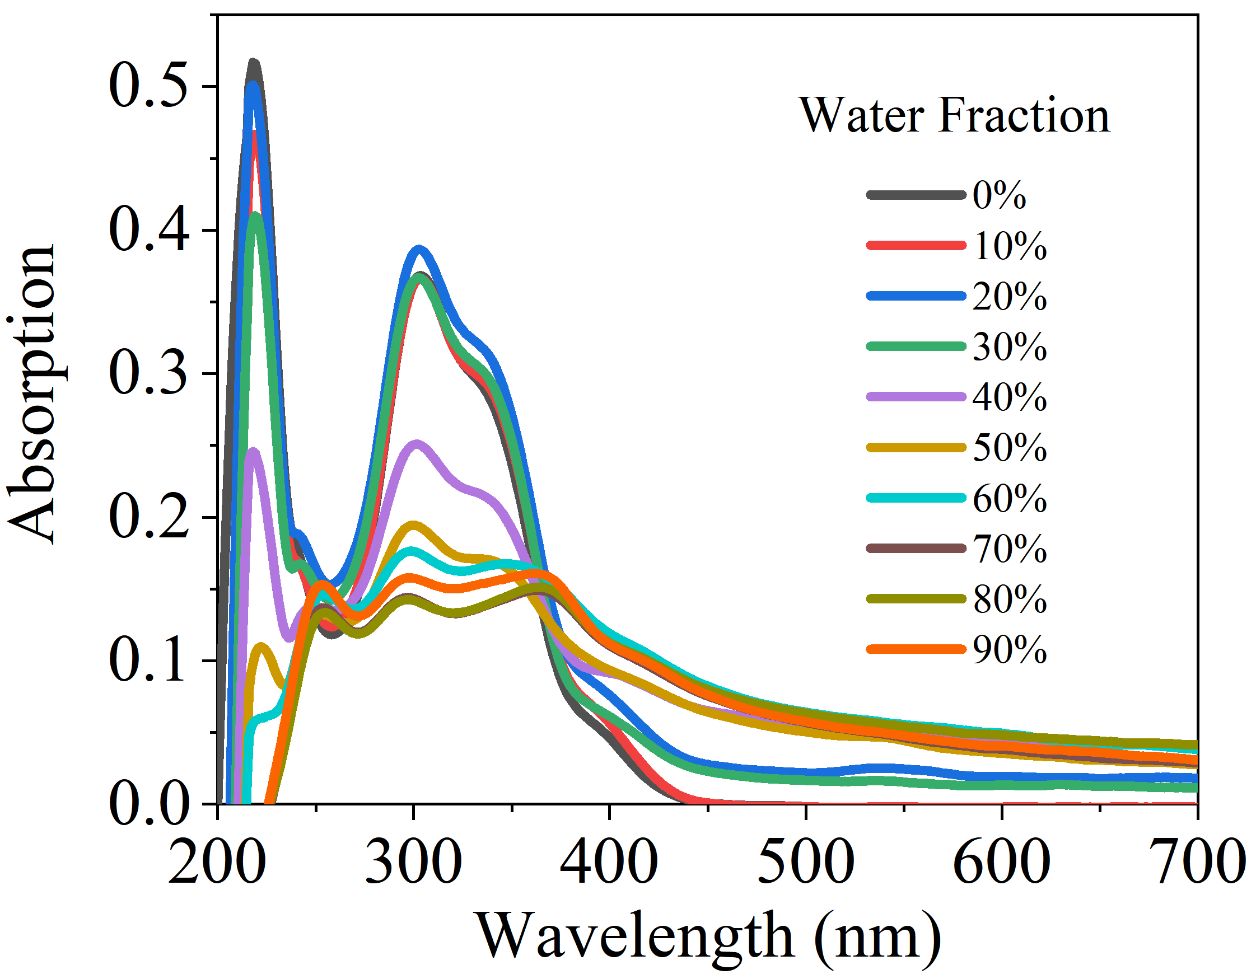
Fig. S4. The UV-vis absorption spectra of EHAT (10 µM) in EtOH/H₂O mixtures with different fractions of water.

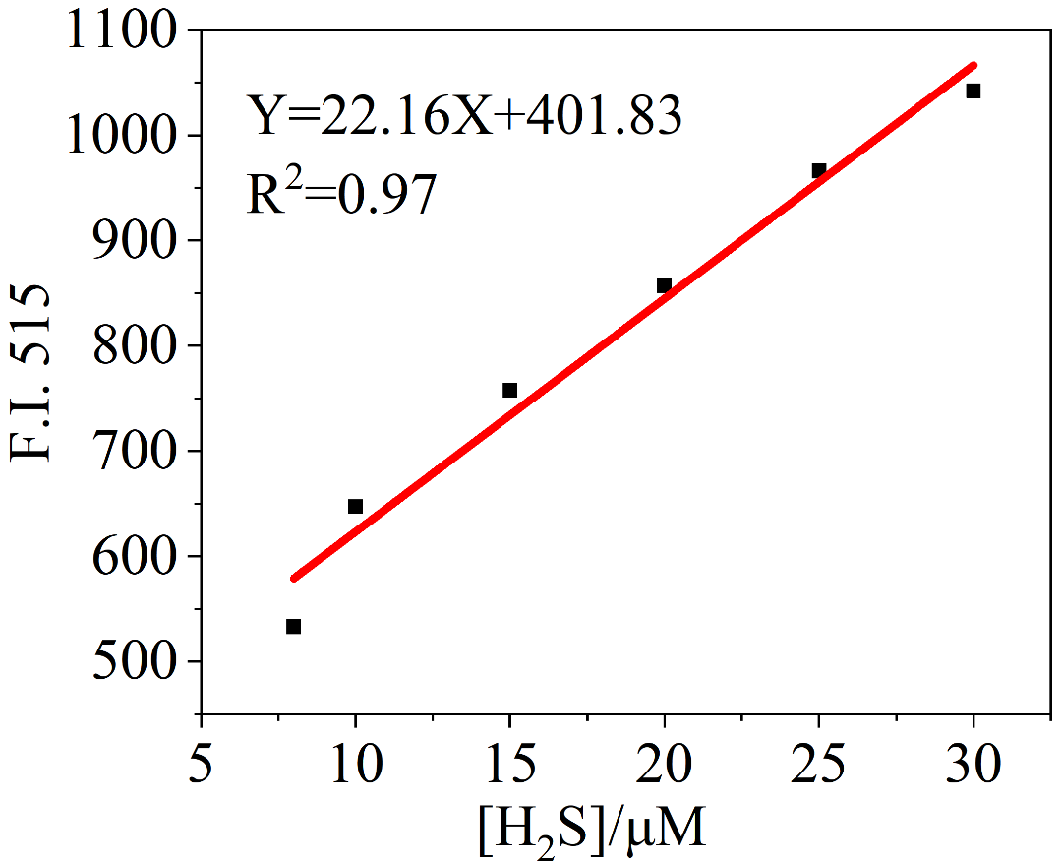
Fig. S5. Plot of fluorescence intensity value at 515 nm versus the number of equiv. of H₂S added.

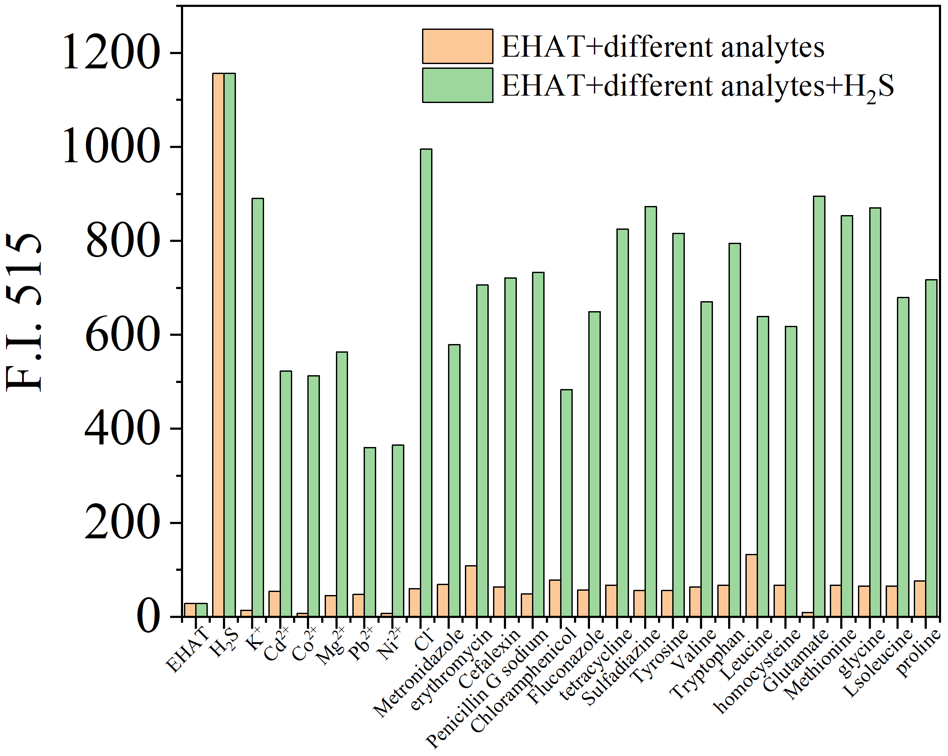
Fig. S6. The Fluorescence spectra of HNMT (10 µM) upon addition of various analytes (50 µM) in presence of H₂S (50 µM) in EtOH/H₂O (1/9, V/V, pH=7.4) medium.

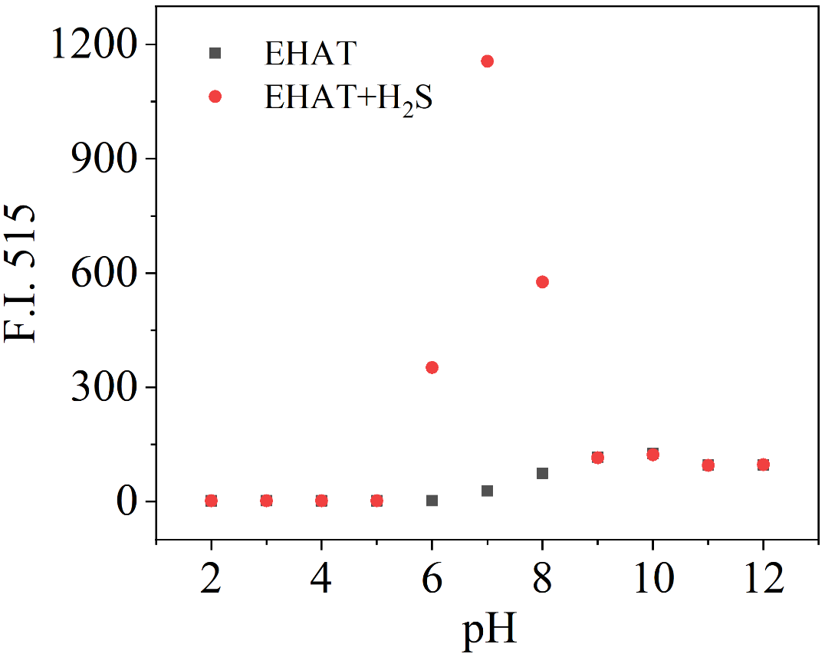
Fig. S7. Fluorescence intensity of EHAT (10 μM) at 515 nm in the absence and presence of H₂S (5 equiv) at various pH values.

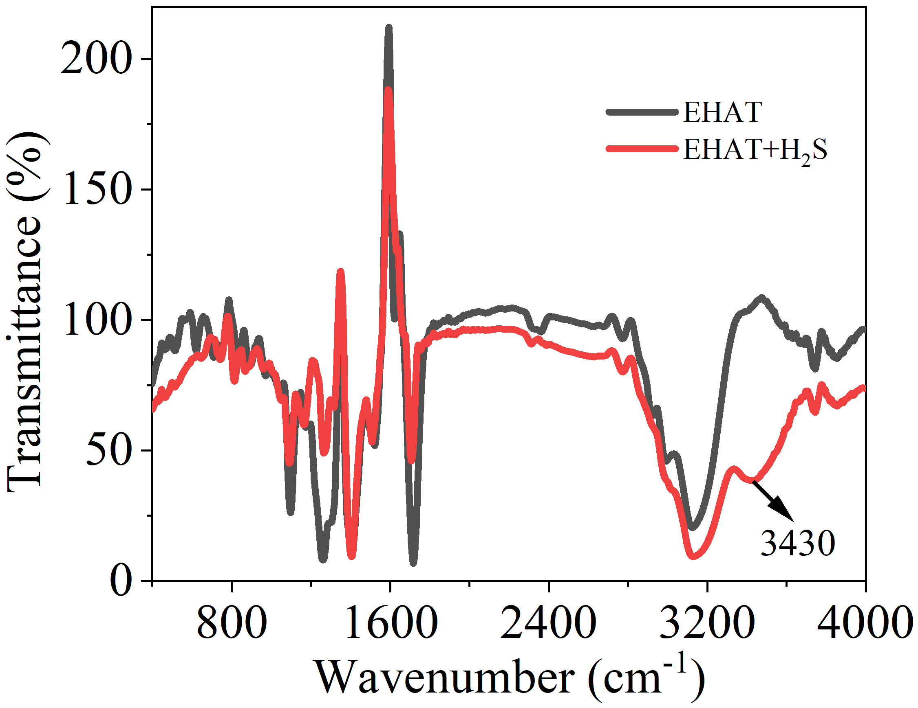

Fig. S8. FT-IR spectra of HNMT and HNMT/H₂S system.

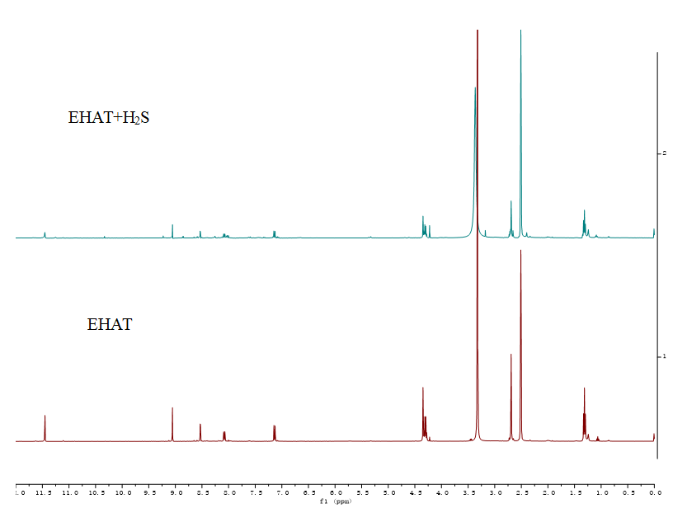
Fig. S9. ¹H NMR spectra of EHAT (line line) and EHAT/H₂S (red line) system (DMSO-d₆, 600 MHz).

[EHAT+H₂S+H⁺]
Fig. S10. ESI-MS spectrum of EHAT (10 μM) upon addition of 5 equiv H₂S in EtOH/H₂O (1/9, V/V, pH=7.4) mixture.

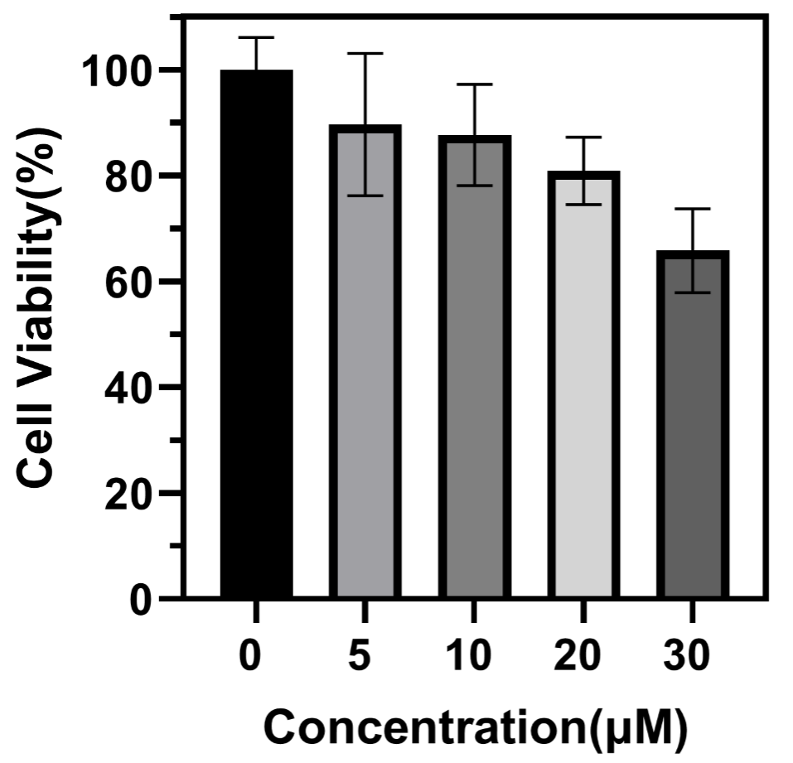
Fig. S11. MTT assay to determine the A549 cells viability in different concentrations of probe EHAT.

