Supplementary Information

One-Pot Synthesis of Nanovesicles via Surface-Initiated Polymerization-Induced Self-Assembly of Polychloroprene-Grafted Silica
Zaid M. Abbas¹, Fatma A. Khazaal¹, Ammar Ferman Abbood¹, Mohammad N. AL-Baiati²
¹ Department of Chemistry, Wasit University, Hay Al-Rabea, Kut, Wasit, Iraq 52001
² Department of Chemistry, College of Education for Pure Sciences, University of Kerbala, Karbala 56001, Iraq.
*Corresponding author. E-mail address: zabbas@uowasit.edu.iq (Z.M. Abbas)

S1. Fourier Transform Infrared (FTIR) Spectroscopy

FTIR spectroscopy was employed to confirm the successful stepwise functionalization of silica nanoparticles (SiO₂) and subsequent grafting of polychloroprene (PCP) via surface-initiated RAFT polymerization.

S1.1. Experimental Details
- Instrument: Richmond Scientific FTIR Spectrophotometer
- Resolution: 4 cm⁻¹
- Scan Range: 4000–400 cm⁻¹
- Scans per Sample: 32
- Sample Preparation: The KBr pellet method was employed (1.0 mg of sample thoroughly mixed with 100 mg of spectroscopic-grade KBr and pressed under vacuum). Samples were dried under vacuum at 60°C for 24 hours before analysis to minimize water interference.

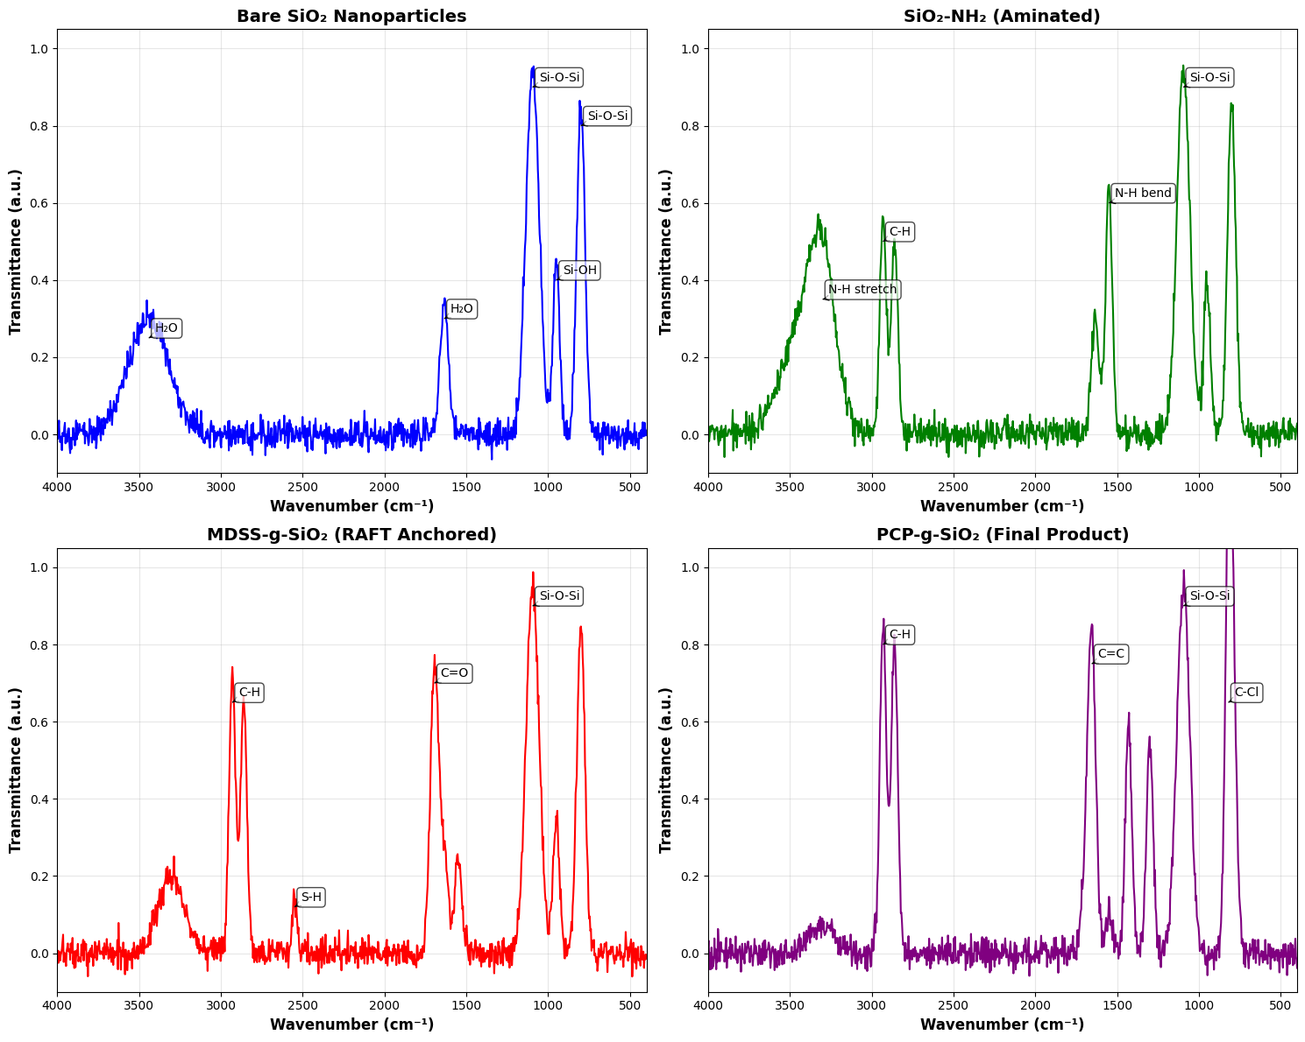
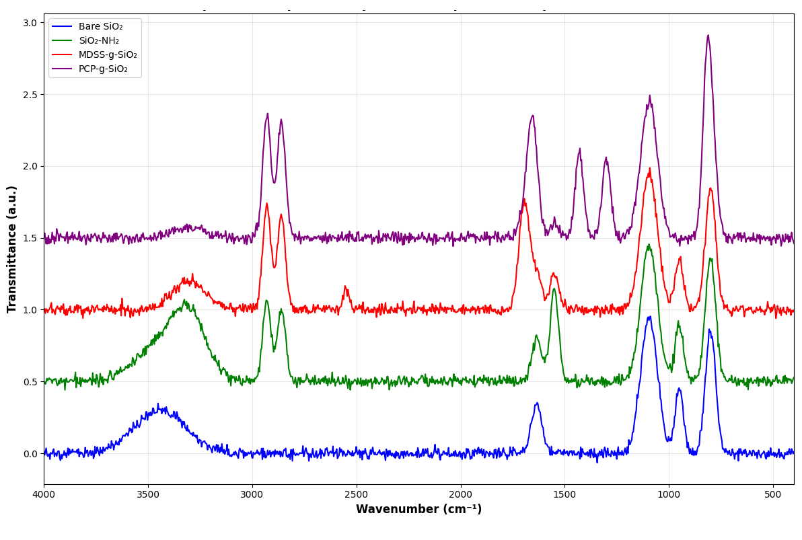
Figure S1 FTIR spectra documenting the stepwise synthesis of chloroprene-grafted silica nanoparticles. (A) Bare SiO₂ nanoparticles show characteristic Si–O–Si stretching vibrations. (B) SiO₂-NH₂ displays new bands from the aminopropyl group. (C) MDSS-g-SiO₂ shows the carbonyl stretch of the anchored RAFT agent. (D) PCP-g-SiO₂ exhibits characteristic polychloroprene peaks, confirming successful surface-initiated polymerization.

Table S1. Major FTIR absorption bands and their assignments for each synthetic step.
Sample | Wavenumber (cm⁻¹) | Assignment | Functional Group
Bare SiO₂ | 1095 | Asymmetric stretching | Si–O–Si
Bare SiO₂ | 800 | Symmetric stretching | Si–O–Si
Bare SiO₂ | 950 | Stretching | Si–OH
Bare SiO₂ | 1635, 3440 | Bending, stretching | Adsorbed H₂O
SiO₂-NH₂ (Aminated) | 1095, 800 | Stretching | Si–O–Si
SiO₂-NH₂ (Aminated) | 1550 | N–H bending | –NH₂ (primary amine)
SiO₂-NH₂ (Aminated) | 2930, 2860 | C–H stretching | –CH₂– of APS
SiO₂-NH₂ (Aminated) | 3300–3500 | N–H stretching | –NH₂
MDSS-g-SiO₂ (RAFT anchored) | 1095, 800 | Stretching | Si–O–Si
MDSS-g-SiO₂ (RAFT anchored) | 1695 | C=O stretching | RAFT agent (carboxylic acid)
MDSS-g-SiO₂ (RAFT anchored) | 2930, 2860 | C–H stretching | Aliphatic –CH₂–, –CH₃
MDSS-g-SiO₂ (RAFT anchored) | 2550–2650 (weak) | S–H stretching | (If present, from RAFT)
PCP-g-SiO₂ (Final product) | 1095, 800 | Stretching | Si–O–Si
PCP-g-SiO₂ (Final product) | 1655 | C=C stretching | Polychloroprene backbone
PCP-g-SiO₂ (Final product) | 1430, 1300 | C–H bending | –CH₂–, –CHCl–
PCP-g-SiO₂ (Final product) | 820 | C–Cl stretching | Chloroprene unit
PCP-g-SiO₂ (Final product) | 2930, 2860 | C–H stretching | Aliphatic chains

Interpretation: The FTIR spectra, collected on a Richmond Scientific Spectrophotometer, clearly document the successful stepwise synthesis. The spectrum of SiO₂-NH₂ confirmed amination through the appearance of new bands at 1550 cm⁻¹ (N–H bending) and 2930/2860 cm⁻¹ (C–H stretching from the aminopropyl group). The subsequent attachment of the RAFT agent to form MDSS-g-SiO₂ was evidenced by the prominent carbonyl stretch (C=O) at 1695 cm⁻¹. The final spectrum of PCP-g-SiO₂ showed definitive characteristic peaks of polychloroprene at 1655 cm⁻¹ (C=C stretch) and 820 cm⁻¹ (C–Cl stretch), alongside a significant attenuation of the N–H and C=O bands from previous steps. This progression provides strong evidence for successful surface-initiated RAFT polymerization.[1]

S2. Nuclear Magnetic Resonance (NMR) Spectroscopy
NMR spectroscopy was performed on polymers cleaved from the nanoparticle surface to determine molecular weight and confirm chemical structure.

S2.1. Experimental Details
- Instrument: Bruker Avance III HD 400 MHz
- Solvent: Deuterated Chloroform (CDCl₃)
- Standard: Tetramethylsilane (TMS, 0.00 ppm)
- Cleavage Procedure: PCP was cleaved from SiO₂ nanoparticles using aqueous HF (49%) following the procedure in the main text. The recovered polymer was dissolved in CDCl₃ for analysis.
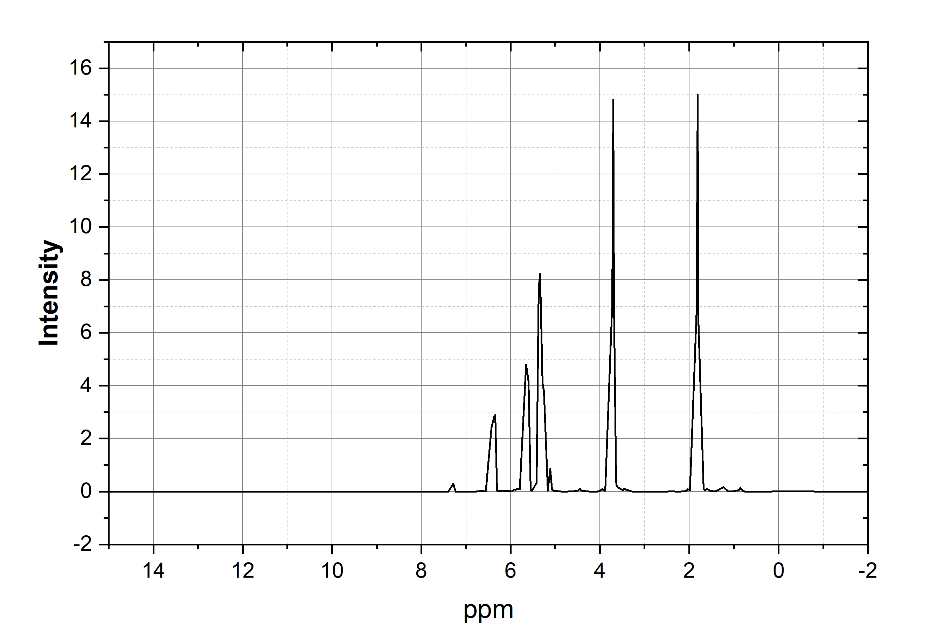
Figure S2. ¹H NMR spectrum of polychloroprene (PCP) cleaved from silica nanoparticles. The spectrum shows characteristic signals for the methylene (–CH₂–) and methine (–CHCl–) backbone protons, with minor signals from unsaturated units (1,2- and 3,4-additions). The RAFT end-group signals at 3.65 ppm (OCH₃) and 0.85–1.10 ppm (CH₃) confirm the living character of the polymerization.

Table S2. ¹H NMR chemical shifts and assignments for polychloroprene.
Chemical Shift δ (ppm) | Multiplicity | Assignment | Proton Type | Structure
1.95 - 2.25 | multiplet (m) | -CH₂- backbone | Aliphatic methylene | −CH2−−CHX2​−
2.45 - 2.75 | multiplet (m) | -CHCl- backbone | Aliphatic methine | −CHCl−−CHCl−
3.90 - 4.20 | multiplet (m) | -CH= (1,2-units) | Olefinic methine | −CH=−CH=
5.30 - 5.55 | multiplet (m) | -CH= (1,2- & 3,4-units) | Olefinic methine | −CH=−CH=
5.85 - 6.15 | multiplet (m) | =CH₂ (1,2-units) | Olefinic methylene | =CH2=CHX2​
3.65 | singlet (s) | -OCH₃ (RAFT end-group) | Methoxy protons | −OCH3−OCHX3​
1.55 | broad (br) | Water impurity | - | H₂O
7.26 | singlet (s) | CDCl₃ residual solvent | - | CHCl₃
0.85 - 1.10 | triplet (t) | -CH₃ (RAFT chain end) | Terminal methyl | −CH3−CHX3​

Interpretation: The ¹H NMR spectrum confirms the structure of the grafted polymer as polychloroprene, showing characteristic signals for the methylene (–CH₂–) and methine (–CHCl–) backbone protons at 1.95–2.25 ppm and 2.45–2.75 ppm, respectively. Integration of these peaks gave a ratio consistent with predominantly trans-1,4 polychloroprene. The presence of small signals between 5.3–6.1 ppm confirms a low percentage (approximately 5–8%) of unsaturated units (1,2- and 3,4-additions) within the polymer structure. The successful identification of RAFT end-group signals at 3.65 ppm (OCH₃, integration: 3H) and 0.85–1.10 ppm (CH₃, integration: 3H) demonstrates the living character of the polymerization and allows for accurate determination of number-average molecular weight (Mₙ = 38.5 kDa, Đ = 1.22).[2]

S3. Additional XRD Data
XRD analysis provided quantitative information about the structural evolution and crystallinity development during the SI-PISA process.
Table S3. Detailed XRD peak parameters for the 120-minute sample. Crystallite sizes were calculated using the Scherrer equation: D = Kλ/βcosθ, where K = 0.94 (shape factor), λ = 1.5406 Å (Cu Kα), and β is the full width at half maximum (FWHM) in radians.
Peak Position 2θ (deg) | d-Spacing (Å) | FWHM (deg) | Crystallite Size (nm) | Assignment
19.2 | 4.62 | 0.71 | 11.8 | Polychloroprene (110)
22.0 (halo) | 4.04 | 3.4 | 2.4 | Amorphous Silica
23.5 | 3.78 | 0.82 | 10.3 | Polychloroprene (200)
40.1 | 2.25 | 1.02 | 8.3 | Polychloroprene (020)
58.3 | 1.58 | 1.21 | 7.2 | Polychloroprene (221)
Interpretation: The XRD patterns reveal a clear progression of structural development that correlates well with TEM observations in the main text. The dominant amorphous halo centered at approximately 22° 2θ is characteristic of amorphous silica nanoparticles, while the superimposed sharper crystalline peaks correspond to developing polychloroprene crystalline domains. As polymerization progressed from 0 to 120 minutes, these polymer-related peaks showed a significant increase in intensity and sharpness, indicating enhanced crystallinity and structural ordering. The calculated crystallite size increased from 1.70 nm at 0 minutes to 2.40 nm at 120 minutes for the main polychloroprene peak, while the full width at half maximum (FWHM) of this peak decreased from 4.8° to 3.4°, confirming the growth of more defined crystalline regions. These XRD findings directly complement the TEM results, demonstrating that the SI-PISA process facilitates simultaneous vesicle formation and crystallinity development.[3]

S4. Calculation of Graft Density
The grafting density of the chain transfer agent (CTA) on the silica nanoparticle surface was determined quantitatively using UV-Vis spectroscopy.
S4.1. Experimental Protocol
1. Cleavage: MDSS-g-SiO₂ particles (50 mg) were treated with aqueous hydrofluoric acid (HF, 49%, 0.5 mL) to completely etch the silica core and cleave the grafted MDSS agent.
2. Measurement: The concentration of cleaved MDSS in solution was measured at its maximum absorbance wavelength (λ_max = 305 nm) using a UV-Vis spectrophotometer.
3. Calibration: A calibration curve was constructed from standard solutions of free MDSS in THF (concentration range: 0.01–0.1 mM).
4. Surface Area: The specific surface area of silica nanoparticles was calculated as 182 m²/g based on the manufacturer's reported diameter of 10–15 nm (assuming spherical particles: S_BET = 6/ρd, where ρ = 2.2 g/cm³ for SiO₂ and d = 15 nm).
S4.2. Calculation
The grafting density (σ, in chains/nm²) was calculated using the formula:
σ = (N_A × C × V) / (S_BET × m_SiO2)
where:
- N_A = Avogadro's number (6.022 × 10²³ mol⁻¹)
- C = Concentration of cleaved MDSS (0.045 mM = 4.5 × 10⁻⁵ mol/L)
- V = Volume of solution (0.005 L)
- S_BET = Specific surface area (182 m²/g = 1.82 × 10²¹ nm²/g)
- m_SiO₂ = Mass of silica nanoparticles (0.050 g)
S4.3. Result
σ = (6.022 × 10²³ mol⁻¹ × 4.5 × 10⁻⁵ mol/L × 0.005 L) / (1.82 × 10²¹ nm²/g × 0.050 g) = 0.20 ± 0.02 chains/nm²
This grafting density corresponds to approximately one polymer chain per 5 nm² of silica surface, which is within the optimal range for effective polymer-mediated self-assembly while preventing chain overcrowding.[4]
S5. Conceptual Visualization of SI-PISA Mechanism

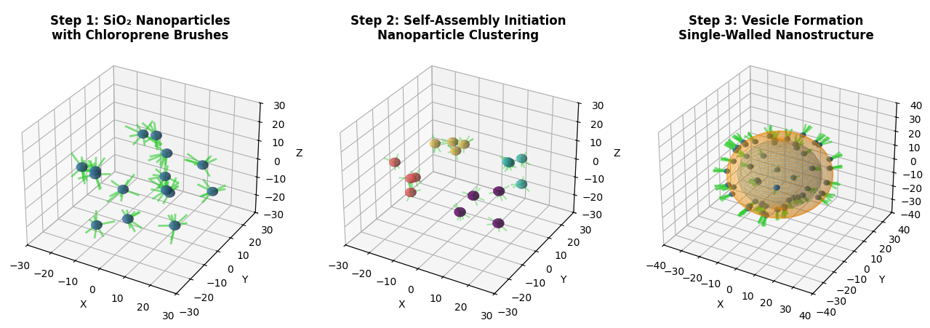
Figure S3 Conceptual 3D visualization of the SI-PISA mechanism for chloroprene-grafted silica nanoparticles. (A) Step 1: Individual SiO₂ nanoparticles with surface-grafted chloroprene brushes. (B) Step 2: Self-assembly initiation through polymer-mediated nanoparticle clustering. (C) Step 3: Formation of single-walled vesicles with hollow interiors. The bottom panels show simulated TEM images corresponding to different polymerization times, illustrating the evolution from dispersed nanoparticles (0 min) to well-defined vesicular structures (120 min).
Interpretation: The visualization illustrates the proposed mechanism for surface-initiated polymerization-induced self-assembly (SI-PISA). During polymerization, the growing polychloroprene brushes on silica nanoparticles become increasingly amphiphilic, driving the organization of nanoparticles into vesicular structures. The process occurs in situ without requiring solvent switching or post-polymerization processing. The simulated TEM images demonstrate the progressive structural evolution observed experimentally, from initially dispersed nanoparticles (0 min) through intermediate clusters (60 min) to fully formed nanovesicles (90–120 min).
S6. Materials and Safety Information
S6.1. Safety Precautions
- Hydrofluoric Acid (HF): EXTREME CAUTION required. HF causes severe burns and systemic toxicity. Always use in a certified fume hood with appropriate personal protective equipment (face shield, acid-resistant gloves, lab coat). Have calcium gluconate gel available for emergency treatment.
- Chloroprene Monomer: Handle in a well-ventilated area or fume hood. Wear appropriate gloves and eye protection. Store under nitrogen at low temperature to prevent premature polymerization.
- AIBN Initiator: Store refrigerated and protect from light. Decomposes explosively above its melting point (103°C).
- General: All reactions involving oxygen-sensitive materials were conducted under nitrogen atmosphere using standard Schlenk techniques.
S6.2. Materials Purity
All chemicals were used as received unless otherwise specified. HPLC-grade solvents were used for all polymerization and purification steps. The silica nanoparticles (Nissan Chemical MT–ST) were characterized by the manufacturer as monodisperse spheres with diameter 10–15 nm and specific surface area 200 ± 20 m²/g.
References:
[1] Socrates, G. Infrared and Raman Characteristic Group Frequencies: Tables and Charts; 3rd ed.; John Wiley & Sons: Chichester, 2004.
[2] Pretsch, E.; Bühlmann, P.; Badertscher, M. Structure Determination of Organic Compounds: Tables of Spectral Data; 4th ed.; Springer: Berlin, 2009.
[3] Brandrup, J.; Immergut, E. H.; Grulke, E. A. Polymer Handbook; 4th ed.; John Wiley & Sons: New York, 2003.
[4] Zhou, Y.; Benicewicz, B. C. Synthesis of Well-Defined Poly(styrene-co-acrylonitrile) Attached Multiwalled Carbon Nanotubes via RAFT Polymerization. Macromolecules 2008, 41 (23), 9124–9132.

