Supplementary 1:

Motor control exercise

Week 1
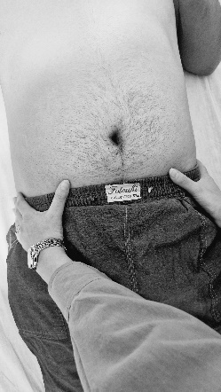
Sessions 1 and 2: Isolated contraction of the Transversus Abdominis and Multifidus muscles, and their combined activation
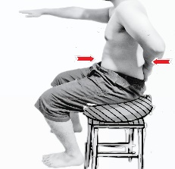
a. The patient is instructed to contract the Transversus Abdominis (TrA) muscle in the supine position without any movement of the spine or pelvis for 10 seconds, while maintaining normal breathing. The lower anterior abdominal wall, just below the umbilicus, should be gently drawn inward (38).
With the additional contraction of the pelvic floor muscles, the patient should continue to control breathing naturally. No movement of the spine or pelvis should be observed during this maneuver (39). (Figure 1)
Figure 1: Sessions one and two:
b. Activation of the lumbar Multifidus is taught in the sitting position on a chair. Then, the patient is asked to contract the Transversus Abdominis while performing the abdominal drawing-in maneuver in sitting, and simultaneously raise the contralateral arm (39). (Figure 2)
Figure 2: First and second session:

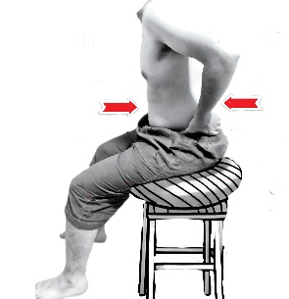
Session 3: Light activity for simultaneous activation of the Transversus Abdominis and lumbar Multifidus
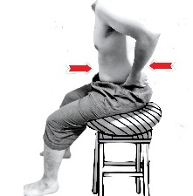
a. The patient is instructed to contract the Transversus Abdominis and lumbar Multifidus muscles simultaneously in the sitting position on a chair. The index and middle fingers of one hand are used to palpate the contraction of the Transversus Abdominis, while the two fingers of the opposite hand are used to palpate the lumbar Multifidus contraction.
This exercise progresses from 10 to 60 seconds of sustained contraction for 10 repetitions (39). (Figure 3)
Figure 3: Third session.
b. The patient sits on a chair while maintaining the neutral position of the lumbar spine and pelvis. Then, during forward and backward trunk movements, both the Multifidus and Transversus Abdominis muscles are contracted simultaneously. This exercise is repeated 10 times (39). (Figure 4)
Figure 4: Third session.

Week 2
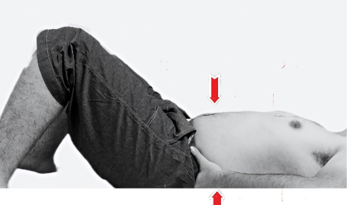
Sessions 4 and 5:
a. The patient lies in the supine position, with the hips flexed to 45° and the knees flexed to 90°. While contracting the Multifidus and Transversus Abdominis simultaneously, the patient performs hip abduction to 45° with one leg and holds the position for 10 seconds. This is repeated 10 times for each leg (39). (Figure 5)
Figure 5: Sessions 4 and 5.
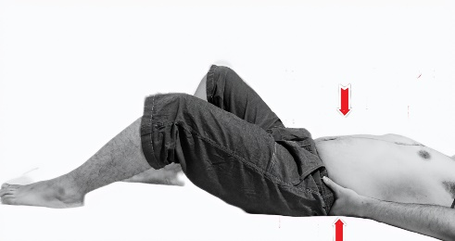
b. In the same position as the previous exercise, the patient contracts both muscles simultaneously and then slides one leg along the bed until the knee is fully extended, maintaining the contraction for 10 seconds before returning the leg to the starting position. This is performed 10 repetitions for each leg (39). (Figure 6)
Figure 6: Session 4 and 5.
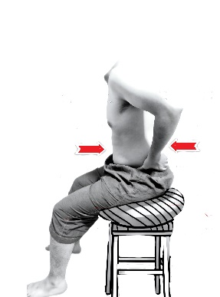
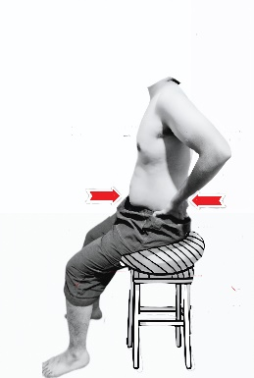
Sessions 6 and 7:
a. The patient sits on a balance board, contracting both the Multifidus and Transversus Abdominis muscles simultaneously. While maintaining a neutral position of the lumbar spine and pelvis, the patient performs contractions during forward, backward, and lateral trunk movements. Each position is maintained for 10 seconds and repeated 10 times (39). (Figure 7)
Figure 7: Sessions 6 and 7.

Week 3
Training simultaneous contraction of the Transversus Abdominis and Lumbar Multifidus: progression to more demanding exercises
Sessions 8 and 9:
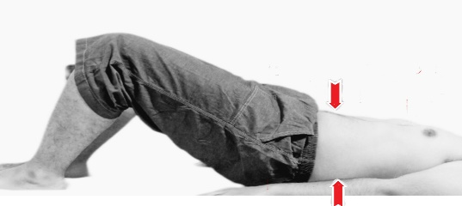
a. The patient lies in the supine position with knees flexed. The patient is asked to lift the hips off the bed while maintaining simultaneous contraction of the Transversus Abdominis and Multifidus muscles. This position is held for 10 seconds and repeated 10 times (39). (Figure 8)
Figure 8: Sessions 8 and 9:
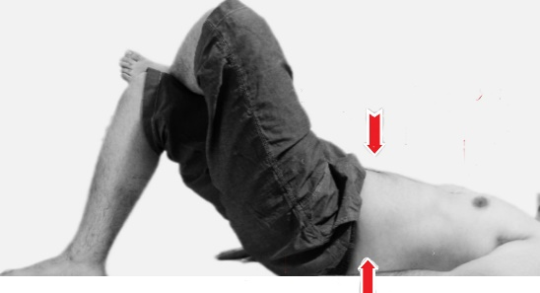
b. In the same position as the previous exercise, but with one leg crossed over the other. The patient contracts both muscles and then lifts the hips off the bed, holding the position for 10 seconds before lowering back down. This exercise is performed 10 repetitions for each leg (39). (Figure 9)
Figure 9: Sessions 8 and 9:
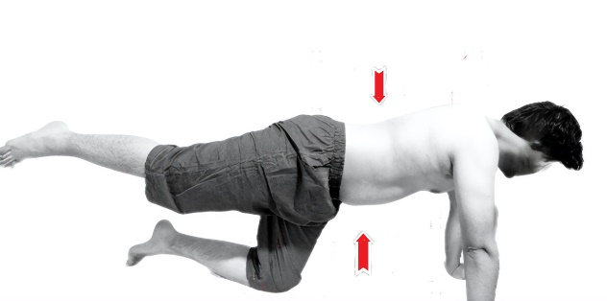
Session 10:
a. The patient assumes the quadruped (all-fours) position, keeping the lumbar spine in neutral alignment. While contracting both the Transversus Abdominis and Multifidus muscles, the patient lifts one leg off the bed, holds for 10 seconds, and then returns to the starting position. This exercise is repeated 10 times for each leg (39). (Figure 10)
Figure 10: Session 10:
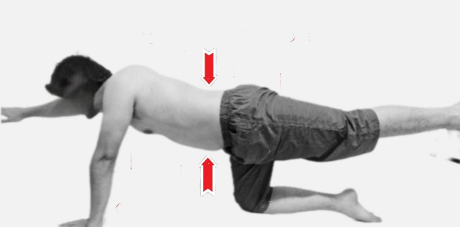
b. In the same quadruped position as the previous exercise, the patient contracts the Transversus Abdominis and Multifidus simultaneously and then raises the contralateral arm and leg. The position is held for 10 seconds, followed by a return to the starting position. This exercise is repeated 10 times for both sides (39). (Figure 11)
Figure 11: Session 10: B
Note 1: The patient will only progress to a more advanced level of exercise if they are able to learn and perform the exercises of the previous level without pain. If the patient is unable to properly master the exercises of one session or experiences pain during execution, they will remain at the same stage.
Note 2: If the patient is unable to perform the exercises of the previous session for more than three consecutive sessions, or if for any reason the program does not progress as planned, the patient will be excluded from the study
McKenzie Evaluation and Exercises:
The repeated extension movement is performed as follows:
The patient lies in the prone position; initially resting on the elbows (Figure 12). If the patient feels comfortable, the exercise is progressed by extending the arms and resting on the hands (Figure 13). This movement is repeated 10 times.
According to the assessment protocol, if Force Progression is required, the following steps are applied:
- First, the patient is instructed to apply self-generated overpressure by relaxing the pelvic and gluteal muscles at the end range of motion.
- If the response is insufficient, the therapist places their hands in a crossed position over the lumbar segment and applies a posterior-to-anterior (PA) pressure while the patient performs 10 repetitions (Figure 14).
- If this technique is still ineffective, a mobilization or manipulation is applied, specifically a posterior-to-anterior glide (Figure 15)
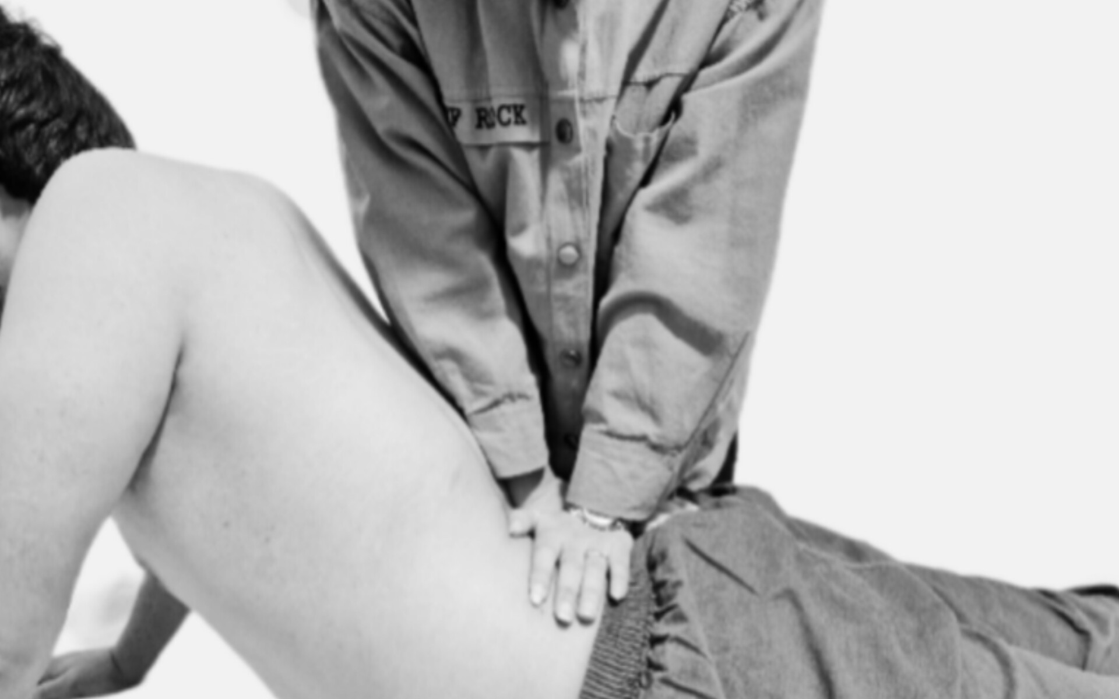
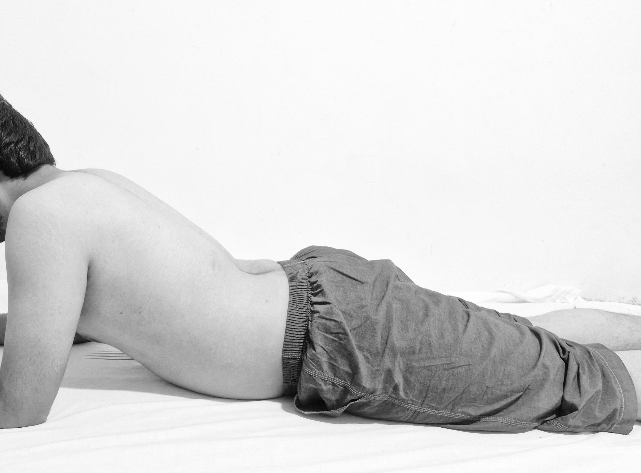
Figure 14: Therapist overpressure - Image taken from reference (44)

Force progression

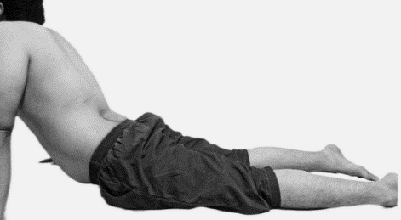
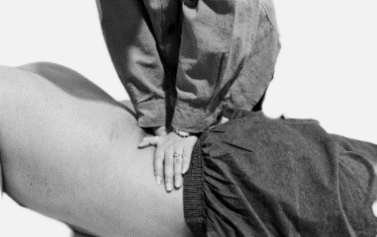
Figure 12: Non-weight-bearing extension; on the elbo)

Figure 15: Mobilization / Manipulation )
Figure 13: Non-weight-bearing hand extension)
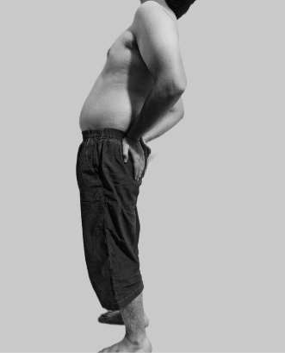
If the patient’s pain increases or becomes peripheral with these movements, the Force Alternative technique is applied as previously described. One of these techniques involves changing the patient’s position. The patient is brought to a standing position and then asked to perform repetitive extension movements (Figure 16). At this stage, no specific patient or therapist force, nor mobilization, is applied.
Figure 16: Preferred direction of extension in weight-bearing position

If symptoms still become peripheral, or if pain increases, or the range of motion decreases, the next technique is applied. At this stage, repetitive extension with hip off-center is used. This movement is illustrated in Figure 17.
If the desired response is still not achieved, the direction of movement is changed, and repetitive lateral movements are performed.

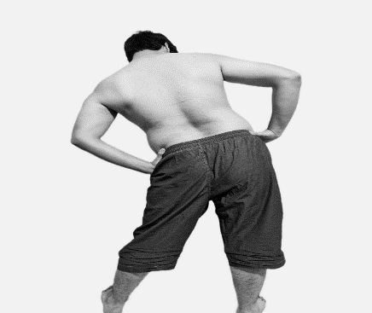
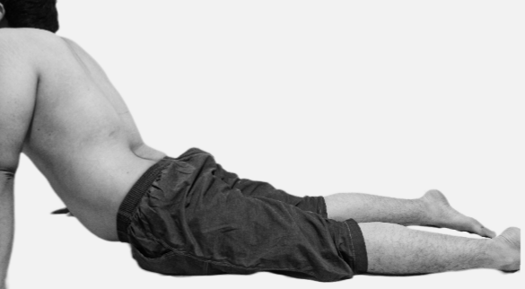
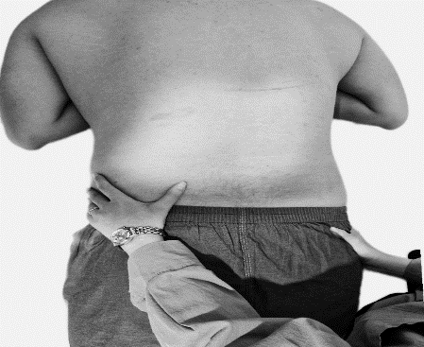
a
b
f
d
c
e
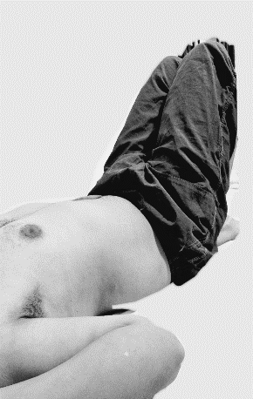
Figure 17: When the preferred direction of extension in previous positions does not yield a response, this position is used.
a) The pelvis is moved toward the non-painful side and the legs toward the opposite side, creating a C-shaped posture (if this direction does not work, the pelvis is moved to the other side), followed by extension.
b) Therapist overpressure.
c) External glide in the prone position on the sagittal plane, maintaining the same previous position.
d) External glide in the standing position.
e & f) Rotation mobilization, performed unilaterally or bilaterally; the patient should not be brought into the hip-off-center position.
In this movement, the patient lies in the supine position, and rotation of the lumbar spine and pelvis is performed toward the painful side (Figure 18).

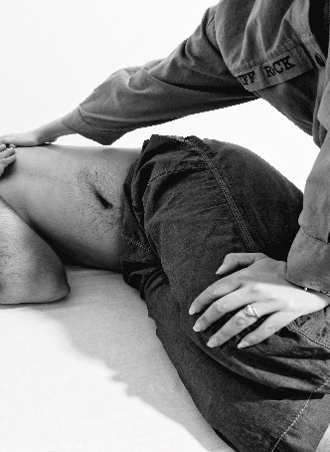
If the Force Progression technique is required, initially the patient applies pressure, and if needed, the therapist provides additional pressure. If the desired response is still not achieved, the therapist applies mobilization at the end of the range of motion in the anterior-posterior direction (Figure 19).
Figure 18: Lateral Rotation movement by the patient; when there is no lateral shift (in the supine position) -

Repetitive lateral movements can also be performed in an alternative way. If there is no response from movements in the sagittal plane or a combination of sagittal and frontal planes, pure movements in the frontal plane are used. Additionally, when a patient presents with a lateral shift, this repetitive movement is used to correct it.
Figure 19: Lateral flexion movement by the therapist/with more pressure from the therapist; and mobilization at the end of the range of motion in the supine position
- If the deviation is away from the painful side, it is called a contralateral shift.
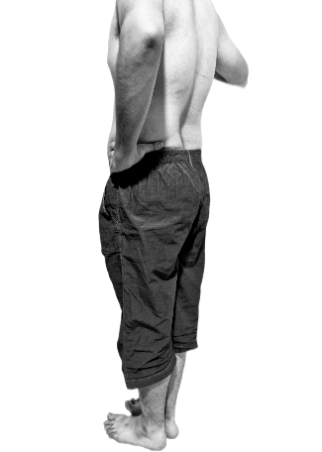
- If the deviation is toward the painful side, it is called an ipsilateral shift.
The patient initially stands next to a wall (if a pelvic shift is present, the patient should stand so that the concave side faces the wall). The patient then places their arm on the wall and performs the lateral movement or shift correction (Figure 20). Pressure is applied if needed. If the desired response is not achieved, other techniques are used, and the therapist applies the necessary pressure to correct the lateral shift. At this stage, mobilization is not defined.
Figure 20: Lateral flexion movement: correction of lateral shift by the patient herself

