Supplementary Materials for
A fully printed stretchable microneedle bioelectronic patch for full-cycle intelligent wound management
Xinzhao Zhou et al.

*Corresponding author. Email: chenhw75@buaa.edu.cn

This PDF file includes:
Figure S1 to S15
Table S1
Legends for movies S1

Other Supplementary Material for this manuscript includes the following:
Movies S1

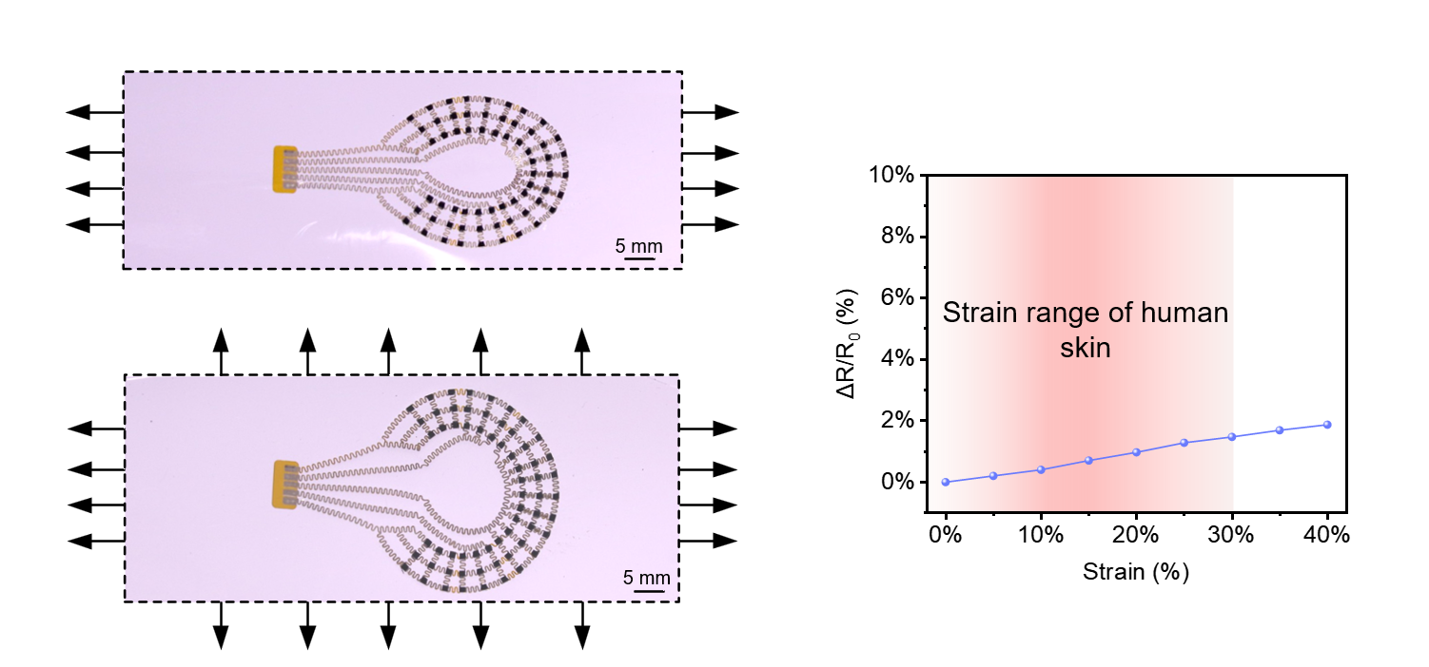
Figure S1. Mechanical compliance characterization of the iSMNP. (A) Optical images of the iSMNP under uniaxial stretching to 30% strain and biaxial equibiaxial stretching to 30% strain. (B) Relative resistance variation of the iSMNP as a function of applied tensile strain.

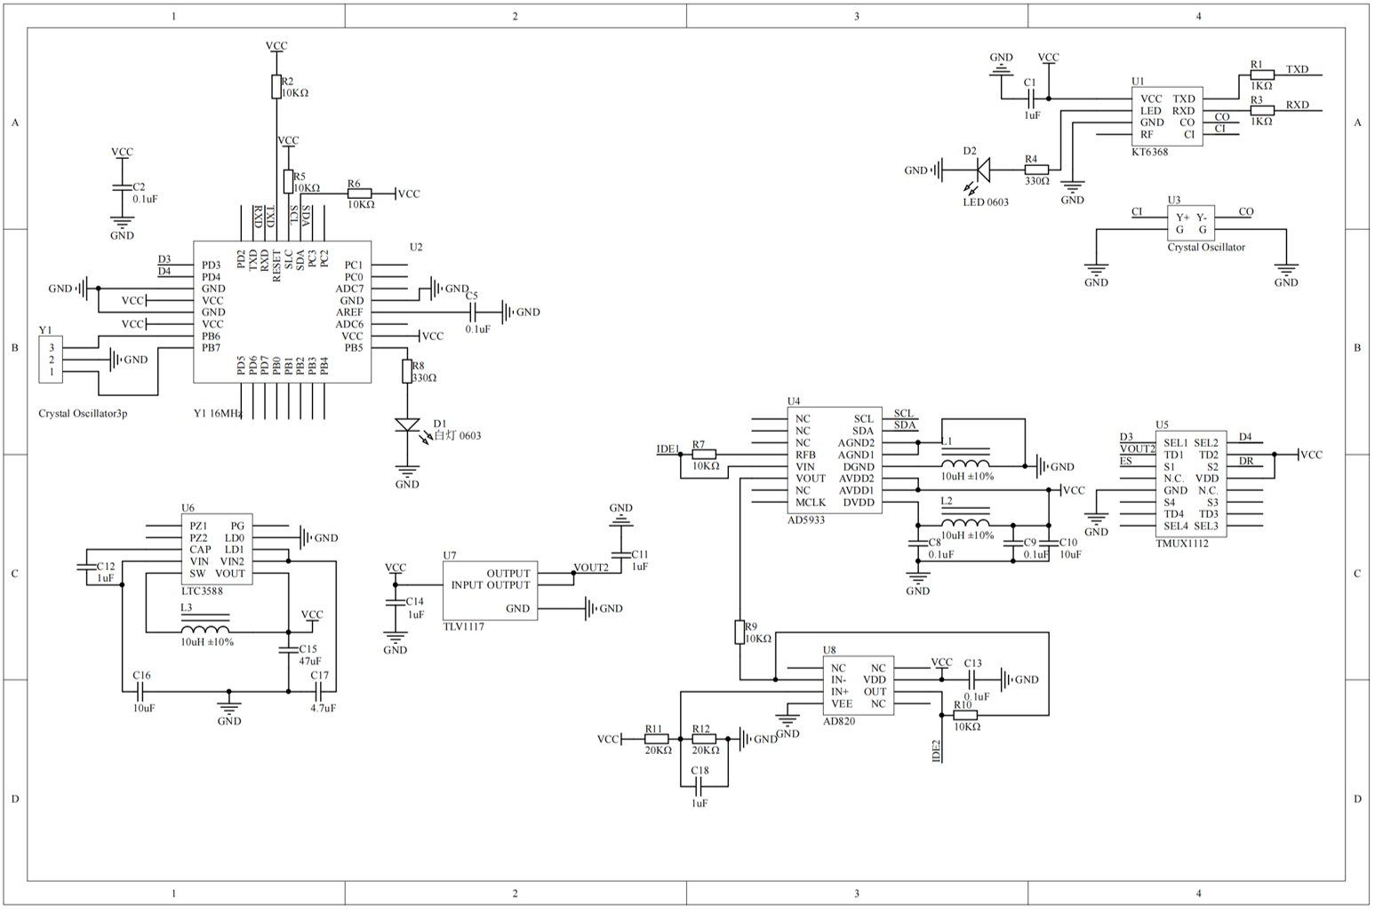
Figure S2. The circuit diagram of the iSMNP hardware design.

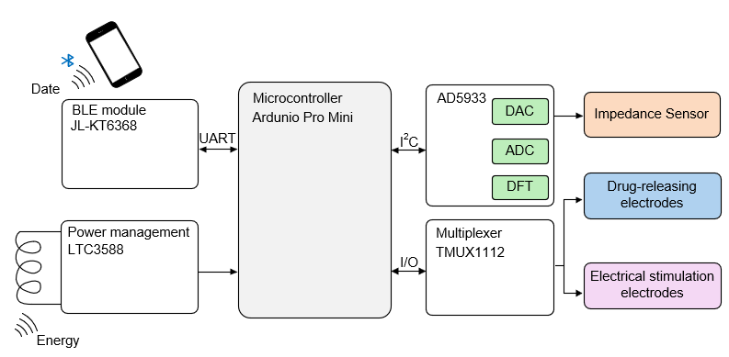
Figure S3. Working logic diagram of the iSMNP.

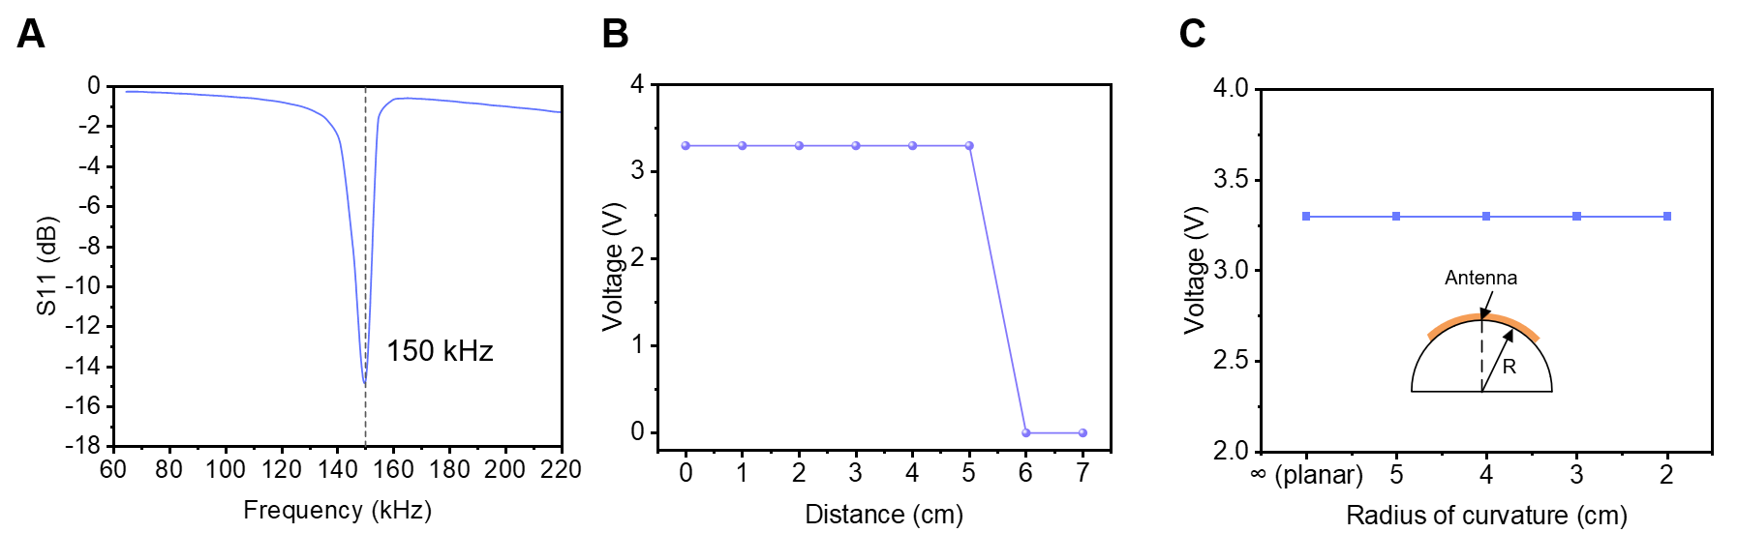
Figure S4. Wireless power transfer performance of the iSMNP. (A) Resonant frequency characterization of the iSMNP receiving antenna. (B) Measured output voltage of the iSMNP as a function of the distance between the receiving coil and the external transmitter. (C) Output voltage of the iSMNP as a function of bending radius, with the coil-transmitter distance fixed at 2 cm.

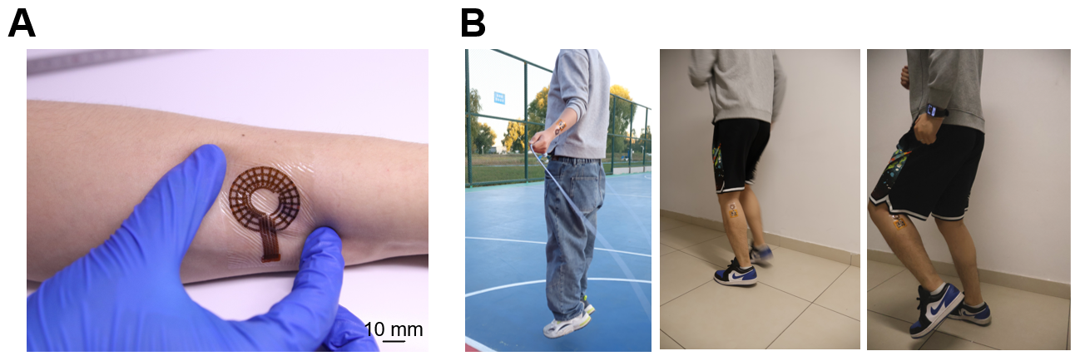
Figure S5. Dynamic conformal performance of the stretchable MN patch and the iSMNP system on skin. (A) Optical image of the stretchable MN patch subjected to tensile deformation while adhered to the skin surface. (B) Optical images of the iSMNP attached to the arm during rope skipping and to the calf during running, demonstrating its excellent dynamic conformability and stable adhesion under vigorous motion.

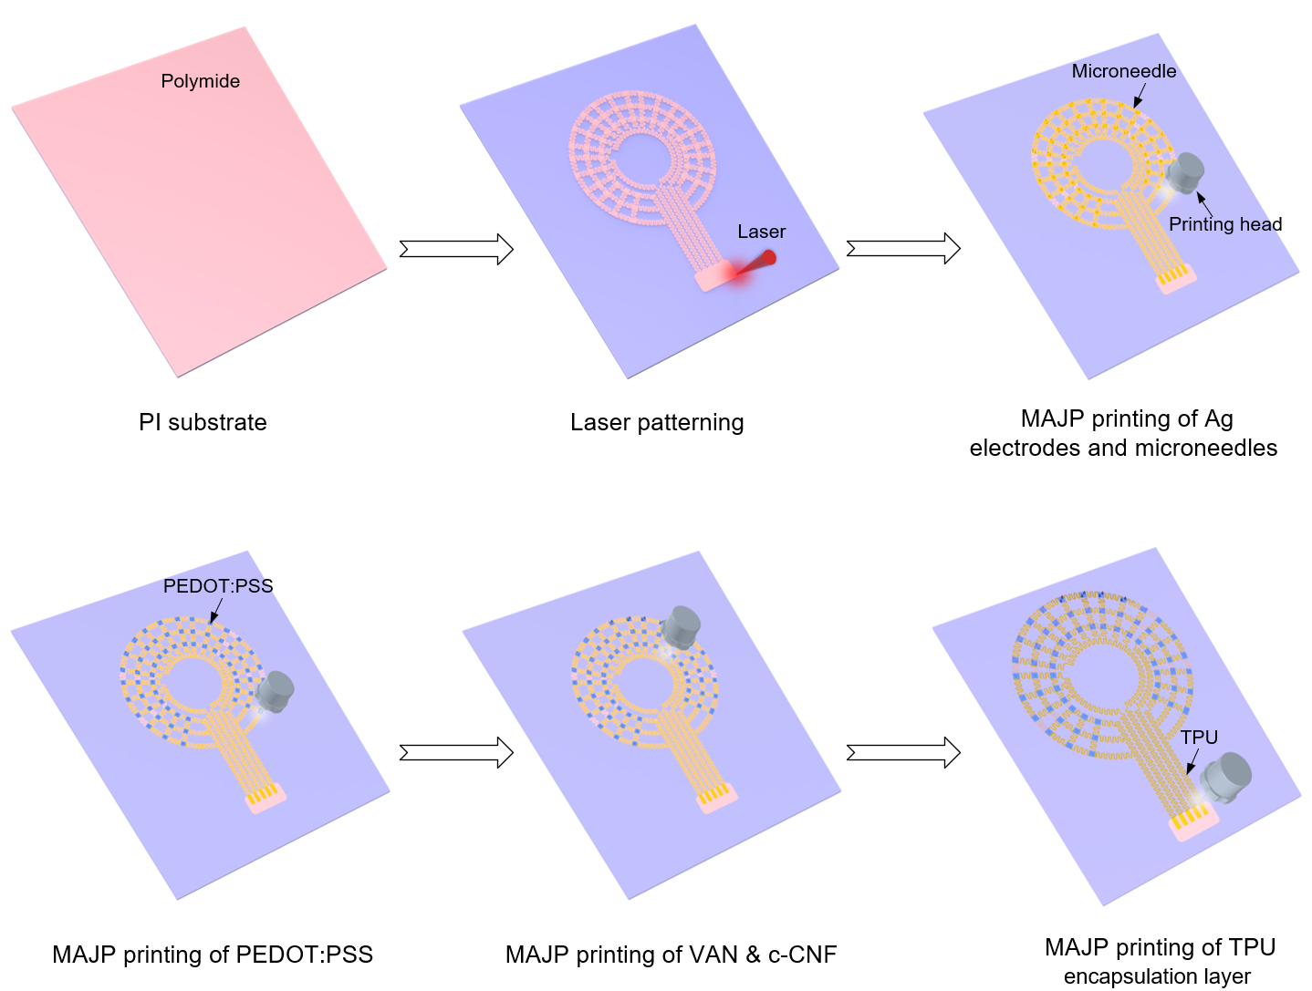
Figure S6. Schematic of the fabrication process of the stretchable MN patch using the MAJP.

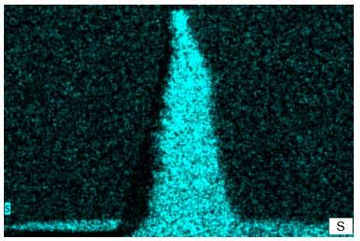
Figure S7. EDX image of PEDOT:PSS-Ag MN, which reveals a uniform sulfur (S) distribution from PEDOT:PSS (C₈H₈O₃S), indicating conformal coating of PEDOT:PSS on Ag MN.

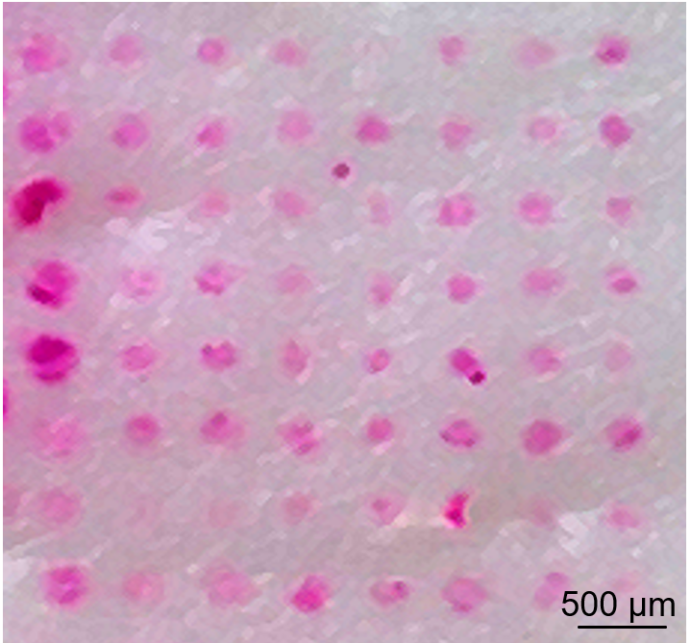
Figure S8. Optical image of porcine skin after insertion of the MN array, with the puncture sites visualized by rhodamine B staining (red).

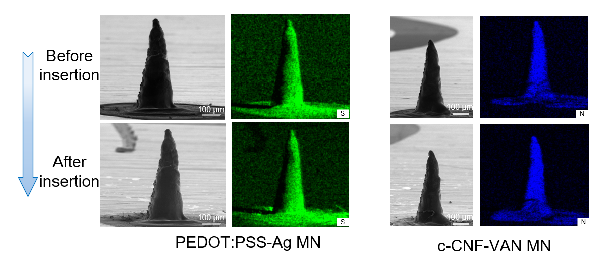
Figure S9. SEM and EDX images of PEDOT:PSS MNs and c-CNF-VAN MNs before insertion and after 200 repeated insertion cycles into 5% agarose, showing no observable coating delamination.

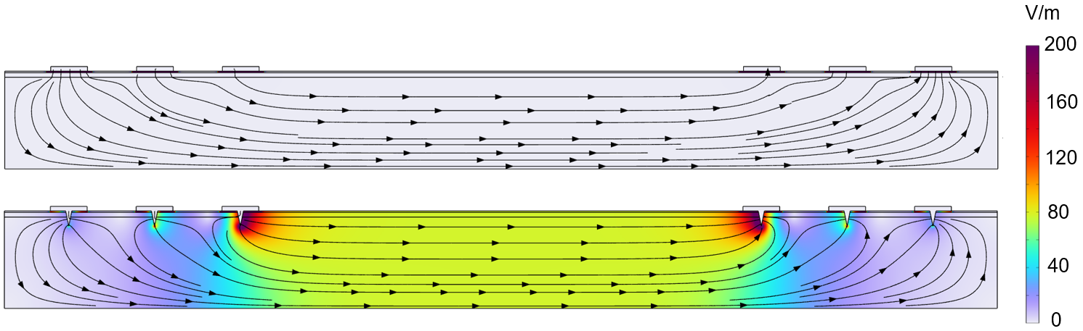
Figure S10. Simulated electric field distributions within a skin model for planar electrode and MN electrode.

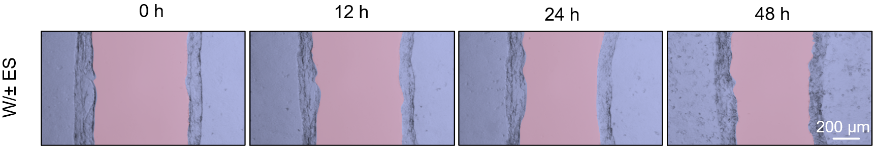
Figure S11. Representative images of the scratch wound healing assay showing HaCaT cell migration in W/±ES groups.

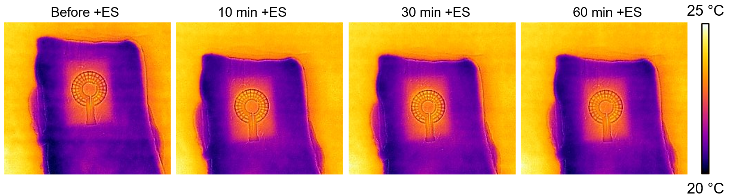
Figure S12. Infrared images of the stretch MN patch during the electrical stimulation.

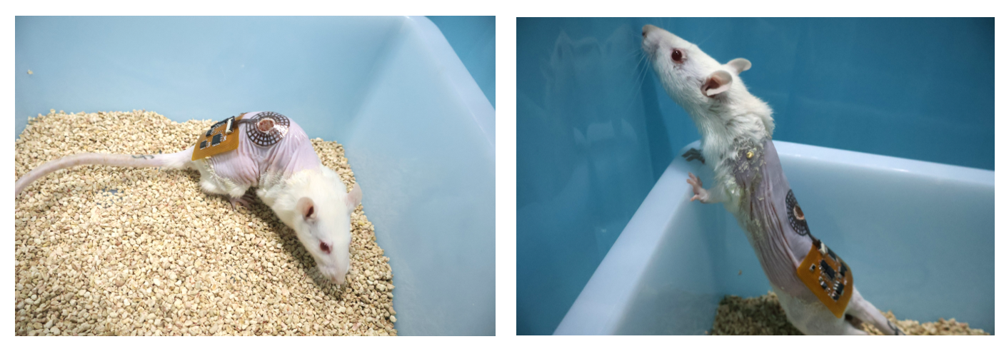
Figure S13. Optical images of the iSMNP attached to the rat dorsal skin under bending and stretching deformations.

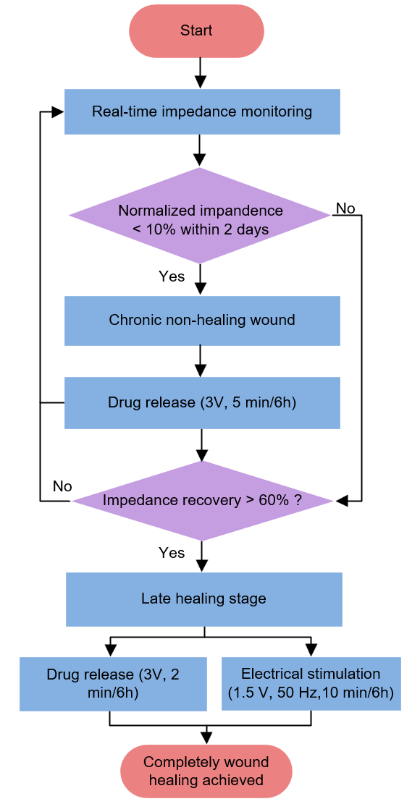
Figure S14. Flowchart depicting the impedance-guided closed-loop control logic of the iSMNP.

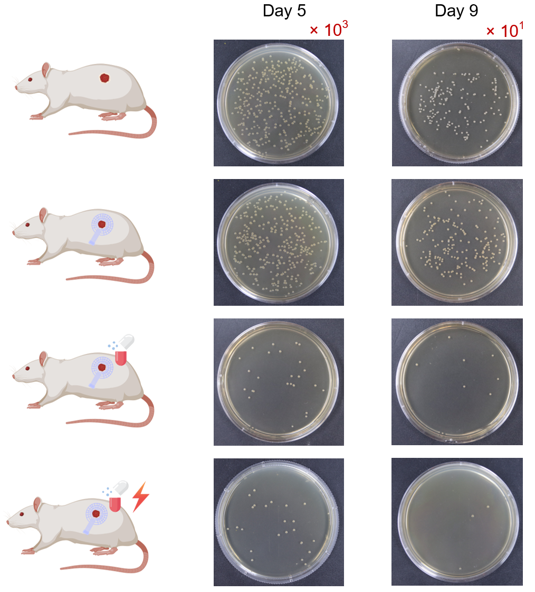
Figure S15. Optical images of bacterial colonies cultured from wound tissue samples collected from rats in different treatment groups on days 5 and 9.

Table S1: Comparison of MN conductivity between previously reported works and this work.
MN type | Materials | Fabrication method | Conductivity  (S/m) | Ref.
Hydrogel  MN | PEDOT:PSS/DA-HA | Mold replication | 1.55×10⁻² | 1
Hydrogel  MN | PEDOT:PSS/  MA resin | 3D printing | 6.17 | 2
Hydrogel  MN | CNT/GelMA | Mold replication | 7.6×10² | 3
Hydrogel  MN | DA-HA  /PEDOT:PSS/Ag-Pt | Mold replication | 2×10² | 4
Hydrogel  MN | PVA/ PEDOT:PSS  /GO/MXene | Mold replication | 3.84×10² | 5
Silicon  MN | Au/Ti/ Silicon | Etching | 4.17×10⁷ | 6
Silicon  MN | Au/Ti/ Silicon | Etching | 4.17×10⁷ | 7
Metal MN | PEDOT:PSS/Ag | MAJP | 7.3×10⁶ | This work
DA: dopamine; HA: hyaluronic acid; MA: methacrylic acid; CNT: carbon nano-tube; GelMA: gelatin methacrylate; GO: graphene oxide

Captions for movies:
Movie S1: Dynamic conformal contact of the iSMNP with the dorsal skin of a rat during free movement.

References
1. Odinotski, S. et al. A Conductive Hydrogel-Based Microneedle Platform for Real-Time pH Measurement in Live Animals. Small 18, 2200201 (2022).
2. Keirouz, A. et al. Conductive Polymer-Coated 3D Printed Microneedles: Biocompatible Platforms for Minimally Invasive Biosensing Interfaces. Small 19, 2206301 (2023).
3. Ghosh, S. et al. Electrically-driven drug delivery into deep cutaneous tissue by conductive microneedles for fungal infection eradication and protective immunity. Biomaterials 314, 122908 (2025).
4. GhavamiNejad, P. et al. A Conductive Hydrogel Microneedle-Based Assay Integrating PEDOT:PSS and Ag-Pt Nanoparticles for Real-Time, Enzyme-Less, and Electrochemical Sensing of Glucose. Adv. Healthc. Mater. 12, 2202362 (2023).
5. Sharifuzzaman, M. et al. Hydrogel Microneedle Array-Based Transdermal Dressing System for Multiplexed Assessment and Intelligent Therapy of Chronic Wounds. Small, e11542 (2025).
6. Kim, H. et al. Skin preparation-free, stretchable microneedle adhesive patches for reliable electrophysiological sensing and exoskeleton robot control. Sci. Adv. 10, eadk5260 (2024).
7. Ji, H.W. et al. Skin-integrated, biocompatible, and stretchable silicon microneedle electrode for long-term EMG monitoring in motion scenario. npj Flexible Electron. 7, 46 (2023).

