Cytoplasmic RBMX coordinates selective mRNA translation to suppress senescence in cancer

Jeeho Kim^{1,2}, In-Youb Chang³, Young Jin Jeon^{2,*}, Jeongsik Yong^{4,*}, Ho Jin You^{1,2,*}

¹Laboratory of Genomic Instability and Cancer therapeutics, ²Department of Pharmacology, ³Department of Anatomy, Chosun University School of medicine, 375 Seosuk-dong, Gwangju 501-759, South Korea. ⁴Department of Biochemistry, Molecular Biology and Biophysics, University of Minnesota Twin Cities, Minneapolis, MN 55455, USA.

Correspondence should be addressed to:
Ho Jin You, M.D., Ph.D.
Phone, 82-62-230-6337; Email: hjyou@chosun.ac.kr
Jeongsik Yong, Ph.D.
Phone, 612-626-2420; Email: jyong@umn.edu
Young Jin Jeon, Ph.D.
Phone, 82-62-230-6338; Email: yjjeon@chosun.ac.kr

Supplementary Figures:
Supplementary Fig.1 RBMX binds to RNA-associated proteins in the cytoplasm and is condensed in the cytoplasm by growth factors.
Supplementary Fig.2 RBMX is associated with translation in the cytoplasm.
Supplementary Fig.3 RBMX binds to cancer-associated transcripts in the cytoplasm.
Supplementary Fig.4 The interaction between RBMX and eIF3i/eIF3F correlates with poor prognosis in colorectal cancer patients.
Supplementary Fig.5 De-methlylation of RBMX promotes translation.
Supplementary Fig.6 RBMX deficiency increases p21 in a p53-independent manner.

Supplementary Methods:
Cell growth assay
Cell migration assay
Soft agar colony formation assay

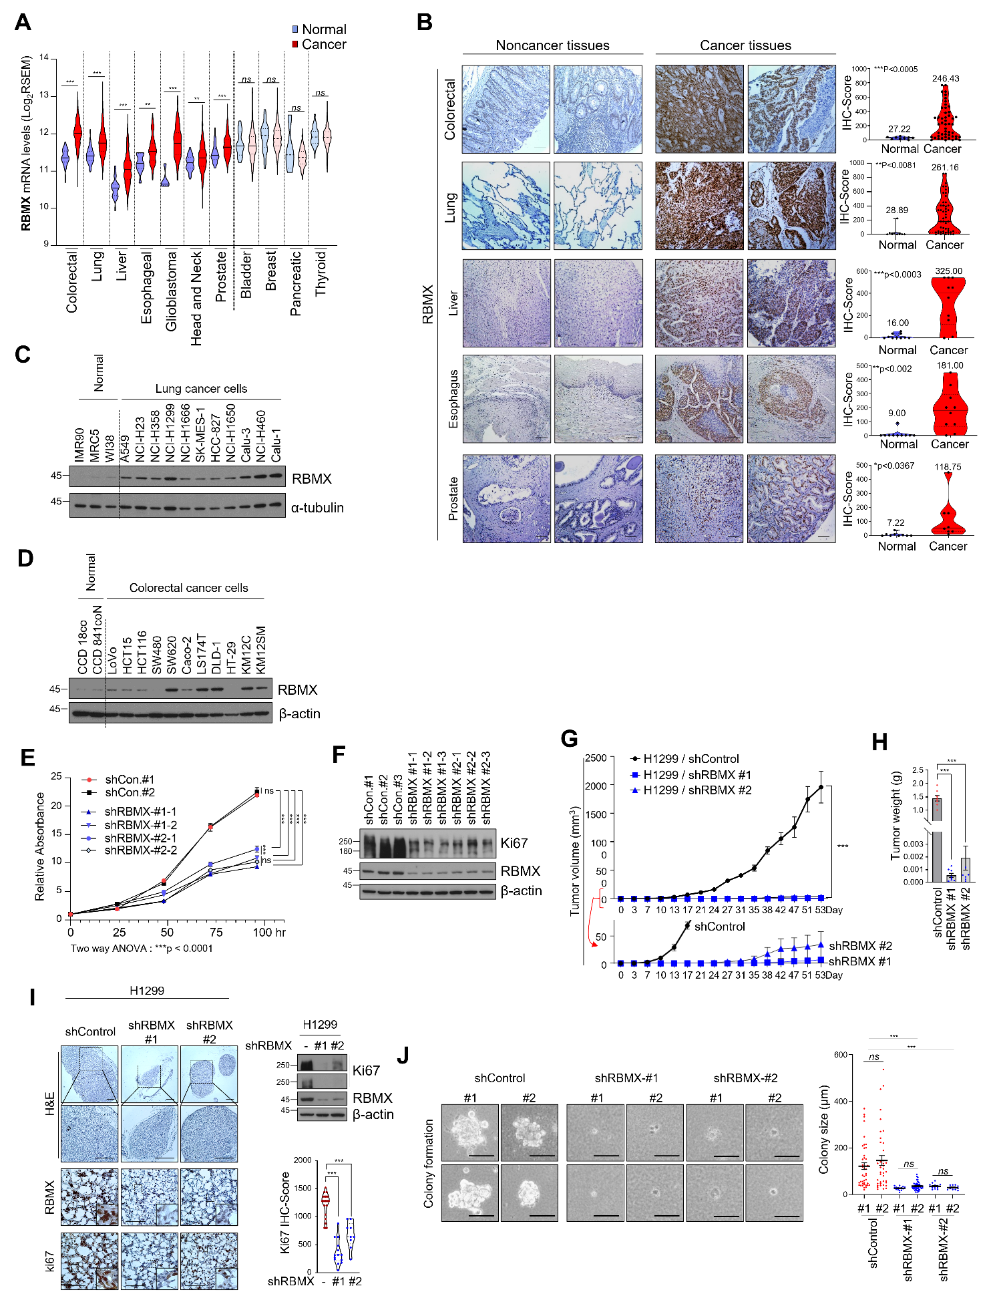
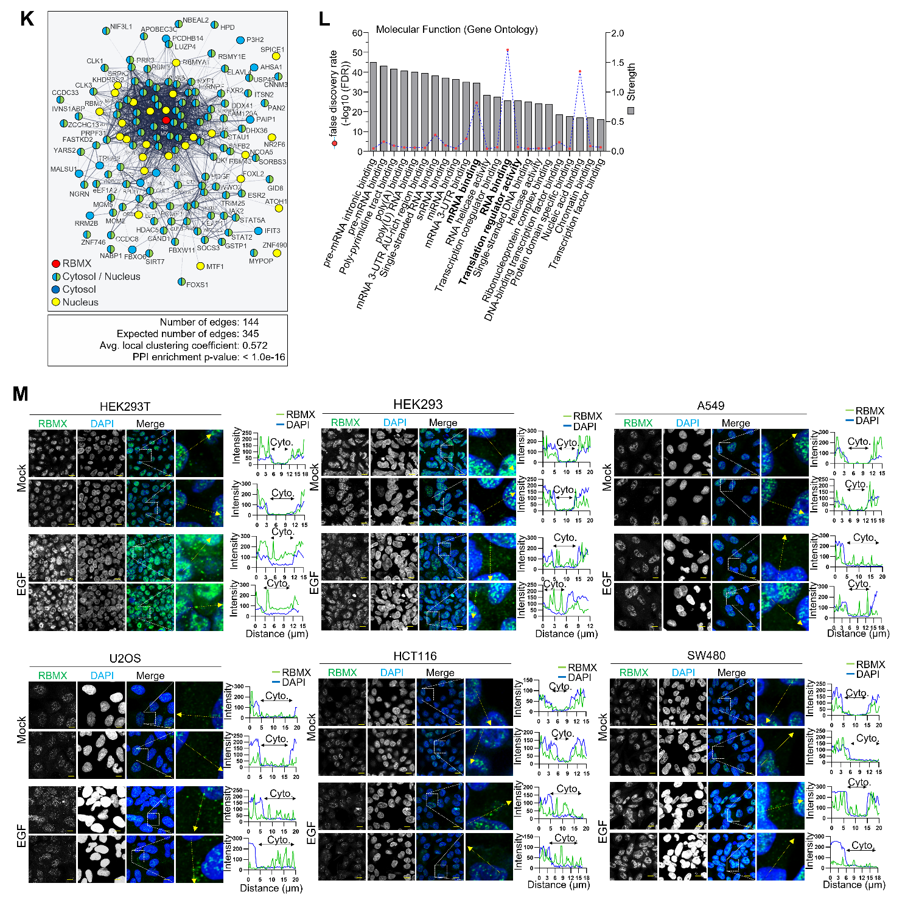
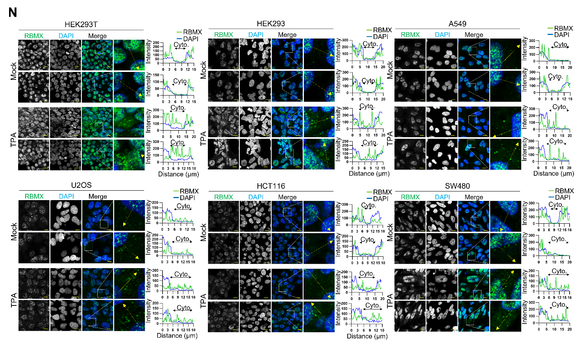
Supplementary Fig.1 RBMX binds to RNA-associated proteins in the cytoplasm and is condensed in the cytoplasm by growth factors. A RBMX mRNA expression levels across 11 primary cancer types from the TCGA dataset are compared to normal tissue. Data presented as mean ± SEM. Statistical analysis is done using a two-tailed Student’s t-test (** p < 0.01, *** p < 0.001, ns, not significant). B Immunohistochemistry (IHC) staining was performed to assess RBMX protein expression in colorectal, lung, liver, esophageal, and prostate cancer tissues alongside their matched normal counterparts. Hematoxylin was used as the counterstain. Scale bar = 100 μm. Quantification data are presented as mean ± SEM, and statistical significance was determined using two-tailed Student’s t-tests (*p < 0.05; **p < 0.01; ***p < 0.001). C, D Immunoblot analysis of RBMX protein levels in 11 lung cancer cell lines (C) and 11 colorectal cancer cell lines (D) compared with corresponding normal cell lines. β-actin was used as a loading control. E Cell proliferation analysis of H1299 cells stably expressing shControl (#1, #2) or shRBMX (#1, #2). Cell growth was assessed using an MTT assay. Data are presented as mean ± SEM. p-values are from Two-way ANOVA. ns, not significant; ***p < 0.001. F Immunoblot analysis of cell lysates from H1299 cells stably expressing shControl (#1, #2) or shRBMX (#1, #2). Immunoblotting was performed using the indicated antibodies. G Control and RBMX-depleted H1299 cells were subcutaneously transplanted into BALB/c nude mice (n = 8). After 53 days of administration, mice were euthanized, and tumors were collected. Tumor volumes recorded at specified intervals are presented. Data are expressed as mean ± SEM. Statistical significance was determined using two-way ANOVA: ***P < 0.001. H At the end point of experiment, average tumor weights of each group are shown. Values are mean ± SEM. Statistical significance is denoted as ns (not significant), ***P < 0.001, assessed with a two-tailed Student’s t-test. I Immunohistochemical (IHC) staining for RBMX and Ki67, along with hematoxylin and eosin (H&E) staining, was performed on H1299 xenograft tumor sections. scale bar = 500 μm. In addition, immunoblot analysis was carried out using the indicated antibodies, and the IHC signals were quantitatively analyzed. J Colony formation assays were performed in H1299 cells stably expressing shControl or shRBMX (#1, #2). Colony size was measured for quantification. Data are presented as mean ± SEM, and statistical significance was determined using two-tailed Student’s t-tests (*p < 0.05; **p < 0.01; *p < 0.001). Scale bar = 100 μm. K, L Bioinformatic analysis of predicted RBMX-interacting proteins using comPPI (https://comppi.linkgroup.hu/) and STRING (https://string-db.org/). (K) Visualization of the predicted RBMX protein–protein interaction network. (L) Gene Ontology (GO) enrichment analysis of proteins predicted to interact with RBMX. M, N Confocal microscopy analysis of RBMX in HEK293T, HEK293, A549, U2OS, HCT116, and SW480 cells following 12 h of serum starvation and subsequent treatment with EGF (100 ng/ml) for 20 min (M) or TPA (200nM) for 20min (N) treatment. Scale bar = 10 μm.

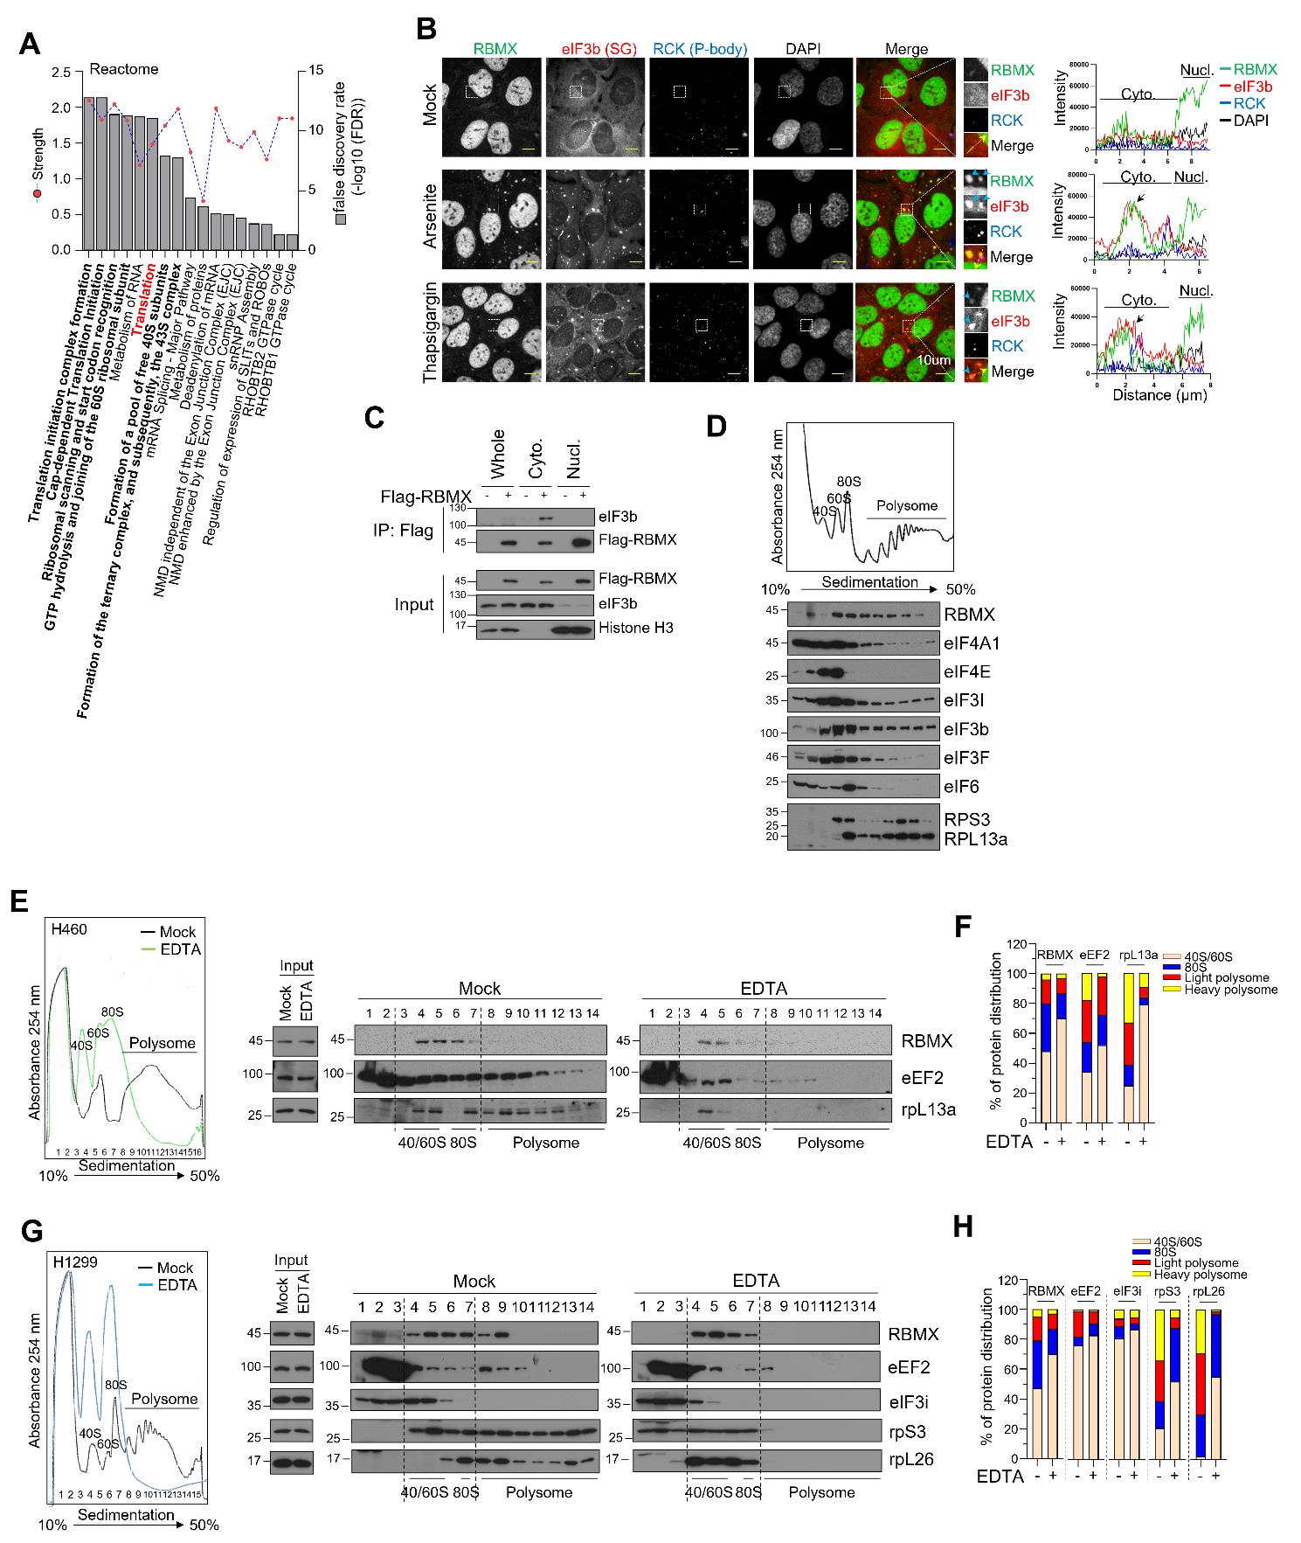
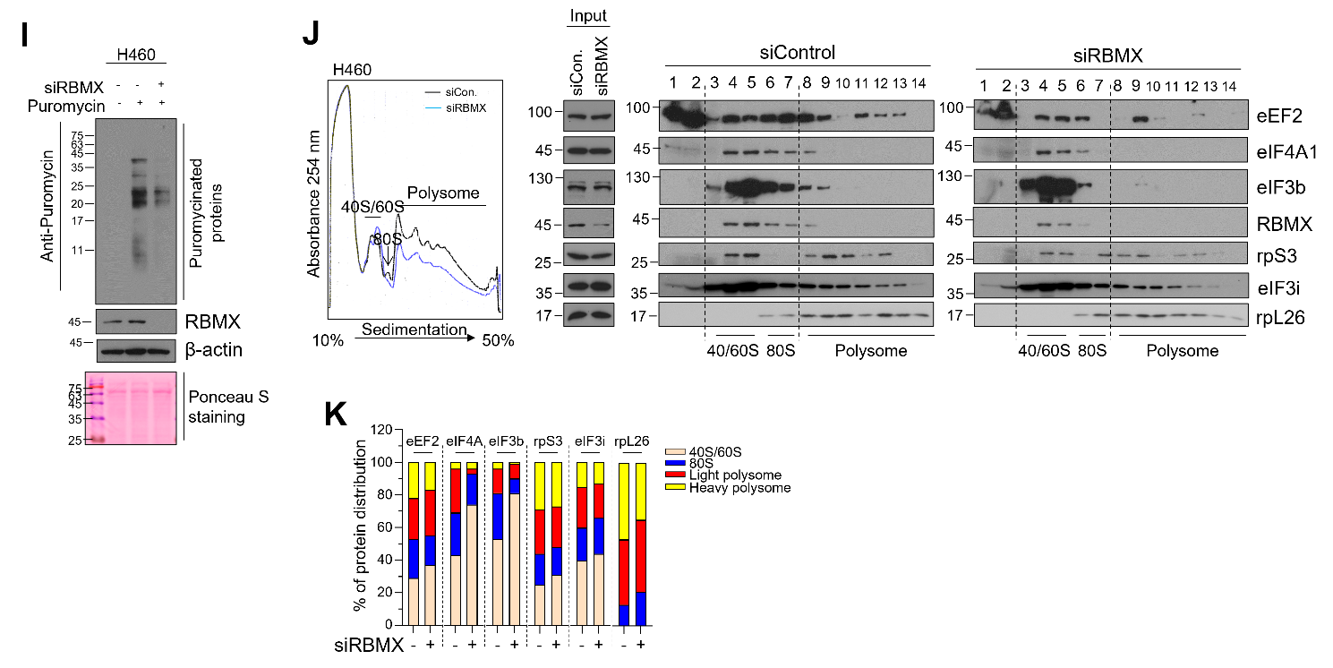
Supplementary Fig.2 RBMX is associated with translation in the cytoplasm. A Functional analysis of proteins interacting with Flag-tagged RBMX in the cytoplasm, based on STRING network analysis followed by Reactome pathway enrichment. B Confocal microscopy analysis of U2OS cells treated with mock, 0.5 mM sodium arsenite for 40 min, or 1µM thapsigargin for 1hr. eIF3b was used as a stress granule (SG) marker, RCK as a P-body marker, and DAPI for nuclear staining. Scale bar = 10 μm. Fluorescence intensity was quantified using Zeiss ZEN software (v3.10). C Co-IP analysis using an anti-Flag antibody in whole, cytoplasmic, and nuclear extracts from HEK293T cells expressing either Flag-vector or Flag-tagged RBMX. Immunoblotting was performed with the indicated antibodies. eIF3b was used as a cytoplasmic marker, and Histone H3 as a nuclear marker. D Polysome profiling analysis of U2OS cells. Each fraction was subjected to immunoblotting with the indicated antibodies. E, F Polysome profiling analysis of H460 cells treated with mock or EDTA (30 mM for 30 min). Each fraction was analyzed by immunoblotting with the indicated antibodies (E), and the corresponding immunoblot signals were quantified (F) using ImageJ software. G, H Polysome profiling analysis of H1299 cells treated with mock or EDTA (30 mM for 30 min). Each fraction was analyzed by immunoblotting with the indicated antibodies (G), and the corresponding immunoblot signals were quantified (H) using ImageJ software. I Translation efficiency in response to RBMX depletion was assessed by a ribo-puromycylation assay in H460 cells subjected to control or RBMX knockdown. Puromycylated nascent polypeptides were detected by Western blotting using an anti-puromycin antibody, and total protein loading was verified by Ponceau S staining. J, K Distribution of translation factors in polysome profiles following RBMX knockdown in H460 cells (J), and quantification of the corresponding immunoblot signals (K) using ImageJ software.
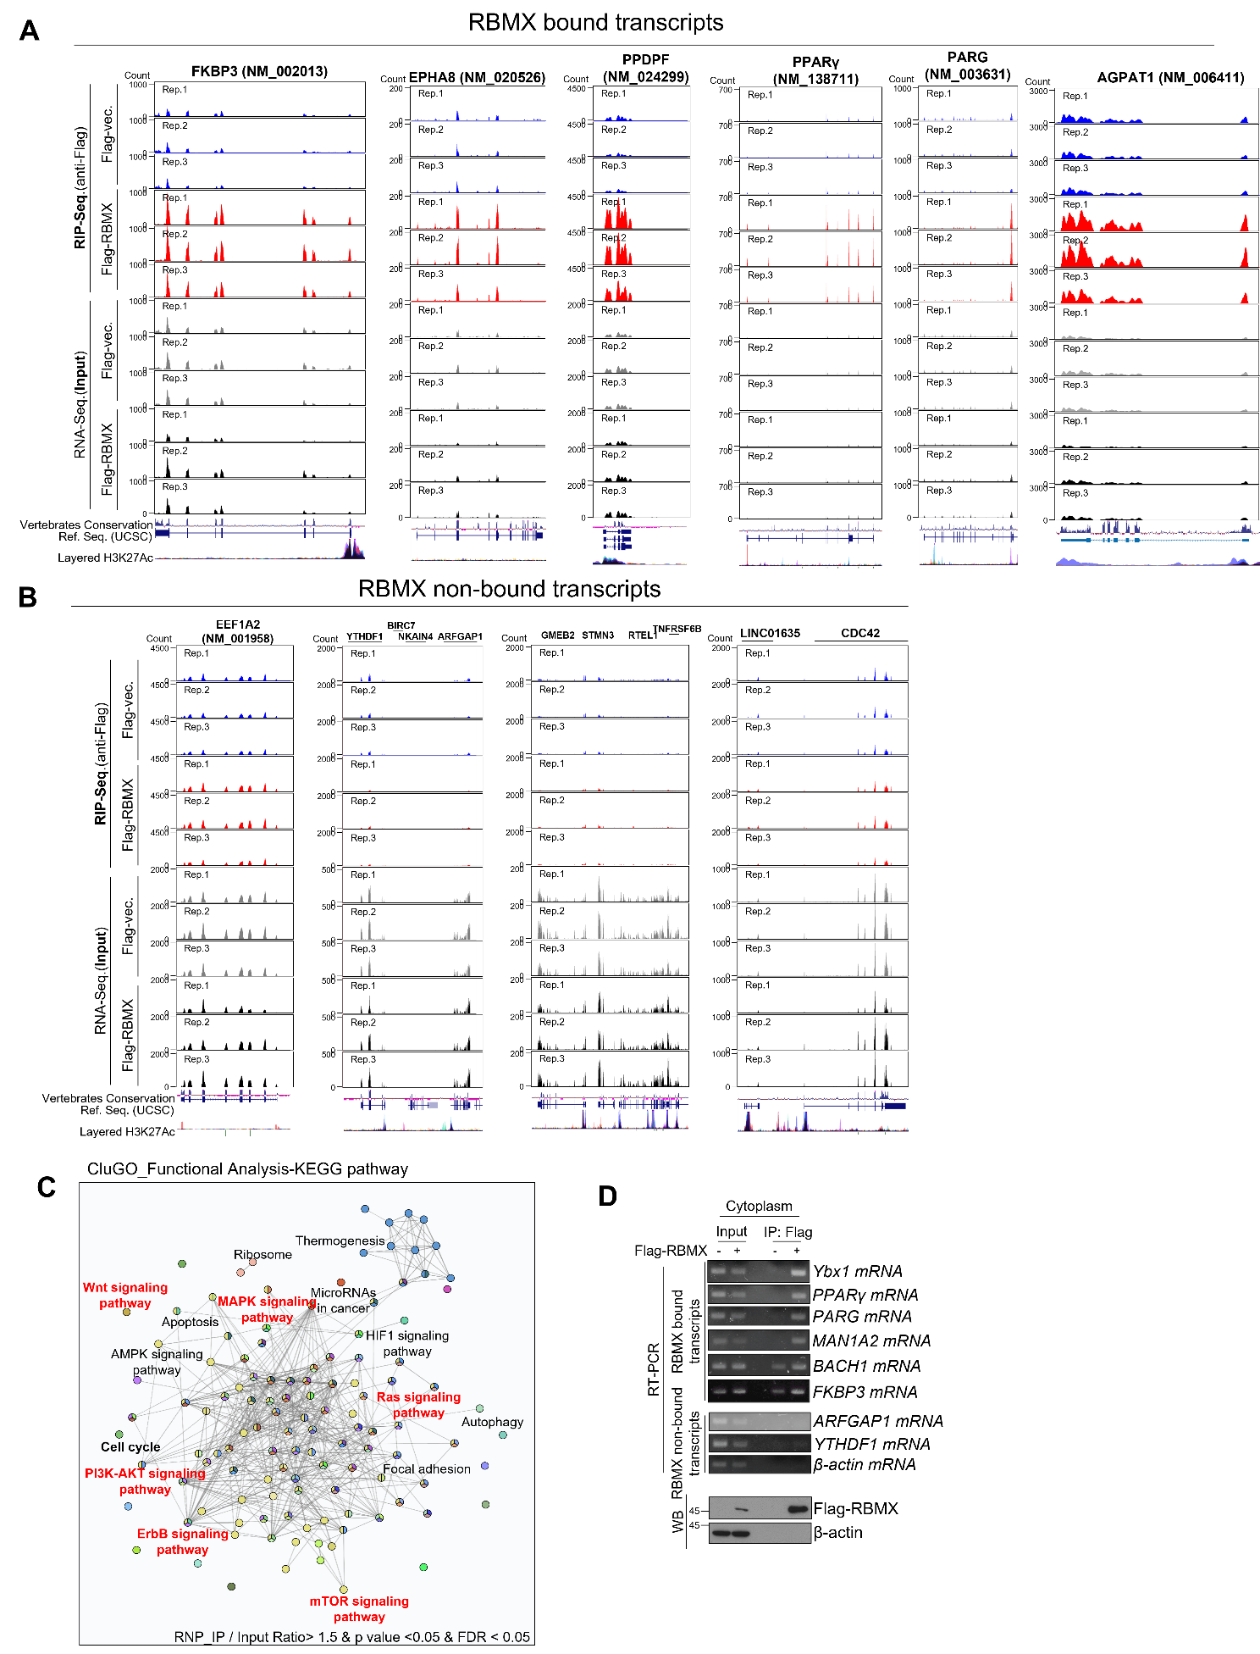
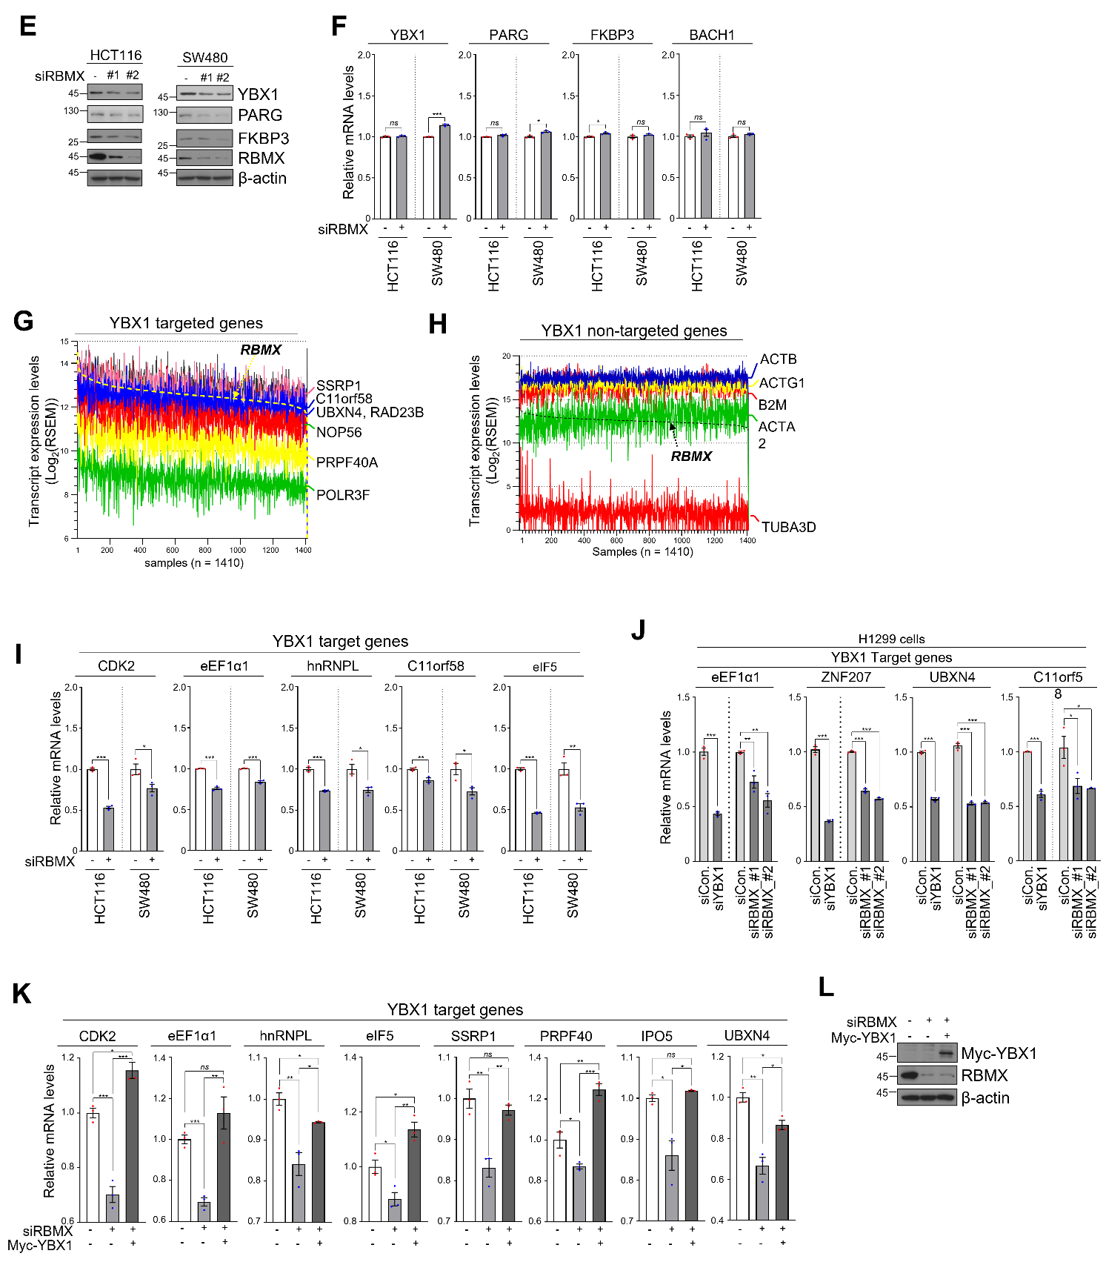
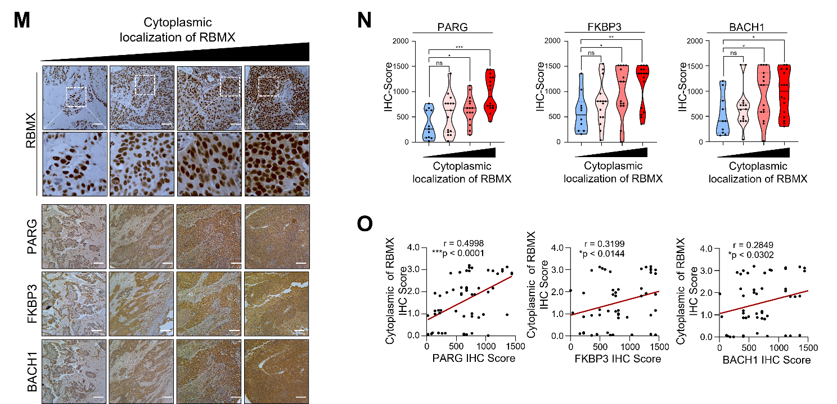
Supplementary Fig.3 RBMX binds to cancer-associated transcripts in the cytoplasm. A, B RIP-seq peak calling analysis using cytoplasmic extracts from HEK293T cells expressing either Flag-vector or Flag-tagged RBMX. Representative examples of RBMX-bound (A) and non-bound transcripts (B) were visualized using the UCSC Genome Browser. C Visualization of CluGO functional analysis (KEGG pathway) based on cytoplasmic Flag-RBMX RIP-seq data. The analysis was performed using a gene list filtered by RIP/Input ratio > 1.5, p < 0.05, and FDR < 0.05. D Validation analysis of RIP-seq data. Cytoplasmic extracts from HEK293T cells expressing Flag-tagged RBMX were immunoprecipitated using an anti-Flag antibody, and bound or unbound mRNAs were analyzed by RT-PCR. E Western blot analysis of HCT116 and SW480 cells treated with siControl or siRBMX (#1, #2). Immunoblotting was performed using the indicated antibodies, with β-actin as a loading control. F qRT-PCR analysis of YBX1, PARG, FKBP3, and BACH1 mRNAs in HCT116 and SW480 cells treated with siControl or siRBMX. G Analysis of RBMX and YBX1 target gene expression in the TCGA_Lung (LUSC, LUAD) cohort. Samples were visualized in order from left to right according to high to low RBMX expression levels. H Analysis of RBMX and YBX1 non-target gene expression in the TCGA_Lung (LUSC, LUAD) cohort. Samples were visualized in order from left to right according to high to low RBMX expression levels. I qRT-PCR analysis of YBX1 target genes -CDK5, eEF1α1, hnRNPL, C11orf58, and eIF5- in HCT116 and SW480 cells treated with siControl or siRBMX. J qRT-PCR analysis of YBX1 target genes -eEF1α1, ZNF207, UBXN4, and C11orf58- in H1299 cells treated with siControl, siYBX1, or siRBMX (#1, #2). K, L qRT-PCR analysis (K) of YBX1 target genes (CDK2, eEF1A1, hnRNPL, eIF5, SSRP1, PRPF40, IPO5, and UBXN4) in HCT116 cells treated with siControl or siRBMX, followed by overexpression of Myc-tagged YBX1. Protein levels were confirmed by immunoblotting using the indicated antibodies (L). M-O Immunohistochemical (IHC) analysis of RBMX, PARG, FKBP3, and BACH1 protein expression in lung cancer patient tissues. Representative images are arranged according to low-to-high cytoplasmic RBMX expression (M). Quantification of staining intensity was performed using ImageJ (Fiji) software, followed by relative expression (N) and correlation analyses (O). ns, not significant, *P < 0.05, **P < 0.01, ***P < 0.001

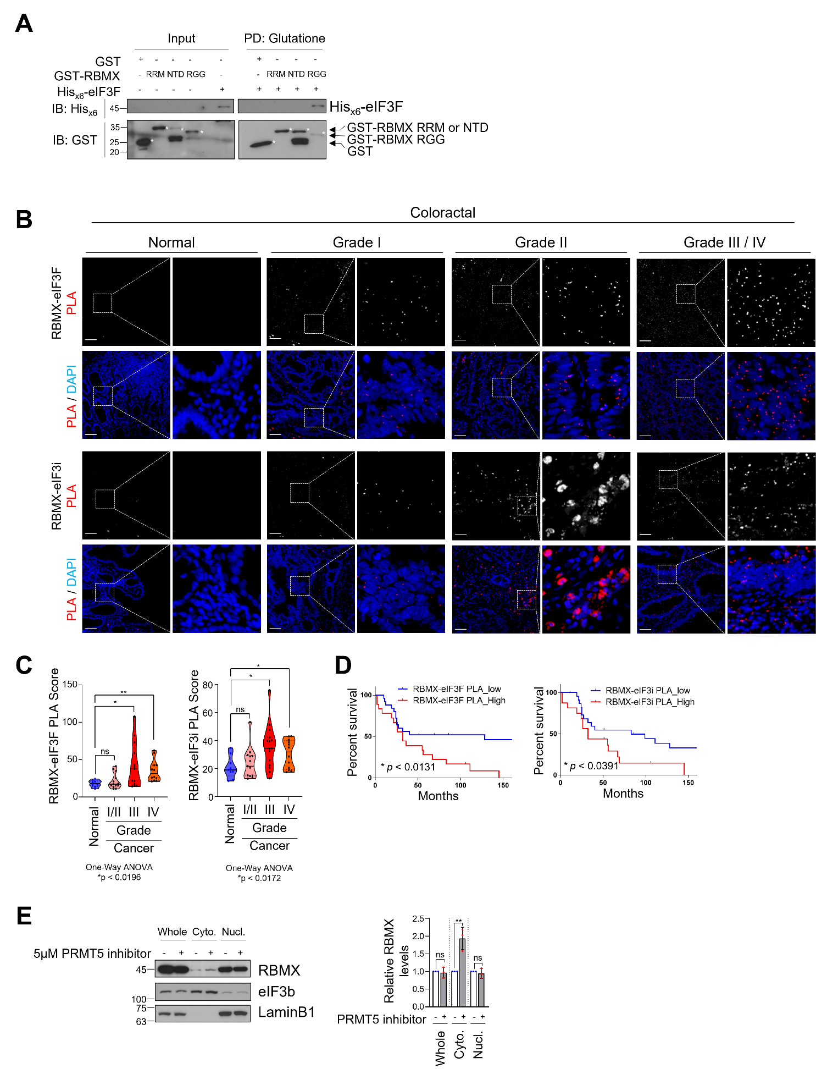

Supplementary Fig.4 The interaction between RBMX and eIF3i/eIF3F correlates with poor prognosis in colorectal cancer patients. A In vitro GST pull-down assay was performed to examine the interaction between GST-tagged RBMX domain (RRM, NTD, and RGG) proteins and recombinant Hisx6-tagged eIF3F. GST alone was used as a negative control. B A proximity ligation assay (PLA) was performed to identify interactions between RBMX and eIF3F or eIF3i (red) in grade I/II (n = 13 ), grade III (n = 14 ), grade IV (n = 12 ), and metastatic (n = 10) CRC tissues and their corresponding normal tissues (n = 9). DAPI (blue) was used as the counterstain to visualize nuclei. Scale bar = 100 μm. C Quantification of PLA data shown in (B). Data are presented as mean ± SEM. p-values are from a two-tailed Student’s t-test. ns, not significant; *p < 0.05. D Kaplan-Meier graph representing overall survival rates for patients with RBMX and eIF3F/3i interaction in CRC. Statistical significance between groups was determined using the log-rank test. *p < 0.05. E Immunoblot analysis of whole-cell, cytoplasmic, and nuclear extracts from HEK293T cells treated with 5 μM PRMT5 inhibitor for 12 hours. eIF3b was used as a cytoplasmic marker, and Lamin B1 served as a nuclear marker.

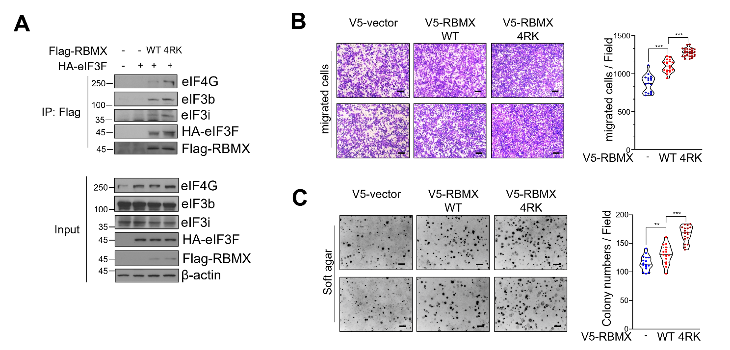
Supplementary Fig.5 De-methlylation of RBMX promotes translation. A Co-IP was performed using an anti-Flag antibody on lysates from HEK293T cells co-expressing either Flag-vector or Flag-tagged RBMX (WT or 4RK mutant) together with HA-tagged eIF3F. Immunoblotting was carried out with the indicated antibodies. B, C Analysis of migratory capacity (B) and anchorage-independent growth (C) in H1299 cells overexpressing V5-empty vector, V5-tagged RBMX (WT), or the 4RK mutant. Representative images are shown, and quantitative assessments were performed to evaluate relative activity.

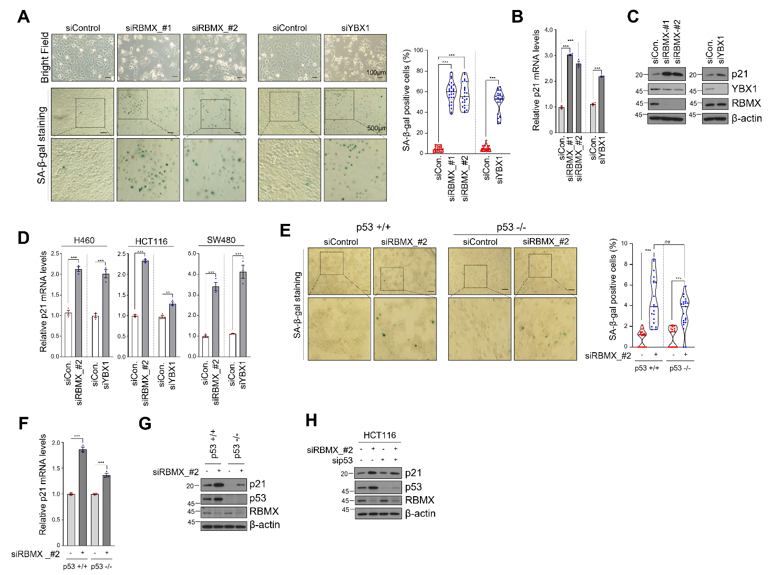
Supplementary Fig.6 RBMX deficiency increases p21 in a p53-independent manner. A SA-β-gal staining analysis of H1299 cells with RBMX or YBX1 depletion. Representative images are shown, and the percentage of SA-β-gal–positive cells was quantified and visualized. Data are presented as mean ± SEM. p-values are from a two-tailed Student’s t-test. ns, not significant; ***p < 0.001. B, C qRT-PCR analysis of p21 mRNA (B) and immunoblotting (C) with the indicated antibodies were performed using lysates from H1299 cells treated with siControl, siRBMX (#1, #2), or siYBX1 for 72 hours. D qRT-PCR analysis of p21 mRNA was performed using lysates from H460, HCT116, and SW480 cells treated with siControl, siRBMX, or siYBX1 for 72 hours. E SA-β-gal staining analysis was performed in HCT116 (p53 +/+) and HCT116 (p53 −/−) cells after 72 hours of treatment with siControl or siRBMX. Data are presented as mean ± SEM. p-values are from a two-tailed Student’s t-test. ns, not significant; ***p < 0.001. F, G qRT-PCR analysis of p21 mRNA (F) and immunoblotting (G) with the indicated antibodies were performed using lysates from HCT116 (p53 +/+) and HCT116 (p53 −/−) cells treated with siControl or siRBMX for 72 hours. H Immunoblot analysis of HCT116 cells treated with siRBMX, si-p53, or their combination for 72 hours. Immunoblotting was performed with the indicated antibodies.
SUPPLEMENTARY METHODS
Cell growth assay
The cell growth assay was performed using the MTT assay. An equal number of H1299 cells were seeded in triplicate in each well of 48-well plates at a density of 1x10⁴ cells/0.2 ml/well. Twenty microliters of MTT solution (5.0 mg/ml) in RPMI-1640 medium was added to each well, and the plates were incubated for the indicated times at 37°C. The purple formazan crystals that formed were dissolved in 200 μl of MTT solvent (0.1% NP-40 and 4 mM HCl in isopropanol) by gentle mixing at room temperature. The optical densities of the wells were measured at 570 nm using a microplate spectrophotometer (Epoch, BioTek, Winooski, VT, USA).

Cell migration assay
Cell migration was evaluated using 24-well Transwell chambers with 8 µm pore polyethylene terephthalate membranes (BD Biosciences). Cells were grown to ~80% confluence, serum-starved for 24 h, detached with trypsin, washed with PBS, and resuspended in serum-free medium. A total of 2 × 10⁴ cells were added to the upper chamber, and complete medium was added to the lower chamber. After incubation, non-migrated cells on the upper surface were removed with cotton swabs. Migrated cells on the lower surface were fixed with 4% formaldehyde and stained with 0.2% crystal violet. Images from three random fields per membrane (10× magnification) were acquired, and the number of migratory cells was counted. Mean values from triplicate wells were used for each condition.

Soft agar colony formation assay
Anchorage-independent growth was assessed in 6-well plates. The base layer consisted of 4 ml 1× medium with 0.6% low–melting point agarose (Duchefa Biochemie, The Netherlands) and was allowed to solidify at 4 °C. A second layer containing 1×10⁴ cells in 4 ml 1× medium with 0.3% low–melting point agarose was overlaid and solidified at 4 °C. Finally, 1 ml of 1× medium (without agarose) was added on top. Cells were incubated at 37 °C with 5% CO₂ for ~14–21 days. Colonies were stained with 0.005% crystal violet (Sigma-Aldrich), imaged using an Olympus microscope (Olympus, Tokyo, Japan), and quantified using Image-Pro Plus 4.5 (Media Cybernetics, Rockville, MD, USA). Experiments were performed in triplicate and repeated at least three times.

