Additional file 1:

Normalized SBL and ratios of normalized SBLs
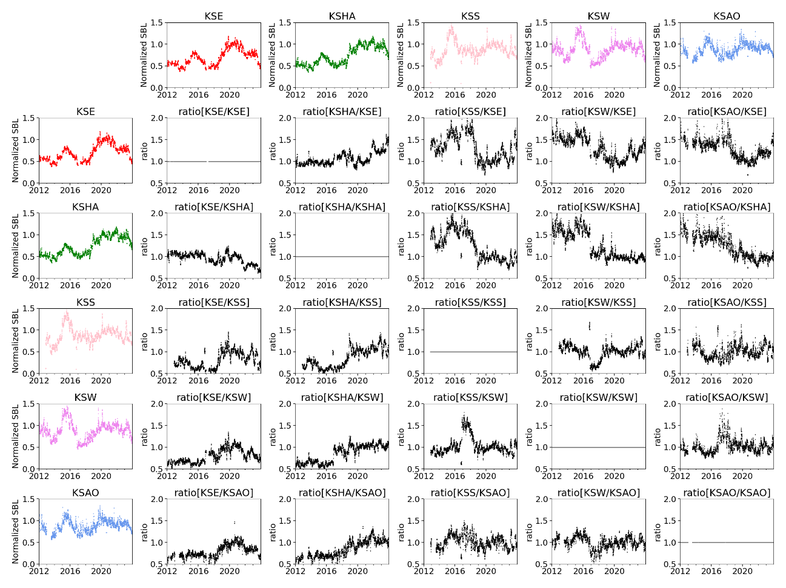

Figure S1: Normalized SBL and ratios of normalized SBLs for various station combinations. Colored plots show the normalized SBLs, and black plots show their ratios, with the row direction corresponding to the denominator station. Data are shown for the period from 2013 to 2023.
The normalized SBLs indicate that the amplitudes at KSHA and KSE were larger during the 2018 unrest than during the 2014 unrest, whereas the opposite relationship is observed at KSW, KSS, and KSAO.
The normalized SBL ratios further show that, for station pairs involving KSHA or KSE, the SBL ratios differed between the 2014 and 2018 unrests. In contrast, for pairs composed of any two of KSS, KSW, and KSAO, the SBL ratios remained approximately unity throughout both unrest periods.

Frequency band using calculation of seismic power and seismometer replacement
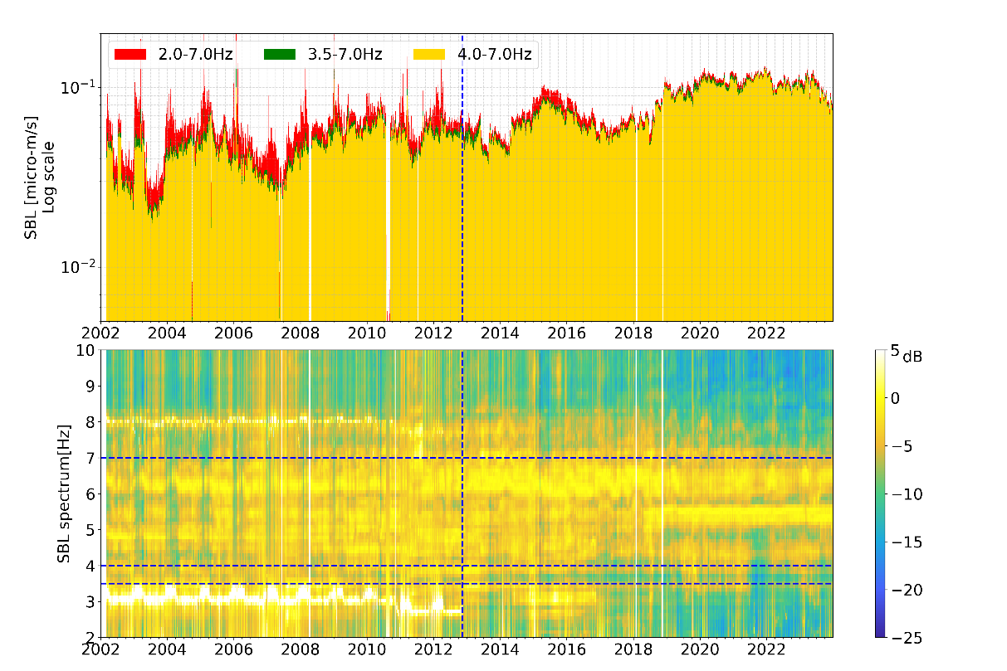
Figure S2: Frequency band using calculation of seismic power and seismometer replacement.
The upper panel shows the SBLs at KSHA, where the colors represent the different frequency bands used to calculate the seismic power. Red: 2.0-7.0Hz, green: 3.5-7.0Hz, yellow: 4.0-7.0Hz. The lower panel shows SBL spectra at KSHA. Vertical dashed line shows day of seismometer replacement, 13 November 2012.
Before replacing the seismometer, there was continuous strong power around 3Hz.
Because it is limited to a very narrow band, it is thought to be noise caused by the installation environment rather than an abnormality in the sensor. Although not shown here, a calibration signal was injected daily before the replacement of the seismometer. Analysis of these calibration signals confirmed that neither the amplitude nor the natural period exhibited any change.
When calculating seismic power, the difference in SBL values is large when comparing results obtained with a lower cutoff frequency of 2 Hz and those obtained with 3.5 Hz. In contrast, the difference is small when comparing results obtained with lower cutoff frequencies of 3.5 Hz and 4.0 Hz. This indicates that the influence of noise leaking into frequency bands above 3.5 Hz is limited.
After the replacement of the seismometer, the characteristic signal around 3 Hz observed during the 2014 unrest falls outside the frequency band used for integration. As a result, the increase in SBL during the 2014 unrest is underestimated. However, even when a lower cutoff frequency of 3.5 Hz is adopted, the temporal trend of the SBL and the relative magnitude between the 2014 and 2018 unrests remain unchanged. Therefore, this limitation does not affect the interpretation of the temporal evolution of the SBL.

