SUPPLEMENTAL MATERIAL

SUPPLEMENTAL METHODS

Serum sample collection and preparation

Serum samples were collected during field visits following previously published procedures.¹ After collection, samples were left to clot for 30 minutes, then centrifuged for 20 minutes to remove clots. Serum was aliquoted into 1.5 mL microcentrifuge tubes (1 mL per tube), placed on dry ice, and stored at -80°C at UCLA on the same day. Frozen serum samples were later shipped on dry ice to Emory University for metabolomics analyses, where they were stored at -80°C until processing.

Serum samples were randomly sorted into batches of 40 and processed using a standardized high-resolution metabolomics (HRM) workflow.² Each sample was mixed with ice-cold acetonitrile (2:1 ratio) to precipitate proteins, incubated on ice for 30 minutes, and centrifuged. The supernatant was then transferred to autosampler vials and analyzed in triplicate using a dual-column, dual-polarity approach: hydrophilic interaction chromatography (HILIC) with positive electrospray ionization (ESI) and C18 chromatography with negative ESI.

SUPPLEMENTAL FIGURES AND TABLES

Supplementary Figure 1. Replication of metabolite-air pollution associations in PEG1 and PEG2. Scatter plots of log₂ fold change (log₂FC) in PEG1 (x-axis) and PEG2 (y-axis) for metabolite features associated with air pollution exposure among Parkinson’s disease (PD) patients. Each point represents one metabolite feature. Colors indicate statistical significance: FDR<0.05, same direction of effect estimates in PEG1 and PEG2 (dark red); p<0.05, same direction (blue); p<0.05, opposite direction (yellow); not significant (grey).

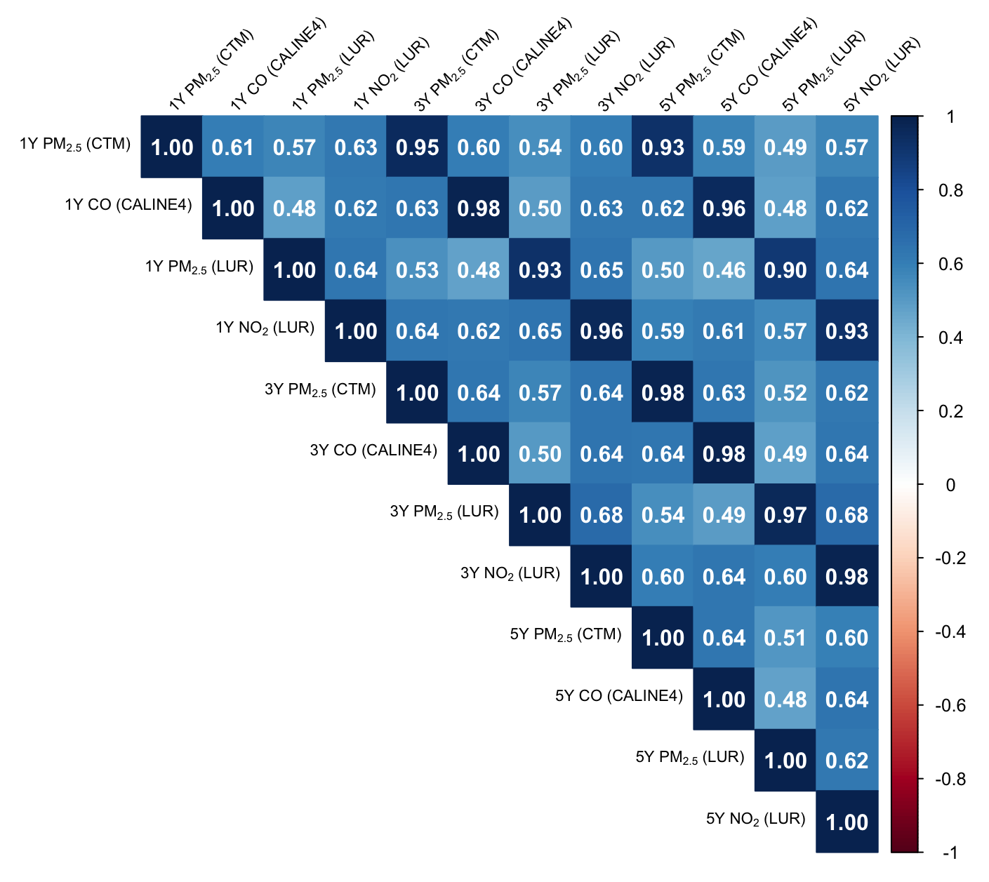
Supplementary Figure 2. Spearman correlations between 1- to 5-year average air pollution concentrations prior to serum collection.

Supplementary Figure 3. Comparison of air pollution-associated metabolomic changes in PD patients and controls. Scatter plots compare the log₂ fold change (log₂FC) in metabolites associated with air pollution exposures between PD (x-axis) and controls (y-axis), stratified by pollutant and exposure model: PM_{2.5} (CTM), CO (CALINE4), PM_{2.5} (LUR), and NO₂ (LUR). Each point represents a metabolite feature. Points are colored based on nominal statistical significance (p<0.05) and replication. Pearson correlation coefficients are shown for shared hits in both PD patients and controls.

Supplementary Figure 4. Metabolomic signatures of air pollution exposure in controls. Volcano plots from untargeted metabolome-wide analysis of serum metabolites and air pollution exposure in patients. Each panel shows results for a different exposure model: PM_{2.5} (CTM) and CO (CALINE4) as main exposures, PM_{2.5} and NO₂ (LUR) as alternatives. Metabolites are colored by statistical significance: FDR<0.05 (red, stringent), p<0.05 with consistent direction in PEG1 and PEG2 (blue), or additionally |log₂FC|>0.2 (orange). Shapes indicate exposure window (circle: 1-year, triangle: 3-year, square: 5-year).

Supplementary Figure 5. Metabolic pathway enrichment analysis of air pollution exposure in PD patients and controls. Heatmap of metabolic pathways enriched among MWAS features associated with air pollution exposures (p<0.05 with replication) in PD patients and controls. Pathways were included if they contained ≥5 metabolites and showed pathway overrepresentation at p<0.05. Color intensity reflects statistical significance, with darker red indicating lower p-values. Gray tiles represent statistically nonsignificant results (p≥0.05). Pathways are grouped by functional class (e.g., inflammation, lipids, amino acids, etc.)

Supplementary Table 1. Distribution of 1–, 3-, and 5-year average air pollution concentrations prior to serum collection.
Pollutant | Unit | Model | Mean | SD | Min | Q1 | Median | Q3 | Max | IQR
1-year average exposure
PM_{2.5} | μg/m³ | CTM | 12.7 | 3.6 | 1.0 | 10.3 | 12.4 | 15.5 | 21.2 | 5.2
CO | ppb | CALINE4 | 3.7 | 8.9 | 1.00e-02 | 0.4 | 1.2 | 3.0 | 94.0 | 2.6
PM_{2.5} | μg/m³ | LUR | 13.6 | 2.1 | 5.0 | 12.5 | 13.9 | 14.9 | 18.9 | 2.4
NO₂ | μg/m³ | LUR | 9.8 | 2.2 | 2.3 | 8.3 | 9.7 | 11.5 | 17.6 | 3.2
3-year average exposure
PM_{2.5} | μg/m³ | CTM | 13.0 | 3.7 | 1.1 | 10.4 | 12.6 | 16.0 | 21.4 | 5.5
CO | ppb | CALINE4 | 4.2 | 10.4 | 1.00e-02 | 0.5 | 1.3 | 3.7 | 114.6 | 3.3
PM_{2.5} | μg/m³ | LUR | 13.9 | 2.1 | 5.4 | 12.8 | 14.2 | 15.2 | 18.2 | 2.4
NO2 | μg/m³ | LUR | 10.1 | 2.3 | 2.5 | 8.5 | 10.0 | 11.8 | 20.1 | 3.3
5-year average exposure
PM_{2.5} | μg/m³ | CTM | 13.2 | 3.6 | 1.1 | 10.6 | 13.2 | 16.3 | 22.1 | 5.7
CO | ppb | CALINE4 | 4.6 | 11.3 | 1.00e-02 | 0.6 | 1.5 | 4.1 | 120.7 | 3.5
PM_{2.5} | μg/m³ | LUR | 14.0 | 2.0 | 5.4 | 13.0 | 14.5 | 15.4 | 18.2 | 2.3
NO₂ | μg/m³ | LUR | 10.5 | 2.3 | 2.7 | 8.9 | 10.4 | 12.1 | 21.2 | 3.2

Supplementary Table 2. Count of metabolite features associated with air pollution exposure in PD patients.
Pollutant | Year | HILIC Positive (n = 2716) |  |  |  | C18 Negative (n = 2046)
Pollutant | Year | FDR<0.05 | p<0.05 | Replicationª | FDR<0.05 |  | p<0.05 | Replicationª
PM_{2.5} | 1-year | 0 | 169 | 154 | 8 |  | 268 | 255
(CTM) | 3-year | 0 | 170 | 162 | 5 |  | 254 | 245
 | 5-year | 0 | 145 | 138 | 14 |  | 230 | 221
CO | 1-year | 31 | 252 | 190 | 0 |  | 57 | 45
(CALINE4) | 3-year | 30 | 266 | 181 | 0 |  | 54 | 42
 | 5-year | 29 | 261 | 167 | 0 |  | 59 | 46
PM_{2.5} | 1-year | 0 | 104 | 100 | 0 |  | 152 | 151
(LUR) | 3-year | 0 | 106 | 102 | 0 |  | 122 | 119
 | 5-year | 1 | 113 | 106 | 0 |  | 119 | 114
NO₂ | 1-year | 0 | 196 | 178 | 0 |  | 145 | 135
(LUR) | 3-year | 0 | 156 | 144 | 0 |  | 140 | 137
 | 5-year | 0 | 142 | 136 | 0 |  | 117 | 115
ªNumber of metabolite features showing nominal statistical significance (p<0.05) in both PEG1 and PEG2 with consistent direction of effect estimates.

Supplementary Table 3. Count of metabolite features associated with air pollution exposure in controls.
Pollutant | Year | HILIC Positive (n = 2716) |  |  |  | C18 Negative (n = 2046)
Pollutant | Year | FDR<0.05 | p<0.05 | Replicationª | FDR<0.05 |  | p<0.05 | Replicationª
PM_{2.5} | 1-year | 0 | 184 | 137 | 0 |  | 183 | 132
(CTM) | 3-year | 0 | 157 | 111 | 0 |  | 180 | 124
 | 5-year | 0 | 134 | 91 | 0 |  | 166 | 117
CO | 1-year | 0 | 122 | 82 | 1 |  | 77 | 52
(CALINE4) | 3-year | 0 | 116 | 77 | 1 |  | 68 | 47
 | 5-year | 0 | 103 | 65 | 1 |  | 92 | 66
PM_{2.5} | 1-year | 0 | 141 | 130 | 0 |  | 164 | 150
(LUR) | 3-year | 0 | 140 | 128 | 0 |  | 171 | 156
 | 5-year | 0 | 164 | 144 | 1 |  | 196 | 168
NO₂ | 1-year | 0 | 127 | 98 | 0 |  | 60 | 50
(LUR) | 3-year | 0 | 141 | 126 | 0 |  | 88 | 78
 | 5-year | 0 | 148 | 133 | 0 |  | 86 | 78
ªNumber of metabolite features showing nominal statistical significance (p<0.05) in both PEG1 and PEG2 with consistent direction of effect estimates.

Supplementary Table 4. Number of metabolite features passing p<0.05 with replication threshold in PD patients and controls.
Pollutant | Year | HILIC Positive (n = 2716) |  |  | C18 Negative (n = 2046)
Pollutant | Year | Bothª | PD^{b} | Control^{c} |  | Bothª | PD^{b} | Control^{c}
PM_{2.5} | 1-year | 8 | 161 | 176 |  | 11 | 257 | 172
(CTM) | 3-year | 8 | 162 | 149 |  | 8 | 246 | 172
 | 5-year | 8 | 137 | 126 |  | 9 | 221 | 157
CO | 1-year | 16 | 236 | 106 |  | 0 | 57 | 77
(CALINE4) | 3-year | 15 | 251 | 101 |  | 1 | 53 | 67
 | 5-year | 11 | 250 | 92 |  | 0 | 59 | 92
PM_{2.5} | 1-year | 8 | 96 | 133 |  | 9 | 143 | 155
(LUR) | 3-year | 11 | 95 | 129 |  | 5 | 117 | 166
 | 5-year | 13 | 100 | 151 |  | 6 | 113 | 190
NO₂ | 1-year | 11 | 185 | 116 |  | 2 | 143 | 58
(LUR) | 3-year | 7 | 149 | 134 |  | 0 | 140 | 88
 | 5-year | 5 | 137 | 143 |  | 1 | 116 | 85
ªFeatures passing p<0.05 with replication in PD patients and controls.
^{b}Features passing p<0.05 with replication in PD patients only.
^{c}Features passing p<0.05 with replication in controls only.

REFERENCES

1 Yan, Q. et al. High-Resolution Metabolomic Assessment of Pesticide Exposure in Central Valley, California. Chem Res Toxicol 34, 1337-1347 (2021). https://doi.org/10.1021/acs.chemrestox.0c00523
2 Paul, K. C. et al. Untargeted serum metabolomics reveals novel metabolite associations and disruptions in amino acid and lipid metabolism in Parkinson's disease. Mol Neurodegener 18, 100 (2023). https://doi.org/10.1186/s13024-023-00694-5

