Supplementary Discussion

Temporal trends in sedimentary P contents
Our new ironstone record shows significant variability in phosphorus availability through time, with temporal complexity linked to major stages in Earth’s surface evolution. Based on the ironstone and iron formation records we can delineate five distinct stages (I–V; Fig. 2) in the evolution of the P cycle: the Archaean (Stage I), the Palaeoproterozoic (Stage II), the Mesoproterozoic to early Neoproterozoic (Stage III), the subsequent Neoproterozoic (late Tonian–Ediacaran periods; Stage IV), and the Phanerozoic (Stage V). Given the skewed datasets, we report these data using the median as a measure of the central tendencies of the distributions of each time bin, and the third quartile (3Q) as an indication of the extent of P enrichment excluding outliers (see Methods). Statistical comparisons of the P/Fe* values and bulk-rock P contents between different time periods for the same lithology are outlined in Table S1.

During the Archaean (Stage I), P/Fe* values are consistently low (i.e., P/Fe* < 1) for continental margin iron formations (median 0.27, 3Q 0.42; n = 301, 19 deposits) and exhalative iron formations (median 0.30, 3Q 0.51; n = 1006, 64 deposits). Only one granular iron formation is reported from the Archaean (Smith et al., 2017), which has similarly low P/Fe* values (median 0.13, 3Q 0.16; n = 7). Ironstones, P-rich shales and phosphorites are conspicuously absent from the Archaean stratigraphic record (Fig. 2), despite the preservation of sedimentary rocks from similar environments. This pattern suggests limited P burial in both coastal and offshore depositional environments.

Low P/Fe* values continue in Palaeoproterozoic exhalative (median 0.38, 3Q 0.69; n = 72, 10 deposits) and continental margin iron formations (median 0.24, 3Q 0.46; n = 661, 36 deposits). However, ironstones first appear in the Palaeoproterozoic (Lechte et al., 2024) (2.5–1.6 Ga; Stage II) and have highly variable P contents (Fig. 2). The oldest known ironstones are from South Africa and feature a generally increasing trend between the oldest deposits (the ca. 2.31 Ga Timeball Hill Formation; median 0.74, 3Q 1.05; n = 35) to subsequent ironstones in the same succession deposited ca. 2.25–2.15 Ga (Fig. 2a). The latest Palaeoproterozoic culminates in the deposition of ironstones in North China, including the P-rich Yunmengshan Formation (ca. 1.70 Ga; median 2.78; 3Q 4.01; n = 24) and the low-P Chuanlinggou Formation (ca. 1.65 Ga; median 0.40, 3Q 0.52; n = 56). Palaeoproterozoic granular iron formations have P/Fe* ratios (median 0.16, 3Q 0.35; n = 510, 14 deposits) that are lower than Palaeoproterozoic ironstones (median 0.74, 3Q 1.62; n = 138, 8 deposits) but similar to contemporaneous exhalative and continental margin iron formations. The Palaeoproterozoic Era also experienced the deposition of the oldest phosphorites at ca. 2.2 Ga; global phosphorite deposition at ca. 2.0 Ga; and the first appearance of thick (>5 m) phosphorites ca. 1.85–1.7 Ga (Papineau, 2010; Planavsky et al., 2023). These phosphorites, often associated with stromatolites, were largely deposited in coastal environments, contrasting with the widespread continental shelf distribution of Phanerozoic phosphorites (Papineau, 2010). These sedimentary archives record the onset of spatial and temporal heterogeneity of P burial during the Palaeoproterozoic (Stage II).

The Mesoproterozoic to early Neoproterozoic (ca. 1.6–0.85 Ga; Stage III) is marked by low sedimentary P enrichments. Ironstones were deposited in northern Australia ca. 1.43–1.30 Ga; these exhibit exceptionally low P/Fe* values (median 0.11, 3Q 0.22; n = 254; 3 deposits), with similar values found at the end of Stage III in the ca. 0.9 Ga ironstones of the Katherine Group in Yukon, Canada (median 0.15, 3Q 0.25; n = 18). Phosphorites are rare to absent during this interval (Fig. 2), consistent with the low P contents found in shales and iron formations from the same period. While the deposition of continental margin iron formations ceased in the Palaeoproterozoic, rare exhalative iron formations can be found from Stage III, which are also characterised by low P/Fe* values (median 0.13, 3Q 0.17; n = 56, 4 deposits).

Subsequently, the Neoproterozoic experienced global deposition of iron formations associated with extreme glaciation during the Cryogenian Period (Lechte et al., 2019), with some of the highest P enrichments known from iron formations (Fig. 2b). These P-rich glacial iron formations have been linked to a major shift in the P cycle (Planavsky et al., 2010), however, our new record suggests that this change began earlier. Exhalative iron formations from the late Tonian (ca. 0.85–0.72 Ga) have higher P/Fe* values (median 1.17, 3Q 1.12; n = 206; 9 deposits) than those in the early Tonian (ca. 1.0–0.85 Ga; median 0.12, 3Q 0.16; n = 25; 2 deposits) and the Mesoproterozoic. Ironstones from the ca. 0.75 Ga Chuar Group in Arizona, USA have elevated P/Fe* values (median 1.57, 3Q 1.93; n = 14) compared to ironstones from Stage III, and metre-scale phosphorite deposition returns in the late Tonian Period (Fig. 2d). Despite the extreme P/Fe* values of some Cryogenian glacial iron formations (<28), the majority of these have P/Fe* values (median 0.84, 3Q 1.57; n = 686; 17 deposits) comparable to those of exhalative iron formations from the late Tonian, or the subsequent Ediacaran Period (median 1.21, 3Q 2.13; n = 52; 5 deposits), suggesting the continuation of a trend rather than a unique episode. Therefore, we suggest that this transitional phase (Stage IV) began in the middle Tonian and ended at the start of the Cambrian (ca. 0.85–0.54 Ga). Collectively, exhalative iron formations from Stage IV have a P/Fe* distribution (median 1.14, 3Q 2.09; n = 262, 15 deposits) that is statistically distinct from earlier stages (Fig. 3). Phosphorites deposited during Stage IV occur as laminated and nodular phosphate in offshore marine shales as well as and reworked granular phosphate (in contrast with Palaeoproterozoic inner shelf phosphorites). These units are considered to mark a transition to phosphogenesis in deeper, offshore environments influenced by upwelling (Nelson et al., 2010; Planavsky et al., 2023). Therefore, the available evidence points to an increase in P burial in both coastal and offshore settings in the late Neoproterozoic.

The Phanerozoic Eon (ca. 0.54–0 Ga; Stage V) experienced major P burial in a wide range of environments with significant secular variation. The P/Fe* distributions of Stage V ironstones (median 3.06, 3Q 4.18; n = 1082, 123 deposits) and exhalative iron formations (median 2.14, 3Q 3.77; n = 650, 32 deposits) are much higher and statistically distinct from those of the middle Proterozoic (Stage III; Fig. 3). Secular variation within the Phanerozoic can also be resolved. Ironstones from the early Phanerozoic (Cambrian–early Carboniferous; ca. 0.54–0.35 Ga) are widespread and characterised by high P/Fe* values (median 2.68, 3Q 4.22; n = 354; 53 deposits). Ironstones become near-absent in the middle Phanerozoic (middle Carboniferous–Triassic; 0.35–0.2 Ga), with those present appearing to show lower P/Fe* values (median 1.08, 3Q 3.29; n = 6; 2 deposits), though further data is needed. During the late Phanerozoic (Jurassic–modern; ca. 0.2–0 Ga), ironstones once again become more abundant, with the highest P/Fe* values (median 3.18, 3Q 4.17; n = 722; 68 deposits). The record of exhalative iron formations follows a qualitatively similar trend: these deposits are abundant and have high P/Fe* values during the early (median 1.10, 3Q 3.56; n = 324, 16 deposits) and late (median 2.32, 3Q 3.99; n = 248, 12 deposits) Phanerozoic, whereas rarer middle Phanerozoic exhalative iron formations are characterised by low P/Fe* values (median 0.46, 3Q 1.10; n = 41, 3 deposits). Further, while phosphorites and P-rich shales were deposited throughout much of the Phanerozoic, metre-scale phosphorite are more common in the early and late intervals (Fig. 2). P-rich shales are near-exclusively found in the Phanerozoic (Reinhard et al., 2017), though variability in shale geochemistry precludes the interpretation of higher-order trends.

Geological context of ironstone samples
The ca. 2310 Ma Timeball Hill Formation, Pretoria Group
The Timeball Hill Formation of the Pretoria Group (Transvaal Supergroup) was deposited in an intractraontic basin on the Kaapvaal Craton, South Africa (Dorland, 1999; Eriksson et al., 2006). The lower part of the Timeball Hill Formation comprises a basal pyritic shale, which coarsens upwards into quartzite and oolitic ironstone (variably known as the Gatsrand or Klapperkop member), which are overlain by carbonaceous shale and diamictite (Dorland, 1999). These ironstones are hosted by quartzites, siltstones, and mudstones, and are interpreted as tidally reworked delta-front deposits (Visser, 1972; Eriksson, 1973; Eriksson et al., 1991). The ironstones predominantly comprise tightly-packed oolites composed of concentric laminations of finely crystalline hematite with intergrown iron-rich chlorite, which were flattened during compaction (Dorland, 1999). This unit is considered to have experienced lower greenschist facies metamorphism (Dorland, 1999). The age of the Timeball Hill Formation is constrained by a Re–Os age of 2322 ± 16 Ma from mudstones in the lower part of the unit (Hannah et al., 2004), as well as a SHRIMP U–Pb detrital zircon age of 2324 ± 17 Ma from near the base (Dorland et al., 2004). A minimum age of the ironstone is provided by a whole-rock Pb–Pb age of 2222 ± 12 Ma from the overlying Hekpoort–Ongeluk volcanics (Cornell et al., 1996). The Timeball Hill Formation represents the oldest-known occurrence of an oolitic ironstone in the geological record (Lechte et al., 2024).

The ca. 1650 Ma Chuanlinggou Formation, Changcheng Group
The Statherian Chuanlinggou ironstone is part of the Changcheng Group deposited in the intracratonic Yanliao Basin (Yanshan–Liaoxi Basin) within the North China Craton (Zhang et al., 2012; Li et al., 2025). This group is dominated by siliciclastic sedimentary rocks with a metamorphic grade generally below prehnite–pumpellyite facies (Chu et al., 2007). The lower Chuanlinggou Formation (Member I) comprises ironstone, silty shale and interbedded sandstone indicative of a shallow subtidal to intertidal marine environment, which grade upwards into subtidal black shales interbedded with sandstone and dolostone (Lu et al., 1996; Song, 2007; Lin et al., 2019). The ironstone is dominated by hematite and is variably ooidal, stromatolitic, and granular in texture (Lin et al., 2019). The iron ooids range from 0.3 mm to 4 mm in diameter and are commonly spherical to ellipsoidal (Wang et al., 2022). A minimum depositional age for the Chuanlinggou Formation is provided by a LA–ICP–MS U–Pb detrital zircon age of 1657 ± 17 Ma from the basal part (Duan et al., 2018). This is supported by U–Pb dating of diabase (1638 ± 14 Ma; Gao et al., 2009) and diorite porphyrite (1634 ± 9 Ma; Zhang et al., 2013) that intrude the Chuanlinggou Formation. A LA–ICP–MS U–Pb zircon age of 1641 ± 4 Ma obtained from volcanic rocks of the overlying Tuanshanzi Formation provides a maximum age constraint (Zhang et al., 2013).

The ca. 1320 Ma Sherwin Formation, Roper Group
The Roper Group was deposited in the intracontinental McArthur Basin of the Northern Territory (Australia), and is subdivided into the lower Collara Subgroup and the upper Maiwok Subgroup (Abbott et al., 2001; Munson, 2016). Within the Maiwok Subgroup, the Sherwin Formation comprises a ~100 m thick interval of crudely bedded to trough cross-stratified sandstones, siltstones, and mudstones with ooidal ironstone lenses interpreted to have been deposited in an energetic, shallow marine setting (Jackson et al., 1986; Haines et al., 1993; Ahmad and Munson, 2013). The ironstone horizons typically feature massive beds of iron ooids predominantly composed of hematite and goethite and pisoids which are typically ~0.5–5 mm in diameter interbedded with coarse-grained ferruginous sandstones (Canavan, 1965; Abbott et al., 2001; Ryall et al., 2012; Munson, 2016). In places the Sherwin ironstone is more dominated by berthierine and greenalite (Johnson et al., 2020). The age of the Sherwin Formation is constrained by detrital zircon U–Pb age of 1313 ± 47 Ma in the overlying Kyalla Formation, with a maximum age of ca. 1345–1320 Ma based upon detrital zircon age populations in the underlying Moroak Sandstone (Yang et al., 2018). The upper Velkerri Formation, which underlies the Moroak Sandstone, has been dated to 1361 ± 21 Ma using whole-rock Re–Os geochronology (Kendall et al., 2009).

The ca. 850 Ma McClure Formation, Katherine Group
The Tonian Katherine Group (Long and Turner, 2012) is a ~1.5 km thick siliciclastic succession within the Mackenzie Mountains Supergroup in the Mackenzie Mountains (Northwest Territories) and the Wernecke Mountains (Yukon) of Canada. The Tonian strata in this region are generally interpreted to have been deposited in an intracratonic sag basin (Rainbird et al., 1996) during crustal attenuation and thermal subsidence in northwestern Laurentia, or due to extension along the western margin due to the break-up of Laurentia (Turner and Long, 2008). The Katherine Group is dominated by sandstone, with subordinate siltstone and mudstone and featuring minor carbonate horizons, interpreted to have been deposited in a shallow marine setting (Hume and Link, 1945; Long and Turner, 2012). The ironstone unit occurs as hematite–berthierine oncoids and pisoids within the upper Katherine Group in the Wernecke Mountains, hosted by the transition from the tidal flat mudstones of the McClure Formation to the cross-laminated sandstones of the Abraham Plains formations deposited in a tide-influenced estuarine setting (Lechte et al., 2024). A minimum age constraint is provided by the Little Dal Basalt, which occurs at the top of the overlying Little Dal Group in the Mackenzie Mountains and has been correlated geochemically with the ca. 775 Ma mafic intrusions (Milton et al., 2017). A significant negative carbon isotope anomaly recorded within the Rams Head Formation (Little Dal Group) is considered to be correlative with the Bitter Springs carbon isotope excursion considered to be globally contemporaneous at ca. 809–802 Ma (Halverson et al., 2022). In the absence of rigid geochronological constraints, and given no significant unconformities occur between the Katherine Group and the Ram Head Formation in the Mackenzie Mountains, we estimate the McClure ironstones to have been deposited sometime between ca. 850 and ca. 900 Ma.

The ca. 750 Ma Galeros Formation, Chuar Group
The Tonian Chuar Group is exposed in the eastern region of the Grand Canyon, Arizona (USA), and is dominantly composed of shale with subordinate sandstone and dolomite deposited in an intracratonic rift basin of southwest Laurentia (Dehler et al., 2001; Dehler et al., 2017). The ironstone occurs at the contact between the Duppa Member of the Galeros Formation and the Carbon Butte Member of the Kwagunt Formation (Walcott, 1895; Hinds, 1933; Wang et al., 2022). The Duppa Member is ~30–180 m in thickness (Ford and Breed, 1973) and dominated by mudstone with limestone interbeds and sandstone with symmetrical ripple marks and mudcracks indicative of intertidal to subtidal marine setting (Dehler et al., 2001; Dehler et al., 2012). The ironstone comprises a thin (<50 cm) oolite horizon, with poorly-cemented beds of iron ooids which are typically ~500 μm in diameter and feature fine, concentric laminae of hematite with variable silica content (Wang et al., 2022). A maximum depositional age for the ironstone is provided by a Re–Os date of 757.0 ± 6.8 Ma from organic-rich carbonates in the stratigraphically lower Carbon Canyon Member (Galeros Formation), and a minimum depositional age is provided by a Re–Os date of 751.0 ± 7.6 Ma from marcasite nodules in the stratigraphically higher Awatubi Member (Kwagunt Formation) (Rooney et al., 2018). These age constraints are consistent with those provided by U–Pb tuff dating (Rooney et al., 2018) and U–Pb detrital zircon dating (Dehler et al., 2017) from the Chuar Group.

The ca. 490 Ma Bliss Formation, New Mexico
The Late Cambrian–Early Ordovician Bliss Formation outcrops in southern New Mexico, southern Arizona, and western Texas (USA) was deposited on a substantial unconformity on middle Proterozoic basement due to the flooding of Laurentia during a major first-order transgression (Kelley, 1951; Mack and Giles, 2004; Krainer et al., 2022). Ironstones composed of moderately sorted hematitic oolites and ooidal sandstones with rounded quartz grains and hematite cement overlie the cross laminated sandstones in the Lower and Upper members of the Bliss Formation, and are interpreted as shallow shoal deposits during the onset of transgression (Krainer et al., 2022). The ironstone intervals are overlain by transgressive siltstones and glauconitic sandstones, and are interpreted to have been deposited in subtidal to tidal-flat environments (Thompson and Potter, 1981; Chafetz et al., 1986). Based upon conodont biostratigraphy, and correlation to regional units that form part of the Sauk Megasequence, the Bliss Formation is broadly constrained to have been deposited during the late Cambrian (Stage 10) and possibly earliest Ordovician (Tremadocian Stage; Taylor and Repetski, 1995; Taylor et al., 2004; Keller et al., 2012).

The ca. 465 Ma Cap de la Chèvre Formation
The lower Ordovician Cap de la Chèvre Formation of the Crozon Peninsula (Brittany, France) comprises ferruginous sandstones, ironstones, conglomerates, and siltstones (Cogné et al., 1991) deposited during transgression and flooding of the Armorican Massif as the Rheic Ocean encroached on the northern margin of Gondwana (Lefebvre et al., 2023). The ironstones are 0.2–2.5 m in thickness, predominantly composed of concentrically laminated, hematite-coated grains (Bonjour and Chauvel, 1988) with lesser magnetite, apatite, chamosite, and minor stilpnomelane (Fernandez et al., 1998). These deposits are interpreted to have been deposited in marginal marine settings in an intertidal to subtidal environment (Fernandez et al., 1998). The age of the Cap de la Chèvre Formation is constrained by a U-Pb age of 465 ± 1 Ma from interbedded volcanoclastic rocks (Bonjour et al., 1988).

The ca. 438 Ma Birmingham ironstone, Red Mountain Formation
The Silurian Birmingham ironstone occurs in the lower part of the Red Mountain Formation of across Alabama, Georgia, and Tennessee (USA), considered to have been deposited in the Appalachian foreland basin developed during the orogenesis of the Taconic highlands (Chowns and Rindsberg, 2015). The Red Mountain Formation comprises the Taylor Ridge, Duck Springs, Birmingham, Ruffner, and Rocky Row members (Chowns, 2006; Chowns and Rindsberg, 2015) which are predominantly composed of siltstones and cross-stratified sandstones, and feature twelve horizons of ooidal ironstones (Baarli et al., 1992), predominantly hosted by the Birmingham Member (Chowns and Rindsberg, 2015). The Red Mountain Formation ironstones are hosted by ferruginous sandstones and conglomerates, and are made up of hematite–chamosite ooids and skeletal fragments with hematite cement (Chowns and Rindsberg, 2015). The ironstone-bearing successions are interpreted to have accumulated as shallow-marine sand bars in tidal deltas or back-barrier lagoonal settings (Baarli et al., 1992; Chowns and Rindsberg, 2015). Biostratigraphy of the Red Mountain Formation constrains the ironstone intervals to the middle Aeronian to early Telychian stages of the Silurian Period (ca. 440–435 Ma; Chowns and Rindsberg, 2015).

The ca. 434 Ma Westmoreland Ironstone, Clinton Group
Similar to the Birmingham Ironstone, the Silurian Clinton Group was deposited in the Appalachian foreland basin in Pennsylvania and New York (USA) following the Taconic Orogeny and prior to or coincident with the deformation of the Salinic Disturbance (Brett et al., 1998). The stratigraphy of the Clinton Group varies regionally: in Pennsylvania, ironstones occur in the Rose Hill Formation and the Keefer Formation (Cotter and Link, 1993), whereas in New York, ironstone intervals are hosted by the Westmoreland, Dawes, and Kirkland formations (Muskatt, 1972; Brett et al., 1996). The iron ooid horizons are typically <0.5 m thick and associated with sandstones featuring flaser bedding, wave ripples, hummocky cross stratification, and burrows, and are interpreted to have been deposited in shallow marine shoal settings (Cotter and Link, 1993; McLaughlin et al., 2012; Sullivan et al., 2012). Iron ooids are predominantly composed of hematite and goethite laminae surrounding cores of skeletal fragments and quartz grains (Schoen, 1962; Maynard, 1983; Cotter and Link, 1993; McLaughlin et al., 2012; Sullivan et al., 2012), though in some cases ooids are composed of interlaminated chamosite and hematite (McLaughlin et al., 2012). The biostratigraphy of the Clinton Group (based upon brachiopod, ostracod, and conodont assemblages) indicates that the ironstone intervals were deposited during the late Telychian to early Sheinwoodian ages (ca. 435–430 Ma; Gillette, 1947; Rickard and Fisher, 1975; Brett et al., 1998; Sullivan et al., 2012).

The ca. 170 Ma Wedelsandstein Formation
The Wedelsandstein Formation is Middle Jurassic carbonate succession in southern Germany which features a ~2-meter-thick ferruginous, fossiliferous limestone composed of hematite-cemented calcarenites with abundant goethite ooids (Dietze et al., 2009; Bläsi et al., 2013). The Blaukalk ironstone conformably overlies the fine-sandy marls of the Oberer Wedelsandstein, which feature burrows with phosphate nodules, and is overlain by marls of the Rimsingen Ton (Sauer, 1948; Dietze et al., 2009). The ammonite biostratigraphy of the Wedelsandstein Formation places the Blaukalk ironstone in the Sauzei Zone of the Bajocian Stage (Dietze et al., 2009).

The ca. 163 Ma Villers Formation
The Villers Formation is located in Villers-sur-Mer (Normandy, France) and is characterised by shallow marine, micritic limestone and marl (Bonte and Hatrival, 1966), with abundant fossil corals, gastropods, and ammonites (Courville et al., 2011). The Villers Formation ironstone features goethite ooids and calcite ooids considered to have replaced iron oxides during diagenesis (Galili et al., 2019). In places, the goethitic ooids feature encrusting foraminifera within ooid laminae (Bayer, 1989), indicating a syndepositional marine origin. The ammonite biostratigraphy of this unit indicates a Lower Oxfordian age (Courville et al., 2011).

The ca. 118 Ma Hidra Formation, Galilee Group
The Hidra Formation of the Galilee and Golan regions is predominantly composed of fossiliferous limestone, and marl with sandstone interbeds (Sneh and Weinberger, 2003; Hall et al., 2005). The upper part of the Hidra Formation features abundant goethite ooids (Galili et al., 2025). The cross-bedded sandstones and siltstones with bioturbation suggest a shallow subtidal to outer platform environment (Bachmann and Hirsch, 2006). An Aptian age has been assigned based upon ostracod biostratigraphy (Rosenfeld and Hirsch, 2005).

The ca. 112 Ma Hatira Formation
The Hatira Formation (Krassilov and Schrank, 2011) is a mixed carbonate-siliciclastic succession in the Negev, southern Israel. This unit is predominantly composed of sandstones and interpreted as continental palaeosols, fluvial sands and shoreface deposits, and these are interspersed with shallow marine intervals of limestone, dolomite, and marl (Weinberger et al., 1990; Rosenfeld and Hirsch, 2005). These shallow marine carbonates contain goethite and hematite ooids (Galili et al., 2025). The ammonite biostratigraphy of the Hatira Formation indicates an Albian age for the ironstone horizons (Galili et al., 2019).

The ca. 87 Ma Bad Heart Formation, Smoky Group
The Bad Heart Formation is an ironstone-bearing, siliciclastic unit within the Late Cretaceous Smoky Group of northwest Alberta (Canada; Kafle et al., 2013). Typically ranging from 5 to 15 metres thick, the Bad Heart Formation is characterized by sandstone with ooidal sandstone, and siltstone with thin, discontinuous conglomerate lenses (Kafle et al., 2013). The Bad Heart Formation ironstone-bearing intervals occur in the middle of the succession within sandstone packages deposited under high-energy, shallow marine conditions (Donaldson et al., 1998; Sliwinski et al., 2010). The mineralogy of the ooids is dominated by goethite and nontronite laminae around detrital fragment cores, including quartz, feldspar, and ooid fragments (Sliwinski et al., 2010). The Bad Heart ironstone has been assigned a middle to late Coniacian age based upon ammonite biostratigraphy (Cobban, 1993; Cobban et al., 2005).

The ca. 64 Ma Bakchar ironstone, Lyulinvor Formation
The Paleocene Lyulinvor Formation (West Siberian Basin, Russia) hosts several ironstone horizons (Belous et al., 1964; Rudmin et al., 2020). This formation is characterized by ooidal ironstones, sideritic sandstones, and authigenic clay-rich siltstones interpreted to represent shallow marine shoreface deposits (Rudmin et al., 2019; Rudmin et al., 2020). Our samples come from the Bakchar ironstone deposit, which occurs in the lower part of the Lyulinvor Formation and features goethitic ooids with minor chamosite, and variable amounts of siderite cement (Rudmin et al., 2020). The palynology of the Lyulinvor Formation constraints the depositional age of the Bakchar ironstones to the late Paleocene (Gnibidenko et al., 2015; Lebedeva et al., 2017).
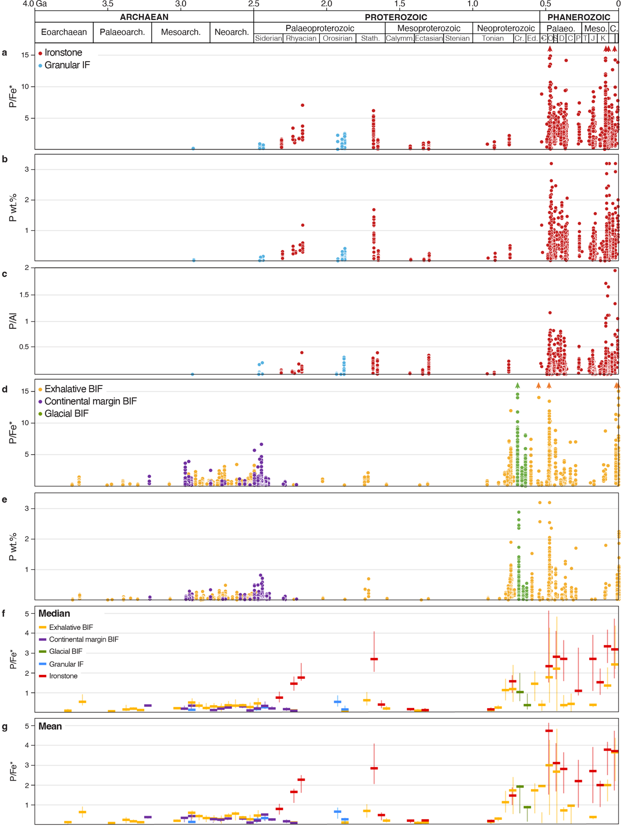
Figure S1. Ironstone P contents using a range of normalisation approaches, including a. P/Fe* values, b. bulk-rock P (in wt %), and c. P/Al ratios. For iron formations, data are shown as d. P/Fe* ratios and e. wt. % P. Note that P/Al ratios are not shown for iron formations, given that the Al contents of these rocks are often exceedingly low, leading to spurious correlations with this normalisation approach. We also highlight the similarity in qualitative trends for f. median values and g. mean values.

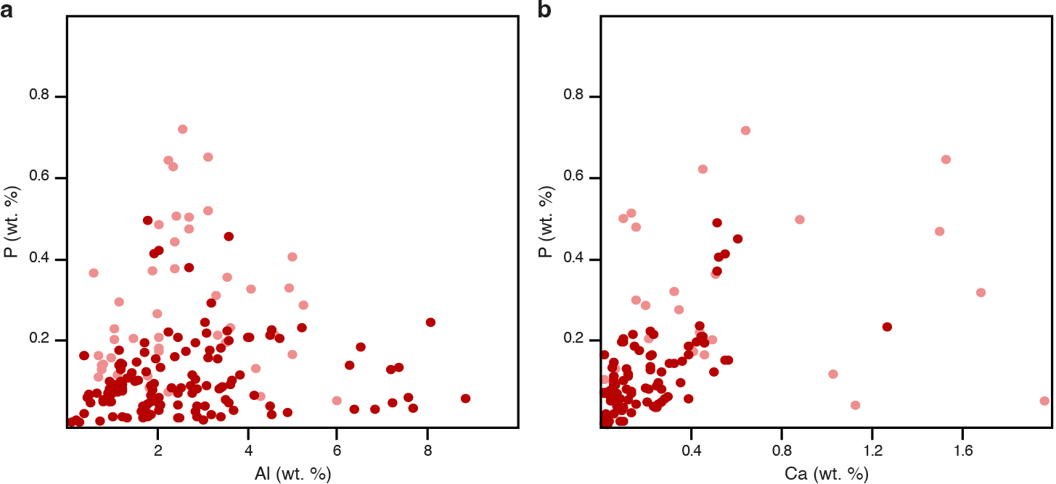
Figure S2. Bulk-rock major element geochemical cross plots (in wt. %). Dark red indicates Proterozoic ironstones, pale red indicates Phanerozoic ironstones. Data from this study. a. P and Al contents, showing no clear correlation. b. Positive correlation between P and Ca contents, indicating that the P is predominantly hosted by Ca phosphates (i.e., apatite).

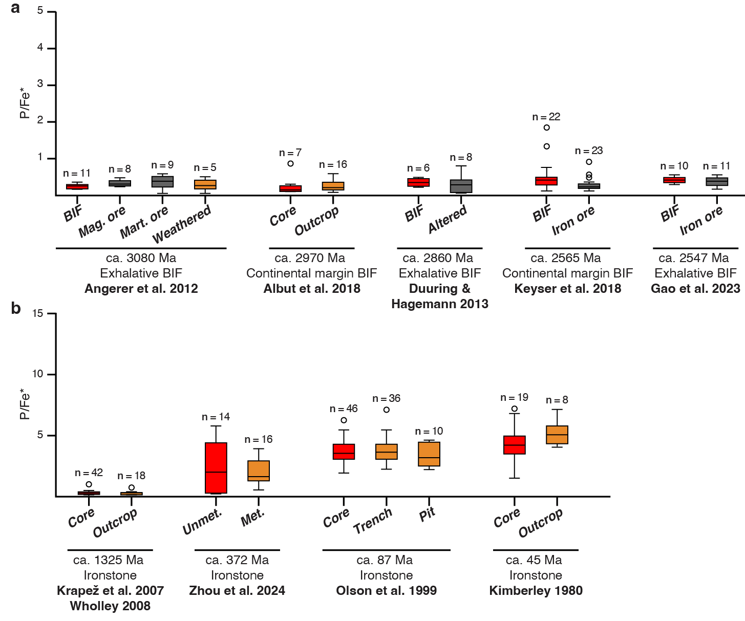
Figure S3. Box and whisker plots comparing bulk-rock P/Fe* values for iron formations and ironstones in various weathering and alteration scenarios. a. Comparison between the P/Fe* values of more pristine banded iron formation (BIF), weathered BIF, and magnetite (mag.) and martite (mart.) ore (data from Angerer and Hagemann, 2010; Duuring and Hagemann, 2013; Albut et al., 2018; Keyser et al., 2018; Gao et al., 2023). b. Comparison between the P/Fe* values of core, pit and trench samples of ironstones, as well as a comparison between unmetamorphosed and metamorphosed samples (data from Kimberley, 1980; Olson et al., 1999; Krapež, 2007; Wholley, 2008; Zhou et al., 2024).

Supplementary References

Abbott, S., Sweet, I., Plumb, K., Young, D., Cutovinos, A., Ferenczi, P., Brakel, A., and Pietsch, B., 2001, Roper Region: Urapunga - Roper River, Northern Territory : combined explanatory notes: Northern Territory Geological Survey; Geoscience Australia; National Geoscience Mapping Accord (Australia), Explanatory Note.
Ahmad, M., and Munson, T., 2013, Geology and mineral resources of the Northern Territory, Northern Territory Geological Survey.
Albut, G., Babechuk, M. G., Kleinhanns, I. C., Benger, M., Beukes, N. J., Steinhilber, B., Smith, A. J., Kruger, S. J., and Schoenberg, R., 2018, Modern rather than Mesoarchaean oxidative weathering responsible for the heavy stable Cr isotopic signatures of the 2.95 Ga old Ijzermijn iron formation (South Africa): Geochimica et Cosmochimica Acta, v. 228, p. 157-189.
Angerer, T., and Hagemann, S. G., 2010, The BIF-hosted high-grade iron ore deposits in the Archean Koolyanobbing Greenstone Belt, Western Australia: structural control on synorogenic-and weathering-related magnetite-, hematite-, and goethite-rich iron ore: Economic Geology, v. 105, no. 5, p. 917-945.
Baarli, B. G., Brande, S., and Johnson, M., 1992, Proximality trends in the Red Mountain Formation (Lower Silurian) of Birmingham, Alabama: Oklahoma Geological Survey Bulletin, v. 145, p. 1-17.
Bachmann, M., and Hirsch, F., 2006, Lower Cretaceous carbonate platform of the eastern Levant (Galilee and the Golan Heights): stratigraphy and second-order sea-level change: Cretaceous Research, v. 27, no. 4, p. 487-512.
Bayer, U., 1989, Stratigraphic and environmental patterns of ironstone deposits: Geological Society, London, Special Publications, v. 46, no. 1, p. 105-117.
Belous, N., Nikolaeva, I., Kazansky, Y., Berdnikov, A., Klyarovskiy, V., Kuznetsov, V., and Babin, A., 1964, The Western-Siberian iron ore basin: Siberian Branch of the Academy of Sciences of the USSR, Novosibirsk ((448 pp.)(in Russia)).
Bläsi, H., Deplazes, G., Schellmann, M., and Traber, D., 2013, Sedimentologie und Stratigraphie des ‘Braunen Doggers’ und seiner westlichen Äquivalente: Nagra Arbeitsbericht, NAB, p. 12-51.
Bonjour, J., Peucat, J.-J., Chauvel, J.-J., Paris, F., and Cornichet, J., 1988, U-Pb zircon dating of the early paleozoic (Arenigian) transgression in Western Brittany (France): A new constraint for the lower paleozoic time-scale: Chemical Geology: Isotope Geoscience section, v. 72, no. 4, p. 329-336.
Bonjour, J.-L., and Chauvel, J.-J., 1988, Un exemple de sedimentation initiale dans un bassin paleozoique; etude petrographique et geochimique de l'Ordovicien inferieur de la presquile de Crozon (Finistere): Bulletin de la Société géologique de France, v. 4, no. 1, p. 81-91.
Bonte, A., and Hatrival, J., 1966, Notice explicative de la feuille Rethel à 1/50000: Carte géologique de la France BRG M. Orléans, v. 29, p. 1-12.
Brett, C., Goodman, W., Broadhead, T., and Hageman, S., 1996, Silurian stratigraphy of the type Clinton area of central New York: Sedimentary Environments of Silurian Taconia: University of Tennessee, Department of Geological Sciences, Studies in Geology, v. 26, p. 200-230.
Brett, C. E., Baarli, B., Chowns, T., Cotter, E., Driese, S., Goodman, W., and Johnson, M. E., 1998, Early Silurian condensed intervals, ironstones, and sequence stratigraphy in the Appalachian foreland basin: New York State Museum Bulletin, v. 491, p. 89-143.
Canavan, F., 1965, Iron ore deposits of Roper Bar: Geology of Australian Ore Deposits, v. 1, p. 212-215.
Chafetz, H. S., Meredith, J. C., and Kocurek, G., 1986, The Cambro-Ordovician Bliss Formation, southwestern New Mexico, USA—Progradational sequences on a mixed siliciclastic and carbonate shelf: Sedimentary geology, v. 49, no. 3-4, p. 201-221.
Chowns, T. M., 2006, Sequence Stratigraphy of the Red Mountain Formation; Setting for the Origin of the Birmingham Ironstones.
Chowns, T. M., and Rindsberg, A. K., 2015, Stratigraphy and depositional environments in the Silurian Red Mountain Formation of the southern Appalachian basin, USA: Field Guides, v. 39, p. 95-143.
Chu, X., Zhang, T., Zhang, Q., and Lyons, T. W., 2007, Sulfur and carbon isotope records from 1700 to 800 Ma carbonates of the Jixian section, northern China: Implications for secular isotope variations in Proterozoic seawater and relationships to global supercontinental events: Geochimica et Cosmochimica Acta, v. 71, no. 19, p. 4668-4692.
Cobban, W., 1993, Diversity and distribution of Late Cretaceous ammonites, Western Interior, United States: Geological Association of Canada, Special Paper, v. 39, p. 435-451.
Cobban, W., Dyman, T., and Porter, K., 2005, Paleontology and stratigraphy of upper Coniacian–middle Santonian ammonite zones and application to erosion surfaces and marine transgressive strata in Montana and Alberta: Cretaceous Research, v. 26, no. 3, p. 429-449.
Cogné, J., Bonhommet, N., Kropacek, V., Zelinka, T., and Petrovski, E., 1991, Paleomagnetism and magnetic fabric of the deformed redbeds of the Cap de la Chèvre formation, Brittany, France: Physics of the earth and planetary interiors, v. 67, no. 3-4, p. 374-388.
Cornell, D., Schütte, S., and Eglington, B., 1996, The Ongeluk basaltic andesite formation in Griqualand West, South Africa: submarine alteration in a 2222 Ma Proterozoic sea: Precambrian Research, v. 79, no. 1-2, p. 101-123.
Cotter, E., and Link, J. E., 1993, Deposition and diagenesis of Clinton ironstones (Silurian) in the Appalachian Foreland Basin of Pennsylvania: Geological Society of America Bulletin, v. 105, no. 7, p. 911-922.
Courville, P., Bonnot, A., Dudicourt, J.-C., and Cuif, G., L’assemblage à Cardioceras (Cardioceras) cordatum (J. Sowerby, 1812) et sa place au sein de la succession ammonitique de l’Oxfordien Inférieur (Jurassique Supérieur). Apport des données ardennaises (Province Subboréale), in Proceedings Annales de Paléontologie2011, Volume 97, Elsevier, p. 9-33.
Dehler, C., Gehrels, G., Porter, S., Heizler, M., Karlstrom, K., Cox, G., Crossey, L., and Timmons, M., 2017, Synthesis of the 780–740 Ma Chuar, Uinta Mountain, and Pahrump (ChUMP) groups, western USA: implications for Laurentia-wide cratonic marine basins: GSA Bulletin, v. 129, no. 5-6, p. 607-624.
Dehler, C. M., Elrick, M., Karlstrom, K. E., Smith, G. A., Crossey, L. J., and Timmons, J. M., 2001, Neoproterozoic Chuar Group (∼ 800–742 Ma), Grand Canyon: A record of cyclic marine deposition during global cooling and supercontinent rifting: Sedimentary Geology, v. 141, p. 465-499.
Dehler, C. M., Porter, S. M., Timmons, J. M., and Karlstrom, K., 2012, The Neoproterozoic Earth system revealed from the Chuar Group of Grand Canyon: Grand Canyon Geology: Two Billion Years of Earth’s History: Geological Society of America Special Paper, v. 489, p. 49-72.
Dietze, V., Kutz, M., Franz, M., and Bosch, K., 2009, Stratigraphy of the Kahlenberg near Ringsheim (Upper Rhine Valley, SW Germany) with emphasis on the Laeviuscula and Sauzei zones (Lower Bajocian, Middle Jurassic): Palaeodiversity, v. 2, p. 19-65.
Donaldson, W. S., Plint, A. G., and Longstaffe, F. J., 1998, Basement tectonic control on distribution of the shallow marine Bad Heart Formation: Peace River Arch area, northwest Alberta: Bulletin of Canadian Petroleum Geology, v. 46, no. 4, p. 576-598.
Dorland, H., Beukes, N., Gutzmer, J., Evans, D., and Armstrong, R., 2004, Trends in detrital zircon provenance from Neoarchaean–Palaeoproterozoic sedimentary successions on the Kaapvaal craton: Geoscience Africa 2004, Abstract Volume, University of the Witwatersrand, Johannesburg, South Africa, p. 176-177.
Dorland, H. C., 1999, Paleoproterozoic laterites, red beds and ironstones of the Pretoria Group with reference to the history of atmospheric oxygen: University of Johannesburg.
Duan, C., Li, Y., Yang, Y., Liang, Y., Wei, M., and Hou, K., 2018, U-Pb Ages and Hf Isotopes of Detrital Zircon Grains from the Mesoproterozoic Chuanlinggou Formation in North China Craton: Implications for the Geochronology of Sedimentary Iron Deposits and Crustal Evolution: Minerals, v. 8, no. 12, p. 547.
Duuring, P., and Hagemann, S., 2013, Leaching of silica bands and concentration of magnetite in Archean BIF by hypogene fluids: Beebyn Fe ore deposit, Yilgarn Craton, Western Australia: Mineralium Deposita, v. 48, no. 3, p. 341-370.
Eriksson, K., 1973, The Timeball Hill Formation--a fossil delta: Journal of Sedimentary Research, v. 43, no. 4.
Eriksson, P., Altermann, W., Hartzer, F., Johnson, M., Anhaeusser, C., and Thomas, R., 2006, The Transvaal Supergroup and its precursors: The Geology of South Africa, p. 237-260.
Eriksson, P., Schreiber, U., and Van der Neut, M., 1991, A review of the sedimentology of the Early Proterozoic Pretoria Group, Transvaal Sequence, South Africa: implications for tectonic setting: Journal of African Earth Sciences (and the Middle East), v. 13, no. 1, p. 107-119.
Fernandez, A., Chauvel, J. J., and Moro, M. C., 1998, Comparative study of the lower Ordovician ironstones of the Iberian massif (Zamora, Spain) and of the Armorican massif (Central Brittany, France): Journal of sedimentary research, v. 68, no. 1.
Ford, T. D., and Breed, W. J., 1973, Late Precambrian Chuar Group, Grand Canyon, Arizona: Geological Society of America Bulletin, v. 84, no. 4, p. 1243-1260.
Galili, N., Bernasconi, S. M., Nissan, A., Alcolombri, U., Aquila, G., Di Bella, M., Blattmann, T. M., Haghipour, N., Italiano, F., and Jaggi, M., 2025, The geologic history of marine dissolved organic carbon from iron oxides: Nature, v. 644, no. 8078, p. 945-951.
Galili, N., Shemesh, A., Yam, R., Brailovsky, I., Sela-Adler, M., Schuster, E. M., Collom, C., Bekker, A., Planavsky, N., and Macdonald, F. A., 2019, The geologic history of seawater oxygen isotopes from marine iron oxides: Science, v. 365, no. 6452, p. 469-473.
Gao, L., Zhang, C., Liu, P., Ding, X., Wang, Z., and Zhang, Y., 2009, Recognition of Meso-and Neoproterozoic stratigraphic framework in North and South China: Acta Geoscientica Sinica, v. 30, no. 4, p. 433-446.
Gao, X., Wang, D., Huang, F., Wang, Y., and Wang, C., 2023, Chronolgy and Geochemistry of the Sijiaying Iron Deposit in Eastern Hebei Province, North China Craton: Implications for the Genesis of High-Grade Iron Ores: Minerals, v. 13, no. 6, p. 775.
Gillette, T., 1947, The Clinton of western and central New York, University of the State of New York.
Gnibidenko, Z., Lebedeva, N., and Levicheva, A., 2015, Magnetostratigraphy of the Campanian–Maastrichtian Bakchar Basin (southeastern West Siberia): Russian Geology and Geophysics, v. 56, no. 11, p. 1652-1661.
Haines, P. W., Pietsch, B. A., Rawlings, D. J., Madigan, T. L. A., and Findhammer, T., 1993, Mount Young, Northern Territory : explanatory notes: Northern Territory Geological Survey, ISBN0724516182
ISSN0814-7485.
Hall, J. K., Krasheninnikov, V. A., Hirsch, F., Benjamini, C., and Flexer, A., 2005, Geological framework of the Levant, volume II: the Levantine Basin and Israel: Historical Productions, Jerusalem.
Halverson, G., Shen, C., Davies, J., and Wu, L., 2022, A Bayesian Approach to Inferring Depositional Ages Applied to a Late Tonian Reference Section in Svalbard. Front: Earth Sci, v. 10, p. 798739.
Hannah, J. L., Bekker, A., Stein, H. J., Markey, R. J., and Holland, H. D., 2004, Primitive Os and 2316 Ma age for marine shale: implications for Paleoproterozoic glacial events and the rise of atmospheric oxygen: Earth and Planetary Science Letters, v. 225, no. 1-2, p. 43-52.
Hinds, N., 1933, Researches on Algonkian formations of Grand Canyon National Park: Carnegie Institution of Washington Yearbook, v. 32, p. 325-328.
Hume, G. S., and Link, T. A., 1945, Canol geological investigations in the Mackenzie River area, Northwest Territories and Yukon, Canada Department of Mines and Resources, Mines and Geology Branch.
Jackson, M., Muir, M., and Sweet, I., Sedimentology of the Middle Proterozoic McArthur Basin, Northern Australia—Field Excursion 13A, in Proceedings 12th International Sedimentological Congress1986, Bureau of Mineral Resources Canberra.
Johnson, B. R., Tostevin, R., Gopon, P., Wells, J., Robinson, S. A., and Tosca, N. J., 2020, Phosphorus burial in ferruginous SiO2-rich Mesoproterozoic sediments: Geology, v. 48, no. 1, p. 92-96.
Kafle, B., Olson, R., Catuneanu, O., and Plint, G., 2013, Stratigraphy of the Bad Heart Formation, Clear Hills and Smoky River areas, Alberta: Bulletin of Canadian Petroleum Geology, v. 61, no. 4, p. 253-282.
Keller, M., Lehnert, O., and Cooper, J. D., 2012, Sauk megasequence supersequences, southern Great Basin: Second-order accommodation events on the southwestern Cordilleran margin platform.
Kelley, V. C., 1951, Oolitic iron deposits of New Mexico: AAPG Bulletin, v. 35, no. 10, p. 2199-2228.
Kendall, B., Creaser, R. A., Gordon, G. W., and Anbar, A. D., 2009, Re–Os and Mo isotope systematics of black shales from the Middle Proterozoic Velkerri and Wollogorang formations, McArthur Basin, northern Australia: Geochimica et Cosmochimica Acta, v. 73, no. 9, p. 2534-2558.
Keyser, W., Ciobanu, C. L., Cook, N. J., Johnson, G., Feltus, H., Johnson, S., Dmitrijeva, M., Ehrig, K., and Nguyen, P. T., 2018, Petrography and trace element signatures of iron-oxides in deposits from the Middleback Ranges, South Australia: From banded iron formation to ore: Ore Geology Reviews, v. 93, p. 337-360.
Kimberley, M., 1980, The Paz de Rio oolitic inland-sea iron formation: Economic Geology, v. 75, no. 1, p. 97-106.
Krainer, K., Tropper, P., Krenn, K., and Lucas, S. G., 2022, Occurrence and origin of glauconite in the Cambro-Ordovician Bliss Formation of southern New Mexico and West Texas (USA): Journal of Sedimentary Research, v. 92, no. 4, p. 353-370.
Krapež, B., 2007, Report of field-work in the Constance Range of Northwestern
Queensland: Constance Range Project.
Krassilov, V., and Schrank, E., 2011, New Albian macro-and palynoflora from the Negev (Israel) with description of a new gymnosperm morphotaxon: Cretaceous Research, v. 32, no. 1, p. 13-29.
Lebedeva, N., Kuzmina, O., Sobolev, E., and Khazina, I., 2017, Stratigraphy of Upper Cretaceous and Cenozoic deposits of the Bakchar iron ore deposit (southwestern Siberia): New data: Stratigraphy and Geological Correlation, v. 25, no. 1, p. 76-98.
Lechte, M., Halverson, G., Wallace, M., Gibson, T., Hood, A., Wang, C., Bui, T. H., Maloney, K., and Millikin, A., 2024, Oolitic ironstones, continental iron flux and reverse weathering in the Proterozoic Eon: insights from the Tonian Katherine Group, Yukon.
Lechte, M. A., Wallace, M. W., van Smeerdijk Hood, A., Li, W., Jiang, G., Halverson, G. P., Asael, D., McColl, S. L., and Planavsky, N. J., 2019, Subglacial meltwater supported aerobic marine habitats during Snowball Earth: Proceedings of the National Academy of Sciences, v. 116, no. 51, p. 25478-25483.
Lefebvre, B., Álvaro, J. J., Casas, J. M., Ghienne, J.-F., Herbosch, A., Loi, A., Monceret, E., Verniers, J., Vidal, M., and Vizcaïno, D., 2023, The Ordovician of France and neighbouring areas of Belgium and Germany.
Li, Y., Lu, X., Cui, X., Cai, Y., Liu, J., Liu, H., Hu, H., Li, J., Chen, J., and Deng, Z., 2025, Clay-hematite association in the late Paleoproterozoic oolitic ironstone from the Chuanlinggou Formation, North China: Palaeogeography, Palaeoclimatology, Palaeoecology, p. 113315.
Lin, Y., Tang, D., Shi, X., Zhou, X., and Huang, K., 2019, Shallow-marine ironstones formed by microaerophilic iron-oxidizing bacteria in terminal Paleoproterozoic: Gondwana Research, v. 76, p. 1-18.
Long, D., and Turner, E., 2012, Formal definition of the Neoproterozoic Mackenzie Mountains Supergroup (NWT), and formal stratigraphic nomenclature for terrigenous clastic units of the Katherine Group: Geological Survey of Canada Open File 7113, p. 40.
Lu, S., Yang, C., Zhu, S., and Mei, H., 1996, Precambrian continental crust profile from eastern Hebei to Jixian, Tianjin: 30th IGC Field Trip Guide, v. 2, p. T105.
Mack, G. H., and Giles, K., 2004, The Cambro-Ordovician Bliss and Lower Ordovician El Paso Formations, southwestern New Mexico and west Texas: Mack, GH, Giles, KA, The geology of New Mexico, Geological History. New Mexico Geological Society Special Publication, v. 11, p. 35-45.
Maynard, J., 1983, Geochemistry of sedimentary ore deposits.
McLaughlin, P. I., Emsbo, P., and Brett, C. E., 2012, Beyond black shales: the sedimentary and stable isotope records of oceanic anoxic events in a dominantly oxic basin (Silurian; Appalachian Basin, USA): Palaeogeography, Palaeoclimatology, Palaeoecology, v. 367, p. 153-177.
Milton, J. E., Hickey, K. A., Gleeson, S. A., and Friedman, R. M., 2017, New U-Pb constraints on the age of the Little Dal Basalts and Gunbarrel-related volcanism in Rodinia: Precambrian Research, v. 296, p. 168-180.
Munson, T. J., 2016, Sedimentary characterisation of the Wilton package, greater McArthur Basin, Northern Territory: Northern Territory Geological Survey, ISBN9780724573059 (PDF)
ISSN1443-1149.
Muskatt, H., 1972, The Clinton group of east-central New York, NY State Geol. Assoc. 44th Annu. Meet. Guidebook, p. A1-A37.
Nelson, G. J., Pufahl, P. K., and Hiatt, E. E., 2010, Paleoceanographic constraints on Precambrian phosphorite accumulation, Baraga group, Michigan, USA: Sedimentary Geology, v. 226, no. 1-4, p. 9-21.
Olson, R., Eccles, D., and Collom, C., 1999, A Study of Potential Co-Product Trace Elements Within the Clear Hills Iron Deposits: Northwestern Alberta, AGS/AEUB Special Report, v. 8.
Papineau, D., 2010, Global biogeochemical changes at both ends of the Proterozoic: insights from phosphorites: Astrobiology, v. 10, no. 2, p. 165-181.
Planavsky, N. J., Asael, D., Rooney, A. D., Robbins, L. J., Gill, B. C., Dehler, C. M., Cole, D. B., Porter, S. M., Love, G. D., and Konhauser, K. O., 2023, A sedimentary record of the evolution of the global marine phosphorus cycle: Geobiology, v. 21, no. 2, p. 168-174.
Planavsky, N. J., Rouxel, O. J., Bekker, A., Lalonde, S. V., Konhauser, K. O., Reinhard, C. T., and Lyons, T. W., 2010, The evolution of the marine phosphate reservoir: Nature, v. 467, no. 7319, p. 1088.
Rainbird, R., Jefferson, C., and Young, G., 1996, The early Neoproterozoic sedimentary Succession B of northwestern Laurentia: Correlations and paleogeographic significance: Geological Society of America Bulletin, v. 108, no. 4, p. 454-470.
Reinhard, C. T., Planavsky, N. J., Gill, B. C., Ozaki, K., Robbins, L. J., Lyons, T. W., Fischer, W. W., Wang, C., Cole, D. B., and Konhauser, K. O., 2017, Evolution of the global phosphorus cycle: Nature, v. 541, no. 7637, p. 386.
Rickard, L. V., and Fisher, D. W., 1975, Correlation of the Silurian and devonian rocks in New York State.
Rooney, A. D., Austermann, J., Smith, E. F., Li, Y., Selby, D., Dehler, C. M., Schmitz, M. D., Karlstrom, K. E., and Macdonald, F. A., 2018, Coupled Re-Os and U-Pb geochronology of the Tonian Chuar Group, Grand Canyon: GSA Bulletin, v. 130, no. 7-8, p. 1085-1098.
Rosenfeld, A., and Hirsch, F., 2005, The cretaceous of Israel: Geological Framework of the Levant, v. 2, p. 393-436.
Rudmin, M., Banerjee, S., Abdullayev, E., Ruban, A., Filimonenko, E., Lyapina, E., Kashapov, R., and Mazurov, A., 2020, Ooidal ironstones in the Meso-Cenozoic sequences in western Siberia: assessment of formation processes and relationship with regional and global earth processes: Journal of Palaeogeography, v. 9, no. 1, p. 1-21.
Rudmin, M., Mazurov, A., and Banerjee, S., 2019, Origin of ooidal ironstones in relation to warming events: Cretaceous-Eocene Bakchar deposit, south-east Western Siberia: Marine and Petroleum Geology, v. 100, p. 309-325.
Ryall, T., Lewis, R., and Sherwin, I., 2012, Roper River Iron Ore Project EL 26412 Annual Report for period 14 April 2011 to 13 April 2012.
Sauer, K., 1948, Geologie der Vorbergzone zwischen Ettenheim, Schweighausen, Herbolzheim:(Doggerstratigraphie, Rheintal-Vulkanismus und-Tektonik): Verlag nicht ermittelbar.
Schoen, R., 1962, Petrology of Iron-bearing Rocks of the Clinton Group in New York State: A Thesis: Harvard University.
Sliwinski, J., Gunning, C., Sheridan, K., Caplan, B., and Smith, B., The Upper Cretaceous Bad Heart Ooidal Ironstones: An integrated mineralogical-sedimentological-ore characterization, in Proceedings Geo Canada Abstract Joint Convention2010.
Smith, A., Beukes, N., Gutzmer, J., Czaja, A., Johnson, C., and Nhleko, N., 2017, Oncoidal granular iron formation in the Mesoarchaean Pongola Supergroup, southern Africa: Textural and geochemical evidence for biological activity during iron deposition: Geobiology, v. 15, no. 6, p. 731-749.
Sneh, A., and Weinberger, R., 2003, Geology of the Metulla quadrangle, northern Israel: Implications for the offset along the Dead Sea Rift: Israel Journal of Earth Sciences, v. 52.
Song, T., 2007, Sedimentary facies indicators and sedimentary environments models of the Changcheng System of Mesoproterozoic in Ming Tombs District, Beijing: Journal of Palaeogeography, v. 9, no. 5, p. 461-472.
Sullivan, N., Brett, C. E., and McLaughlin, P., Ironstones, condensed beds, and sequence stratigraphy of the Clinton Group (Lower Silurian) in its type area, central New York, in Proceedings Field Trip Guidebook for the 84th Annual Meeting of the New York State Geological Association, pp. B5–1–B5–402012.
Taylor, J. F., Myrow, P. M., Ripperdan, R. L., Loch, J. D., and Ethington, R. L., 2004, Paleoceanographic events and faunal crises recorded in the Upper Cambrian and Lower Ordovician of west Texas and southern New Mexico.
Taylor, J. F., and Repetski, J. E., 1995, High-Resolution trilobite and conodont biostratigraphy across the Cambrian-Ordovician boundary in south-central New Mexico.
Thompson, S., and Potter, P., 1981, Paleocurrents of Bliss Sandstone (Cambrian-Ordovician), southwestern New Mexico and western Texas. NM Bur: Mines Miner. Resour., Annu. Rep, p. 36-51.
Turner, E. C., and Long, D. G., 2008, Basin architecture and syndepositional fault activity during deposition of the Neoproterozoic Mackenzie Mountains supergroup, Northwest Territories, Canada: Canadian Journal of Earth Sciences, v. 45, no. 10, p. 1159-1184.
Visser, J., 1972, THE TIMEBALL HILL FORMATION AT PRETORIA. A PROGRADING SHORE-LINE DEPOSIT.
Walcott, C. D., 1895, Pre-Cambrian Igneous Rocks of the Unkar Terrane, Grand Canyon of the Colorado, Arizona, US Government Printing Office.
Wang, C., Lechte, M. A., Reinhard, C. T., Asael, D., Cole, D. B., Halverson, G. P., Porter, S. M., Galili, N., Halevy, I., Rainbird, R. H., Lyons, T. W., and Planavsky, N. J., 2022, Strong evidence for a weakly oxygenated ocean–atmosphere system during the Proterozoic: Proceedings of the National Academy of Sciences.
Weinberger, G., Flexer, A., and Livnat, A., 1990, The value of bivariate methods for identification and discrimination of fluvial sandstones from the Lower Cretaceous Hatira Formation, northern Negev: Israel. Newsl. Stratigr., v. 21, p. 175-185.
Wholley, D., 2008, Constance Range Project Annual Report for EPM14479: CSA Australia Pty. Ltd.
Yang, B., Smith, T. M., Collins, A. S., Munson, T. J., Schoemaker, B., Nicholls, D., Cox, G., Farkas, J., and Glorie, S., 2018, Spatial and temporal variation in detrital zircon age provenance of the hydrocarbon-bearing upper Roper Group, Beetaloo Sub-basin, Northern Territory, Australia: Precambrian Research, v. 304, p. 140-155.
Zhang, S., Li, Z.-X., Evans, D. A., Wu, H., Li, H., and Dong, J., 2012, Pre-Rodinia supercontinent Nuna shaping up: a global synthesis with new paleomagnetic results from North China: Earth and Planetary Science Letters, v. 353, p. 145-155.
Zhang, S., Zhao, Y., Ye, H., Hu, J., and Wu, F., 2013, New constraints on ages of the Chuanlinggou and Tuanshanzi formations of the Changcheng System in the Yan-Liao area in the northern North China Craton: Acta Petrologica Sinica, v. 29, no. 7, p. 2481-2490.
Zhou, M.-F., Lyu, Y. J., Liu, Z. R., Liu, P.-P., Meng, L., Qiu, W. J., and Zhao, W. W., 2024, Devonian stratiform ironstone deposits in South China formed in a shallow marine environment of a passive continental margin: Journal of Asian Earth Sciences, v. 262, p. 105997.

