Supplementary Information for

Linking Long-range Surface-Induced Mobility Enhancement and Fragility in Polymer Glasses

Haoran Nie^{1†}, Xiwen Chen^{1,2†}, Xiyue Li¹, Zongyi Ma¹, Rui Zhang^{1 ,2, 3*}, and
Ophelia K. C. Tsui^{1 ,2*}

*Corresponding authors. Email: okctsui@ust.hk and ruizhang@ust.hk
† These authors contributed equally to this work.

This file includes:

Supplementary Note
Supplementary Figs. 1 to 10
Supplementary Tables 1 to 2
Supplementary References

Supplementary Note
- Heaviside-step model for the τ(z) profile of freestanding polymer films
We model the relaxation times for freestanding polymer films using a layer model, where the relaxation time near the two free surfaces ($τ_{surf}$) is significantly shorter than the that in the interior ($τ_{0}$) sandwiched in the middle. As depicted in Fig. 1c, if we assume that the molecular dynamics in each region are homogeneous and that the thickness of each surface region is $h_{t}$, the layer model for $τ(z)$ of freestanding films with thickness $h>2h_{t}$ is expressed as,
$τ(z)=τ_{surf}+H(z-h_{t}^{nano})⋅(τ_{0}-τ_{surf})-H(z-h+h_{t}^{nano})⋅(τ_{0}-τ_{surf})$, (1)
where $H(z')$ represents the Heaviside-step function, equal to zero when $z'<0$ and one when $z'>0$. For a freestanding film with thickness $h$, the average relaxation time $τ_{film}$ is evaluated through linear arithmetic averaging:
$τ_{film}(h)=\frac{1}{h}\int_{0}^{h}{τ(z)dz}$. (2)

- Mapping ratios of PMMA, PS and PVC in simulation
The determination of the mapping ratio for coarse-grained (CG) models of different polymers follows the protocol proposed by Kwansa et al. ¹. For PVC, PS and PMMA, the corresponding monomers consist of 6, 16, and 15 atoms respectively. Excluding hydrogen atoms—which contribute minimally to mass and are less relevant to molecular dynamics in systems without hydrogen bonding—we find that the effective atom counts are 3, 8, and 7 for PVC, PS, and PMMA, respectively.
For the systems including both backbone (A) and side-group (B) beads, i.e., PS and PMMA, the mapping ratio is defined as the ratio of the number of heavy atoms (excluding hydrogen) to the number of CG beads: 4:1 for PS and 3.5:1 for PMMA. In the case of PVC, if we use two CG beads, the mapping ratio becomes 1.5:1, which is significantly lower than those for PS and PMMA. This indicates that the degree of coarse graining is too high for PVC. Consequently, we used a single CG bead to represent the whole PVC monomer, yielding a mapping ratio of 3:1. The ratio is comparable to that of PS and PMMA, indicating similar degrees of coarse-graining across these polymers (Supplementary Table 2).

- Determination of T_{g} and fragility for different polymers from CG-MD simulations
To compute the fragility ($m$) of the polymers, a bulk model without free surfaces was constructed for PMMA, PS and PVC, with an example for PS shown in Supplementary Fig. 4a. This model consists of 50 chains, each containing 200 monomers, with periodic boundary conditions applied in all dimensions. The initial configuration was generated using a random walk algorithm and equilibrated at 300 K following the method described by Hsu and co-workers (34, 43). After equilibrium, the system was heated to higher temperatures $T$. At each $T$, equilibration was performed for 10 ns, during which physical quantities such as atomic positions ($r$) were recorded every 0.4 ns. To determine the glass transition temperature ($T_{g})$, we first computed the self-part of the intermediate scattering function, $F_{s}$:
$F_{s}(q,t)=\frac{1}{N}\sum_{j}^{N}{\left\langle \exp\left[-iq⋅\left(r_{j}\left(t\right)-r_{j}\left(0\right)\right)\right]\right\rangle }$, (3)
where $r_{j}$ is the position of the j^{th} atom and $q$ is the first peak of the structure factor, $S(q)$, which is defined by
$S(q)=\frac{1}{N}\sum_{j=1}^{N}{\sum_{k=1}^{N}{\exp\left[-iq⋅\left(r_{j}-r_{k}\right)\right]}}$. (4)
Here, the magnitude of q was fixed at 15.19 nm⁻¹ in the x-direction, with variations in either the magnitude or direction having an insignificant effect on the results. The structural relaxation time ($τ$) for each temperature $T$ is defined as the time at which $F_{s}\left(q,τ\right)=0.2$ (Supplementary Fig. 4b). All results for $τ(T)$ are fitted to the Vogel-Fucher-Tammann (VFT) equation ²:
$τ(T)=τ_{}\exp\left(\frac{B}{T-T_{0}}\right)$, (5)
where $τ_{}$ represents the high−$T$ limit of $τ$, and B and $T_{0}$ are material-specific parameters. Following common practice in molecular dynamics (MD) simulations, $T_{g}$ is defined as the temperature at which $τ$ reaches 1 ns (34, 43). Using this criterion, the T_{g} of PS is determined to be ~371 K, while that of PMMA is ~401 K, and that of PVC is ~355 K.
In this work, we define intrinsic fragility ($m$) by:
$m={\left(\frac{∂\log_{10}{τ}}{∂\left(\frac{T_{g}}{T}\right)}\right)}_{T=Tg}$ (6)
A plot of $\log_{10}{τ}$ verses ${T_{g}}/T$ for PMMA, PS, and PVC is shown in Supplementary Fig. 4c. The computational results of $m$ are presented in Table 2 and Supplementary Fig. 4d.

- Instantaneous positions of atoms and the shear mode assumption
Two side-view snapshots of the slender model (Fig. 8c), taken at different times along the $x$ and $y$ axes for the three polymers are shown in Supplementary Fig. 6. The results show that the shear mode is approximately linear at the beginning of the simulation. As simulation progresses beyond ~100 ns, fluctuating noise gradually distorts the linear configuration of the model.
According to the shear mode assumption proposed in our previous paper ³, enhanced relaxations in the microscale surface region arise from spontaneous shear excitations involving an initial lateral displacement ($ξ)$ and a vertical propagation distance $(l)$, as illustrated in Supplementary Fig. 7a. By equating the energy of such an excitation, $U$, to $k_{B}T$, corresponding to spontaneous excitations, we derive:
$U≈\frac{1}{2}G{\left(\frac{ξ}{l}\right)}^{2}ξ^{2}l≈k_{B}T$, (7)
which can be rearranged to give:
$l≈\frac{ξ^{4}G}{2k_{B}T}$. (8)
Here, $G≈1 GPa$ is the shear modulus of the polymer. By substituting $T=300$ K and $ξ\sim 1$ nm, one finds that $l\sim 1$ $μm$. Although the exact value of the shear modulus varies slightly among the different polymers investigated, this simple equation demonstrates that short-range thermal excitations in nanoscale mobile layer can produce long-range shear modes extending up to micrometer scale.
We notice that the length scale of shear excitation, $l$, is proportional to the 4th power of $ξ$, making its value highly sensitive to the lateral displacement in different polymers. In the main text, we find that the average velocity field is strongest for PVC, followed by PS and PMMA (Fig. 5b). Consequently, the lateral displacement $ξ$ is also the greatest for PVC, followed by PS and PMMA, resulting in the most penetrating shear mode for PVC compared to PS and PMMA (Supplementary Fig. 7a). In our simulation, the model’s vertical dimension is restricted to 250 nm. Due to the significant molar mass applied to the substrate atoms, all shear mode displacements are terminated at the bottom. Under this circumstance, the gradient of lateral displacements along the z-axis can serve as an indicator of the strength of the shear mode (Supplementary Fig. 7b).

- The diffusion displacement profile for determining $h_{t}^{nano}$
The profiles of $σ_{diff}$ at $Δt=0.8, 2.4 and 8.0$ ns are shown in Supplementary Fig. 8 (a to c). All profiles show an increase near the surface at $z=0$. Although the value of $σ_{diff}$ increases with $Δt$, the curves overlap after normalization with the bulk average (computed from the data in the rage $50<z<150$ nm) (Supplementary Fig. 8 (d to f)). This result indicates that the trend of $σ_{diff}$ is independent of $Δt$. In these normalized graphs, we observe that $σ_{diff}$ decreases linearly near the surface. The intersection of the fitted linear line with $y=1$ is calculated as the thickness of the nanoscale mobile layer.

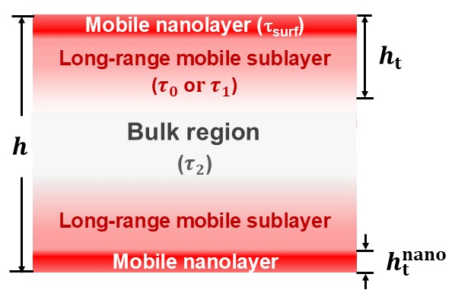

Supplementary Fig. 1 | Schematic showing the mobile surface bilayer structure within a free-standing film as well as symbols for the layer and film properties discussed in this paper.

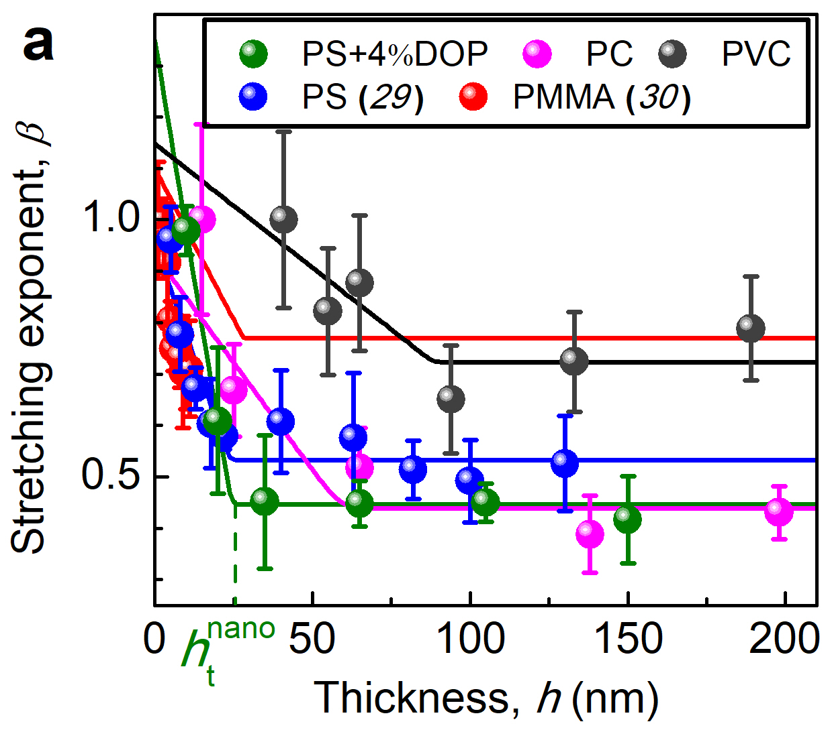
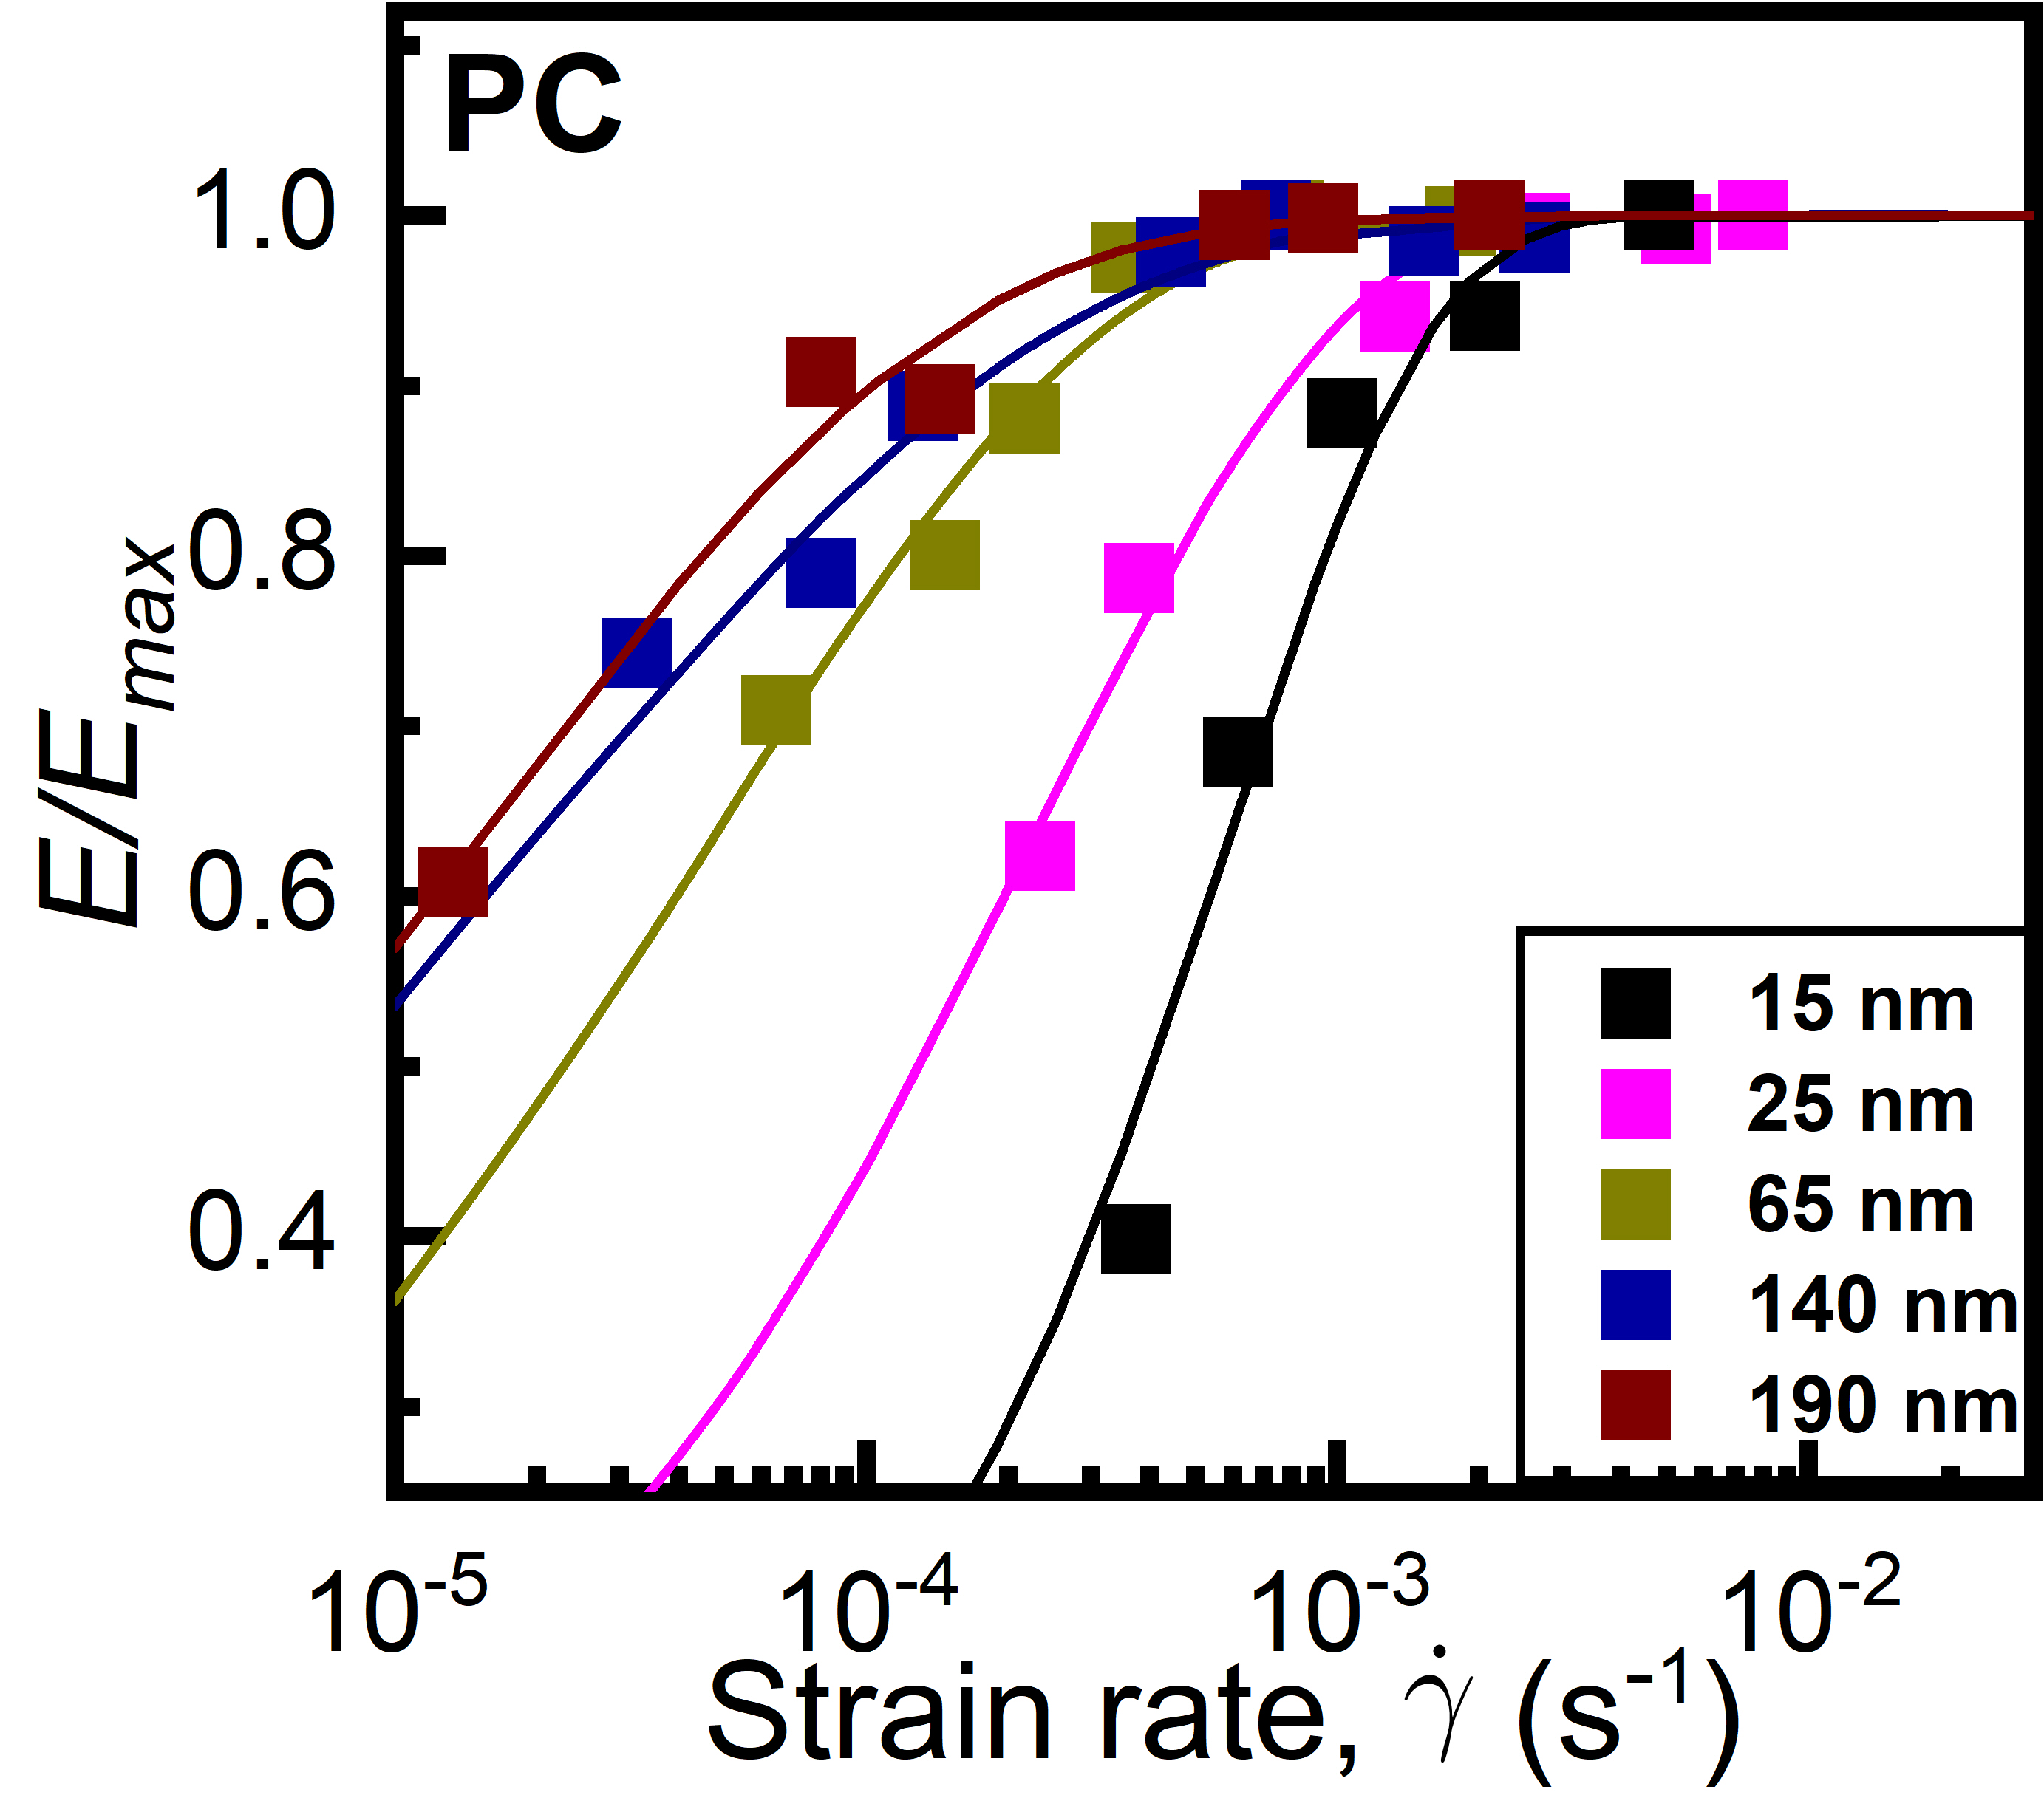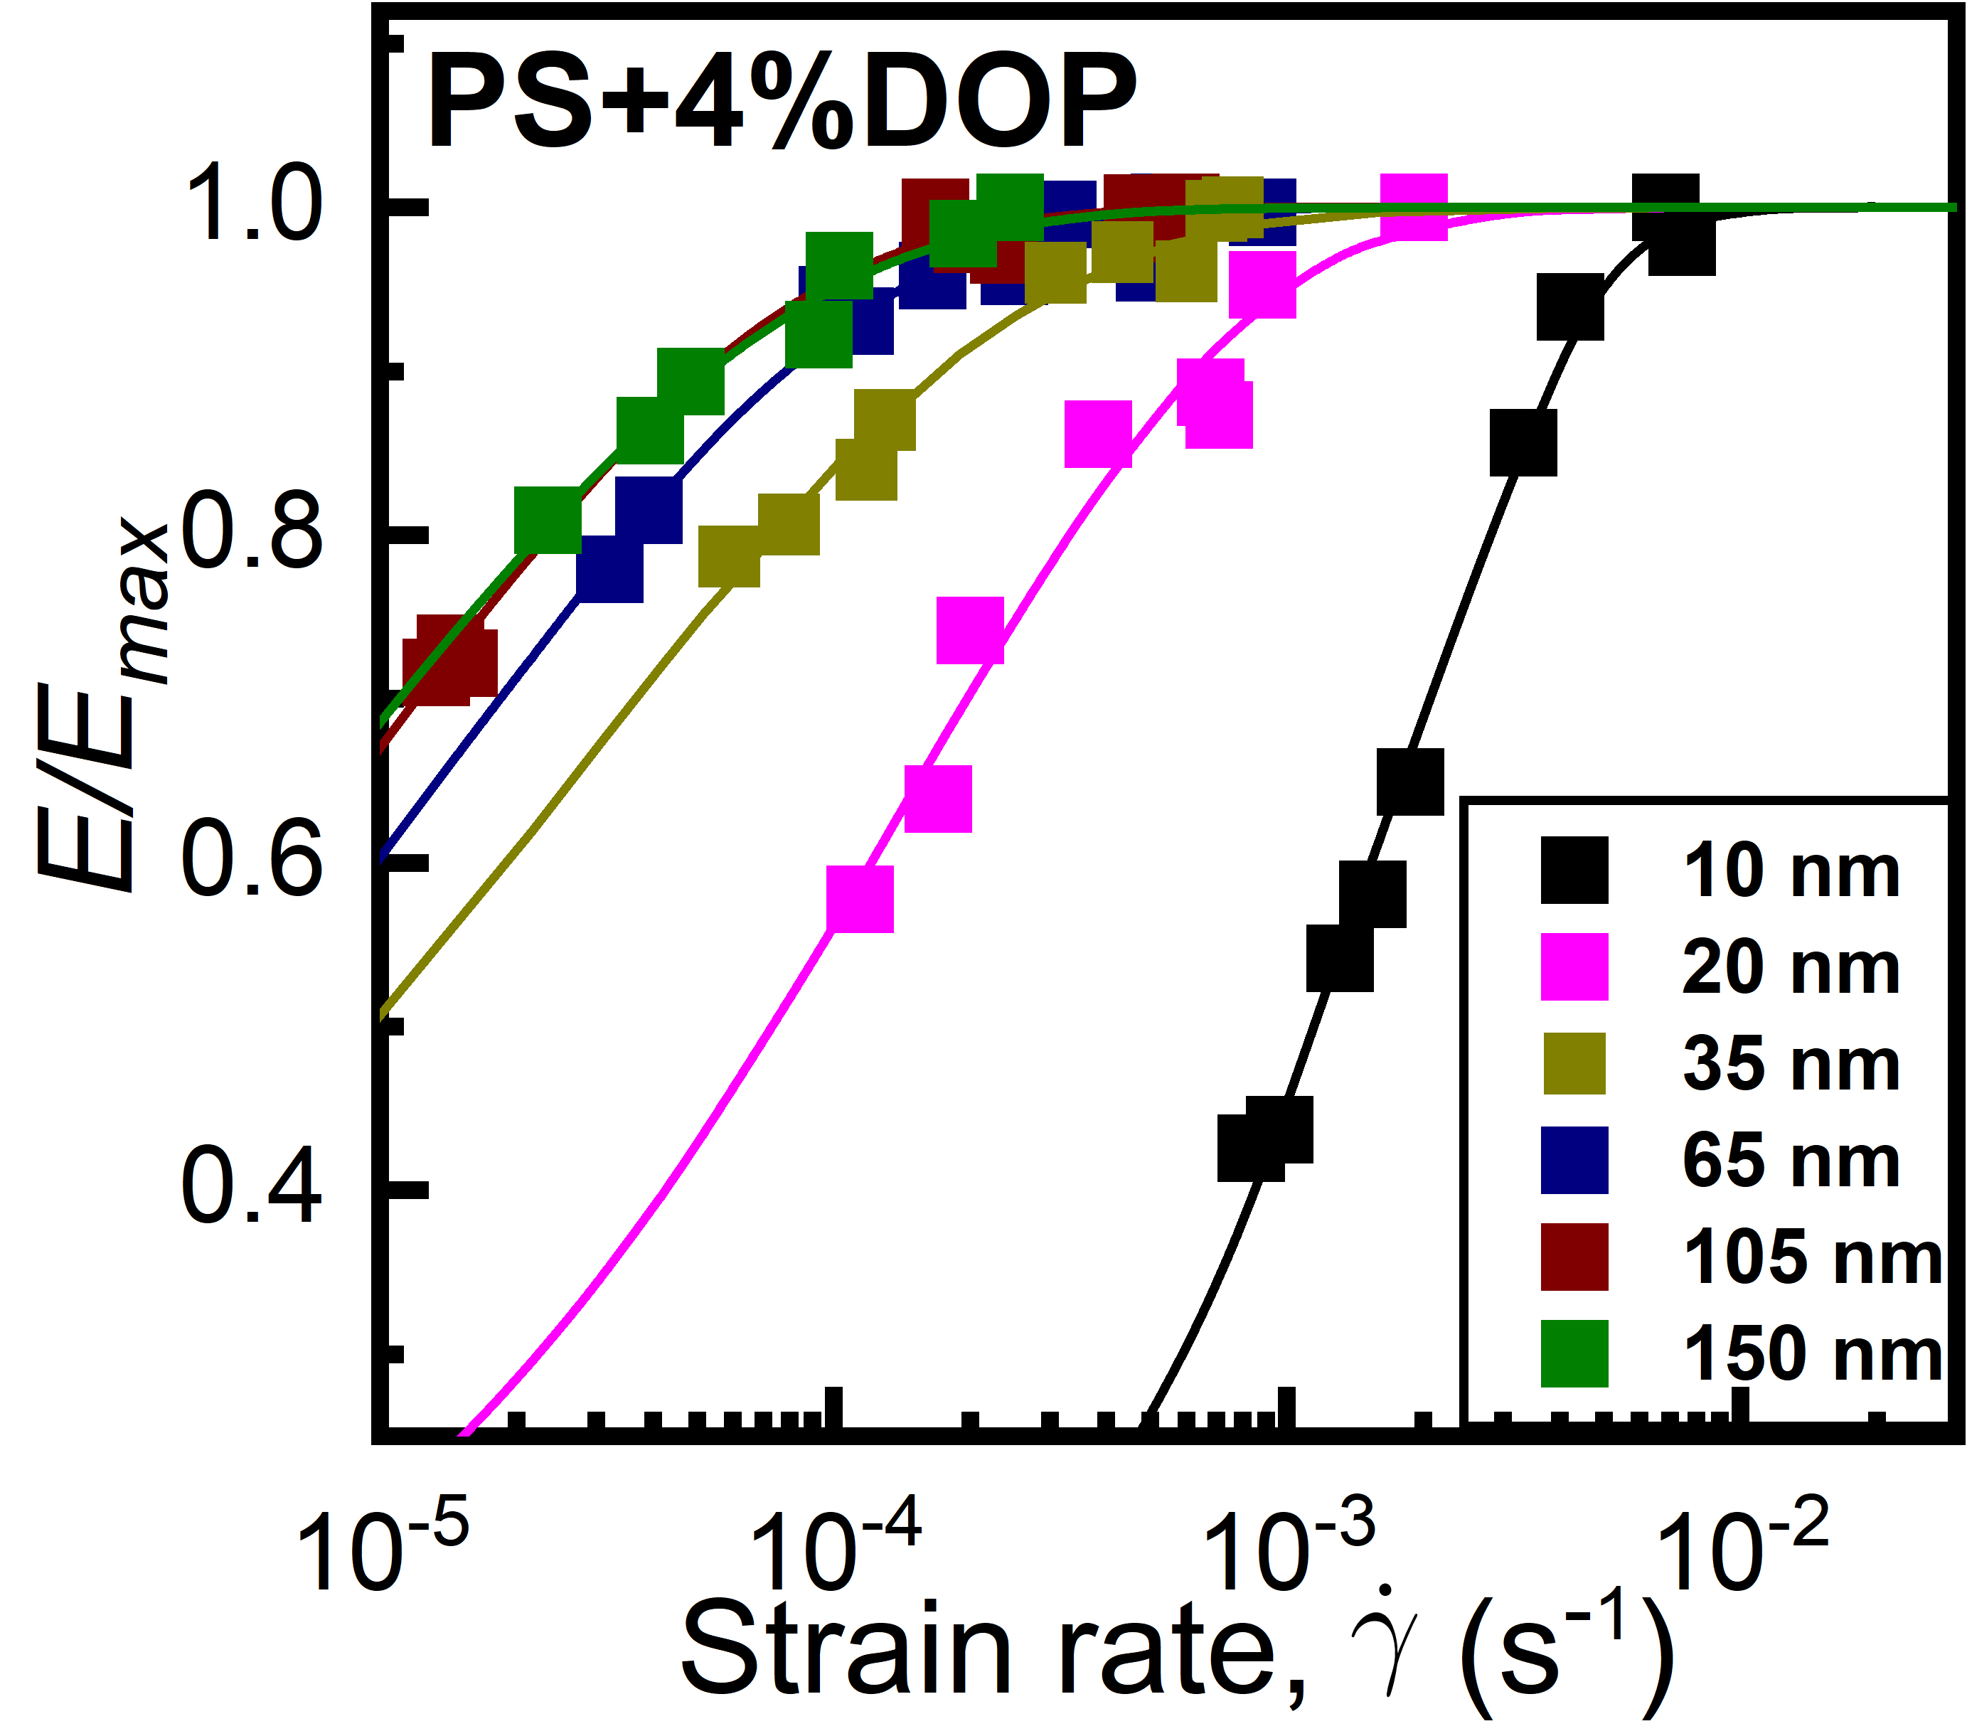
a
b
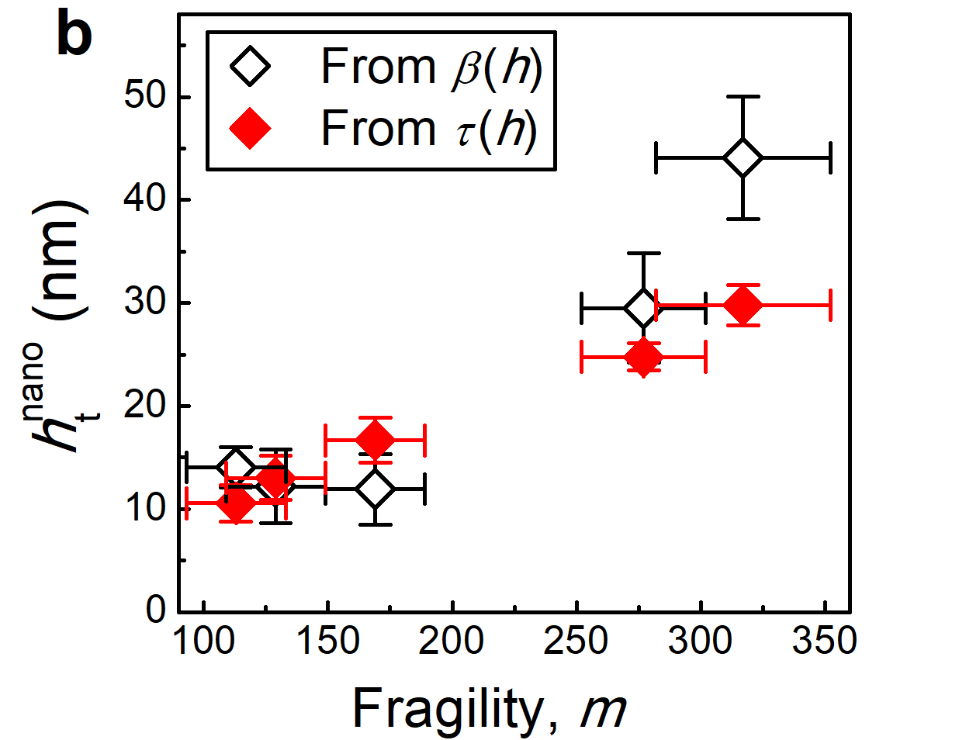
c
d

Supplementary Fig. 2 | Analysis from strain-rate dependent elastic measurements of the polymers studied. a-b Normalized elastic moduli for films of PS+4% DOP and PC, respectively, with varying thicknesses at room temperature. The solid lines represent best fits to Equation (1) in main context. c Plots of stretching exponent versus film thickness for the polymers studied. Dashed lines indicate previously reported data for PS²⁹ and PMMA³⁰. Available under a CC BY-NC 4.0 License. Copyright 2025, Nie et al. c Stretching exponent β plotted versus film thickness h for various polymers. d Surface nanolayer thickness h_{t}^{nano} plotted against fragility m, with data coming from different sources: open diamonds are extracted from c as the thickness at which β becomes independent of h; the red diamonds are obtained from Fig. 1b as the thickness below which τ_{film} becomes constant.

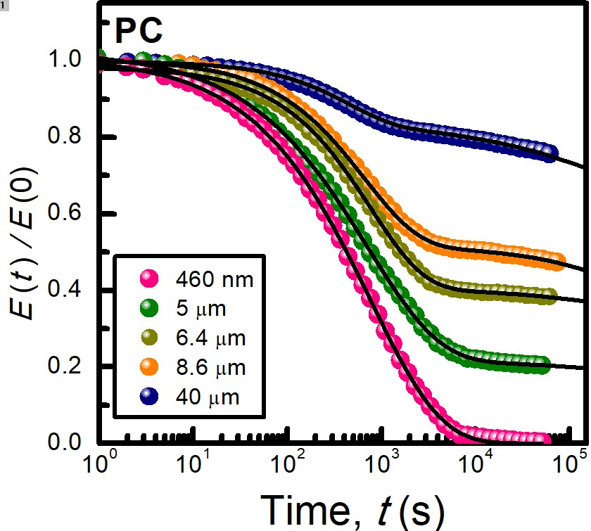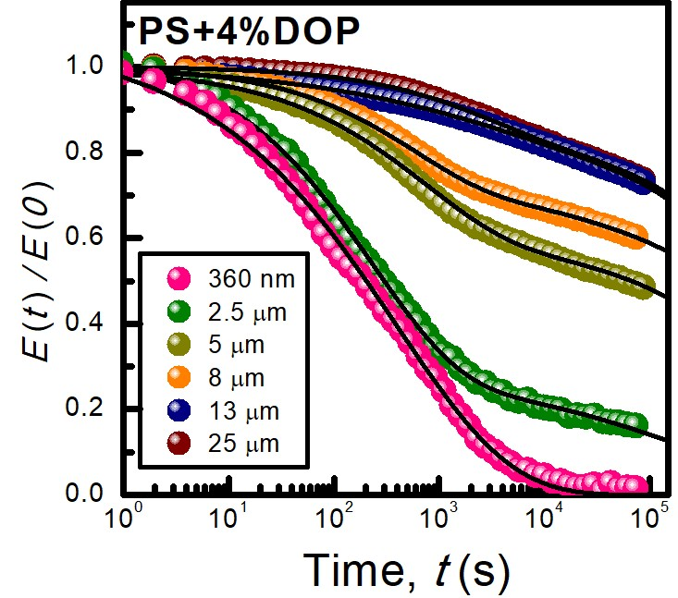
b
a
Supplementary Fig. 3 | Time dependence of the normalized relaxation moduli (${E(t)}/{E_{0}}$) for a PS+4%DOP and b PC at a temperature of 0.89$T_{g}$.

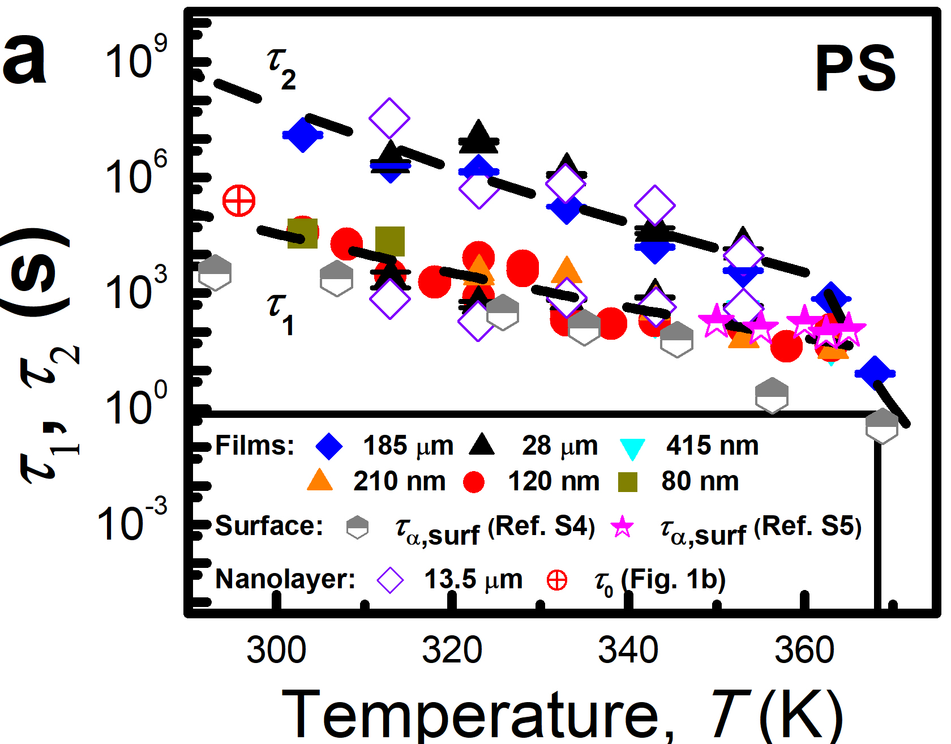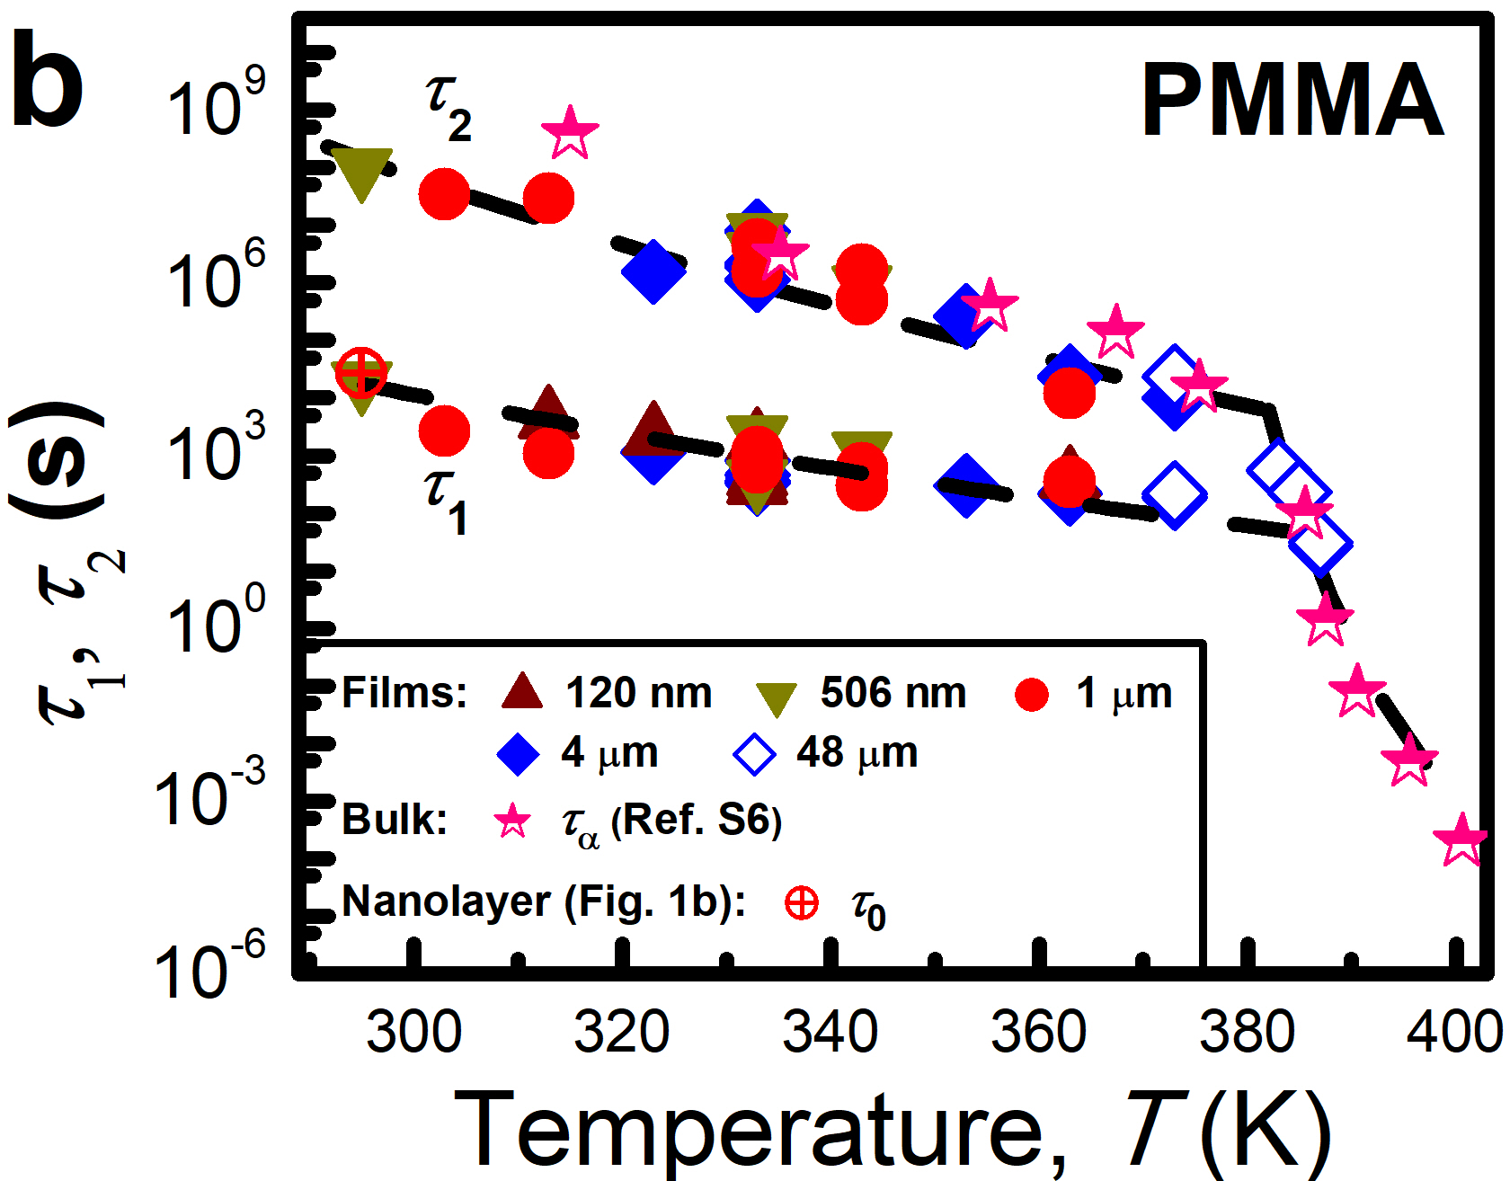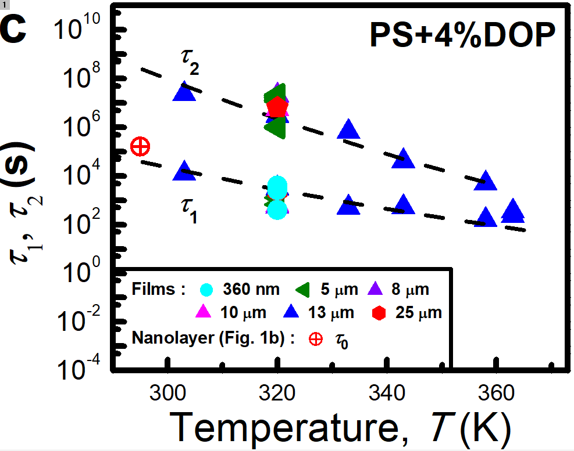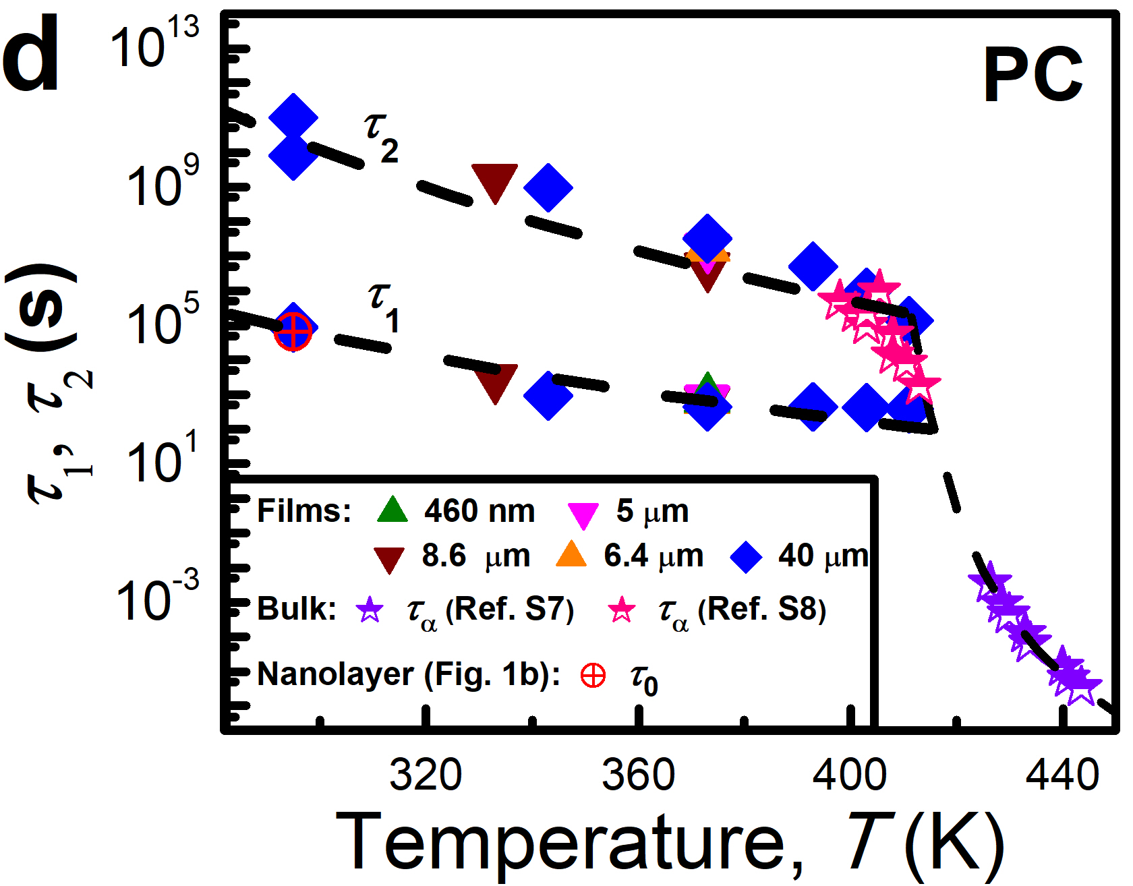
c
Supplementary Fig. 4 | Fast (𝝉_{𝟏}) and slow (𝝉_{𝟐}) relaxation times for films of various polymers as a function of temperature. The polymers include a PMMA, b PS, c PC, and d PVC. The black dashed lines represent Arrhenius fits to the data of 𝜏₁ and 𝜏₂ at temperatures below 𝑇_{𝑔}−10 K, as well as a Vogel-Fulcher-Tammann (VFT) fit (Supplementary Equation (5)) for 𝜏₂ at temperatures above 𝑇_{𝑔}−10 K. The values of 𝜏₁ and 𝜏₂ at room temperature (~295 K) for each polymer were obtained by extrapolating the Arrhenius fits of their temperature-dependent data to ~295 K. The structural relaxation times (𝜏_{𝛼}) of the surface and the bulk, as reported in literature within a wide 𝑇 range (half-filled symbols) if available, are included to demonstrate alignment with our findings. Among these data, Supplementary Reference 4 (Ref. S4 in a) was adapted with permission. Copyright 2008 by the American Association for the Advancement of Science. Supplementary Reference 5 (Ref. S5 in a) was adapted with permission. Copyright 2011 by The American Chemical Society. Supplementary Reference 6 (Ref. S6 in b) was adapted with permission. Copyright 1952, Elsevier Inc. Supplementary Reference 7 (Ref. S7 in d) was adapted with permission. Copyright 1966, Wiley Periodicals, Inc. Supplementary Reference 8 (Ref. S8 in d) was adapted with permission. Copyright 2001, by Elsevier Science Ltd.

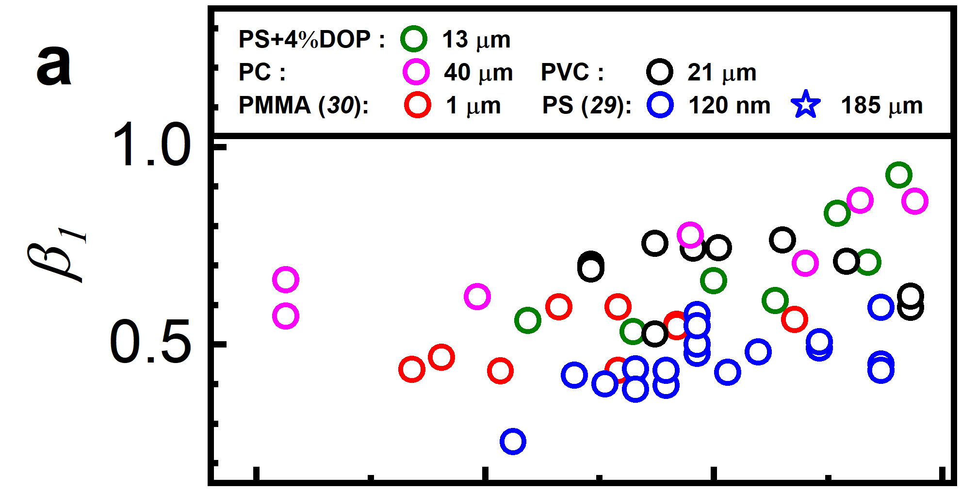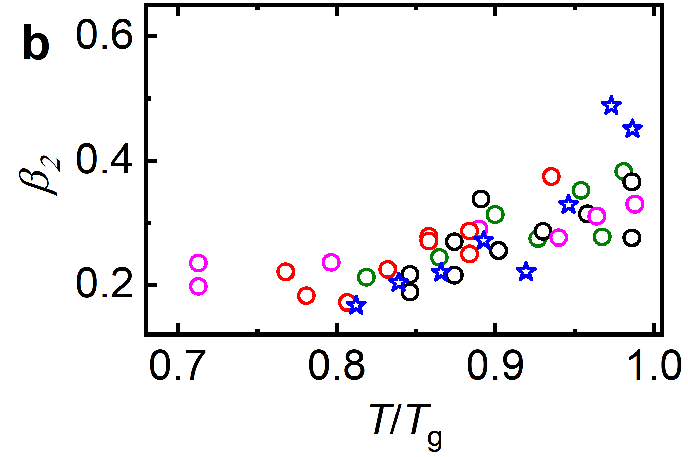

Supplementary Fig. 5 | Plots of β₁ (a) and β₂ (b) of the polymers studied as a function of temperature (T) normalized by the polymer’s T_{g}.

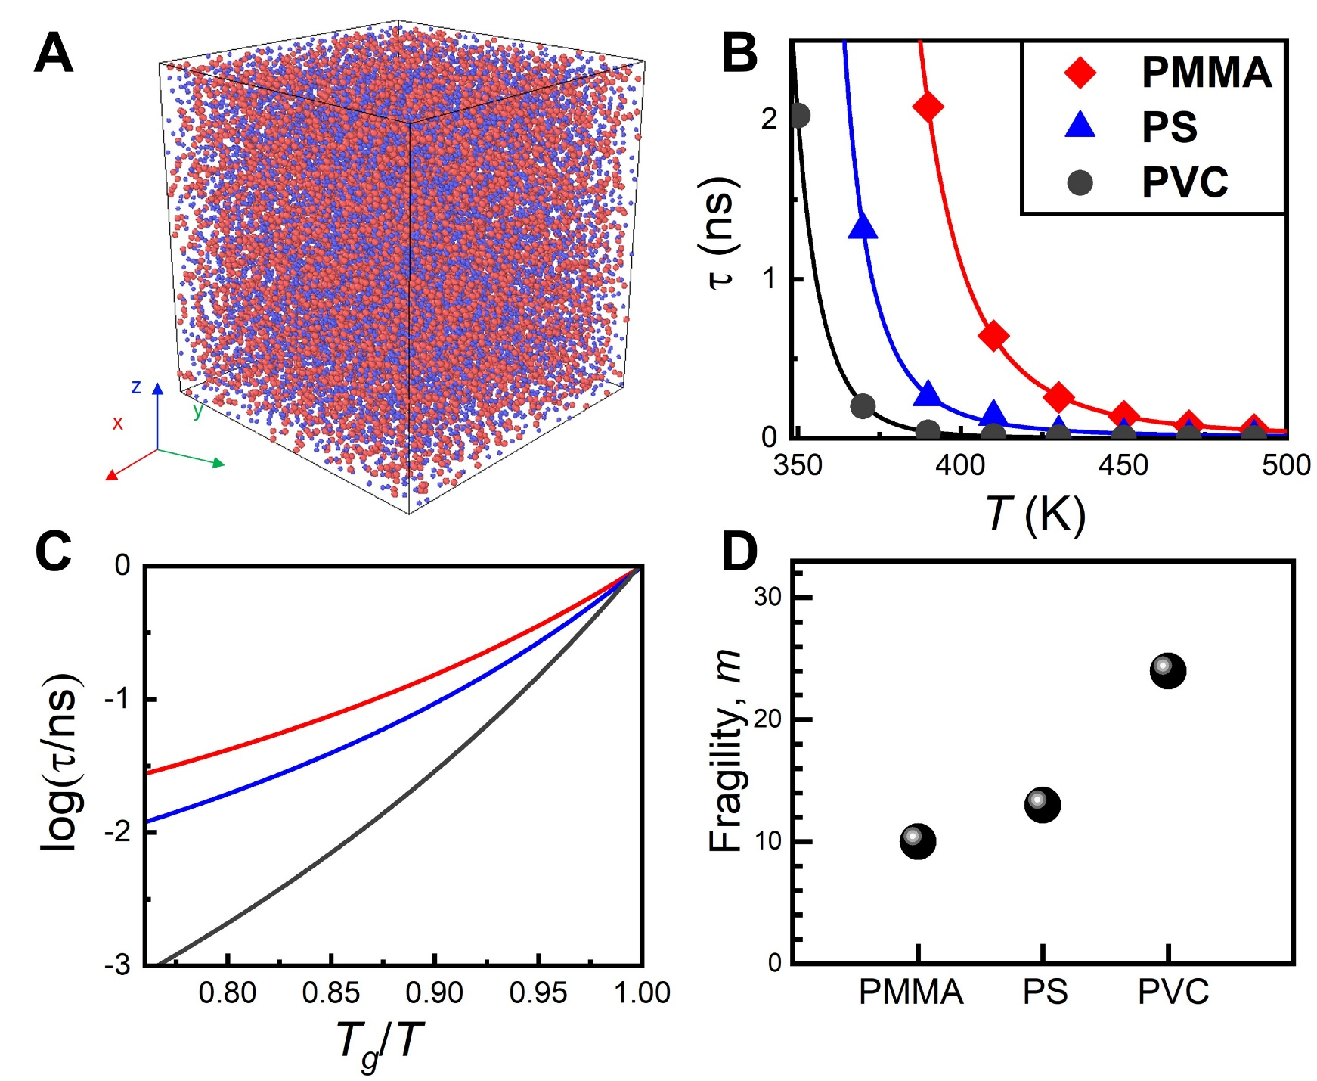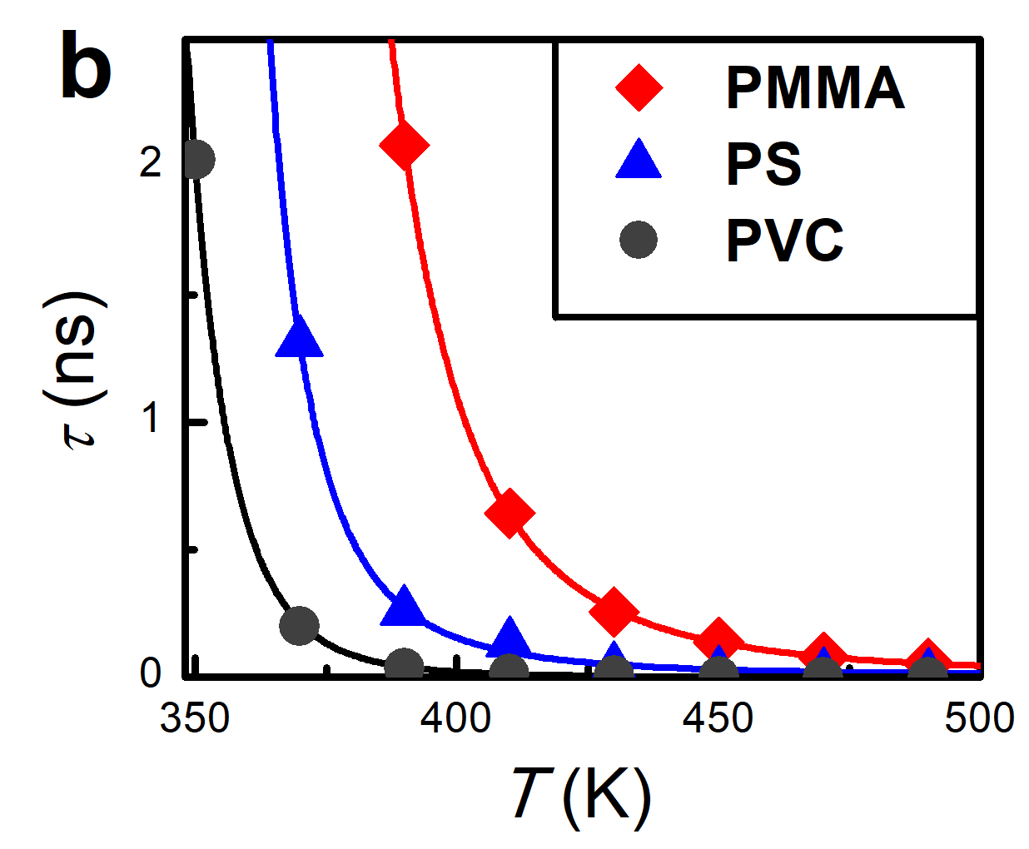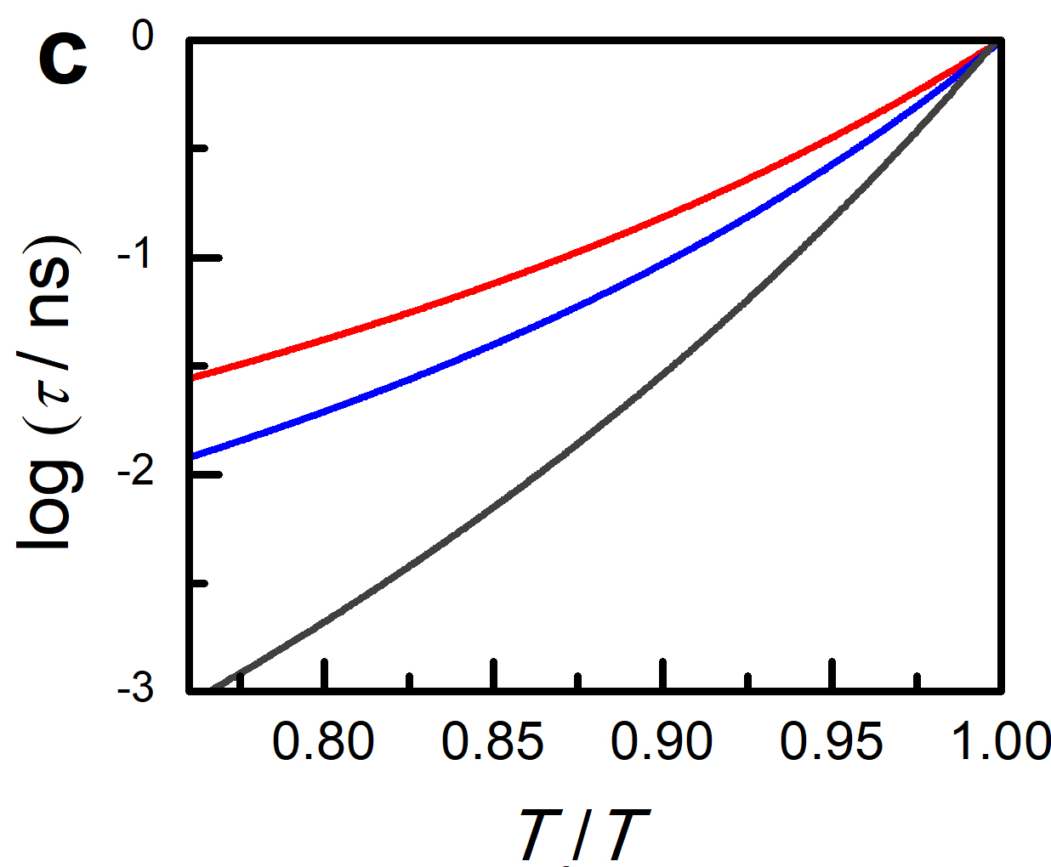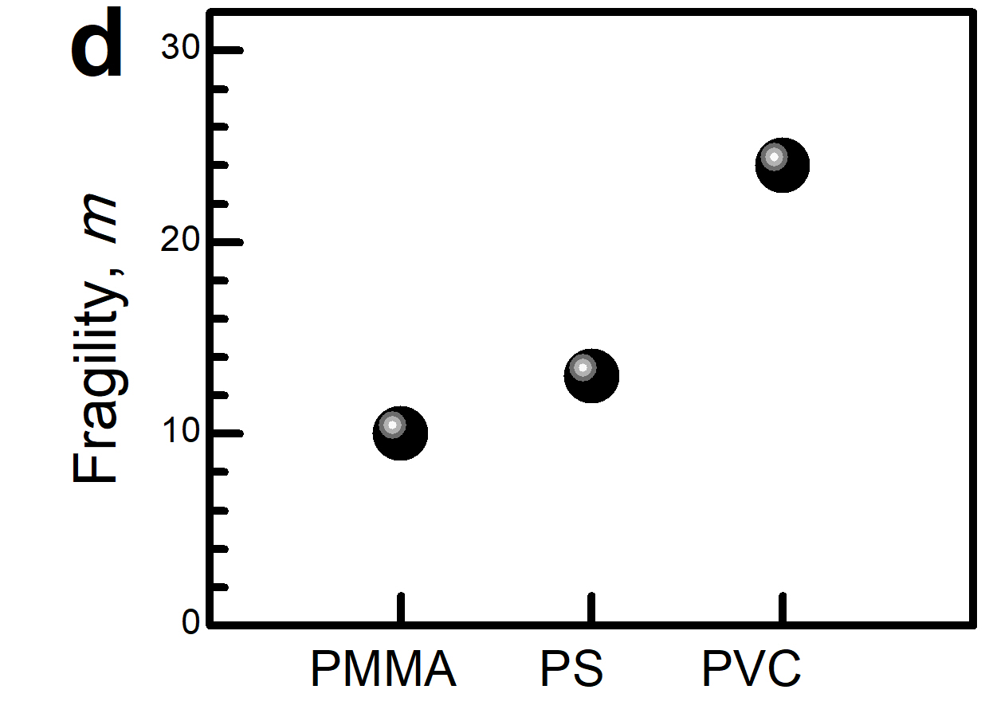
a
Supplementary Fig. 6 | Determination of fragility ($m$) for CG models of PMMA, PS, and PVC using their $τ(T)$ data. a A representative bulk CG-model used to compute the structural relaxation time of the polymer system. b, Plots of 𝜏 as a function of temperature T for various polymers. The solid lines represent the best fits to Supplementary Equation (5). c Data from b replotted as log 𝜏 verses ${T_{g}}/T$, where $T_{g}$ refers to the $T_{g,CG}^{bulk}$ values listed in Table 2. d The computed fragility values for PMMA, PS and PVC, derived from the data in c.

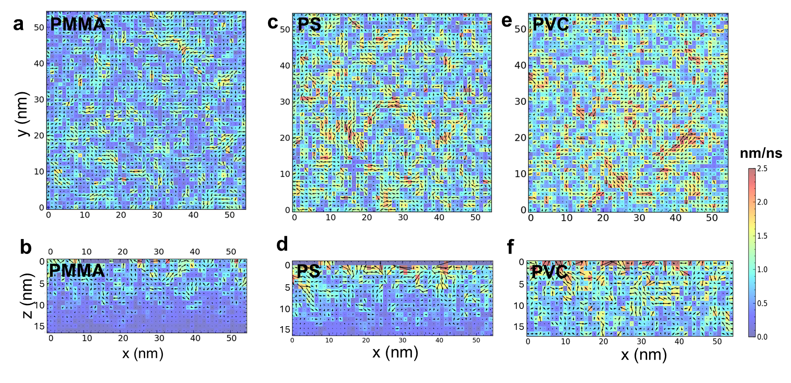
Supplementary Fig. 7 | The average velocity fields for the three polymers studied. The top panels show the $x$-$y$ cross-sections at 1 nm below the top boundary, while the bottom panels show the $x$-$z$ cross-sections at y = 0 of these fields. The previously published data for PMMA and PS ³ are available under a CC BY-NC 4.0 License. Copyright 2025, Nie et al.

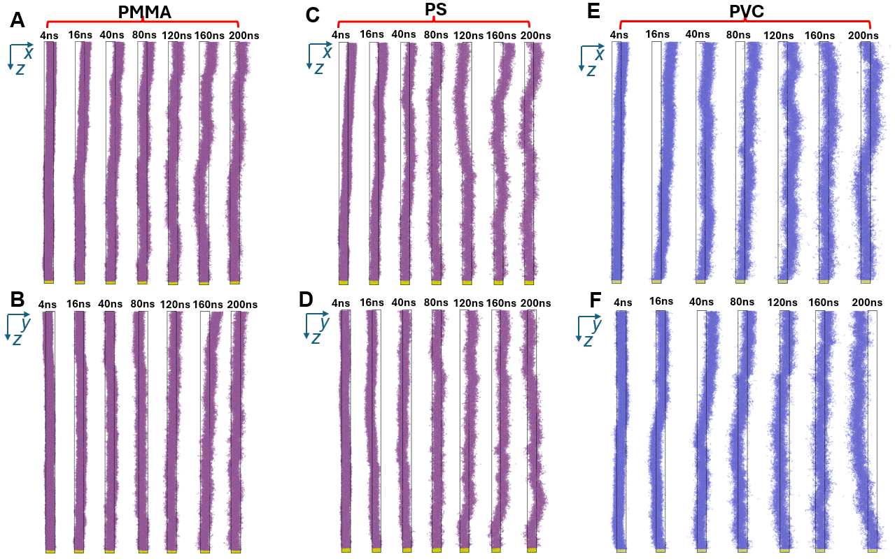
a
c
e
b
d
f

Supplementary Fig. 8 | Side-view snapshots of the slender model after various time intervals for three polymers. a–b, Time evolution of the model for PMMA, viewed along the $y$ (a) and $x$ (b) axes. c–d, Time evolution of the model for PS, viewed along the $y$ (c) and $x$ (d) axes. e to f, Time evolution of the model for PVC, viewed along the $y$ (e) and $x$ (f) axes.

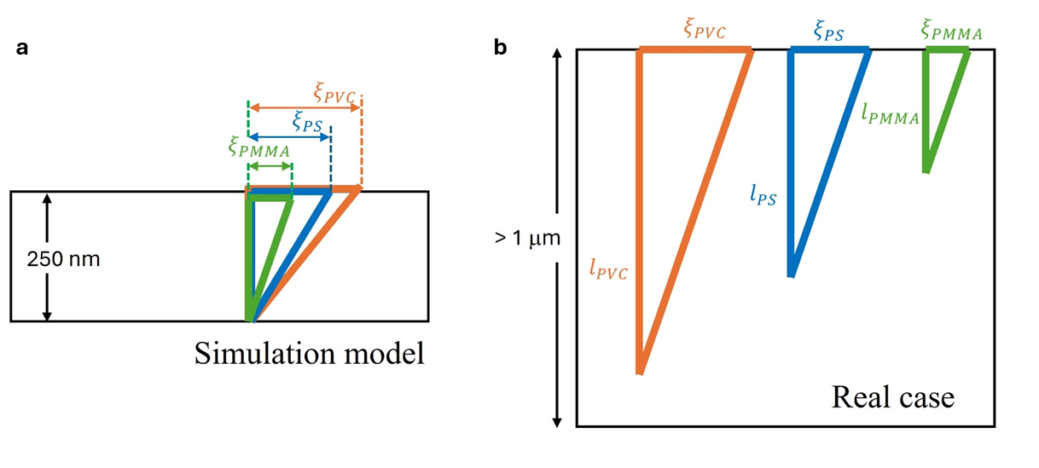

Supplementary Fig. 9 | Illustration of the COM displacement field in a shear excitation mode for the three simulated polymer models. a Simulation model: due to simulation constraints, the model thickness (h) is set to 250 nm, which is smaller than the intrinsic propagation distance ($l$) of the shear mode, causing the shear mode to terminate at the substrate. Consequently, the observed value of $l$ equals the system thickness. b Experimental (real) case: the system thickness exceeds the intrinsic length of the longest shear mode. So, shear propagation terminates naturally before reaching the substrate. The assumption that ξ ~ l aligns with the experimentally observed scaling between the surface relaxation rate and h_{t} or $h_{t}^{nano}$(Fig. 7b) and the simulated scaling between the surface velocity and $h_{t}^{nano}$ (lower panel of Fig. 7a).

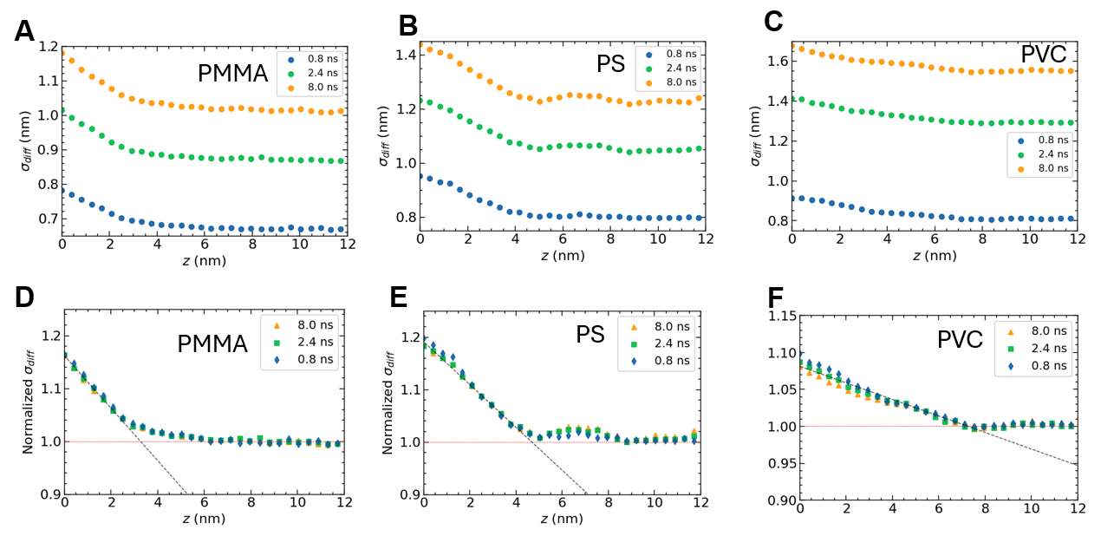
a
b
c
d
e
f

Supplementary Fig. 10 | Depth (z) profiles of the diffusive displacement ($σ_{diff}$) for the studied polymers. The upper panels display the depth profiles of $σ_{diff}$ at different times: 8.0, 2.4, and 0.8 ns. The lower panels show the same data normalized to the bulk value of $σ_{diff}$. The black and red straight lines represent the best fits for the near-surface and bulk regions, respectively. In all panels, $z$ = 0 indicates the position of the free surface.

PS+4%DOP:
h (nm) | E_{max} (GPa)
10 | 2.80 ± 0.13
20 | 2.86 ± 0.02
35 | 2.91 ± 0.02
65 | 3.00 ± 0.08
105 | 3.05 ± 0.02
150 | 3.03 ± 0.04

h (nm) | E_{max} (MPa)
15 | 2.11 ± 0.12
25 | 2.21 ± 0.14
65 | 2.29 ± 0.07
140 | 2.34 ± 0.08
190 | 2.38 ± 0.02

PC:

h (nm) | E_{max} (MPa)
41 | 2.70 ± 0.09
65 | 2.84 ± 0.11
94 | 2.89 ± 0.08
133 | 2.93 ± 0.03
189 | 2.98 ± 0.05
PVC:

Supplementary Table 1 | Lists of maximum elastic moduli ($E_{max}$) used to obtain the normalized data presented in Fig. 1 and Supplementary Fig. 1. The samples are films of PS+4%DOP, PC and PVC and the temperature is 295 K.

Polymers | Monomer  formula | # of atoms (all atoms) | # of heavy atoms | # of CG beads | mapping ratio
PVC | C₂H₃Cl | 6 | 3 | 1 | 3:1
PS | C₈H₈ | 16 | 8 | 2 | 4:1
PMMA | C₅H₈O₂ | 15 | 7 | 2 | 3.5:1

Supplementary Table 2 | Mapping ratios of PVC, PS and PMMA.

Supplementary References

1. Kwansa AL, et al. Molecular mechanism of plasticizer exudation from polyvinyl chloride. Macromolecules 56, 4775-4786 (2023).

2. Fulcher GS. Analysis of recent measurements of the viscosity of glasses. J Am Ceram Soc 8, 339-355 (1925).

3. Nie H, Chen X, Ma Z, Zhang R, Tsui OK. Exploring Long-Range Surface-Induced Mobility Enhancement in Poly (methyl methacrylate). Macromolecules 58, 10937-10947 (2025).

4. Fakhraai Z, Forrest JA. Measuring the Surface Dynamics of Glassy Polymers. Science 319, 600-604 (2008).

5. Paeng K, Swallen SF, Ediger MD. Direct Measurement of Molecular Motion in Freestanding Polystyrene Thin Films. J Am Chem Soc 133, 8444-8447 (2011).

6. McLoughlin JR, Tobolsky AV. The viscoelastic behavior of polymethyl methacrylate. J Colloid Sci 7, 555-568 (1952).

7. Matsuoka S, Ishida Y. Multiple Transitions in Polycarbonate. J Polym Sci, Part C: Polym Symp 14, 247-259 (1966).

8. Heymans N, Dequenne B. Relationship between conformation and enthalpy or volume relaxation in polycarbonate. Polymer 42, 5337-5342 (2001).

