Fluorescent Sensing Platform Based on Nitrogen-Doped Carbon Dots for Selective Detection of Sulfur Dioxide Derivatives
Xiaojing Wu¹, Rulin jia², Chang Liu², Hongda Li^{*, 2, 3}, Rui Zhang*^{, 4}
1. Institute of Functional Molecules, Shenyang University of Chemical Technology, Shenyang, 110142, China.
2. Department of Forensic Chemistry, Criminal Investigation Police University of China, Shenyang 110035, China.
3.Criminal Investigation Detachment, Shenyang Public Security Bureau, Shenyang 110000, China.
4. Shenyang Key Laboratory of Medical Molecular Theranostic Probes in School of Pharmacy, School of Pharmacy, Shenyang Medical College, Shenyang, 110034, China
*Corresponding author: E-mail: lhd870821@163.com (for Hongda Li); ruizhang@symc.edu.cn (for Rui Zhang).

1. Quantum Yield (QY) of d-CDs
The quantum yield (QY) of the d-CDs was determined by comparing their fluorescence intensity and absorbance with those of quinine sulfate. To minimize reabsorption effects, the absorbance of the d-CDs sample in a 10 mm fluorescence cuvette was maintained below 0.05 at the excitation wavelength. Quinine sulfate (QY = 0.54) dissolved in 0.1 mol/L H₂SO₄(refractive index = 1.33) was used as the standard reference, while the d-CDs were dissolved in ultrapure water (refractive index = 1.33). The quantum yield of the d-CDs was calculated as shown in Equation (1):
$\text{Q}{\text{Y}}_{\text{C}}\text{=}\text{Q}{\text{Y}}_{\text{R} }\left(\frac{{\text{I}}_{\text{C}}{\text{A}}_{\text{R}}}{{\text{I}}_{\text{R}}{\text{A}}_{\text{C}}}\right)\text{×}{\left(\frac{{\text{η}}_{\text{R}}}{{\text{η}}_{\text{C}}}\right)}^{\text{2}}$ (1)
The quantum yield (QY) was calculated using Equation (1):QY = quantum yield; I = integrated emission intensity of the measured luminescence spectrum; A = absorbance measured at the excitation wavelength using a UV-vis spectrophotometer; η = refractive index of the solvent; R = standard reference for QY; C = d-CDs sample.

2. Figures
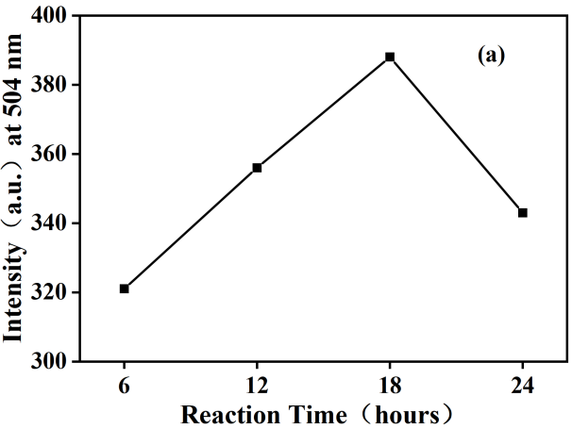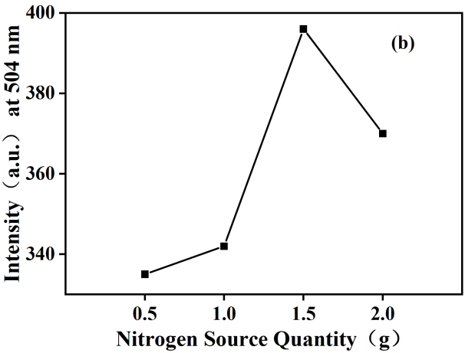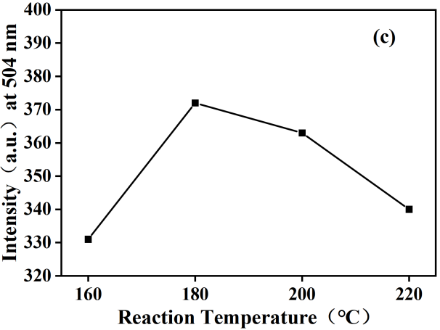
Figure S1. The fluorescence intensity of d-CDs as a function of key synthesis parameters: (a) reaction time, (b) amount of nitrogen source, and (c) reaction temperature.
Figure S2 a) UV-VIS absorption spectra and b) fluorescence intensity and fluorescence spectra of d-CDs at different excitation wavelengths

3. Tables
Table S1. Comparison with existing sulfite detection methods
Carbon source | Detection limit  (μmol·L⁻¹) | Yield  (%) | Cite
Glycine, urea | 0.25 | 12.2 | [1]
3-formyl-4-hydroxybenzoic acid | 0.45 | 11 | [2]
Serine, polyethylene glycol | 0.24 | 12.9 | [3]
Malonic acid, barbituric acid | 0.22 | 23.2 | This paper

[1] P. Wang, Y. Zhang, Y. Liu, X. Pang, P. Liu, W.-F. Dong, Q. Mei, Q. Qian, L. Li, R. Yan, Starch-Based Carbon Dots for Nitrite and Sulfite Detection, Front. Chem. 9 (2021) 782238. https://doi.org/10.3389/fchem.2021.782238.
[2] X. Pan, Y. Zhong, Y. Jiang, G. Zuo, J. Li, W. Dong, Reaction-based fluorescent sensor for detection of bisulfite through 1,4-addition reaction in water, Mater. Chem. Phys. 213 (2018) 83–88. https://doi.org/10.1016/j.matchemphys.2018.04.008.
[3] Z. Liu, L. Chen, Q. Wang, R. Yang, X. Hu, H. Liu, J. Li, Y. Liu, Novel fluorescent recoverable probe based on carbon quantum dots/polypyrrole composite for the simultaneous determination of chromium(VI) and sulfite, J. Mol. Struct. 1247 (2022) 131409. https://doi.org/10.1016/j.molstruc.2021.131409.

