Supplementary files

Title:
Carbon cloth electrode for electrochemical synthesis of ammonia from nitrogen and water without any catalyst under ambient temperature and pressure

Author:
Seiji Tanahashi¹, Kaku Uehara^{2,3}*, and Masakazu Tanahashi¹

¹Tanah Process Ltd.: 541-0045 Dosho-machi 1-2-11, Chuoh-ku, Osaka City, Japan
tanahashi.seiji@tanap.jp, tanahashi.masakazu@tanap.jp

²Uehara Research Institute of Advanced Science and Technology: 590-0134 Miikedai 4-19-2, Minami-ku, Sakai, Osaka, Japan
kaku_uehara@yahoo.co.jp
³Emeritus Professor of Osaka Prefecture University
*Author for correspondence

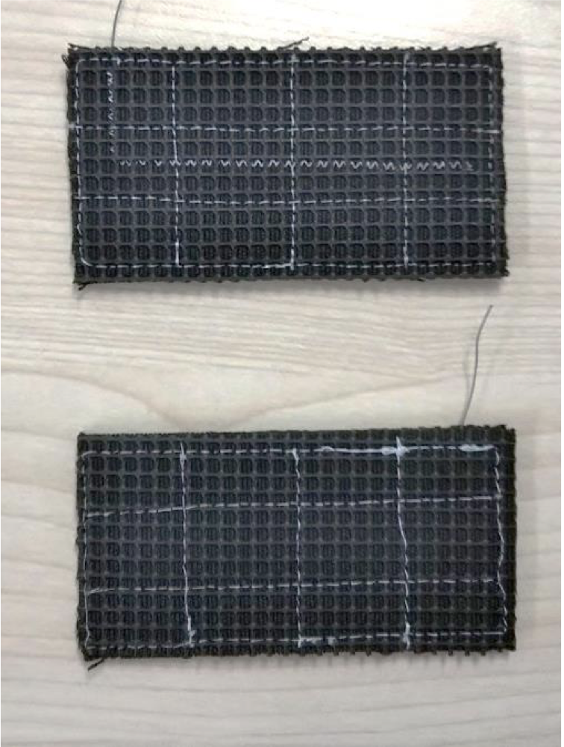

Figure S1 High surface area porous activated carbon cloth electrode.

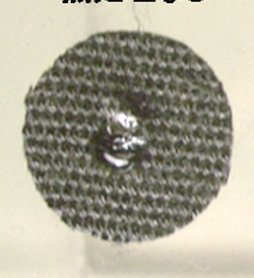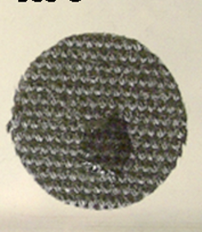
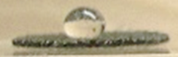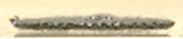
Before After (900℃)

Figure S2 Before and after heat treatment of carbon cloth.

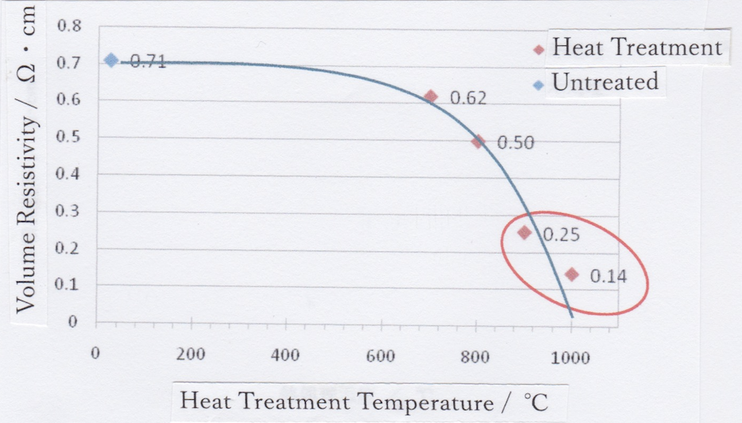

Figure S3 Volume resistivity of the high surface area porous activated carbon cloth before and after heat treatment at various temperature.

Table S1 The raw data of Figure 2

 | pH=0 | pH=2 | pH=4
blue dashed line | 0.10 volt | 0.10 volt | 0.10 volt
red dashed line | -0.14 volt | -0.14 volt | -0.14 volt

Table S2 The raw data of Figure 3

volt | -3.53 | -3.04 | -2.84 | -1.50 | 2.84 | 3.04 | 3.53
NH₃mmol | 2.7 | 2.1 | 1.2 | 0.05 | - | - | -
H₂ ppm | 0.05 | 0.02 | 0 | 0 | - | - | -
O₂ ppm | - | - | - | - | 0 | 0.01 | 0.025

Table S3 The raw data of Figure S3

HeatTemper  ature ℃ | 25 | 700 | 800 | 900 | 1000
VolumeResis  tivity Ωcm | 0.71 | 0.62 | 0.50 | 0.25 | 0.14

