Supporting Information

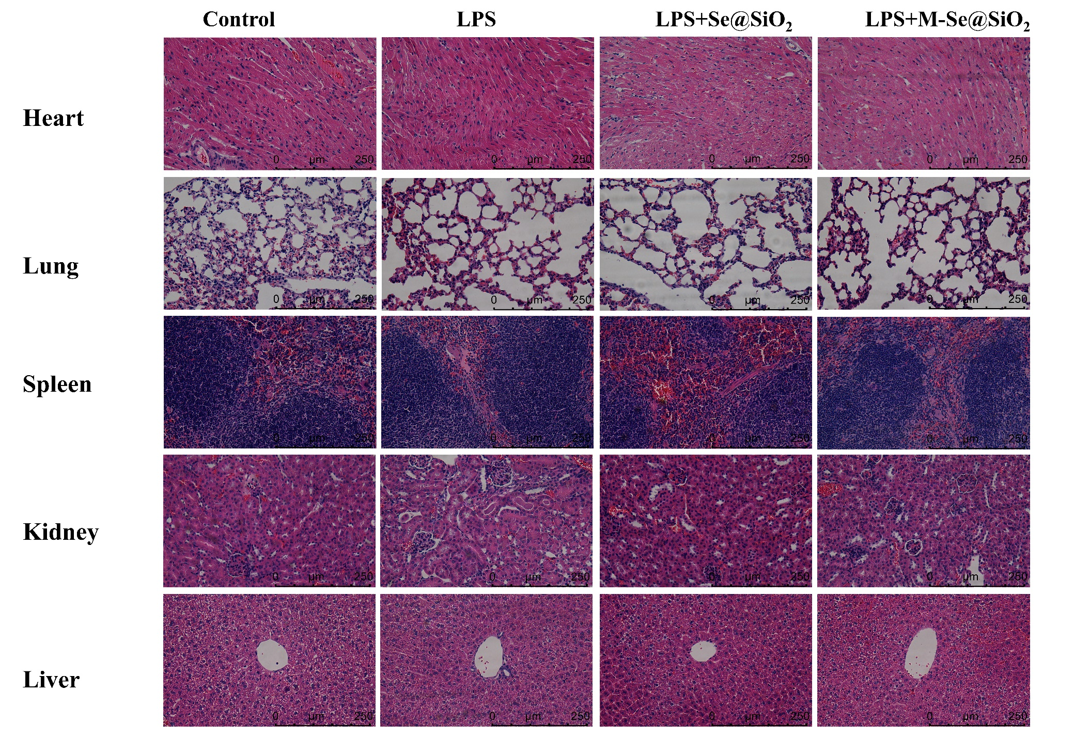
Figure S1. Evaluation of the biocompatibility of each group with major organs. H&E staining shows excellent biocompatibility in in vivo experiments of nanoparticles.

Figure S2. Representative image of SDS gel showing protein bands of different nanoparticles

Gene | primer sequences (5’ to 3’)
CD86 | F:ACGGAGTCAATGAAGATTTCCT  R:GATTCGGCTTCTTGTGACATAC
iNOS | F:CACCTTGGAGTTCACCCAGT  R:ACCACTCGTACTTGGGATGC
CD206 | F:CCTATGAAAATTGGGCTTACGG  R:CTGACAAATCCAGTTGTTGAGG
ARG-1 | F:CARGGGCAACCTGTGTCCTT R:TCCTGGTACATCTGGGAACTTTC
BMP-2 | F:AGTAGTTTCCAGCACCGAATTA  R:CACTAACCTGGTGTCCAATAGT
OCN | F:ACCGCCTACAAACGCATCTA R:AGAGGACAGGGAGGATCAAGT
OPN | F:CTTGAGCATTCCAAAGAGAGC R:CTTGTGGCTGTGAAACTTGTG
β-actin | F:CTACCTCATGAAGATCCTGACC  R:CACAGCTTCTCTTTGATGTCAC
Table S1. Primers for RT-PCR used to quantify the expression of BMDM and BMSC cells

