Supplementary Tables
Table 1. Baseline characteristics of children in the training and test datasets for the Grasp of Cereal task.
Variables | Training set (n=37) | Test set (n=27)
Age (years) | 5.41±1.46 | 5.74±1.13
Gender (male:female) | 30 (81) : 7 (19) | 19 (70) : 8 (30)
CP type
Spastic, bilateral | 13 (35) | 8 (29)
Spastic, unilateral | 22 (59) | 17 (61)
Dyskinetic | 1 (3) | 1 (4)
Ataxic | 1 (3) | 1 (4)
MACS level  (I:II:III:IV: V) | 1 (3) : 15 (41) : 20 (54)  : 1 (3) : 0 (0) | 1 (4) : 14 (52) : 10 (37)  : 2 (7) : 0 (0)
Values are presented as mean ± standard deviation or number (%), unless otherwise indicated.
Percentages are rounded and may not total 100%.
CP, cerebral palsy; MACS, Manual Ability Classification System.

Table 2. Baseline characteristics of children in the training and test datasets for the Grasp of Cube task.

Variables | Training set (n=41) | Test set (n=39)
Age (years) | 5.54±1.40 | 5.62±1.21
Gender (male:female) | 32 (78) : 9 (22) | 28 (72) : 11 (28)
CP type
Spastic, bilateral | 11 (27) | 11 (28)
Spastic, unilateral | 28 (68) | 26 (67)
Dyskinetic | 1 (2) | 1 (3)
Ataxic | 1 (2) | 1 (3)
MACS level  (I:II:III:IV: V) | 1 (2) : 17 (42) : 22 (54)  : 1 (2) : 0 (0) | 1 (3) : 17 (44) : 19 (49)  : 2 (5) : 0 (0)
Values are presented as mean ± standard deviation or number (%), unless otherwise indicated.
Percentages are rounded and may not total 100%.

Supplementary Figure
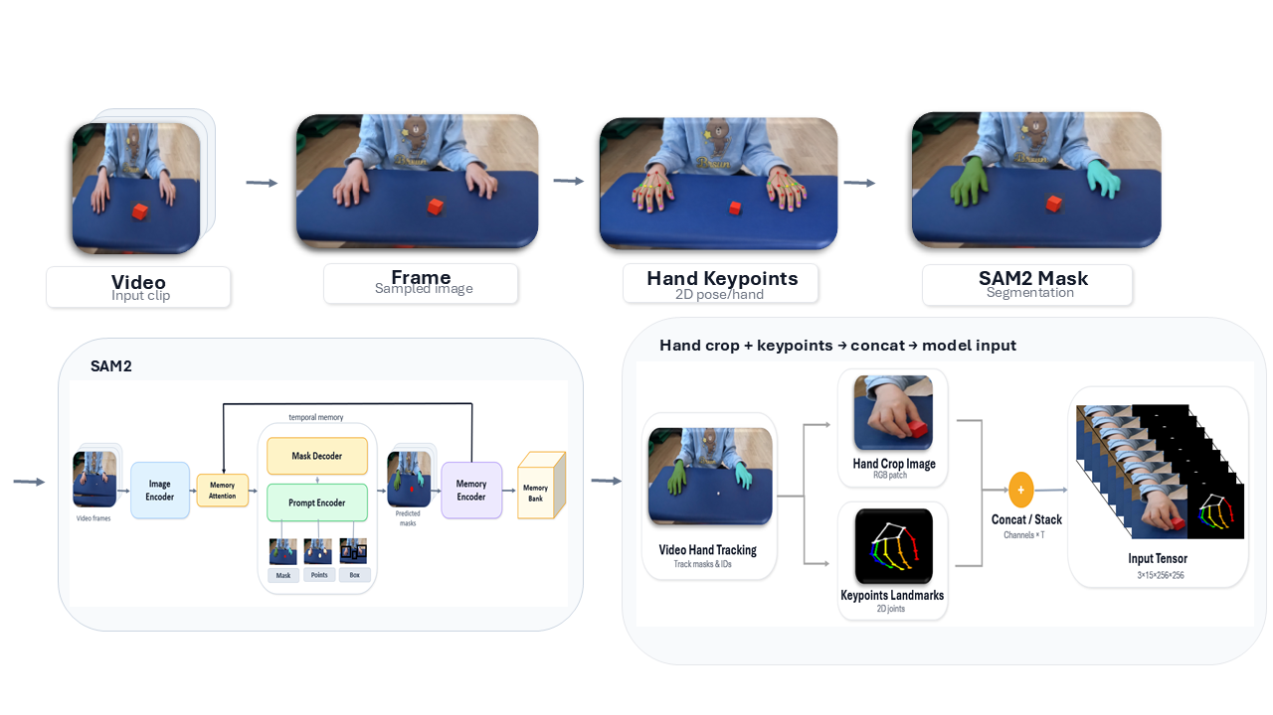
Figure 1. Preprocessing pipeline for hand-centric spatiotemporal input construction, including frame sampling, keypoint extraction, SAM2-based masking, hand-region cropping, and landmark visualization.

