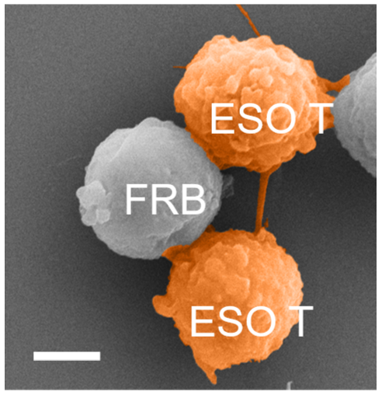
Supplementary figure 1
SEM imaging of the sorted NY-ESO-1-specific T (ESO-T) cells interacting with FRB at 2 hours, forming immunological synapses. Scale bar, 3μm.

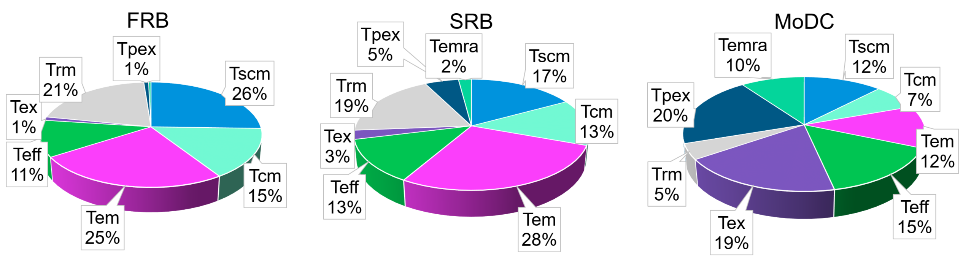
Supplementary figure 2
Pie chart of the percentage of the different cell clusters shown in Figure 3a.

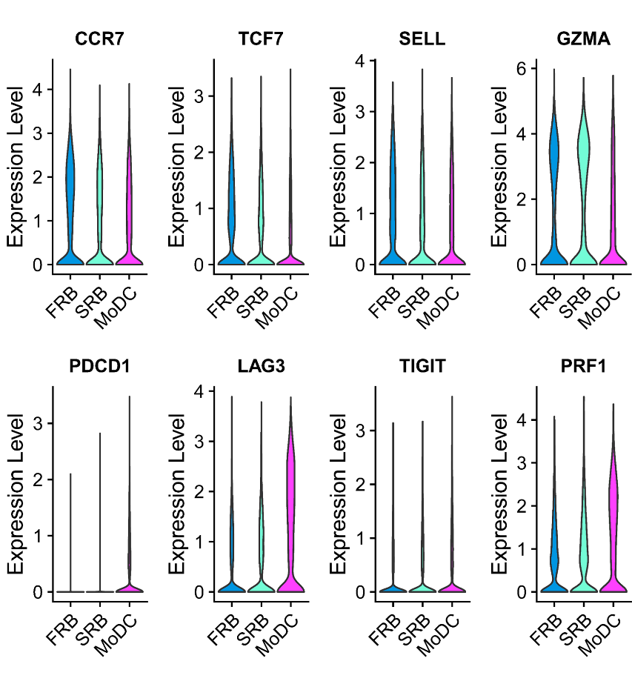
Supplementary figure 3
Violin plots of the gene expression shown in Figure 3c.

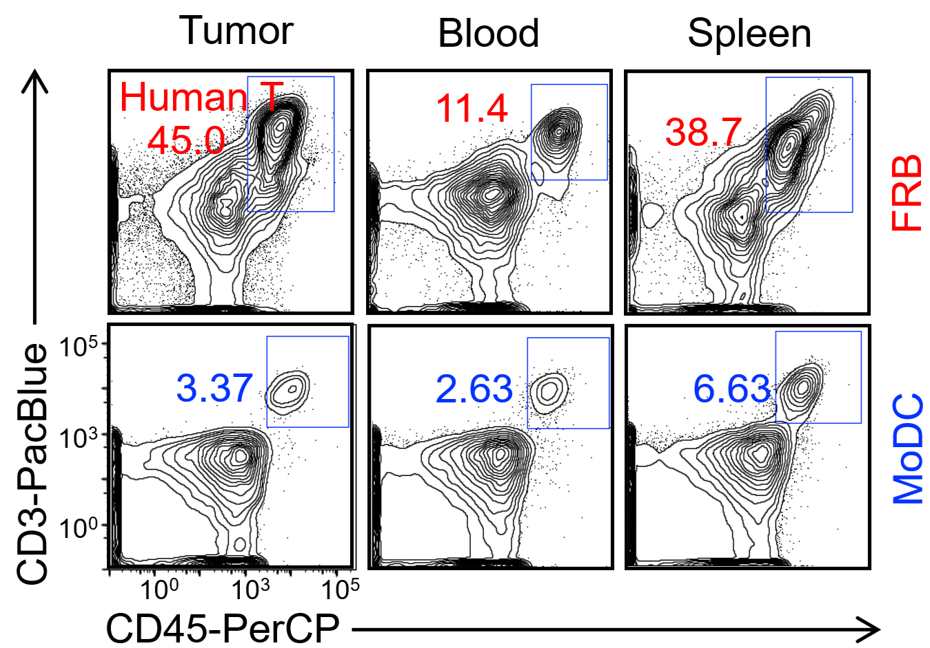
Supplementary figure 4
Representative flow cytometry results of the frequency of human T cells in the tumor, blood, and spleen at day 32.

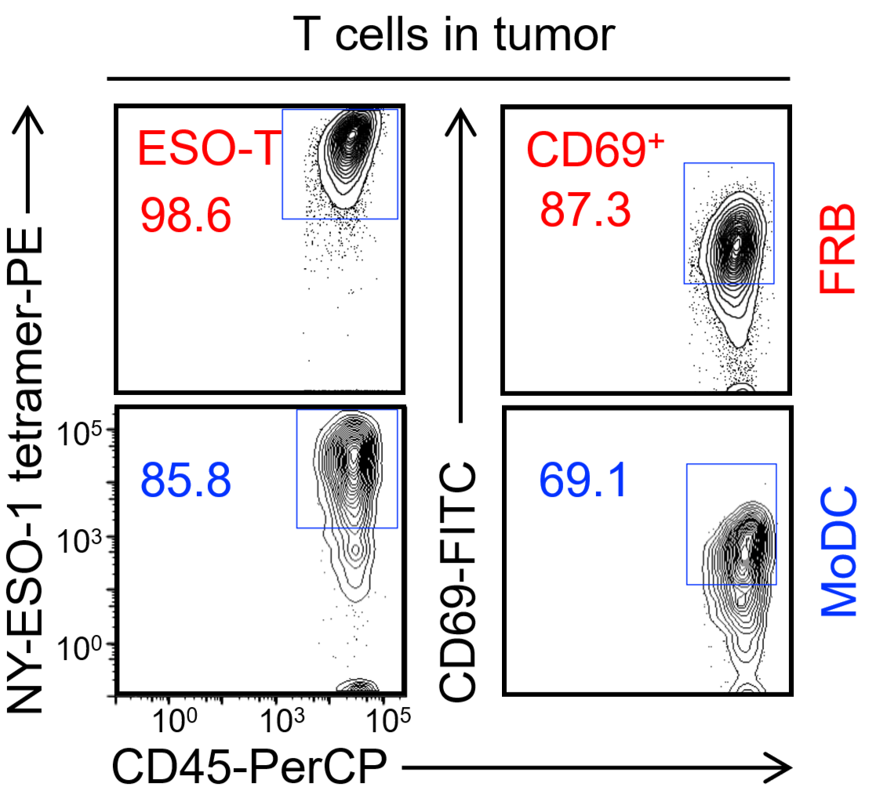
Supplementary figure 5
Representative flow cytometry results of the frequency of human ESO-T cells and CD69⁺ T cells in the tumor at day 32.

