Exploratory Data Analysis of Long-Term Oak Ridge Reservation Meteorological Data for Extreme Weather Event Discovery

Ziwei Liu¹, Kevin Birdwell², Morgan Steckler², and Xiao-Ying Yu^{1,*}
¹ Materials Science and Technology Division, Oak Ridge National Laboratory, Oak Ridge, TN 37830
²Computational Sciences and Engineering Division, Oak Ridge National Laboratory, Oak Ridge, TN 37830
*Corresponding author: Dr. Xiao-Ying Yu, email: yuxiaoying@ornl.gov

Table of Contents
Supporting Figures S-3
Fig. S1. Multi-year Distribution of Temperature Across Towers and Sensor Heights S-3
Fig. S2 Multi-year Time Series from 2017-2022 S-4
Fig. S3 Weekly Sen’s Slope for Vertical Wind Speed S-5
Fig. S4 Weekly Sen’s Slope for Solar Radiation S-6
Fig. S5 Weekly Sen’s Slope for Wind Direction Variability S-7
Fig. S6a Jan – Jun Monthly Spatial Distribution of Sen’s slope for Temperature. S-8
Fig. S6b. July – Dec. Monthly Spatial Distribution of Sen’s slope for Temperature S-9

Supporting Figures
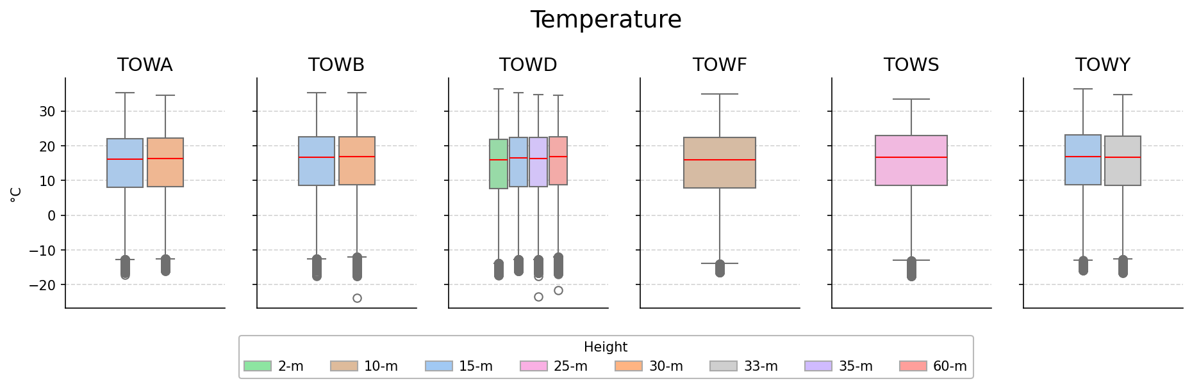

Fig. S1. Multi-year Distribution of Temperature Across Towers and Sensor Heights

Fig. S1 illustrates the annual distribution of temperature measurements collected from six meteorological towers (TOWA–TOWY) at varying sensor heights between 2017 and 2022. This shows that temperatures across all towers share a consistent multi-year range (−20°C to 35°C) with only modest differences among sensor heights, indicating weak vertical gradients and broadly similar microclimatic conditions across the site.

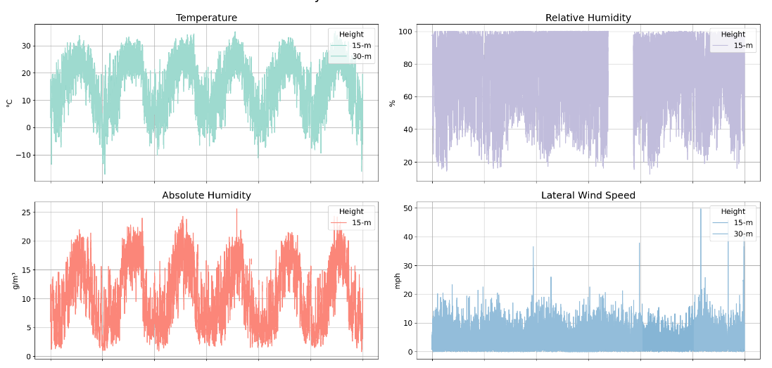

Fig. S2 Multi-year Time Series from 2017-2022
Fig. S2 displays the key meteorological features recorded at Tower A from 2017 to 2022. The temperature and absolute humidity series show clear annual cycles, with summer peaks and winter lows, while relative humidity follows the opposite pattern. Wind speed metrics exhibit strong short-term variability and occasional seasonal increases.

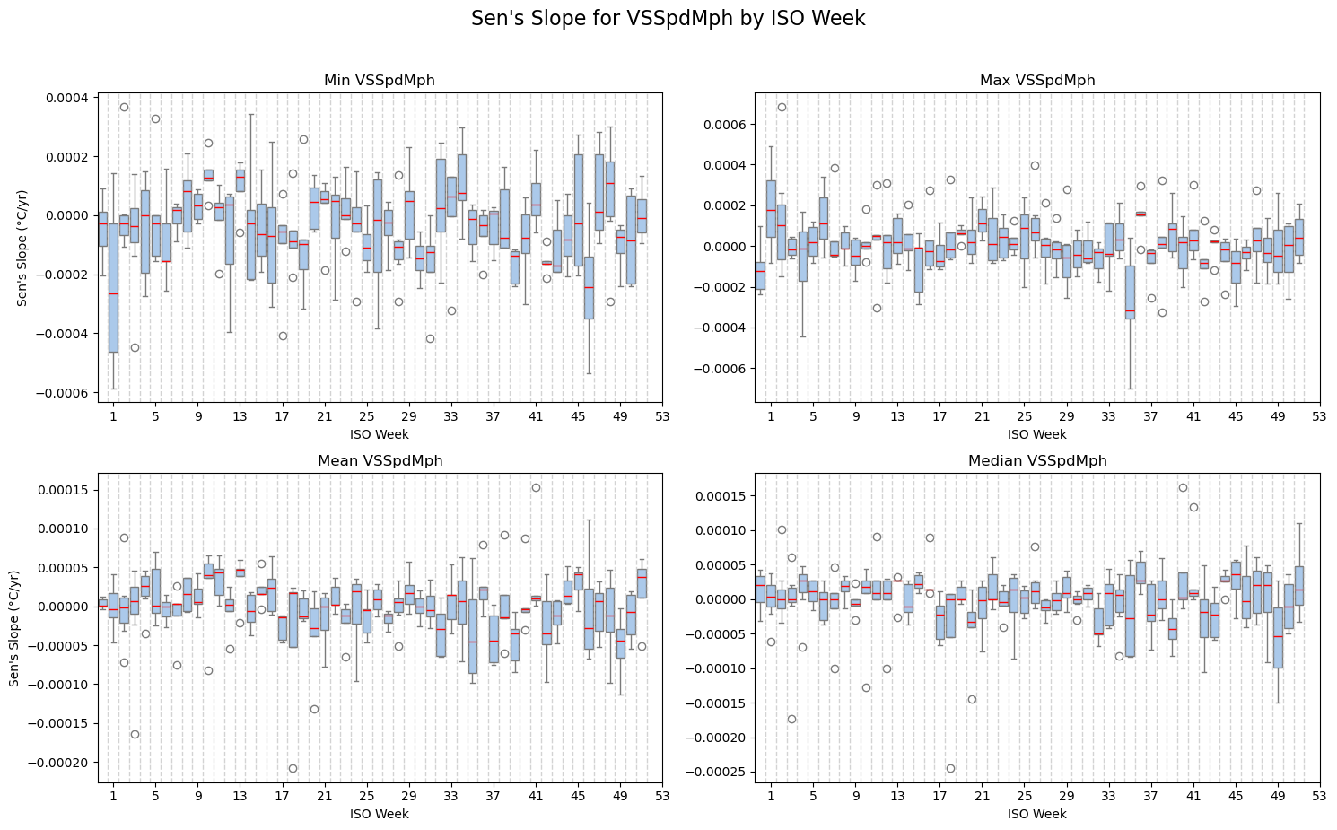

Fig. S3 Weekly Sen’s Slope for Vertical Wind Speed
Fig. S3 summarizes Sen’s slope distributions for minimum, maximum, mean, and median vertical wind speed by ISO week. Vertical wind speed shows negligible multi-year trends, with Sen’s slopes fluctuating around zero and no clear seasonal structure.

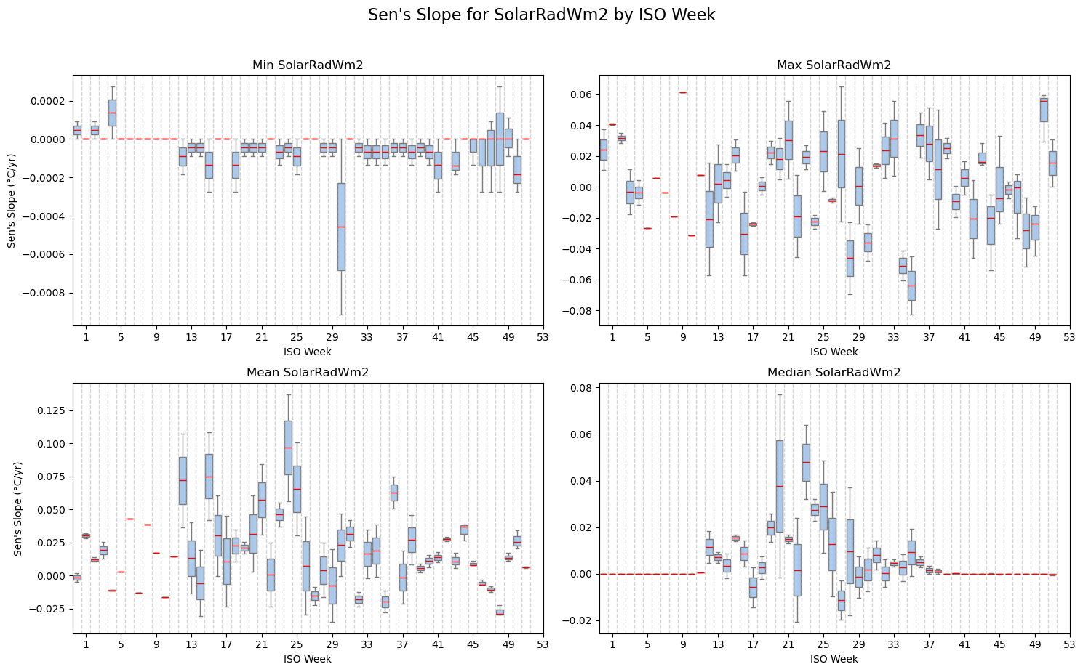

Fig. S4 Weekly Sen’s Slope for Solar Radiation
Fig. S4 shows the weekly Sen’s slope estimates for solar radiation variables. Solar radiation exhibits large interannual variability but no consistent week-specific long-term trend, with Sen’s slopes scattered around zero across all metrics.

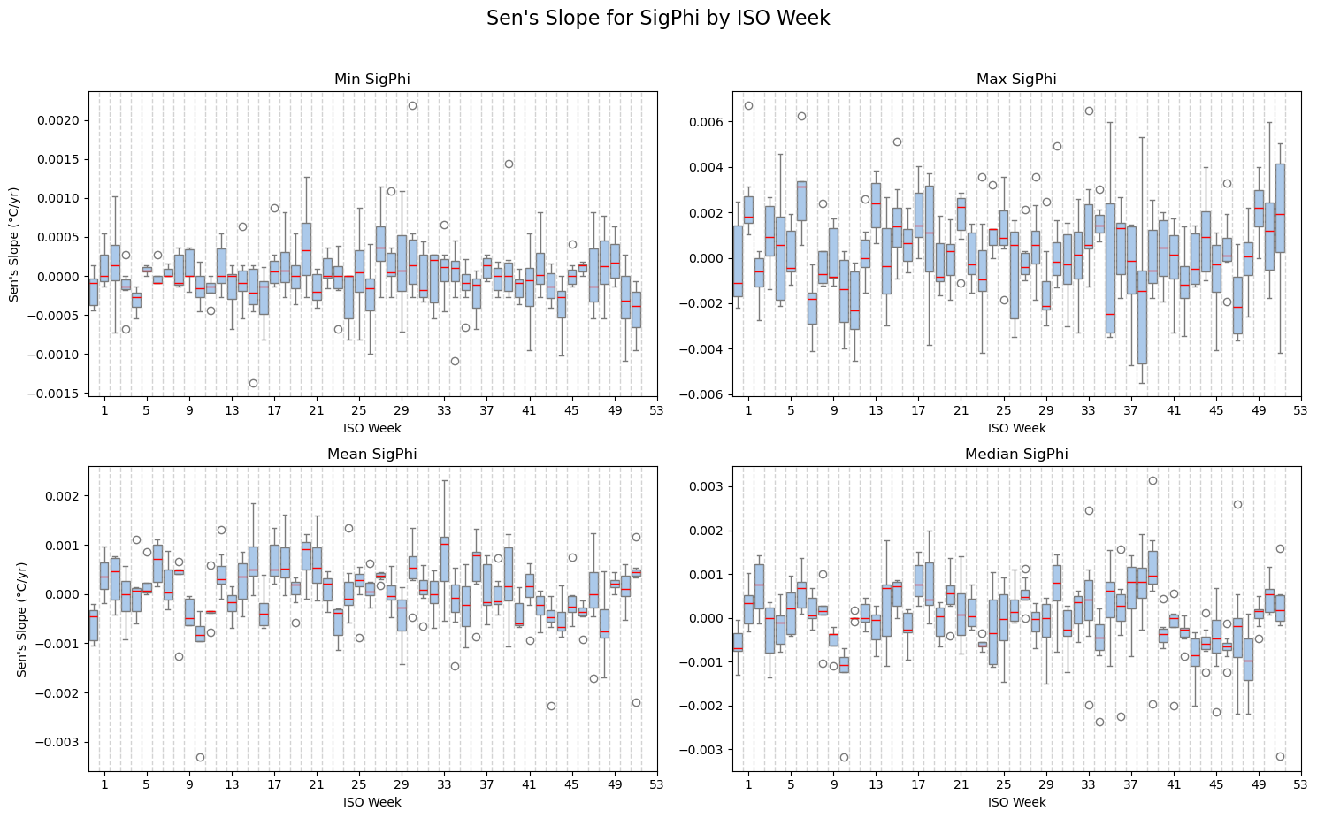

Fig. S5 Weekly Sen’s Slope for Wind Direction Variability
Fig. S5 depicts the Sen’s slope distributions for wind direction variability (SigPhi), which shows no meaningful long-term trend, with weekly Sen’s slopes remaining near zero and dominated by short-term fluctuations.

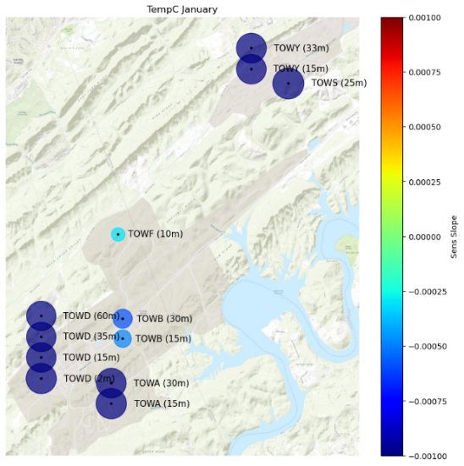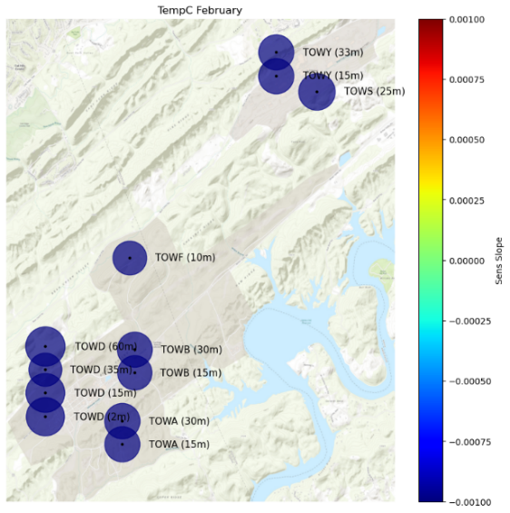
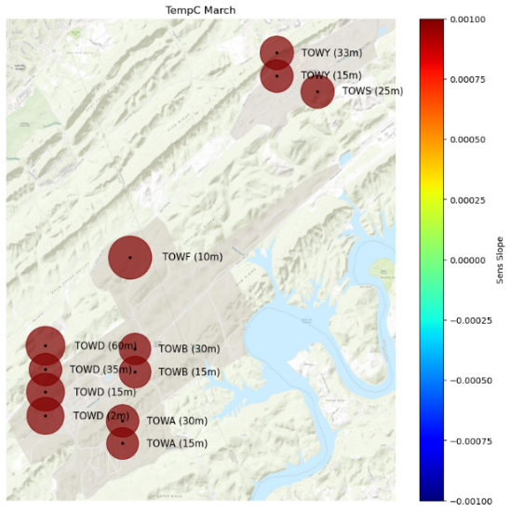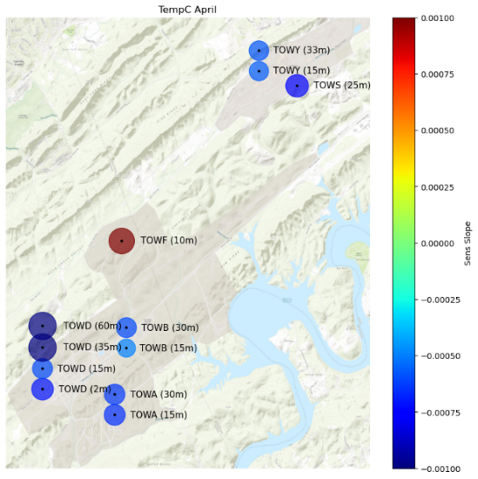
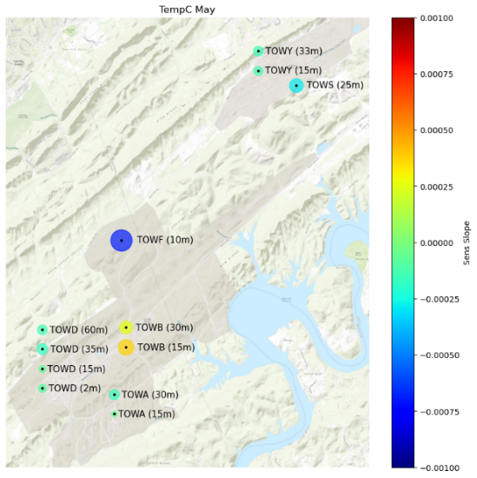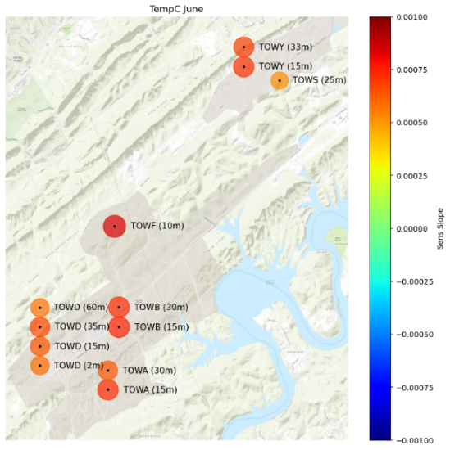

Fig. S6a Jan – Jun Monthly Spatial Distribution of Sen’s slope for Temperature.

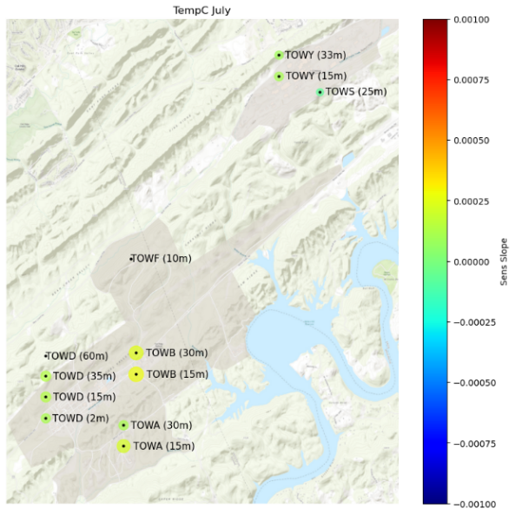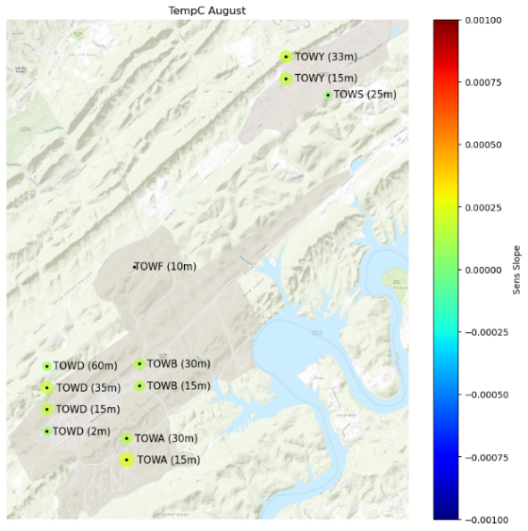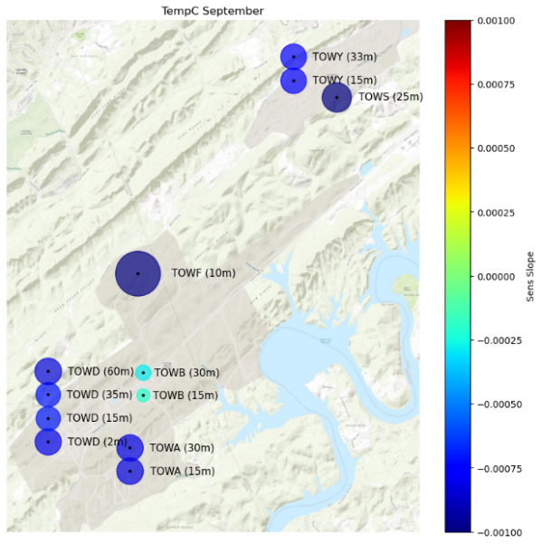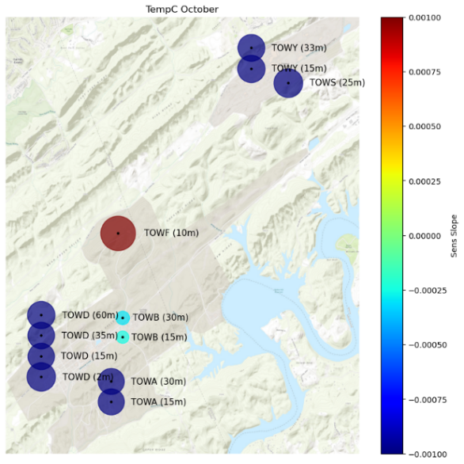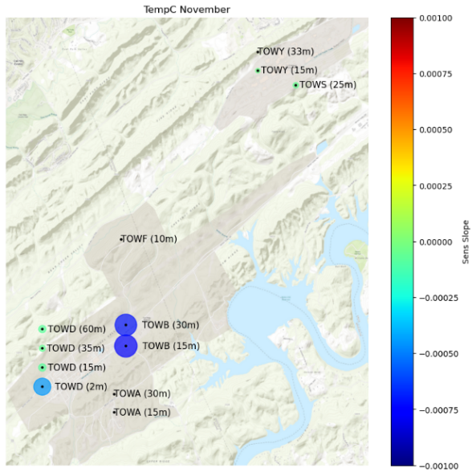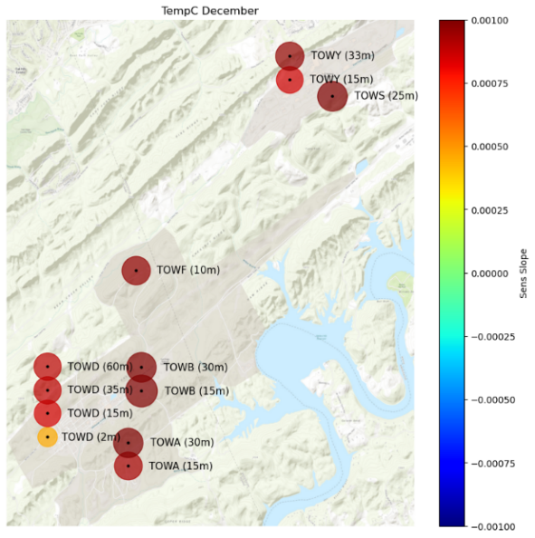

Fig. S6b. July – Dec. Monthly Spatial Distribution of Sen’s slope for Temperature

