Supplementary Information
Opioidergic modulation of stress-induced hyperalgesia in adult zebrafish

Fabiano V. Costa^{a,b,c, h*}, Lana Ferreira^{b}, Lucca K. Lima^{b}, Julia Canzian^{d,e}, Allan V. Kalueff ^{f,g},
Denis B. Rosemberg^{d,e,g}, Carla D. Bonan^{a,b,c}

ªGraduate Program in Cellular and Molecular Biology, School of Health and Life Sciences, Pontifical Catholic University of Rio Grande Do Sul, Porto Alegre, RS, Brazil.
^{b}Laboratory of Neurochemistry and Psychopharmacology, School of Health and Life Sciences, Pontifical Catholic University of Rio Grande do Sul, Porto Alegre, RS, Brazil.
^{c}Graduate Program in Medicine and Health Sciences, School of Medicine, Pontifical Catholic University of Rio Grande Do Sul, Porto Alegre, RS, Brazil.
^{d}Laboratory of Experimental Neuropsychobiology, Department of Biochemistry and Molecular Biology, Natural and Exact Sciences Center, Federal University of Santa Maria. Santa Maria, RS, Brazil.
^{e}Graduate Program in Biological Sciences: Toxicological Biochemistry, Federal University of Santa Maria, Santa Maria, RS, Brazil.
^{f}Department of Biosciences and Bioinformatics, Suzhou Municipal Key Laboratory of Neurobiology and Cell Signaling, Xi’an Jiaotong-Liverpool University, Suzhou, China
^{g}International Zebrafish Neuroscience Research Consortium (ZNRC), New Orleans, USA
^{h}Undergraduate Program in Nursing, La Salle University, Canoas, RS, Brazil

*Correspondence to: Fabiano V. Costa, Ph.D., Pontifical Catholic University of Rio Grande do Sul, Ipiranga Avenue, 6681, Building 12D/301.Porto Alegre, RS, Brazil. fvcosta88@gmail.com
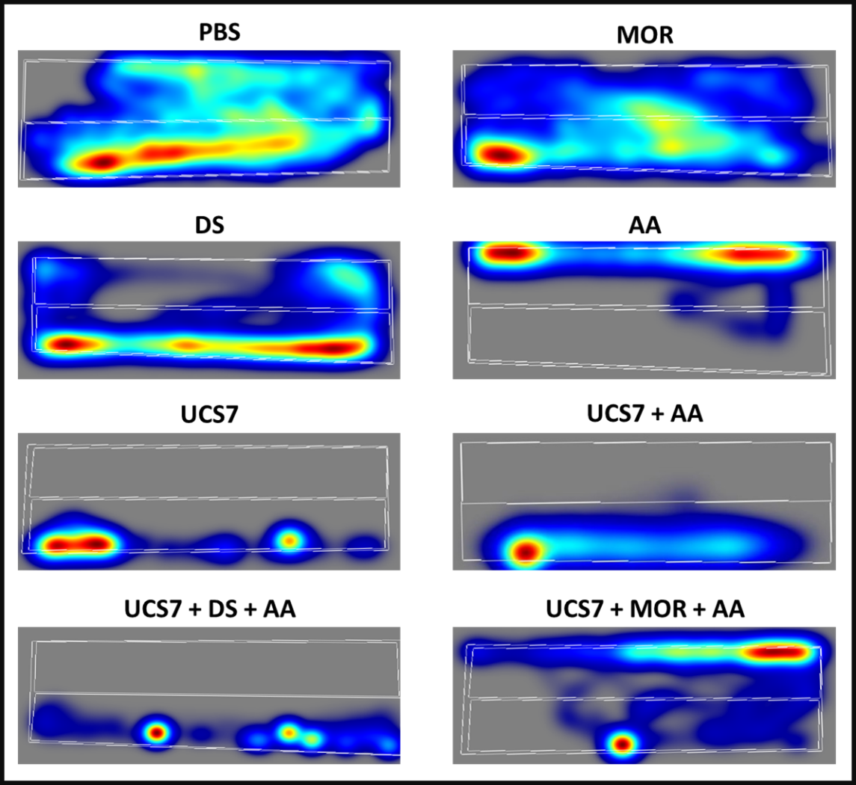
Supplementary Fig. 1. Representative images displaying the zebrafish phenotypes after acetic acid injection, as well as the effects of acetic acid plus UCS protocol in relation to PBS group.

Supplementary Fig. 2. Representative heatmap of zebrafish locomotor profiles under main treatments.

