Supplementary information
- Carrier concentration analyze
It is necessary to select the optimal carrier concentration in the ITO film, that is, the concentration at which the device will have the lowest light propagation loss (IL) and the minimize length of the active part (in which modulation occurs). In the case of using the design of the Mach-Zehnder interferometer, the length of the active part of the device L should be such that a complete phase shift of the light (Δφ = π) in one of the arms (1) is provided.
$$∆φ=\frac{2π}{λ}LΔn_{eff}$$ | (1)
The change in the effective refractive index Δn_{eff} is determined by the initial carrier concentration of the ITO n_{ITO} film, the bias in the MOS capacitor V_{g}, and the design of the device (the thickness of the ITO and oxide films, the cross section of the waveguide, the location of the electrode, etc.).
We analyzed ITO films with a number of values of the carrier concentration N_{c} (1·10¹⁹…4·10²⁰ см⁻³). The dependence of the spectra of the refractive index n_{ITO} and the absorption coefficient k_{ITO} on the carrier concentration is shown in Fig. 1.
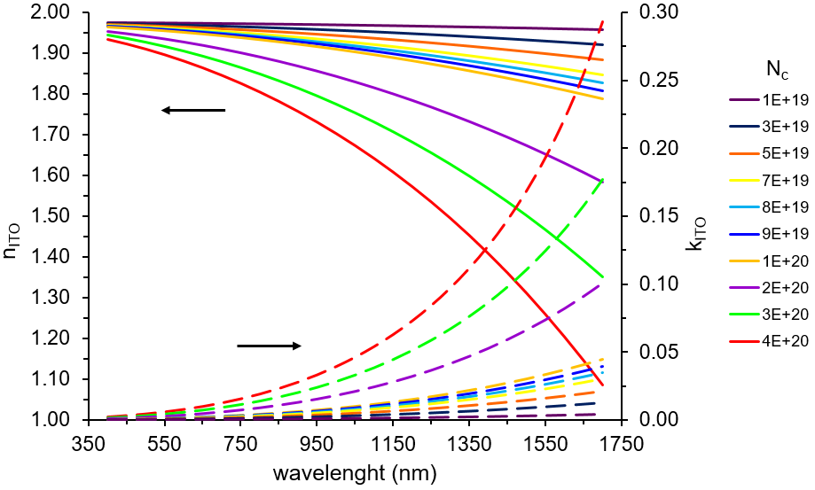
Fig. 1 – Dependence of the n_{ITO} and k_{ITO} spectra on the carrier concentration of the ITO film
The change in the carrier concentration under the conditions of charge accumulation / depletion in an ITO film at an applied voltage V_{g} can be calculated using formula (2).
$$∆N_{c}=\frac{ε_{0}ε_{ITO}V_{g}}{t_{SiO2}t_{acc}e} ,$$ | (2)
where ε₀ is the dielectric constant of vacuum, ε_{ITO} is the relative permittivity of ITO, e is the electron charge, t_{SiO2} is the oxide thickness, t_{acc} is the thickness of the accumulating layer, which can be calculated from the Thomas-Fermi shielding theory (3).
$$t_{acc}={\left[\frac{ε_{ITO}ε_{0}h^{2}}{4π^{2}m_{eff}e^{2}}\right]}^{\frac{1}{2}}{\left[\frac{π^{4}}{3N_{0}}\right]}^{\frac{1}{6}} ,$$ | (3)
where N₀ is the initial concentration of charge carriers in the ITO film, m_{eff} is an effective electron mass.
Thus, it is possible to calculate the value of the ITO carrier concentration under conditions of accumulation N_{c}⁺ = N_{c} + ΔN_{c} and under conditions of depletion N_{c}– = N_{c} – ΔN_{c}. Knowing these values, using the Drude-Lorenz model (), it is possible to find the refractive index and absorption coefficient under the conditions of accumulation n⁺, k⁺ and depletion n–, k–. To analyze the parameters of the device, operating voltages of ± 6, ± 13, ± 16 V [] were selected.
The characteristics Δn_{eff} = n_{eff}– – n_{eff}⁺ and Δk_{eff} = k_{eff}⁺ – k_{eff}– can be derived by substituting the values of n⁺, k⁺ and n–, k– into the COMSOL model with a typical design [], which is shown in Fig. 2.
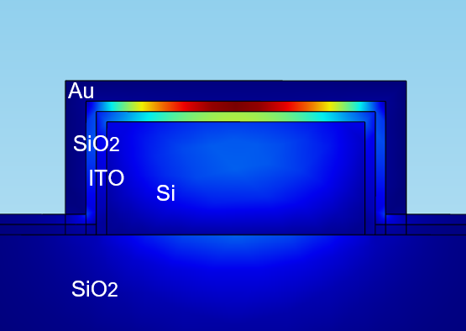
Fig. 2 – COMSOL model for extracting the Δn_{eff} and Δk_{eff} characteristics
It is possible to find the propagation loss per unit length in the active part of the device using the relation (4).
$$α[dB/um]=\frac{2πk_{eff}^{+}10\log_{10}{(e)}}{λ[um]}=\frac{2πk_{eff}^{+}4.34}{λ[um]},$$ | (4)
It should be noted that for the calculation, the absorption coefficient is used exactly in the state of the device where it is of greater importance, and a metal passive contact is installed on the parallel arm of the interferometer to balance the loss of light propagation in both arms (the length of the passive contact is calculated using simulation). In other words, due to the fact that in the process of changing the refractive index, the ITO layer also changes its absorption coefficient, the losses of the device also increase in the light-transmitting state (ON) by the amount of their change during the ON-OFF transition so that they are equal to the losses in the non-transmitting state (OFF).
Having determined the length of the active part of the device L from relation (1), we find the propagation loss IL over the entire length (5).
$$IL[dB]=α[dB/um]∙L[um],$$ | (5)
The dependence of the device length and propagation loss on the carrier concentration of the original ITO film is shown in Fig 3. The device length has the smallest value at the point N_{c} = 5.5·10²⁰ cm⁻³ where ITO has a peak (maximum) of the refractive index change Δn_{ITO} [] but the propagation loss in this point are colossal (> 30 dB which is equivalent to almost complete loss of light in the waveguide).
With an increase in the operating voltage of the device, the light propagation loss IL decreases. This is due to the fact that an increase in voltage has a stronger effect on a decrease in the device length (and with it a decrease in IL) than an effect on an increase in ΔN_{c} (and the inevitable associated increase in IL).
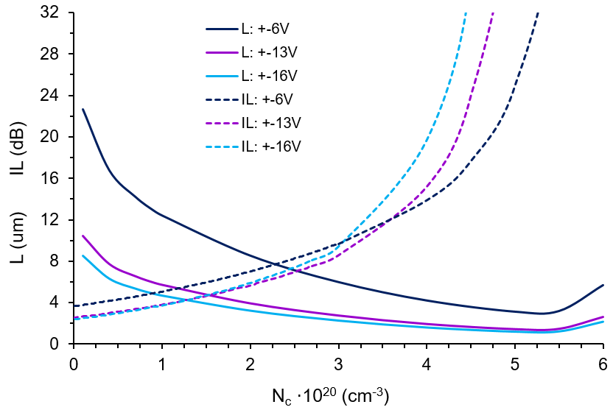
Fig. 3 – Dependence of device parameters on the concentration of ITO film carriers
Thus, there is a trade-off between device length and propagation loss. The optimal range of carrier concentration for ITO film is from 0.5·10²⁰ to 2·10²⁰ cm⁻³ where the values of the device parameters find a trade-off.
- Detailed description of the ITO films resistivity investigation
Subsequent annealing of room temperature films evaporated without ion beam assistance dramatically lower the resistivity to 2.5·10⁻⁴ Ω·cm (Fig. 4a, film4). Ion-beam assistance with Ar/O2 mixture and elevated temperature during evaporation (without annealing) leads to ITO films with a higher resistance value of 15.8·10⁻⁴ Ω·cm (Fig. 4a, film1). Subsequent annealing of high temperature IBAD ITO films distinguishably lower resistance from 15.8·10⁻⁴ to 4·10⁻⁴ Ω·cm (Fig. 4a, film3). Finally, IBAD ITO films evaporated at room temperature with subsequent annealing leads to the medium value of resistivity around 11·10⁻⁴ Ω·cm (Fig. 4a, film2).
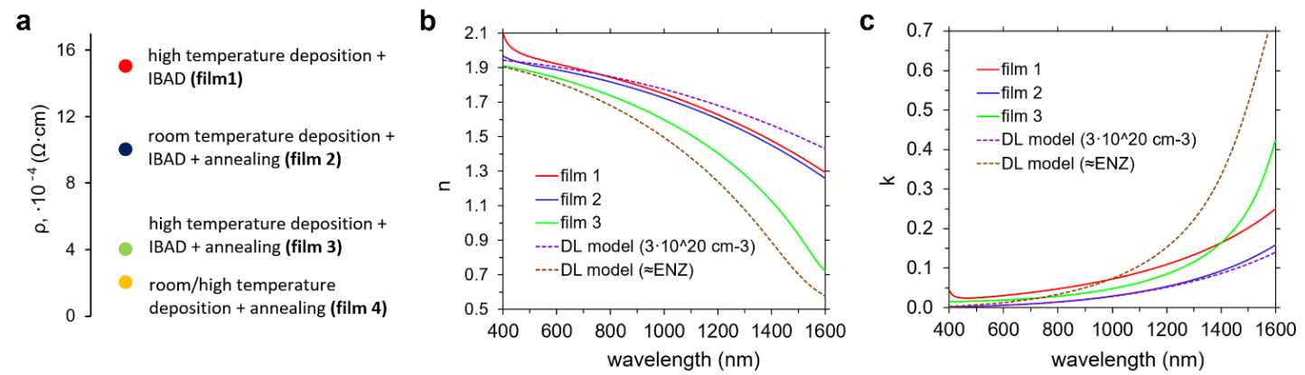
Fig. 4 – a) ITO films resistivity via deposition technique; ITO films b) n and c) k dependence on wavelength
- Calculation of the ITO accumulation layer optical constants
In an ellipsometry model, ITO film was presented by two layers: a bottom ultra-thin accumulation layer and an upper one. We estimate the accumulation layer thickness using Thomas-Fermi screening theory for deriving the carrier distribution for a given voltage applied to the electrodes [Melikyan, A., Lindenmann, N., Leuthold, J., et al. Surface plasmon polariton absorption modulator. Optics express 2011, 19, 8855-8869]. The resulting thickness was found to be between 0.7 and 1 nm (for different ITO films carrier concentration).
$$λ_{TF}={\left[\frac{ε_{ITO}ε_{0}h^{2}}{4π^{2}m_{eff}e^{2}}\right]}^{\frac{1}{2}}{\left[\frac{π^{4}}{3N_{0}}\right]}^{\frac{1}{6}},$$ | (6)
The complex refractive index of the accumulation layer was calculated using the Drude-Lorentz model in the wavelength range from 550 to 1600 nm.
- Detailed description of the ITO films resistivity investigation
ITO film3 shows maximum shift in the range from +16 V to -16 V (since it is the closest to ENZ point) – Δn = 0.199, Δk = 0.240 (Table 1). However, it has the highest extinction coefficient in the IR range that will result in higher IL of an electro-optical modulator. ITO film2 is the most suitable for an electro-optical modulator since it has the lowest extinction coefficient in the IR range and is comparable to film3 in terms of electro optical effect (Δn = 0.101, Δk = 0.084) for the voltage range from +16 V to 16 V.
Table 1. Comparison of refractive index and extinction coefficient change for the various ITO films at λ = 1550 nm.
parameter | film 1 | film 2 | film 3
Δn (+16 V) | 0.053 | 0.048 | 0.101
Δn (-16 V) | 0.030 | 0.053 | 0.098
Δk (+16 V) | 0.030 | 0.028 | 0.119
Δk (-16 V) | 0.016 | 0.056 | 0.121
Δn | 0.083 | 0.101 | 0.199
Δk | 0.046 | 0.084 | 0.240
n (at 0V) | 1.342 | 1.308 | 0.675
k (at 0V) | 0.226 | 0.141 | 0.329
- The device bandwidth analyze
There are two schemes of the electro-optical modulator (Fig. 5): lateral (without electrode on top) and vertical (with electrode on top).
The active element resistance calculations:
$$R_{Si}=ρ_{Si}\frac{L_{1}+L_{2}}{Wd_{Si}}={5∙10}^{-5}Ωm∙\frac{5+2}{0.22∙0.5}∙{10}^{6}=3.2 kΩ;$$
$$R_{ITO1}=ρ_{ITO}\frac{d_{ITO}}{WL_{1}}={2.8∙10}^{-5}Ωm∙\frac{0.02}{0.22∙5}∙{10}^{6}=0.5 Ω;$$
$$R_{ITO2}=ρ_{ITO}\frac{W_{min}}{{L_{1}d}_{ITO}}={2.8∙10}^{-5}Ωm∙\frac{1.5}{5∙0.02}∙{10}^{6}=400 Ω;$$
$$R=R_{Si}+R_{ITO}; R_{without el.}=3.6 kΩ; R_{with el.}=3.2 kΩ;$$
The active element capacity calculations:
$$C=ε_{0}ε_{r}\frac{LW}{d}=8.85∙{10}^{-12}∙9.1∙\frac{5∙0.5}{0.02}∙{10}^{-6}=10 fF;$$
3dB frequency calculations:
$$f_{3dB}=\frac{1}{2πRC};$$
$$f_{3dB without el.}=4.4 GHz; f_{3dB with el.}=5.0 GHz;$$
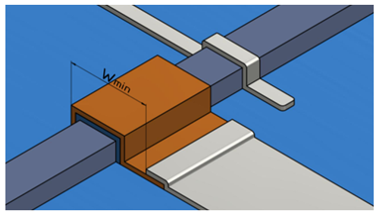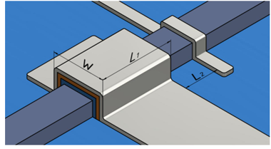
Fig. 5 – Comparison of lateral (left) electrode scheme and vertical (right) electrode scheme.

