Extensive mobilome dynamics in a widespread endosymbiont: long read metagenomics reveal dimeric plasmids and highly fragmented prophages in Wolbachia from Culex pipiens

Supplementary Figures:

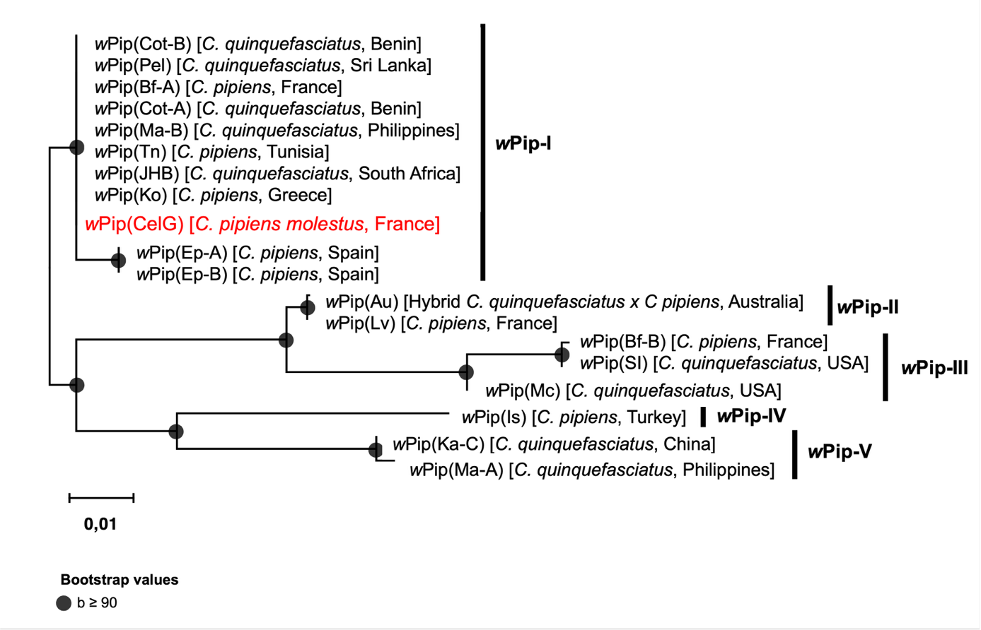

Supplementary Figure 1: Phylogenetic placement of wPipCelG within the wPip groups. Maximum Likelihood phylogeny inferred from the concatenated alignment of six genes (mutL, ank2, pk1, pk2, GP12, and GP15) totaling 5,423 bp. Bootstrap values were estimated using 1,000 replicates. The tree was constructed using the GTR+I substitution model.

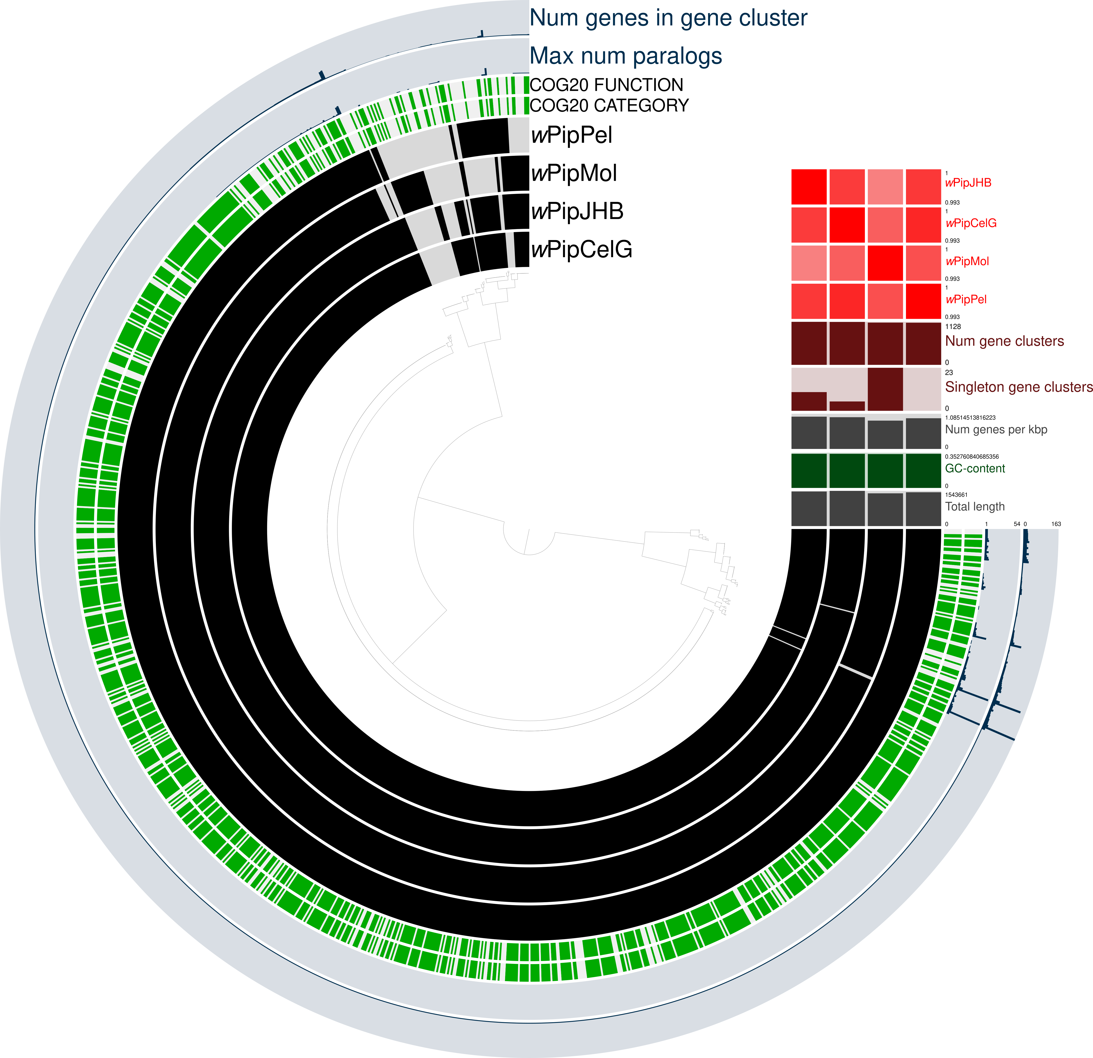

Supplementary Figure 2: Pangenome with wPipCelG, wPipPel, wPipJHB and wPipMol. A total of 1,166 gene clusters were identified and hierarchically clustered in the dendrogram based on their presence/absence patterns. The heatmap displays, from top to bottom: ANIm alignment nucleotide identity, number of gene clusters, number of singleton gene clusters, number genes by kbp, GC content, and total genome length.

Supplementary Figure 3: Sequence alignment between the dimeric pWCP contig of wPipCelG and the reference pWCP. The dimeric plasmid contig was split into two monomeric units (positions 1–9,242 and 9,243–18,485) and aligned independently to the reference pWCP to assess sequence identity and confirm the dimeric configuration.

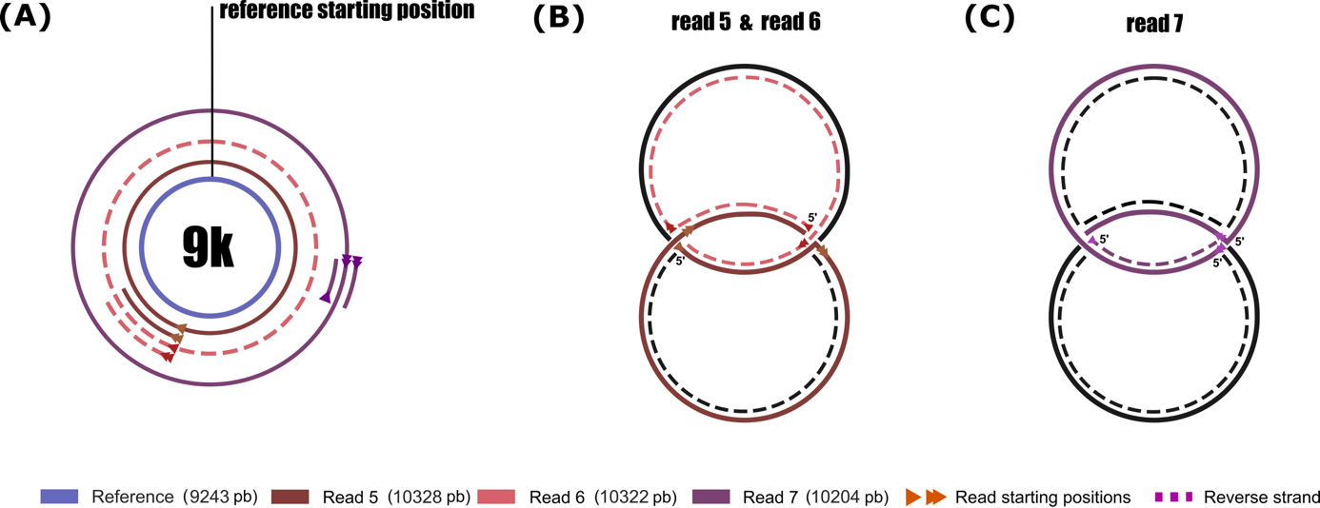

Supplementary Figure 4: Hypothetical model of theta-replication in the pWCP plasmid. (A) Representative reads were mapped to the 9,228 monomeric pWCP reference sequence (B) Schematic interpretation of forward and reverse strand potentially from a single DNA molecule undergoing theta replication (C) Example of a plasmid read containing overlapping sense and antisense regions consistent with replication fork progression.

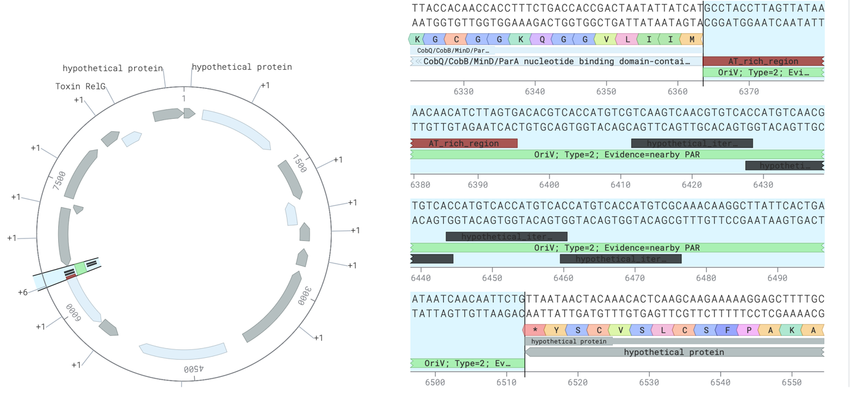

Supplementary Figure 5: Identification of a putative origin of replication (oriV) in the pWCP plasmid. The oriV region was predicted using OriV-Finder [1] and is located between positions 6,363 and 6,513 bp of the pWCP sequence. This region overlaps with a tandem repeat zone previously annotated as a VNTR and contains a set of putative iterons (dark brown), characteristic of iteron-based replication initiation mechanisms.

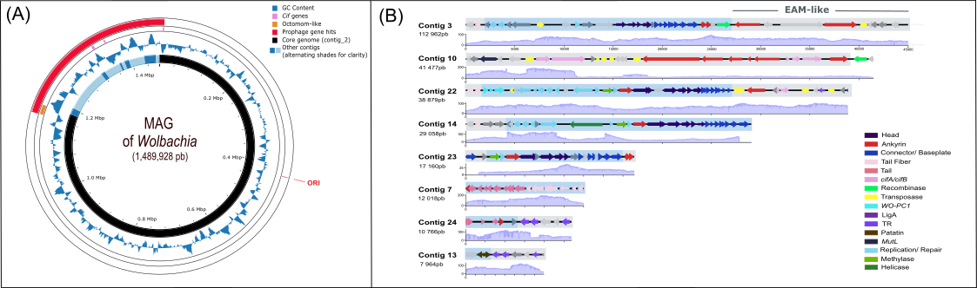

Supplementary Figure 6: Genome organization and annotation of phage associated contigs in wPipCelG. (A) Schematic representation of the Wolbachia MAG wPipCelG, showing the position of the predicted origin of replication (ORI) and the fragmented contigs corresponding to phage-associated regions, illustrating the overall genome organization obtained from long-read sequencing. (B) Phage-associated contigs larger than 7 kb are displayed, showing their gene synteny and the sequencing coverage profile for each contig, highlighting structural organization and depth of mapping across these phage regions.

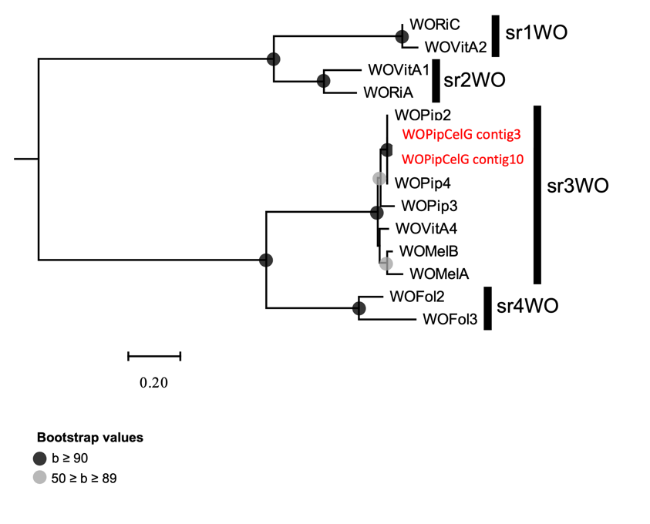
Supplementary Figure 7: Phylogeny on the serine recombinase of WO. Maximum Likelihood tree inferred from amino acid sequences of large serine recombinases (LSRs) encoded by WO prophages, including sequences from the reference wMel genome (WD_0288 and WD_0634) and representative members of the four srWO clades defined by Bordenstein & Bordenstein (2022). Newly identified sequences from this study are highlighted in red. Node support values represent bootstrap percentages (1,000 replicates), and the tree is midpoint-rooted.

Supplementary Figure 8: Coverage of filtered reads mapped to phage WO genes clusters and estimation of gene copy numbers. Filtered reads were mapped to representative sequences of phage WO gene clusters, and coverage depth is shown alongside estimated gene copy numbers in wPipCelG (in red), assembled copies in wPipCelG (in green), and in wPipPel (in blue). Gene clusters were generated during pangenomic analyses, and each coverage value corresponds to the mapping depth on the longest gene of the cluster.
The figure aggregates all modules, including integration/replication (transposases, ankyrin repeats, connector/baseplate, replication/repair), structural and effector components (tail, head, tail fiber, toxins, cytoplasmic incompatibility factors), and additional modules of interest (repair machinery, transcriptional regulators, DUF1016, WO-PC1, patatin phospholipases, chaperones, metabolism-related genes, and six remaining individual genes). The average estimated copy number per module (red value) is indicated in the upper-right inset of each panel.

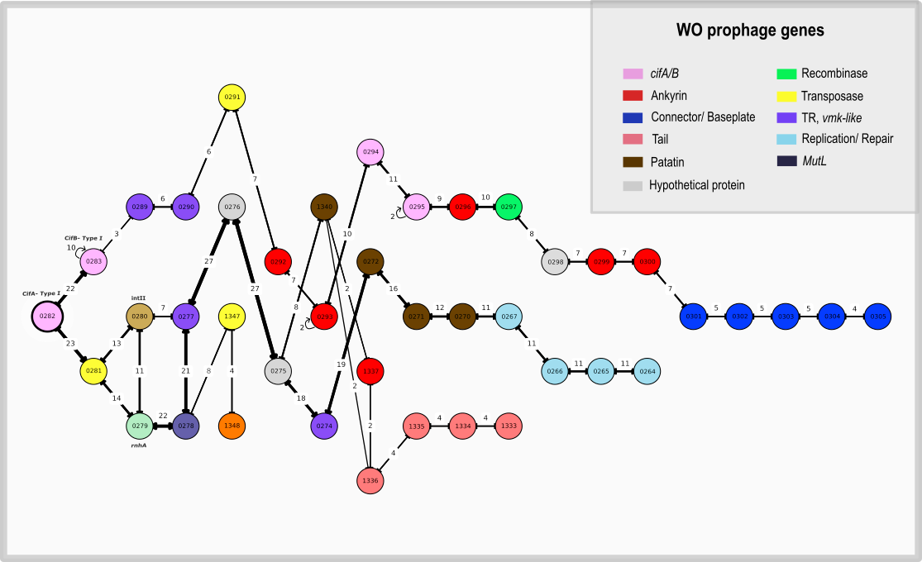

Supplementary Figure 9: The cifA (Type I) synteny puzzle: long-read gene-adjacency graph. Directed gene-adjacency graph derived from 60 annotated Nanopore reads (≥10 kb) that contained cif (Type I or IV) and/or genes from the region near these loci (e.g., transposases WP0281/WP0291, rnhA WP0279, mutLWP0278, intII WP0280, TR/wmk-like). For each long read, WO gene hits were ordered by their coordinates on the read, and every consecutive pair was tallied as an adjacency event. Nodes represent genes; edges represent observed adjacencies, labeled with the number of adjacency events aggregated across reads, and drawn with widths proportional to this count. The layout is rooted at cifA (WP0282) to emphasize alternative routes emanating from this gene.
Supplementary Tables:

Supplementary Table 1: Details of sample preparation for long-read sequencing

Supplementary Table 2: Summary of contig-level assembly metrics and sequencing
This table reports the characteristics of each contig identified in the wPipCelG assembly, shown separately for raw mapping data (before quality filtering) and after applying a mapping quality filter of MapQ > 2. The columns indicate: BLAST_identification: best BLAST hit obtained for the contig, indicating its associated phage type when applicable. Coverage_qc_of_splits: sequencing depth across different splits of the dataset. Longest_read: length (in bp) of the longest read mapped to the contig. Mean_read_length: mean length (in bp) of the reads mapped to the contig. N50_reads: N50 value for the reads mapped to the contig, representing the read length above which 50% of the mapped bases are contained. Detection: proportion of samples or splits in which the contig was detected.

Supplementary Table 3: qPCR-based quantification of Wolbachia, WO and pWCP plasmid

Supplementary Table 4: List of the 10 genes unique to wPipCelG and 8 genes not present in wPipCelG

References
1. Li Y, Gao F. OriV-Finder: a comprehensive web server for bacterial plasmid replication origin analysis. Nucleic Acids Research. 2025;gkaf341.

