Supplemental Methods

Systemic Inequities Composite variable. The systemic inequities variable was consistent of information regarding income. Our income variable was self-reported gross monthly income. This variable was stratified into five groups: (1) ≤$249, (2) $250-$499, (3) $500-$999, (4) $1000-$1999 and (5) ≥ $2000. Our composite variable had additional information on lack of resources. This information was assessed using items on the Stressful Events Questionnaire II (SEQ-II) [1]. The SEQ-II is a 39-item instrument assessing recent and lifetime exposure to stress life events [1]. The SEQ-II assess a wide range of stress events including divorce, unemployment, crime, financial and interpersonal stressors. The SEQ-II collects’ data on whether participants experienced these events coded as (no = 0, yes=1). The specific items used from the SEQ-II for this composite were items 19 (“Homelessness, living in shelter/on streets”), 20 (“Homelessness with temporary or unplanned housing”), 21 (“Evicted from house or apartment’) and item 22 (“Inadequate financial resources or support to obtain food for family”). Self-reported income along with responses to the specific items from the SEQ-II were rescaled and standardized via Z-score transformation and they were then added together to create the systemic inequities composite variable for analysis.

Supplemental Results
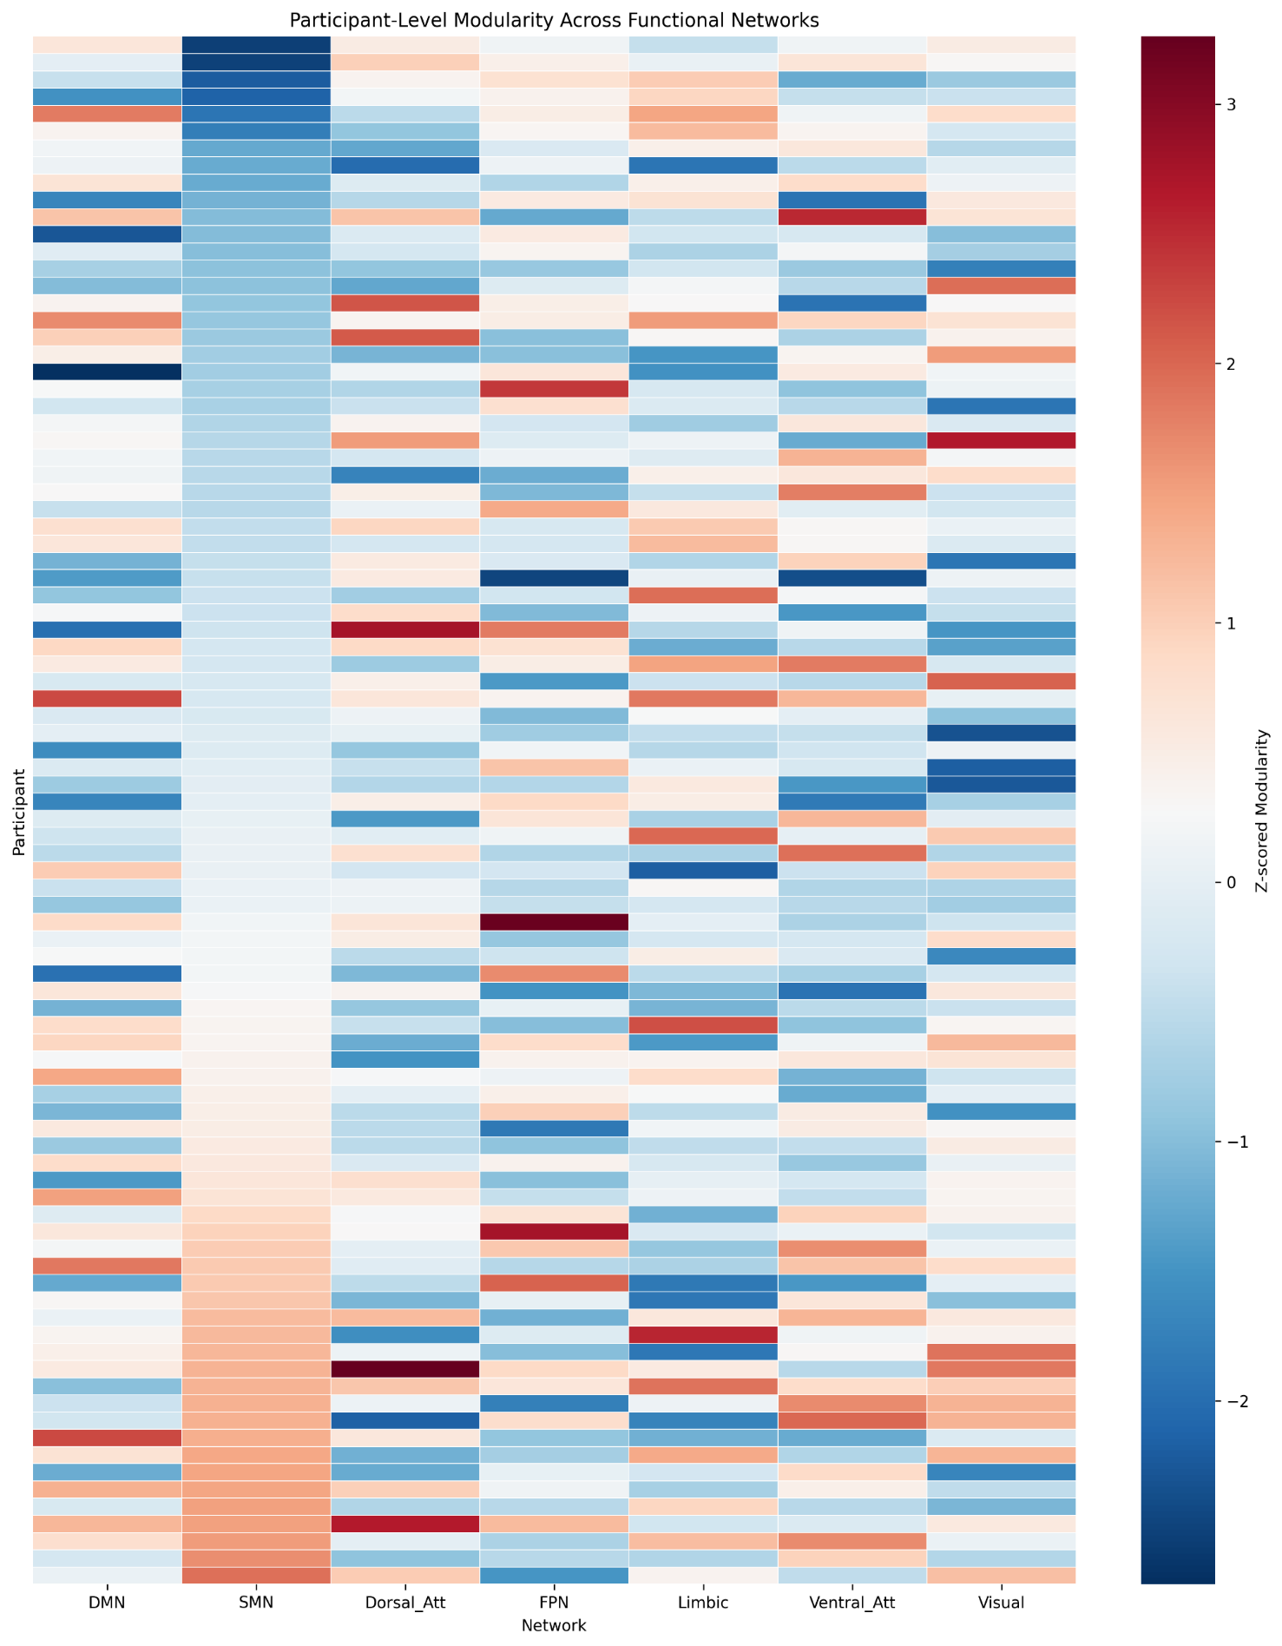
Figure 1. Participant Level (A) Modularity and (B) Clustering Coefficient Across Resting State Networks
(A)

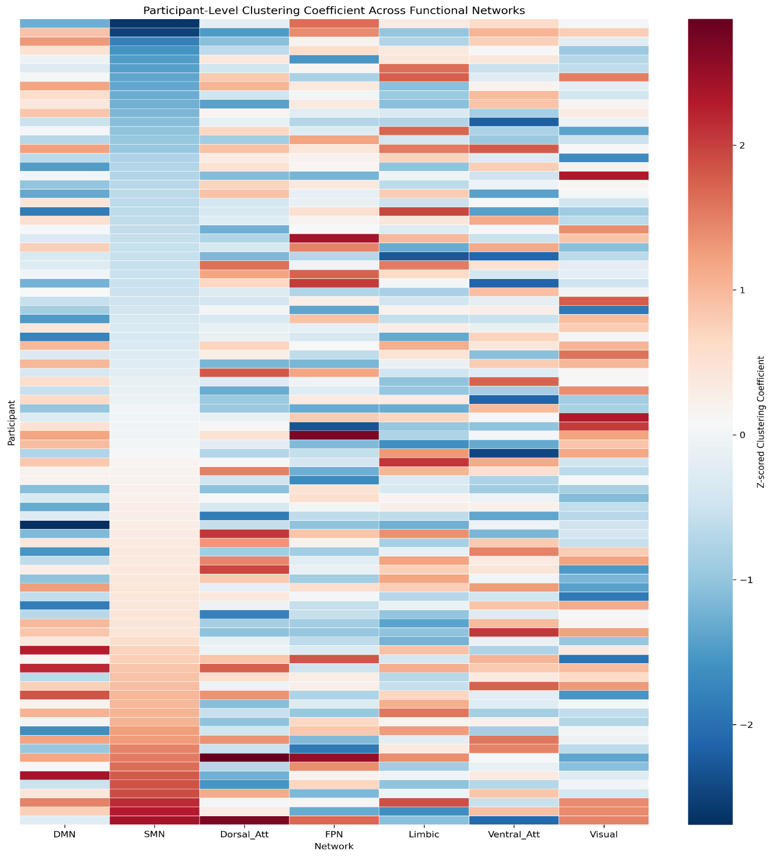
(B)
Figure 1 Caption. Heat Maps of (A) Modularity and (B) Clustering Coefficient values across resting state networks. Rows represent individual participants and columns represent networks. Participants were ordered by SMN values to visualize interindividual variability across the seven networks. Values were z-scored within network to standardized values for easier visualization. Abbreviations: SMN, Somatomotor Network; DMN, Default Mode Network; Dorsal_Att, Dorsal Attention Network; FPN, Frontoparietal Network; Ventral_Att, Ventral Attention Network

Table 1. Statistical Summaries of Moderation Models Examining the Effects of SMN Clustering Coefficient on the Associations Between Racial Discrimination and PTSD Symptom Clusters (Re-experiencing, Avoidance/Numbing and Hyperarousal) after Controlling for Age, Adult Trauma Exposure, Childhood Trauma Exposure, Systemic Inequities and Scanner type
Overall Models
Model | R² (overall) | F (df) | p (overall)
1 – Re-experiencing | .49 | 3.00 (7,73) | .005
2- Hyperarousal | .48 | 2.85 (7,73) | .008
3- Avoidance/numbing | .58 | 4.64 (7,73) | <.001

Model (1): Re-experiencing
Predictor | β | p | 95% Cl
Racial Discrimination (EOD total) | 3.2 | .02 | [.38,6.12]
SMN Clustering Coefficient (CC) | 8.84 | .26 | [-6.8,24.5]
RD (EOD total) x SMN CC | -5.4 | .014 | [-10.9, -.004]
Age | -.005 | .85 | [-.06,05]
Adult Trauma Exposure | .18 | .17 | [-.09,.46]
Childhood Trauma | .01 | .68 | [-.03,.05]
Systemic Inequities | .15 | .17 | [-.06,.36]
Scanner Type | .62 | .35 | [-.71, 1.9]
Abbreviations: SMN, Somatomotor Network; EOD, Experiences of Discrimination; CC, Clustering Coefficient

Model (2): Hyperarousal
Predictor | β | p | 95% Cl
Racial Discrimination (EOD total) | 2.13 | .30 | [-1.9,6.25]
SMN Clustering Coefficient (CC) | 2.65 | .81 | [-19.8,25.1]
RD (EOD total) x SMN CC | -4.2 | .28 | [-12.1,3.6]
Age | -.01 | .84 | [-.09,.07]
Adult Trauma Exposure | .62 | .002 | [.22,1.2]
Childhood Trauma | .01 | .58 | [-.04,.07]
Systemic Inequities | .15 | .33 | [-.16,.46]
Scanner Type | 1.47 | .13 | [-.44, 3.4]
Abbreviations: SMN, Somatomotor Network; EOD, Experiences of Discrimination; CC, Clustering Coefficient
Model (3): Avoidance/Numbing
Predictor | β | p | 95% Cl
Racial Discrimination (EOD total) | 2.13 | .30 | [-1.9,6.25]
SMN Clustering Coefficient (CC) | 2.65 | .81 | [-19.8,25.1]
RD (EOD total) x SMN CC | -4.2 | .28 | [-12.1,3.6]
Age | -.01 | .84 | [-.09,.07]
Adult Trauma Exposure | .62 | .002 | [.22,1.2]
Childhood Trauma | .01 | .58 | [-.04,.07]
Systemic Inequities | .15 | .33 | [-.16,.46]
Scanner Type | 1.47 | .13 | [-.44, 3.4]
Abbreviations: SMN, Somatomotor Network; EOD, Experiences of Discrimination; CC, Clustering Coefficient

References

1. Smith, A.K., et al., Differential immune system DNA methylation and cytokine regulation in post‐traumatic stress disorder. American Journal of Medical Genetics Part B: Neuropsychiatric Genetics, 2011. 156(6): p. 700-708.

