SUPPLEMENTARY INFORMATION
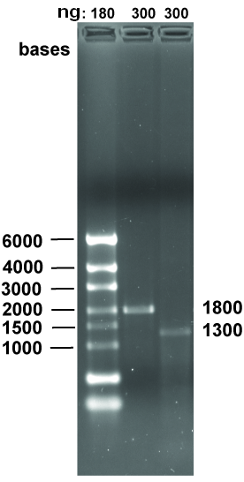
Figure S1. ssRNA corresponding to the expected lengths of 1800 or 1300 bp were produced in transcription reactions by biotinylated E. coli RNA polymerase from either F_{luc} (lane 2) or pDM_400_N1 (lane 3) templates. Lane 1 is RiboRuler ssRNA ladder.
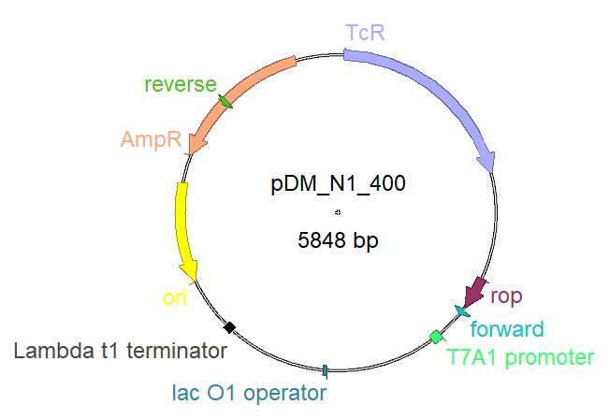
Figure S2. Schematic representation of the pDM_N1_400 DNA template.
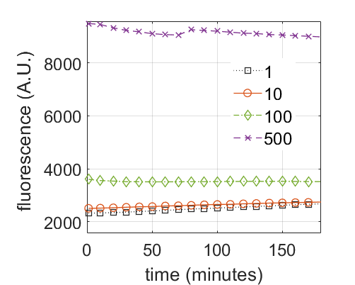
Figure S3. Fluorescence background from template DNA with SYBR Green II. The fluorescence intensities of mixtures of SYBR Green II and plasmid DNA in buffer were monitored for 3 hours.
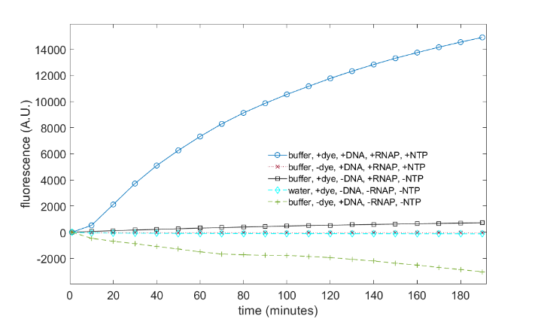
Figure S4. Fluorescence of control samples. The fluorescence intensities of mixtures of SYBR Green II (dye), E. coli RNAP, NTPs, plasmid DNA, in buffer or water were monitored for 3 hours. Only the complete mixture produced a significant increase in fluorescence.
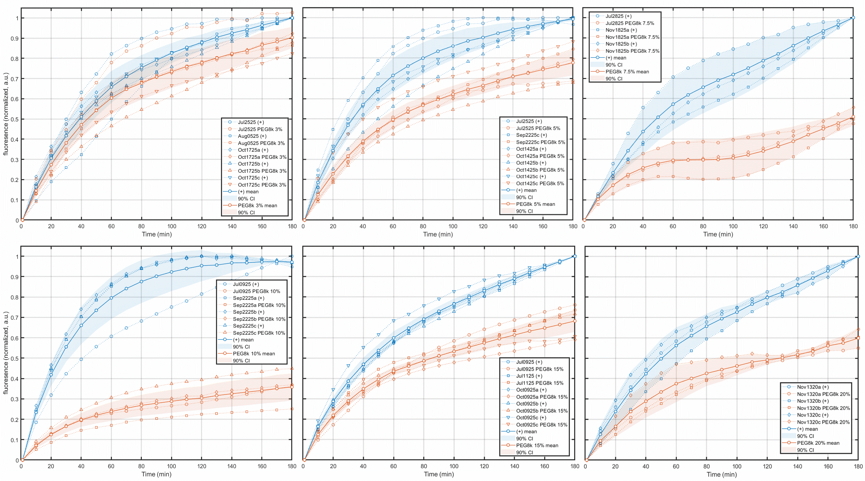
Figure S5. Individual trials of transcription reactions show inhibition with different volume fractions of PEG 8k (orange) compared to reactions without PEG 8k (blue). Mean value curves for both conditions are depicted in thicker solid lines. Shaded areas indicate 95% confidence intervals of the mean.
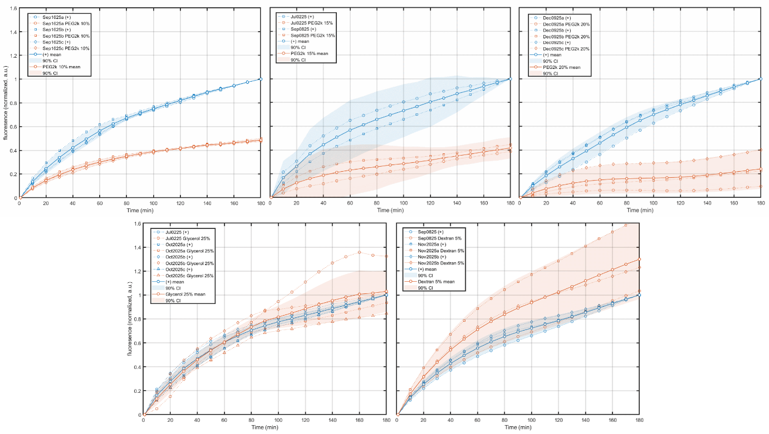
Figure S6. Individual trials of transcription reactions show inhibition with different volume fractions of PEG 2k, Dextran 70, or glycerol (orange) compared to reactions without crowders (blue). Mean value curves for both conditions are depicted in thicker solid lines. Shaded areas indicate 95% confidence intervals of the mean.

