Supporting information

A synergistic strategy to develop photostable and bright dyes with long Stokes shift for super-resolution microscopy

Gangwei Jiang^{1,§}, Tian-Bing Ren^{1,§}, Elisa D’Este⁴, Mengyi Xiong¹, Bin Xiong¹, Kai Johnsson^{3,5}, Xiao-Bing Zhang¹, Lu Wang^{2,3,*}, Lin Yuan^{1,*}

1 State Key Laboratory of Chemo/Biosensing and Chemometrics, College of Chemistry and Chemical Engineering, Hunan University.
2 Key Laboratory of Smart Drug Delivery, Ministry of Education, School of Pharmacy, Fudan University, Shanghai, China.
3 Department of Chemical Biology, Max Planck Institute for Medical Research, Heidelberg, Germany.
4 Optical Microscopy Facility, Max Planck Institute for Medical Research, Heidelberg, Germany.
5 Institute of Chemical Sciences and Engineering, École Polytechnique Fédérale de Lausanne (EPFL), Lausanne, Switzerland.
§ These authors contributed equally: G. J., T. -B. R..
Correspondence and requests for materials should be addressed to L.Y. (email: lyuan@hnu.edu.cn) or L.W. (email:lu.wang@mr.mpg.de).

Supplemental Figures and Tables

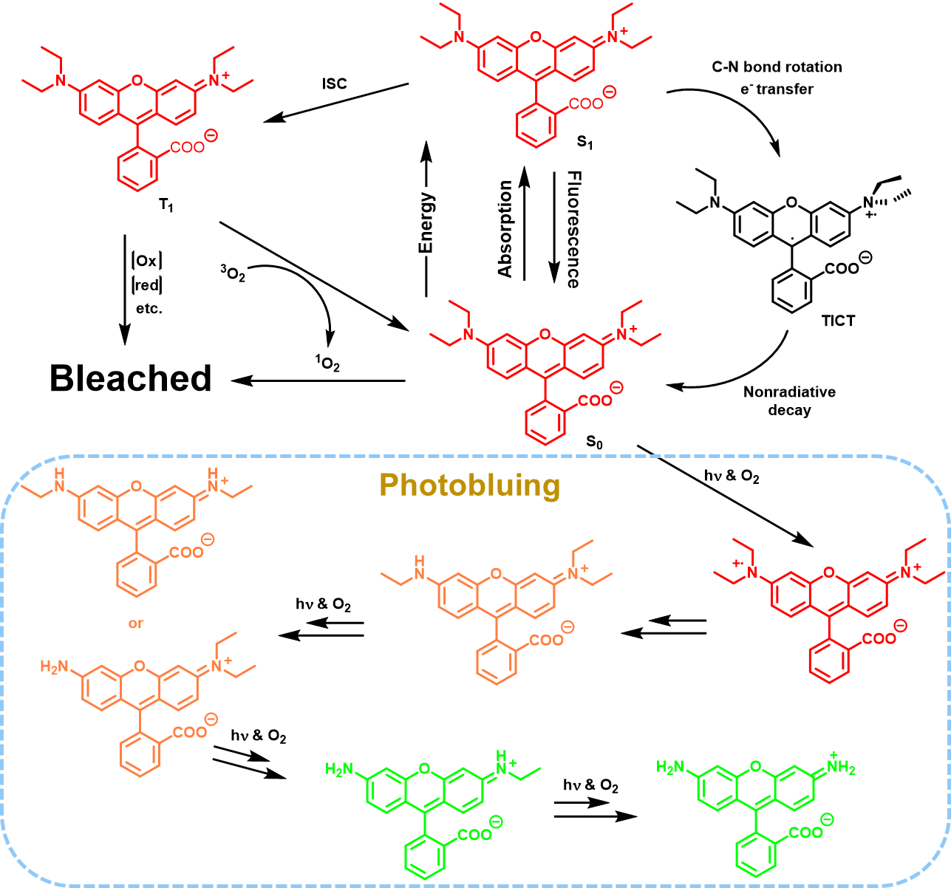
Supplementary Fig. 1 Jabłoński diagram showing the process of twisted internal charge transfer (TICT) and general mechanisms for the fluorophore photobleaching and photobluing^{1, 2, 3}.

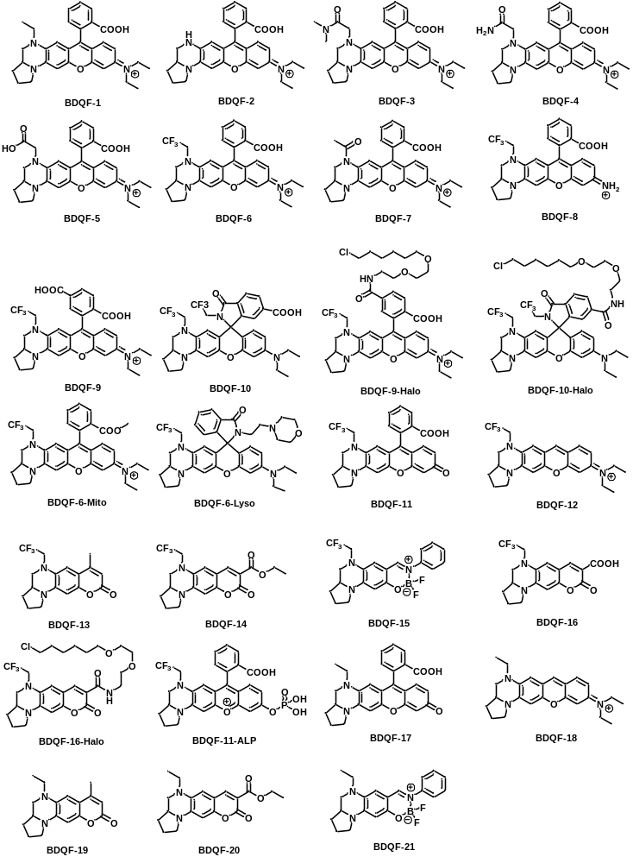
Supplementary Fig. 2 Structures of synthetic fluorophores and probes.

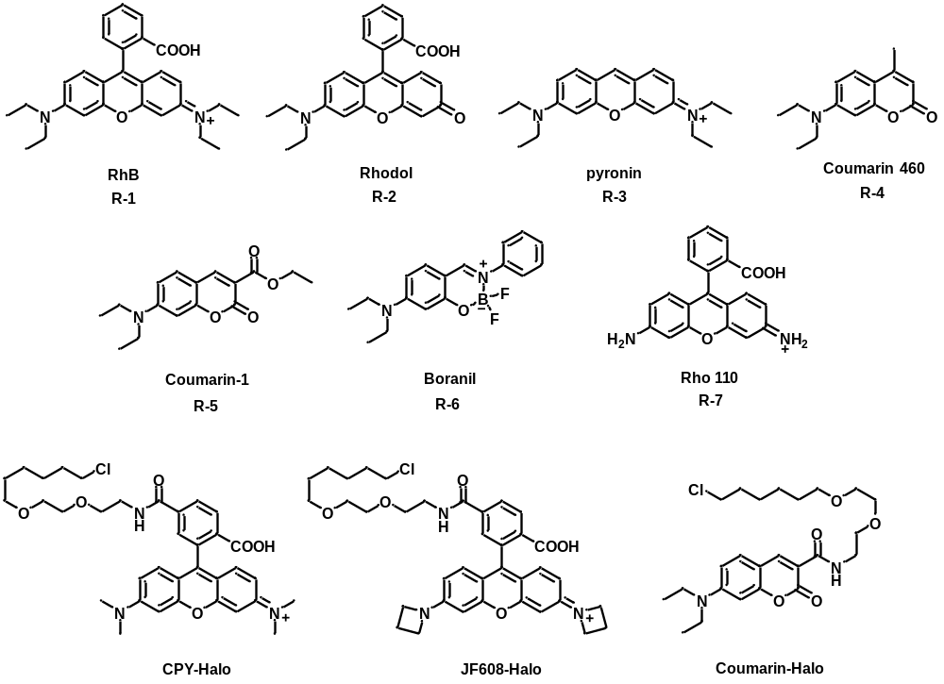
Supplementary Fig. 3 Structures of reference fluorophores and probes.

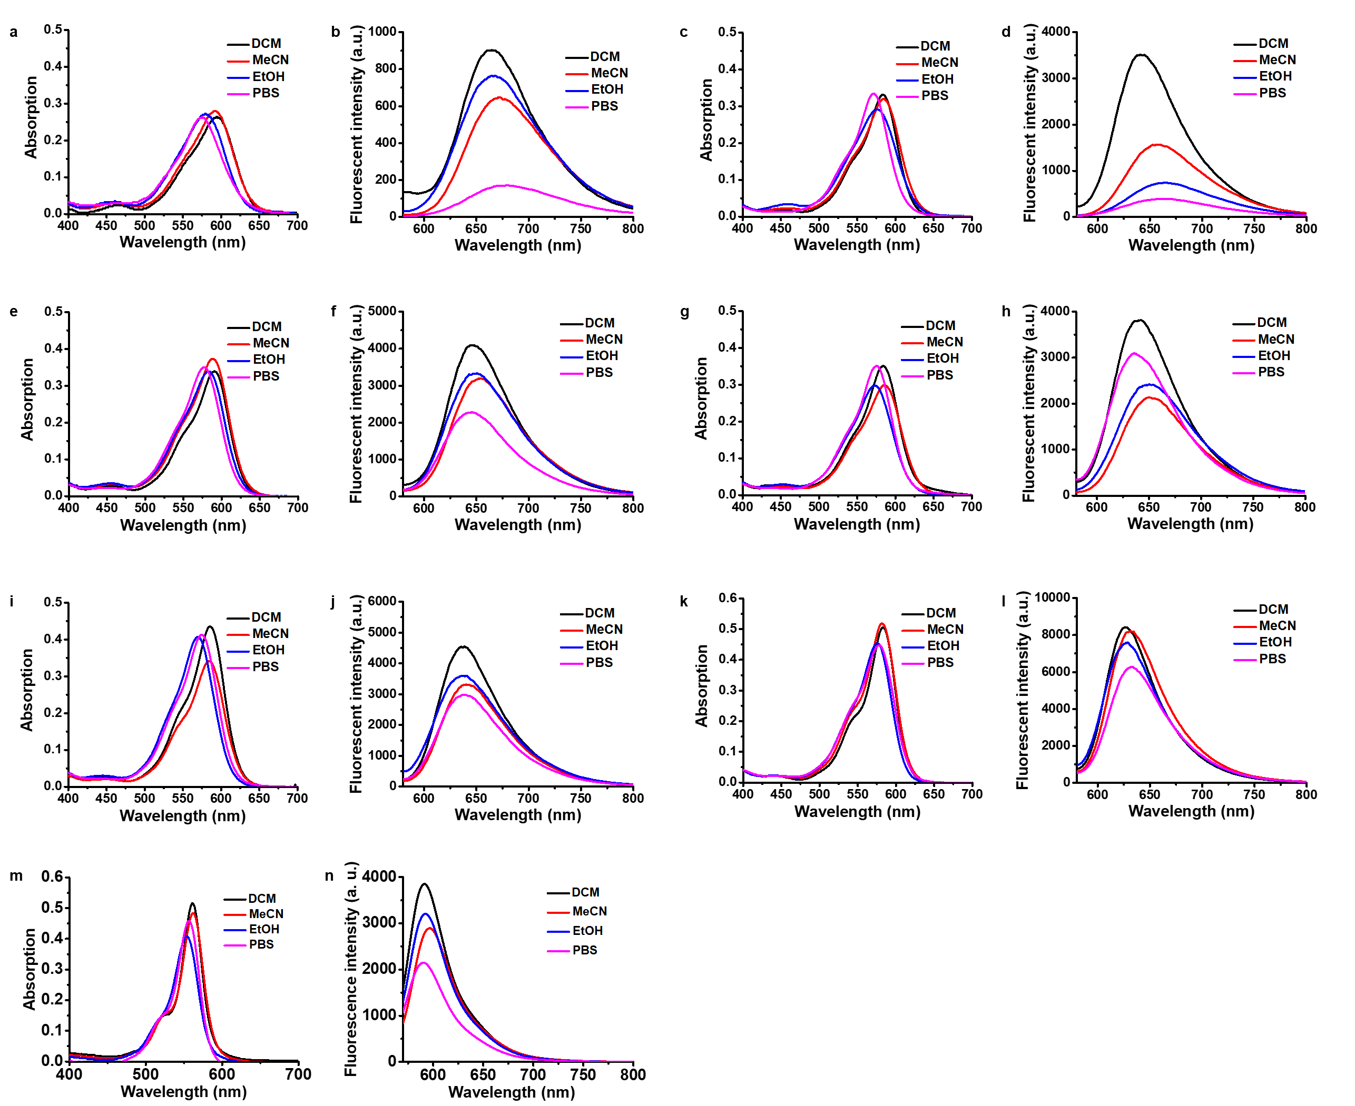
Supplementary Fig. 4 Absorption and emission spectra of BDQF-1 (a, b), BDQF-2 (c, d), BDQF-3 (e, f), BDQF-4 (g, h), BDQF-5 (i, j), BDQF-6 (k, l), BDQF-7 (m, n) (5 μM) in various solvents (CH₂Cl₂ (containing 0.1% TFA), MeCN (Containing 0.1% TFA), EtOH, PBS buffer (25 mM)) at 25 °C.

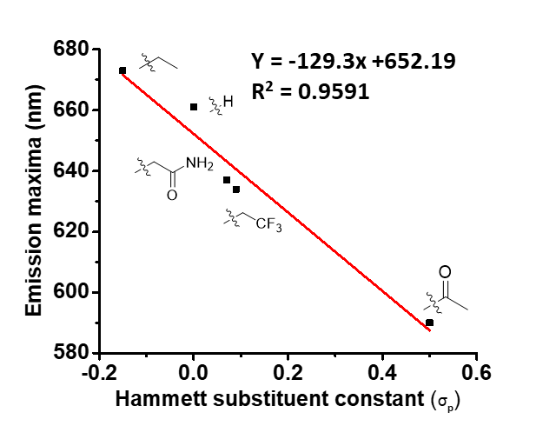
Supplementary Fig. 5 Correlation of emission maxima of dye BDQFs versus Hammett constants (σ_{p}) of the substituents at the quinoxaline⁴.

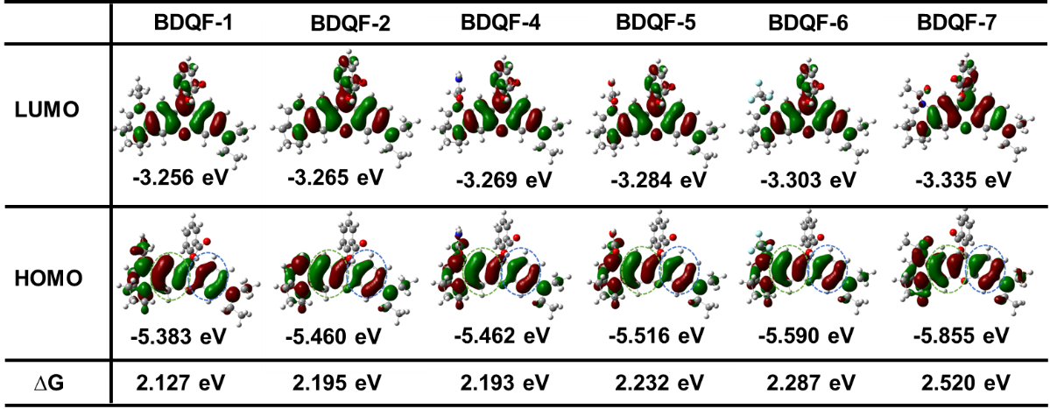
Supplementary Fig. 6 DFT optimized molecular orbital plots (LUMO and HOMO) of BDQF-(1-7).

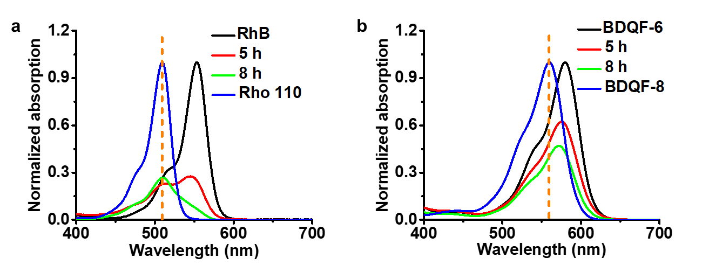
Supplementary Fig. 7 Normalized absorption spectra of BDQF-6 (b, 100 μM) and RhB (a, 100 μM) as a function of irradiation time in EtOH containing 0.1% TFA. Laser parameters: 530 nm, 1 W.

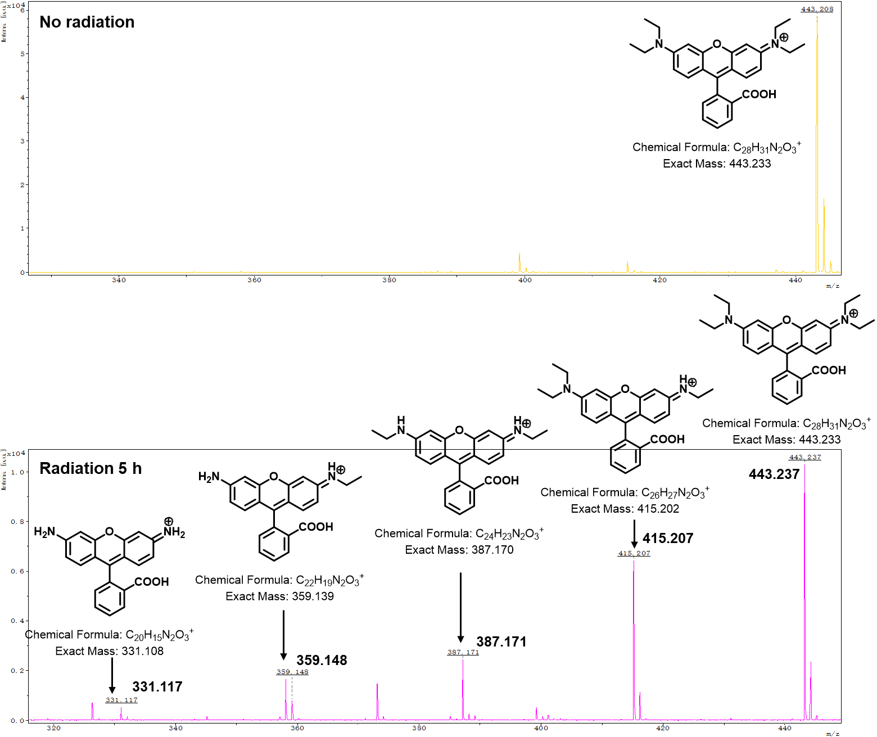
Supplementary Fig. 8 The MALDI-TOF/MS spectra of RhB in the absence or presence of radiation (5 h). Laser parameters: 530 nm, 1 W. EtOH containing 0.1% TFA.

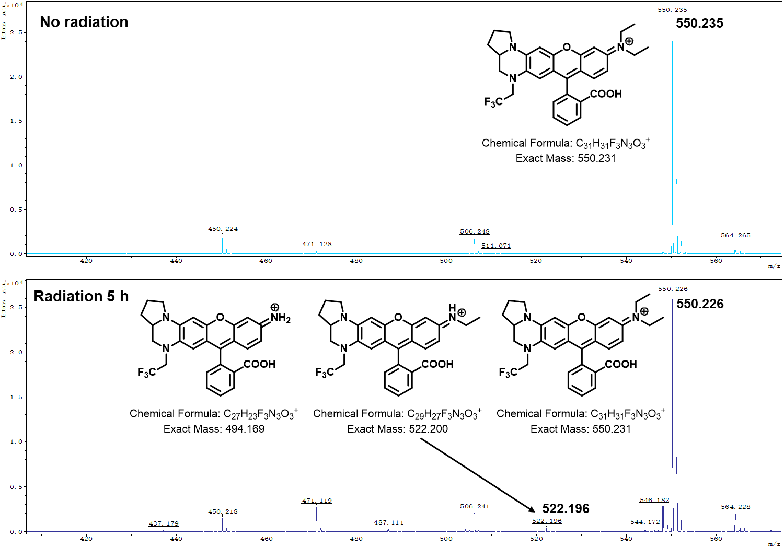
Supplementary Fig. 9 The MALDI-TOF/MS spectra of BDQF-6 in the absence or presence of radiation (5 h). Laser parameters: 530 nm, 1 W. EtOH containing 0.1% TFA.

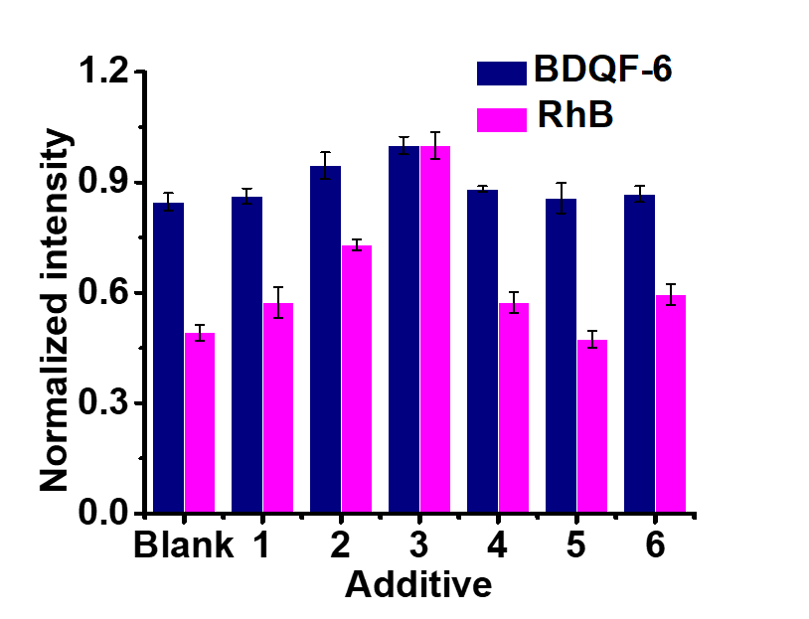
Supplementary Fig. 10 Normalized fluorescence maximum intensities of BDQF-6 and RhB in PBS buffer solution with abundant proteins (1: 10 mg/mL BSA; 2: 30 mg/mL BSA; 3: 50 mg/mL BSA; 4: 25 mg/mL CRP; 5: 1 mg/mL Gox; 6: 90 μL/mL Serum). Error bars, ± s.e.m. n = 3.

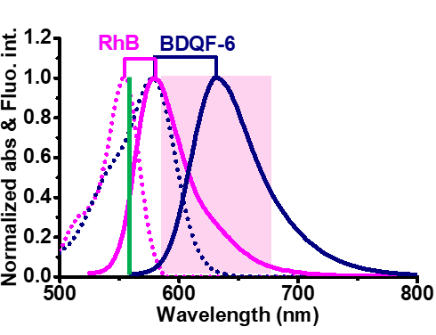
Supplementary Fig. 11 Normalized absorption and emission spectra of BDQF-6 and RhB. The green line and light pink area respectively mark the excitation wavelength (560 nm) and the bandpass of the confocal filter (585-675 nm) for cell imaging.

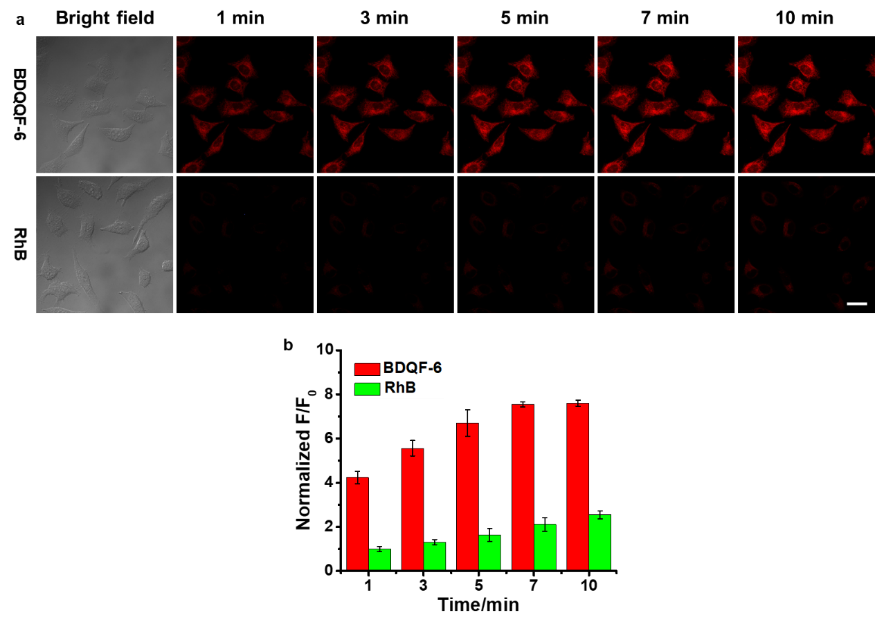
Supplementary Fig. 12 Staining performance of BDQF-6 and RhB. Confocal fluorescence images of live HeLa cells incubated with BDQF-6 or RhB (5.0 μM) as a function of incubation time (1–10 min). Quantification of the relative mean fluorescence intensities of BDQF-6 and RhB in live Hela cells. The fluorescence intensities were normalized to that of the cells incubated with RhB for 0 min (F₀). HeLa cells in each group were examined in 3 independent experiments separately. Scale bar = 20 μm. λ_{ex} = 561 nm, detection range 585–675 nm. Error bars, ± s.e.m. from about 50 cells.

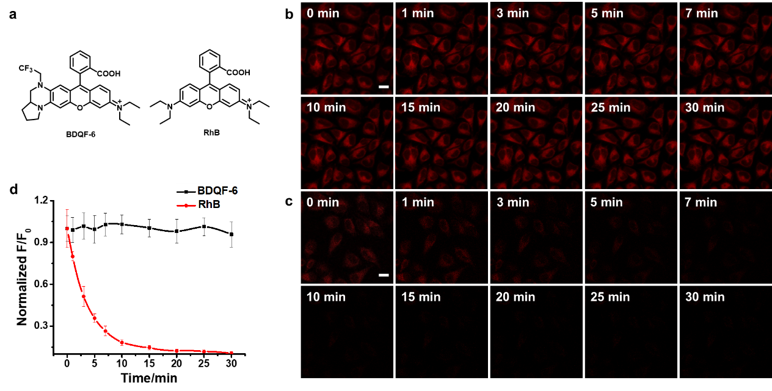
Supplementary Fig. 13 Comparison of BDQF-6 and RhB in live-cell imaging. (a) Structures of BDQF-6 and RhB. (b-c) Confocal fluorescence images of live HeLa cells cultured with BDQF-6 (5.0 μM) (b) and RhB (5.0 μM) (c) under continuous irradiation at 561 nm for 30 min. (d) Normalized fluorescence intensities of live Hela cells in b and c. The fluorescence intensities were normalized to that of the cells incubated with BDQF-6 or RhB for 0 min (F₀) before irradiation at 561 nm. HeLa cells in each group were examined in 3 independent experiments separately. Scale bar = 20 μm. λ_{ex} = 561 nm, detection range 585–675 nm. Error bars, ± s.e.m. from about 50 cells.

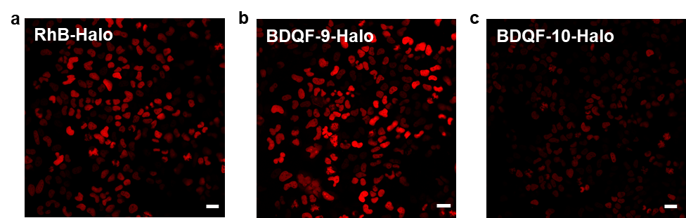
Supplementary Fig. 14 Confocal images of living H2B-Halo-expressed HeLa cells treated with RhB-Halo (a), BDQF-9-Halo (b), and BDQF-10-Halo (c). Hela cells were incubated with 250 nM probes for 6 h, washed once with phenol-red-free DMEM and incubated for 1 h prior to cell imaging. HeLa cells in each group were examined in 3 independent experiments separately. Scale bar = 50 nm. λ_{ex} = 561 nm, detection range 585–675 nm. Error bars of figure 3f, ± s.e.m. from about 100 cells.

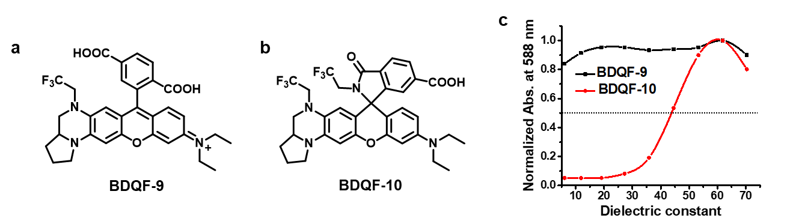
Supplementary Fig. 15 Comparison of BDQF-9 and BDQF-10. (a, b) Structures of BDQF-9 and BDQF-10. (c) Normalized absorbance at 588 nm in zwitterionic form of 5 μM BDQF-9 and BDQF-10 in water-dioxane mixtures (v/v, 10/90-90/10) as a function of dielectric constant. The absorbance was normalized to the maximum absorbance of BDQF-9.

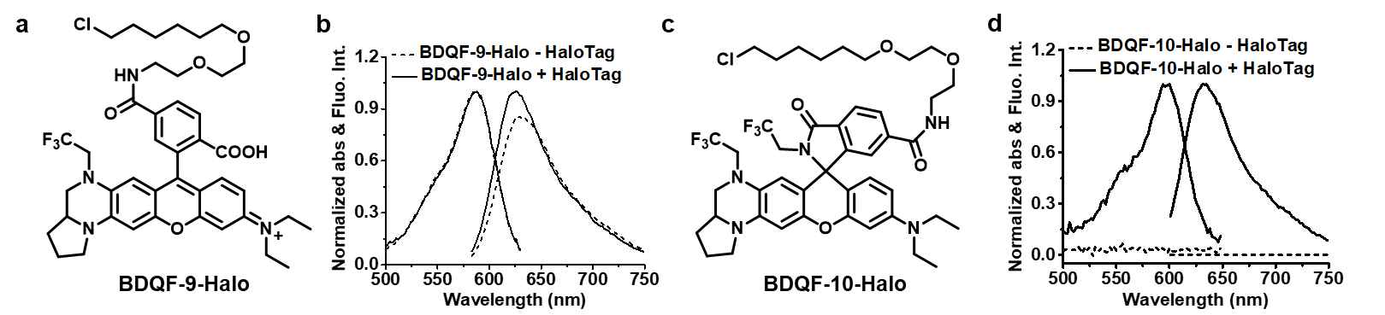
Supplementary Fig. 16 In vitro response of BDQF-9-Halo and BDQF-10-Halo towards HaloTag. (a, c) Structures of BDQF-9-Halo and BDQF-10-Halo. (b, d) Normalized absorption and emission spectra of BDQF-9-Halo (b) and BDQF-10-Halo (d) measured in the presence (+ protein) and absence (- protein) of HaloTag protein after 1 h incubation.

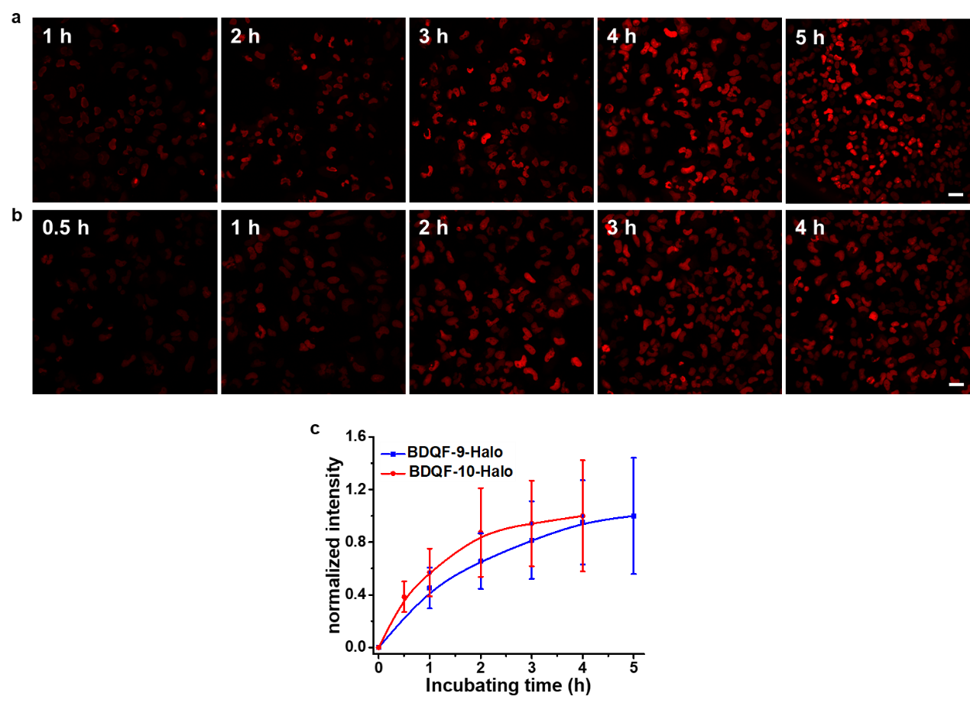
Supplementary Fig. 17 Intracellular protein labeling with BDQF-9-Halo and BDQF-10-Halo as a function of time. (a, b) Time-dependent confocal images of live HeLa H2B-Halo-expressing cells labeled with 250 nM BDQF-9-Halo (a) or BDQF-10-Halo (b). (c) Normalized fluorescence intensities of live Hela cells incubated with BDQF-9-Halo or BDQF-10-Halo at different time points. The fluorescence intensities were normalized to the intensity of cells treated with BDQF-9-Halo for 4 h or that of BDQF-10-Halo for 5 h. Scale bar = 50 μm. λ_{ex} = 561 nm, detection range 585–675 nm. Error bars, ± s.e.m. from about 50 cells.

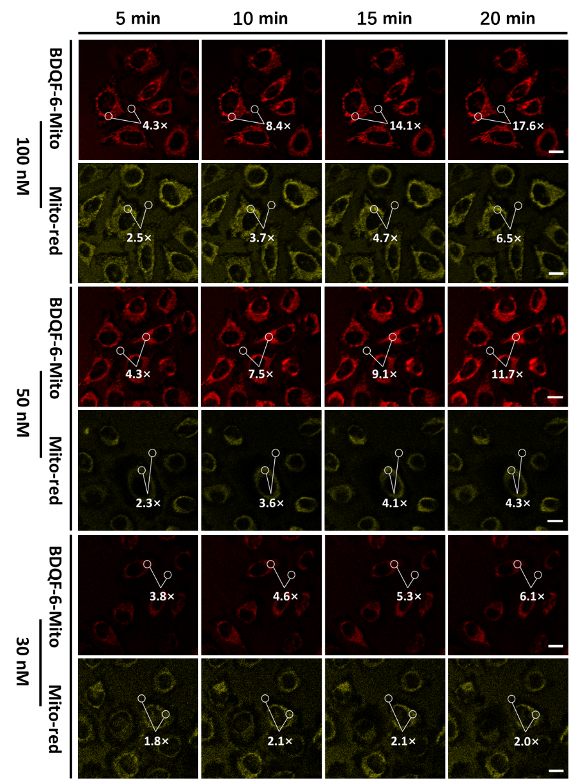
Supplementary Fig. 18 Staining performance of BDQF-6-Mito and Mito-Red in live-cell imaging. Confocal fluorescent images of live HeLa cells incubated with BDQF-6-Mito or Mito-red at different concentrations (100, 50, and 30 nM). Scale bar = 20 μm. λ_{ex} = 561 nm, detection range 585–675 nm.

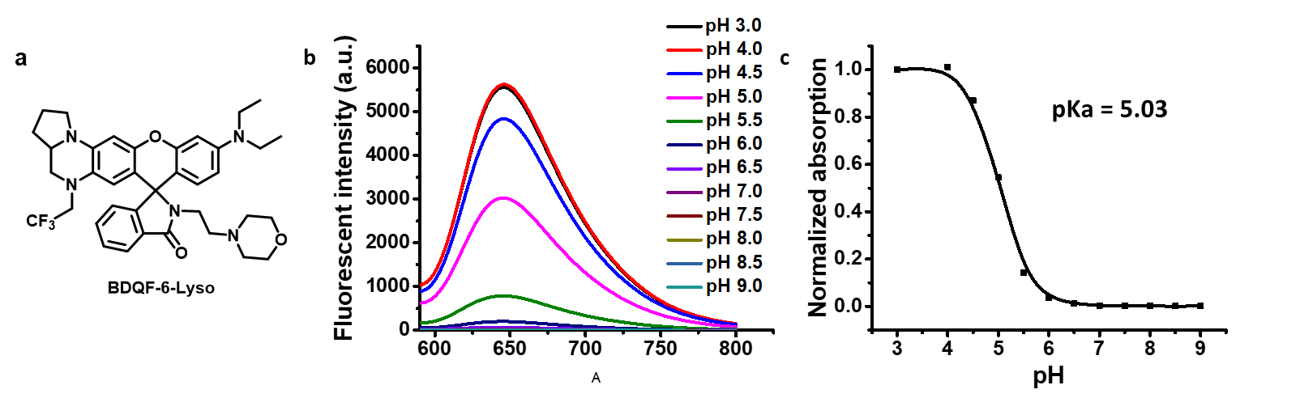
Supplementary Fig. 19 Response of BDQF-6-Lyso to pH. (a) Structure of BDQF-6-Lyso. (b) Fluorescence spectra of BDQF-6-Lyso (5 μM) at different pH values in PBS buffer (25 mM). (c) pH titration curve was plotted by BDQF-6-Lyso fluorescence intensities at 635 nm as a function of pH.
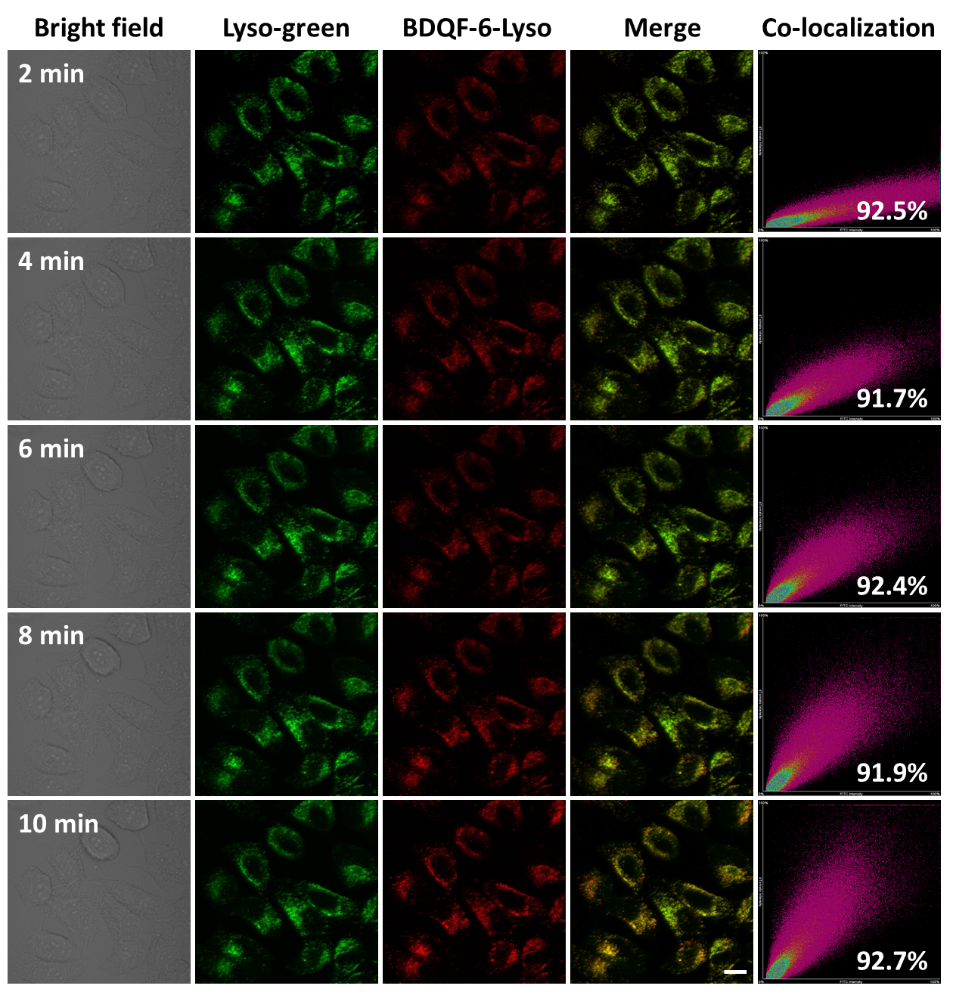
Supplementary Fig. 20 Confocal fluorescent images of live HeLa cells incubated with BDQF-6-Lyso (500 nM) for different time periods. HeLa cells were pre-incubated with Lyso-Green (500 nM) for 10 min before the addition of BDQF-6. Scale bar = 20 μm. λ_{ex} = 561 nm, detection range 585–675 nm.

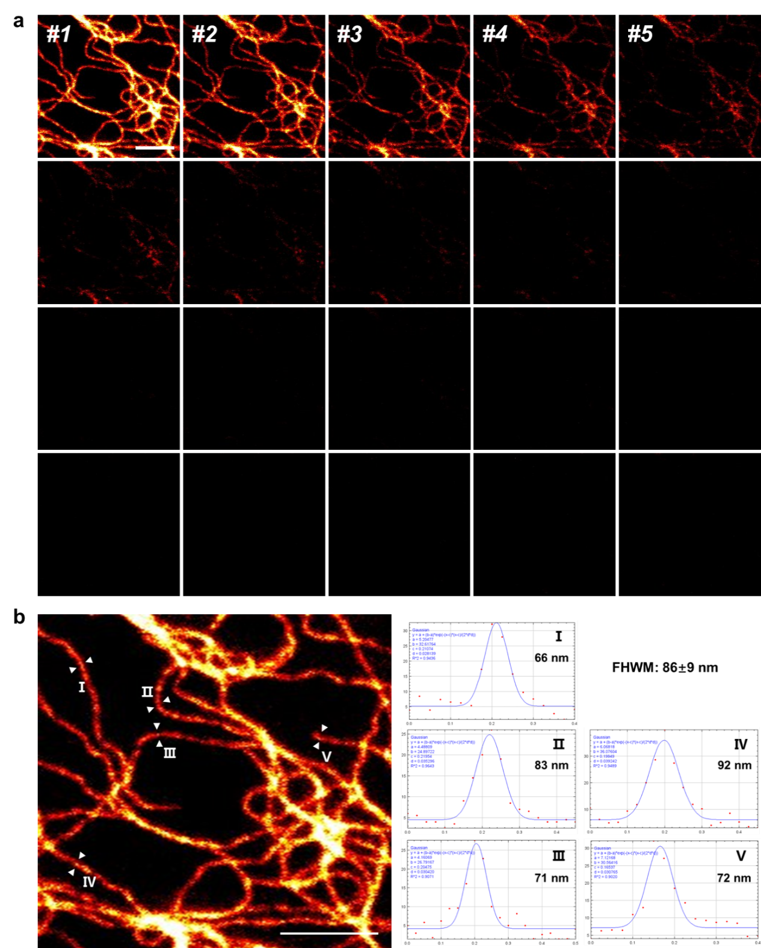
Supplementary Fig. 21 (a) Multiframe STED images of fixed U-2 OS stably expressing vimentin-HaloTag-expressing cells labeled with 50 nM CPY-Halo for 6 h. (b) The resolution of vimentin filaments in the first frame of graph a. The corresponding line profiles drawn perpendicular to the indicated filaments. Counts were averaged over five pixels along the direction of the filament and fitted to the Gaussian function. Resulting full-width at half maximum values are given for each fit, providing an upper boundary for the optical resolution. 20 areas from 5 cells were examined in 2 independent experiments separately. Scale bar = 1 μm.

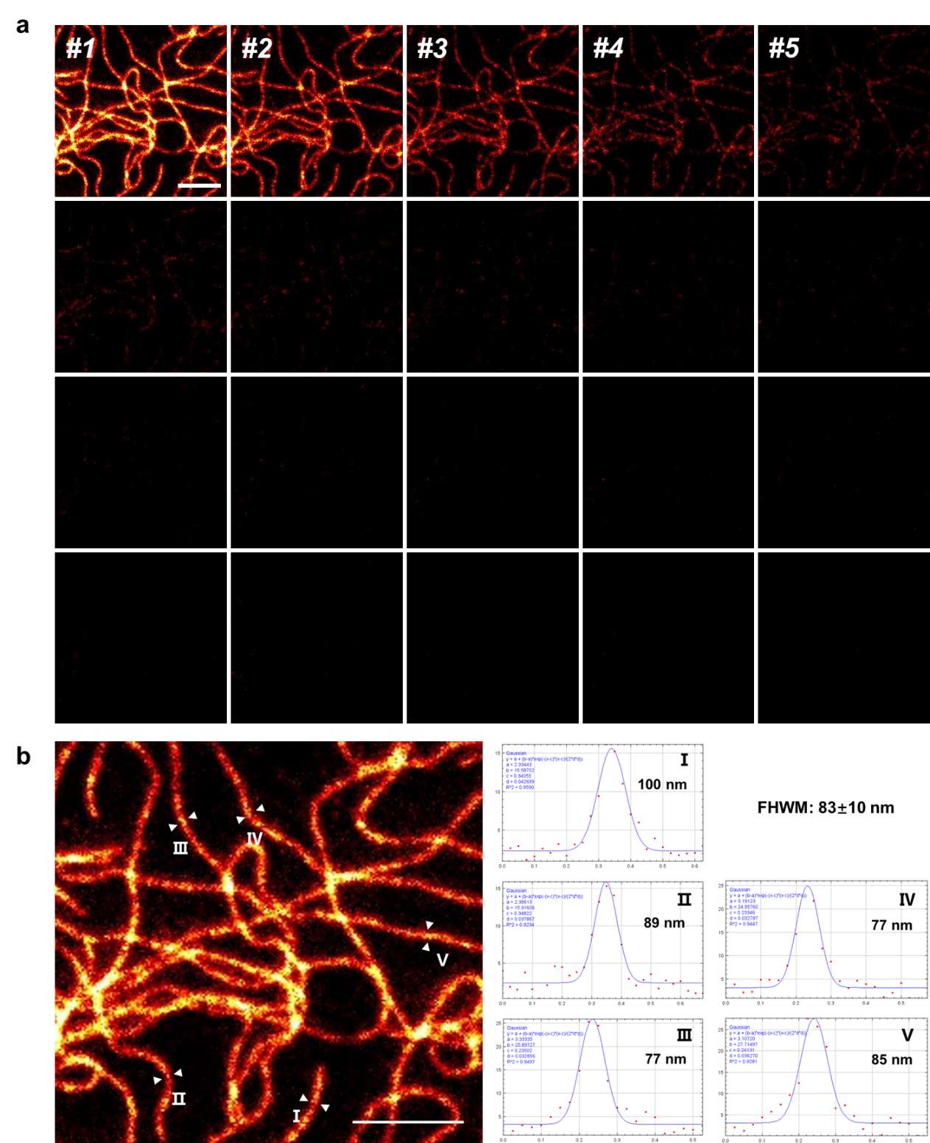
Supplementary Fig. 22 (a) Multiframe STED images of fixed U-2 OS stably expressing vimentin-HaloTag-expressing cells labeled with 50 nM JF608-Halo for 6 h. (b) The resolution of vimentin filaments in the first frame of graph a. The corresponding line profiles drawn perpendicular to the indicated filaments. Counts were averaged over five pixels along the direction of the filament and fitted to the Gaussian function. Resulting full-width at half maximum values are given for each fit, providing an upper boundary for the optical resolution. 20 areas from 5 cells were examined. Scale bar = 1 μm.

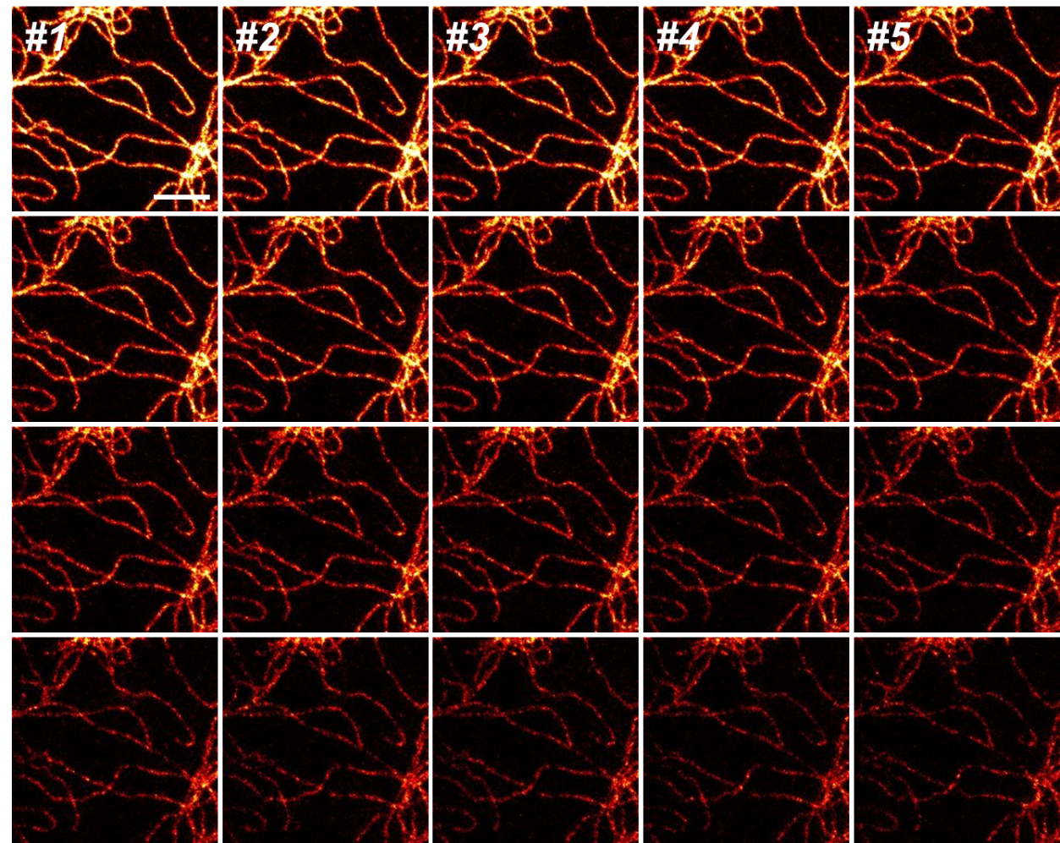
Supplementary Fig. 23 Multiframe STED images of fixed U-2 OS stably expressing vimentin-HaloTag-expressing cells labeled with 50 nM BDQF-9-Halo for 6 h. 3 independent experiments were performed separately. Scale bar = 1 μm.

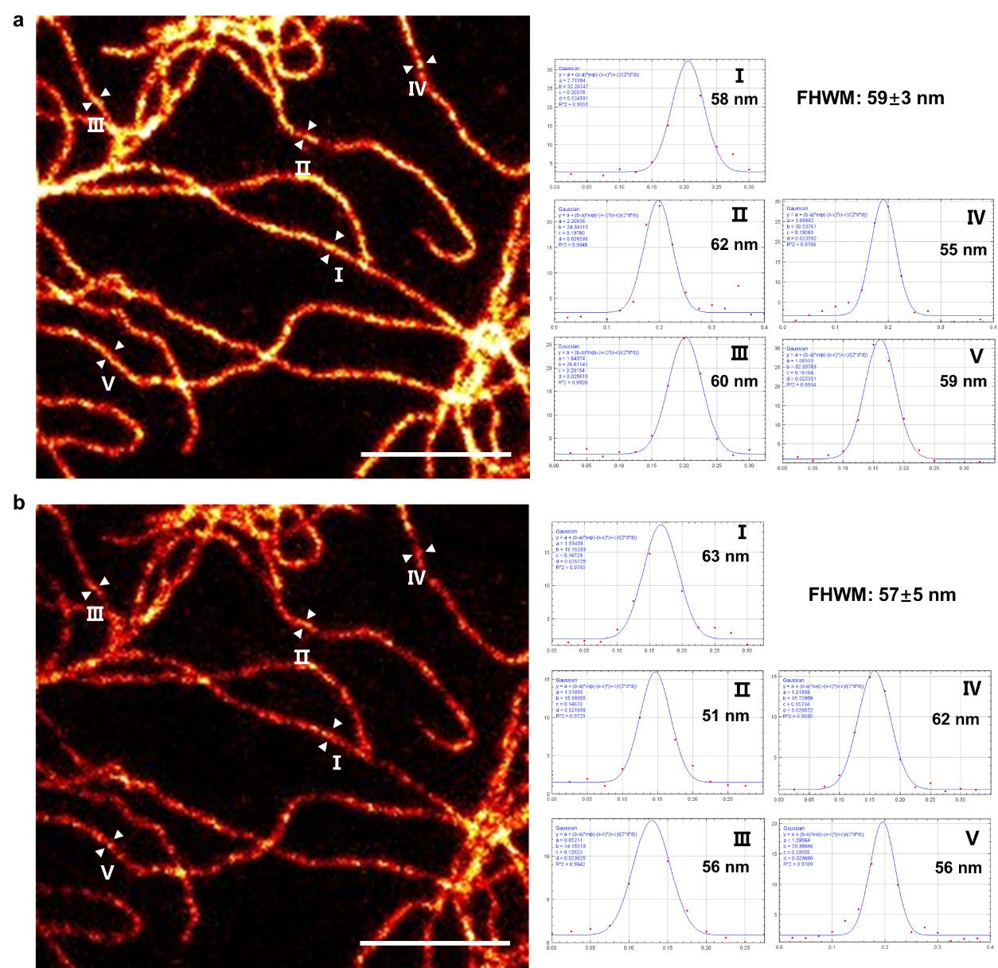
Supplementary Fig. 24 The resolution of vimentin filaments in the first (a) and ninth (b) frame of Supplementary Fig. 23. The corresponding line profiles drawn perpendicular to the indicated filaments. Counts were averaged over five pixels along the direction of the filament and fitted to the Gaussian function. Resulting full-width at half maximum values are given for each fit, providing an upper boundary for the optical resolution. 20 areas from 5 cells were examined in 3 independent experiments separately. Scale bar: 1 µm.

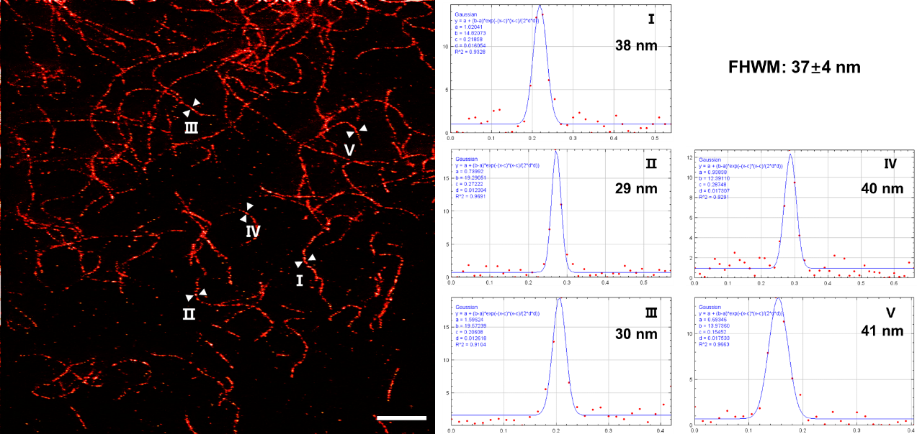
Supplementary Fig. 25 Ultrahigh-resolution STED images of live U-2 OS stably expressing vimentin-HaloTag-expressing cells labeled with 50 nM BDQF-9-Halo for 6 h. The resolution of vimentin filaments when optimizing the imaging settings. The corresponding line profiles drawn perpendicular to the indicated filaments. Counts were averaged over five pixels along the direction of the filament and fitted to the Gaussian function. Resulting full-width at half maximum values are given for each fit, providing an upper boundary for the optical resolution. 20 areas from 5 cells were examined. Scale bar: 1 µm.

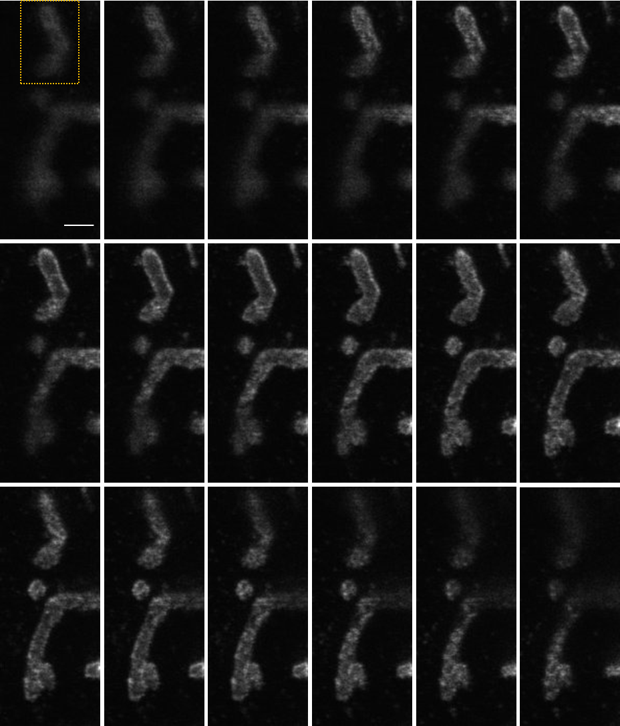
Supplementary Fig. 26 STED images of U-2 OS expressing mitochondrial import receptor Tomm20-HaloTag cells labeled with 50 nM BDQF-9-Halo for 6 h. Frames were recorded in sequential xzy-scanning mode. STED images of mitochondria in the dashed box were utilized to construct a 3D STED image (Figure 4c). Scale bar = 1 μm.

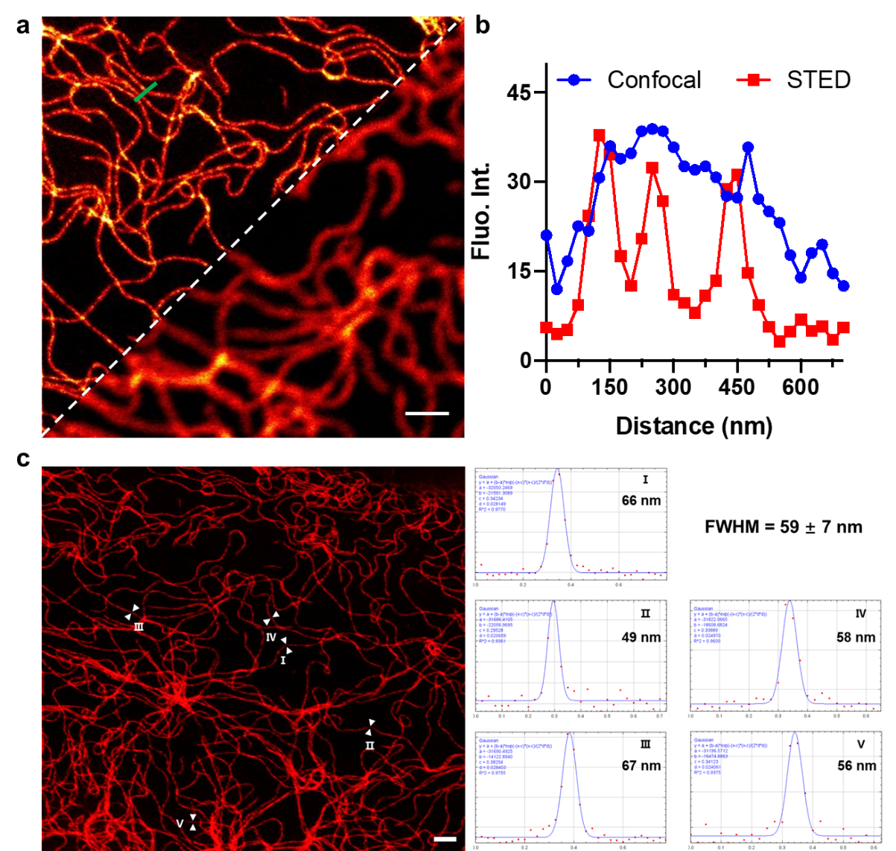
Supplementary Fig. 27 STED images of live U-2 OS cells labeled with BDQF-9-Halo. (a) STED images of vimentin filaments in live U-2 OS cells that expressed vimentin-Halo fusion protein after incubation with BDQF-9-Halo (50 nM) for 6 h. (b) Plot of line-scan intensity in a (green line) as a function of line length in a. (c) The corresponding line profiles drawn perpendicular to the indicated filaments. Counts were averaged over five pixels along the direction of the filament and fitted to the Gaussian function. Resulting full-width at half maximum values are given for each fit, providing an upper boundary for the optical resolution. 20 areas from 5 cells were examined in 3 independent experiments separately. Scale bar = 1 μm.

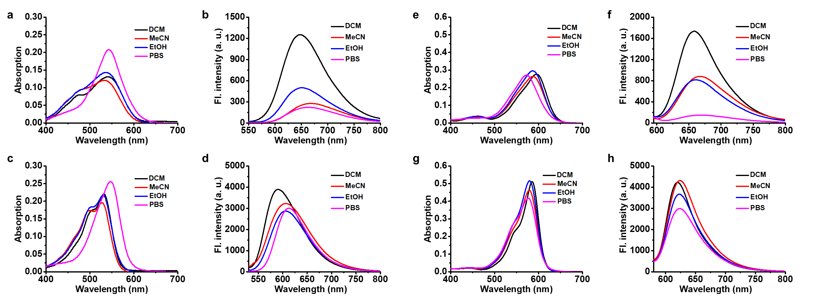
Supplementary Fig. 28 Absorption and emission spectra of BDQF-17 (a, b), BDQF-11 (c, d), BDQF-18 (e, f), BDQF-12 (g, h) (5 μM) in various solvents (CH₂Cl₂, MeCN, EtOH, PBS buffer (25 mM)) at 25 °C.

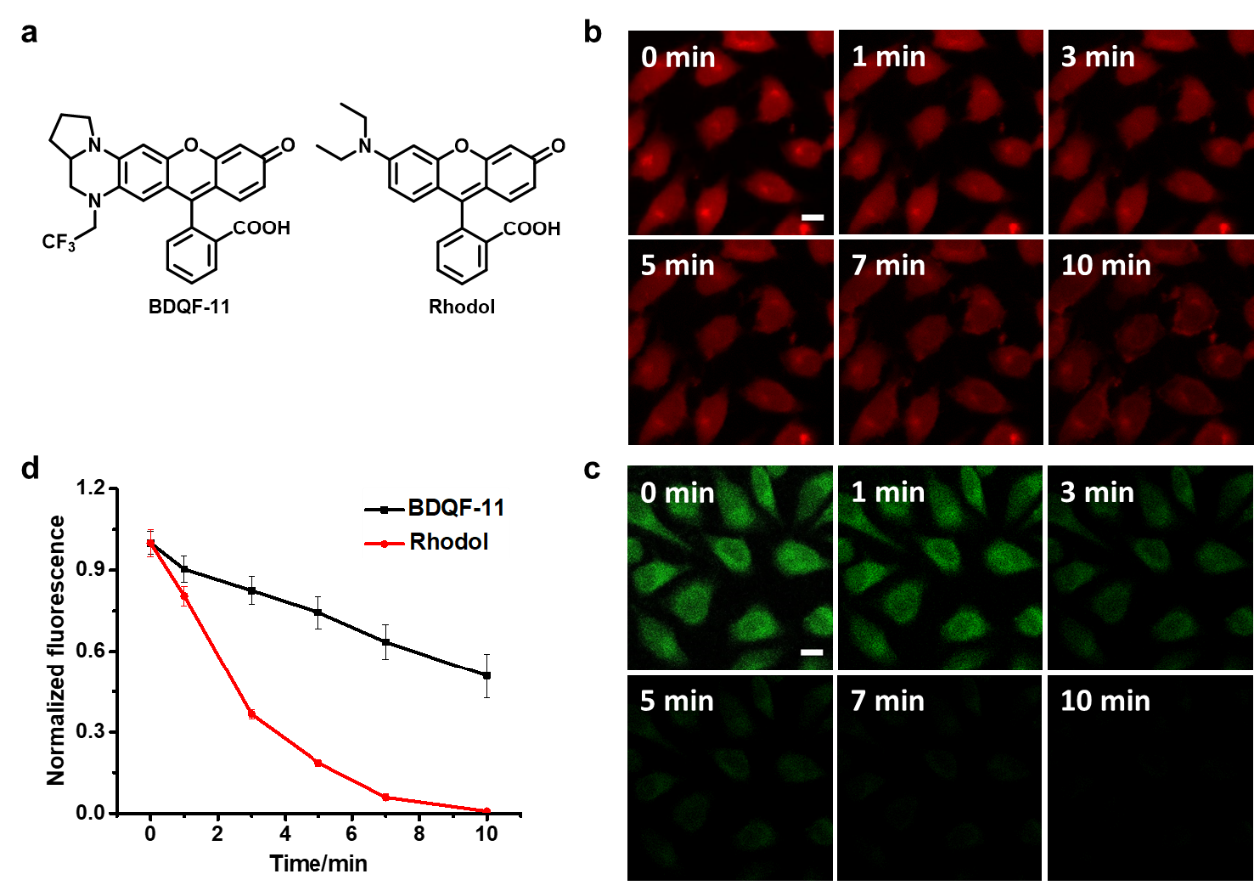
Supplementary Fig. 29 Comparison of BDQF-11 and Rhodol in live-cell imaging. (a) structures of BDQF-11 and Rhodol (R-2). (b-c) Confocal fluorescence images of live HeLa cells cultured with BDQF-11 (5.0 μM) (b) and Rhodol (5.0 μM) (c) under continuous irradiation for 10 min. (d) Normalized fluorescence intensities of live Hela cells in b and c. The fluorescence intensities were normalized to that of the cells incubated with BDQF-11 or Rhodol for 0 min (F₀) prior to irradiation. HeLa cells in each group were examined in 3 independent experiments separately. Scale bar = 20 μm. For BDQF-11, λ_{ex} = 561 nm, detection range, 585-675 nm. For Rhodol, λ_{ex} = 488 nm, detection range 500-550 nm. Error bars, ± s.e.m. from about 50 cells.

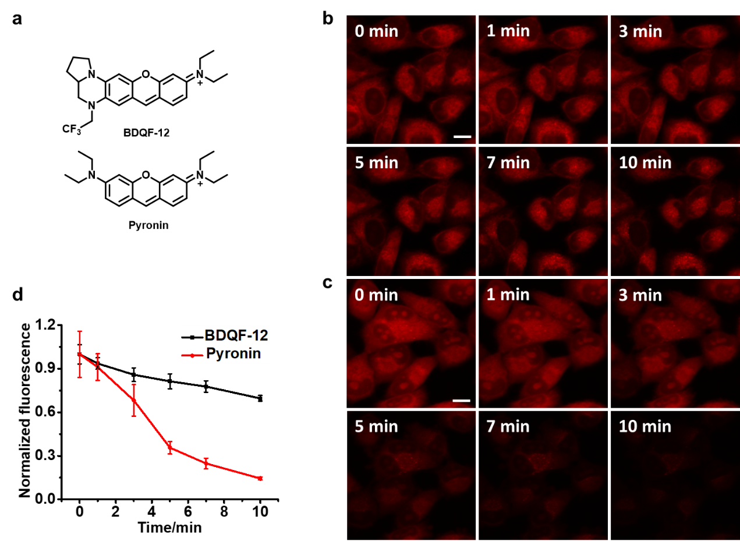
Supplementary Fig. 30 Comparison of BDQF-12 and Pyronin in live-cell imaging. (a) structures of BDQF-12 and Pyronin (R-3). (b-c) Confocal fluorescence images of live HeLa cells cultured with BDQF-12 (5.0 μM) (b) and Pyronin (5.0 μM) (c) under continuous irradiation for 10 min. (d) Normalized fluorescence intensities of live Hela cells in b and c. The fluorescence intensities were normalized to that of the cells incubated with BDQF-12 or Pyronin for 0 min (F₀) before irradiation. HeLa cells in each group were examined in 3 independent experiments separately. Scale bar = 20 μm. λ_{ex} = 561 nm, detection range, 585-675 nm. Error bars, ± s.e.m. from about 50 cells.

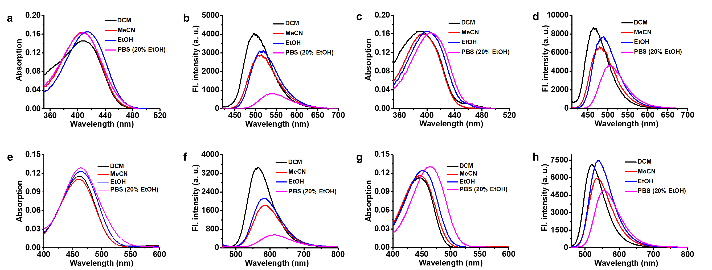
Supplementary Fig. 31 Absorption and emission spectra of BDQF-19 (a, b), BDQF-13 (c, d), BDQF-20 (e, f), BDQF-14 (g, h) (5 μM) in various solvents (CH₂Cl₂, MeCN, EtOH, PBS buffer (25 mM)) at 25 °C.

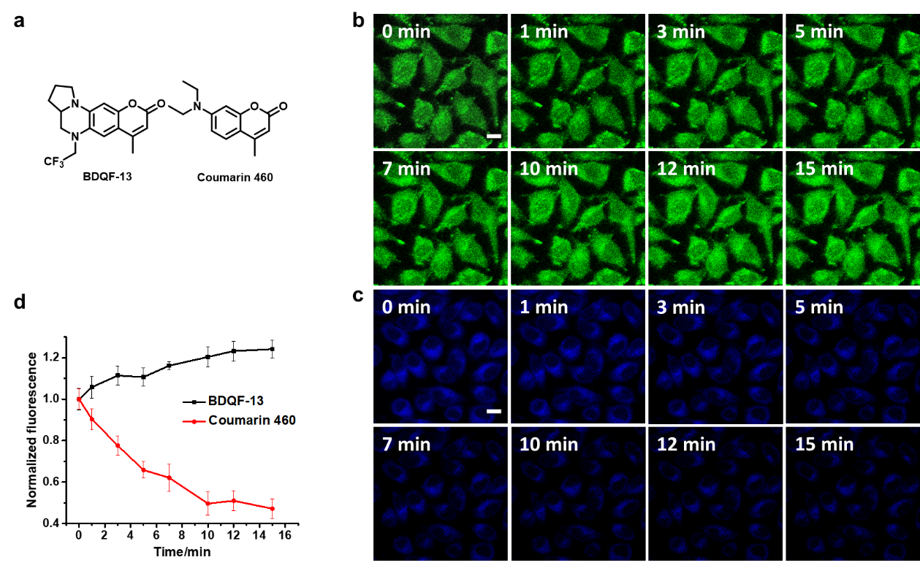
Supplementary Fig. 32 Comparison of BDQF-13 and Coumarin 460 in live-cell imaging. (a) structures of BDQF-13 and Coumarin 460 (R-4). (b-c) Confocal fluorescence images of live HeLa cells cultured with BDQF-13 (5.0 μM) (b) and Coumarin 460 (5.0 μM) (c) under continuous irradiation for 15 min. (d) Normalized fluorescence intensities of live Hela cells in b and c. The fluorescence intensities were normalized to that of the cells incubated with BDQF-13 or Coumarin 460 for 0 min (F₀) before irradiation. HeLa cells in each group were examined in 3 independent experiments separately. Scale bar = 20 μm. For BDQF-13, λ_{ex} = 405 nm, detection range, 500-550 nm. For Coumarin 460, λ_{ex} = 405 nm, detection range 425-475 nm. Error bars, ± s.e.m. from about 50 cells.

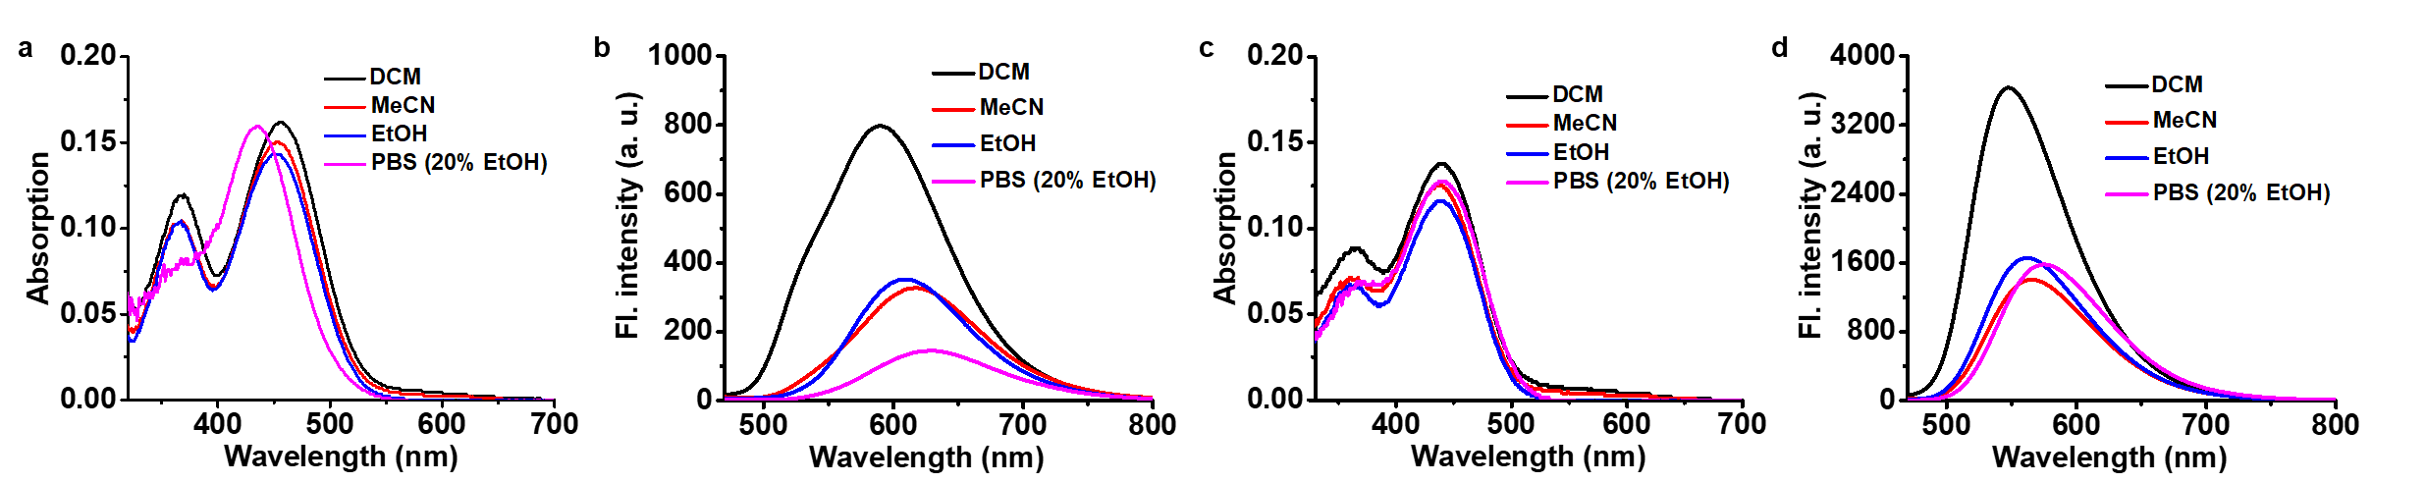
Supplementary Fig. 33 Absorption and emission spectra of BDQF-21 (a, b), BDQF-15 (c, d) (5 μM) in various solvents (CH₂Cl₂, MeCN, EtOH, PBS buffer (25 mM)) at 25 °C.

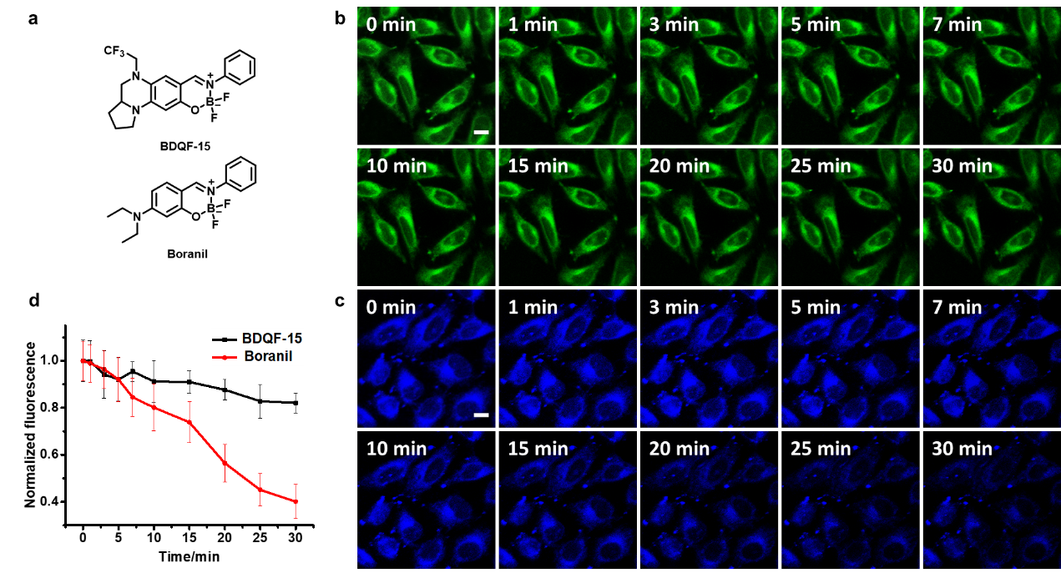
Supplementary Fig. 34 Comparison of BDQF-15 and Boranil in live-cell imaging. (a) structures of BDQF-15 and Boranil (R-5). (b-c) Confocal fluorescence images of live HeLa cells cultured with BDQF-15 (5.0 μM) (b) and Boranil (5.0 μM) (c) under continuous irradiation for 30 min. (d) Normalized fluorescence intensities of live Hela cells in b and c. The fluorescence intensities were normalized to that of the cells incubated with BDQF-15 or Boranil for 0 min (F₀) before irradiation. HeLa cells in each group were examined in 3 independent experiments separately. Scale bar = 20 μm. For BDQF-15, λ_{ex} = 405 nm, detection range, 570-620 nm. For Boranil, λ_{ex} = 405 nm, detection range 425-475 nm. Error bars, ± s.e.m. from about 50 cells.

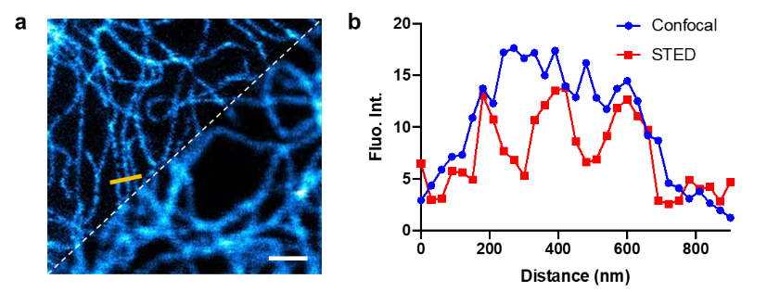
Supplementary Fig. 35 STED images of vimentin filaments in live U-2 OS cells that expressed vimentin-Halo fusion protein after incubation with BDQF-16-Halo (50 nM) for 6 h. (b) Plot of line-scan intensity in a (yellow line) as a function of line length.Scale bar = 1 μm. λ_{ex} = 485 nm, detection range, 500–550 nm, STED laser 595 nm.

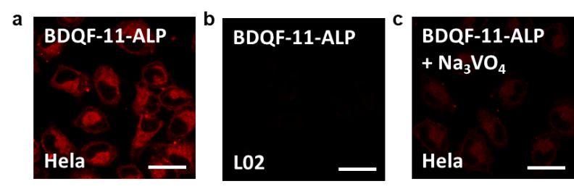
Supplementary Fig. 36 Utilization of BDQF-11-ALP for sensing ALP in live-cell imaging. (a-b) Confocal images of living HeLa (a) or L02 (b) cells stained with BDQF-11-ALP (5 μM) after 1 h of incubation. (c) Confocal fluorescence images of live HeLa cells incubated with BDQF-11-ALP (5 μM) for 1 h with pre-incubation with 1 mM Na₃VO₄ for 2 h. Normalized fluorescence intensities of living Hela cells in a-c. The fluorescence intensities were normalized to that of the L02 cells incubated with BDQF-11-ALP (Figure 5i). Cells in each group were examined in 3 independent experiments separately. Scale bar = 20 μm. λ_{ex} = 561 nm, detection range, 585-675 nm.

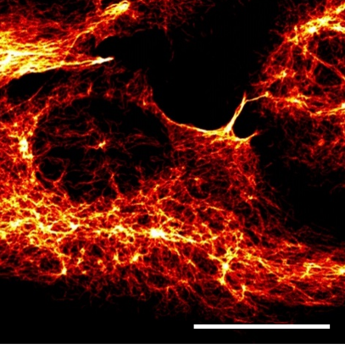
Supplementary Fig. 37 Two-photon images of vimentin filaments in live U-2 OS cells that expressed vimentin-Halo fusion protein after incubation with BDQF-9-Halo (50 nM) for 6 h. Scale bar = 20 μm. λ_{ex} = 870 nm, detection range, 570–780 nm.

Supplementary Table 1 Photophysical properties of BDQF-(1-7) in various solvents (CH₂Cl₂, MeCN, EtOH, PBS buffer (25 mM)) at 25 °C.
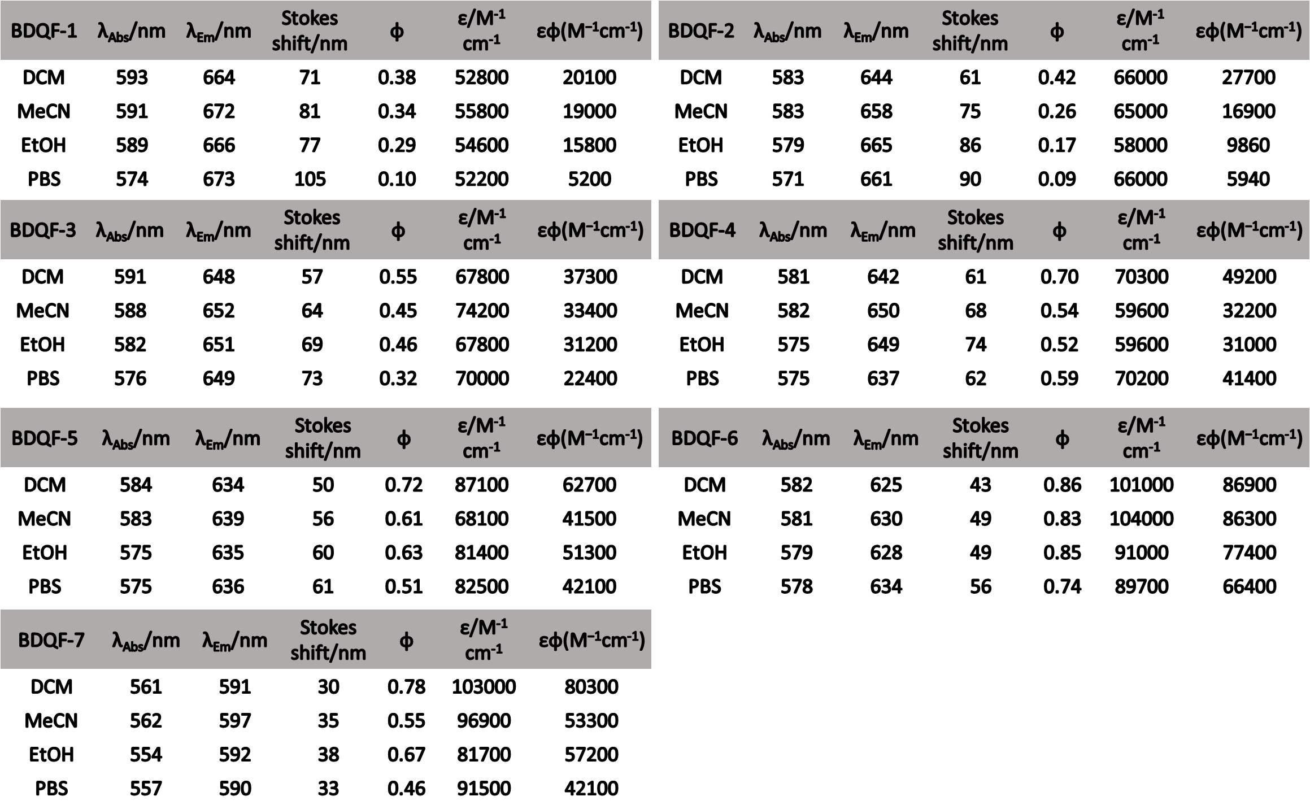

Supplementary Table 2 Photophysical properties of BDQF-(11, 12, 17, 18) (5 μM) in various solvents (CH₂Cl₂, MeCN, EtOH, PBS buffer (25 mM)) at 25 °C.
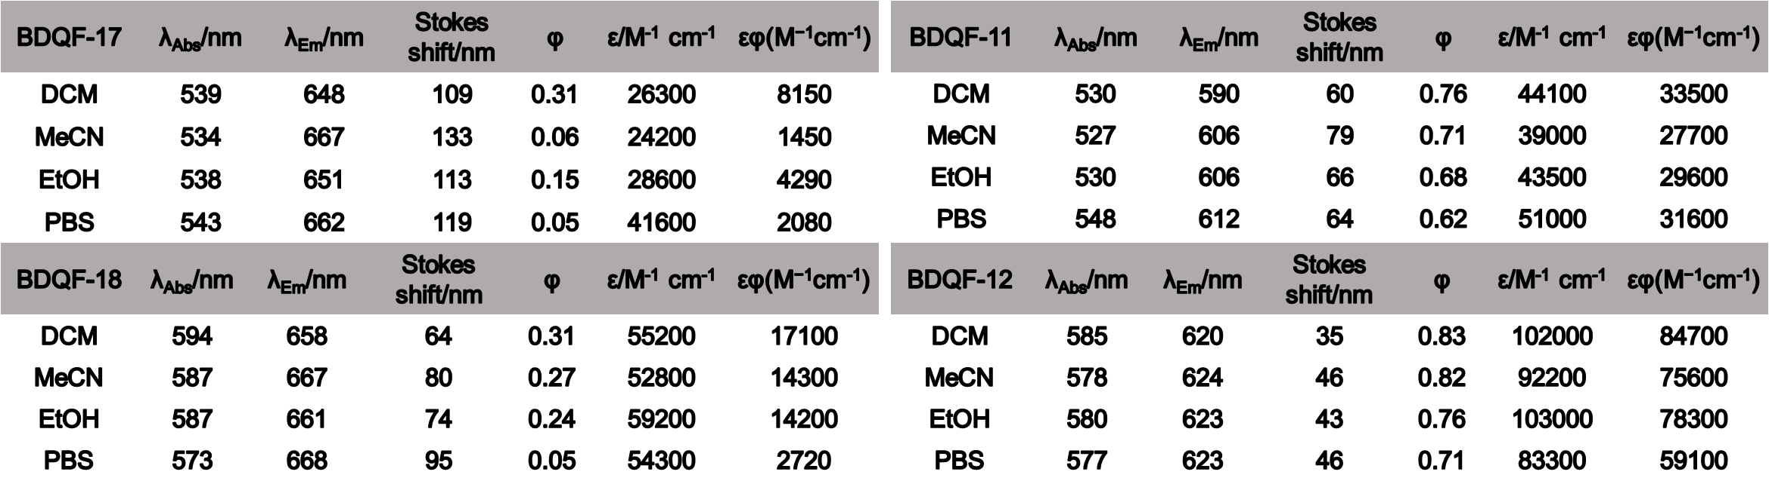

Supplementary Table 3 Photophysical properties of BDQF-(13, 14, 19, 20) (5 μM) in various solvents (CH₂Cl₂, MeCN, EtOH, PBS buffer (25 mM, containing 20% EtOH)) at 25 °C.
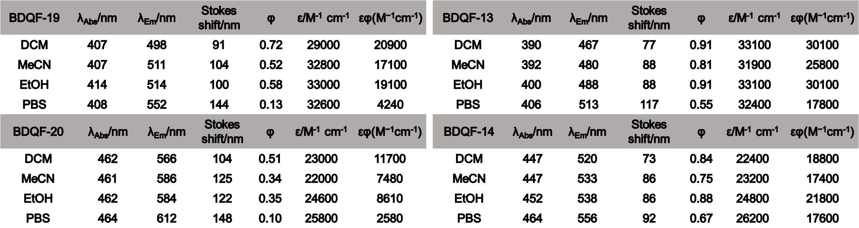

Supplementary Table 4 Photophysical properties of BDQF-(15, 21) (5 μM) in various solvents (CH₂Cl₂, MeCN, EtOH, PBS buffer (25 mM, containing 20% EtOH)) at 25 °C.
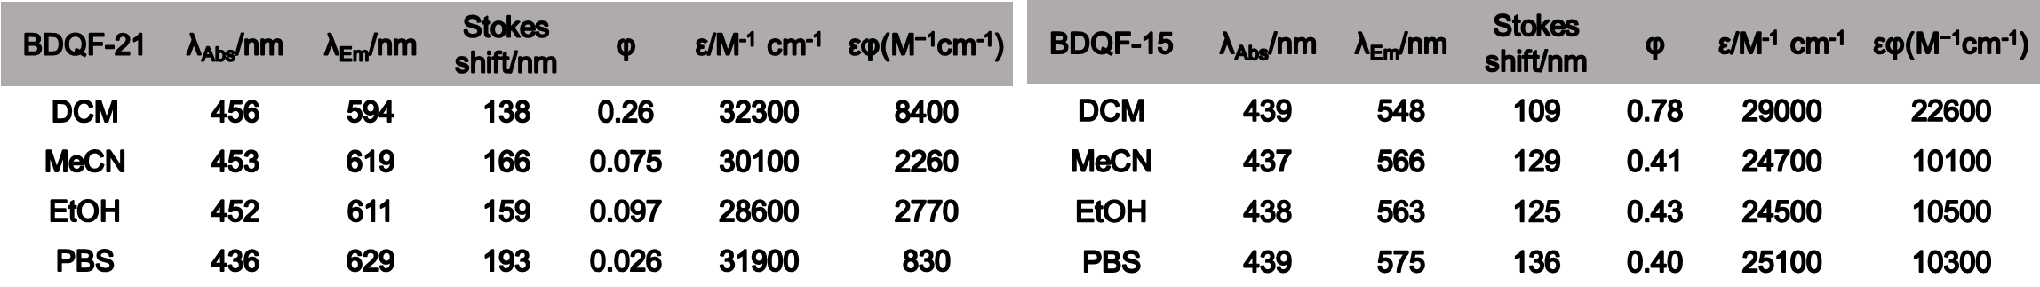

Synthesis Procedure
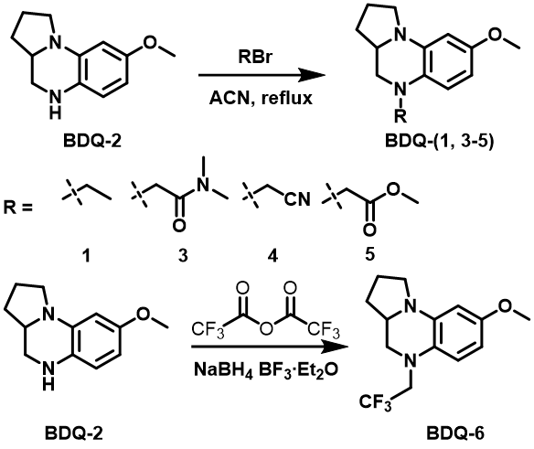
Supplementary Scheme 1 Synthesis of BDQ-(1-6).

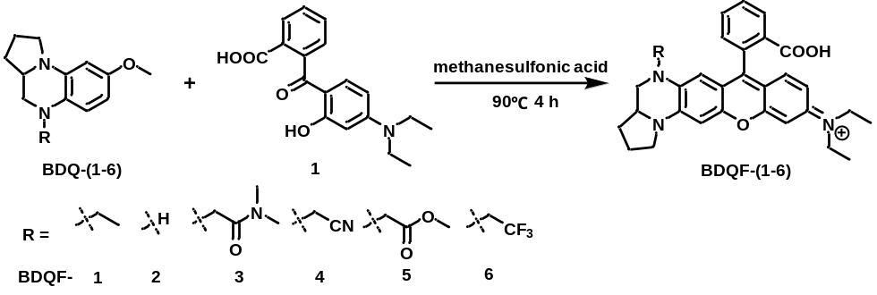
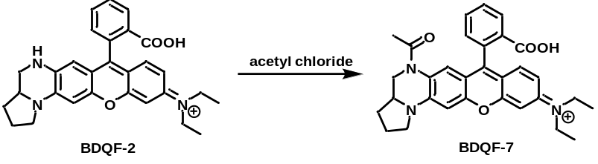
Supplementary Scheme 2 Synthesis of BDQF-(1-7).

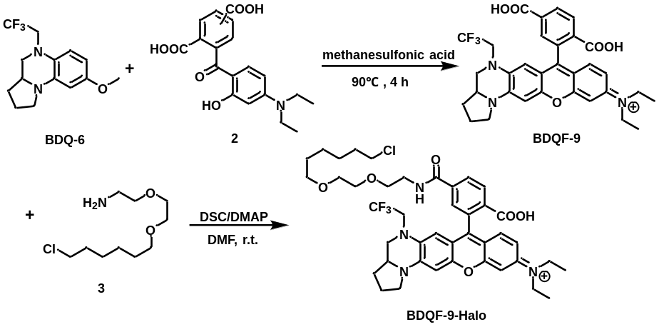
Supplementary Scheme 3 Synthesis of BDQF-9-Halo.

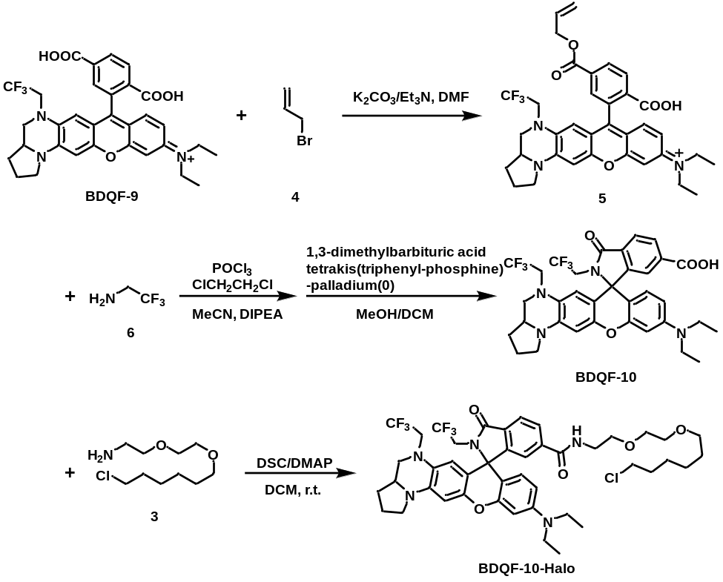
Supplementary Scheme 4 Synthesis of BDQF-10-Halo.

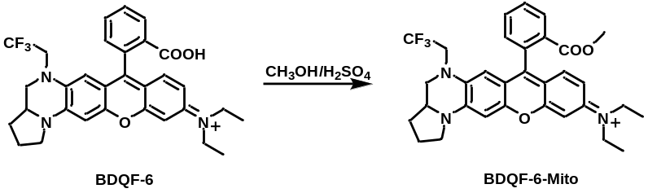
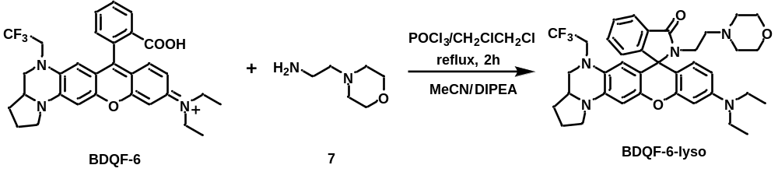
Supplementary Scheme 5 Synthesis of BDQF-6-Mito and BDQF-6-Lyso.

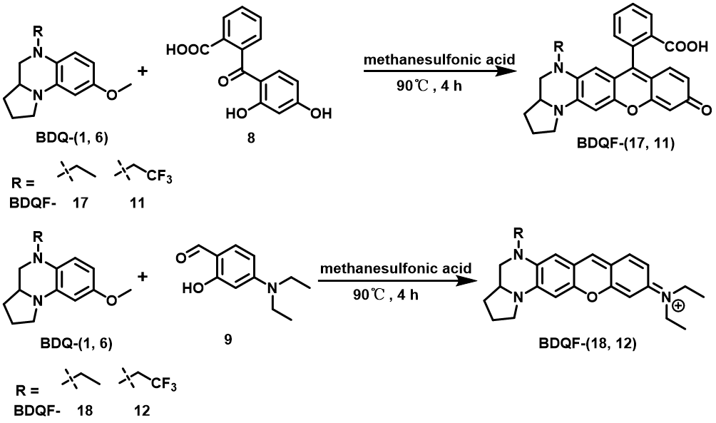
Supplementary Scheme 6 Synthesis of BDQF-(11, 12, 17, 18).

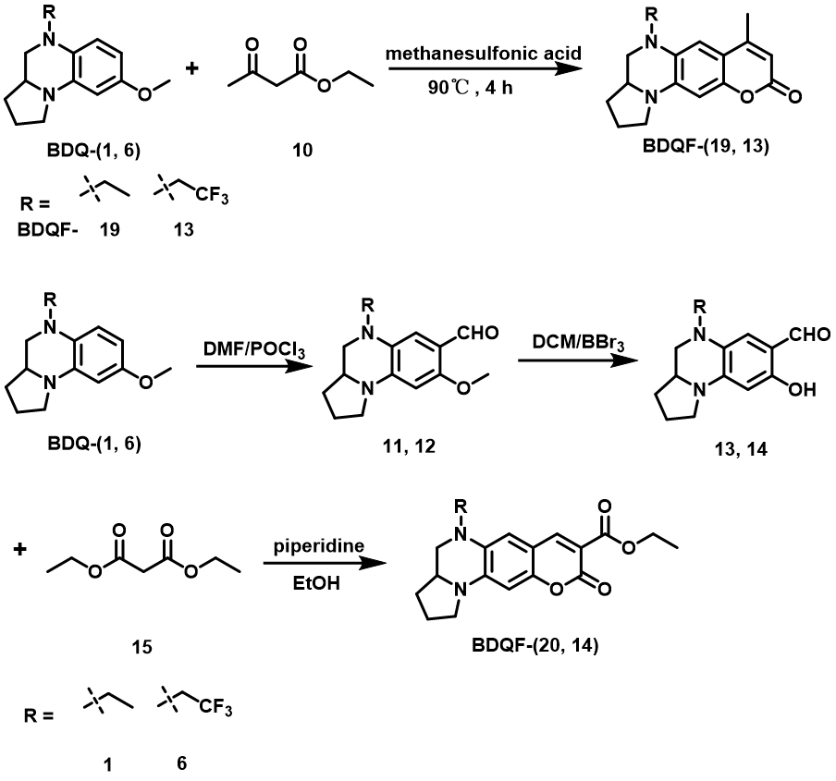
Supplementary Scheme 7 Synthesis of BDQF-(13, 14, 19, 20).

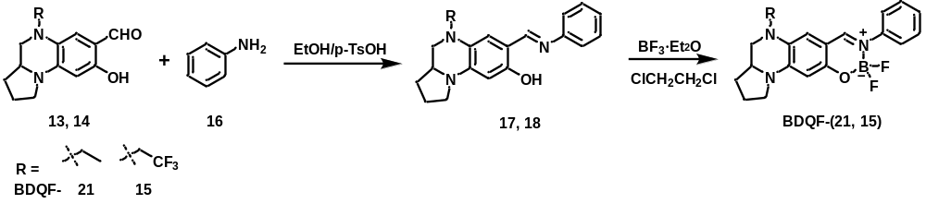
Supplementary Scheme 8 Synthesis of BDQF-(15, 21).

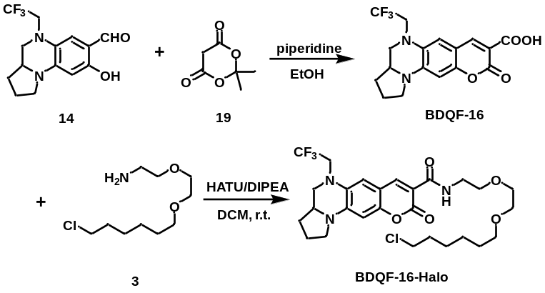
Supplementary Scheme 9 Synthesis of BDQF-16-Halo.

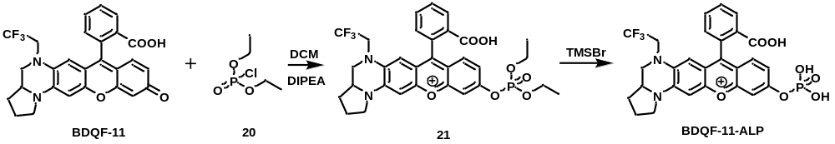
Supplementary Scheme 10 Synthesis of BDQF-11-ALP.

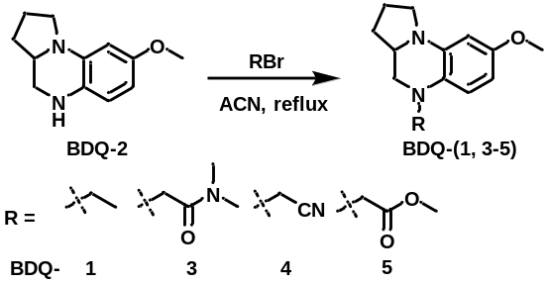
Synthesis of compounds BDQ 3-5. BDQ-1 and BDQ-2 were synthesized based on the previous literature⁵. BDQ-2 (1.0 g, 1.0 eqiuv.) was dissolved in 20 mL MeCN and then the mixture was stirred strongly. K₂CO₃ (3.0 eqiuv.) and RBr (1.5 eqiuv.) were next added and the mixture was refluxed for 2 h. After the reaction completing monitored by TLC analysis, the mixture was cooled to r.t. and evaporated. The residue was purified by column chromatography on silica gel using an EA/PE mixture as the eluent. Colorless or light-yellow oily liquid, yield: 80% - 95%.

BDQ-3. ¹H NMR (400 MHz, CDCl₃) δ 6.39 (d, J = 8.2 Hz, 1H), 6.05 (s, 2H), 3.94 (s, 2H), 3.72 (s, 3H), 3.31 (s, 3H), 3.05 (s, 4H), 2.95 (s, 4H), 2.06 – 2.00 (m, 2H), 1.98 – 1.90 (m, 1H), 1.43 (d, J = 7.6 Hz, 1H). ¹³C NMR (100 MHz, CDCl₃) δ 169.90, 154.02, 137.05, 127.91, 111.55, 99.36, 98.43, 56.79, 55.64, 53.61, 47.88, 36.97, 35.87, 30.26, 23.74. MALDI-TOF/MS, m/z: calc 289.18, found 289.22.

BDQ-4. ¹H NMR (400 MHz, CDCl₃) δ 6.43 (d, J = 8.2 Hz, 1H), 6.09 (s, 2H), 3.99 (s, 2H), 3.77 (s, 3H), 3.35 (s, 3H), 3.10 (s, 4H), 3.00 (s, 4H), 2.11 – 2.05 (m, 2H), 2.03 – 1.94 (m, 1H), 1.47 (d, J = 7.6 Hz, 1H). ¹³C NMR (100 MHz, CDCl₃) δ 155.46, 137.71, 125.07, 115.65, 113.09, 99.45, 98.63, 56.45, 55.61, 53.04, 47.89, 41.11, 30.42, 23.82. MALDI-TOF/MS, m/z: calc 243.14, found 243.12.

BDQ-5. ¹H NMR (400 MHz, CDCl₃) δ 6.32 (d, J = 8.5 Hz, 1H), 6.12 (s, 1H), 6.07 (s, 1H), 3.87 – 3.67 (m, 8H), 3.65 – 3.49 (m, 1H), 3.34 (s, 2H), 3.26 (s, 1H), 3.05 (s, 1H), 2.11 – 2.01 (m, 2H), 2.01 – 1.91 (m, 1H), 1.44 (d, J = 7.6 Hz, 1H). ¹³C NMR (100 MHz, CDCl₃) δ 171.69, 153.72, 136.44, 127.29, 110.85, 99.49, 98.54, 56.41, 55.48, 53.75, 53.43, 51.76, 47.54, 29.98, 23.39. ESI/MS, m/z: calc 276.15, found 276.07.

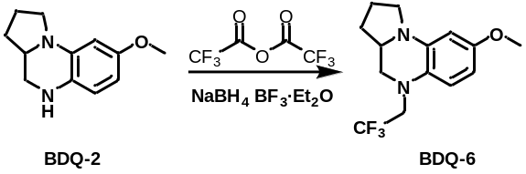
Synthesis of BDQ-6. BDQ-2 (1.0 g, 1.0 eqiuv.) was dissolved in 20 mL THF and the mixture was stirred strongly. Trifluoroacetic anhydride (2.0 equiv.) was added dropwise to the above solution and the mixture was continuously stirred for 10 min at r.t.. NaBH₄ (5.0 equiv.) and BF₃·Et₂O (5.0 equiv.) were added slowly and the mixture was refluxed for 1-2 h. After the reaction completing monitored by TLC analysis, the mixture was cooled to r.t.. Ice-water (10 mL) was added dropwise to quench the reaction (note: the reaction was violently exothermic). The mixture was extracted with ethyl acetate (EA, 30.0 mL) three times. The organic layers were combined, dried with Na₂SO₄, and evaporated. The residue was purified by column chromatography on silica gel using an EA/PE mixture as the eluent. Colorless or light-yellow oily liquid, yield: 70%.
BDQ-6. ¹H NMR (400 MHz, CDCl₃) δ 6.66 (d, J = 8.6 Hz, 1H), 6.20 (d, J = 8.6 Hz, 1H), 6.13 – 6.07 (m, 1H), 3.76 (d, J = 7.5 Hz, 4H), 3.64 (m, J = 8.9 Hz, 1H), 3.45 (d, J = 8.0 Hz, 1H), 3.39 (d, J = 8.4 Hz, 1H), 3.30 (t, J = 8.0 Hz, 2H), 2.86 (t, J = 10.2 Hz, 1H), 2.09 (m, 2H), 2.02 – 1.94 (m, 1H), 1.48 – 1.41 (m, 1H). ¹³C NMR (100 MHz, CDCl₃) δ 154.38, 136.74, 126.93, 124.23, 114.10, 100.08, 98.57, 55.51, 54.56, 54.02, 47.29, 29.81, 23.19. ESI/MS, m/z: calc 286.13, found 286.13.

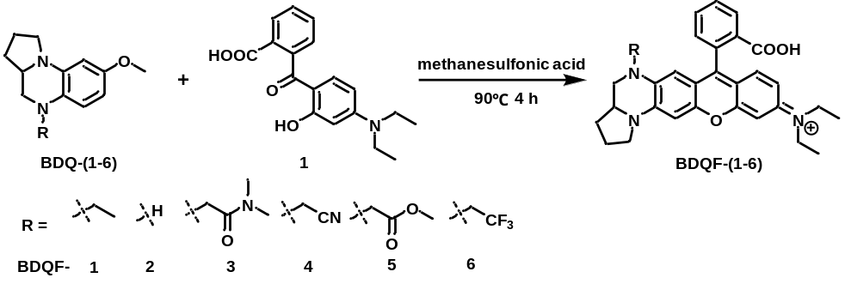
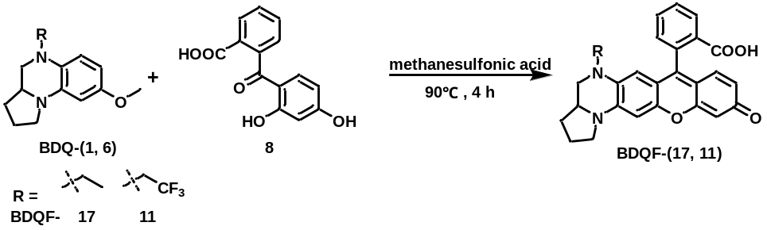
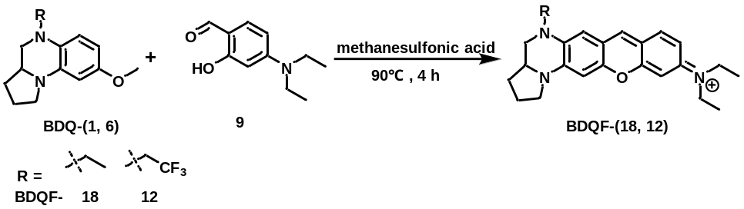
Synthesis of BDQF-(1-6, 11, 12, 17, 18): 2-(4-(diethylamino)-2-hydroxybenzoyl)benzoic acid/ 2-(2,4-dihydroxybenzoyl)benzoic acid/2-(8-hydroxy-2,3,6,7-tetrahydro-1H,5H-pyrido[3,2,1-ij]quinoline-9-carbonyl)benzoic acid (1.1 equiv.) and BDQ-(1-6) (300.0 mg, 1.0 equiv.) were dissolved in methanesulfonic acid (3.0 mL). The mixture was stirred and heated at 90 °C for 3-6 h. After the reaction completing monitored by TLC analysis, the mixture was poured into ice water, and then perchloric acid (0.5 mL) was added. The resulting precipitate was filtered off and washed with plenty of water. After the sample dried, purification by silica gel chromatography using a CH₂Cl₂/EtOH mixture as the eluent gave compound BDQFs (It was worth noting that the reaction of BDQ-4 with 2-(4-diethylamino-2-hydroxybenzoyl)benzoic acid in methanesulfonic acid would produce the corresponding acetamido substituted product BDQF-4). Crimson or atropurpureus solid. yield: 60% - 80%.
BDQF-1: ¹H NMR (400 MHz, CD₃OD containing 20% CDCl₃) δ 8.22 (s, 1H), 7.71 (s, 2H), 7.29 (s, 1H), 7.14 (t, J = 8.2 Hz, 1H), 6.96 – 6.83 (m, 2H), 6.68 (s, 1H), 6.05 (d, J = 10.1 Hz, 1H), 3.85 – 3.70 (m, 2H), 3.63 – 3.54 (d, J = 7.6 Hz, 6H), 3.33 (s, 2H), 2.85 (t, J = 9.9 Hz, 1H), 2.30 – 2.04 (m, 3H), 1.64 – 1.52 (m, 1H), 1.25 (s, 9H). ¹³C NMR (100 MHz, CD₃OD containing 20% CDCl₃) δ 156.56, 156.27, 154.63, 153.34, 146.27, 134.44, 134.41, 130.77, 130.59, 130.09, 129.70, 129.67, 129.31, 115.41, 113.36, 113.03, 105.27, 105.10, 95.45, 94.49, 58.31, 45.13, 43.81, 43.73, 29.55, 22.81, 11.77. HRMS (ESI): m/z calc. for C₃₁H₃₄N₃O₃ [M] 496.2595; found 496.2606.
BDQF-2: ¹H NMR (400 MHz, CD₃OD containing 20% CDCl₃) δ 8.28 (s, 1H), 7.76 (s, 2H), 7.34 (s, 1H), 7.24 (d, J = 8.8 Hz, 1H), 6.98 (d, J = 9.1 Hz, 1H), 6.92 (s, 1H), 6.74 (s, 1H), 6.35 (s, 1H), 3.87 – 3.77 (m, 2H), 3.67 (q, J = 6.5 Hz, 6H), 2.88 (q, J = 10.2 Hz, 1H), 2.38 – 2.28 (m, 2H), 2.26 – 2.16 (m, 1H), 1.73 – 1.60 (m, 1H), 1.36 (t, J = 6.8 Hz, 6H). ¹³C NMR (100 MHz, CD₃OD containing 20% CDCl₃) δ 156.23, 156.18, 154.65, 153.31, 146.96, 133.71, 131.29, 131.00, 130.73, 129.99, 129.92, 129.79, 129.69, 129.55, 115.39, 113.36, 113.09, 103.21, 95.55, 94.64, 57.95, 49.58, 45.43, 45.16, 29.71, 22.65, 11.80, 8.76, 8.52. HRMS (ESI): m/z calc. for C₂₉H₃₀N₃O₃ [M] 468.2282; found 468.2295.
BDQF-3: ¹H NMR (400 MHz, CD₃OD containing 20% CDCl₃) δ 8.47 (t, J = 7.3 Hz, 1H), 7.98 – 7.87 (m, 2H), 7.43 (t, J = 7.1 Hz, 1H), 7.25 (t, J = 9.0 Hz, 1H), 7.02 (d, J = 9.2 Hz, 1H), 6.98 (s, 1H), 6.81 (s, 1H), 5.70 (d, J = 7.6 Hz, 1H), 4.26 (t, J = 9.9 Hz, 1H), 4.05 – 3.99 (m, 1H), 3.97 – 3.87 (m, 2H), 3.72 (d, J = 7.2 Hz, 6H), 3.53 – 3.46 (m, 1H), 2.98 – 2.87 (m, 6H), 2.47 – 2.35 (m, 2H), 2.35 – 2.20 (m, 1H), 1.79 – 1.70 (m, 1H), 1.42 (t, J = 6.9 Hz, 6H). ¹³C NMR (100 MHz, CD₃OD containing 20% CDCl₃) δ 169.23, 167.80, 167.23, 157.28, 156.19, 155.62, 154.43, 147.48, 135.50, 134.89, 133.66, 133.20, 132.11, 131.68, 131.23, 130.65, 115.95, 114.29, 104.10, 96.68, 95.72, 58.97, 53.27, 52.81, 46.26, 36.74, 36.04, 30.57, 23.67, 12.90. HRMS (ESI): m/z calc. for C₃₃H₃₇N₄O₄ [M] 553.2809; found 553.2814.
BDQF-4: ¹H NMR (400 MHz, CD₃OD containing 20% CDCl₃) δ 8.25 (s, 1H), 7.76 (s, 1H), 7.73 (d, J = 5.7 Hz, 1H), 7.51 (t, J = 9.6 Hz, 1H), 7.33 (d, J = 5.7 Hz, 1H), 7.08 (d, J = 9.2 Hz, 1H), 7.00 (s, 1H), 6.82 (s, 1H), 6.35 (s, 1H), 4.29 – 4.10 (m, 1H), 4.08-3.85 (m, 3H), 3.78 (q, J = 6.8 Hz, 6H), 3.51 (s, 1H), 2.53 – 2.24 (m, 3H), 1.85 – 1.70 (m, 1H), 1.48 (t, J = 7.1 Hz, 6H). ¹³C NMR (100 MHz, CD₃OD containing 20% CDCl₃) δ 159.95, 159.58, 157.57, 155.66, 155.58, 154.56, 147.24, 134.68, 134.47, 131.89, 130.21, 130.17, 116.11, 116.00, 114.62, 114.51, 114.01, 106.17, 105.89, 96.42, 95.53, 58.88, 58.67, 53.63, 53.14, 46.21, 30.59, 23.76, 12.93. HRMS (ESI): m/z calc. for C₃₁H₃₃N₄O₄ [M] 525.2496; found 525.2509.
BDQF-5: ¹H NMR (400 MHz, CD₃OD containing 20% CDCl₃) δ 8.26 – 8.10 (m, 1H), 7.71-7.57 (m, 2H), 7.35-7.24 (m, 1H), 7.18 (t, J = 6.6 Hz, 1H), 6.93 (d, J = 8.8 Hz, 1H), 6.86 (s, 1H), 6.70 (s, 1H), 6.07 (d, J = 9.9 Hz, 1H), 3.93 (s, 1H), 3.77 (t, J = 9.0 Hz, 1H), 3.65 – 3.61 (m, 5H), 3.59 (s, 3H), 3.38 – 3.27 (m, 1H), 2.38 – 2.24 (m, 2H), 2.25 – 2.09 (m, 1H), 1.71 – 1.57 (m, 1H), 1.32 (t, J = 6.5 Hz, 6H). ¹³C NMR (100 MHz, CD₃OD containing 20% CDCl₃) δ 171.22, 160.72, 157.63, 155.92, 154.74, 147.32, 134.28, 134.14, 131.89, 131.76, 131.20, 130.28, 130.05, 129.86, 116.14, 114.82, 114.18, 106.31, 106.23, 96.54, 95.73, 59.00, 54.04, 52.86, 46.28, 30.71, 23.86, 18.40, 12.94. MALDI-TOF/MS, m/z: calc 526.23, found 526.15.
BDQF-6: ¹H NMR (400 MHz, CD₃OD containing 20% CDCl₃) δ 8.43 – 8.36 (m, 1H), 7.85 (m, 2H), 7.38 (t, J = 8.4 Hz, 1H), 7.21 (t, J = 9.4 Hz, 1H), 7.02 – 6.91 (m, 2H), 6.80 (s, 1H), 6.27 (d, J = 7.5 Hz, 1H), 3.97 – 3.86 (m, 2H), 3.85 – 3.77 (m, 3H), 3.68 (q, J = 6.8 Hz, 5H), 3.17 (t, J = 10.8 Hz, 1H), 2.37 (m, 2H), 2.29 – 2.14 (m, 1H), 1.69 (m, 1H), 1.37 (t, J = 7.0 Hz, 6H). ¹³C NMR (100 MHz, CD₃OD containing 20% CDCl₃) δ 167.00, 156.73, 156.59, 154.47, 154.03, 146.26, 134.12, 132.72, 132.50, 131.27, 130.98, 130.12, 130.03, 129.96, 114.59, 113.64, 113.41, 104.95, 95.75, 95.29, 57.45, 57.42, 53.39, 51.81, 45.40, 29.55, 22.66, 11.94. HRMS (ESI): m/z calc. for C₃₁H₃₁F₃N₃O₃ [M] 550.2312; found 550.2329.
BDQF-17: ¹H NMR (400 MHz, CD₃OD containing 20% CDCl₃) δ 8.37 (d, J = 7.6 Hz, 1H), 7.84 (m, 2H), 7.40 (t, J = 8.8 Hz, 1H), 7.21 (dd, J = 8.9, 4.4 Hz, 1H), 7.13 (s, 1H), 6.97 (d, J = 9.0 Hz, 1H), 6.84 (s, 1H), 6.04 (d, J = 4.4 Hz, 1H), 3.89 (m, 2H), 3.77 – 3.63 (m, 2H), 3.32 – 3.24 (m, 1H), 3.24 – 3.11 (m, 1H), 3.04 (m, 1H), 2.34 (s, 2H), 2.19 (s, 1H), 1.70 (m, 1H), 1.09 – 0.95 (m, 3H). ¹³C NMR (100 MHz, CD₃OD containing 20% CDCl₃) δ 168.09, 165.47, 157.42, 155.87, 155.47, 150.22, 135.96, 135.70, 133.90, 133.74, 132.42, 131.39, 131.21, 130.63, 118.84, 117.71, 116.59, 103.05, 102.72, 96.26, 59.57, 50.50, 50.06, 46.76, 30.77, 23.67, 9.57. MALDI-TOF/MS, m/z: calc 440.17, found 441.13. [M+H] ⁻
BDQF-11: ¹H NMR (400 MHz, CD₃OD containing 20% CDCl₃) δ 8.32 (s, 1H), 7.77 (m, 2H), 7.32 (t, J = 7.4 Hz, 1H), 7.16 (t, J = 8.6 Hz, 1H), 7.07 (s, 1H), 6.92 (d, J = 8.4 Hz, 1H), 6.80 (s, 1H), 6.21 (d, J = 7.0 Hz, 1H), 3.83 (m, 5H), 3.66 (s, 1H), 3.21 – 3.06 (m, 1H), 2.26 (s, 2H), 2.11 (s, 1H), 1.72 – 1.51 (m, 1H). ¹³C NMR (100 MHz, CD₃OD containing 20% CDCl₃) δ 166.96, 165.26, 156.67, 156.05, 155.26, 148.38, 134.15, 134.03, 133.93, 132.58, 132.47, 131.26, 130.12, 129.99, 129.91, 129.84, 116.88, 115.36, 103.93, 101.91, 95.41, 58.00, 51.73, 51.51, 48.97, 29.38, 22.46. HRMS (ESI): m/z calc. for C₂₇H₂₁F₃N₂O₄ [M+H]⁺ 495.1526; found 495.1526.
BDQF-18: ¹H NMR (400 MHz, CD₃OD containing 20% CDCl₃) δ 8.40 (s, 1H), 7.79 (d, J = 9.1 Hz, 1H), 7.15 (d, J = 8.9 Hz, 1H), 6.91 (s, 1H), 6.84 (s, 1H), 6.70 (s, 1H), 4.01 – 3.90 (m, 1H), 3.86 – 3.79 (m, 1H), 3.73 (q, J = 6.8 Hz, 6H), 3.50 (m, 2H), 3.02 (m, 1H), 2.46 – 2.32 (m, 2H), 2.29 – 2.18 (m, 1H), 1.72 (m, 1H), 1.44 – 1.34 (m, 9H). ¹³C NMR (100 MHz, CD₃OD containing 20% CDCl₃) δ 157.51, 155.96, 154.95, 148.72, 142.32, 135.18, 132.60, 117.77, 114.90, 114.53, 105.71, 96.75, 95.89, 59.21, 50.26, 46.62, 46.44, 46.26, 30.85, 23.75, 12.98, 10.15. MALDI-TOF/MS, m/z: calc 376.24, found 376.21.
BDQF-12: ¹H NMR (400 MHz, CD₃OD containing 20% CDCl₃) δ 8.50 (s, 1H), 7.84 (d, J = 8.4 Hz, 1H), 7.20 (d, J = 8.7 Hz, 1H), 7.13 (s, 1H), 6.96 (s, 1H), 6.80 (s, 1H), 3.93 (d, J = 11.0 Hz, 2H), 3.75 (d, J = 6.9 Hz, 6H), 3.29 (s, 2H), 2.45 – 2.34 (m, 2H), 2.25 (d, J = 6.8 Hz, 1H), 1.80 – 1.68 (m, 1H), 1.42 (d, J = 7.0 Hz, 6H). ¹³C NMR (100 MHz, CD₃OD containing 20% CDCl₃) δ 156.93, 154.74, 154.52, 146.87, 142.61, 133.03, 131.89, 126.88, 115.67, 114.07, 113.77, 106.62, 95.63, 95.23, 57.61, 54.86, 51.72, 45.40, 44.16, 29.51, 22.57, 11.77. MALDI-TOF/MS, m/z: calc 430.21, found 430.16.

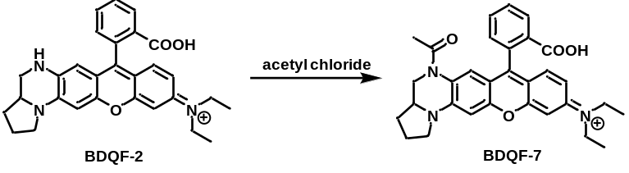
Synthesis of BDQF-7: BDQF-2 (100.0 mg, 1.0 equiv.) and DIPEA (3.0 equiv.) was dissolved into CH₂Cl₂ (10.0 mL). Acetyl chloride (2.0 equiv.) was added dropwise and the mixture was stirred at r.t. for 1 h. water (10.0 mL) was added carefully to the above mixture for quenching the reaction. The mixture was extracted with CH₂Cl₂ (20.0 mL) three times. The organic phases were combined, dried, concentrated. And the crude was purified by column chromatography on silica gel chromatography using a CH₂Cl₂/EtOH mixture as the eluent. Atropurpureus solid. Yield 75%.
BDQF-7: ¹H NMR (400 MHz, CD₃OD containing 20% CDCl₃) δ 8.25 (d, J = 6.7 Hz, 1H), 7.74 (q, J = 6.5, 5.8 Hz, 2H), 7.33 (d, J = 6.7 Hz, 1H), 7.24 (m, 1H), 7.17 (d, J = 9.5 Hz, 1H), 6.95 (d, J = 9.8 Hz, 1H), 6.90 (s, 1H), 6.81 (s, 1H), 3.81 – 3.70 (m, 2H), 3.70 – 3.55 (m, 7H), 2.34 – 2.24 (m, 2H), 2.11 (m, 4H), 1.64 – 1.56 (m, 1H), 1.32 – 1.28 (m, 6H). ESI-MS m/z calcd for C₃₁H₃₆N₃O₄ [M], 510.24; Found, 510.30

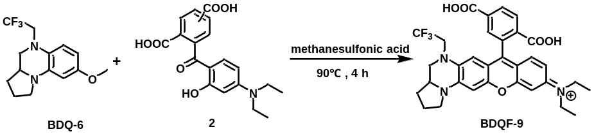
Synthesis of BDQF-9. BDQ-6 (150.0 mg, 1.0 equiv.) and 2 (1.2 equiv.) were dissolved in methanesulfonic acid (4.0 mL) and then stirred at 90 °C for 4 h. The mixture was cooled to r.t. and poured into ice-water (100.0 mL), and then perchloric acid (0.5 mL) was added. The resulting precipitate was filtered off and washed with ice water (100 mL). After the sample dried, purification by silica gel chromatography using a CH₂Cl₂/EtOH mixture as the eluent. Atropurpureus solid. yield 35%.
BDQF-9: ¹H NMR (400 MHz, CD₃OD containing 20% CDCl₃) δ 8.50 (s, 2H), 8.09 (d, J = 9.9 Hz, 1H), 7.30 (t, J = 8.6 Hz, 1H), 7.07 (d, J = 9.8 Hz, 1H), 7.01 (s, 1H), 6.87 (s, 1H), 6.36 (d, J = 9.2 Hz, 1H), 4.00 – 3.85 (m, 5H), 3.76 (q, J = 6.5 Hz, 4H), 3.56 (d, J = 7.0 Hz, 1H), 3.27 (q, J = 10.1 Hz, 1H), 2.5-2.42 (m, 2H), 2.37 – 2.27 (m, 1H), 1.84 – 1.73 (m, 1H), 1.47 (d, J = 6.9 Hz, 6H). HRMS (ESI): m/z calc. for C₃₂H₃₁F₃N₃O₅ [M] 594.2210; found 594.2223.

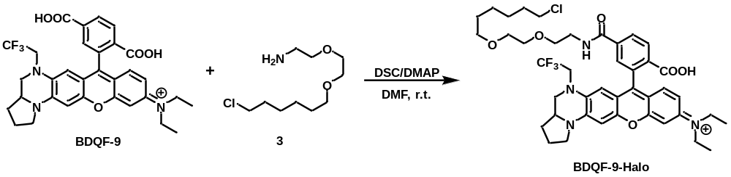
Synthesis of BDQF-9-Halo. BDQF-9 (50.0 mg, 1.0 equiv.), DSC (1.5 equiv.), DMAP (0.1 equiv.) and DIPEA (3.0 equiv.) were dissolved in DMF (3.0 mL) and stirred at 60 °C for 4 h. The solvent was removed under reduced pressure and the residue was dissolved in THF. 3 (1.1 equiv.) and DIPEA (3.0 equiv.) were added. The mixture was stirred at r.t. for 5 h. The solvent was removed and the residue was purified by Prep-HPLC. Atropurpureus solid. Yield 72%.
BDQF-9-Halo. ¹H NMR (400 MHz, CD₃OD containing 20% CDCl₃) δ 8.58 – 8.50 (t, J = 7.8 Hz, 1H), 8.36 – 8.30 (d, J = 6.8 Hz, 1H), 7.95 (d, J = 9.4 Hz, 1H), 7.31 – 7.22 (m, 1H), 7.06 (d, J = 9.4 Hz, 1H), 7.02 (s, 1H), 6.88 (s, 1H), 6.31 (s, 1H), 4.01-3.85 (m, 5H), 3.81 (d, J = 4.5 Hz, 2H), 3.78 – 3.73 (m, 11H), 3.65 (d, J = 6.6 Hz, 2H), 3.60 (t, J = 6.6 Hz, 2H), 3.26 (t, J = 10.8 Hz, 1H), 2.48-2.38 (m, 2H), 2.36 – 2.24 (m, 1H), 1.91 – 1.86 (t, J = 7.6 Hz, 2H), 1.81-1.73 (m, 1H), 1.71 – 1.67 (m, 2H), 1.56 (d, J = 8.0 Hz, 2H), 1.51 (d, J = 9.8 Hz, 2H), 1.45 (s, 6H). ¹³C NMR (100 MHz, CD₃OD containing 20% CDCl₃) δ 166.94, 157.58, 156.14, 155.37, 154.95, 147.16, 138.96, 135.43, 135.26, 134.48, 134.19, 133.67, 132.43, 130.95, 130.22, 129.38, 115.45, 114.66, 114.24, 105.63, 96.74, 96.31, 71.95, 70.80, 70.70, 70.14, 58.36, 52.92, 52.83, 46.38, 45.50, 40.83, 33.27, 30.49, 30.36, 30.00, 27.34, 26.02, 23.58, 12.92. HRMS (ESI): m/z calc. for C₄₂H₅₁ClF₃N₄O₆ [M] 799.3444; found 799.3452.

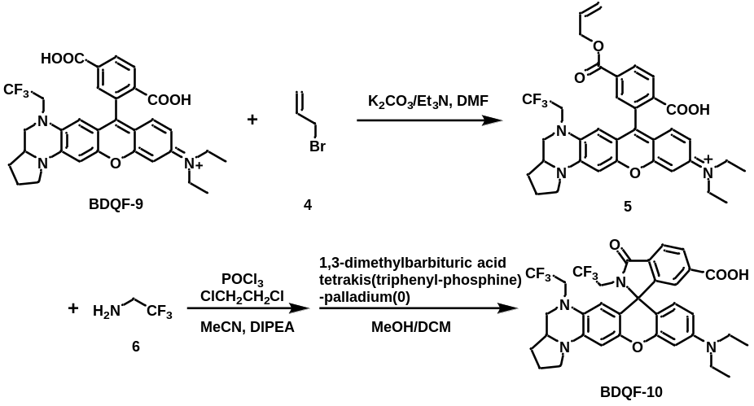
Synthesis of BDQF-10. BDQF-9 (100.0 mg, 1.0 equiv.) was dissolved in DMF (3.0 mL) and K₂CO₃ (2.0 equiv.) and Et₃N (2.0 equiv.) were added subsequently. The reaction was cooled down in an ice bath and allyl bromide (4, 1.5 equiv.) was slowly added. Then the mixture was allowed to warm up to r.t. and stirred for 2 h. The reaction was diluted with water and extracted with CH₂Cl₂ (20.0 mL) three times. The combined organic phase was washed with brine, dried with MgSO₄, filtered, and concentrated in vacuo. The mixture was purified by fast flash chromatography on silica gel using a CH₂Cl₂/EtOH mixture as the eluent, obtaining the crude product 5. The crude product (1.0 equiv.) was dissolved in CH₂ClCH₂Cl (4.0 mL). POCl₃ (5.0 equiv.) was added and the reaction was refluxed for 3 h. The solution was removed by rotary evaporator and the crude acyl chloride residue was dissolved in dry MeCN (3.0 mL). DIPEA (5.0 equiv.) and 2,2,2-Trifluoroethylamine (4, 2.0 equiv.) were added quickly and the reaction was stirred at 90 ºC for 2 h. The solution was removed by rotary evaporator and the residue was mixed with 1,3-dimethylbarbituric acid (3.0 equiv.), and tetrakis(triphenyl-phosphine)palladium(0) (0.5 equiv.) in MeOH/ CH₂Cl₂ (5/1) and stirred at r.t for 1 h. The solvent was removed and the residue was purified by silica gel flash chromatography using a CH₂Cl₂/EtOH mixture as the eluent. Atropurpureus solid. Yield 31%.
BDQF-10. ¹H NMR (400 MHz, CD₃OD containing 20% CDCl₃) δ 8.48 (d, J = 8.1 Hz, 1H), 8.14 – 8.06 (m, 2H), 7.27 (t, J = 9.9 Hz, 1H), 7.05 (d, J = 9.4 Hz, 1H), 6.97 (s, 1H), 6.84 (d, J = 2.6 Hz, 1H), 6.37 (d, J = 9.4 Hz, 1H), 3.91 – 3.84 (m, 5H), 3.74 – 3.69 (m, 4H), 3.54 – 3.47 (m, 2H), 3.46 (s, 1H), 2.44 – 2.35 (m, 2H), 2.28 – 2.19 (m, 1H), 1.78 – 1.67 (m, 1H), 1.40 (s, 6H). HRMS (ESI): m/z calc. for C₃₄H₃₂F₆N₄O₄ [M+H]⁺ 674.2401; found 674.2405.
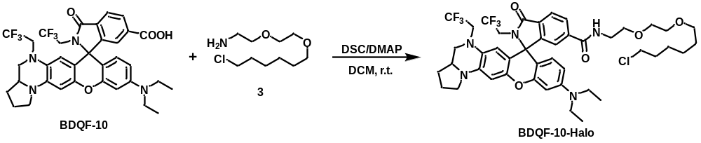
Synthesis of BDQF-10-Halo. Please refer to the synthesis of BDQF-9-Halo. Atropurpureus solid. Yield 67%.
BDQF-10-Halo: ¹H NMR (400 MHz, CD₃OD containing 20% CDCl₃) δ 9.11 – 9.04 (m, 1H), 8.35 – 8.28 (m, 1H), 8.09 (t, J = 8.0 Hz, 1H), 7.98 (m, 1H), 7.34 – 7.24 (m, 1H), 7.09 – 7.03 (m, 1H), 6.99 (s, 1H), 6.86 (s, 1H), 6.41 – 6.36 (m, 1H), 3.93 – 3.85 (m, 5H), 3.78 – 3.69 (m, 15H), 3.61 (t, J = 6.6 Hz, 2H), 3.55 (t, J = 6.6 Hz, 2H), 3.21 (m, 1H), 2.44 – 2.36 (m, 2H), 2.32 – 2.19 (m, 1H), 1.86 – 1.80 (m, 2H), 1.76 – 1.69 (m, 1H), 1.65 – 1.60 (m, 2H), 1.54 – 1.46 (m, 4H), 1.40 (s, 6H). HRMS (ESI): m/z calc. for C₄₄H₅₂ClF₆N₅O₅ [M+H]⁺ 880.3639; found 880.3641.

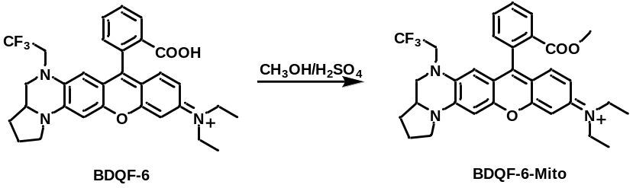
Synthesis of BDQF-6-Mito. BDQF-6 (100.0 mg, 1.0 equiv.) was dissolved in CH₃OH (2.0 mL). The reaction was stirred and H₂SO₄ (0.5 mL) was added dropwise. Then the mixture was refluxed for 6-10 h. The mixture was poured into H₂O (10.0 mL) and extracted with CH₂Cl₂ (20.0 mL) three times. The organic phase was dried over anhydrous MgSO₄, filtered, evaporated and the crude was purified by column chromatography on silica gel chromatography using a CH₂Cl₂/EtOH mixture as the eluent. Atropurpureus solid. Yield 46%.
BDQF-6-Mito: ¹H NMR (400 MHz, CD₃OD containing 20% CDCl₃) δ 8.44 – 8.33 (m, 1H), 7.98-7.81 (m, 2H), 7.44 (t, J = 8.4 Hz, 1H), 7.19 (t, J = 9.7 Hz, 1H), 7.05 – 6.97 (m, 2H), 6.85 (s, 1H), 6.23 (d, J = 4.4 Hz, 1H), 3.97-3.89 (m, 2H), 3.85 (d, J = 11.1 Hz, 3H), 3.75-3.65 (m, 8H), 3.20 (q, J = 9.9 Hz, 1H), 2.42-2.32 (m, 2H), 2.31 – 2.17 (m, 1H), 1.76 – 1.64 (m, 1H), 1.37 (d, J = 7.7 Hz, 6H). ¹³C NMR (100 MHz, CD₃OD containing 20% CDCl₃) δ 166.84, 157.81, 156.83, 156.71, 155.57, 155.23, 147.46, 135.37, 135.23, 133.99, 133.89, 132.08, 131.31, 131.19, 130.96, 115.58, 114.88, 114.37, 105.63, 96.92, 96.46, 58.58, 55.15, 53.01, 46.47, 32.01, 30.76, 30.62, 23.72, 12.95. HRMS (ESI): m/z calc. for C₃₂H₃₃F₃N₃O₃ [M] 564.2469; found 564.2482.

Synthesis of BDQF-6-Lyso. BDQF-6 (50.0 mg, 1.0 equiv.) was dissolved in CH₂ClCH₂Cl (4.0 mL). POCl₃ (5.0 equiv.) was added and the reaction was refluxed for 3 h. The solvent was removed under reduced pressure and the residue was dissolved in MeCN (2.0 mL). The 2-morpholin-4-ylethanamine (7, 3.0 equiv.) and DIPEA (10.0 equiv.) were dissolved in dry MeCN (2.0 mL), then transferred into the above solution. The reaction was stirred at 70 ºC for 2 h. The solvent was removed under reduced pressure to give the crude product, which was purified by silica gel flash chromatography using a CH₂Cl₂/EtOH mixture as the eluent. Atropurpureus solid. Yield 68%.
BDQF-6-Lyso: ¹H NMR (400 MHz, DMSO-d₆) δ 7.85 (s, 1H), 7.54 (s, 2H), 7.11 – 6.77 (m, 2H), 6.47 (s, 2H), 6.23 (s, 1H), 5.78 (d, J = 7.6 Hz, 1H), 3.90 (s, 2H), 3.83 – 3.67 (m, 5H), 3.55 (m, 5H), 3.32 – 3.23 (m, 3H), 3.05 – 2.85 (m, 4H), 2.07 – 1.87 (m, 3H), 1.36 (d, J = 7.2 Hz, 1H), 1.22 (m, 4H), 1.08 (t, J = 6.3 Hz, 6H). HRMS (ESI): m/z calc. for C₃₇H₄₂F₃N₅O₃ [M+H]⁺ 662.3318; found 662.3317.

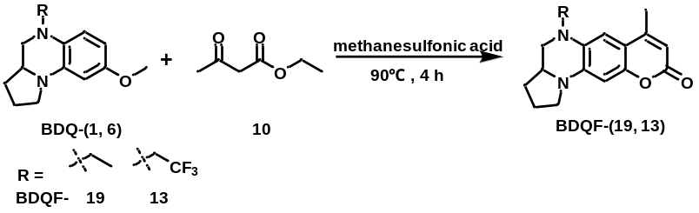
Synthesis of BDQF-(19, 13): Ethyl acetoacetate (10, 1.1 equiv.) and BDQ-1 or BDQ-6 (300.0 mg, 1.0 equiv.) were dissolved in methanesulfonic acid (3.0 mL). The mixture was stirred and heated at 90 °C for 3 h and then was poured into ice water. Perchloric acid (0.5 mL) was dropwise added when the solution was stirred. The resulting mixture was extracted with CH₂Cl₂ (30.0 mL). The organic phase was dried over anhydrous MgSO₄, filtered, evaporated and the crude was purified by column chromatography on silica gel chromatography using an EA/PE mixture as the eluent.
BDQF-19: Yield 64%. ¹H NMR (400 MHz, CDCl₃) δ 6.55 (s, 1H), 6.25 (s, 1H), 5.93 (s, 1H), 3.66 (s, 1H), 3.44 (s, 3H), 3.28 (s, 2H), 2.70 (s, 1H), 2.33 (s, 3H), 2.17 – 2.08 (m, 2H), 2.06 – 1.94 (m, 1H), 1.51 – 1.41 (m, 1H), 1.23 – 1.15 (m, 3H). ¹³C NMR (100 MHz, Chloroform-d) δ 162.67, 152.85, 149.58, 139.67, 130.56, 108.99, 108.41, 103.57, 96.52, 56.60, 50.61, 47.32, 45.71, 30.24, 23.31, 18.80, 10.06. MALDI-TOF/MS, m/z: calc 284.15, found 284.13.
BDQF-13: Yield 71%. ¹H NMR (400 MHz, CDCl₃) δ 6.69 (s, 1H), 6.29 (s, 1H), 5.95 (s, 1H), 3.97-3.86 (m, 1H), 3.83-3.72 (m, 1H), 3.55 (d, J = 9.1 Hz, 2H), 3.45-3.29 (m, 2H), 3.00-2.90 (m, 1H), 2.32 (s, 3H), 2.18 – 2.10 (m, 2H), 2.08 – 1.97 (m, 1H), 1.50-1.40 (m, 1H). ¹³C NMR (100 MHz, CDCl₃) δ 162.35, 152.69, 150.11, 139.11, 129.33, 126.85, 124.04, 109.07, 105.74, 97.24, 55.31, 54.28, 53.39, 47.20, 29.92, 23.12, 18.64. MALDI-TOF/MS, m/z: calc 338.12, found 228.10.

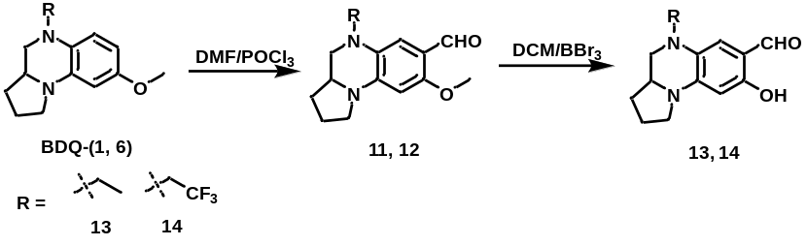
Synthesis of 13, 14: DMF (0.5 mL) and CH₂Cl₂ (2.0 mL) was mixed in a 25 mL vial. The mixture was cooled to 0 °C and stirred under N₂. And following POCl₃ (3.0 equiv.) was added dropwise. The reaction was carried out at 0°C for 1 h. Then CH₂Cl₂ (2.0 mL) containing BDQ-1 or BDQ-6 (300.0 mg, 1.0 equiv.) was added dropwise to the above mixture. the reaction was then slowly warmed to r.t. and stirred for 2 h. TLC was used to monitor the reaction. When BDQ-1 or BDQ-6 disappeared from the reaction, NaOH (aq, 0.5 mol/L, 10.0 equiv.) was added to the mixture. And the reaction was stirred at r.t. for 10 min. The mixture was extracted with CH₂Cl₂ (20.0 mL) three times. The organic phase was washed once with saturated NaCl solution and then was evaporated in vacuo. The resulting residue was subjected to fast column chromatography using an EA/PE mixture as the eluent to obtain the crude product of 11 or 12. And then the crude product was dissolved in CH₂Cl₂ (3.0 mL) and cooled to 0 °C. BBr₃ (3.0 equiv.) was added to the mixture. The reaction was slowly warmed to r.t. and continue stirred overnight. After completing, the mixture was poured into H₂O (10.0 mL), followed by the adjustment of pH of the solution to neutral with Na₂CO₃ aqueous solution. The mixture was extracted with EA (20.0 mL) three times. The organic phase was washed once with saturated NaCl solution, dried over anhydrous MgSO₄, filtered, evaporated and the crude was purified by column chromatography on silica gel chromatography using an EA/PE mixture as the eluent.
13: Yield 63%. ¹H NMR (400 MHz, CDCl₃) δ 11.66 (s, 1H), 9.42 (s, 1H), 6.45 (s, 1H), 5.83 (s, 1H), 3.67 (s, 1H), 3.45 – 3.29 (m, 3H), 3.28 – 3.17 (m, 2H), 2.62-2.50 (m, 1H), 2.15 – 2.03 (m, 2H), 2.01 – 1.91 (m, 1H), 1.48 – 1.35 (m, 1H), 1.16 (t, J = 5.8 Hz, 3H). ¹³C NMR (100 MHz, CDCl₃) δ 191.65, 159.46, 144.34, 127.26, 112.62, 110.33, 96.08, 57.49, 50.34, 47.53, 45.69, 30.28, 23.45, 10.33.
14: Yield 55%. ¹H NMR (400 MHz, CDCl₃) δ 11.58 (s, 1H), 9.45 (s, 1H), 6.63 (s, 1H), 5.90 (s, 1H), 3.83-3.66 (m, 2H), 3.59 (s, 1H), 3.53 – 3.40 (m, 2H), 3.33 (q, J = 8.4 Hz, 1H), 2.91-2.81 (m, 1H), 2.20 – 2.08 (m, 2H), 2.06 – 1.94 (m, 1H), 1.54-1.38 (m, 1H). ¹³C NMR (100 MHz, CDCl₃) δ 192.08, 159.87, 143.75, 126.95, 126.03, 115.37, 110.46, 96.83, 55.91, 54.63, 53.08, 47.53, 30.06, 23.35.

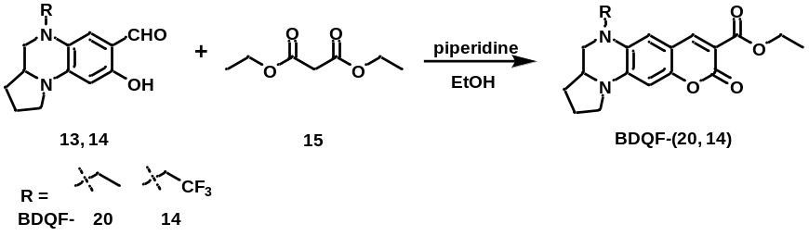
Synthesis of BDQF-(20, 14): Diethyl malonate (1.5 equiv.) and piperidine (3 equiv.) were added to a solution of 13 or 14 (100.0 mg, 1.0 equiv.) in EtOH (3.0 mL). The mixture was heated to reflux and stirred for 4 h. The solvent was evaporated in vacuo. The crude product was purified by silica gel chromatography using an EA/PE mixture as the eluent. Orange or dark red solid.
BDQF-20: Orange solid. Yield 83%. ¹H NMR (400 MHz, CDCl₃) δ 8.38 (s, 1H), 6.45 (s, 1H), 6.18 (s, 1H), 4.34 (q, J = 7.1 Hz, 2H), 3.71 (dt, J = 9.8, 5.3 Hz, 1H), 3.49-3.39 (m, 3H), 3.34-3.21 (m, 2H), 2.76 – 2.66 (m, 1H), 2.22-2.10 (m, 2H), 2.08 – 1.94 (m, 1H), 1.51 – 1.43 (m, 1H), 1.37 (t, J = 7.1 Hz, 3H), 1.17 (t, J = 7.0 Hz, 3H). ¹³C NMR (100 MHz, CDCl₃) δ 164.36, 158.53, 153.33, 148.97, 141.91, 129.88, 109.02, 108.98, 107.68, 96.32, 61.07, 56.02, 53.92, 53.59, 52.76, 47.43, 29.93, 23.05, 14.40. MALDI-TOF/MS, m/z: calc 342.16, found 342.13.
BDQF-14: Yellow solid. Yield 81%. ¹H NMR (400 MHz, CDCl₃) δ 8.40 (s, 1H), 6.64 (s, 1H), 6.27 (s, 1H), 4.36 (q, J = 7.1 Hz, 2H), 3.98-3.73 (m, 2H), 3.65 (dt, J = 9.7, 5.1 Hz, 1H), 3.61-3.54 (m, 1H), 3.49 (t, J = 9.6 Hz, 1H), 3.37 (q, J = 9.6 Hz, 1H), 3.05 – 2.95 (m, 1H), 2.24-2.14 (m, 2H), 2.11 – 1.98 (m, 1H), 1.55 – 1.46 (m, 1H), 1.38 (t, J = 7.1 Hz, 3H). ¹³C NMR (100 MHz, CDCl₃) δ 164.86, 159.07, 153.29, 149.11, 142.88, 131.36, 108.16, 107.90, 107.18, 95.67, 61.06, 57.28, 50.21, 47.62, 45.75, 30.34, 23.35, 14.61, 10.03. MALDI-TOF/MS, m/z: calc 396.13, found 419.14.[M+Na]

Synthesis of BDQF-(21, 15): EtOH (2.0 mL) dissolving 13 or 14 (100.0 mg, 1.0 equiv.) was added to a solution of phenylamine (16, 1.5 equiv.) and p-TsOH (0.1 equiv.) in ethanol (4.0 mL). The mixture refluxed for 4 h and then the solvent was evaporated in vacuo. The resulting residue was dissolved with CH₂ClCH₂Cl (4.0 mL). BF₃·Et₂O (2.0 equiv.) was added to the above solution. And the mixture was stirred at r.t. for 3 h. DIPEA (2.5 equiv.) was added. The mixture was continuously stirred until the color of the solution became yellow or orange. The mixture was poured into H₂O (10.0 mL), followed by the adjustment of pH of the solution to neutral with Na₂CO₃ aqueous solution. The mixture was extracted with EA (10.0 mL) three times. The organic phase was washed once with saturated NaCl solution, dried over anhydrous MgSO₄, filtered, evaporated and the crude was purified by column chromatography on silica gel chromatography using an EA/PE mixture as the eluent. Orange or dark red solid.
BDQF-21: Orange solid. Yield 74%. ¹H NMR (400 MHz, CDCl₃) δ 7.98 (s, 1H), 7.50 (d, J = 6.3 Hz, 2H), 7.40 (s, 2H), 7.29 (s, 1H), 6.33 (s, 1H), 6.01 (s, 1H), 3.75 (s, 1H), 3.51 (s, 1H), 3.38 (s, 2H), 3.24 (s, 1H), 2.67 (s, 1H), 2.15 (s, 2H), 2.02 (s, 1H), 1.49 (s, 1H), 1.26 (s, 2H), 1.17 (s, 3H). ¹³C NMR (100 MHz, CDCl₃) δ 158.03, 157.20, 147.09, 143.81, 129.42, 128.80, 127.20, 123.30, 109.38, 106.62, 97.36, 57.84, 50.31, 47.78, 45.67, 30.30, 23.36, 10.12. MALDI-TOF/MS, m/z: calc 369.18, found 369.22.
BDQF-15: Yellow solid. Yield 87%. ¹H NMR (400 MHz, CDCl₃) δ 7.99 (s, 1H), 7.48 (d, J = 7.6 Hz, 2H), 7.40 (t, J = 7.5 Hz, 2H), 7.31 (d, J = 6.8 Hz, 1H), 6.50 (s, 1H), 6.03 (s, 1H), 3.87 – 3.59 (m, 3H), 3.56-3.44 (m, 2H), 3.37 (q, J = 9.3 Hz, 1H), 2.99-2.87 (m, 1H), 2.23-2.10 (m, 2H), 2.10 – 1.93 (m, 1H), 1.55 – 1.41 (m, 1H). ¹³C NMR (100 MHz, CDCl₃) δ 158.13, 157.89, 146.27, 143.54, 129.48, 127.54, 126.88, 124.07, 123.33, 111.69, 106.34, 97.92, 56.54, 54.33, 52.93, 47.76, 30.03, 23.22. MALDI-TOF/MS, m/z: calc 423.15, found 423.15.

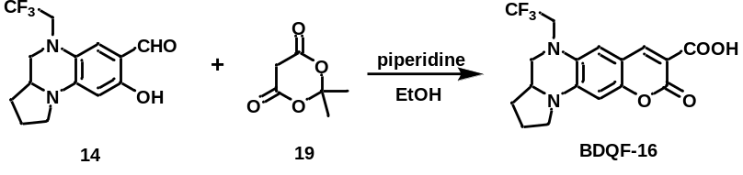
Synthesis of BDQF-16. Meldrum's acid (19, 1.5 equiv.) and piperidine (3.0 equiv.) were added to a solution of 14 (100.0 mg, 1.0 equiv.) in ethanol (3.0 mL). The mixture was heated to reflux and stirred for 4 h. The resulting solution was acidified with hydrochloric acid. The mixture was extracted with CH₂Cl₂ (20.0 mL) three times. The combined organic phase was washed with brine, dried with MgSO₄, filtered, and concentrated in vacuo. The residue was purified by silica gel flash chromatography using a CH₂Cl₂/EtOH mixture as the eluent. Yellow solid. Yield 78%.
BDQF-16: ¹H NMR (400 MHz, CDCl₃) δ 12.48 (s, 1H), 8.52 (s, 1H), 6.64 (s, 1H), 6.31 (s, 1H), 3.97 (m, 1H), 3.89 – 3.77 (m, 1H), 3.71 (s, 1H), 3.64-3.51 (m, 2H), 3.48-3.38 (m, 1H), 3.06 (t, J = 7.6 Hz, 1H), 2.28 – 2.18 (m, 2H), 2.16 – 2.05 (m, 1H), 1.55 (s, 1H). ¹³C NMR (100 MHz, CDCl₃) δ 165.78, 164.87, 153.21, 149.71, 143.19, 131.02, 126.75, 108.98, 108.75, 105.54, 96.43, 56.58, 53.49, 52.59, 47.88, 30.12, 23.23. HRMS (ESI): m/z calc. for C₁₇H₁₅F₃N₂O₄ [M+H]+ 369.1062; found 369.1065.

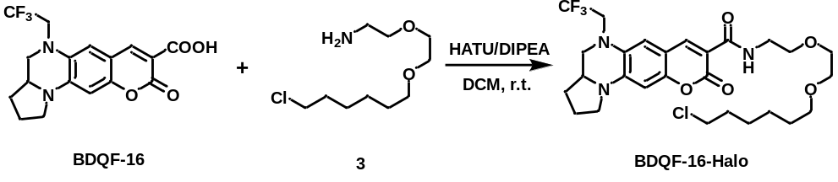
Synthesis of BDQF-16-Halo. BDQF-16 (50.0 mg, 1.0 equiv.) was dissolved in CH₂Cl₂ (4.0 mL). DIPEA (5.0 equiv.) and HATU (2.0 equiv.) were added and the mixture was stirred at r.t. for 10 min. 3 (1.5 equiv.) was added and the reaction was continue stirred at r.t. for 4 h. The solvent was removed and the residue was purified by silica gel flash chromatography using EA/PE mixture as the eluent. Yellow-brown solid. Yield 69%.
BDQF-16-Halo: ¹H NMR (400 MHz, CD₃OD) δ 9.25 (s, 1H), 8.40 (s, 1H), 6.75 (s, 1H), 6.12 (s, 1H), 4.16-3.89 (m, 2H), 3.67 – 3.63 (m, 5H), 3.62 – 3.54 (m, 8H), 3.48 (dd, J = 6.5, 4.0 Hz, 4H), 2.93 – 2.83 (m, 1H), 2.17 – 2.10 (m, 2H), 2.07 – 1.98 (m, 1H), 1.73 – 1.67 (m, 2H), 1.58 – 1.50 (m, 3H), 1.40 – 1.35 (m, 3H). ¹³C NMR (100 MHz, CD₃OD) δ 165.67, 164.12, 153.81, 148.86, 143.75, 132.05, 128.74, 109.95, 109.67, 109.56, 96.63, 72.43, 71.72, 71.40, 70.73, 57.71, 53.62, 45.87, 40.74, 33.93, 30.95, 30.80, 27.95, 26.66, 24.11. HRMS (ESI): m/z calc. for C₂₇H₃₅ClF₃N₃O₅ [M+H]⁺ 574.2296; found 574.2303.
Synthesis of BDQF-11-ALP. BDQF-11 (100.0 mg, 1.0 equiv.) was dissolved in CH₂Cl₂ (4.0 mL). DIPEA (3.0 equiv.) and diethyl chlorophosphate (20, 1.5 equiv.) were added. The reaction was stirred at r.t. for 4 h. Ice water (2.0 mL) was added to quench the reaction. The mixture was extracted with CH₂Cl₂ (20 mL) three times. The combined organic phase was washed with brine, dried with MgSO₄, filtered, and concentrated in vacuo. The residue was dissolved in CH₂Cl₂ (5.0 mL) and bromo(trimethyl)silane (TMSBr, 15.0 equiv.) was added dropwise under N₂ atmosphere. The mixture was stirred overnight at room temperature and monitored by TLC. When the reaction was complete, the intermediate product was obtained by removing the organic solvent in vacuum. BDQF-11-ALP was obtained by silica gel flash chromatography using a CH₂Cl₂/EtOH mixture (containing 0.5% HCOOH) as the eluent. Scarlet solid. Yield 40%.
BDQF-11-ALP: ¹H NMR (400 MHz, CD₃OD containing 20% CDCl₃) δ 8.45 (s, 1H), 8.07 – 7.95 (m, 1H), 7.95 – 7.83 (m, 2H), 7.50 – 7.21 (m, 3H), 7.00 (s, 1H), 6.30 (d, J = 6.5 Hz, 1H), 4.09 – 3.77 (m, 6H), 2.94 (s, 1H), 2.47 – 2.33 (m, 2H), 2.31 – 2.20 (m, 1H), 1.81 – 1.73 (m, 1H). HRMS (ESI): m/z calc. for C₂₇H₂₃F₃N₂O₇P [M+H]⁺ 576.1262; found 576.1251.

Measurements of UV-Vis, fluorescence spectroscopy, and quantum yields.
Fluorescent molecules for spectroscopy were prepared as stock solutions (0.1 – 10 mM) in DMSO. Maximum absorption wavelength (λ_{abs}) and maximum emission wavelength (λ_{em}) were taken in 20 mM PBS buffer unless otherwise noted; reported values are averages of 3 measurements.

Calculation of fluorescence quantum yield. Fluorescence quantum yield was determined using an optically matching solution of cresol purple (Φ_{f} = 0.58 in ethanol)⁶, RhB (Φ_{f} = 0.65 in ethanol)⁷ or coumarin 102 (Φ_{f} = 0.93 in ethanol)⁸ as the standard and the quantum yield was calculated using the following equation:
Φ_{s} = Φ_{r}(A_{r}F_{s}/A_{s}F_{r}) (n_{s}²/n_{r}²)
where, s and r denote sample and reference, respectively. A is the absorbance. F is the relative integrated fluorescence intensity and n is the refractive index of the solvent. Measurements were performed using dilute samples (A ≈ 0.05) and reported values are averages (n=3). Reference fluorophore: BDQF 1-6, 8, 11-14, cresol purple; BDQF 7, RhB; BDQF 16-20, R 4-6, coumarin 102. R 1-3: According to the reported literatures^{9, 10, 11}.

Photostability of BDQF-6 and RhB. Solutions of 10 μM BDQF-6 and RhB in EtOH containing 0.5% trifluoracetic acid (TFA) were prepared. The absorbance spectra were recorded using cock threaded quartz cuvette on a UV-1800 spectrophotometer (Shimadzu Corporation, Japan). The measurements were carried out under the irradiation of a laser at 530 nm (1W) at ambient temperature. The solution was continuously irradiated and the absorbance of the solution was recorded every 20 min. Absorbance was normalized to the maximum absorbance of each fluorophore and plotted against radiation time. Reported values are averages of 3 measurements.

Computational Methods. The calculations were carried out using the Gaussian 09 program package¹². The geometries of DQF dyes were optimized at the B3LYP/6-31+G(d) level using a CPCM solvation model with water as the solvent. Potential energy surfaces of diethylamino in BDQF-6 and RhB with increasing twist angle (φ) were calculated with CAM-B3LYP method at the LRC-TDDFT/6-31+G(d) level¹³. The rotation step is 10º in the range of 0º–90º. Coordinate-driven potential surface scans were generated by fixing the bridge dihedral angle (Figure 3) and minimizing all other degrees of freedom subject to this constraint.

Photostability of BDQFs in living cells. HeLa cells were incubated with DMEM containing 5 μM fluorophores for 30 min and next continuously illuminated under the confocal laser and imaged at a fixed time point (10-30 min). The relative mean intracellular fluorescence of cells was utilized for quantification and normalization. Error bars, ± s.e.m. from about 50 cells.

Measurements of UV absorbance spectra in water-dioxane mixtures. Solutions of 5 μM BDQF-9 and BDQF-10 in water-dioxane mixtures containing 10%, 20%, 30%, 40%, 50%, 60%, 70%, 80% and 90% of dioxane (by volume) were prepared. The absorbance spectra were recorded using a quartz cuvette on a UV-1800 spectrophotometer (Shimadzu Corporation, Japan). The measurements were taken at ambient temperature. Absorbance was normalized to the maximum absorbance of each carboxyl-fluorophores. Normalized absorbance was plotted against the dielectric constant of the water-dioxane mixture¹⁴.

Measurement of absorption, emission spectra, and quantum yields after binding with proteins. Fluorogenic probes were diluted to 2.5 μM in 10 mM HEPES, pH 7.3. Then an aliquot of HaloTag protein (2.0 equiv.) was added and the resulting mixture was incubated for 1h. Absorbance measurements were performed in V-770 Spectrophotometer (Jasco), while fluorescence measurements were performed in a 96-well plate (Thermo Fisher Scientific) with an optical bottom. Reported values are averages of 3 measurements.

Time-dependent live-cell imaging. Live HeLa H2B-Halo-expressed cells were incubated with BDQF-9-Halo and BDQF-10-Halo (250 nM) and directly imaged every 0.5-1 h. Intracellular brightness of all the cells in the view field was recorded and averaged. Error bars, ± s.e.m. from about 50 cells.

Two-photon microscopy. U-2 OS stably expressing Vimentin-HaloTag cells seeded on glass coverslips were incubated in phenol red-free imaging medium that contained 50 nM BDQF-9-Halo for 6 h at 37℃. The cells were fixed with 4% PFA for 20 min and then quenched for 5 min in NH₄Cl and glycine (100 mM), washed in PBS, and mounted in Mowiol. Imaging was performed on an Abberior multiphoton Infinity Line microscope. Imaging conditions: λ_{ex} 870 nm, detection range 570–780 nm, STED laser 775 nm.

NMR spectroscopy
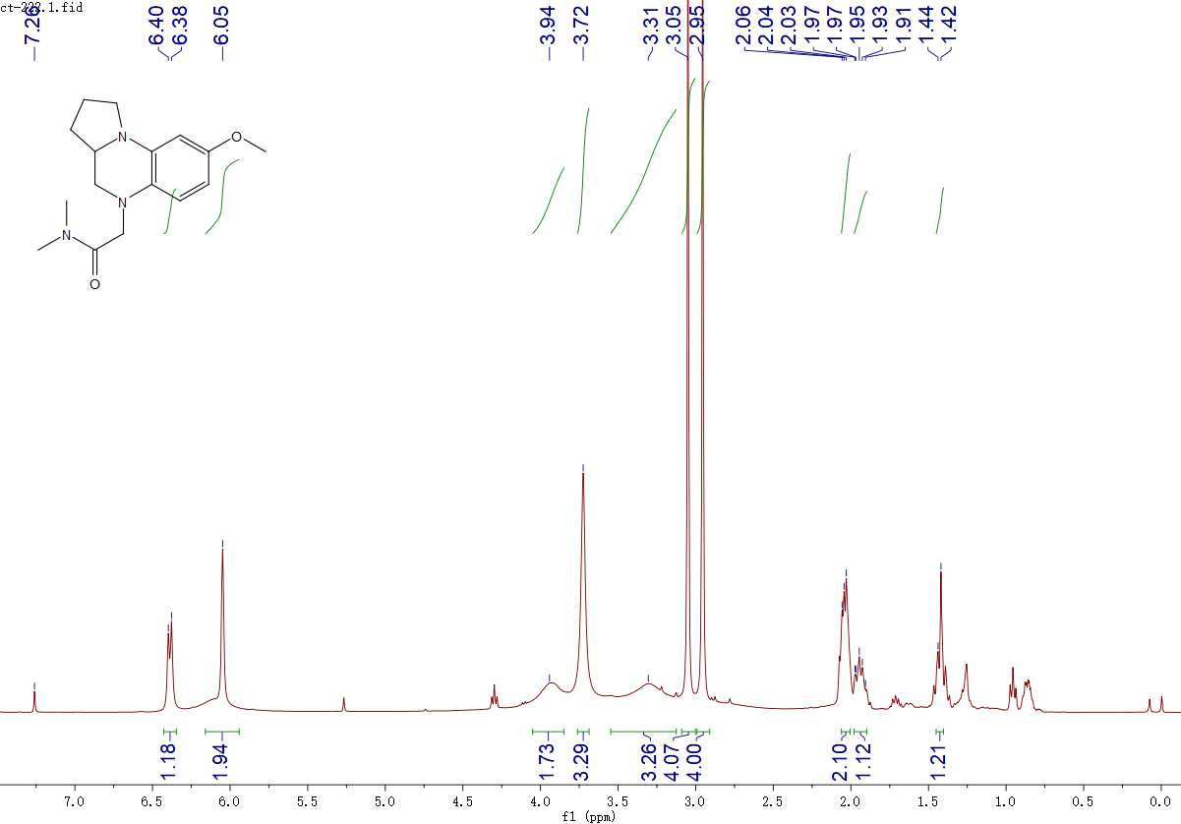
¹H NMR spectrum of BDQ-3 in CDCl₃

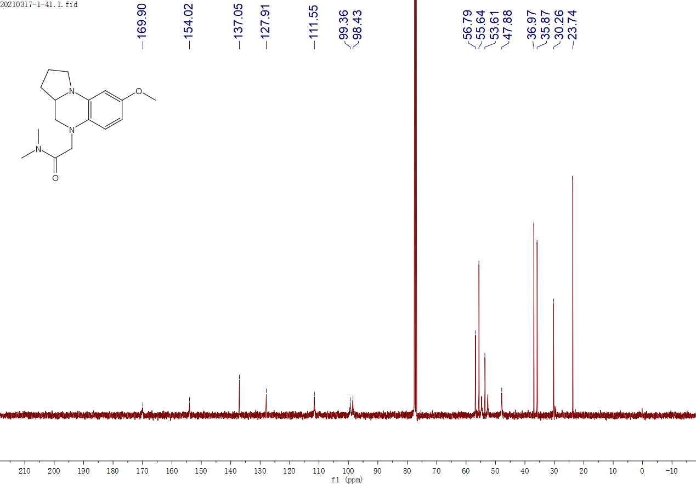
¹³C NMR spectrum of BDQ-3 in CDCl₃

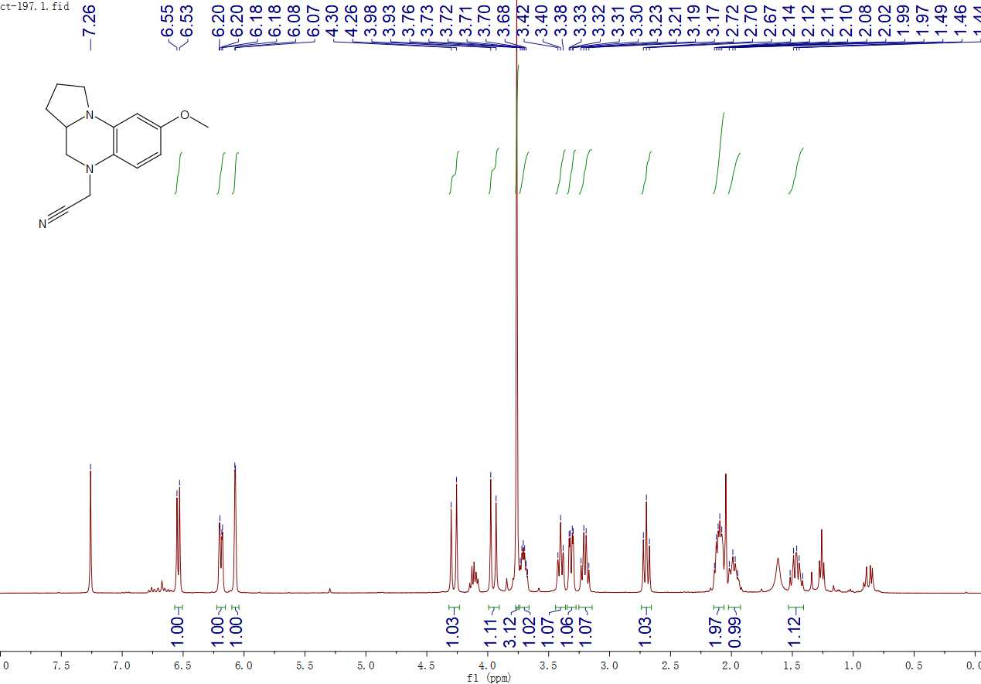
¹H NMR spectrum of BDQ-4 in CDCl₃
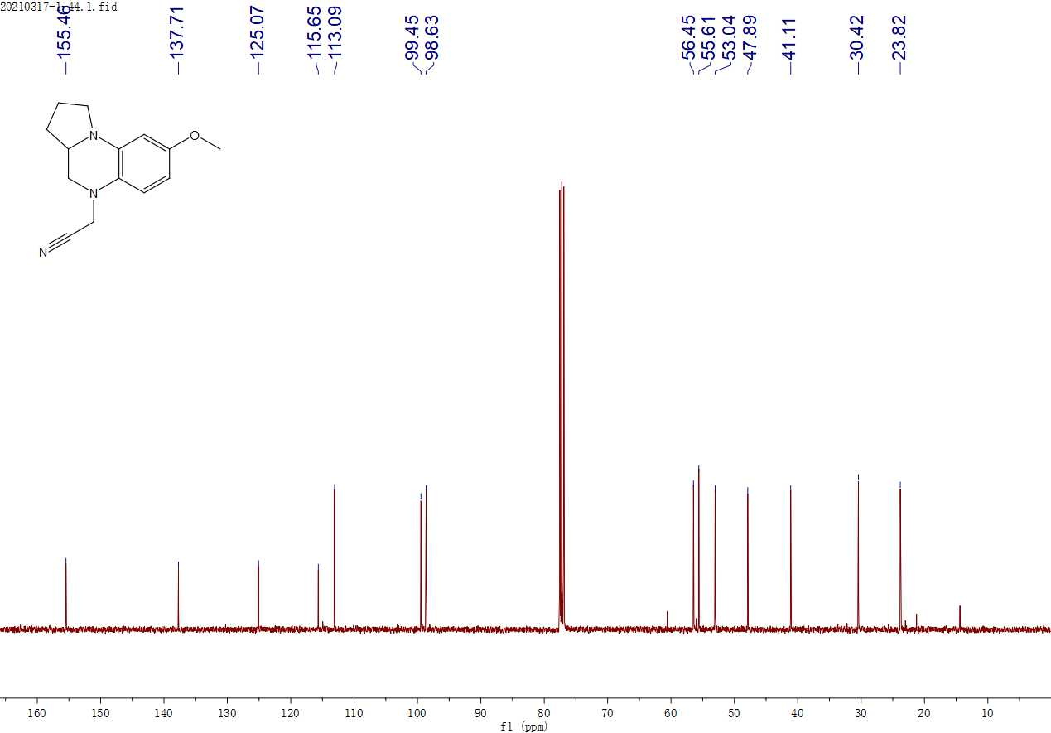
¹³C NMR spectrum of BDQ-4 in CDCl₃

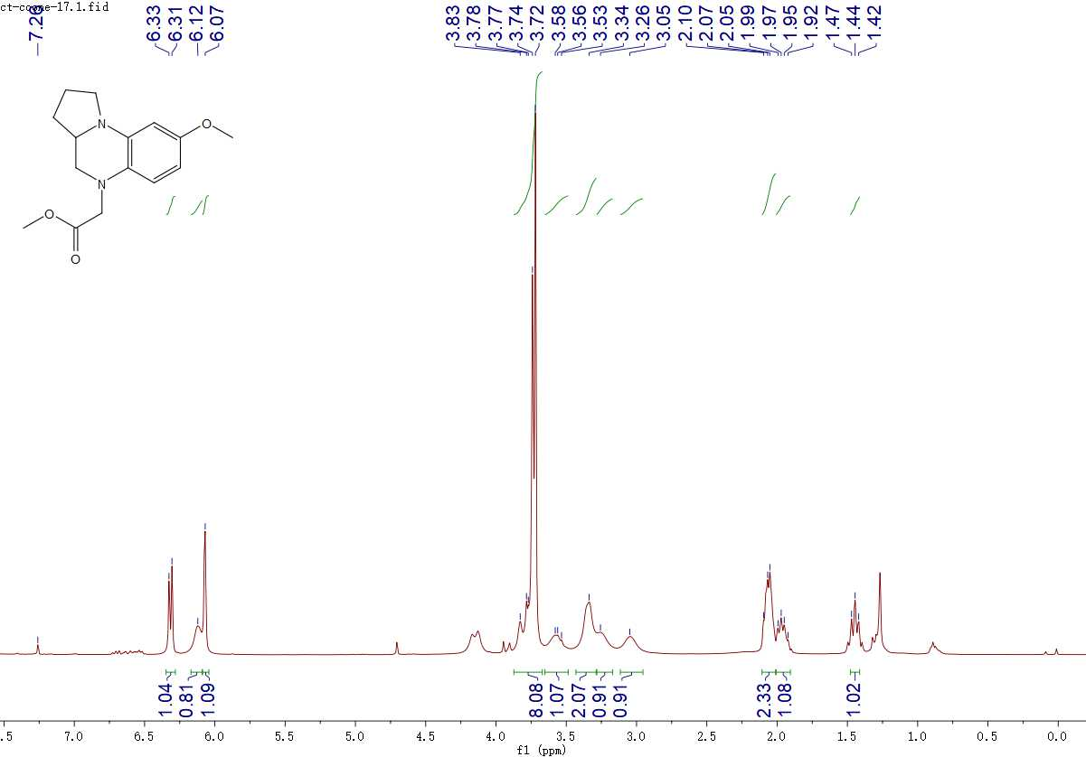
¹H NMR spectrum of BDQ-5 in CDCl₃

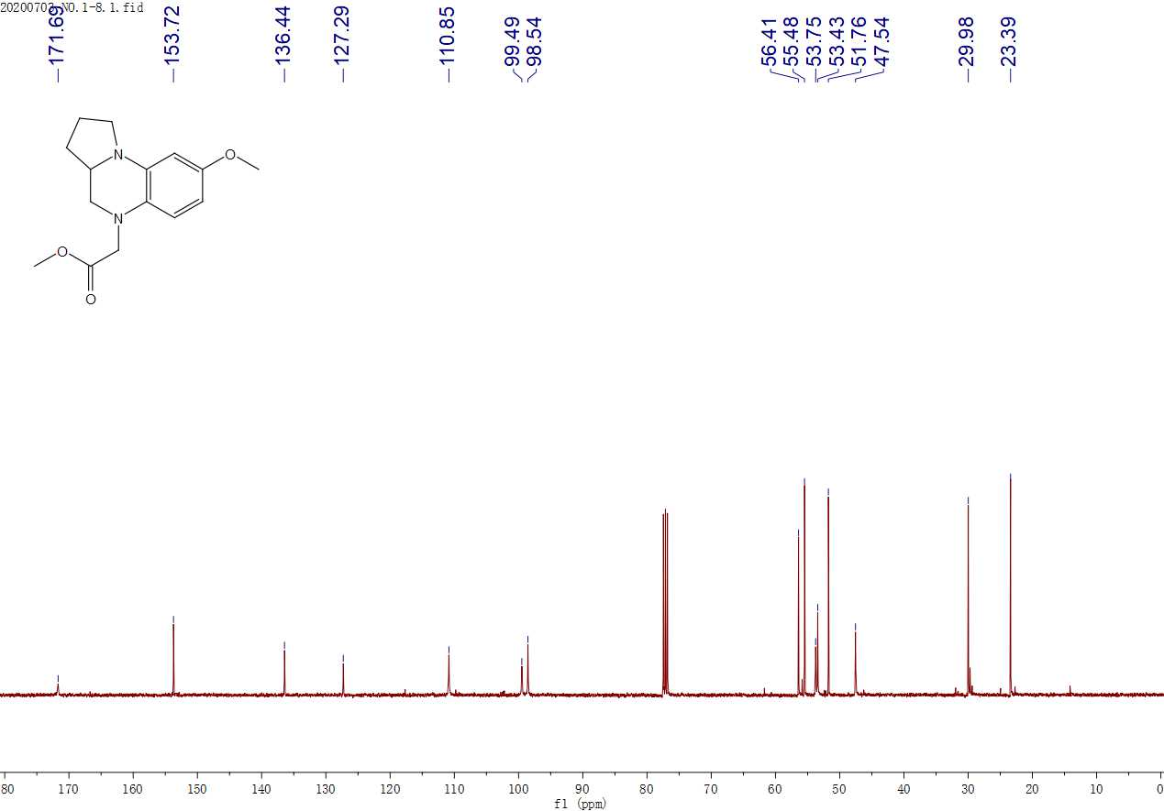
¹³C NMR spectrum of BDQ-5 in CDCl₃

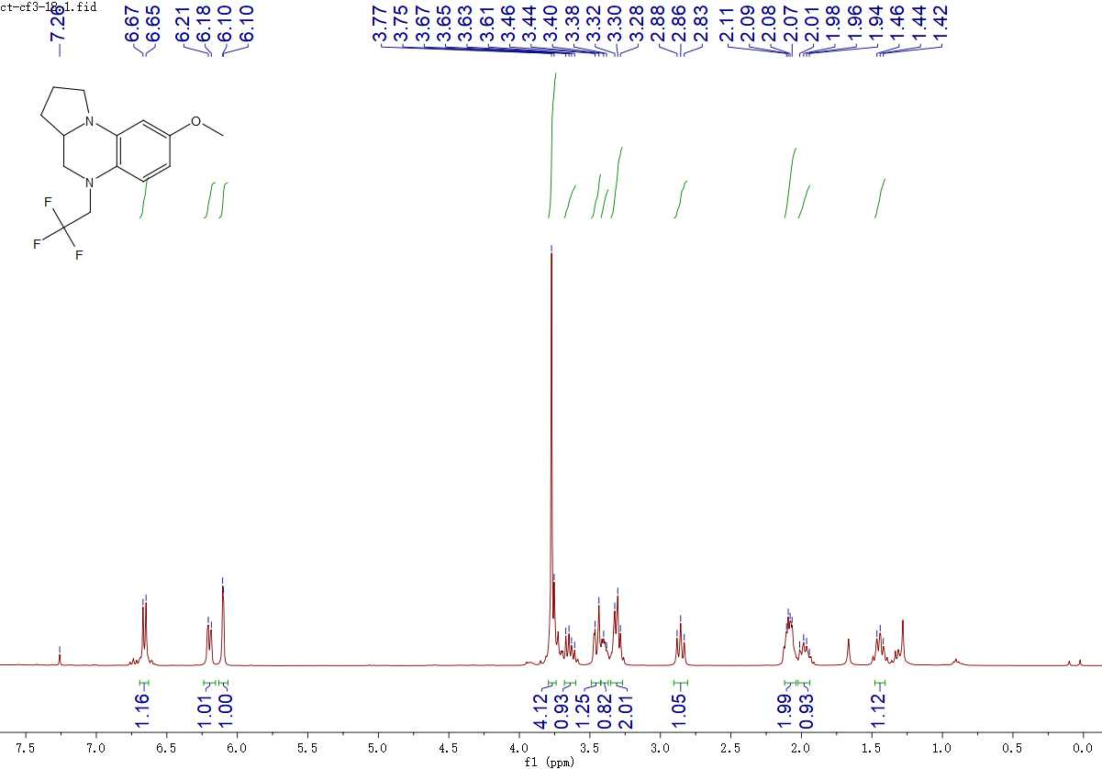
¹H NMR spectrum of BDQ-6 in CDCl₃

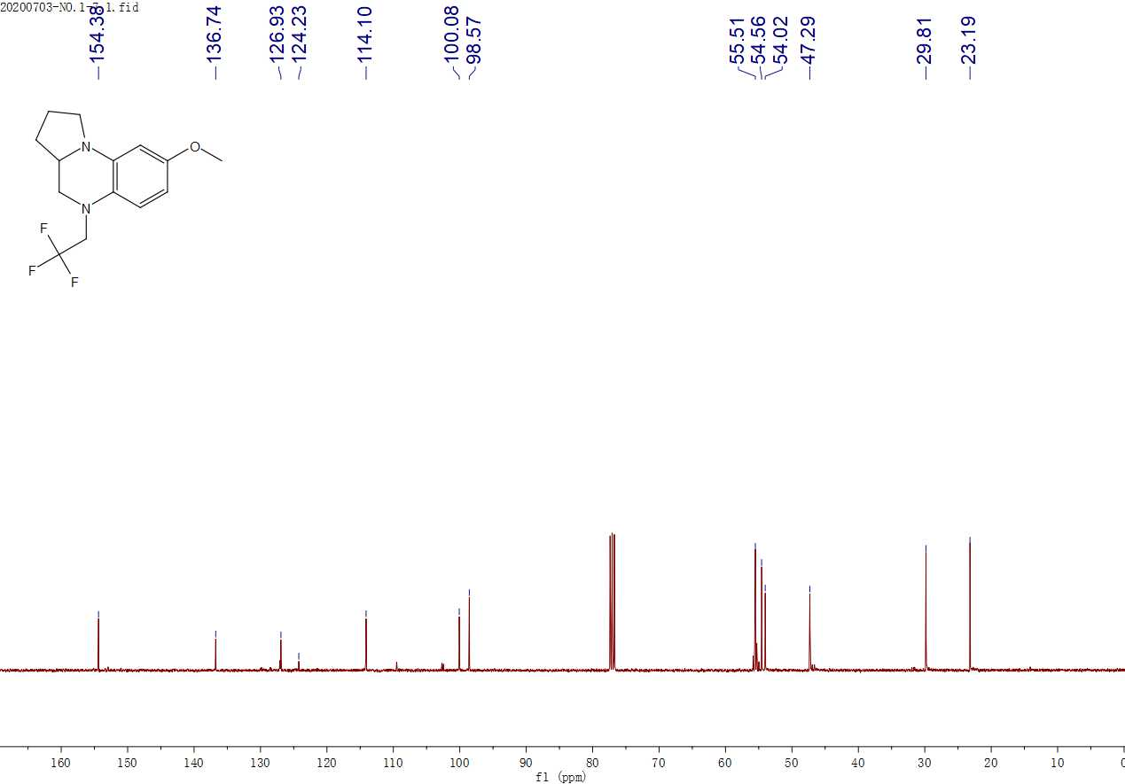
¹³C NMR spectrum of BDQ-6 in CDCl₃

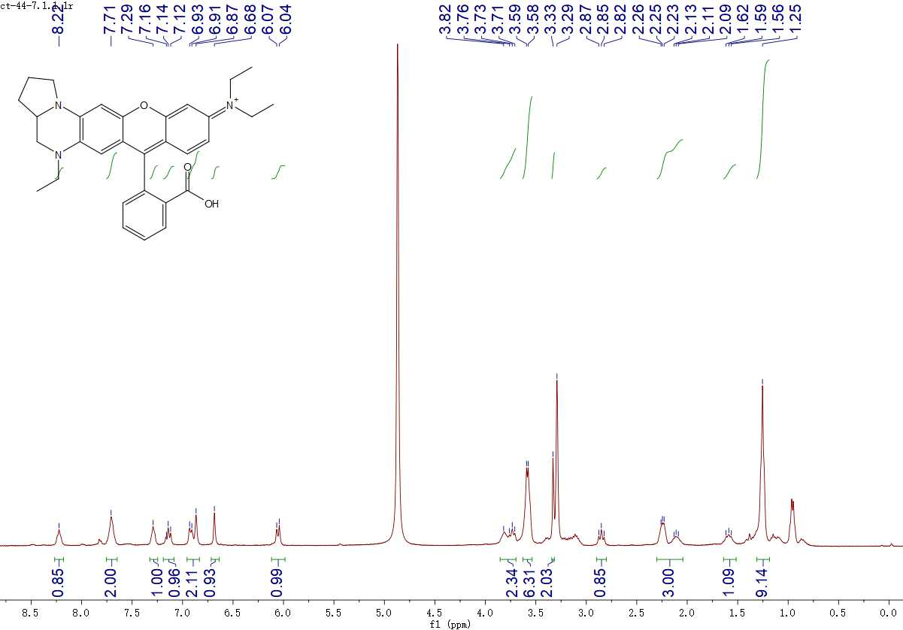
¹H NMR spectrum of BDQF-1 in CD₃OD containing 20 % CDCl₃

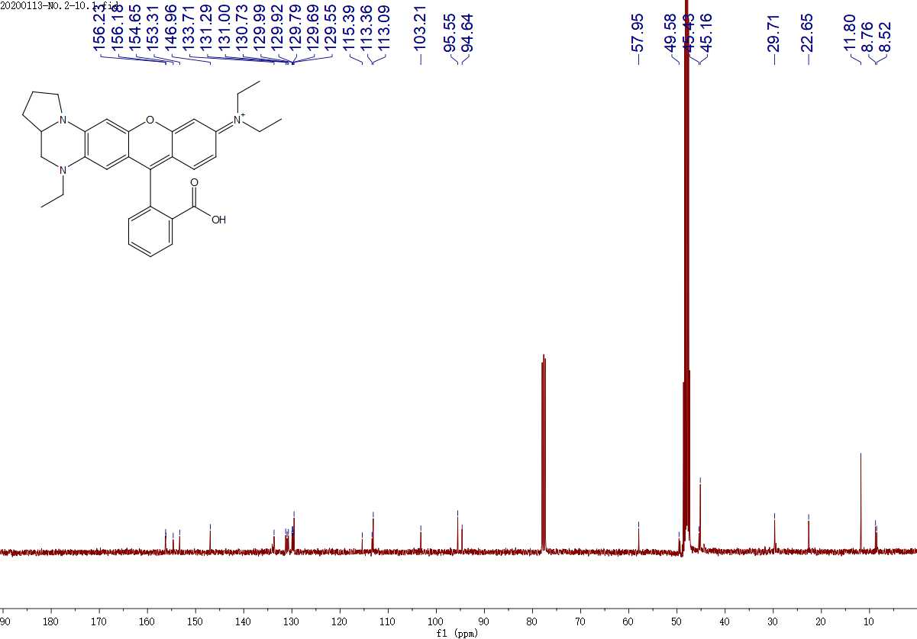
¹³C NMR spectrum of BDQF-1 in CD₃OD containing 20 % CDCl₃

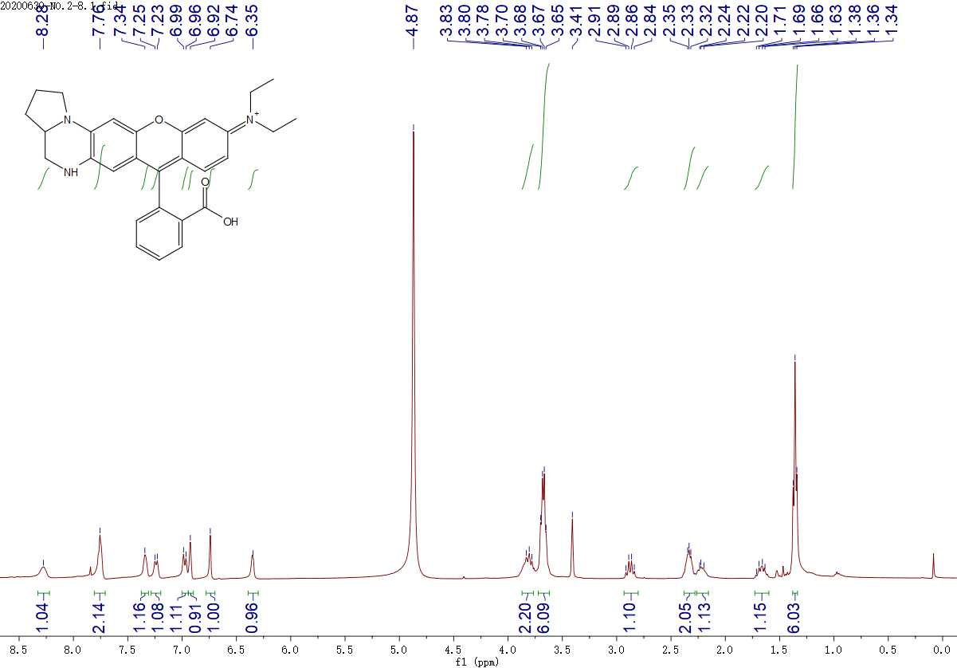
¹H NMR spectrum of BDQF-2 in CD₃OD containing 20 % CDCl₃

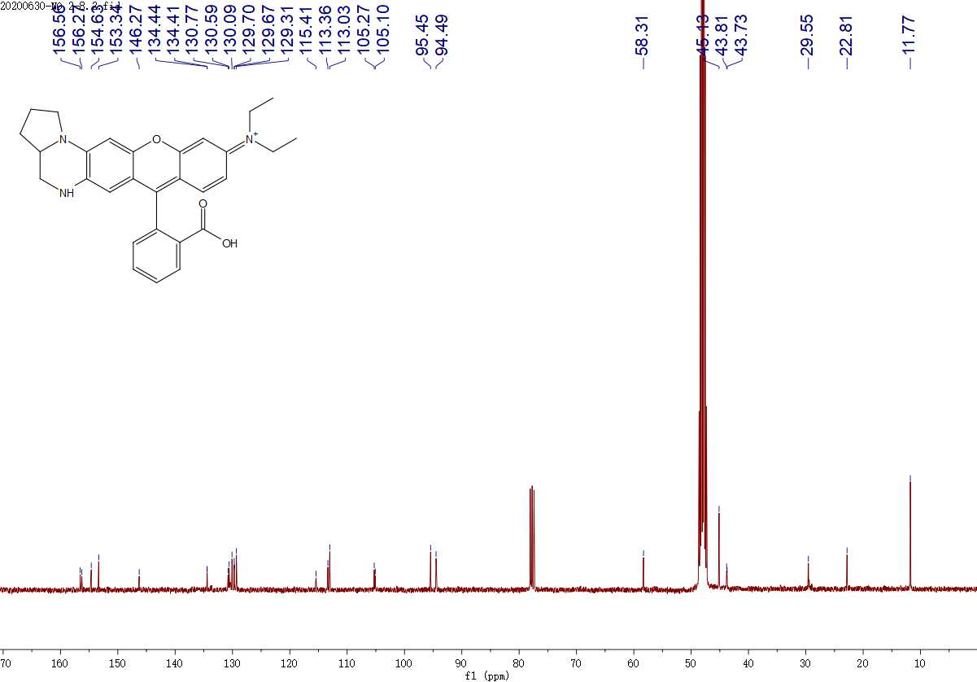
¹³C NMR spectrum of BDQF-2 in CD₃OD containing 20 % CDCl₃

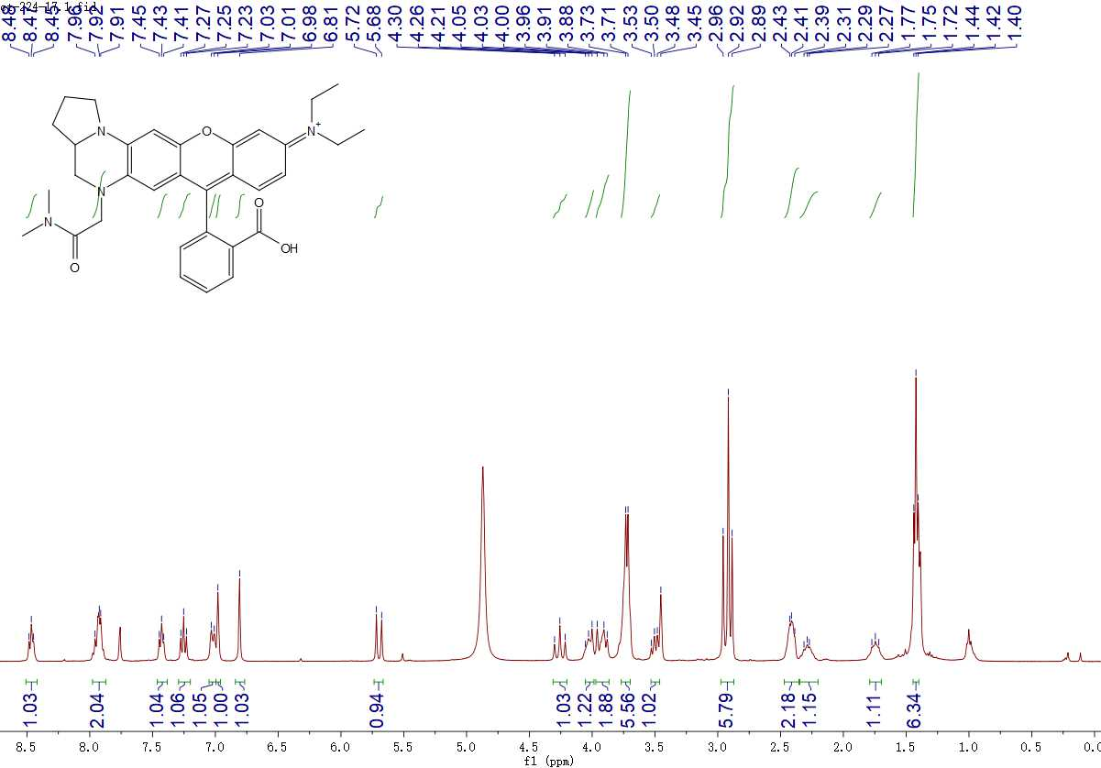
¹H NMR spectrum of BDQF-3 in CD₃OD containing 20 % CDCl₃

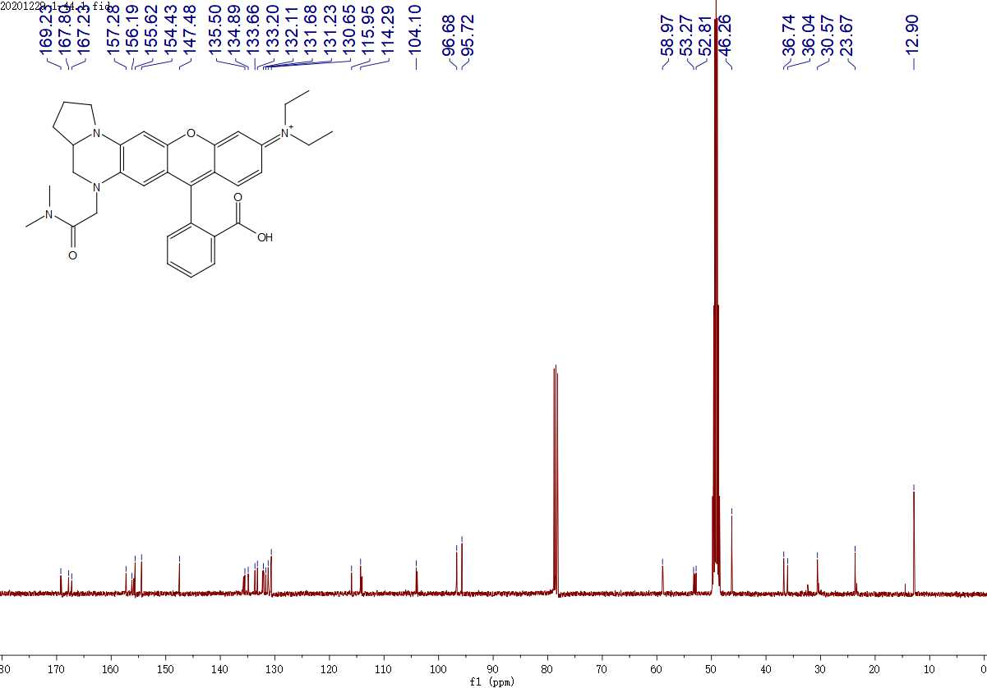
¹³C NMR spectrum of BDQF-3 in CD₃OD containing 20 % CDCl₃

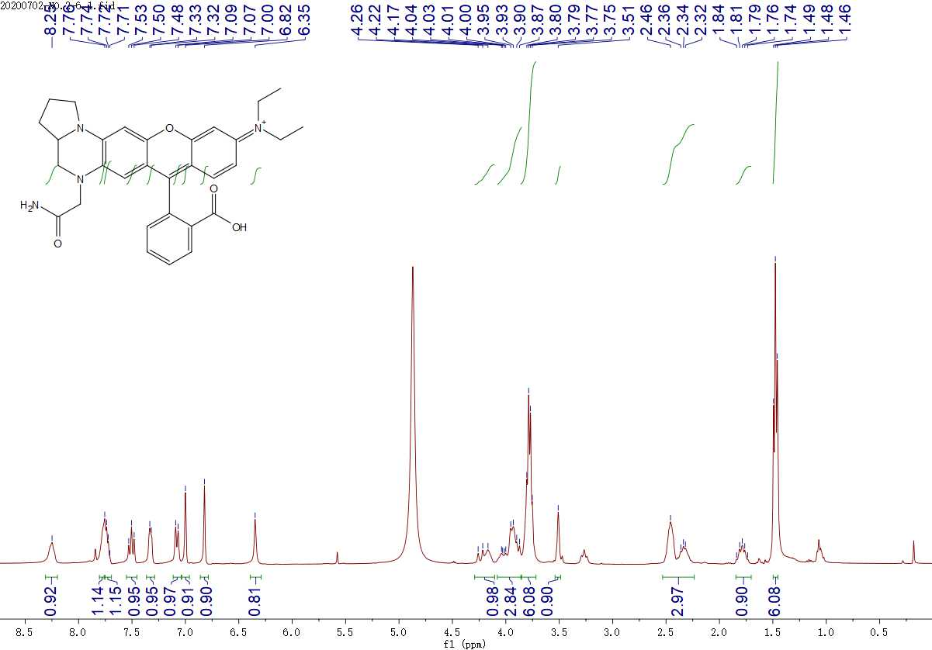
¹H NMR spectrum of BDQF-4 in CD₃OD containing 20 % CDCl₃

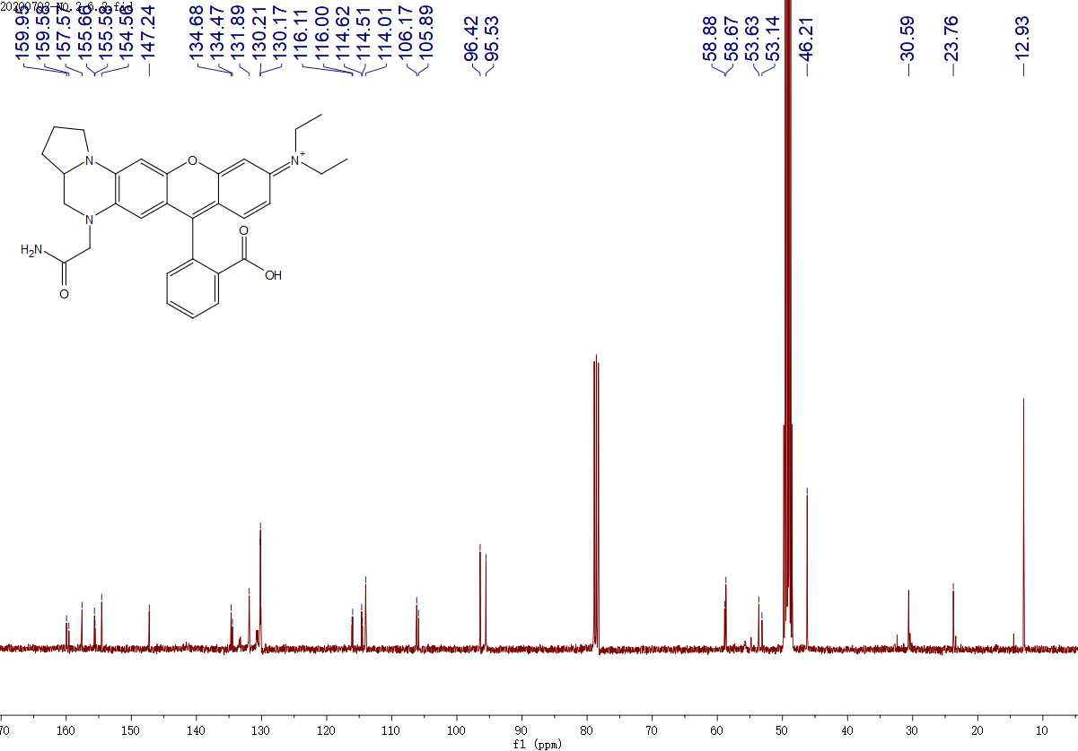
¹³C NMR spectrum of BDQF-4 in CD₃OD containing 20 % CDCl₃

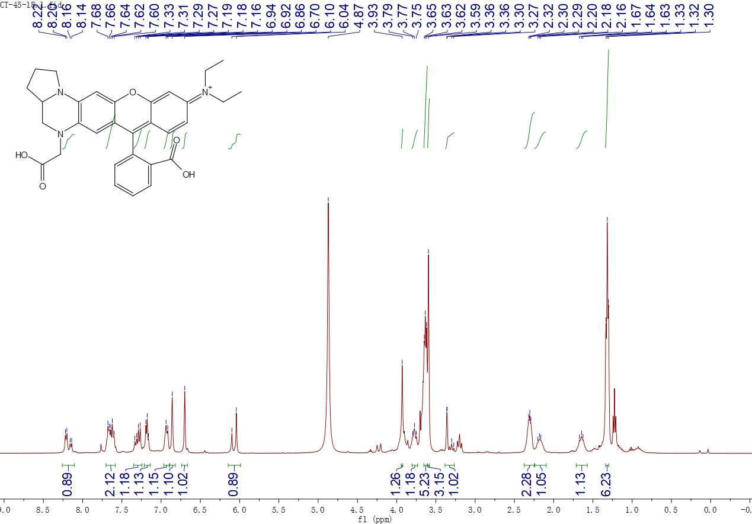
¹H NMR spectrum of BDQF-5 in CD₃OD containing 20 % CDCl₃

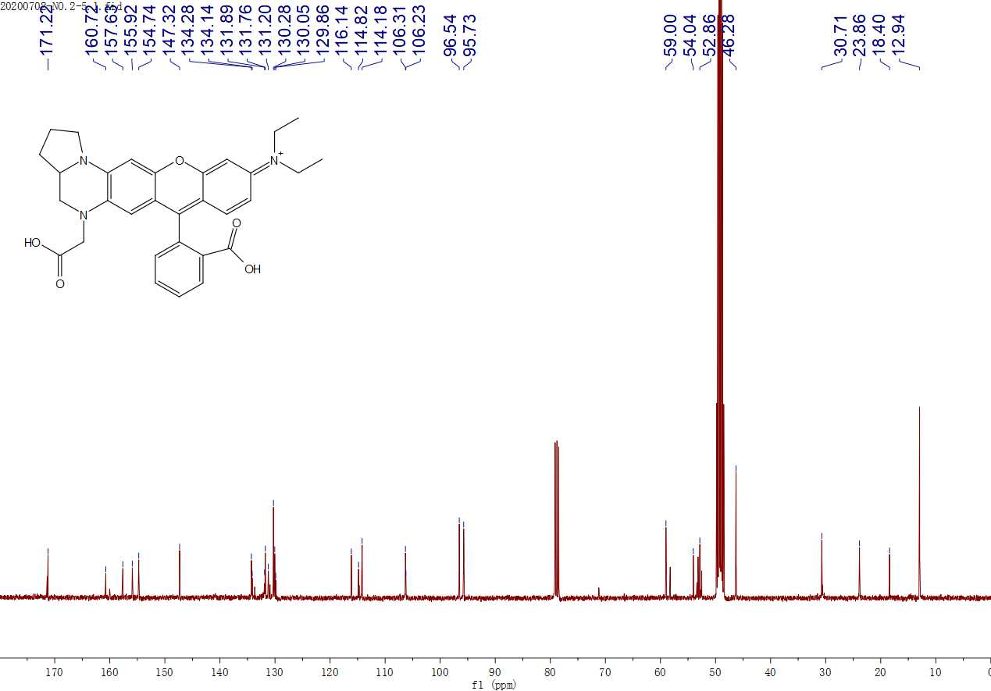
¹³C NMR spectrum of BDQF-5 in CD₃OD containing 20 % CDCl₃

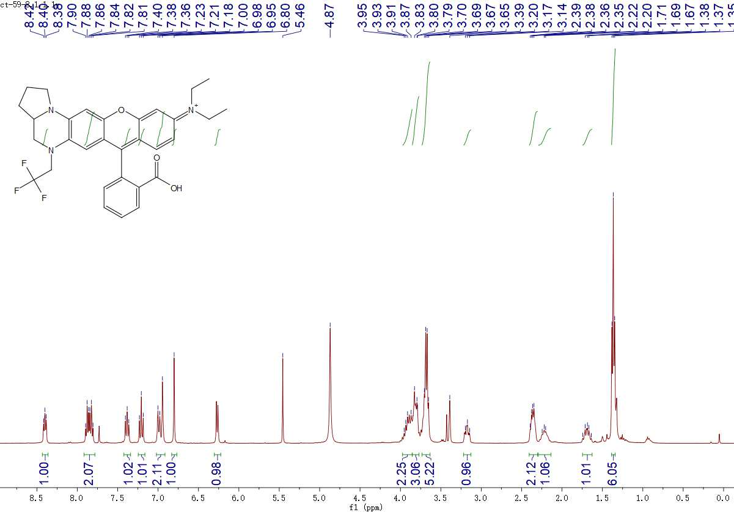
¹H NMR spectrum of BDQF-6 in CD₃OD containing 20 % CDCl₃

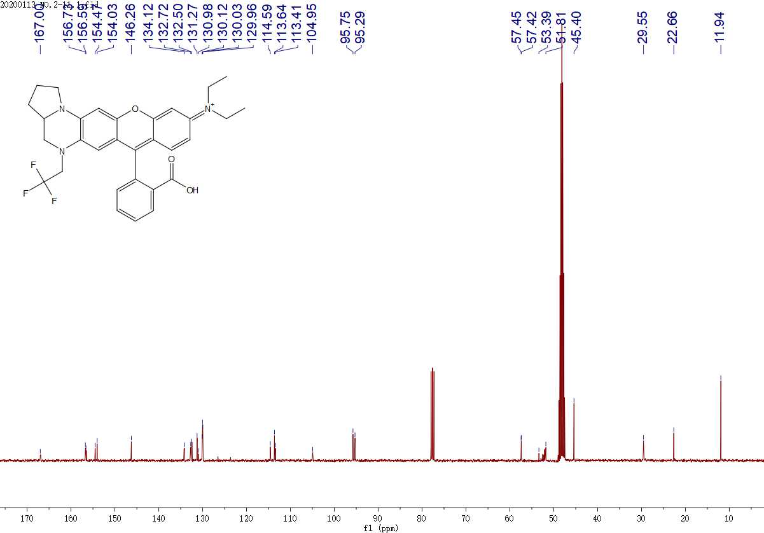
¹³C NMR spectrum of BDQF-6 in CD₃OD containing 20 % CDCl₃

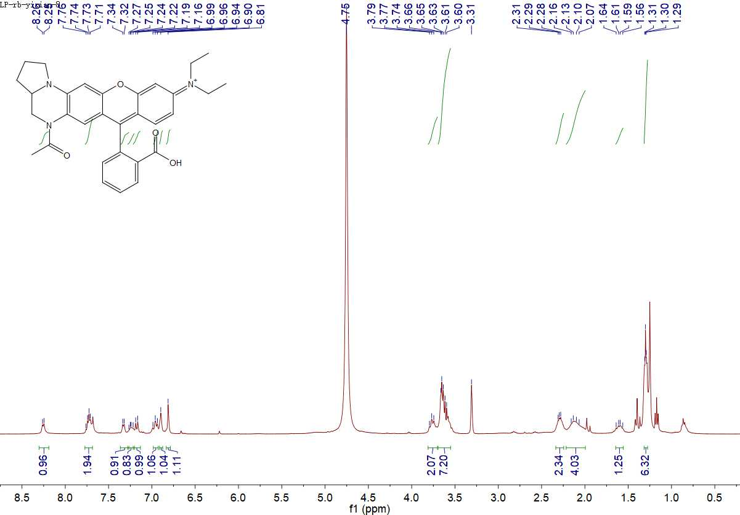
¹H NMR spectrum of BDQF-7 in CD₃OD containing 20 % CDCl₃

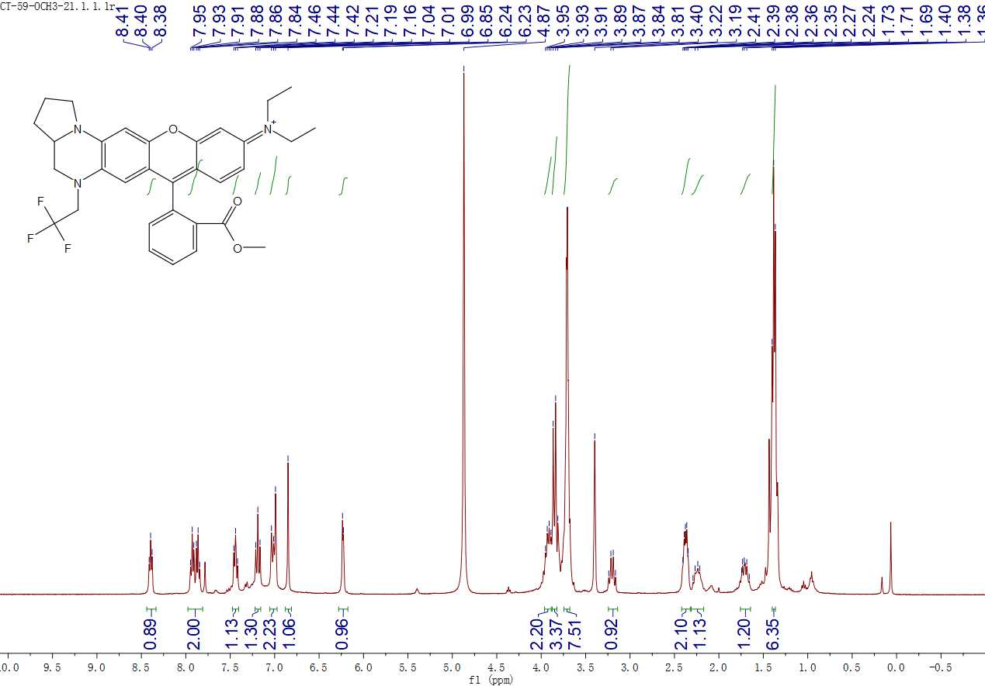
¹H NMR spectrum of BDQF-6-Mito in CD₃OD containing 20 % CDCl₃

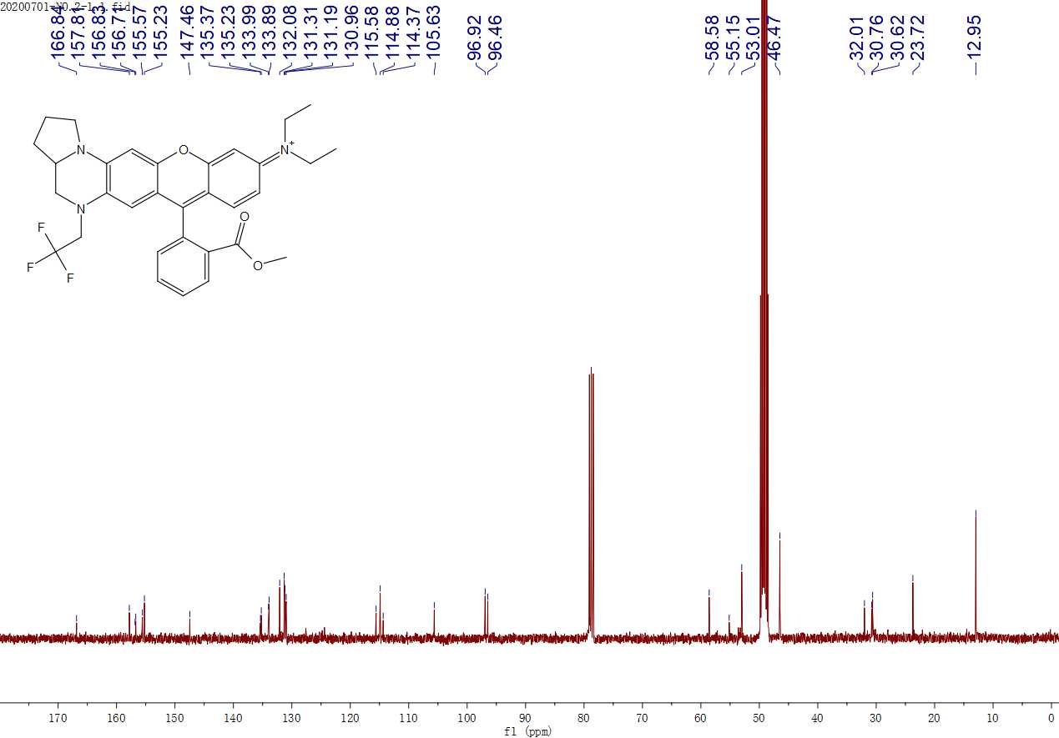
¹³C NMR spectrum of BDQF-6-Mito in CD₃OD containing 20 % CDCl₃

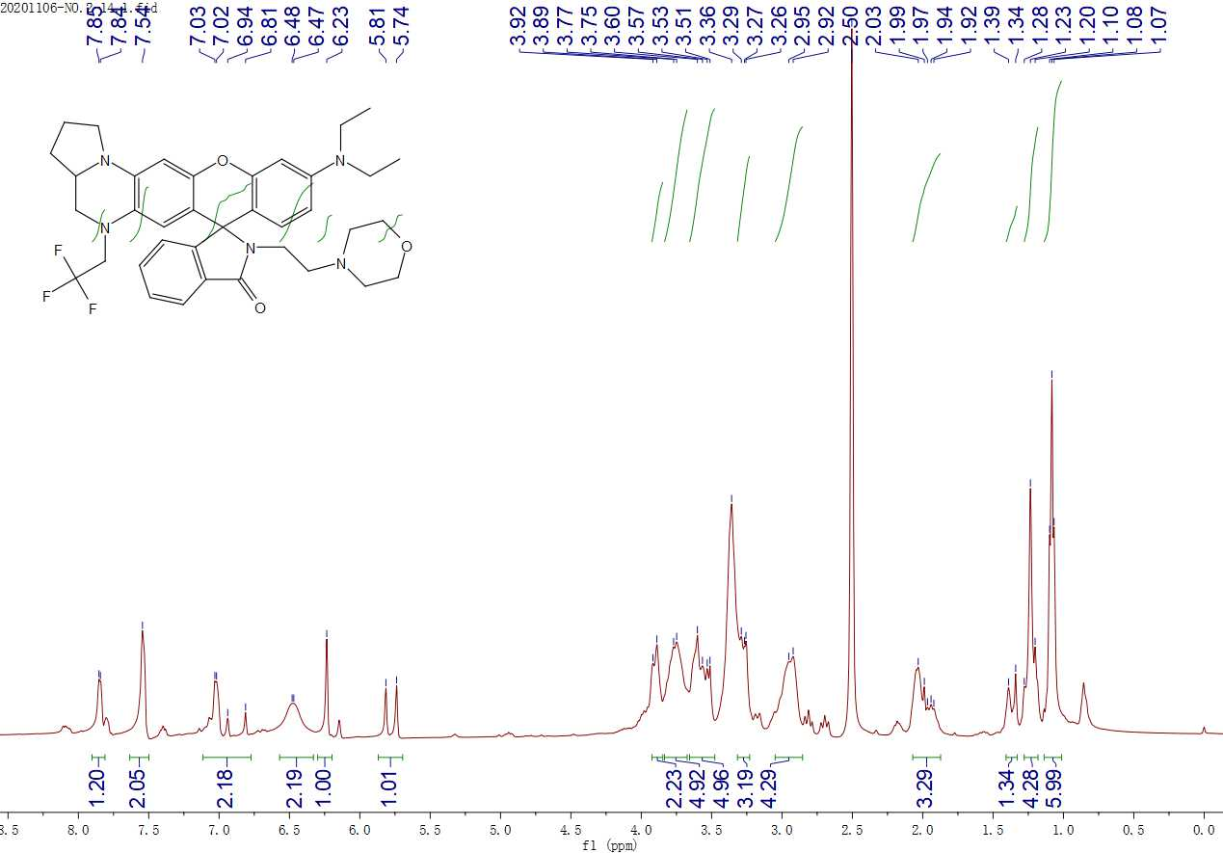
¹H NMR spectrum of BDQF-6-Lyso in CD₃OD containing 20 % CDCl₃

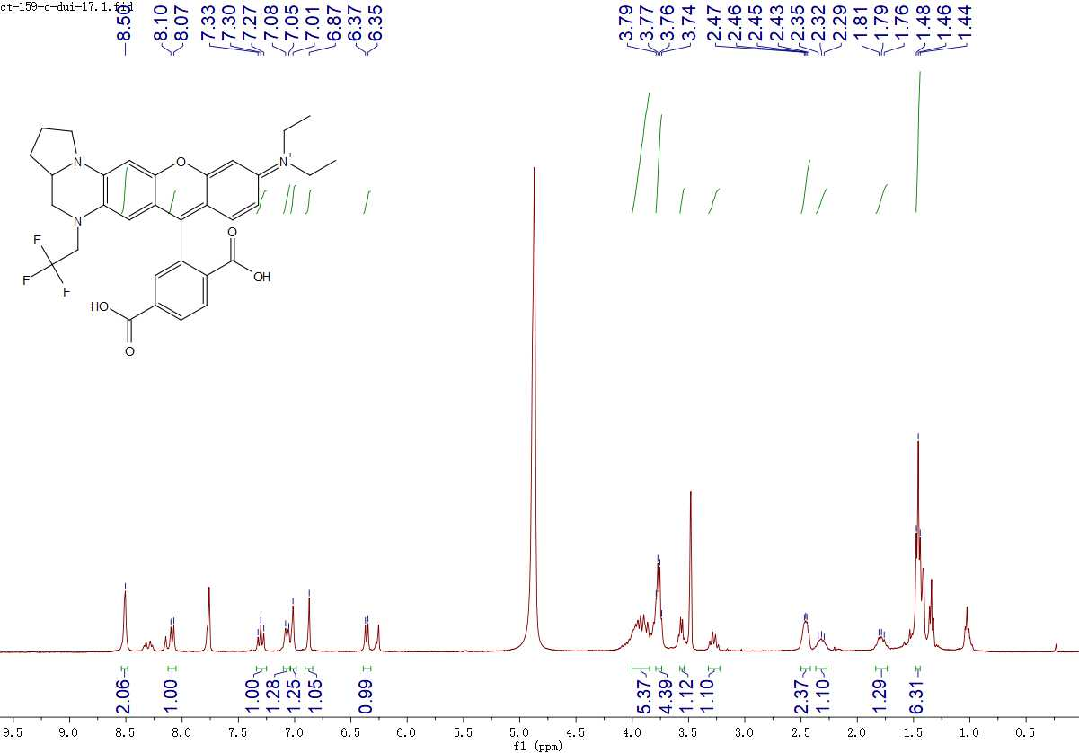
¹H NMR spectrum of BDQF-9 in CD₃OD containing 20 % CDCl₃

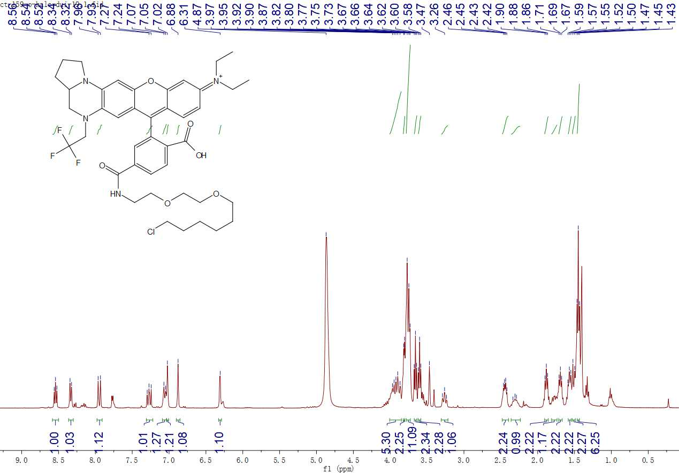
¹H NMR spectrum of BDQF-9-Halo in CD₃OD containing 20 % CDCl₃

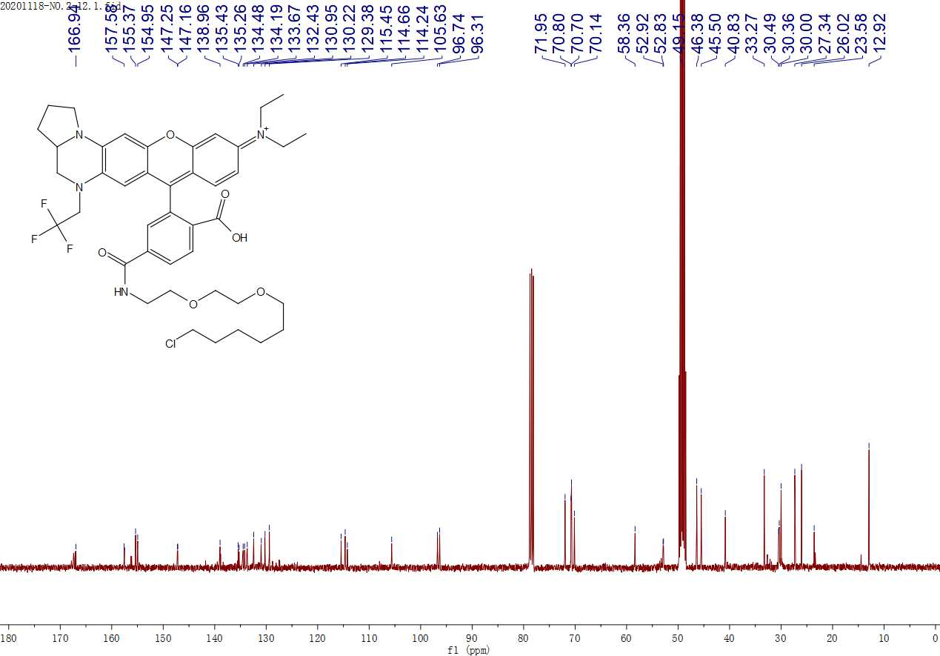
¹³C NMR spectrum of BDQF-9-Halo in CD₃OD containing 20 % CDCl₃

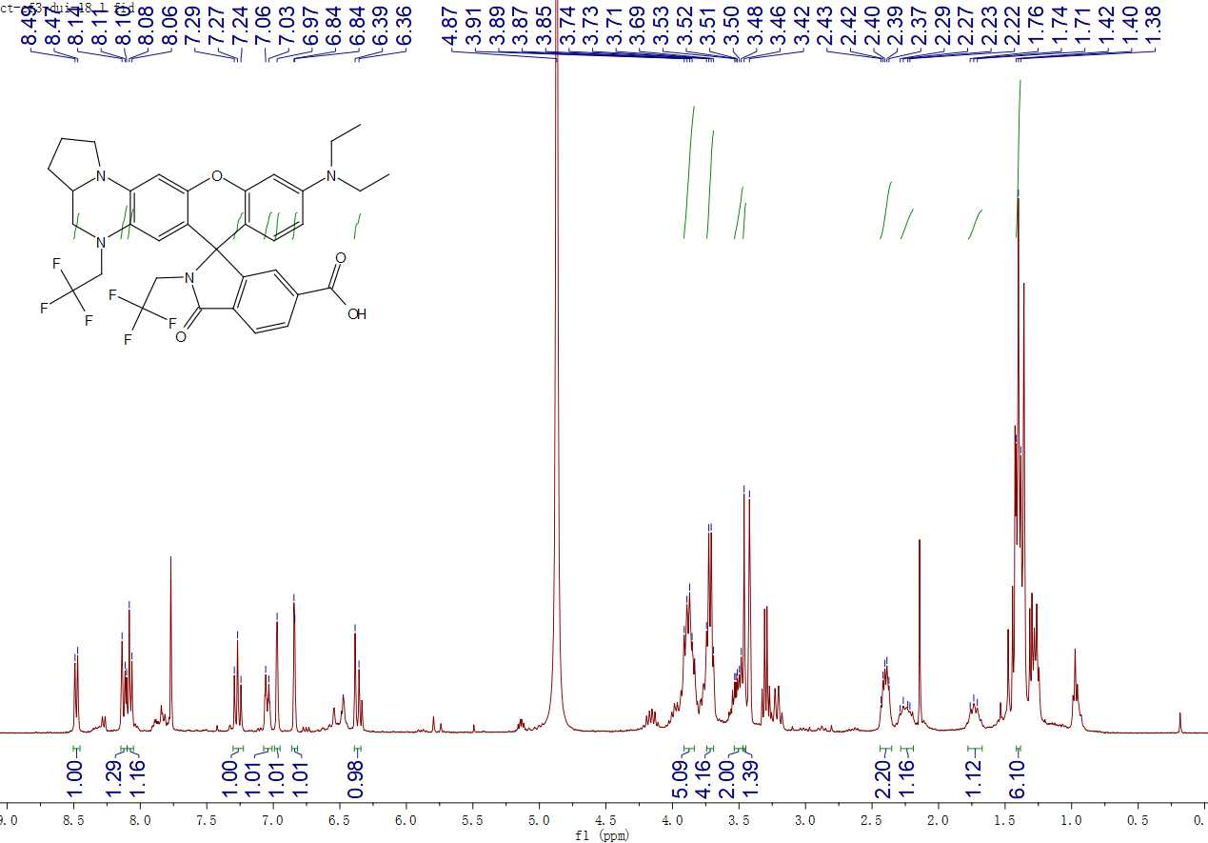
¹H NMR spectrum of BDQF-10 in CD₃OD containing 20 % CDCl₃

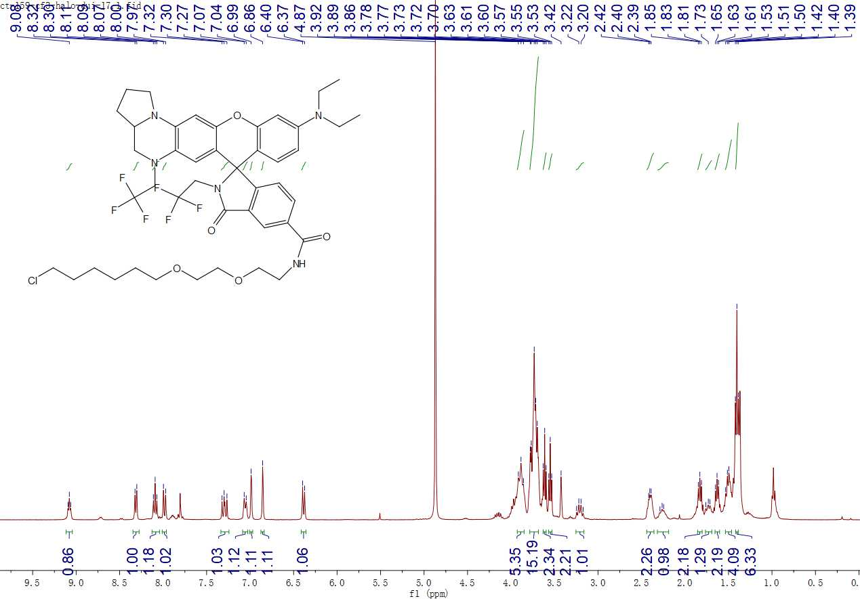
¹H NMR spectrum of BDQF-10-Halo in CD₃OD containing 20 % CDCl₃

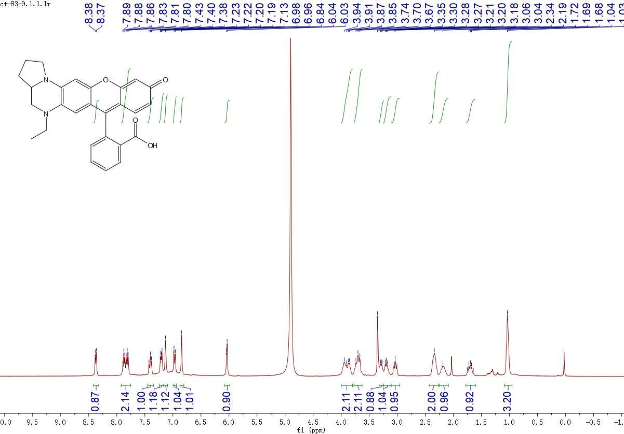
¹H NMR spectrum of BDQF-17 in CD₃OD containing 20 % CDCl₃

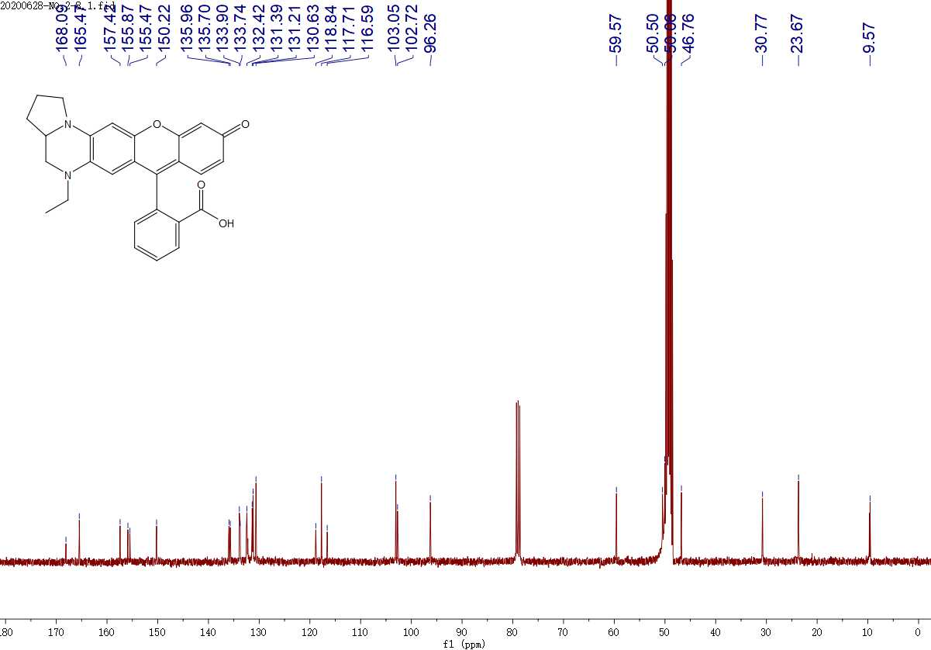
¹³C NMR spectrum of BDQF-17 in CD₃OD containing 20 % CDCl₃

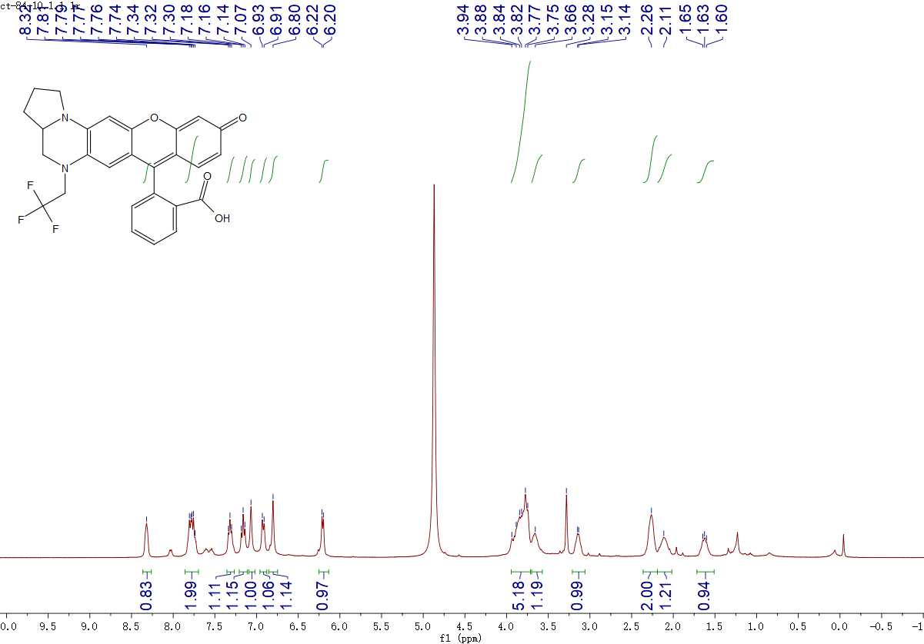
¹H NMR spectrum of BDQF-11 in CD₃OD containing 20 % CDCl₃

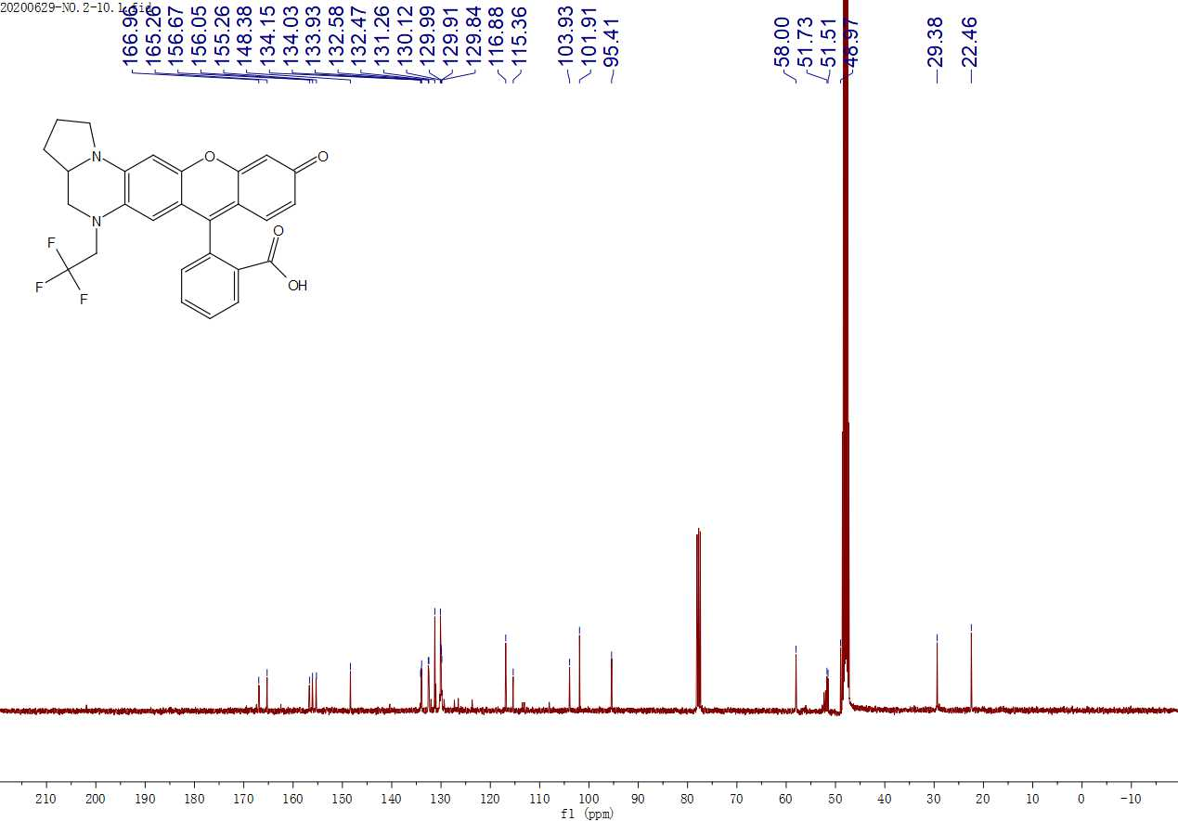
¹³C NMR spectrum of BDQF-11 in CD₃OD containing 20 % CDCl₃

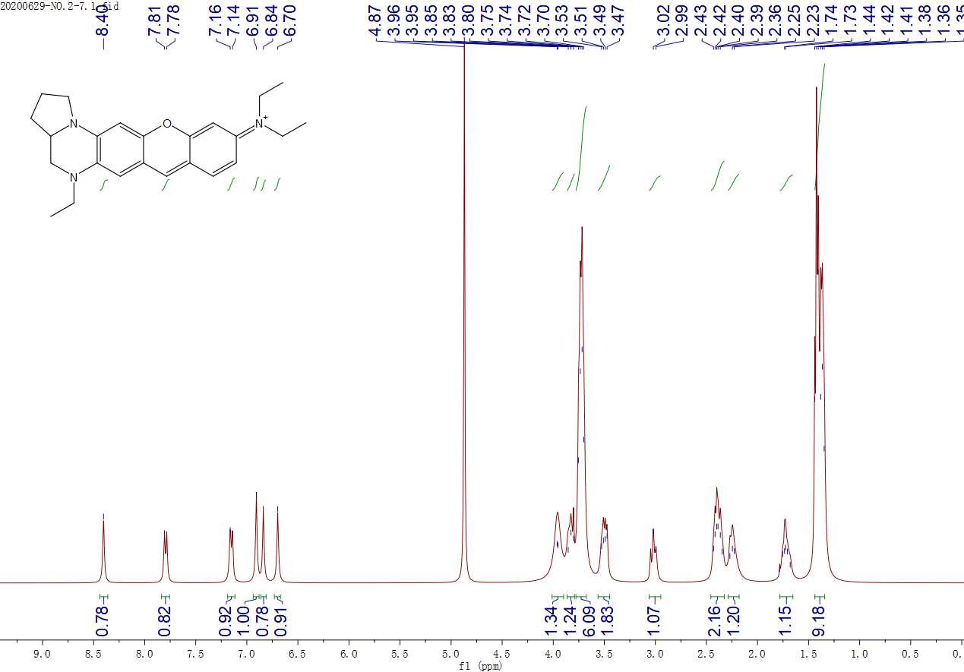
¹H NMR spectrum of BDQF-18 in CD₃OD containing 20 % CDCl₃

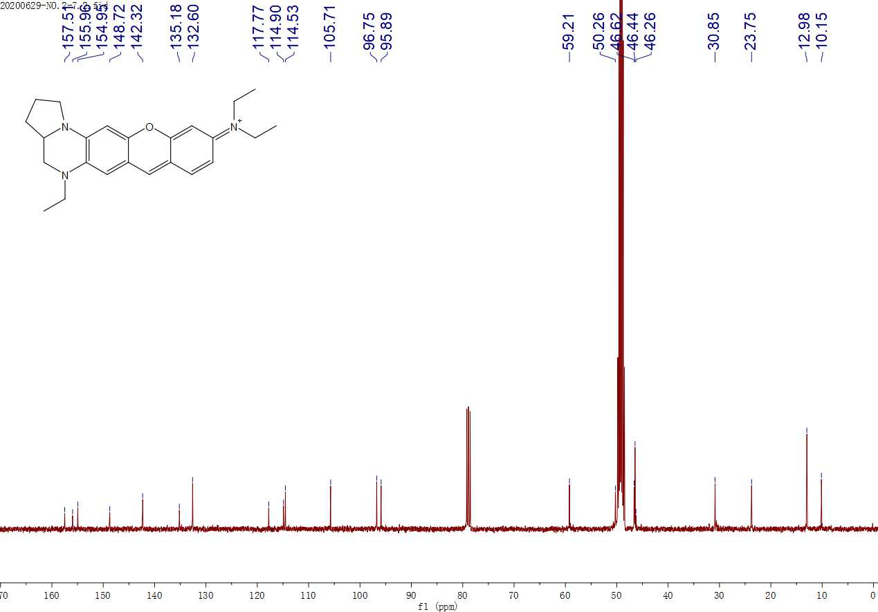
¹³C NMR spectrum of BDQF-18 in CD₃OD containing 20 % CDCl₃

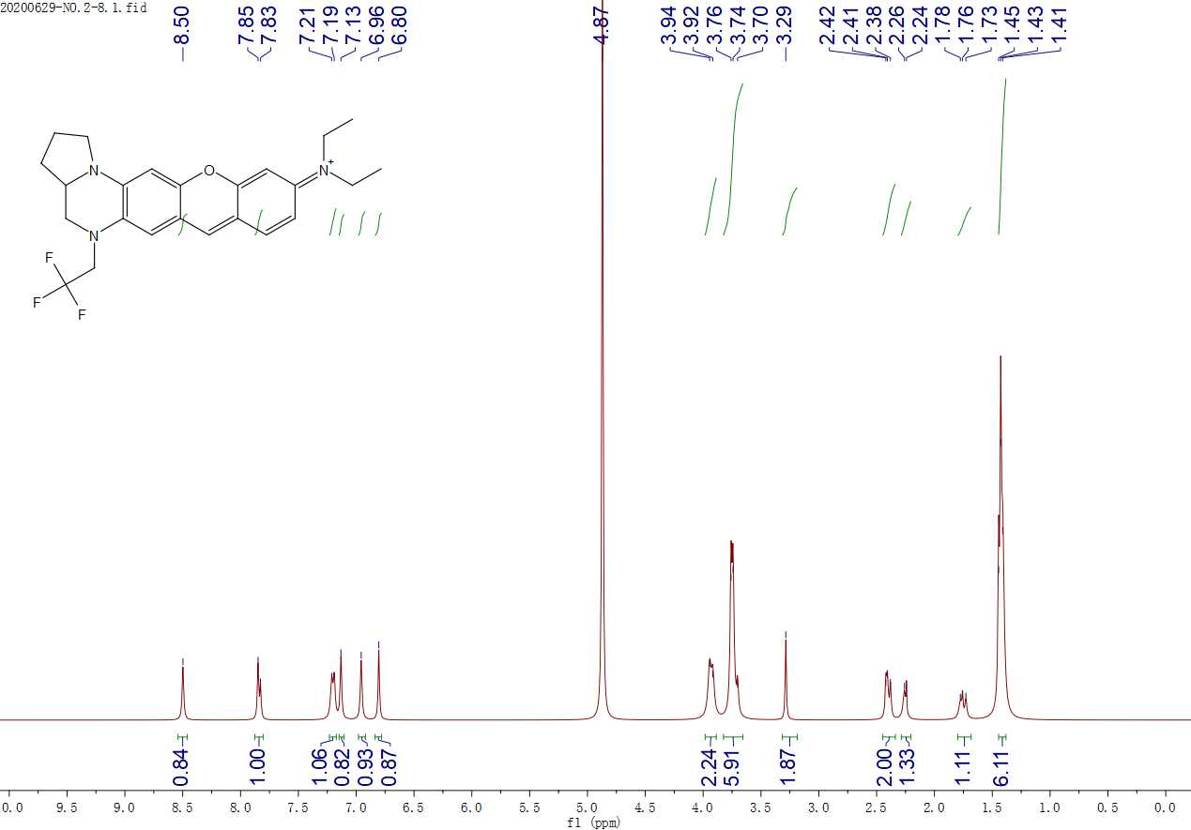
¹H NMR spectrum of BDQF-12 in CD₃OD containing 20 % CDCl₃

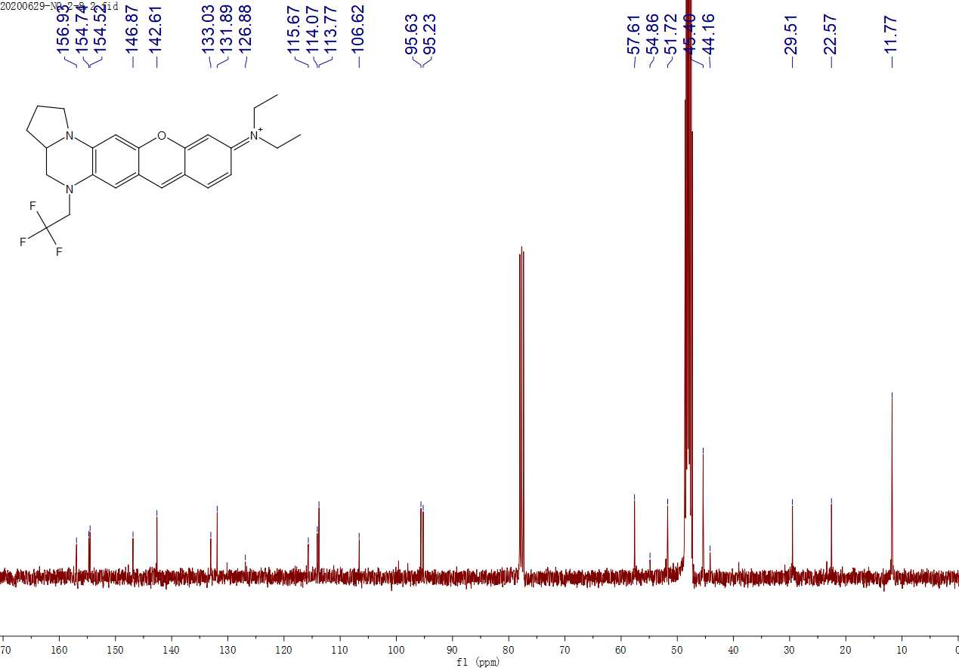
¹³C NMR spectrum of BDQF-12 in CD₃OD containing 20 % CDCl₃

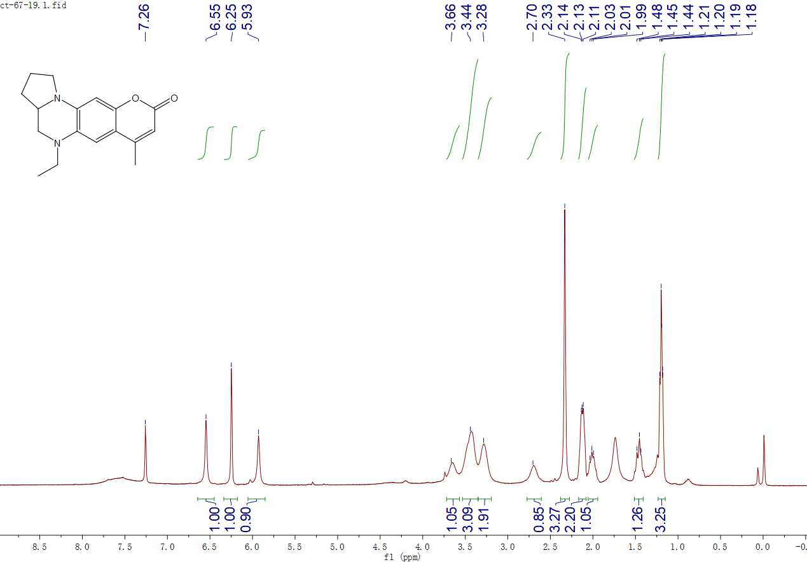
¹H NMR spectrum of BDQF-19 in CDCl₃

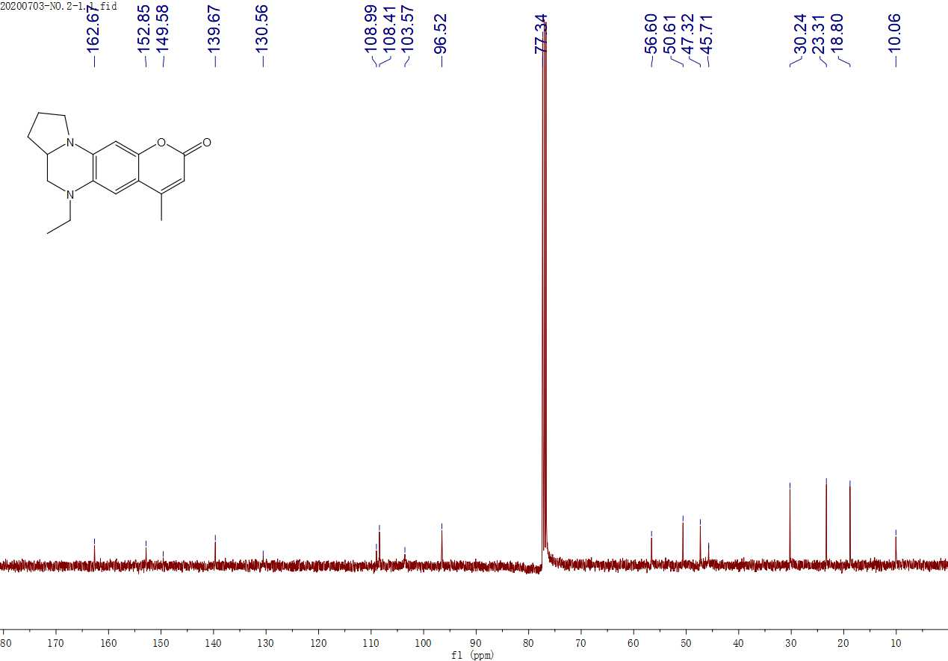
¹³C NMR spectrum of BDQF-19 in CDCl₃

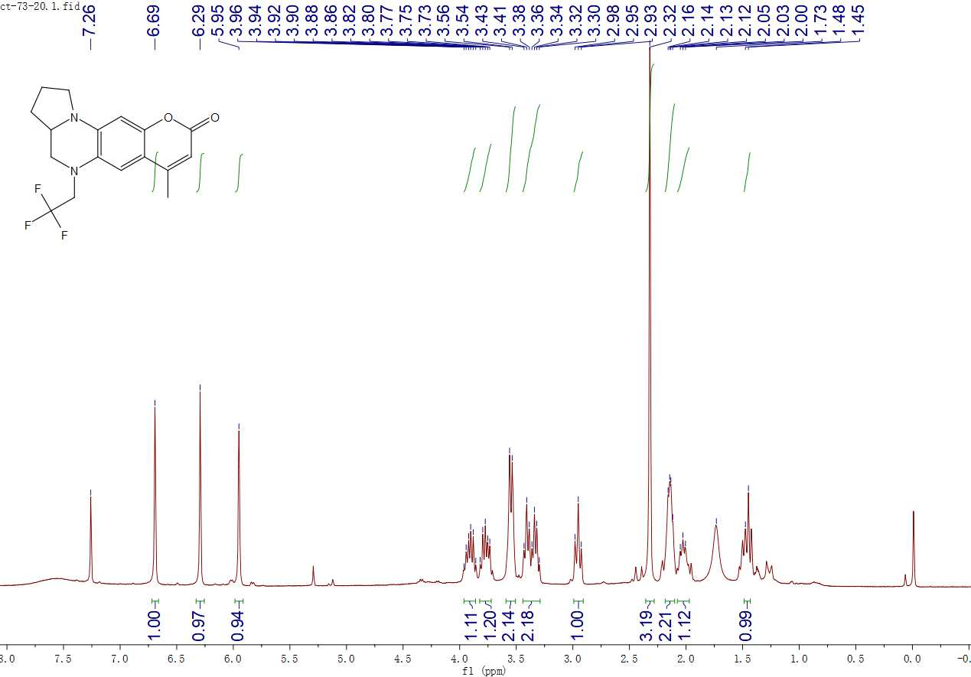
¹H NMR spectrum of BDQF-13 in CDCl₃

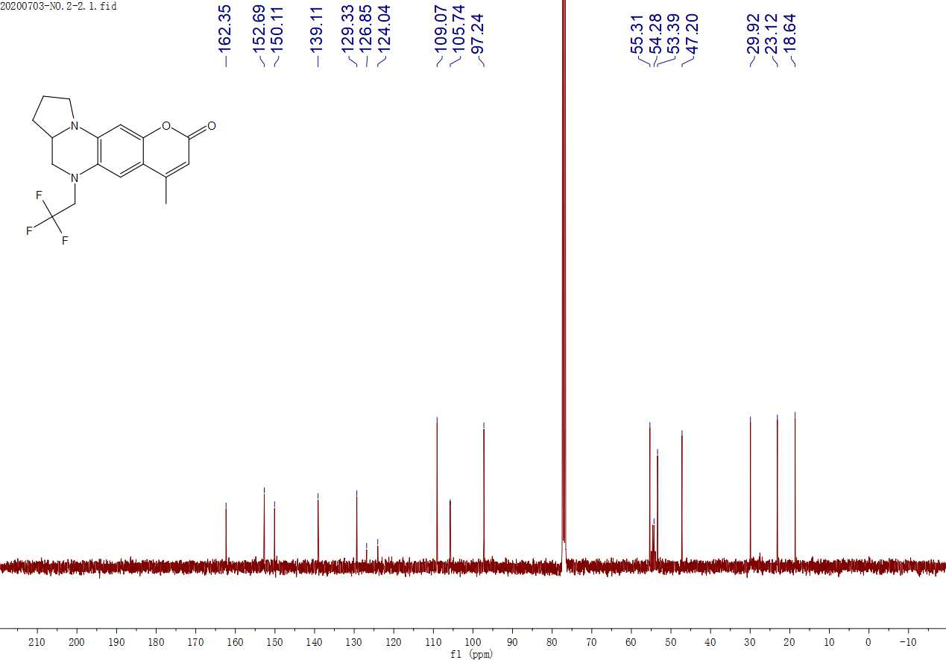
¹³C NMR spectrum of BDQF-13 in CDCl₃

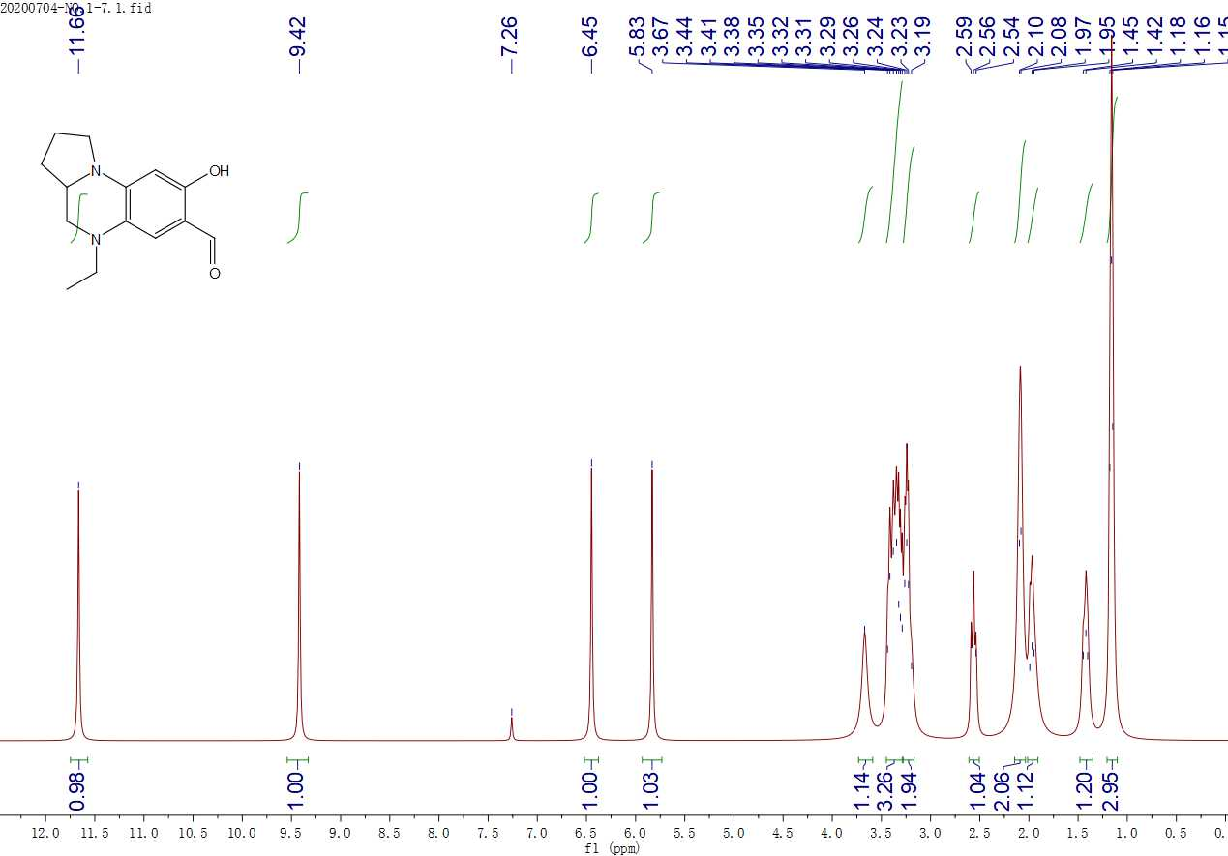
¹H NMR spectrum of 13 in CDCl₃

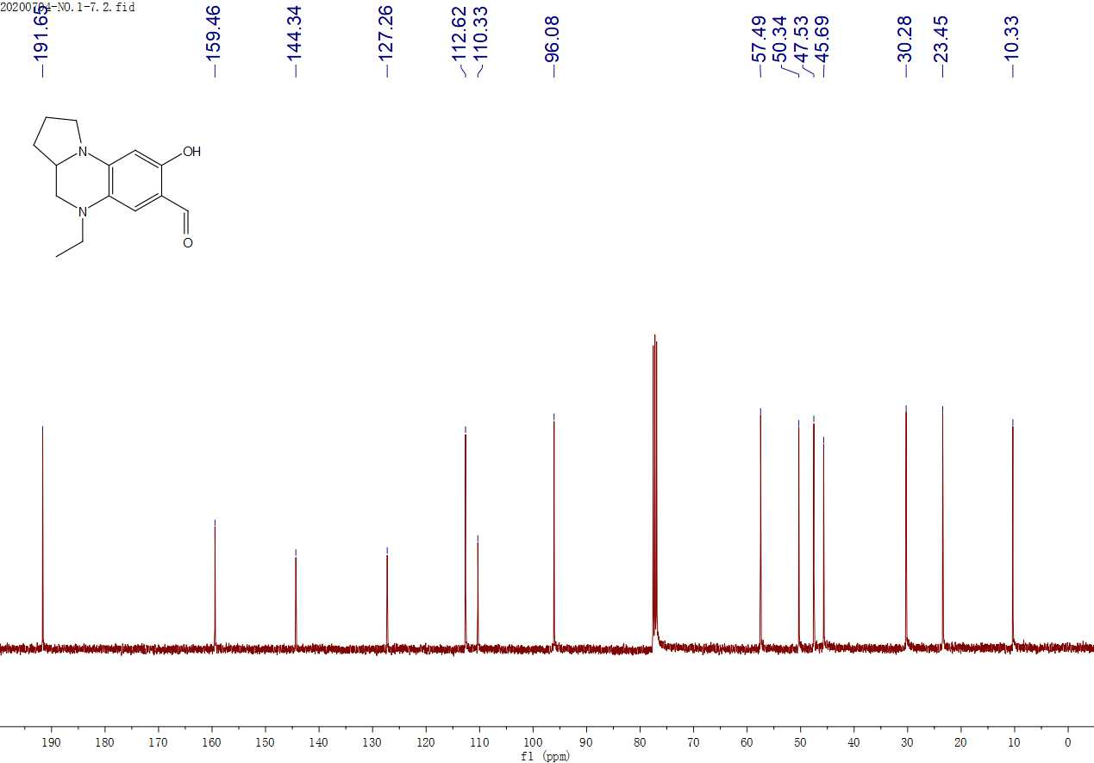
¹³C NMR spectrum of 13 in CDCl₃

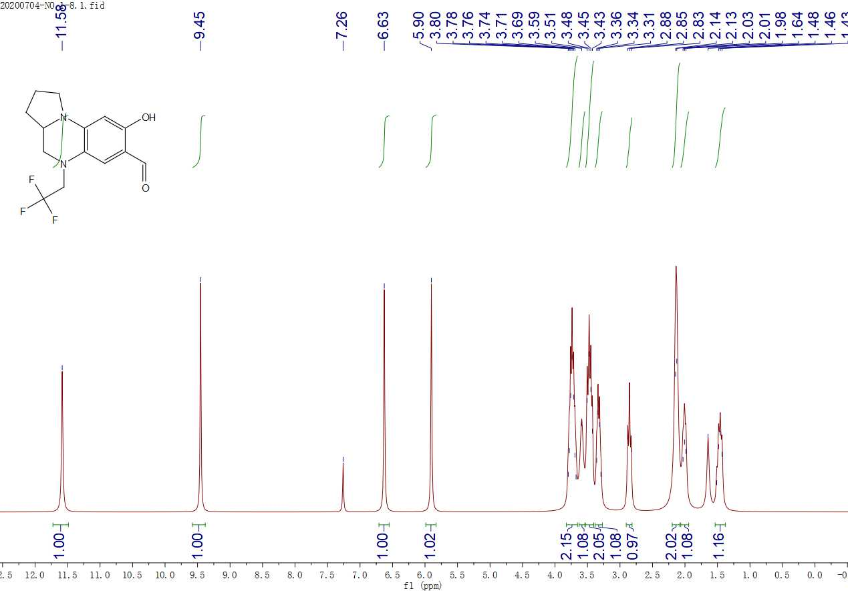
¹H NMR spectrum of 14 in CDCl₃

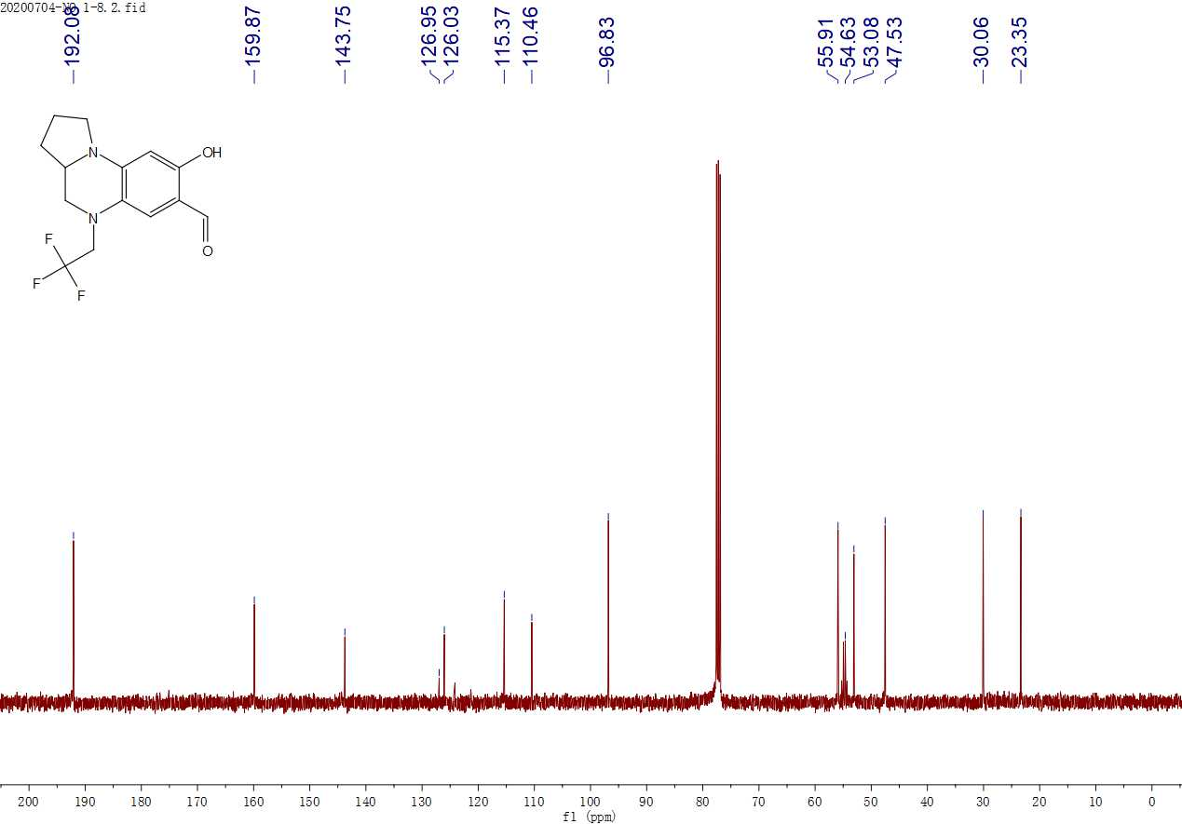
¹³C NMR spectrum of 14 in CDCl₃

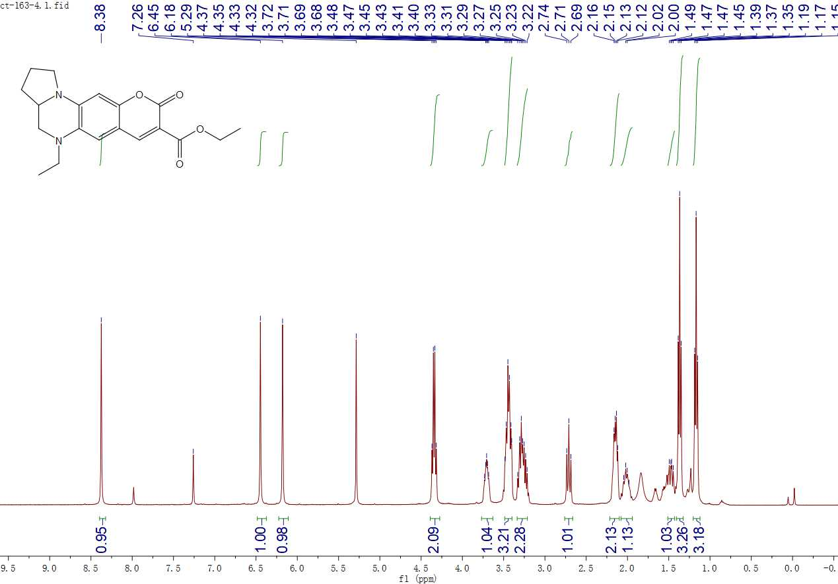
¹H NMR spectrum of BDQF-20 in CDCl₃

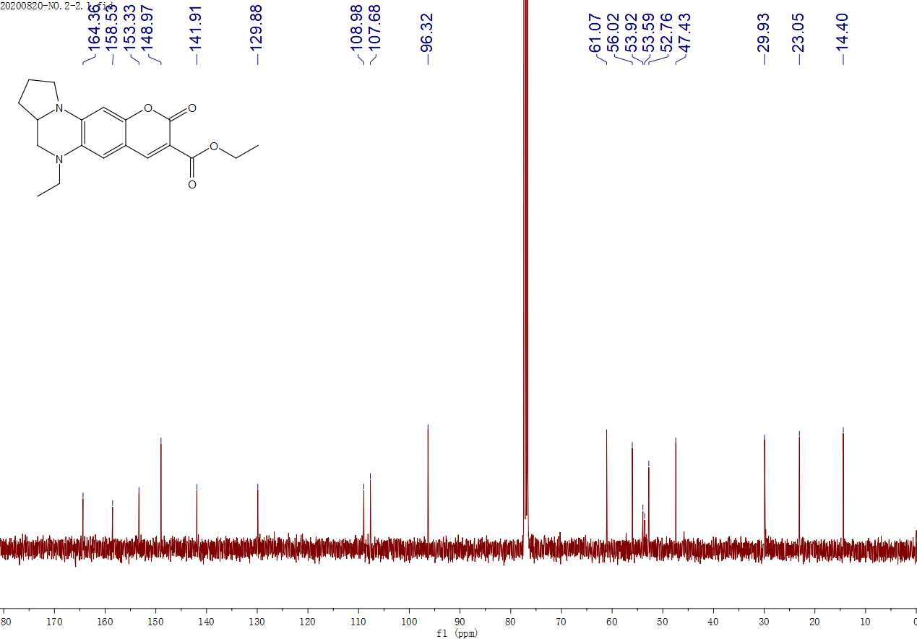
¹³C NMR spectrum of BDQF-20 in CDCl₃

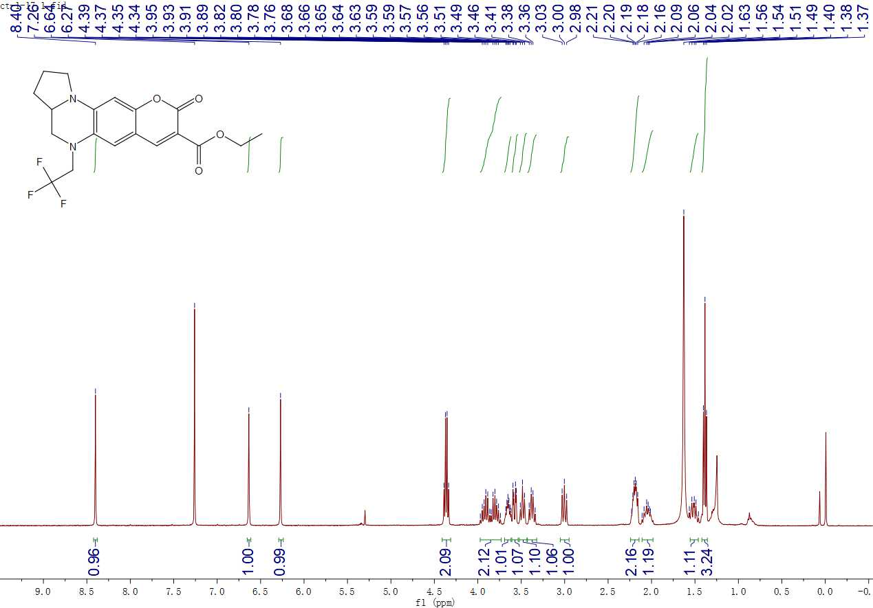
¹H NMR spectrum of BDQF-14 in CDCl₃

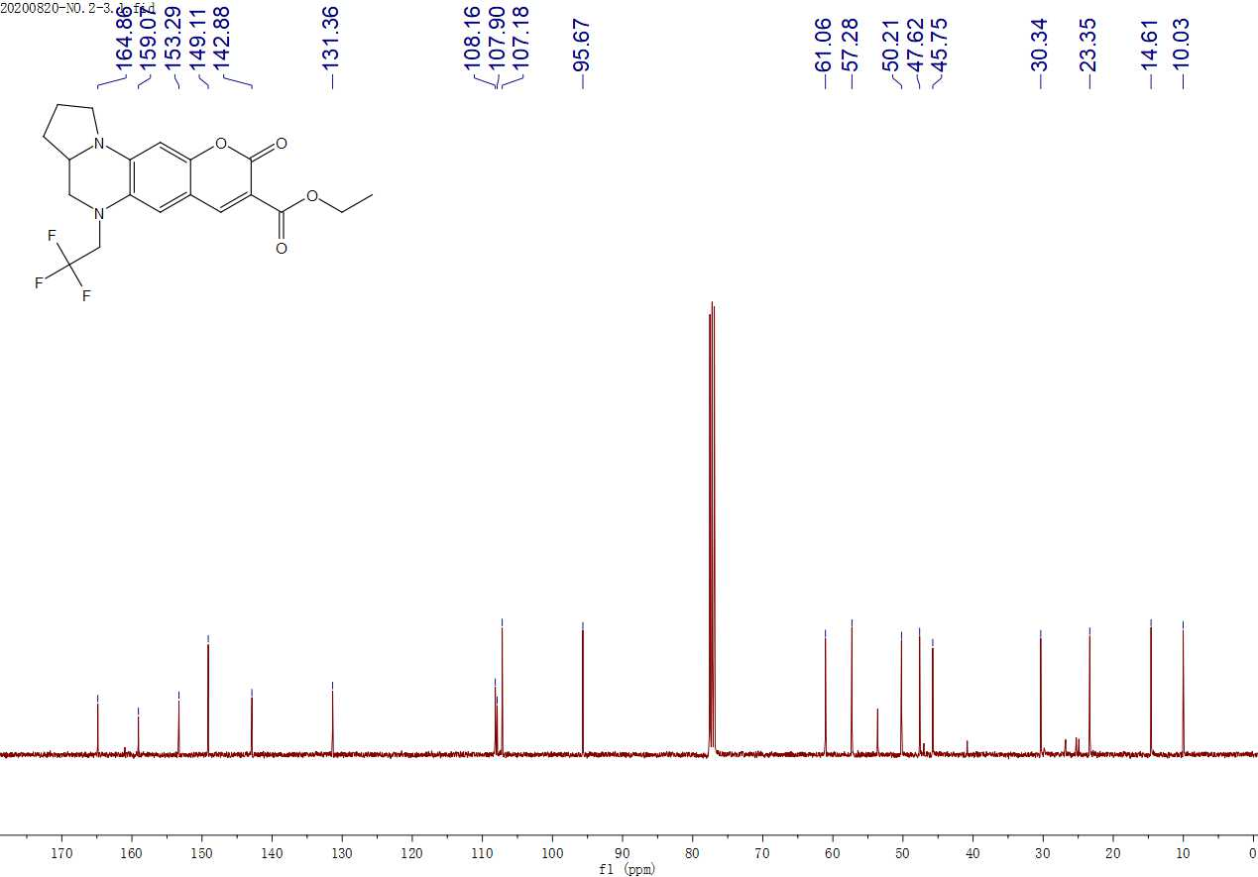
¹³C NMR spectrum of BDQF-14 in CDCl₃

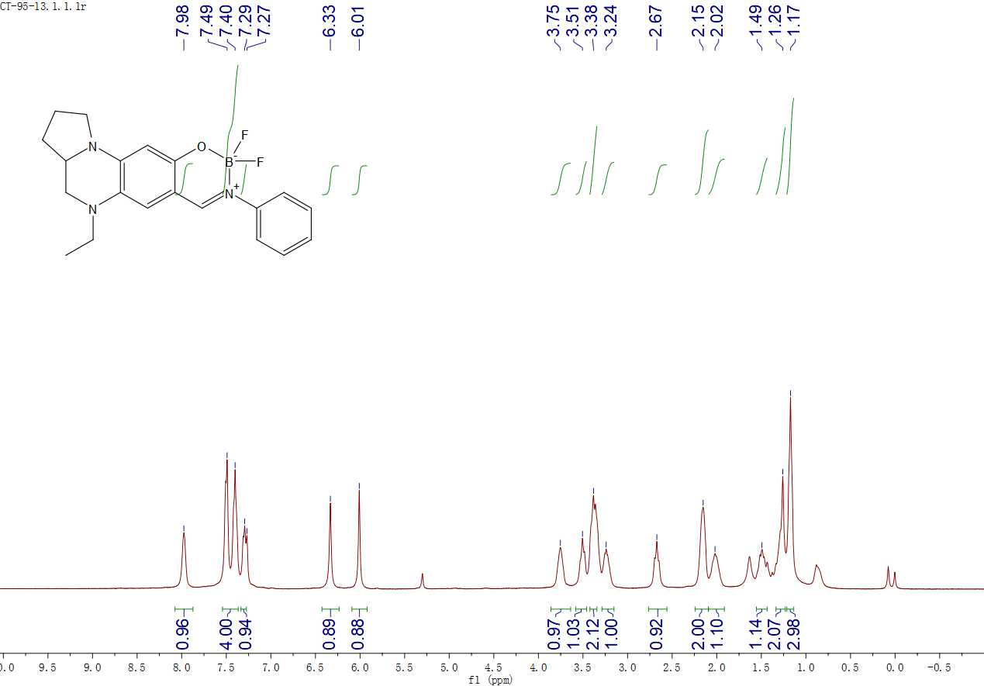
¹H NMR spectrum of BDQF-21 in CDCl₃

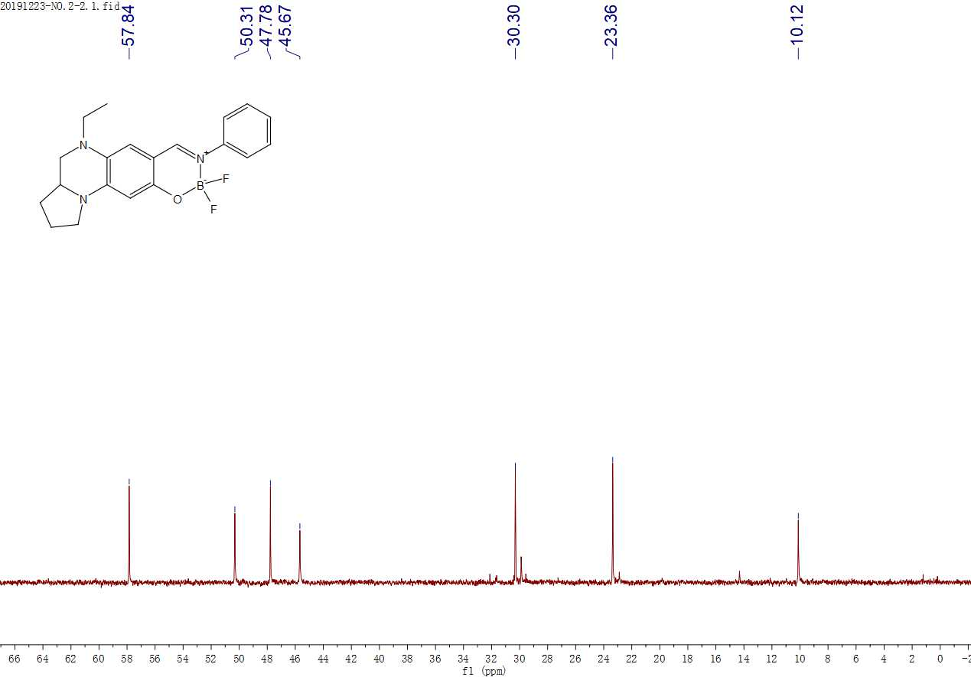
¹³C NMR spectrum of BDQF-21 in CDCl₃

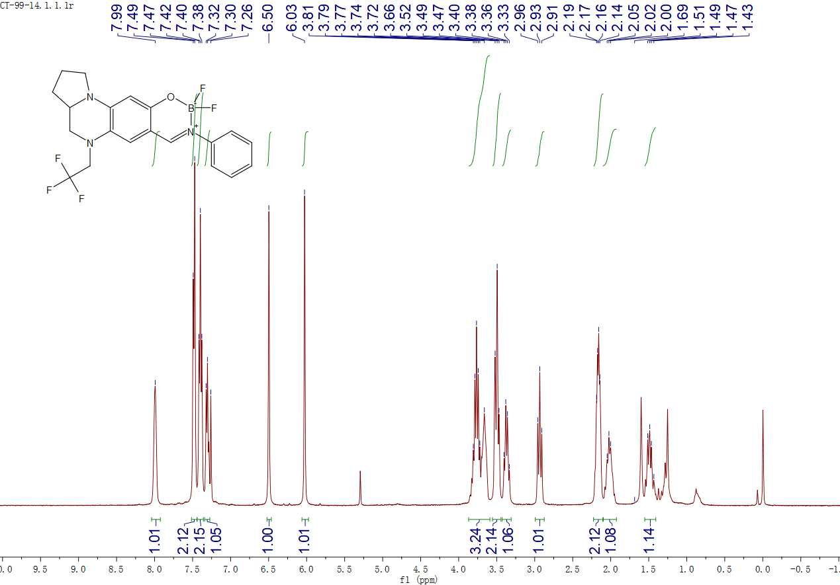
¹H NMR spectrum of BDQF-15 in CDCl₃

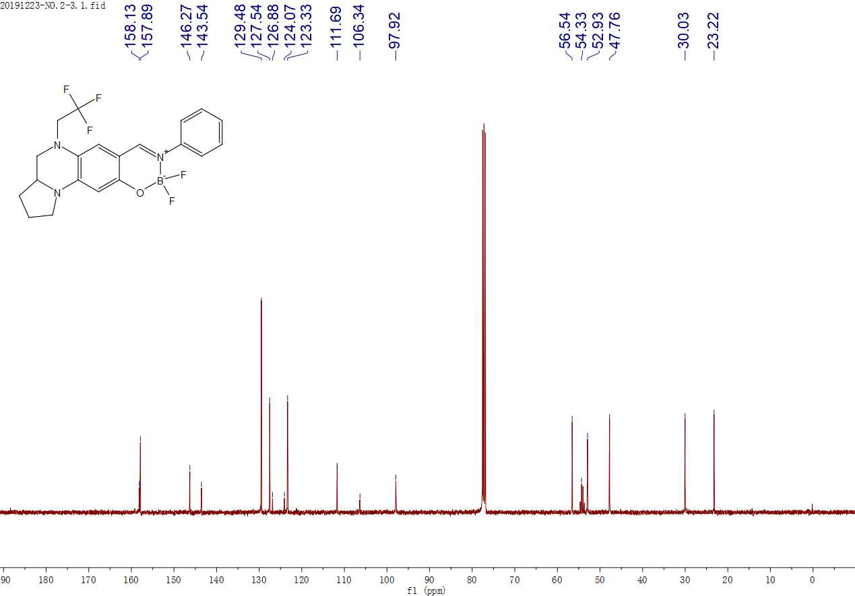
¹³C NMR spectrum of BDQF-15 in CDCl₃

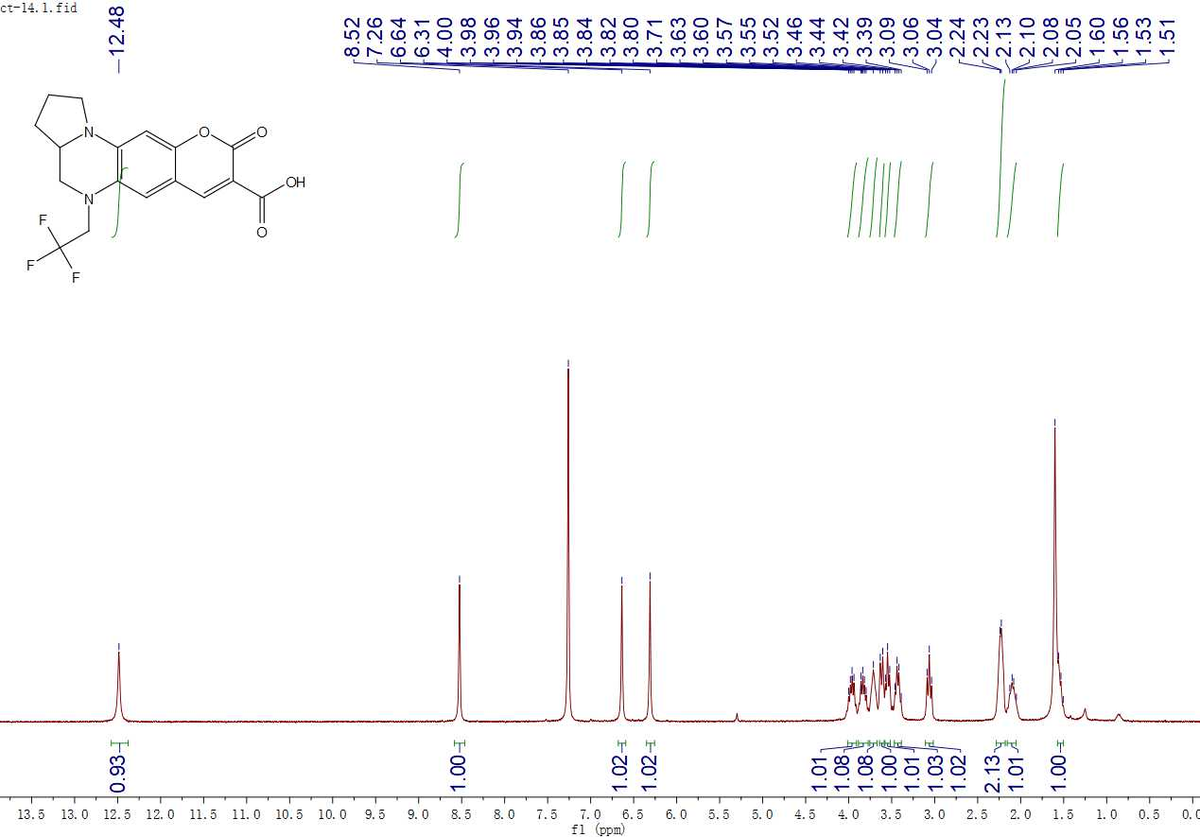
¹H NMR spectrum of BDQF-16 in CDCl₃

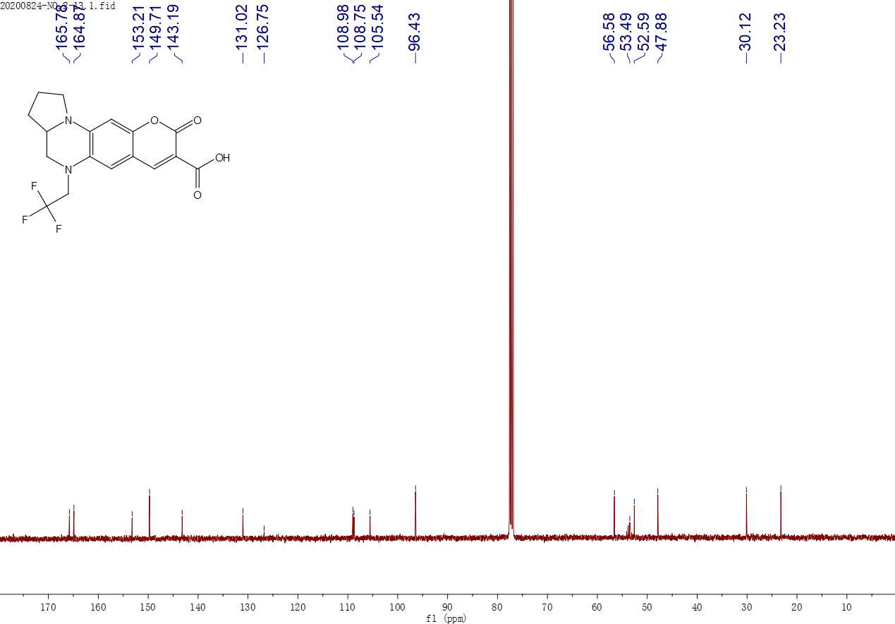
¹³C NMR spectrum of BDQF-16 in CDCl₃

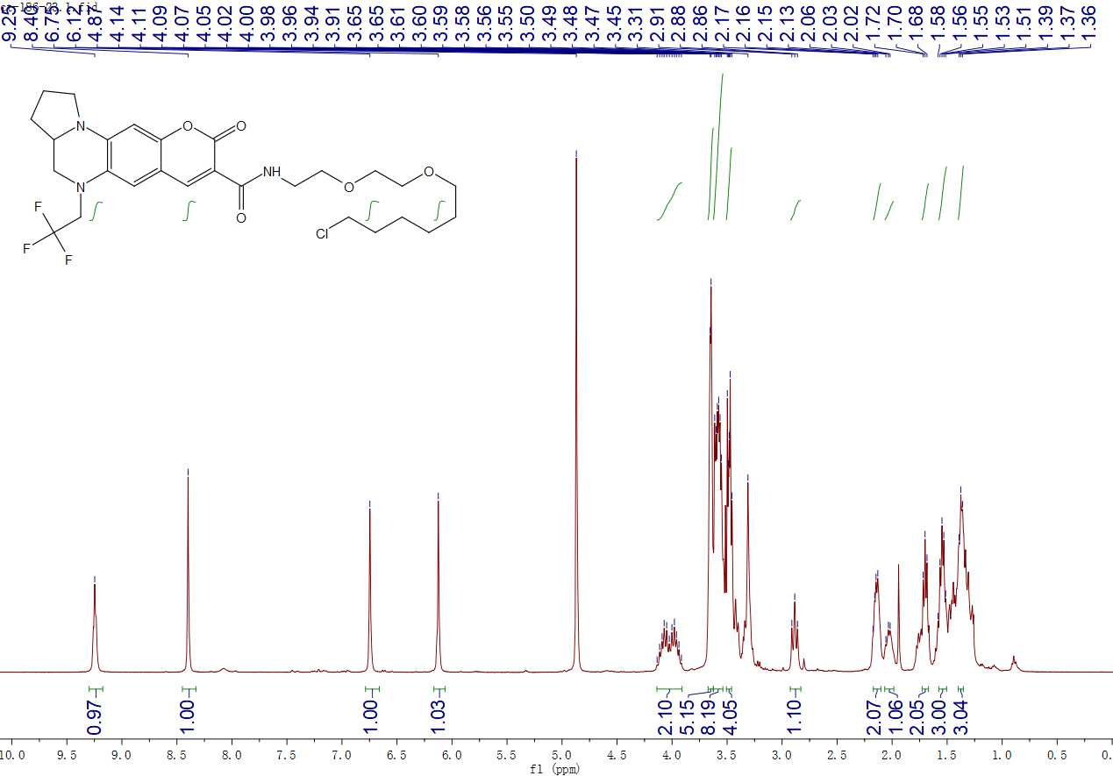
¹H NMR spectrum of BDQF-16-Halo in CD₃OD

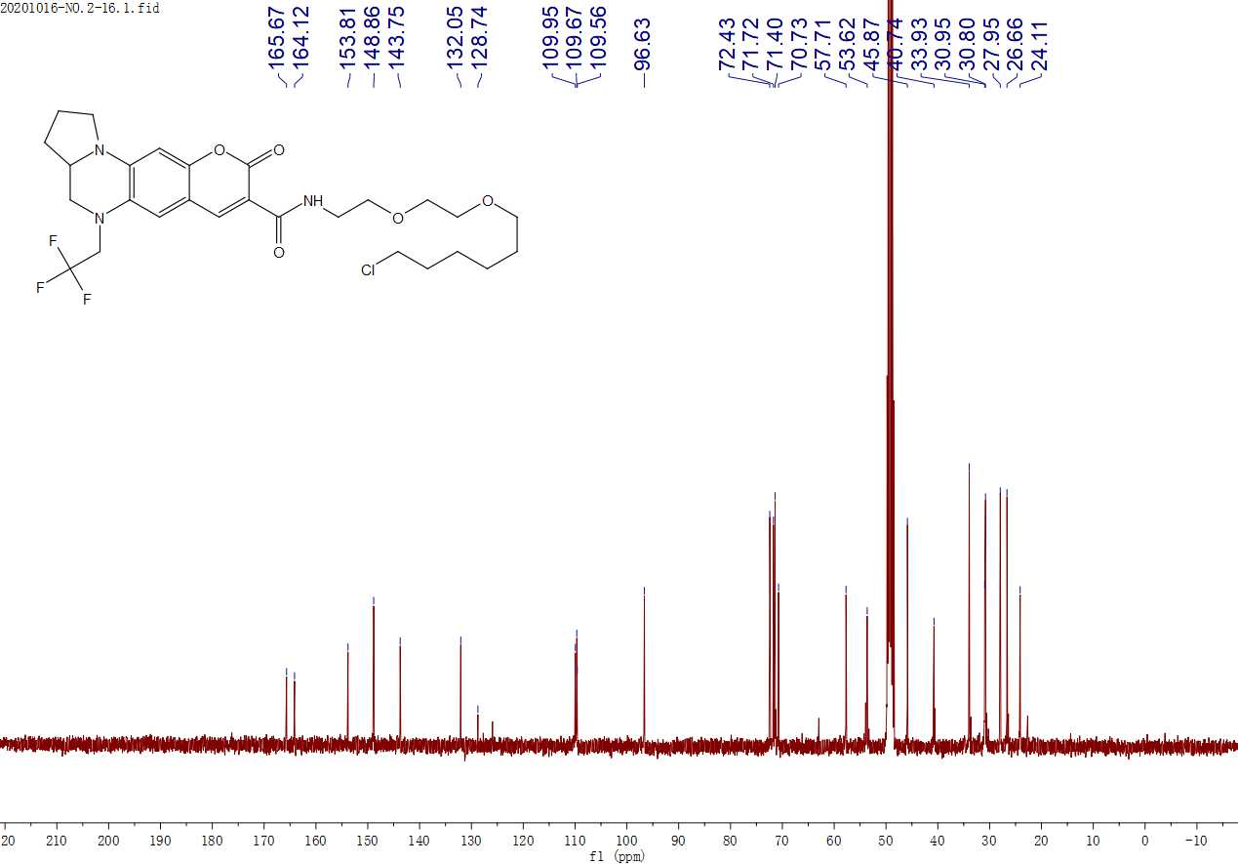
¹³C NMR spectrum of BDQF-16-Halo in CD₃OD

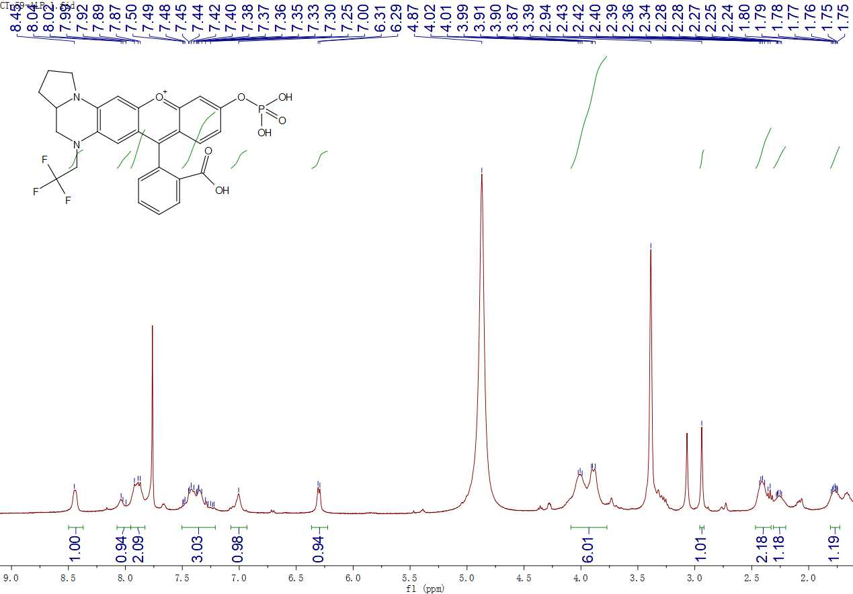
¹H NMR spectrum of BDQF-11-ALP in CD₃OD containing 20 % CDCl₃

References

1. Zheng Q., Lavis L. D. Development of photostable fluorophores for molecular imaging. Curr. Opin. Chem. Biol. 39, 32-38 (2017).
2. Grimm J. B., et al. A general method to improve fluorophores for live-cell and single-molecule microscopy. Nat. Methods 12, 244-250 (2015).
3. Butkevich A. N., Bossi M. L., Lukinavicius G., Hell S. W. Triarylmethane fluorophores resistant to oxidative photobluing. J. Am. Chem. Soc. 141, 981-989 (2019).
4. Hansch C., Leo A., Raft R. W. A survey of hammett substituent constants and resonance and field parameters. Chem. Rev. 91, 165-195 (1991).
5. Chen W., Xu S., Day J. J., Wang D., Xian M. A general strategy for development of near-infrared fluorescent probes for bioimaging. Angew. Chem. Int. Ed. 56, 16611-16615 (2017).
6. Rurack K., Spieles M. Fluorescence quantum yields of a series of red and near-infrared dyes emitting at 600-1000 nm. Anal. Chem. 83, 1232-1242 (2011).
7. Kubin R. F., Fletcher A. N. Fluorescence quantum yields of some rhodamine dyes. J. Lumin. 27, 455-462 (1982).
8. Liu X., et al. Methylated chromenoquinoline dyes: synthesis, optical properties, and application for mitochondrial labeling. Chem. Commun. 54, 1509-1512 (2018).
9. Zhou W., Fang X., Qiao Q., Jiang W., Zhang Y., Xu Z. Quantitative assessment of rhodamine spectra. Chinese Chem. Lett. 32, 943-946 (2021).
10. Zhang X., Zhang J., Lu X. The fluorescence properties of three rhodamine dye analogues: acridine red, pyronin Y and pyronin B. J. Fluoresc. 25, 1151-1158 (2015).
11. Peng T., Yang D. Construction of a library of rhodol fluorophores for developing new fluorescent probes. Org. Lett. 12, 496-499 (2010).
12. Frisch M. J., et al. Gaussian 09, Revision A.1; Gaussian, Inc.: Wallingford, CT. (2009).
13. Yanai T., Tew D. P., Handy N. C. A new hybrid exchange-correlation functional using the coulomb-attenuating method (CAM-B3LYP). Chem. Phys. Lett. 393, 51-57 (2004).
14. Critchfield F. E., Gibson J. A., Hell J. L. Dielectric constant for the dioxane water system from 20 to 35°. J. Am. Chem. Soc. 75, 1991-1992 (1953).

