Enhanced sampling and ligandability assessment to expand the repertoire of potentially druggable cryptic pockets

Authors: Neha Vithani^{1#}, She Zhang¹, Judith Günther², Hans Purkey³, J. David Lawson⁴, Anthony Nicholls¹, A. Geoffrey Skillman¹, David N. LeBard^{1#}
¹ OpenEye, Cadence Molecular Sciences, Santa Fe, New Mexico 87508, United States
² Bayer AG, Drug Discovery Sciences, Berlin 13353, Germany
³ Genentech, Inc., South San Francisco, CA 94080, United States
⁴ Khartis Therapeutics, Inc., San Diego, California 92121, United States

# corresponding authors: vithanin@cadence.com, david.lebard@eyesopen.com

Figure S1
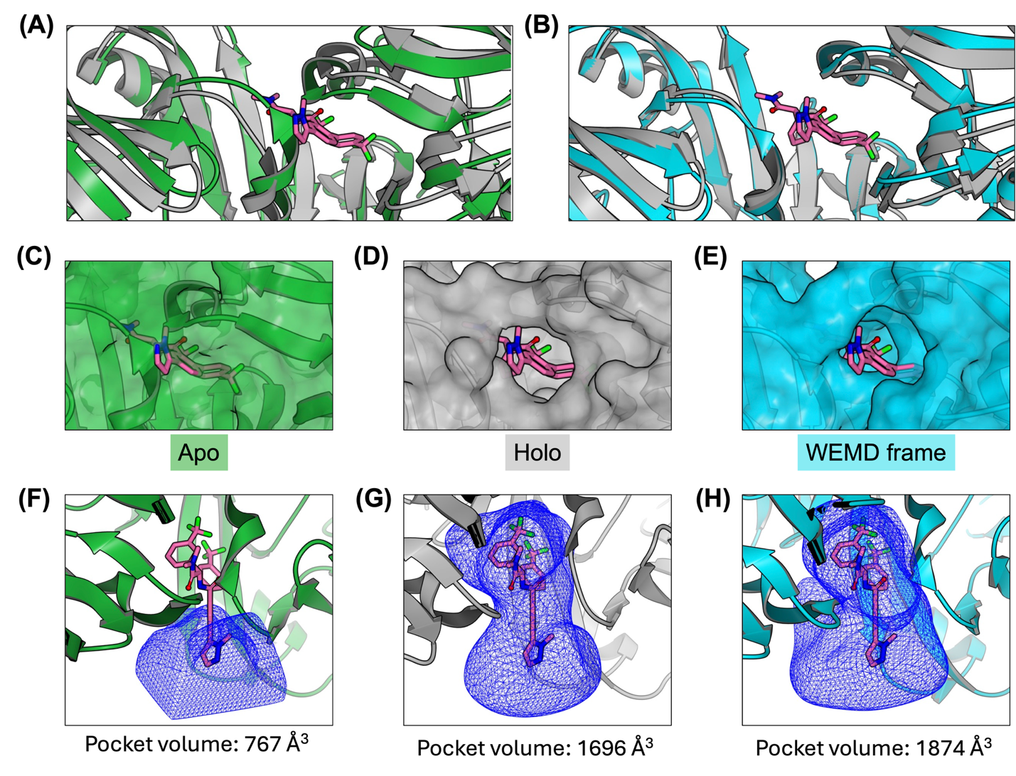

Figure S1. Allosteric cryptic pocket formation in NKG2D. (A) Superposition of the apo (green) and holo (gray) structures of NKG2D is shown along with bound ligand shown in sticks representation with the carbon atoms colored pink. (B) Superposition of a holo-like conformation sampled by WEMD (sky-blue) and the holo (gray) structure of NKG2D. (C) Surface represent of the apo structure aligned with the holo structure shows the closed pocket. Bound ligand from the holo structure is shown as a reference. (C) Holo structure with pocket open state and the bound ligand. (D) Open pocket conformation sampled by WEMD aligned to the holo structure is shown along with the bound ligand from the holo structure as a reference. Pocket receptors (blue mesh) and corresponding pocket volumes are shown for the (F) apo structure, (G) holo structure, and (H) holo-like pocket conformation sampled by WEMD.

