Supplementary Figures S1-9
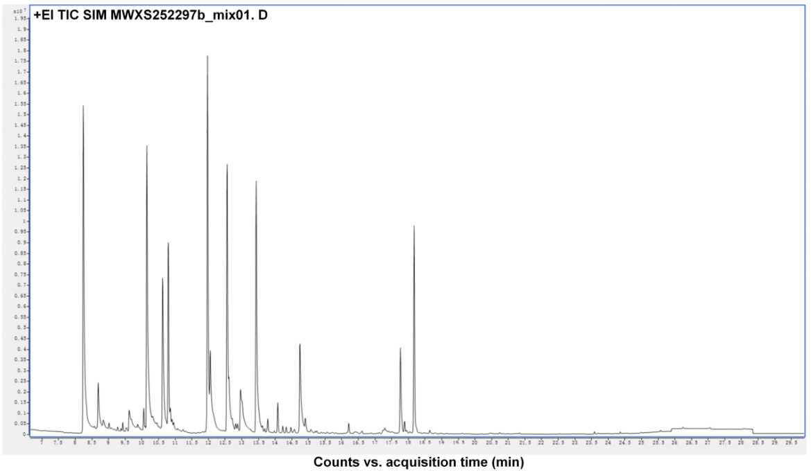
Fig. S1. Total ion chromatogram of the quality control sample. The x-axis represents the retention time (Rt) of metabolite detection, and the y-axis indicates the ion current intensity (in counts per second, cps).
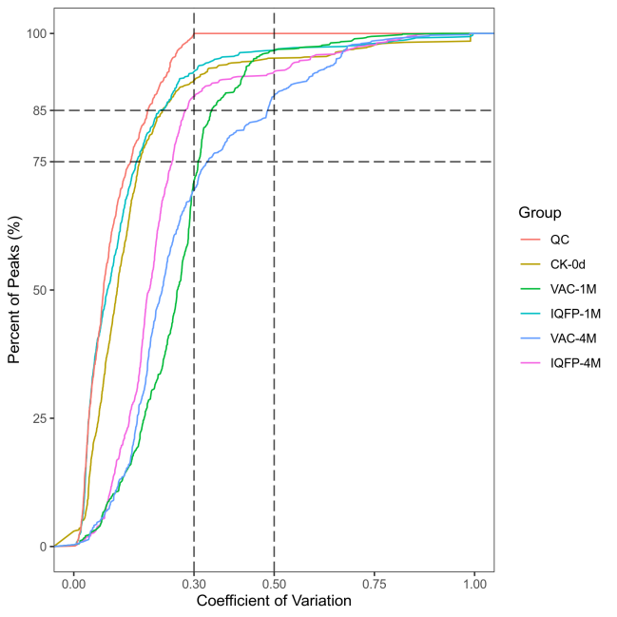
Fig. S2. Distribution of coefficient of variation (CV) values across all samples. The cumulative proportion of metabolites (y-axis) with a CV less than a given threshold (x-axis) is plotted separately for each sample group (including the quality control group), distinguished by color.
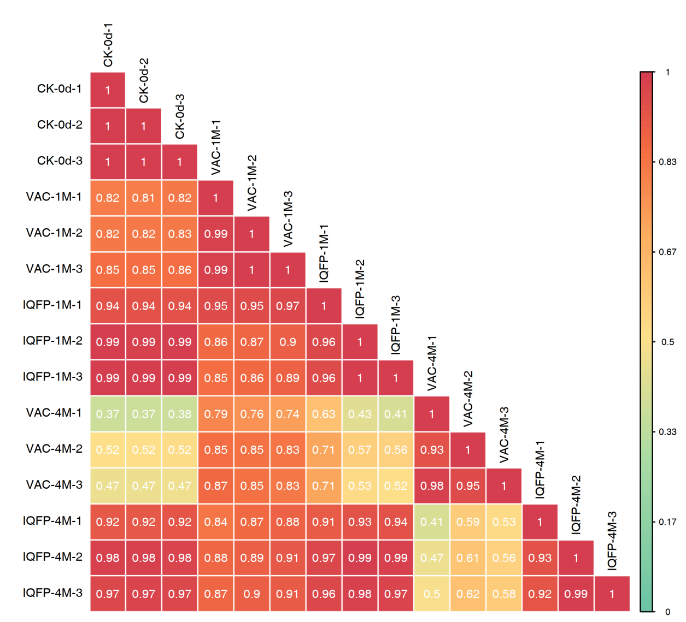
Fig. S3. Sample-sample correlation heatmap. The color intensity in each cell represents the Pearson correlation coefficient between the corresponding samples labeled on the vertical and horizontal axes, with red indicating strong positive correlation and green indicating weak correlation.
Fig. S4. Circular composition plot of metabolite categories. Each color represents a distinct metabolite class, with the area of each segment corresponding to its relative proportion.
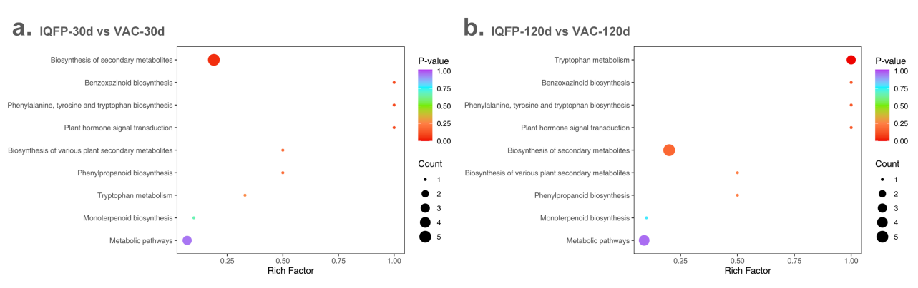
Fig. S5. Bubble plot of KEGG enrichment analysis in volatile organic compounds head space: IQFP-30d vs VAC-30d (a), and IQFP-120d vs VAC-120d (b).
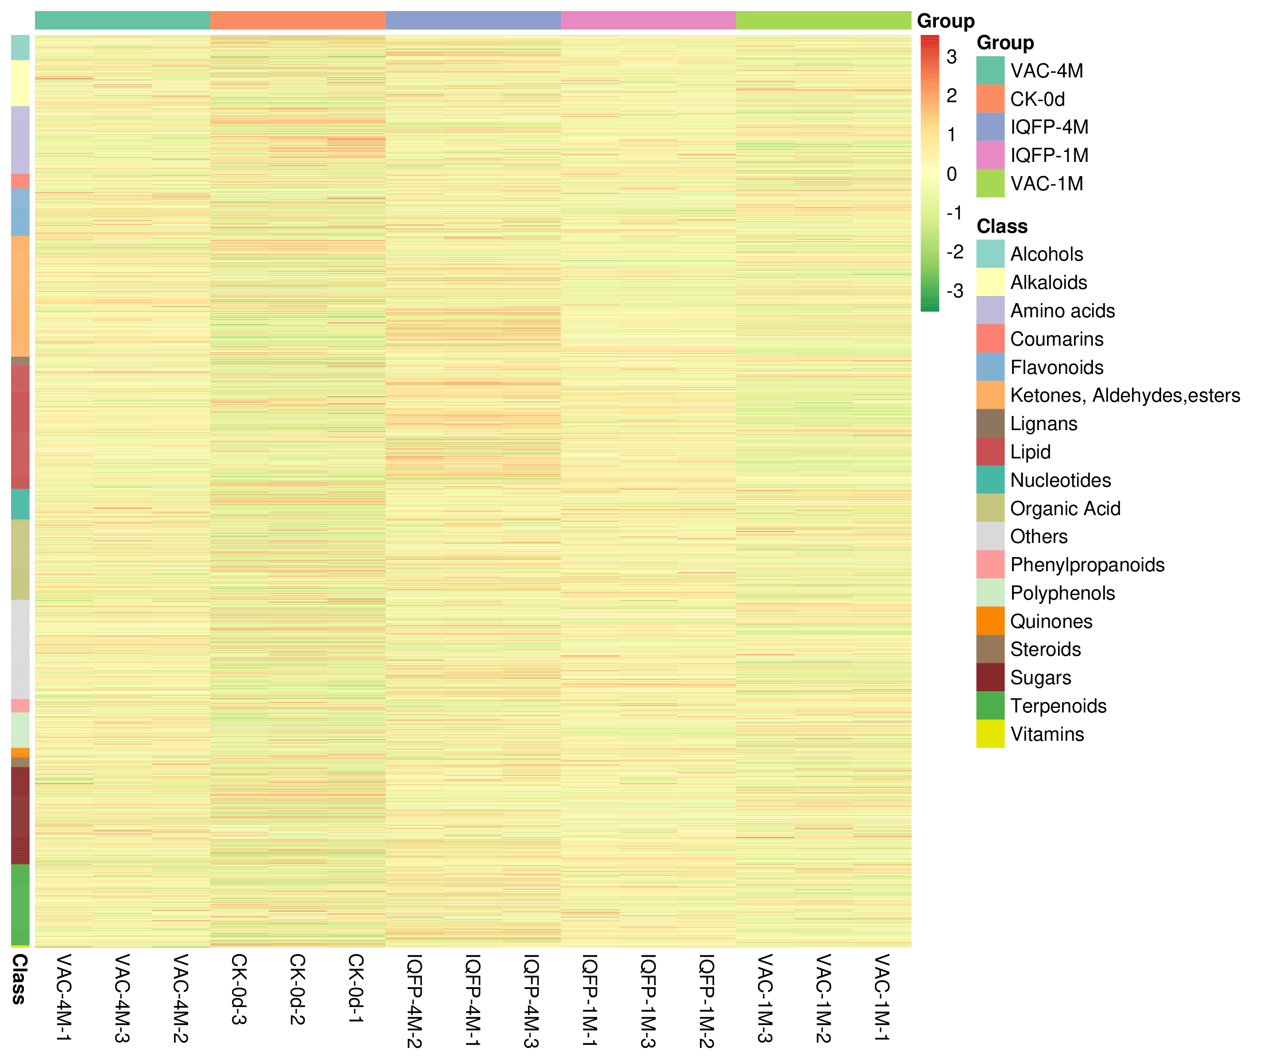
Fig. S6. Cluster heatmap analysis of all samples. Horizontal axis: sample information; vertical axis: metabolite information. The "Group" represents the sample grouping, and different colors indicate normalized relative content values (red represents high content; green represents low content).
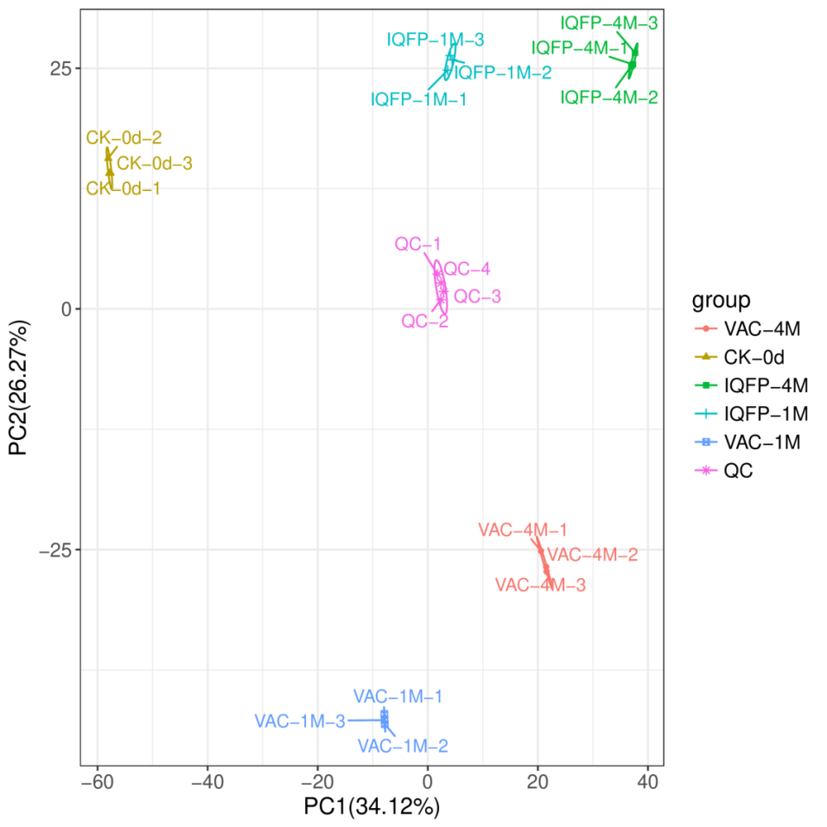
Fig. S7. Principal component analysis of metabolomics data. Each point in the figure represents one sample; samples from the same group are shown in the same color, and samples from different groups are distinguished by distinct colors. The ellipses represent the 95% confidence interval for each group.
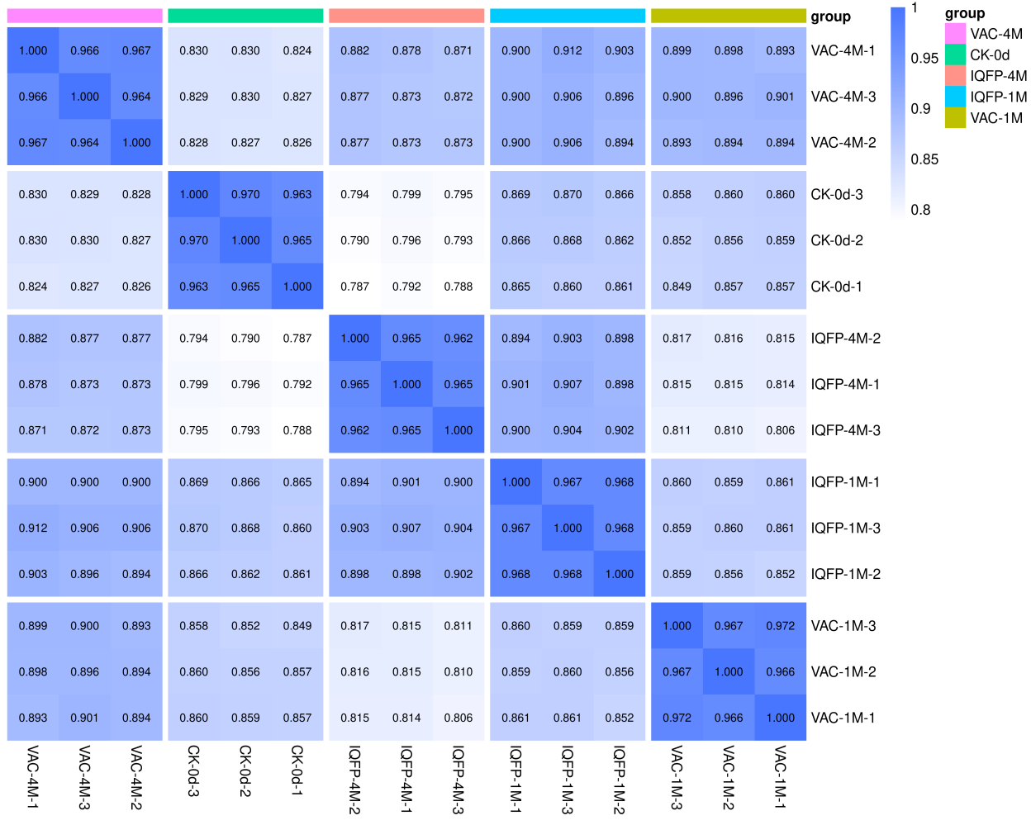
Fig. S8 Inter-sample correlation analysis. Correlation coefficients (r) between samples are shown in the heatmap, with color intensity indicating the strength of correlation. Sample grouping is indicated.

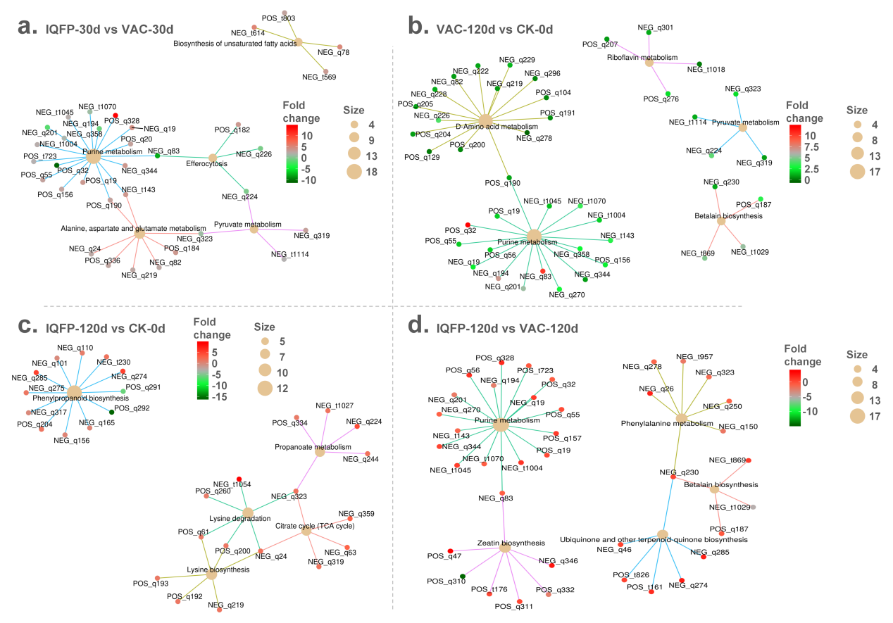
Fig. S9. Network plots of KEGG enrichment analysis in metabolomics: IQFP-30d vs VAC-30d (a),VAC-120d vs CK-0d (b), IQFP-120d vs CK-0d (c), and IQFP-120d vs VAC-120d (d).

