Supplementary information to:
The under-ice habitat constitutes a critical survival hub for zooplankton in the Central Arctic Ocean
A Cornils, H Flores, KJ Wermeyer, P Anhaus, CJ Ashjian, RG Campbell, G Castellani, C Gelfman, N Hildebrandt, CJM Hoppe, C Katlein, N Knüppel, S Sakinan, FL Schaafsma, K Schmidt, KM Shoemaker, M Vortkamp, MOSAiC TEAMs ECO, ICE & OCEAN, B Niehoff

Suppl. Table 1: Horizontal Under-ice net sampling stations during MOSAiC from November 2019 to May 2020 at the under-ice surface and at 10 m depth.; stations marked with asterisks (*) were only sampled at 10 m depth; from 2 samples (**) at the IWI subsamples of 10% were taken for molecular purposes; ***Number of organisms removed for stable isotope/fatty acid analysis.
Cruise leg | Station | Date | Time (local) | Position |  | Organisms removed***
 |  |  |  | Longitude | Latitude | IWI | 10 m
1 | 06-118* | 10.11.2019 | 09:07 | 116.077 | 85.822 |  | 142
1 | 10-113 | 06.12.2019 | 18:13 | 122.301 | 86.142 | 1
1 | 10-113 | 06.12.2019 | 23:24 | 122.301 | 86.142
1 | 10-113 | 07.12.2019 | 05:35 | 122.301 | 86.142
1 | 10-113 | 07.12.2019 | 11:41 | 122.301 | 86.142 |  | 1
2 | 18-089 | 04.01.2020 | 12:31 | 115.393 | 87.007 | 2 | 31
2 | 19-115* | 11.01.2020 | 08:20 | 111.325 | 87.214 |  | 157
2 | 20-101 | 18.01.2020 | 07:57 | 98.298 | 87.413 | 76 | 140
2 | 21-125** | 25.01.2020 | 18:13 | 92.830 | 87.405 | 1 | 71
2 | 22-107 | 02.02.2020 | 08:22 | 95.280 | 87.345
2 | 23-116 | 08.02.2020 | 07:37 | 93.862 | 87.669 |  | 107
2 | 25-104 | 22.02.2020 | 07:44 | 64.891 | 88.573 |  | 176
3 | 30-069 | 07.03.2020 | 10:09 | 27.204 | 88.076 | 4
3 | 32-078** | 22.03.2020 | 08:29 | 15.682 | 86.230 | 193 | 1
3 | 33-083* | 28.03.2020 | 09:14 | 13.340 | 85.626
3 | 35-032 | 07.04.2020 | 08:46 | 14.534 | 84.502 | 5
3 | 35-095 | 11.04.2020 | 07:57 | 14.749 | 84.332 | 3 | 4
3 | 36-112 | 18.04.2020 | 08:36 | 13.819 | 84.454 | 1
3 | 37-108 | 25.04.2020 | 08:53 | 15.646 | 84.018 | 15
3 | 38-091 | 02.05.2020 | 08:15 | 17.562 | 83.910 | 35 | 9
3 | 39-077 | 09.05.2020 | 08:23 | 14.128 | 83.791 | 5
5 | 59-369* | 29.08.2020 | 09:30 | 109.271 | 88.094 | 134
5 | 60-167 | 05.09.2020 | 07:16 | 119.459 | 88.750 | 160 | 51
5 | 61-200 | 12.09.2020 | 08:59 | 101.628 | 88.771 | 43 | 247

Suppl. Table 2: Number of taxa found in the ROV net samples during the MOSAiC drift expedition from November 2019 to September 2020. Taxa with single occurrences are marked with asterisks (^{x}).
Phylum | Class | Order | Family | Genus | Species | Taxon
Annelida | Polychaeta |  |  |  |  | Polychaeta
 |  | Phyllodocida | Typhloscolecidae |  |  | Typhloscolecidae
Arthropoda | Copepoda | Calanoida | Aetideidae |  |  | Aetideidae, CI-CV
 |  |  |  | Chiridius | C. obtusifrons | Chiridius obtusifrons, female
 |  |  |  | Gaetanus | G. tenuispinus | Gaetanus tenuispinus, female
 |  |  |  | Jaschnovia | Jaschnovia sp. | Jaschnovia sp., female
 |  |  | Calanidae | Calanus | C. finmarchicus | Calanus finmarchicus
 |  |  |  |  | C. glacialis | Calanus glacialis
 |  |  |  |  | C. hyperboreus | Calanus hyperboreus
 |  |  | Clausocalanidae | Microcalanus |  | Microcalanus spp.
 |  |  |  | Pseudocalanus |  | Pseudocalanus spp.
 |  |  | Euchaetidae | Paraeuchaeta |  | Paraeuchaeta spp.
 |  |  | Heterorhabdidae |  |  | Heterorhabdidae  (Heterorhabdus norvegicus)
 |  |  | Lucicutiidae | Lucicutia |  | Lucicutia spp.
 |  |  | Metridinidae | Metridia | M. longa | Metridia longa
 |  |  | Scolecitrichidae | Scaphocalanus | S. magnus | Scaphocalanus magnus
 |  |  |  | Scaphocalanus | Scaphocalanus sp. | Scaphocalanus sp.
 |  |  |  | Scolecithricella | S. minor | Scolecithricella minor
 |  |  | Spinocalanidae | Spinocalanus |  | Spinocalanus spp.
 |  | Cyclopoida | Oithonidae | Oithona |  | Oithona spp.
 |  |  | Oncaeidae |  |  | Oncaeidae
 |  |  | Cyclopinidae | Cyclopina |  | Cyclopina spp.
 |  | Harpacticoida |  |  |  | Harpacticoida
 |  |  | Ectinosomatidae |  |  | Ectinosomatidae
 | Malacostraca | Amphipoda | Calliopiidae | Apherusa | A. glacialis | Apherusa glacialis
 |  |  | Hyperiidae | Themisto | T. abyssorum | Themisto abyssorum
 |  |  |  |  | T. libellula | Themisto libellula
 |  |  | Uristidae | Onisimus | Onisimus sp. | Onisimus sp.^{x}
 |  |  |  | Eusirus | E. holmi | Eusirus holmi
 |  | Euphausiacea | Euphausiidae |  |  | Euphausiacea  (Thysanoessa longicaudata)
 |  | Isopoda |  |  |  | Isopoda
 | Ostracoda | Halocyprida | Halocyprididae |  |  | Ostracoda
Chaetognatha | Sagittoidea | Aphragmophora | Sagittidae | Parasagitta | P. elegans | Parasagitta elegans
 |  | Phragmophora | Eukrohniidae | Eukrohnia | E. hamata | Eukrohnia hamata
Chordata | Actinopteri |  |  | Boreogadus | B. saida | Boreogadus saida ^{x}
 | Appendicularia | Copelata | Fritillariidae |  |  | Fritillariidae
 |  |  | Oikopleuridae |  |  | Oikopleuridae
Cnidaria | Hydrozoa |  |  |  |  | Cnidaria (Botrynema spp.,  Sminthea arctica)
 |  | Anthoathecata |  | Corymorpha | Corymorpha sp. | Corymorpha sp.
 |  | Siphonophorae |  |  |  | Siphonophorae
Ctenophora |  |  |  |  |  | Ctenophora (Beroe cucumis, Mertensia ovum)
Mollusca | Gastropoda |  |  |  |  | Gastropoda
Rhizaria | Foraminifera |  |  |  |  | Foraminifera

Suppl. Table 3: Conversion factors from wet mass (WM) to dry mass (DM) and carbon content (C) derived from Kjørboe (2013), ªKosobokova and Hirche (2000), ^{b}Cornils et al. (2022) and ^{c}Postel et al. (2000), respiration factors (RF_{t}) from Ikeda (2014 – global).
Phylum | Taxon | Original taxon | WM - DM | DM - C | RF_{t}
Annelida | Polychaeta | Tomopteris spp. | 0.134 | 0.370 | 0.382
Arthropoda | Copepoda | “Arctic Copepoda” | 0.162ª | 0.480 | 0
 |  | C. hyperboreus | 0.08^{b} | 0.480 | 0
 | Amphipoda |  | 0.239 | 0.345 | 0.416
 | Parathemisto | P. libellula | 0.224 | 0.382 | 0.416
 | Euphausiacea |  | 0.228 | 0.419 | 0.697
 | Ostracoda |  | 0.182 | 0.435 | -0.395
 | Crustacea |  | 0.182 | 0.435 | 0.416
Chaetognatha | Chaetognatha | Eukrohnia hamata | 0.093 | 0.350 | -0.448
Chordata | Appendicularia | Tunicata | 0.054 | 0.103 | 1.604
Cnidaria | Cnidaria |  | 0.041 | 0.132 | -0.480
Ctenophora | Ctenophora |  | 0.04 | 0.051 | -1.257
Mollusca | Mollusca | Limacina helicina | 0.230 | 0.289 | 0
 | Other zooplankton |  | 0.2^{c} | WM - C  0.12 | 0

Suppl. Table 4: Results of the PERMANOVA based on Bray-Curtis similarities on log-transformed abundances of the under-ice zooplankton community; used model: Region + Regime + depth stratum. The permutation test (999 permutations) was conducted using adonis2() in the vegan R package (Oksanen et al. 2024); significances: *** p < 0.001, ** p < 0.01, * p < 0.05.
Factor | Degrees of Freedom | Sum of Squares | F | R² | p-value | Significance
Region | 2 | 1.1590 | 13.22 | 0.277 | 0.001 | ***
Regime | 2 | 1.1071 | 12.63 | 0.264 | 0.001 | ***
Depth | 1 | 0.2597 | 5.93 | 0.062 | 0.002 | **
Residual | 38 | 1.6654 | — | 0.397 | — | —
Total | 43 | 4.1912 | — | 1.000 | — | —

A PERMANOVA indicated that season had similar and significant effects on community composition (Region: F = 13.22, R² = 0.28, p = 0.001, Regime: F = 12.62, R² = 0.26, p = 0.001, Depth: F = 5.93, R² = 0.06, p = 0.002), together explaining about 60% of the total variation (Suppl. Table 4). Only main effects were tested due to unbalanced replication across all combinations of the three factors. Tests for homogeneity of multivariate dispersion indicated a higher within-group dispersion in the Amundsen Basin (average distance to centroid = 028) compared to the Gakkel Ridge (0.19) and the Nansen Basin (0.13), reflecting broader seasonal coveraged in the Amundsen Sea, whereas dispersion was similar across regimes (AUT: 0.22, WIN:0.22, SPR: 0.20) and depth strata (IWI: 0.28, 10 m: 0.29; Suppl. Table 5).

Suppl. Table 5: Dispersion homogeneity; tested with betadisper() and permutest() from the vegan R package (Oksanen et al. 2024); using Bray–Curtis dissimilarities (999 permutations).
Factor | Groups (average distance to centroid) | Average distance to median | p-value (permutest)
Region | AB: 0.284,  GK: 0.188,  NB: 0.132 | 0.002 | Slight heterogeneity among regions
Regime | AUT: 0.221,  SPR: 0.200,  WIN: 0.225 | 0.676 | Homogeneous dispersion
Depth | 0 m: 0.282,  10 m: 0.295 | — | Homogeneous dispersion

Suppl. Table 6: NBSS slopes for individual sampling dates (see Suppl. Table 1).
Station | Regime | Region | Depth layer | Slope | Intercept | R² | Bins
06-118 | WIN | AB | 10 m | -0.740 | 1.370 | 0.698 | 14
10-113 | WIN | AB | 10 m | -0.526 | 2.683 | 0.539 | 16
10-113 | WIN | AB | IWI | -0.705 | -0.074 | 0.815 | 13
10-113 | WIN | AB | IWI | -0.758 | 0.984 | 0.814 | 11
10-113 | WIN | AB | 10 m | -0.214 | 5.328 | 0.147 | 13
10-113 | WIN | AB | IWI | -0.451 | 4.001 | 0.561 | 11
10-113 | WIN | AB | 10 m | -0.284 | 5.084 | 0.233 | 15
10-113 | WIN | AB | IWI | -0.567 | 2.132 | 0.594 | 13
10-113 | WIN | AB | 10 m | -0.538 | 3.511 | 0.517 | 16
18-089 | WIN | AB | 10 m | -0.333 | 4.605 | 0.257 | 14
19-115 | WIN | AB | IWI | -0.690 | 1.281 | 0.680 | 14
19-115 | WIN | AB | 10 m | -0.530 | 3.493 | 0.396 | 14
20-101 | WIN | AB | 10 m | -0.478 | 2.717 | 0.307 | 14
20-101 | WIN | AB | IWI | -0.570 | 2.240 | 0.608 | 13
21-125 | WIN | AB | IWI | -0.688 | 0.673 | 0.751 | 13
21-125 | WIN | AB | 10 m | -0.525 | 2.044 | 0.593 | 14
22-107 | WIN | AB | 10 m | -0.601 | 2.718 | 0.533 | 16
22-107 | WIN | AB | IWI | -0.439 | 3.813 | 0.484 | 12
23-116 | WIN | AB | IWI | -0.652 | 1.482 | 0.816 | 14
23-116 | WIN | AB | 10 m | -0.237 | 4.616 | 0.134 | 13
25-104 | WIN | AB | IWI | -0.321 | 3.371 | 0.429 | 14
25-104 | WIN | AB | 10 m | -0.477 | 3.724 | 0.523 | 16
30-069 | SPR | AB | 10 m | -0.723 | -0.583 | 0.844 | 13
30-069 | SPR | AB | IWI | -0.688 | -1.062 | 0.848 | 14
32-078 | SPR | GR | 10 m | -0.810 | -2.711 | 0.725 | 12
32-078 | SPR | GR | IWI | -0.407 | 1.518 | 0.360 | 13
33-083 | SPR | GR | 10 m | -0.608 | -0.311 | 0.804 | 11
35-032 | SPR | GR | IWI | -0.775 | -1.648 | 0.739 | 14
35-032 | SPR | GR | 10 m | -0.733 | -1.742 | 0.652 | 12
35-095 | SPR | NB | 10 m | -0.801 | -1.331 | 0.617 | 13
35-095 | SPR | NB | IWI | -0.939 | -0.581 | 0.843 | 12
36-112 | SPR | NB | 10 m | -1.184 | -3.178 | 0.840 | 11
36-112 | SPR | NB | IWI | -1.087 | -3.652 | 0.772 | 10
37-108 | SPR | NB | 10 m | -1.301 | -5.620 | 0.737 | 12
37-108 | SPR | NB | IWI | -1.007 | -2.748 | 0.820 | 14
38-091 | SPR | NB | 10 m | -1.029 | -3.989 | 0.534 | 11
38-091 | SPR | NB | IWI | -0.843 | -1.359 | 0.658 | 13
39-077 | SPR | NB | 10 m | -0.934 | -1.645 | 0.572 | 12
39-077 | SPR | NB | IWI | -1.091 | -3.713 | 0.737 | 11
59-369 | AUT | AB | 10 m | -0.817 | 3.983 | 0.851 | 14
61-200 | AUT | AB | 10 m | -0.623 | 3.160 | 0.596 | 15
60-167 | AUT | AB | IWI | -1.015 | -1.755 | 0.765 | 14
60-167 | AUT | AB | 10 m | -0.797 | 1.666 | 0.718 | 13
61-200 | AUT | AB | IWI | -0.572 | 0.411 | 0.363 | 14

Suppl. Figure 1: Cluster analysis and Elbow plot based on the (A) under-ice zooplankton communities and (B) environmental variables of the sampling dates during the MOSAiC drift expedtion 2019/2020.

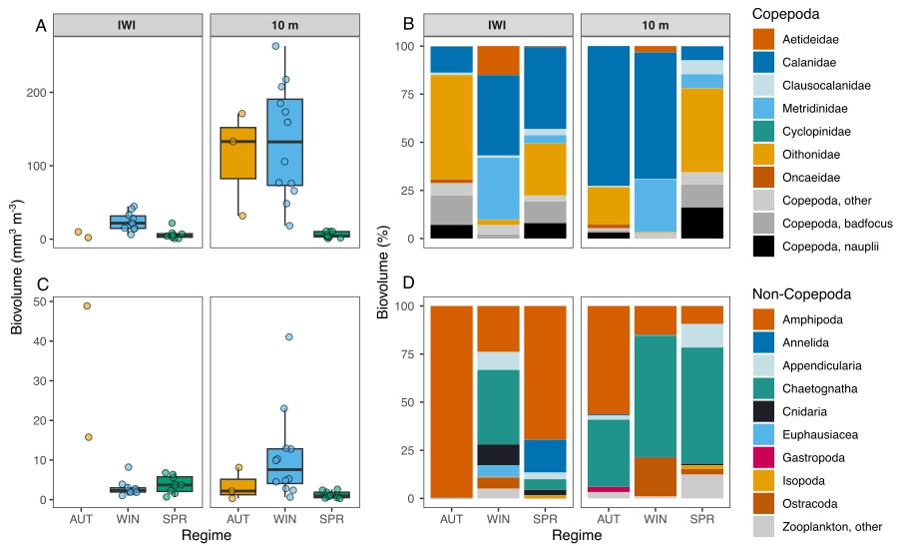
Suppl. Figure 2: The biovolume (mm³ m⁻³; top) of the under-ice fauna at the Ice-Water-Interface (IWI) and at 10 m depth (10 m) during the MOSAiC drift for (A) Copepoda and (C) other zooplankton coloured by regime (summer/autumn, winter, spring), and the relative biovolume composition of (B) copepod families (%) and of (D) non-copepod taxa (%) of the under-ice fauna during the four regimes.

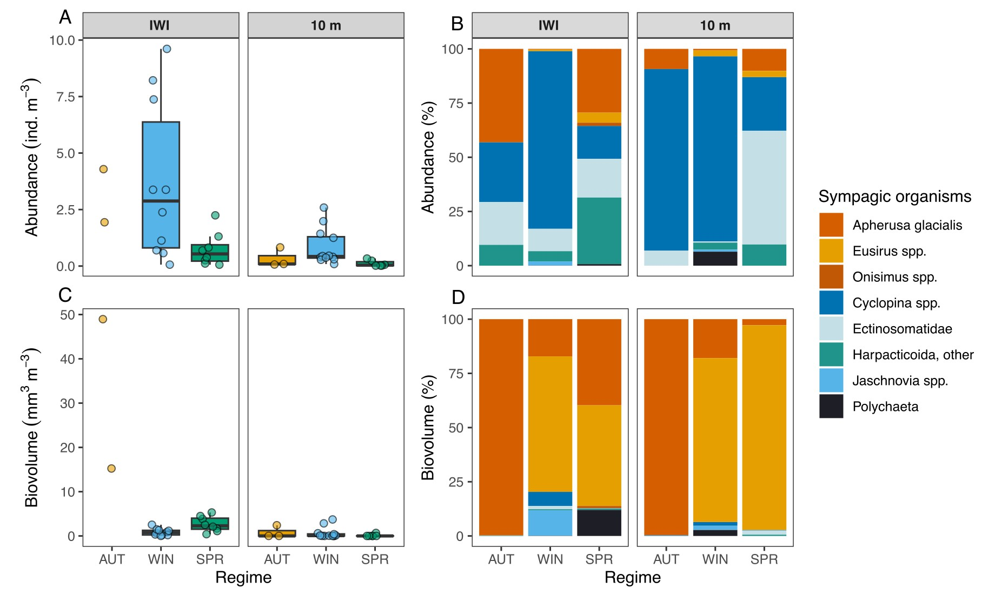
Suppl. Figure 3: Taxa that represent sympagic (ice-associated) organisms of the under-ice fauna at the Ice-Water-Interface (IWI) and at 10 m depth (10 m) during the three regimes summer/autumn (AUT), winter (WIN) and spring (SPR), displaying their (A) total (ind. m⁻³) and (B) relative abundance (%), and their (C) total (mm³ m⁻³) and (D) relative biovolume (%).

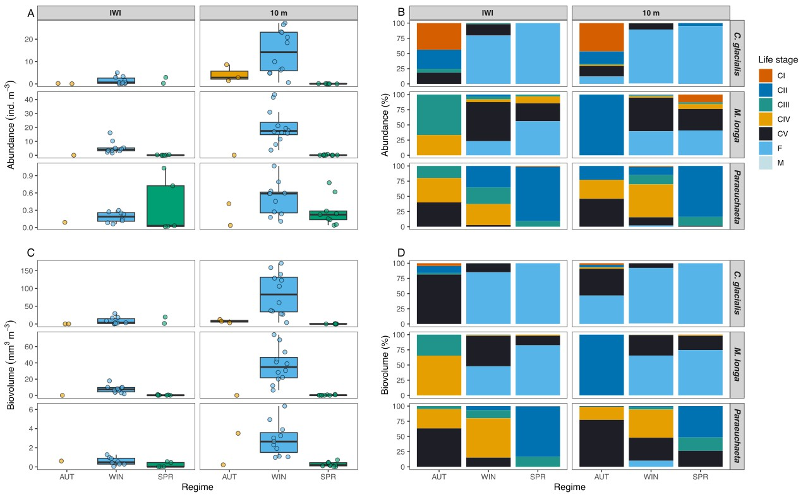
Suppl. Figure 4: Abundance and biovolume of Calanus glacialis, Metridia longa and Paraeuchaeta spp. at the Ice-Water-Interface (IWI) and at 10 m depth (10 m) during the three regimes summer/autumn (AUT), winter (WIN) and spring (SPR), displaying their (A) total (ind. m⁻³) and (B) relative abundance (%) of their life stages, and (C) total (mm³ m⁻³) and (D) relative biovolume (%) of their life stages. C1 – C5: copepodite stage CI – CV, F: female, M: male.

Suppl Figure 5: Normalized abundances (% of max. abundance per taxon) of all taxa
Cited References
Cornils, A. et al. Testing the usefulness of optical data for zooplankton long-term monitoring: Taxonomic composition, abundance, biomass, and size spectra from ZooScan image analysis. Limnol. Oceanogr. 20, 428–450 (2022).

Ikeda, T. Respiration and ammonia excretion by marine metazooplankton taxa: synthesis toward a global-bathymetric model. Mar. Biol. 161, 2753–2766 (2014).

Kiørboe, T. Zooplankton body composition. Limnol. Oceanogr. 58, 1843–1850 (2013).

Kosobokova, K. & Hirche, H.-J. Zooplankton distribution across the Lomonosov Ridge, Arctic Ocean: species inventory, biomass and vertical structure. Deep Sea Research Part I: Oceanographic Research Papers 47, 2029–2060 (2000).

Oksanen, J. et al. vegan: Community Ecology Package. CRAN: Contrib. Packag. (2025) doi:10.32614/cran.package.vegan.

Postel, L., Fock, H. & Hagen, W. Biomass and abundance. in 83–192 (2000). doi:10.13140/2.1.4985.3765.

