Supplementary Material
Five-minute sleep hypnogram patterns without chronic diseases
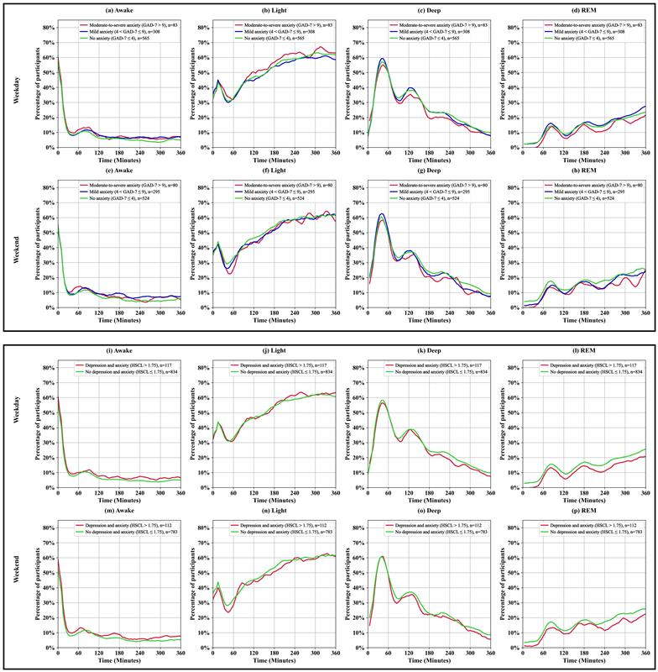
Figure S1: Percentage of participants in each sleep stage (Awake, Light, Deep, and REM) over time during detected sleep period on weekdays and weekend, stratified by anxiety and depression symptom levels. Panels (a–h) represent comparisons based on anxiety severity measured using the GAD-7 score, categorized as no anxiety, mild anxiety, and moderate-to-severe anxiety. Panels (i–p) represent comparisons based on the presence or absence of depression and anxiety symptoms measured by the HSCL-25. The top rows (a–d, i–l) show sleep stage percentages for weekdays, and the bottom rows (e–h, m–p) show percentages for weekend. The y-axis indicates the percentage of participants, and the x-axis represents time (minutes) over the sleep period. The number of participants in each group is indicated by n in the panel legends.
Five-minute nocturnal heart rate profiles without chronic diseases
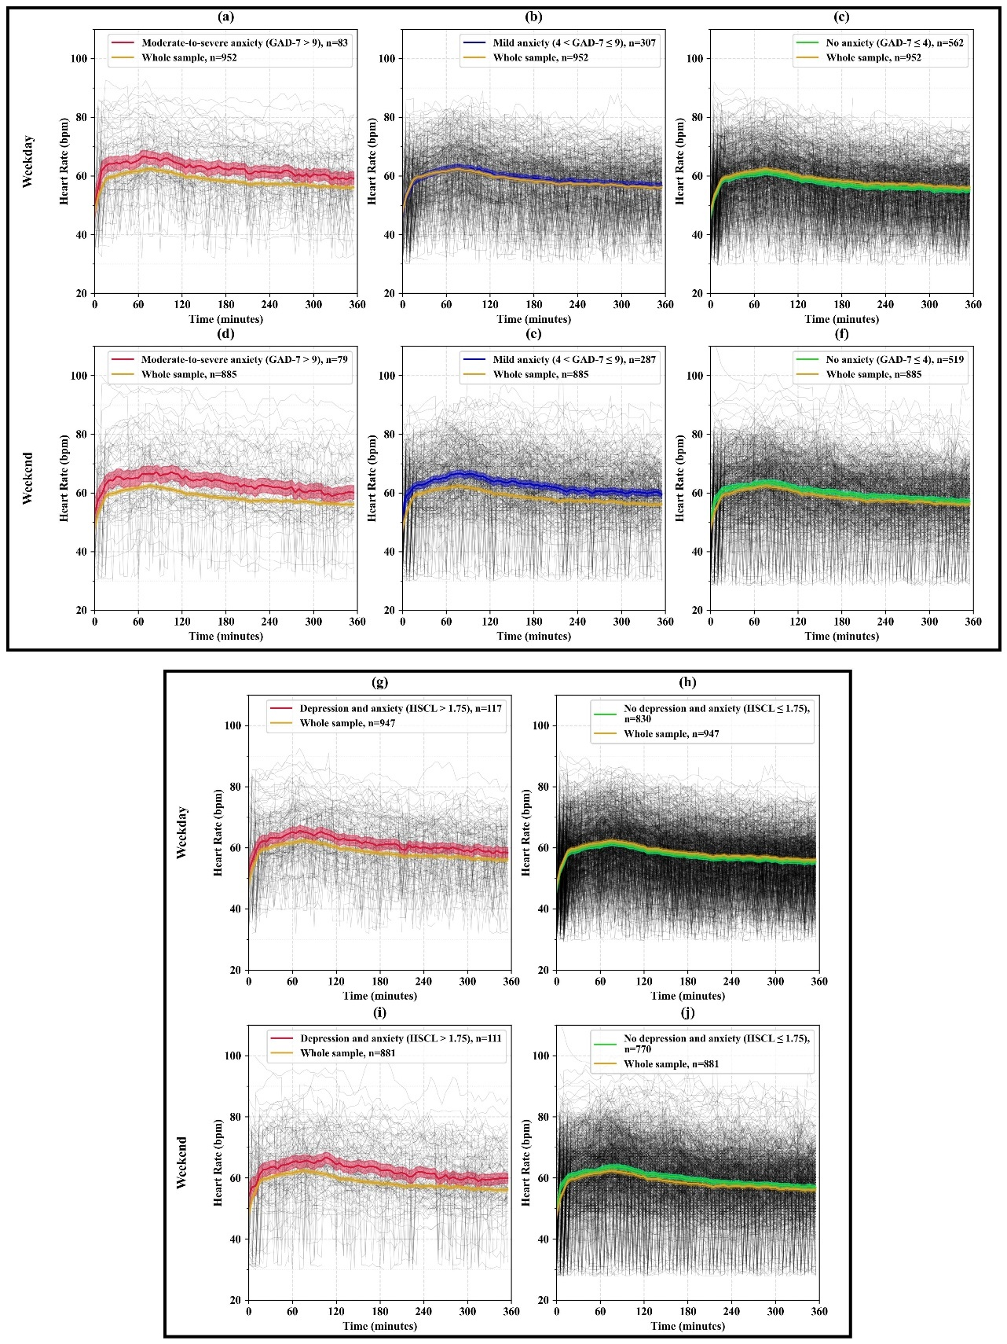
Figure S2: Mean HR (beats/minute) during detected sleep period on weekdays and weekend. Panels (a–f) show the results based on anxiety severity measured by the GAD-7 scores, categorized as no anxiety, mild anxiety, and moderate-to-severe anxiety. Panels (g–j) show the results based on the no depression and anxiety and depression and anxiety symptoms measured by the HSCL-25. The number of participants in each category is indicated by $n$ in the panel legends. The gray lines represent individual HR trajectories, while the colored lines indicate the mean HR for each group. The y-axis shows HR (bpm), and the x-axis represents time (minutes) over the sleep period.
Five-minute nocturnal RMSSD profiles without chronic diseases
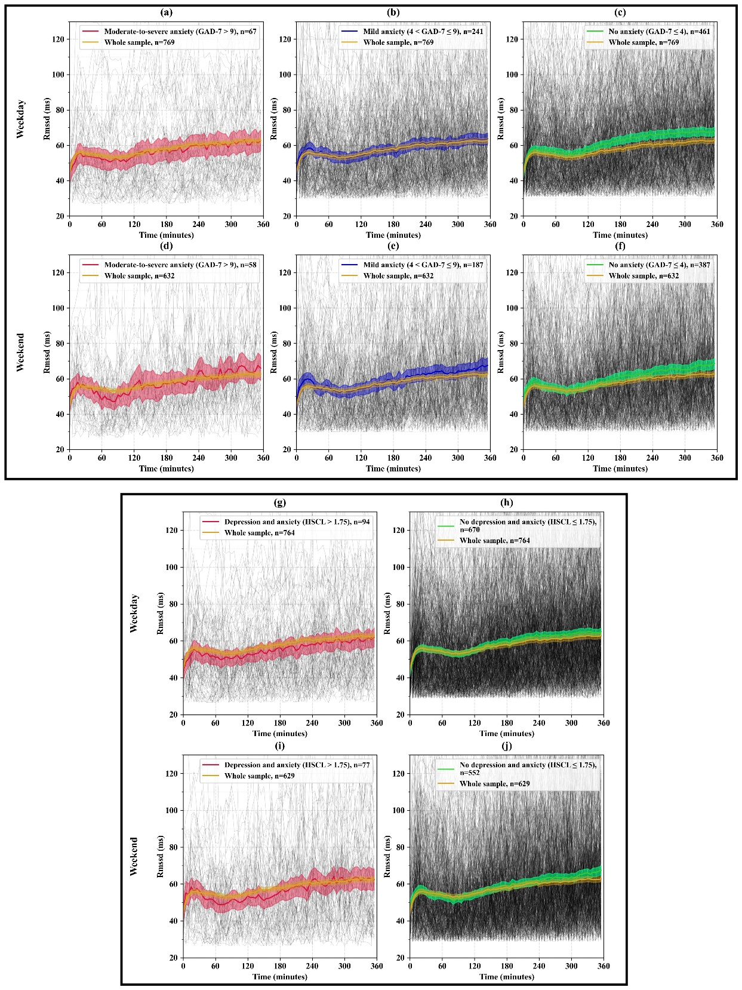
Figure S3: Mean RMSSD (milliseconds) during detected sleep period on weekdays and weekend. Panels (a–f) show the results based on anxiety severity measured by the GAD-7 scores, categorized as no anxiety, mild anxiety, and moderate-to-severe anxiety. Panels (g–j) show the results based on the no depression and anxiety and depression and anxiety symptom measured by the HSCL-25. The number of participants in each category is indicated by $n$ in the panel legends. The gray lines represent individual RMSSD trajectories, while the colored lines indicate the RMSSD for each group. The y-axis shows RMSSD (ms), and the x-axis represents time (minutes) over the sleep period.
One-Minute MET activity profiles without chronic diseases
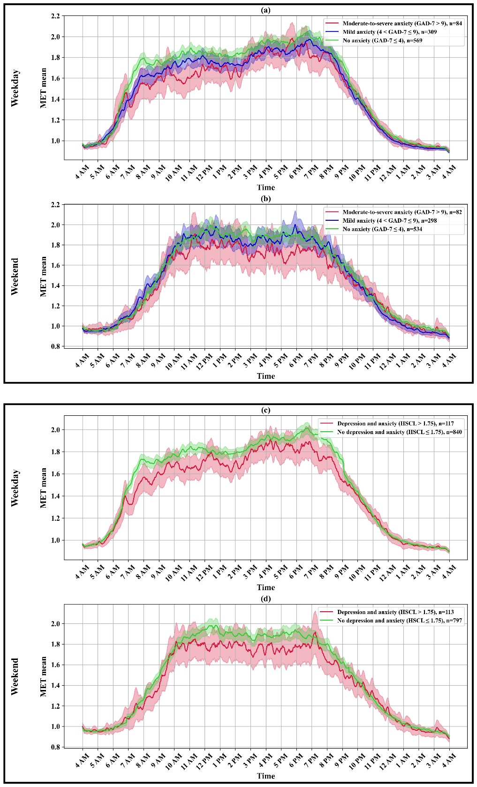
Figure S4: Mean MET values across 24 hours on weekdays and weekend. Panels (a–b) show the results based on anxiety severity measured by the GAD-7 scores, categorized as no anxiety, mild anxiety, and moderate-to-severe anxiety. Panels (c–d) show the results based on the presence or absence of depression and anxiety symptom measured by the HSCL-25. The number of participants in each category is indicated by n in the panel legends. The coloured lines represent the mean MET values for each group, and the shaded areas indicate the 95% confidence intervals. The y-axis shows the mean MET values, and the x-axis represents time of day (hours).

