Supplementary Materials for

Compartment-specific remodeling of skeletal muscle in Duchenne muscular dystrophy

Clara Martínez Mir et al.

*Corresponding author. Email: f.g.sage@lumc.nl, n.geijsen@lumc.nl

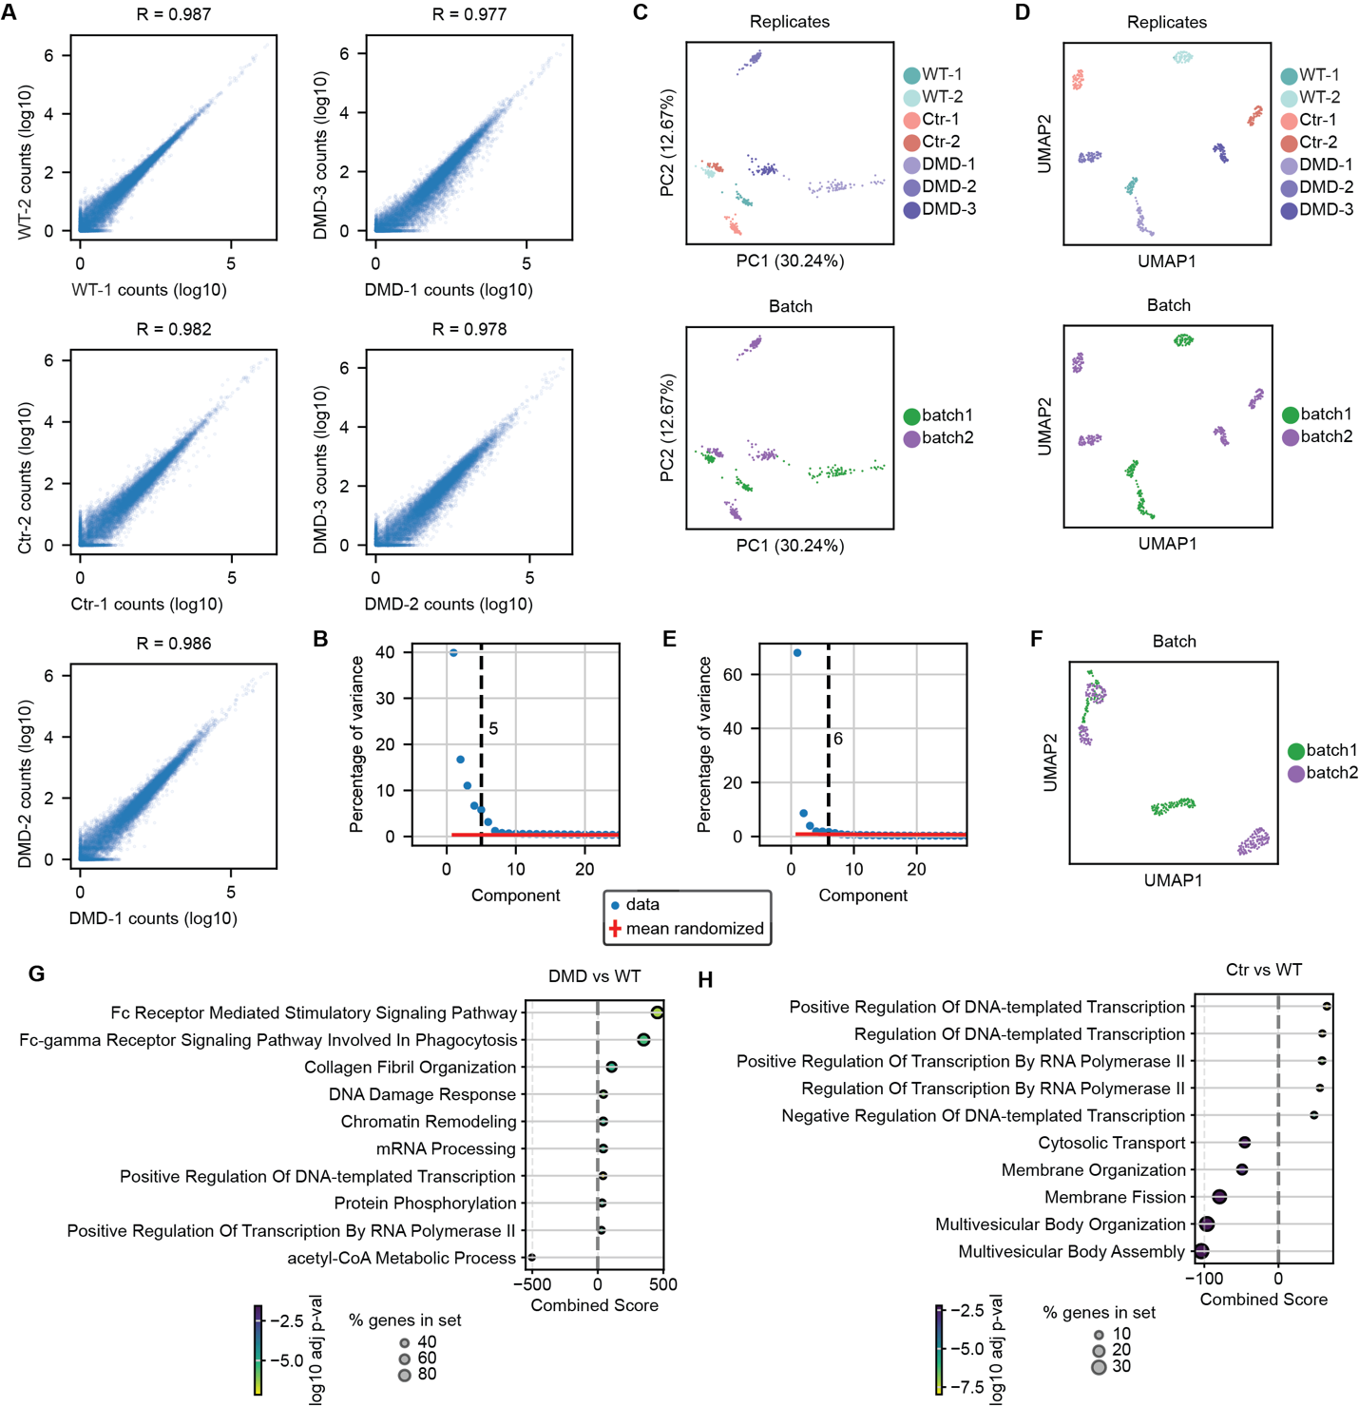

Supplementary Fig. 1. TOMOseq on WT, Ctr and DMD TA muscles.
(A) Pearson correlation of total transcript counts data for each pair-wise comparison between biological replicates. (B) Scatterplots after PCA displaying n = 419 sections, where each point is a section. Colors represent biological replicate (top) or experimental batch (bottom) for each section (Supplementary Data 1). (C) Percentage of the variance explained by the principal component analysis (PCA) of the data (blue dots) and the randomized data (red crosses). Threshold (black dashed line) indicates the number of PCs that explain 1.2x more variance than the randomized data used for UMAP projection. (D) UMAP projection displaying n = 419 sections, where each point is a section. Colors represent biological replicate (top) or experimental batch (bottom) for each section (Supplementary Data 1). (E) Percentage of the variance explained by the Harmony-corrected PCs of the data (blue dots) and the randomized data (red crosses). Threshold (black dashed line) indicates the number of Harmony-corrected PCs that explain 1.2x more variance than the randomized data used for UMAP projection and Leiden clustering. (F) UMAP projection after Harmony correction displaying n = 419 sections, where each point is a section. Colors represent experimental batch for each section (Supplementary Data 1). (G-H) GO-term analysis for the DEGs between DMD and WT samples (G) or Ctr and WT samples (H).
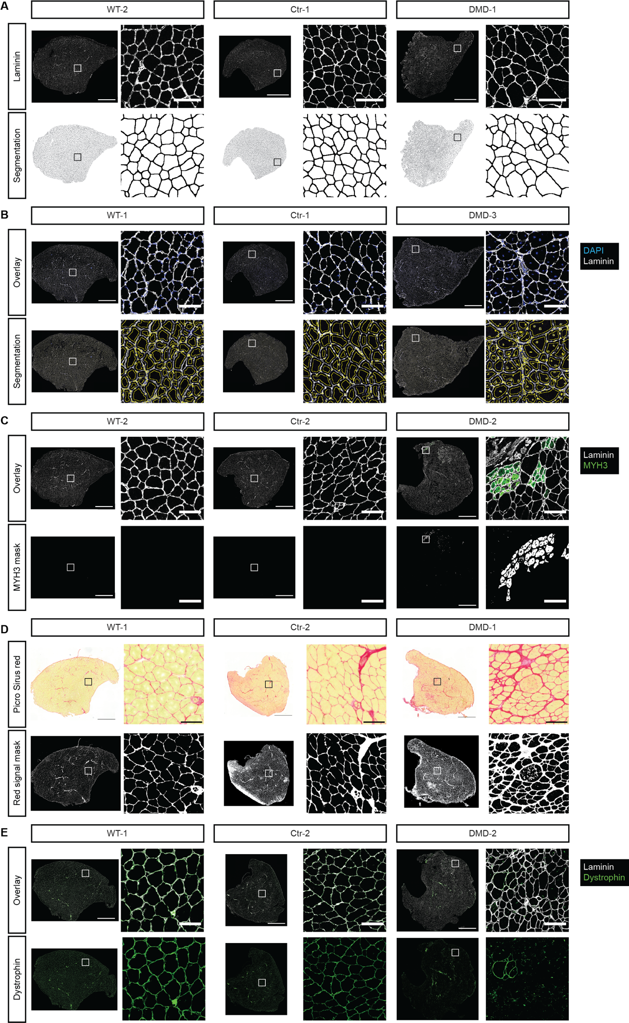

Supplementary Fig. 2. Histopathological features of TA muscles used for TOMOseq.
(A) Representative images of adjacent central sections (left) and zoom in on region of interest (right) of TA muscles used for TOMOseq to quantify CSA, (B) centralized nuclei, (C) MYH3 expression, (D) fibrosis with Picro Sirius red staining, and (E) dystrophin expression. One central tissue section was analyzed per muscle. Scale bar full sections, 1000 μm; scale bar zoom in, 100 μm.
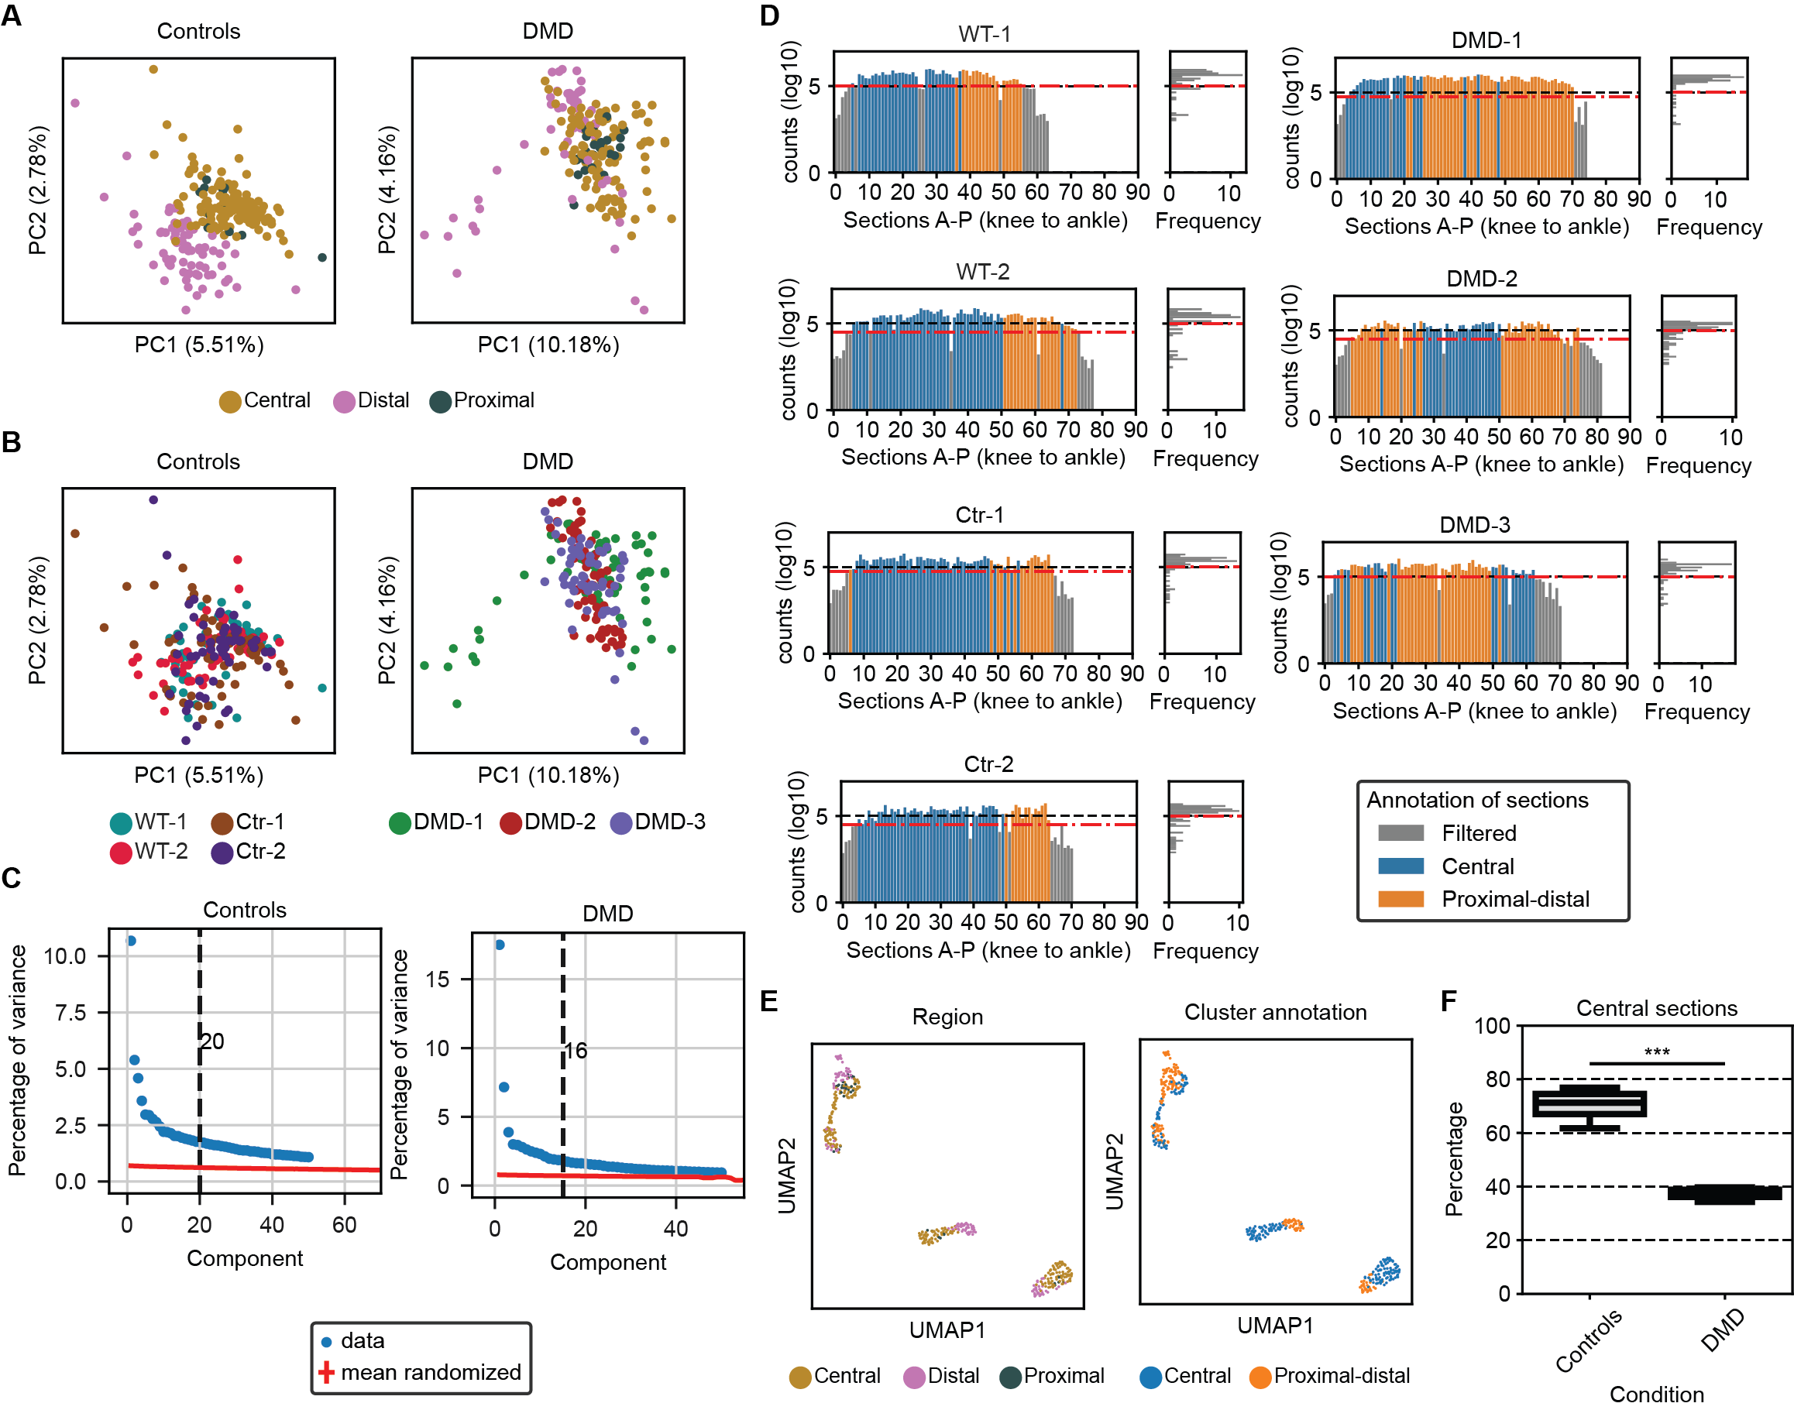

Supplementary Fig. 3. Regionalization of gene expression in controls and DMD tissues.
(A) Scatterplots after PCA displaying n = 228 (controls, left) and n = 191 (DMD, right) sections, where each point is a section. Colors represent manual region annotation based on anatomical features of controls (left) or DMD samples (right) for each section (Supplementary Data 2,3). (B) Scatterplots after PCA displaying n = 228 (controls, left) and n = 191 (DMD, right) sections, where each point is a section. Colors represent biological replicate of controls (left) or DMD samples (right) for each section (Supplementary Data 2,3). (C) Percentage of the variance explained by the PCA of the data (blue dots) and the randomized data (red crosses) on controls (left) and DMD samples (right). Threshold (black dashed line) indicates the number of PCs that explain 1.2x more variance than the randomized data used for Leiden clusters. (D) UMAP projection displaying n = 419 sections after batch correction with Harmony, where each point is a section. Colors represent manual region annotation based on anatomical features (left) or Leiden cluster annotation (right) for each section (Supplementary Data 1,2,3). (E) Distribution of the percentage of sections annotated as central in controls or DMD. Statistical significance was assessed using a two-sided t-test. Significance levels: *** < 0.001. Box plot characteristics: center line, median; box limits, upper and lower quartiles; whiskers, 1.5x interquartile range; circles, outliers.

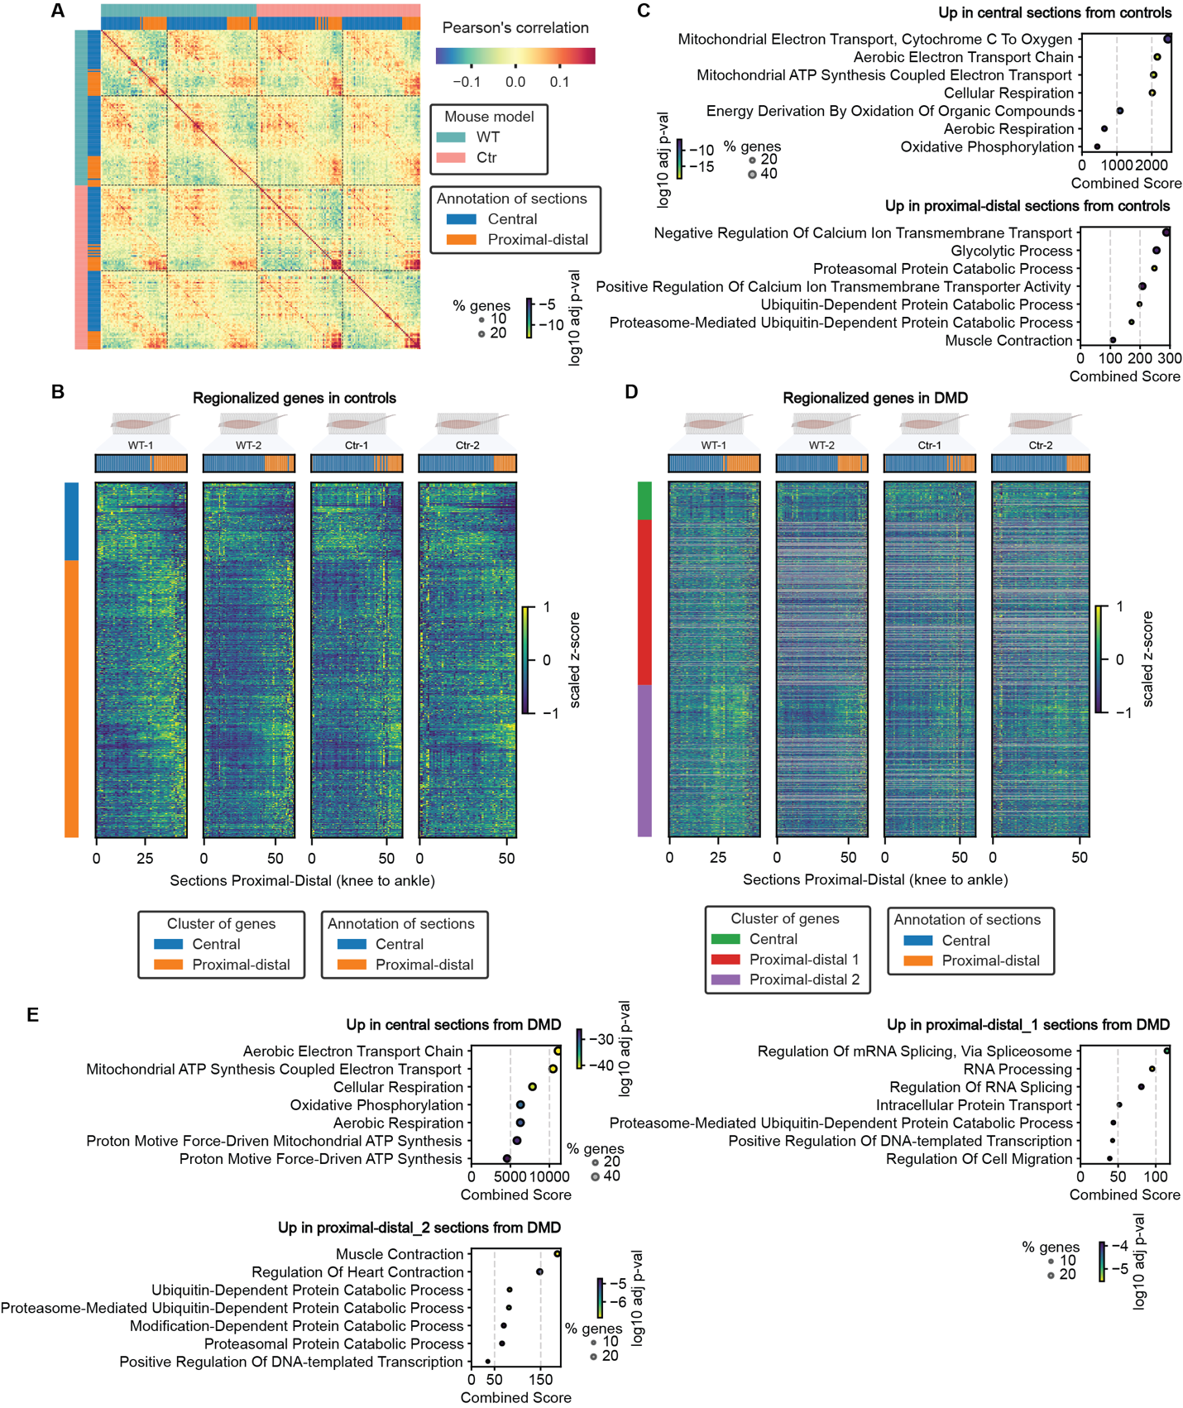

Supplementary Fig. 4. Spatial transcriptomics in TAs of DMD and control mouse models.
(A) Pairwise correlation heatmap of individual sections among all genes detected at more than four transcripts in at least three consecutive sections in all control samples. Sections are colored by Leiden cluster annotation and mouse model. (B,D) Heatmaps display the average proximal-distal expression patterns of the 733 DEG detected in control regionalization (B) and 1601 DEG detected in DMD regionalization (D) in all control samples. Colors represent clusters of genes and annotation of sections. (C,E) GO-term analysis of the up-regulated genes in central and proximal-distal sections in control samples (C) or in central, proximal-distal 1 and proximal-distal 2 sections in DMD samples (E). Muscle diagrams in B and D were created with BioRender.com.
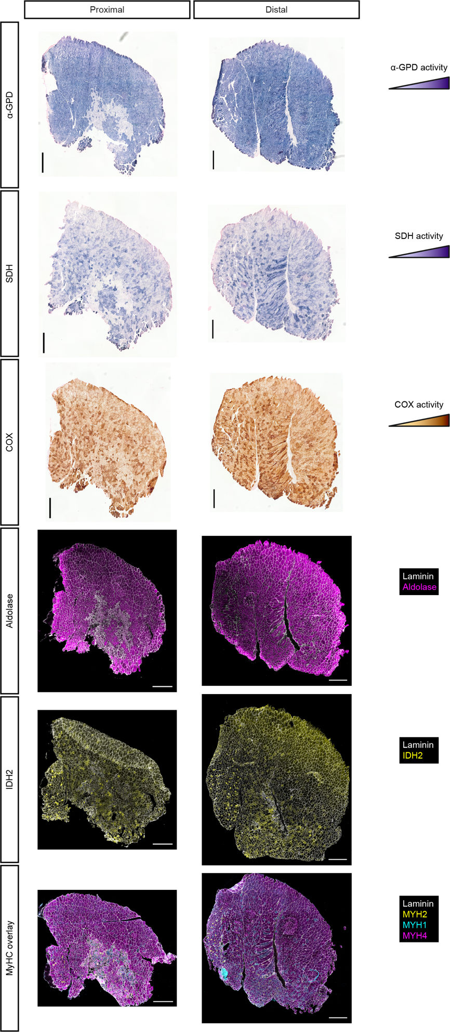

Supplementary Fig. 5. Metabolic changes in proximal and distal regions of DMD TA muscles.
Representative images of proximal and distal TA muscle sections from DMD mice showing staining for metabolic enzymes: SDH, COX, IDH2 (oxidative markers), α-GPD, and aldolase (glycolytic markers), alongside fiber type markers MYH1, MYH2, and MYH4. Scale bar, 500 µm.
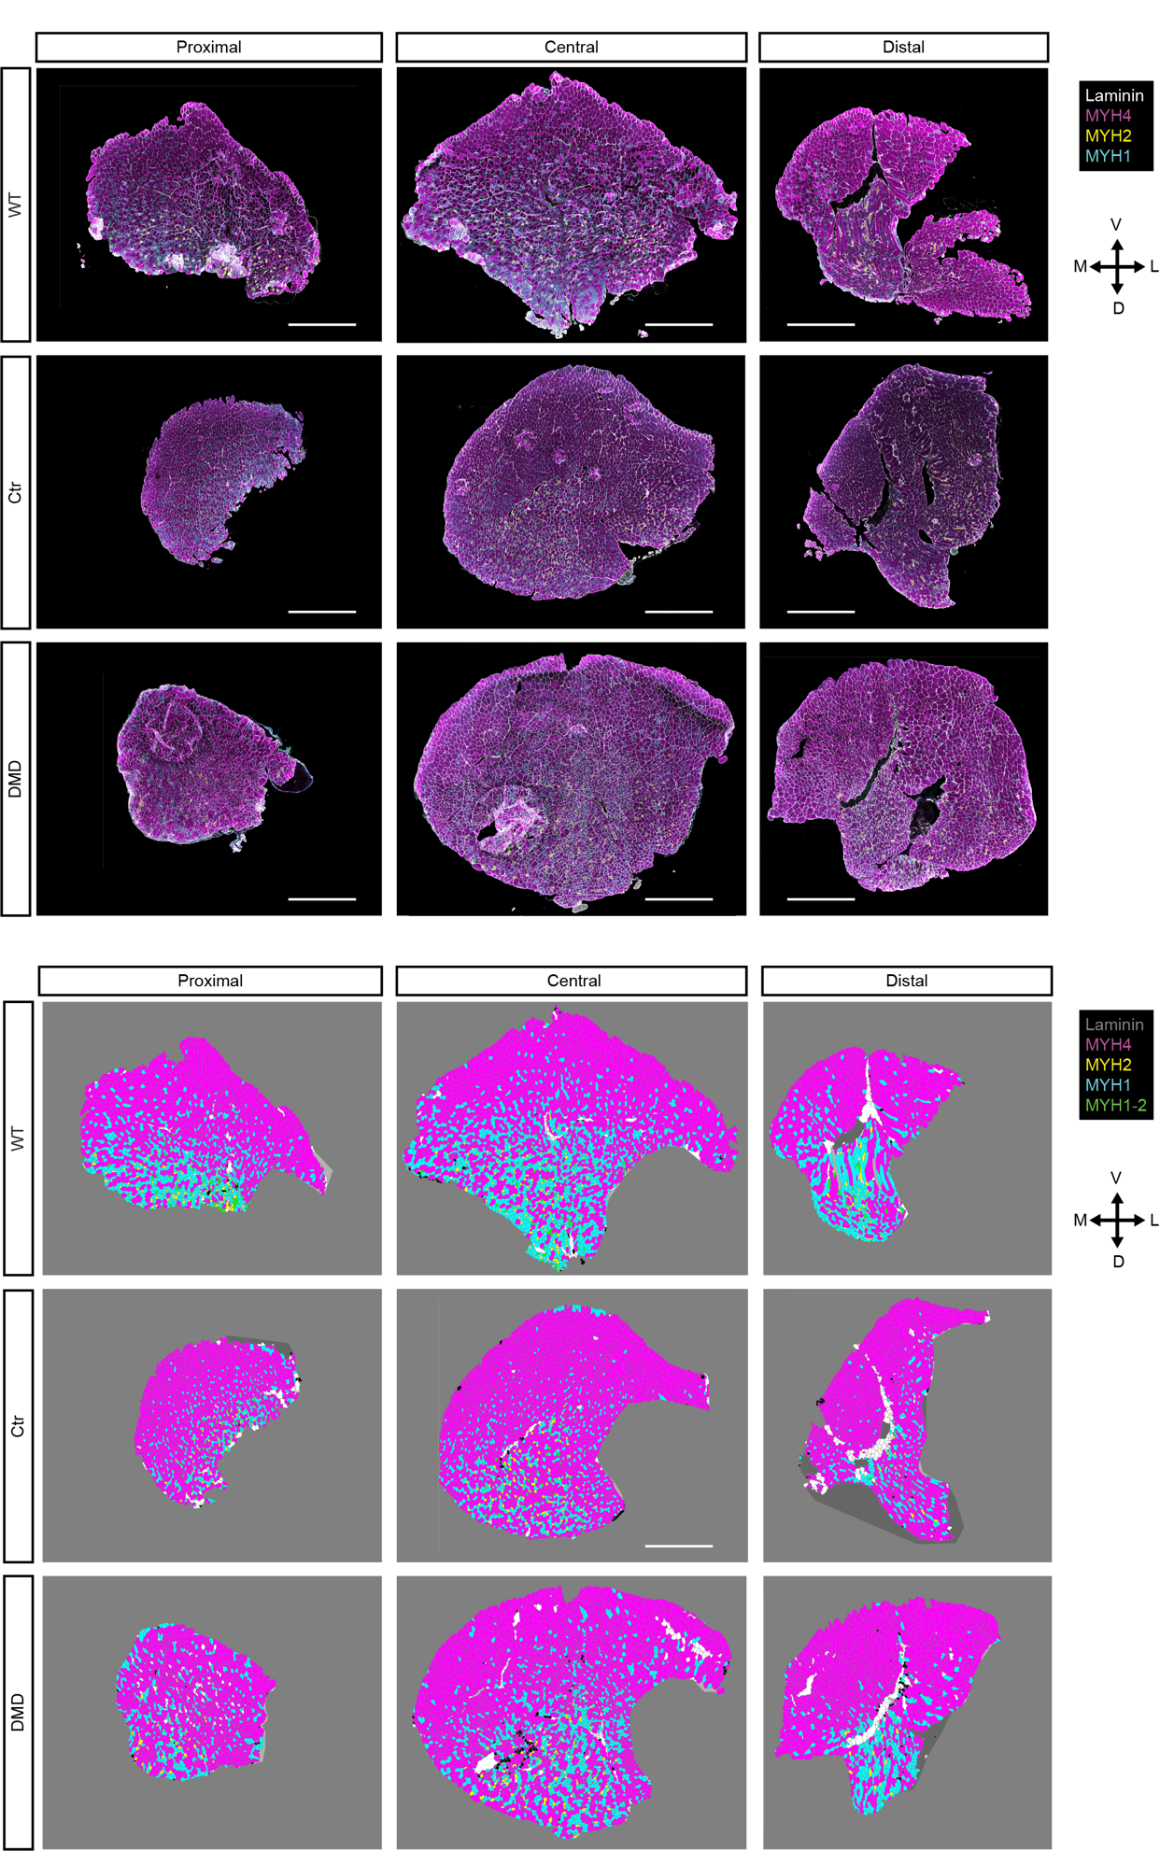

Supplementary Fig. 6. MyHC distribution in TA muscles.
Representative images of immunofluorescence staining of fiber types (top) and assigned fiber type based on clustering analysis (bottom) in proximal, central and distal areas of WT, Ctr and DMD TA muscles. Yellow, type 2a myofiber (MYH2); cyan, type 2x myofiber (MYH1); magenta, type 2b myofiber (MYH4); grey, laminin subunit α-1. Scale bar, 1000 μm. Arrows display lateral-medial and dorsal-ventral orientation of the tissue sections. L, lateral; D, dorsal; M, medial; V, ventral.
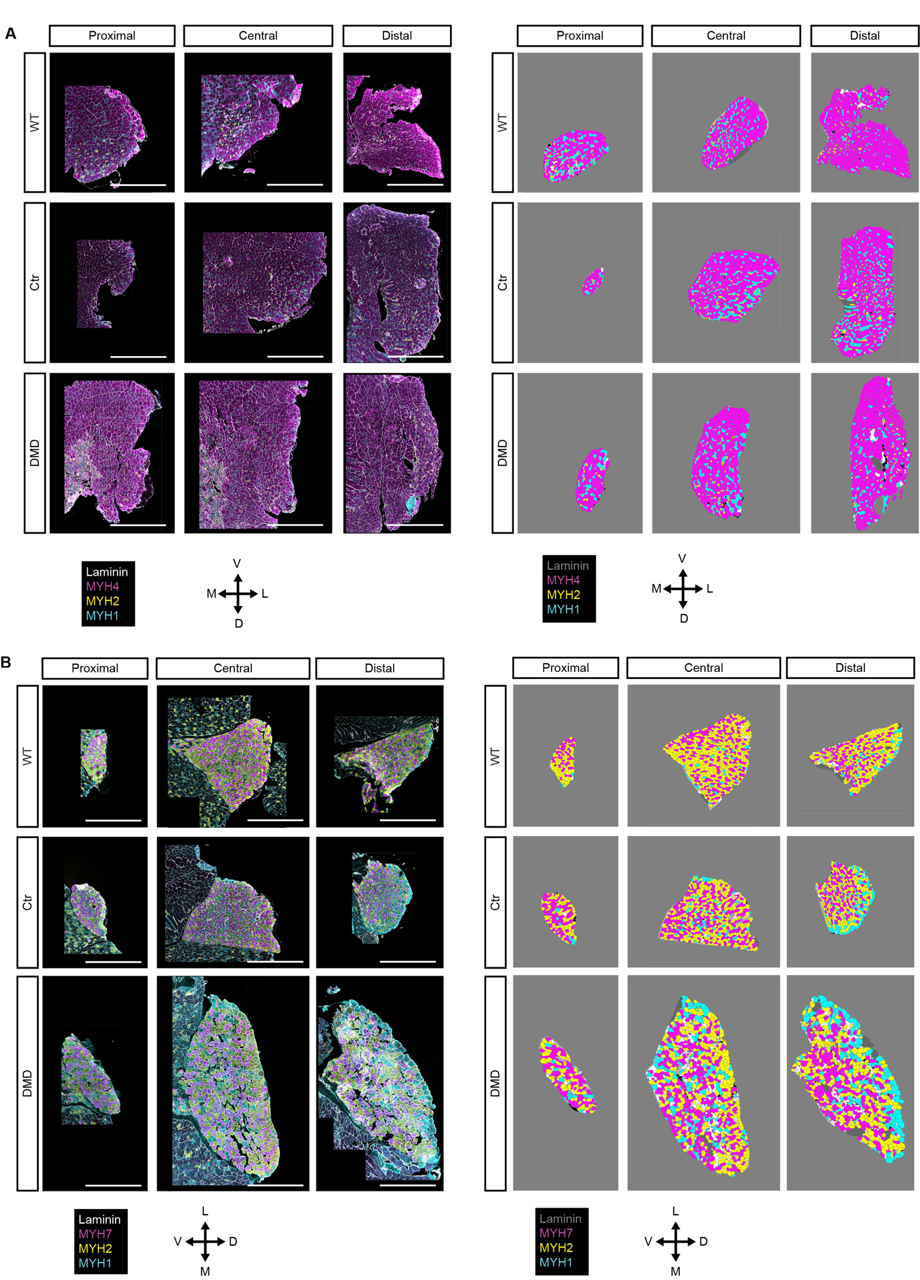

Supplementary Fig. 7. MyHC distribution in EDL and SOL muscles.
(A,B) Representative images of immunofluorescence staining of fiber types (left) and assigned fiber type based on clustering analysis (right) in proximal, central and distal areas of WT, Ctr and DMD EDL (A, top) and SOL (B, bottom) muscles. Yellow, type 2a myofiber (MYH2); cyan, type 2x myofiber (MYH1); magenta, type 2b myofiber (MYH4) or type 1 myofibers (MYH7); grey, laminin subunit α-1. Scale bar, 1000 μm. Arrows display lateral-medial and dorsal-ventral orientation of the tissue sections. L, lateral; D, dorsal; M, medial; V, ventral.

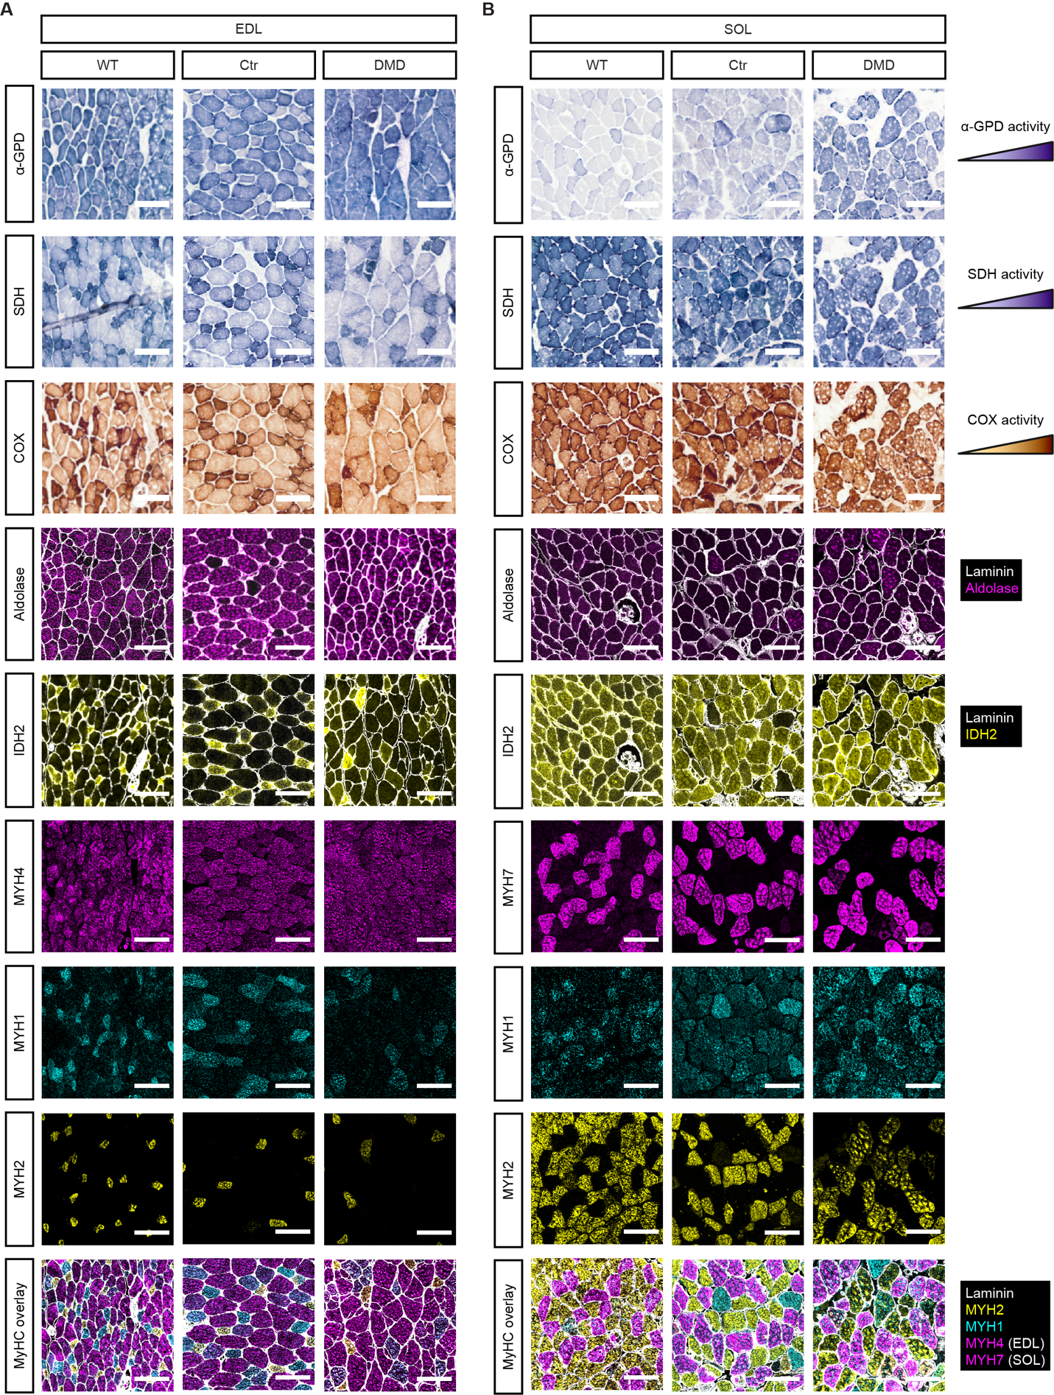

Supplementary Fig. 8. Metabolic changes in EDL and TA muscles of DMD and controls mouse models.
(A,B) Representative images of EDL (A) and SOL (B) muscle sections from WT, Ctr and DMD mice showing staining for metabolic enzymes: SDH, COX, IDH2 (oxidative markers), α-GPD, and aldolase (glycolytic markers), alongside fiber type markers MYH1, MYH2, and MYH4. Scale bar, 100 μm.

