Neutrophil Percentage-to-Albumin Ratio as an Early Prognostic Marker in ICU Patients with Acute Pancreatitis: A 12-Month Cohort Study
Tien Manh Huynh¹, Thanh Chi Phan Nguyen², Phuc-loi Luu³, Doan Thi Nha Nguyen¹, Duc Trong Quach^{1,4,5*}
- Department of Internal Medicine, School of Medicine, University of Medicine and Pharmacy at Ho Chi Minh City
- Faculty of Mathematics and Computer Science, University of Science
- Institute for Applied Research in Health Sciences and Aging (ARiHA)-Thong Nhat Hospital, Ho Chi Minh City - Mathematics Department, Faculty of Fundamental Sciences, University of Medicine and Pharmacy at Ho Chi Minh City, Ho Chi Minh City, Vietnam
- Department of Internal Medicine, Faculty of Medicine, Universitas Airlangga.
- Department of Gastroenterology, Nhan Dan Gia Dinh Hospital.

SUPPLEMENTARY FILES
Table S1. Threshold effect analysis of the relationship between NPAR and all-cause mortality at serial time points in patients with acute pancreatitis
Model | 7-day mortality |  | 28-day mortality |  | 90-day mortality |  | 1 year mortality
Description | aHR (95% CI) | p | aHR (95% CI) | p | aHR (95% CI) | p | aHR (95% CI) | p
Model I
One-line slope | 1.045  (1.02-1.07) | 0.002 | 1.025  (1.01-1.04) | 0.008 | 1.022  (1.01-1.04) | 0.005 | 1.016  (1.00-1.03) | 0.035
Model II (*)
Turning point (K) | 48.1 | - | 40.3 | - | 43.2 | - | 46.4
< K | 1.048  (1.007-1.090) | 0.020 | 1.043  (1.014-1.074) | 0.004 | 1.030  (1.008-1.053) | 0.008 | 1.018  (0.999-1.037) | 0.049
≥ K | 1.013  (0.929-1.104) | 0.768 | 0.996  (0.951-1.043) | 0.858 | 1.009  (0.967-1.052) | 0.692 | 1.017  (0.970-1.066) | 0.483
Likelihood Ratio Test | - | <0.001 | - | <0.001 | - | <0.001 |  | <0.001
aHR- adjust hazard ratio with age and gender; NPAR, neutrophil percentage-to-albumin ratio/

Table S2. Univariate COX regression analysis of variables associated with mortality in acute pancreatitis
Variable | 7-day mortality |  | 28-day mortality |  | 90-day mortality |  |  | 1-Year mortality
Variable | HR (95% CI) | p | HR (95% CI) | p |  | HR (95% CI) | p |  | HR (95% CI) | p
Gender | 0.994  (0.528–1.871) | 0.984 | 1.070  (0.729–1.572) | 0.728 |  | 0.892  (0.650–1.223) | 0.478 |  | 0.970  (0.725–1.296) | 0.835
Age | 1.040  (1.020–1.060) | <0.001 | 1.034  (1.022–1.046) | <0.001 |  | 1.035  (1.025–1.045) | <0.001 |  | 1.036  (1.026–1.045) | <0.001
BMI | 0.98(0.94, 1.03) | 0.423 | 0.99(0.97, 1.02) | 0.637 |  | 0.99(0.97, 1.01) | 0.444 |  | 0.98(0.96, 1.01) | 0.167
MBP | 0.921  (0.887–0.955) | <0.001 | 0.950  (0.931–0.970) | <0.001 |  | 0.966  (0.951–0.981) | <0.001 |  | 0.977  (0.963–0.990) | <0.001
Respiratory rate | 1.096  (1.023–1.174) | 0.009 | 0.991  (0.949–1.036) | 0.695 |  | 0.962  (0.927–0.999) | 0.044 |  | 0.951  (0.919–0.984) | 0.004
Temperature | 0.260  (0.189–0.359) | <0.001 | 0.380  (0.300–0.483) | <0.001 |  | 0.427  (0.347–0.526) | <0.001 |  | 0.483  (0.400–0.585) | <0.001
NPAR | 1.045  (1.017–1.075) | 0.002 | 1.025  (1.006–1.044) | 0.008 |  | 1.022  (1.007–1.038) | 0.005 |  | 1.017 (1.003–1.032) | 0.019
Glucose | 1.000  (0.999–1.001) | 0.655 | 1.000  (0.998–1.001) | 0.533 |  | 1.000  (1.000–1.001) | 0.203 |  | 1.000  (1.000–1.001) | 0.386
Hemoglobin | 0.843  (0.734–0.969) | 0.016 | 0.825  (0.758–0.897) | <0.001 |  | 0.863  (0.805–0.925) | <0.001 |  | 0.881  (0.828–0.938) | <0.001
Platelets | 0.993  (0.989–0.997) | 0.002 | 0.998  (0.996–1.000) | 0.040 |  | 1.000  (0.998–1.001) | 0.863 |  | 1.000  (0.999–1.001) | 0.875
White blood cell | 1.021  (0.994–1.048) | 0.123 | 1.028  (1.013–1.044) | <0.001 |  | 1.023  (1.010–1.037) | <0.001 |  | 1.015  (1.002–1.028) | 0.023
Anion gap | 1.078  (1.045–1.113) | <0.001 | 1.044  (1.020–1.069) | <0.001 |  | 1.027 (1.005–1.048) | 0.014 |  | 1.019 (1.000–1.039) | 0.053
Bicarbonate | 0.858  (0.813–0.905) | <0.001 | 0.938  (0.907–0.970) | <0.001 |  | 0.973  (0.946–1.000) | 0.052 |  | 0.981  (0.956–1.006) | 0.138
Calcium | 0.852  (0.661–1.097) | 0.215 | 1.099  (0.943–1.280) | 0.226 |  | 1.215  (1.074–1.375) | 0.002 |  | 1.215  (1.083–1.362) | <0.001
Chloride | 1.027  (0.989–1.066) | 0.171 | 0.984  (0.962–1.007) | 0.163 |  | 0.985  (0.966–1.004) | 0.121 |  | 0.988  (0.971–1.005) | 0.172
Creatinine | 1.159  (1.069–1.257) | <0.001 | 1.125  (1.059–1.196) | <0.001 |  | 1.093  (1.032–1.157) | 0.002 |  | 1.067  (1.010–1.127) | 0.021
Sodium | 1.035  (0.992–1.080) | 0.108 | 1.001  (0.973–1.030) | 0.950 |  | 1.002  (0.978–1.026) | 0.879 |  | 1.000  (0.979–1.022) | 0.978
Potassium | 1.702  (1.379–2.101) | <0.001 | 1.328  (1.126–1.566) | <0.001 |  | 1.248  (1.080–1.441) | 0.003 |  | 1.256  (1.102–1.432) | <0.001
Total bilirubin | 1.041  (1.013–1.069) | 0.004 | 1.037  (1.022–1.053) | <0.001 |  | 1.029  (1.014–1.043) | <0.001 |  | 1.021  (1.007–1.036) | 0.003
Heart failure | 1.043  (0.479–2.270) | 0.915 | 1.475  (0.963–2.257) | 0.074 |  | 1.452  (1.015–2.076) | 0.041 |  | 1.344  (0.965–1.870) | 0.080
Liver disease | 1.681  (0.819–3.451) | 0.157 | 2.179  (1.451–3.272) | <0.001 |  | 1.552  (1.079–2.234) | 0.018 |  | 1.415  (1.007–1.991) | 0.046
Renal disease | 0.874  (0.366–2.085) | 0.761 | 1.927  (1.270–2.925) | 0.002 |  | 1.958  (1.383–2.772) | <0.001 |  | 1.873  (1.362–2.575) | <0.001
CCI | 1.088  (0.989–1.198) | 0.083 | 1.190  (1.125–1.257) | <0.001 |  | 1.205  (1.151–1.262) | <0.001 |  | 1.217  (1.168–1.267) | <0.001
APS III | 1.040  (1.030–1.050) | <0.001 | 1.022  (1.016–1.029) | <0.001 |  | 1.014  (1.007–1.020) | <0.001 |  | 1.007  (1.002–1.013) | 0.012
SOFA | 1.235  (1.152–1.324) | <0.001 | 1.118  (1.071–1.167) | <0.001 |  | 1.053  (1.016–1.091) | 0.005 |  | 1.024  (0.991–1.057) | 0.160
AKI | 3.594 (1.504-8.590) | 0.004 | 2.406 (1.441-4.016) | <0.001 |  | 1.630 (1.112-2.389) | 0.012 |  | 1.129 (0.819-1.556) | 0.459
Mechanical ventilation | 2.141 (0.972-4.715) | 0.059 | 0.596 (0.367-0.967) | 0.036 |  | 0.432 (0.289-0.645) | <0.001 |  | 0.315 (0.219-0.453) | <0.001
Vasopressor | 5.624  (2.794–11.321) | <0.001 | 3.027  (1.979–4.630) | <0.001 |  | 1.769  (1.258–2.488) | 0.001 |  | 1.451  (1.068–1.971) | 0.017
ERCP | 1.132  (0.401–3.190) | 0.815 | 0.852  (0.414–1.753) | 0.664 |  | 1.048  (0.604–1.817) | 0.869 |  | 1.485  (0.959–2.300) | 0.077

3.594 (1.504-8.590) | 0.004 | 2.406 (1.441-4.016) | <0.001 | 1.630 (1.112-2.389) | 0.012 | 1.129 (0.819-1.556) | 0.459

NPAR: Neutrophil Percentage-to-Albumin Ratio, MBP: Mean lood Pressure, CCI- Charlson Comorbidity Index, APSIII- Acute Physiology Score III, ERCP: Endoscopic Retrograde Cholangiopancreatography; AKI, Acute kidney injury; MV, Mechanical ventilation

Table S3. Sensitivity analysis of NPAR and mortality
Outcome |  | Crude |  | Model 1 |  | Model 2 |  | Model 3
 |  | HR (95% CI | P | HR (95% CI | P | HR (95% CI | P | HR (95% CI | P
NPAR | 7-day | 1.120  (1.050-1.195) | 0.001 | 1.103  (1.040-1.171) | 0.001 | 1.092  (1.017-1.172) | 0.015 | 1.201  (1.031-1.400) | 0.019
NPAR | 28-day | 1.041  (0.990-1.095) | 0.114 | 1.058  (1.014-1.104) | 0.010 | 1.050  (1.007-1.094) | 0.023 | 1.131  (1.042-1.227) | 0.003
NPAR | 90-day | 1.011  (0.970-1.055) | 0.600 | 1.029  (0.994-1.065) | 0.111 | 1.026  (0.992-1.062) | 0.132 | 1.079  (1.017-1.144) | 0.011
NPAR | 1-year | 1.004  (0.968-1.041) | 0.833 | 1.022  (0.991-1.054) | 0.166 | 1.025  (0.994-1.057) | 0.117 | 1.050  (1.000-1.102) | 0.049
HR hazard ratio, CI confidence interval, NPAR neutrophils to albumin ratio. Crude: non-adjusted; Model 1: adjusted for age, sex; Model 2: adjusted model 1 + body temperature, hemoglobin, serum creatinine, prothrombin time; Model 3: adjusted for model 2 + acute physiology score III, Charlson comorbidity index, AKI in 48 h, vasopressor.

Table S4. Prognostic performance of NPAR-BISAP decision tree
Outcome | AUC (95% CI) | F1-score | Sensitivity | Specificity | Accuracy
7 days | 0.768 (0.699–0.837) | 0.843 | 0.667 | 0.744 | 0.739
28 days | 0.738 (0.692–0.784) | 0.667 | 0.815 | 0.520 | 0.571
90 days | 0.743 (0.704–0.783) | 0.566 | 0.917 | 0.406 | 0.533
1 year | 0.717 (0.680–0.755) | 0.638 | 0.850 | 0.498 | 0.603
AUC-95: Area Under the Curve (95% Confidence Interval)

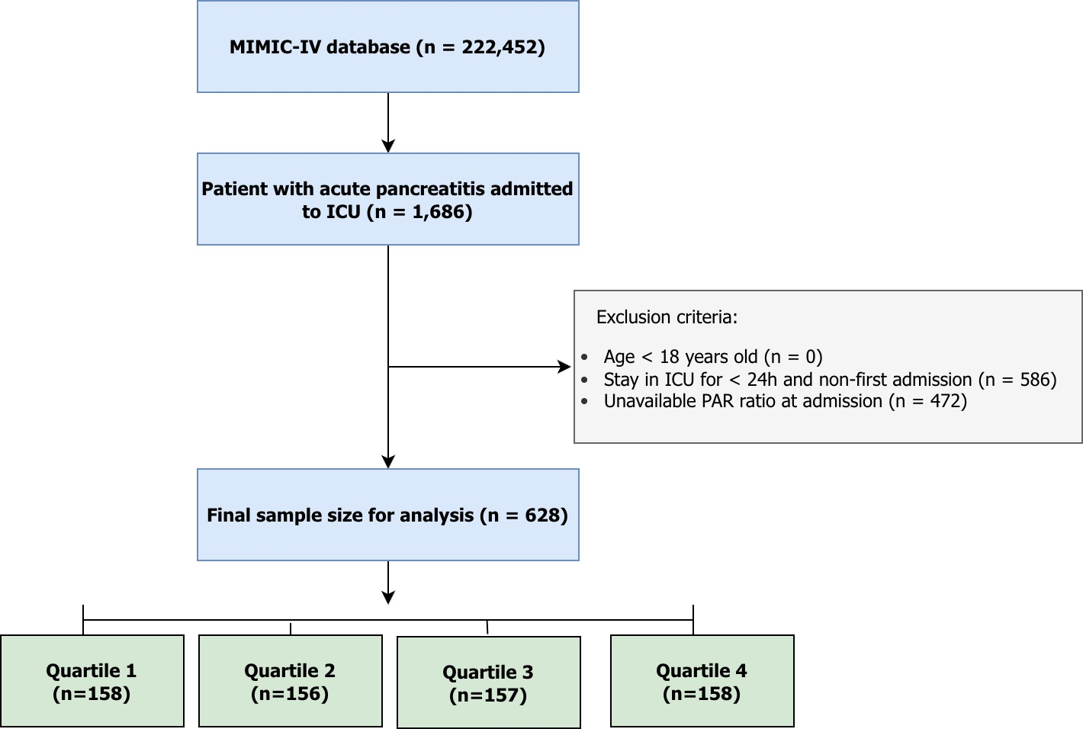
Figure S1. Flowchart of study.

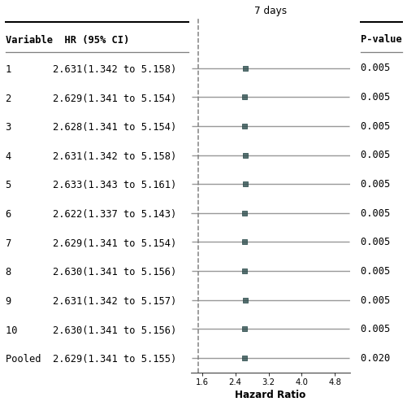 | 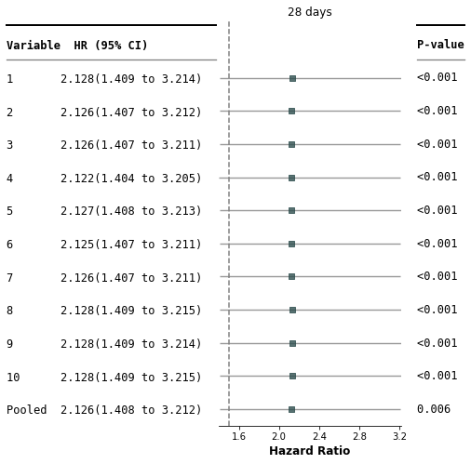
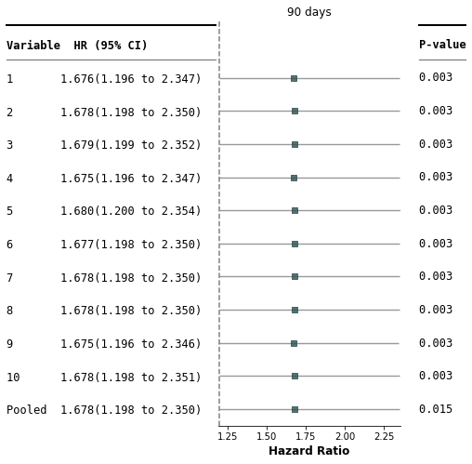 | 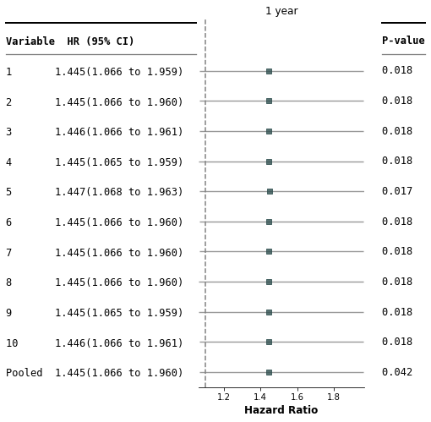
Figure S2. Forest plot of the relationship between NPAR and all-mortality adjusted for multiple imputation

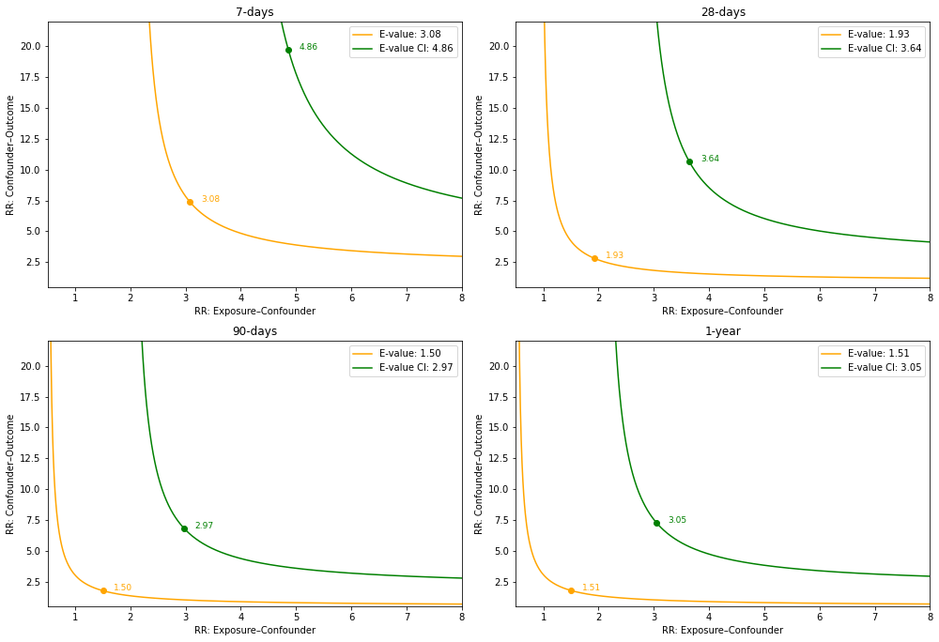
Figure S3. E-values for unmeasured confounding and their impact on the association between NPAR and all-cause mortality.

