Title: National-scale evidence for rapid cotton yield gains under sustainable intensification in Uzbekistan.
Authors: Ibrokhim Y. Abdurakhmonov ^{1,2,3}*, Abdumuxtor E. Ergashev³, Shukhrat I. Otajonov²,³, Alisher N. Shukurov³, Shakhrukh S. Khayitov³, Zabardast T. Buriev¹,², Mukhtor M.Darmanov³, Shodmon E. Namazov²,³, Mirzakamol S. Ayubov¹, Shamshod Sh. Ergashev⁴, Bahriddin M. Ahatqulov³, & The Council for Cotton Growing under the President of the Republic of Uzbekistan
Affiliations:
¹ Center of Genomics and Bioinformatics, Academy of Sciences of Uzbekistan, Tashkent 100053, Uzbekistan.
² Council for Cotton Growing under the President of the Republic of Uzbekistan, Tashkent 100000, Uzbekistan.
³ Ministry of Agriculture of the Republic of Uzbekistan, Tashkent 100000, Uzbekistan.
⁴ Cotton Breeding, Seed Production and Agrotechnologies Research Institute, Ministry of Agriculture of Uzbekistan.
*Correspondence to: Ibrokhim Y. Abdurakhmonov (i.y.abdurakhmonov@gmail.com)

Supplementary Material

Supplementary Table S1. Descriptive Structural Change Analysis

A. Segmented regression results
Parameter | Value | Interpretation
Breakpoint year | 2024.00 | Best interior-year breakpoint (Figure 2 method)
Segment 1 slope (pre-breakpoint) | 0.005 | Near-flat yield trend before the breakpoint
Segment 2 slope (post-breakpoint) | 1.170 | Accelerated yield increase after the breakpoint
Slope change | +1.164 | Increase in annual slope (ton/ha per year)
Piecewise R² | 0.8834 | Two-phase fit improvement over linear
Simple linear R² | 0.4517 | Single-trend baseline model

B. Davies test for breakpoint significance
Statistic | Value | Threshold | Conclusion
F-statistic | 1.85 | F (2,1) =199.5 | —
P-value | 0.461 | α=0.05 | Not statistically significant
Effect size (ΔR²) | 0.4317 | — | Model fit improvement (descriptive)

C. Technology adoption breakpoints (from master dataset)
Technology | Breakpoint Year | Threshold | Interpretation
Chinese Bt/Gt | 2024 | 5% adoption | Technology adoption tipping point
RNAi | 2021 | 1% adoption | Domestic biotech adoption is established
MAS | 2023 | 1% adoption | Marker-assisted selection adoption
Other Foreign | 2024 | 1% adoption | Other foreign germplasm expansion

D. Economic/structural comparison (computed from national area-weighted yield and planted area)
Indicator | Pre-breakpoint (2021–2023) | Post-breakpoint (2024–2025) | Change
Average yield growth (%) | 6.48 | 43.53 |  | 37.05
Area change (%) | -0.91 | -12.77 |  | -11.86
Production growth (%) | 5.51 | 25.32 |  | 19.81
Advanced technology share change (pp/year) | 0.20 | 23.20 |  | 23.00

Supplementary Table 2. Spatial Pattern Analysis Results (2025)
A. Regional yield performance (area-weighted yield; planted area summed across cultivars)
Region | Yield (ton/ha) | Area (ha) | Production (t) | Zone | Cluster
Andijan | 4.655 | 60000 | 279301 | Fergana Valley | High
Bukhara | 4.744 | 85301 | 404677 | Desert Zone | High
Fergana | 4.499 | 72000 | 323904 | Fergana Valley | Medium
Jizzakh | 4.736 | 67600 | 320171 | Central Plains | High
Karakalpakstan | 4.130 | 80000 | 330387 | Arid/Northern | Low
Kashkadarya | 4.386 | 126000 | 552598 | Desert Zone | Medium
Khorezm | 4.775 | 70000 | 334242 | Arid/Northern | High
Namangan | 4.582 | 48898 | 224043 | Fergana Valley | Medium
Navoiy | 4.459 | 24730 | 110259 | Desert Zone | Medium
Samarkand | 4.428 | 60000 | 265649 | Central Plains | Medium
Sirdaryo | 4.736 | 72700 | 344279 | Central Plains | High
Surkhondaryo | 4.631 | 62850 | 291071 | Desert Zone | High
Tashkent | 4.519 | 45538 | 205774 | Capital Region | Medium
Total | 4.553 | 875615 | 3986355 | - | -
B. Moran’s I spatial autocorrelation (as previously reported)
Statistic | Value | Interpretation
Moran’s I | -0.0529 | Slight negative spatial autocorrelation
Expected I | -0.0833 | Expected value under the null hypothesis
Z-score | 0.3198 | Standardized test statistic
P-value | 0.7491 | Not statistically significant (p>0.05)
Conclusion | No significant spatial clustering | Random spatial pattern

C. K-means cluster analysis on regional yields (k=3)
Cluster | Number of Regions | Mean Yield (ton/ha) | Total Area (ha) | Production (tons) | Production Share (%)
High | 6 | 4.717 | 418451 | 1973742 | 49.5
Low | 1 | 4.130 | 80000 | 330387 | 8.3
Medium | 6 | 4.460 | 377165 | 1682226 | 42.2

Supplementary Table 3. Comprehensive Statistical Analysis Summary

A. Hypothesis test results (α = 0.05)
Analysis | Test Statistic | P-value | Significance | Effect Size
Genotype Effects | F = 4.410 | < 0.001 | Significant | η² = 13.48%
Environment Effects (Zone × Year) | F = 33.546 | < 0.001 | Significant | η² = 41.01%
G×E Interaction | F = 0.681 | 0.999 | Not significant | η² = 12.89%
Chinese Bt/Gt advantage (2025, cluster-robust SEs) | t = 6.417 | < 0.001 | Significant | d = 1.446
Yield breakpoint (piecewise vs linear) | F = 0.304 | 0.637 | Not significant | ΔR² = 0.070

B. Model performance metrics
Model | R² | Adj. R² | RMSE | AIC | BIC
Two-way ANOVA (Zone×Year environment) | — | — | — | — | —
Piecewise regression (national yield) | 0.5401 | — | 0.3459 | 9.5746 | 8.4029
Simple linear regression (national yield) | 0.4701 | — | 0.3713 | 8.2828 | 7.5017

Note: R² values differ from Table S1 because this model refers to the breakpoint hypothesis-testing regression, whereas Table S1 reports descriptive segmented fit to the national mean time series.

C. Effect size classification
Effect | Effect size | Classification | Practical significance
G×E Interaction | 12.89% | Moderate | Some regional specificity
Environment | 41.01% | Very large | Strong agro-ecological control
Genotype | 13.48% | Context-dependent | Important genetic differences
Chinese Bt/Gt Advantage | 1.446 (Cohen's d) | Large | Yield advantage effect

D. Statistical power/adequacy checks
Test | Power (1-β) | Required Sample Size | Achieved Sample Size | Status
ANOVA (Genotype) | 1.000 | — | 617 | Adequate
Paired t-test (Yield 2024 vs 2025) | 1.000 | — | 171 | Adequate
Segmented regression (national yield) | — | n=5 years | 5 | Exploratory (short time series; low power for formal breakpoint detection)

Notes: All yield analyses use observations from the master dataset where harvested area > 0 and yield data are present, with the observational unit being cultivar × region × year. Two-way ANOVA was conducted with Genotype as a fixed factor and Environment defined as Agro-climatic Zone × Year. Aggregate records ('Across Uzbekistan' and 'All districts') were excluded from inferential models to avoid duplication. Technology yield advantages were estimated using weighted least squares with harvested area as weights and cluster-robust standard errors at the regional level. Breakpoint tests compared segmented and linear regressions of national area-weighted yield.

Supplementary Table 4: Economic Analysis of Intensive vs Traditional Schemes
A. Detailed Cost Comparison (per hectare)
Cost Component | Unit ($1=12,260 Uzbek soum) | Traditional 90cm Scheme | Intensive 76cm Scheme | Absolute Difference | Percentage Change
TOTAL COST | thousand soum | 7,428 | 3,311 | -4,117 | -55.4%
1. Mineral Fertilizer
- Total Amount | kg | 540 | 80 | -460 | -85.2%
- Total Cost | thousand soum | 5,349 | 922 | -4,427 | -82.8%
* Nitrogen* | kg | 240 | 20 | -220 | -91.7%
* Cost* | thousand soum | 2,117 | 176 | -1,941 | -91.7%
* Phosphorus* | kg | 180 | 45 | -135 | -75.0%
* Cost* | thousand soum | 2,734 | 684 | -2,050 | -75.0%
* Potassium* | kg | 120 | 15 | -105 | -87.5%
* Cost* | thousand soum | 498 | 62 | -436 | -87.5%
2. Seeds
- Amount | kg | 45 | 23 | -22 | -48.9%
- Cost | thousand soum | 900 | 460 | -440 | -48.9%
3. Plastic Film
- Amount | kg | 0 | 57 | +57 | +100%*
- Cost | thousand soum | 0 | 1,539 | +1,539 | +100%*
4. Water Consumption
- Volume | m³ | 6,500 | 3,900 | -2,600 | -40.0%
- Cost | thousand soum | 650 | 390 | -260 | -40.0%
5. Labor Costs
- Total Labor | thousand soum | 529.21 | 0 | -529.21 | -100%
* Pre-planting* | thousand soum | 153.19 | 0 | -153.19 | -100%
* Planting* | thousand soum | 173.63 | 0 | -173.63 | -100%
* Post-planting* | thousand soum | 202.39 | 0 | -202.39 | -100%
*Note: Plastic film cost represents an initial investment in the intensive system, not required in the traditional system.
B. Input Efficiency Comparison
Efficiency Metric | Traditional Scheme | Intensive Scheme | Improvement
Water Use Efficiency | 0.49 kg cotton/m³ water* | 1.18 kg cotton/m³ water* | +140.8%
Fertilizer Use Efficiency | 0.59 kg cotton/kg fertilizer | 5.75 kg cotton/kg fertilizer | +874.6%
Seed Use Efficiency | 71.1 kg cotton/kg seed | 200.0 kg cotton/kg seed | +181.3%
Cost Efficiency | 0.43 kg cotton/thousand soum | 1.39 kg cotton/thousand soum | +223.3%
*Based on the average yield of 3.2 tons/ha for the traditional scheme and 4.6 tons/ha for the intensive scheme.
C. Economic Impact ($1=12,260 soum) Analysis at National Scale (100,000 ha)
Economic Indicator | Traditional Scheme | Intensive Scheme | Net Benefit
Total Cost | 742,821 million soum | 331,120 million soum | 411,701 million soum saved
Fertilizer Savings | 534,900 million soum | 92,220 million soum | 442,680 million soum
Seed Savings | 90,000 million soum | 46,000 million soum | 44,000 million soum
Water Savings | 65,000 million soum | 39,000 million soum | 26,000 million soum
Labor Cost Elimination | 52,921 million soum | 0 million soum | 52,921 million soum
Additional Film Cost | 0 million soum | 153,900 million soum | (153,900 million soum)
D. Break-even and Sensitivity Analysis
Parameter | Base Value | Break-even Point | Notes
Yield Advantage Required | 43.75% | 15.2% | Yield increase needed to offset initial investment.
Cotton Price Sensitivity | 5,000 soum/kg | 2,200 soum/kg | Minimum price for the intensive scheme profitability
Water Cost Sensitivity | 100 soum/m³ | 250 soum/m³ | The point where water savings equal system cost
Fertilizer Price Sensitivity | 9,900 soum/kg N | 21,500 soum/kg N | Fertilizer price that eliminates the savings advantage
Payback Period | - | 1.2 years | Time to recover the initial drip irrigation investment
Net Present Value (5 years) | - | +1,847 million soum/ha | At 10% discount rate
E. Environmental Impact Assessment
Environmental Indicator | Traditional Scheme | Intensive Scheme | Environmental Benefit
Water Consumption | 6,500 m³/ha | 3,900 m³/ha | 40.0% reduction
Nitrogen Application | 240 kg N/ha | 20 kg N/ha | 91.7% reduction
Phosphorus Application | 180 kg P₂O₅/ha | 45 kg P₂O₅/ha | 75.0% reduction
Potassium Application | 120 kg K₂O/ha | 15 kg K₂O/ha | 87.5% reduction
Estimated Nutrient Runoff | 35-45% of applied | 5-10% of applied | 70-85% reduction
Carbon Footprint (fertilizer) | 1,200 kg CO₂-eq/ha | 200 kg CO₂-eq/ha | 83.3% reduction
F. Farmer Profitability Analysis
Profitability Metric | Traditional Scheme | Intensive Scheme | Change
Yield | 3.2 ton/ha | 4.6 ton/ha | +43.75%
Revenue (5,000 soum/kg) | 16,000 thousand soum/ha | 23,000 thousand soum/ha | +7,000 thousand soum/ha
Total Cost | 7,428 thousand soum/ha | 3,311 thousand soum/ha | -4,117 thousand soum/ha
Gross Margin | 8,572 thousand soum/ha | 19,689 thousand soum/ha | +11,117 thousand soum/ha
Profit Increase | - | - | +129.7%
Return on Investment | - | 335% | For a drip irrigation system
Risk Reduction | High weather dependence | Reduced drought risk | Significant improvement
G. Adoption Economics
Adoption Factor | Traditional System | Intensive System | Implication
Initial Investment | Low | High (drip system) | Barrier to adoption
Operating Costs | High | Low | Incentive for adoption
Skill Requirement | Traditional knowledge | Technical training needed | Extension support required
Risk Profile | High (price, weather) | Lower (efficiency buffer) | More stable income
Government Subsidy Impact | Input subsidies | Infrastructure subsidies | Different policy approach
Scalability | Limited by water | Enhanced by efficiency | Better for expansion
Note: ($1=12,260 Uzbek soum as of February 2026); Input-use values reflect reported farm records under demonstration and early-adopter conditions and should be interpreted as indicative rather than universal across all production systems

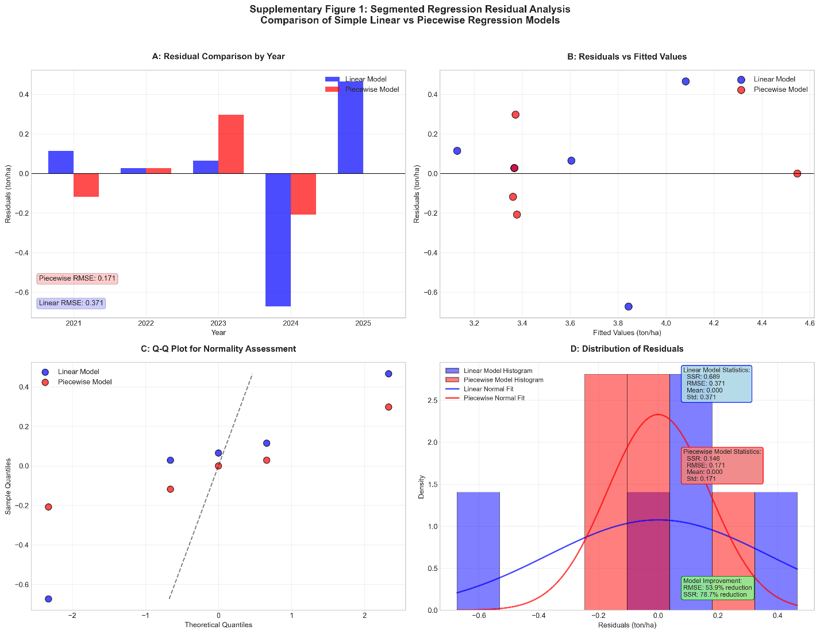Supplementary Fig. S1. Residual comparison of linear and segmented regression models.
Residual plots comparing the simple linear regression model and the segmented (piecewise) regression model fitted to the national cotton yield time series (2021–2025). The segmented model uses the data-driven breakpoint identified in Fig. 2 and reduces the magnitude of the residual in later years of the series, thereby improving the representation of late-period yield deviation. Given the short time series, this improvement should be interpreted as descriptive rather than definitive evidence of a structural break.

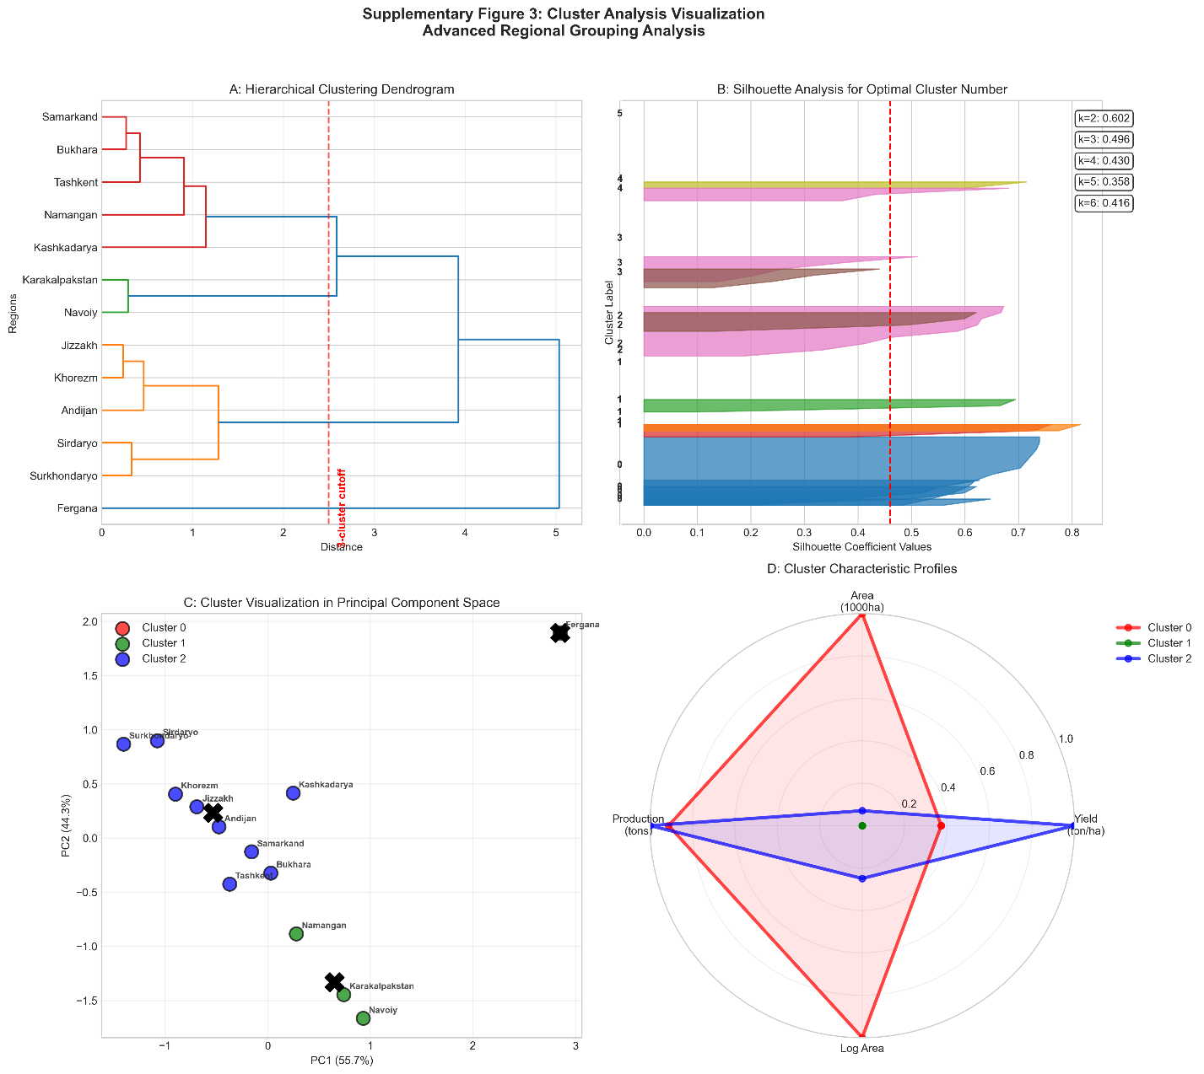

Supplementary Fig. S2. Regional clustering and yield–area relationships. (A) Scatter plot of regional cotton yield versus cultivated area (2025), with regions grouped into clusters using k-means classification. Clusters represent broad productivity classes across regions. (B) Silhouette plot evaluating the separation and cohesion of the three-cluster solution, showing the distribution of silhouette coefficients for regions within each cluster. Cluster labels are positioned for clarity outside the axis frame. (C) Boxplots comparing yield distributions among clusters, illustrating differences in productivity levels across regional groups.

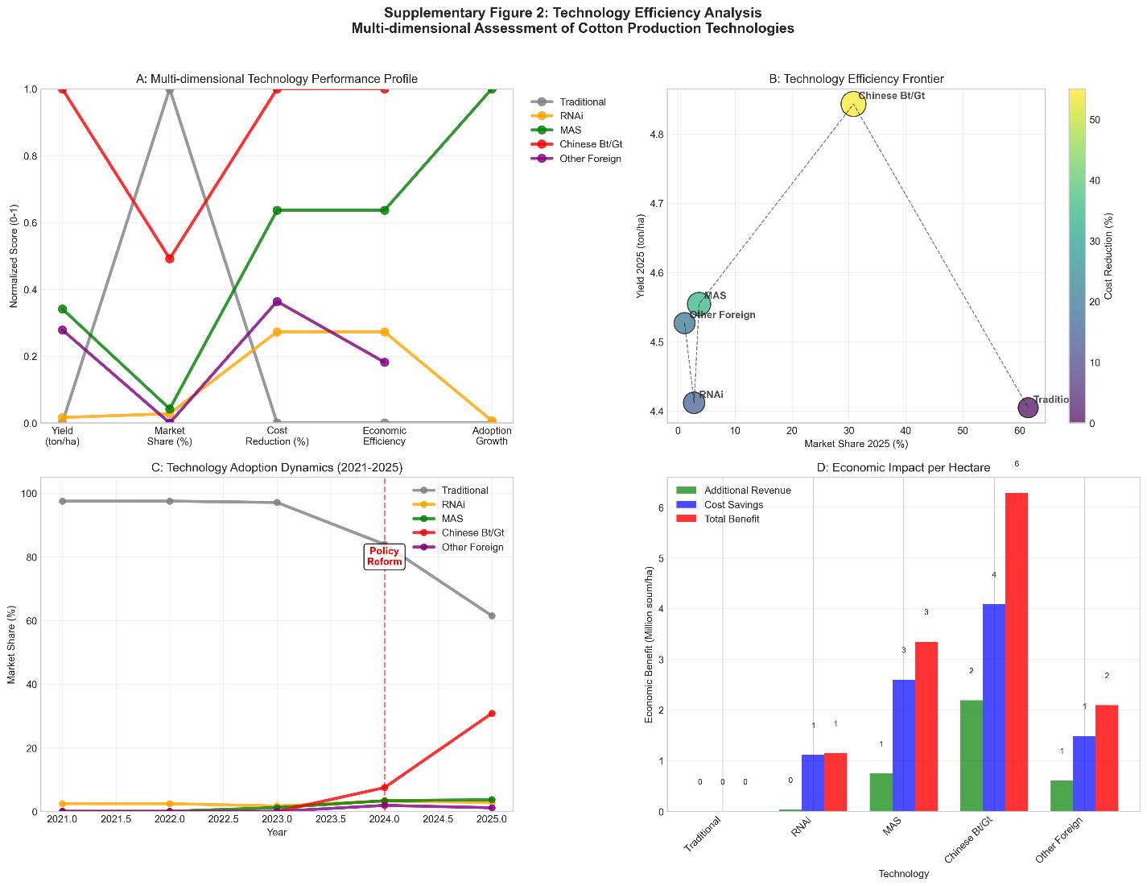
Supplementary Fig. S3. Integrated efficiency comparison of cotton production technologies. (A) Normalized multi-criteria performance profiles for major technology groups based on yield, market share, input cost reduction, economic efficiency, and recent adoption growth. Values are scaled (0–1) for relative comparison. (B) Technology efficiency frontier relating 2025 yield to market share, with bubble size and color indicating relative cost reduction; the dashed envelope highlights higher efficiency combinations. (C) Adoption dynamics (2021–2025) showing shifts in cultivated area share; the dashed vertical line marks the reform period linked to accelerated diffusion of advanced technologies. (D) Estimated per-hectare economic impact by technology, partitioned into additional revenue (yield gains), cost savings, and total benefit based on standardized production and input-cost estimates. This figure provides an integrative efficiency perspective that complements the production-share analysis in Fig. 5.

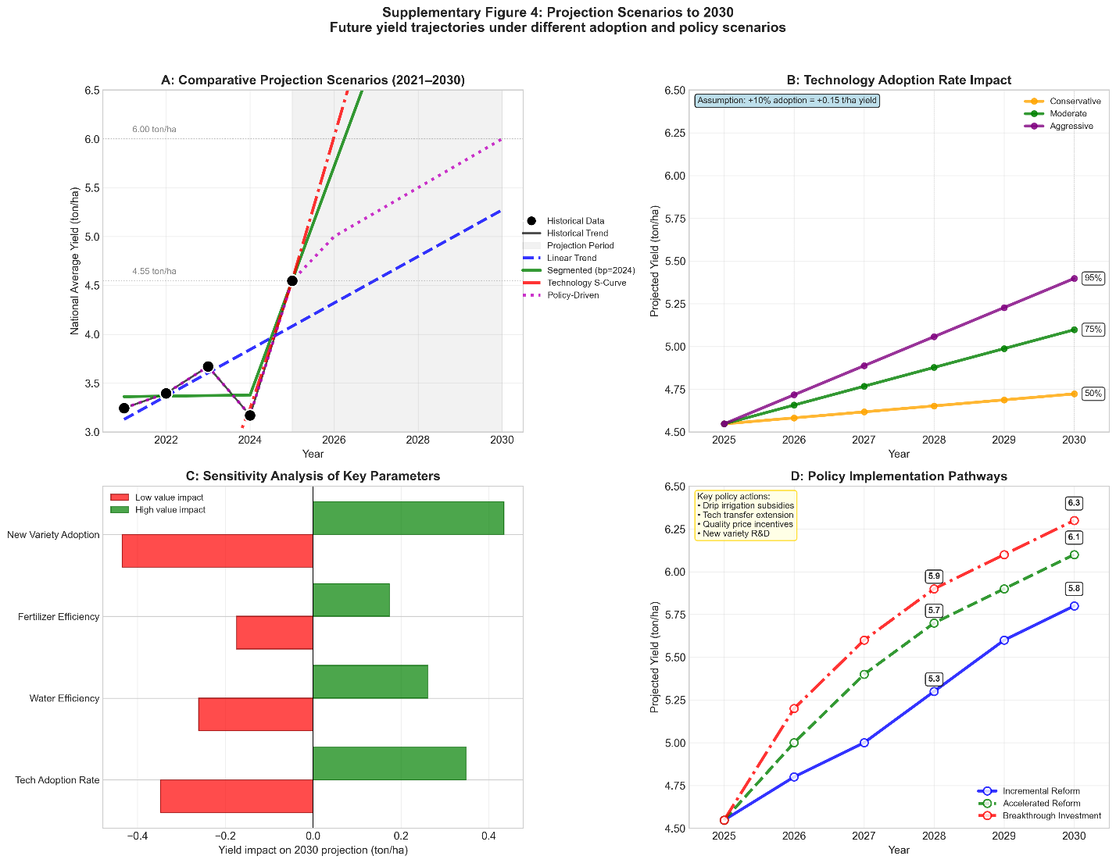
Supplementary Fig. S4. Scenario and sensitivity analysis of future national yield trajectories. (A) Comparative yield projections to 2030 under alternative modeling approaches, including linear continuation, segmented-trend extrapolation, technology diffusion (S-curve), and policy-driven acceleration. The shaded region indicates the projection period. (B) Sensitivity of projected yield to alternative technology adoption rates, illustrating how faster diffusion of advanced technologies translates into higher national yield outcomes. (C) Sensitivity analysis of key parameters affecting the 2030 projection, showing the relative yield impact of changes in variety adoption, fertilizer-use efficiency, water-use efficiency, and technology diffusion rate. (D) Alternative policy implementation pathways and their associated projected yield trajectories, comparing incremental reform, accelerated reform, and breakthrough investment strategies.
This figure examines the robustness of future yield projections across varying adoption rates, parameter assumptions, and policy pathways, complementing the core reform-impact projection presented in Fig. 8.

Supplementary Fig. S5. Field application of high-density Xinjiang cotton production technology. (A) Early-stage cotton establishment under 76 cm double-row high-density planting with plastic mulch and drip irrigation. (B) Mid-stage crop development showing uniform stand establishment under the mulched drip-irrigation system. (C) Mechanized field management within the high-density planting configuration. (D) Late vegetative-stage canopy closure under optimized irrigation and nutrient management. (E) Close-up of vigorous boll formation under high-density cultivation. (F) Mature cotton field at harvest, illustrating high boll density and uniform crop development. These images illustrate the agronomic practices and crop performance associated with the intensive cotton production system in 2025, referenced in the study.

