Supplementary Paper
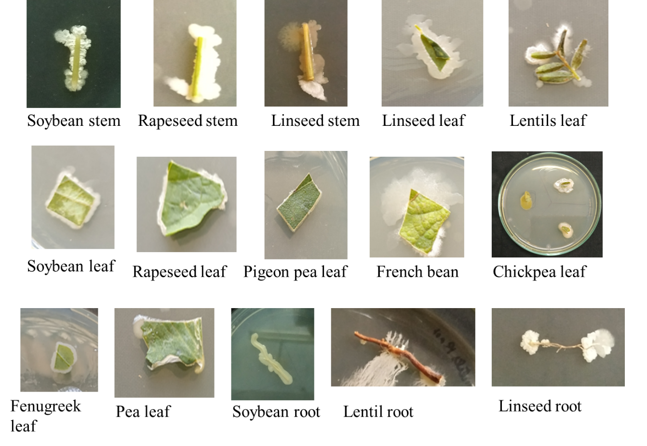
Figure S1: Isolation of endophytic bacteria from diverse oil seed and legume crops
Table S1: Effect of different concentrations of PEG 6000 on the growth of endophytic bacterial isolates
S.No. | Bacterial isolates | 2% | 6% | 8% | 10%
1 | PLSD6 | + | + | + | +
2 | PLSD1 | + | + | + | +
Table S2: Determination of chemical nature of endophytic bacterial siderophore
S.No. | Bacterial isolates | Hydroxamate | Catecholate | Carboxylate
1 | PLSD6 | + | - | -
2 | PLSD1 | + | - | +
Table S3: Morphological and Gram staining characters of selected bacterial isolates
SN | Bacterial Isolates | Gram reaction | Shape | Edge | Elevation | Surface | Chromogenesis | Endospore
1 | PLSD1 | Gram negative | Circular | Even | Convex | Glistening | white | -
2 | PLSD6 | Gram negative | Circular | Even | Convex | Glistening | Yellowish and translucent | -

Table S4: Biochemical characteristics of selected bacterial isolates
S.No | Bacterial sample | Starch hydrolysis | Urease  Production | Catalase Production | Gelatinase Production | Casein Hydrolysis | Cellulase Activity | Lipolytic Activity | Citrate Utilization | Indole | Methyl red | Voges  proskauers
1. | PLSD1 | - | + | + | + | + | - | + | + | - | - | -
2. | PLSD6 | - | - | - | + | - | - | + | + | + | + | -
+ Sign represents presence of activity whereas – sign represents absence of activity

Table S5: Carbohydrate source utilization of selected endophytic bacterial isolates
S.No | Carbon source | Bacterial isolate
S.No | Carbon source | PLSD6 | PLSD1
1 | Lactose | Positive | Negative
2 | Xylose | Positive | Positive
3 | Maltose | Positive | Negative
4 | Fructose | Positive | Positive
5 | Dextrose | Positive | Positive
6 | Galactose | Positive | Positive
7 | Raffinose | Positive | Negative
8 | Trehalose | Positive | Negative
9 | Melibiose | Positive | Positive
10 | Sucrose | Positive | Negative
11 | L-arabinose | Positive | Positive
12 | Mannose | Positive | Negative
13 | Inulin | Positive | Negative
14 | Sodium gluconate | Negative | Negative
15 | Glycerol | Positive | Positive
16 | Salicin | Positive | Negative
17 | Dulcitol | Negative | Negative
18 | Inositol | Positive | Negative
19 | Sorbitol | Negative | Negative
20 | Mannitol | Positive | Positive
21 | Adonitol | Negative | Negative
22 | Arabitol | Positive | Positive
23 | Erythritol | Negative | Negative
24 | α-methyl-D- glucoside | Positive | Negative
25 | Rhamnose | Positive | Negative
26 | Cellobiose | Positive | Negative
27 | Melizitose | Negative | Negative
28 | α-methyl-D- mannoside | Negative | Negative
29 | Xylitol | Negative | Negative
30 | ONPG | Negative | Negative
31 | Esculin | Negative | Negative
32 | D-arabinose | Negative | Negative
33 | Citrate | Positive | Positive
34 | Malonate | Negative | Negative
35 | Sorbose | Negative | Negative

Table S6: Antibiotic sensitivity test of selected endophytic bacterial isolates
S.N. | Antibiotic (µg/disc) | Bacterial isolates
S.N. | Antibiotic (µg/disc) | PLSD6 | PLSD1
1 | Cephalothin (CEP, 30 µg/disc) | + | -
2 | Clindamycin (CD, 2 µg/disc) | + | -
3 | Co-Trimoxazole (CO, 25 µg/disc) | + | -
4 | Erythromycin (E, 15 µg/disc) | + | +
5 | Gentamicin (GEN, 10 µg/disc) | + | +
6 | Ofloxacin (OF, 1 µg/disc) | + | +
7 | Penicillin-G (P, 10 µg/disc) | + | -
8 | Vancomycin (VA, 30 µg/disc) | - | -
9 | Chloramphenicol (C, 30 µg/disc) | + | +
10 | Ampicillin (A, 30 µg/disc | - | +
11 | Tetracycline (T, 15 µg/disc | + | +
12 | Kanamycin (K, 30 µg/disc | + | +
13 | Amikacin (AK, 15 µg/disc | + | +
14 | Streptomycin (S, 15 µg/disc | + | +
15 | Polymixin B (PB, 10 µg/disc) | - | +
16 | Cefuroxime (CXM, 15 µg/disc) | - | +
18 | Cloxacillin (COX, 10 µg/disc) | + | -
+ Sign represents presence of sensitivity against antibiotic, whereas – sign represents resistance

