RNA qualitative and quantitative assessment using NanoDrop 2000, Thermo Fisher Scientific (Wilmington, Delaware USA)
Duplicate Nanodrop measurements per sample; average values were used in subsequent analysis.

Sample | Tissue | Nucleic Acid Conc. | Unit | A260 | A280 | 260/280 | 260/230 | Sample Type
wildtype_20 months | duodenum | 190.50 | ng/µl | 4.76 | 2.32 | 2.05 | 2.15 | RNA
wildtype_20 months | duodenum | 191.00 | ng/µl | 4.77 | 2.34 | 2.04 | 2.14 | RNA
transgene_20 months | duodenum | 757.60 | ng/µl | 18.94 | 8.71 | 2.18 | 2.18 | RNA
transgene_20 months | duodenum | 806.30 | ng/µl | 20.16 | 9.17 | 2.20 | 2.19 | RNA
wildtype_20 months | heart | 221.00 | ng/µl | 5.53 | 2.65 | 2.08 | 2.06 | RNA
wildtype_20 months | heart | 218.10 | ng/µl | 5.45 | 2.60 | 2.10 | 2.09 | RNA
transgene_20 months | heart | 400.10 | ng/µl | 10.00 | 4.71 | 2.13 | 1.98 | RNA
transgene_20 months | heart | 406.40 | ng/µl | 10.16 | 4.78 | 2.13 | 1.98 | RNA
wildtype_20 months | insestines | 127.70 | ng/µl | 3.19 | 1.60 | 1.99 | 1.63 | RNA
wildtype_20 months | insestines | 127.10 | ng/µl | 3.18 | 1.58 | 2.01 | 1.60 | RNA
transgene_20 months | insestines | 78.50 | ng/µl | 1.96 | 0.97 | 2.03 | 2.14 | RNA
transgene_20 months | insestines | 83.20 | ng/µl | 2.08 | 1.05 | 1.98 | 2.14 | RNA
wildtype_20 months | kidney | 411.70 | ng/µl | 10.29 | 4.76 | 2.16 | 1.92 | RNA
wildtype_20 months | kidney | 410.90 | ng/µl | 10.27 | 4.76 | 2.16 | 1.92 | RNA
transgene_20 months | kidney | 528.80 | ng/µl | 13.22 | 6.20 | 2.13 | 2.05 | RNA
transgene_20 months | kidney | 526.90 | ng/µl | 13.17 | 6.18 | 2.13 | 2.06 | RNA
wildtype_20 months | liver | 1828.00 | ng/µl | 45.70 | 21.00 | 2.18 | 1.92 | RNA
wildtype_20 months | liver | 1846.00 | ng/µl | 46.15 | 21.21 | 2.18 | 1.91 | RNA
transgene_20 months | liver | 1767.20 | ng/µl | 44.18 | 20.25 | 2.18 | 2.12 | RNA
transgene_20 months | liver | 1784.90 | ng/µl | 44.62 | 20.44 | 2.18 | 2.13 | RNA
wildtype_20 months | spleen | 716.80 | ng/µl | 17.92 | 8.94 | 2.00 | 2.16 | RNA
wildtype_20 months | spleen | 697.10 | ng/µl | 17.43 | 8.74 | 1.99 | 2.16 | RNA
transgene_20 months | spleen | 843.10 | ng/µl | 21.08 | 9.90 | 2.13 | 1.91 | RNA
transgene_20 months | spleen | 837.50 | ng/µl | 20.94 | 9.86 | 2.12 | 1.93 | RNA
wildtype_20 months | stomach | 1256.60 | ng/µl | 31.41 | 14.51 | 2.17 | 2.05 | RNA
wildtype_20 months | stomach | 1254.50 | ng/µl | 31.36 | 14.41 | 2.18 | 2.05 | RNA
transgene_20 months | stomach | 737.60 | ng/µl | 18.44 | 8.57 | 2.15 | 2.12 | RNA
transgene_20 months | stomach | 735.70 | ng/µl | 18.39 | 8.59 | 2.14 | 2.12 | RNA
wildtype_20 months | hindbrain | 133.50 | ng/µl | 3.34 | 1.63 | 2.05 | 1.81 | RNA
wildtype_20 months | hindbrain | 132.40 | ng/µl | 3.31 | 1.62 | 2.04 | 1.81 | RNA
transgene_20 months | hindbrain | 99.00 | ng/µl | 2.47 | 1.29 | 1.92 | 1.72 | RNA
transgene_20 months | hindbrain | 97.20 | ng/µl | 2.43 | 1.26 | 1.93 | 1.74 | RNA
wildtype_4 months | hindbrain | 134.10 | ng/µl | 3.35 | 1.71 | 1.96 | 1.64 | RNA
wildtype_4 months | hindbrain | 130.10 | ng/µl | 3.25 | 1.66 | 1.96 | 1.62 | RNA
transgene_4 months | hindbrain | 58.90 | ng/µl | 1.47 | 0.79 | 1.86 | 2.20 | RNA
transgene_4 months | hindbrain | 58.60 | ng/µl | 1.47 | 0.78 | 1.87 | 2.20 | RNA
wildtype_20 months | forebrain+midbrain | 343.40 | ng/µl | 8.58 | 3.98 | 2.16 | 1.79 | RNA
wildtype_20 months | forebrain+midbrain | 341.60 | ng/µl | 8.54 | 3.96 | 2.16 | 1.79 | RNA
transgene_20 months | forebrain+midbrain | 386.80 | ng/µl | 9.67 | 4.46 | 2.17 | 2.06 | RNA
transgene_20 months | forebrain+midbrain | 385.20 | ng/µl | 9.63 | 4.44 | 2.17 | 2.06 | RNA
wildtype_4 months | forebrain+midbrain | 486.10 | ng/µl | 12.15 | 5.74 | 2.12 | 1.93 | RNA
wildtype_4 months | forebrain+midbrain | 489.70 | ng/µl | 12.24 | 5.77 | 2.12 | 1.93 | RNA
transgene_4 months | forebrain+midbrain | 451.80 | ng/µl | 11.30 | 5.30 | 2.13 | 1.98 | RNA
transgene_4 months | forebrain+midbrain | 452.90 | ng/µl | 11.32 | 5.32 | 2.13 | 1.98 | RNA

Primer and amplicon specificity assessment using NCBI BLAST (blastn, National Center for Biotechnology Information, Bethesda, MD, USA)

Target Information
Gene symbol | PGPEP1
Sequence accession number | NM_023217.4
PGPEP1_forward | cggaaggcggtagtggtaac
PGPEP1_reverse | aacatgcactacgagctggg
Location of amplicon | 108 - 314
Amplicon length | 207

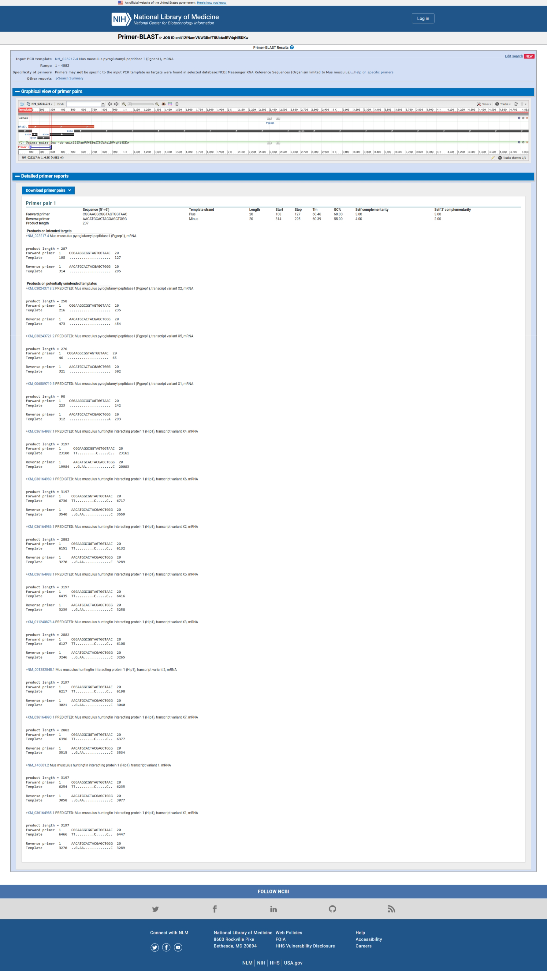

Cq Values and calculation of concentatin (according standard curve calculation per run, provided by the Rotor-Gene Software (version 2.2.2))

"Technical triplicates were filtered for standard deviations (SD) < 0.5 of Cq values whereby some reactions were reduced to technical duplicates when a given technical replicate deviated from the Cq values of the other two technical replicates having a SD < 0.5.
For two probes exhibiting higher intrinsic variability, a threshold of 0.7 was used to retain data quality."

* Not included in analyis (outlayer)
** Not included in analysis (Melting curve indicating contamination)

Run | Sample | Cq values | Mean Cq values | SD of Cq values | Calculation concentraion | Mean Calculation concentraion | Copies per µl of RNA concentration
1 | wt_20M_duodenum | 25.74 | 25.51 | 0.33 | 437.88493 | 5.34E+02 | 2.67E+02
 | wt_20M_duodenum | **24.97
 | wt_20M_duodenum | 25.27 |  |  | 629.91217
1 | tg_20M_duodenum | 25.1 | 24.60 | 0.71 | 718.45571 | 1.14E+03 | 5.72E+02
 | tg_20M_duodenum | 24.09 |  |  | 1569.49523
 | tg_20M_duodenum | *26.56 |  |  | -
2 | wt_20M_heart | 20.5 | 20.55 | 0.07 | 7202.77751 | 6.94E+03 | 3.47E+03
 | wt_20M_heart | 20.6 |  |  | 6677.28633
 | wt_20M_heart | *21.78 |  |  | -
2 | tg_20M_heart | 20.17 | 20.16 | 0.02 | 9248.47230 | 9.32E+03 | 4.66E+03
 | tg_20M_heart | 20.14 |  |  | 9461.06443
 | tg_20M_heart | 20.17 |  |  | 9248.47230
1 | wt_20M_insestines | 24.78 | 25.35 | 0.49 | 939.55022 | 6.38E+02 | 3.19E+02
 | wt_20M_insestines | 25.61 |  |  | 494.35622
 | wt_20M_insestines | 25.65 |  |  | 479.29180
1 | tg_20M_insestines | 22.3 | 22.41 | 0.15 | 6269.02497 | 5.80E+03 | 2.90E+03
 | tg_20M_insestines | *21.39 |  |  | -
 | tg_20M_insestines | 22.51 |  |  | 5328.92981
2 | wt_20M_kidney | 18.18 | 18.45 | 0.38 | 41761.87605 | 3.48E+04 | 1.74E+04
 | wt_20M_kidney | *19.31 |  |  | -
 | wt_20M_kidney | 18.72 |  |  | 27740.86507
2 | tg_20M_kidney | 19.78 | 19.94 | 0.22 | 12427.39207 | 1.11E+04 | 5.56E+03
 | tg_20M_kidney | *22.62 |  |  | -
 | tg_20M_kidney | 20.09 |  |  | 9826.29957
2 | wt_20M_liver | 19.93 | 20.38 | 0.53 | 11092.51437 | 8.27E+03 | 4.14E+03
 | wt_20M_liver | 20.96 |  |  | 5083.46690
 | wt_20M_liver | 20.26 |  |  | 8638.93090
2 | tg_20M_liver | 21.09 | 20.96 | 0.23 | 4606.70073 | 5.12E+03 | 2.56E+03
 | tg_20M_liver | 20.7 |  |  | 6190.13328
 | tg_20M_liver | 21.1 |  |  | 4571.93450
2 | wt_20M_spleen | 21.68 | 22.19 | 0.71 | 2946.32058 | 2.16E+03 | 1.08E+03
 | wt_20M_spleen | 22.69 |  |  | 1370.85020
 | wt_20M_spleen | *19.54 |  |  | -
2 | tg_20M_spleen | 22.45 | 22.19 | 0.37 | 1644.18242 | 2.05E+03 | 1.03E+03
 | tg_20M_spleen | *23.02 |  |  | -
 | tg_20M_spleen | 21.92 |  |  | 2456.51828
2 | wt_20M_stomach | *23.14 |  |  | - | 2.56E+03 | 1.28E+03
 | wt_20M_stomach | 21.87 | 21.87 | 0.01 | 2551.34976
 | wt_20M_stomach | 21.86 |  |  | 2570.75092
2 | tg_20M_stomach | 22.16 | 22.15 | 0.15 | 2048.14170 | 2.07E+03 | 1.03E+03
 | tg_20M_stomach | 22 |  |  | 2312.06479
 | tg_20M_stomach | 22.3 |  |  | 1842.04400
1 | wt_20M_hindbrain | 23.58 | 23.63 | 0.07 | 2328.73462 | 2.24E+03 | 1.12E+03
 | wt_20M_hindbrain | 23.68 |  |  | 2155.36090
 | wt_20M_hindbrain | *25.08
1 | tg_20M_hindbrain | 24.83 | 24.98 | 0.21 | 885.36021 | 7.96E+02 | 3.98E+02
 | tg_20M_hindbrain | 25.12 |  |  | 707.42434
 | tg_20M_hindbrain | *26.5 |  |  | -
1 | wt_4M_hindbrain | *26.59 | 24.78 | 0.32 |  | 9.38E+02 | 4.69E+02
 | wt_4M_hindbrain | 25 |  |  | 776.24712
 | wt_4M_hindbrain | 24.55 |  |  | 1099.51207
1 | tg_4M_hindbrain | 26.04 | 25.61 | 0.40 | 347.18424 | 4.98E+02 | 2.49E+02
 | tg_4M_hindbrain | 25.56 |  |  | 503.31515
 | tg_4M_hindbrain | 25.24 |  |  | 644.70346
1 | wt_20M_forebrain+midbrain | *24.79 | 23.55 | 0.11 | - | 2.39E+03 | 1.19E+03
 | wt_20M_forebrain+midbrain | 23.63 |  |  | 2240.37130
 | wt_20M_forebrain+midbrain | 23.47 |  |  | 2535.59566
1 | tg_20M_forebrain+midbrain | 24.35 | 23.97 | 0.51 | 1283.51220 | 1.82E+03 | 9.09E+02
 | tg_20M_forebrain+midbrain | 23.39 |  |  | 2697.49097
 | tg_20M_forebrain+midbrain | 24.17 |  |  | 1475.29884
1 | wt_4M_forebrain+midbrain | 23.23 | 23.33 | 0.29 | 3052.95217 | 2.86E+03 | 1.43E+03
 | wt_4M_forebrain+midbrain | 23.11 |  |  | 3349.96292
 | wt_4M_forebrain+midbrain | 23.66 |  |  | 2188.97096
1 | tg_4M_forebrain+midbrain | 24.54 | 23.94 | 0.54 | 1108.05164 | 1.86E+03 | 9.29E+02
 | tg_4M_forebrain+midbrain | 23.51 |  |  | 2458.32898
 | tg_4M_forebrain+midbrain | 23.77 |  |  | 2010.38854

