Supplemantary Table 1: Stemloop RT and Forward Primers of 10 candidate miRNAs were listed.
miRNA | Stemloop Reverse Transcriptase Primers 5’-3’ | Forward Primers 5’-3’
miRlet7b-5p | GTC GTA TCC AGT GCA GGG TCC GAG GTA TTC GCA CTG GAT ACG ACA ACC AC | TCG CTT GAG GTA GTA GGT TGT
miR19a-3p | GTC GTA TCC AGT GCA GGG TCC GAG GTA TTC GCA CTG GAT ACG ACT CAG TT | TCG CTT GTG CAA ATC TAT GCA A
miR19b-3p | GTC GTA TCC AGT GCA GGG TCC GAG GTA TTC GCA CTG GAT ACG ACT CAG TT | TCG CTT GTG CAA ATC CAT GCA A
miR20a-5p | GTC GTA TCC AGT GCA GGG TCC GAG GTA TTC GCA CTG GAT ACG ACC TAC CT | TCG CTT AAA GTG CTT ATA GTG C
miR106a-5p | GTC GTA TCC AGT GCA GGG TCC GAG GTA TTC GCA CTG GAT ACG ACC TAC CT | TCG CTA AAA GTG CTT ACA GTG C
miR146a-5p | GTC GTA TCC AGT GCA GGG TCC GAG GTA TTC GCA CTG GAT ACG ACA ACC CA | TCG CTT GAG AAC TGA ATT CCA
miR188-5p | GTC GTA TCC AGT GCA GGG TCC GAG GTA TTC GCA CTG GAT ACG ACC CCT CC | TCG CTC ATC CCT TGC ATG GT
miR20b-5p | GTC GTA TCC AGT GCA GGG TCC GAG GTA TTC GCA CTG GAT ACG ACC TAC CT | TCG CTC AAA GTG CTC ATA GTG C
miR4800-5p | GTC GTA TCC AGT GCA GGG TCC GAG GTA TTC GCA CTG GAT ACG ACT CCT TC | TCG CTA GTG GAC CGA GGA AG
miR5571-5p | GTC GTA TCC AGT GCA GGG TCC GAG GTA TTC GCA CTG GAT ACG ACG GGA GG | TCG CTC AAT TCT CAA AGG AG

Supplementary Table 2: Universal Reversal Primer was showed.
Universal Reversal Primer 3’-5’ | GTG CAG GGT CCG AGG T
Supplementary Table 3: U6 Internal Control Gene Forward and Reverse Primers were showed.
 | Forward Primer 5’-3’ | Reverse Primer 5’-3’
U6 | CTC GCT TCG GCA GCA CA | AAC GCT TCA CGA ATT TGC GT

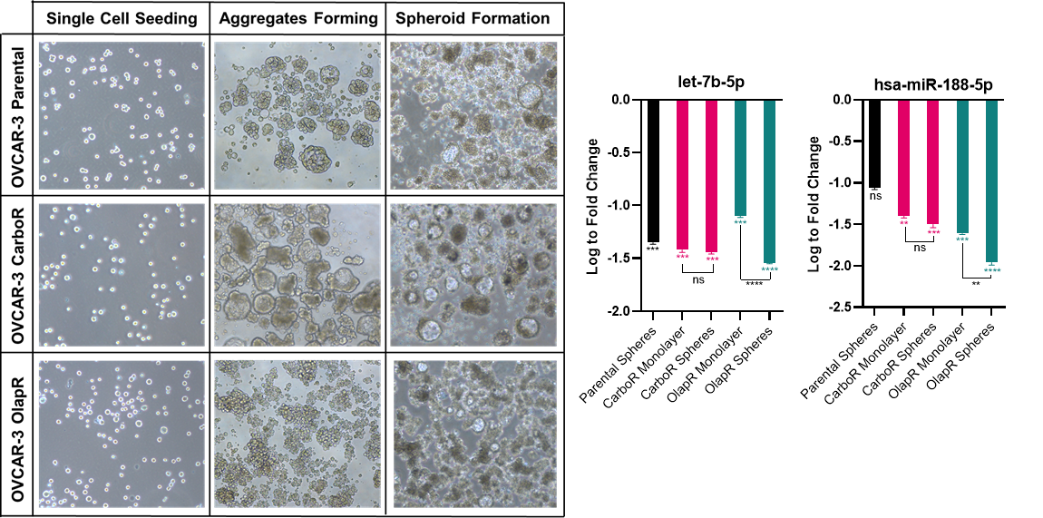
Supplementary Figure 1: Spheroid formation capacity and miRNA expression changes in OVCAR-3 parental and drug-resistant cell strains.
OVCAR-3 Parental, Carboplatin-resistant, and Olaparib-resistant cells were cultured under ultra-low attachment conditions to assess 3D spheroid-forming ability. All three cell strains generated compact, multicellular spheroids, representative brightfield images are included in the figure. Relative expressions of miR-188-5p and let-7b-5p quantified in spheroids and corresponding 2D monolayer cultures are shown in bar graphs next to the brightfield microscopy images. Across all conditions, spheroid formation was accompanied by downregulation compared to monolayers, most prominently with miR-188-5p and with the greatest downregulation observed in the Olaparib-resistant strain. Values represent log to fold changes. (p < 0.05 = *, p < 0.01= **, p < 0.001 = ***, p < 0.0001 = ****)

Supplementary Table 4: Predicted target genes and associated pathways of selected miRNAs based on TargetScan, miRDB, and miRNet analysis were listed.
miRNA | Predicted Targets | Enriched Pathways (GO/KEGG)
miR-19a-3p / miR-19b-3p | PTEN, PIK3IP1, PMEPA1, STAT1, TGFBR2 | PI3K-Akt signaling, TGF-β/SMAD, EMT regulation
miR-20a-5p / miR-20b-5p / miR-106a-5p | STAT1, E2F1, CDKN1A, PI3KIP1 | Cell cycle progression, apoptosis, DNA repair
miR-146a-5p | IRAK1, TRAF6, NFKB1 | NF-κB pathway, cytokine signaling, EMT
miR-188-5p | BUB3, SUMO2, RAD51D, FOXN2, PTEN, PLCG1, FGF5, SOS2, STAT3 | Cell cycle control, DNA damage response, homologous recombination

Supplementary Table 5: Combination index (CI) analysis of miR-188-5p-transfected OVCAR-3-olaR cells treated with Olaparib. OVCAR-3-olaR cells transfected with either negative control (NC) or miR-188-5p mimic were treated with Olaparib at concentrations of 10 µM, 20 µM, and 40 µM, or left untreated, for 5 days. CI values were calculated to assess the synergistic effect between miR-188-5p and Olaparib. CI values were calculated using the Chou–Talalay method; CI < 1 indicates synergy, CI = 1 additive effect, and CI > 1 antagonism.
OVCAR-3-olaR |  | 188-5p | 188-5p | 188-5p | NC
OLAPARIB  (µM) | 40 | 0.35 |  |  | 1.00
OLAPARIB  (µM) | 20 |  | 0.07 |  | 1.00
OLAPARIB  (µM) | 10 |  |  | 0.02 | 1.00
OLAPARIB  (µM) | 0 | 1.00 | 1.00 | 1.00

