Phenology–soil moisture synchronisation and foliar boron regulate physiological resilience and yield stability of field pea (Pisum sativum L.) in rainfed rice-fallow systems
Supplementary Table S1: Interactive effect of sowing dates and B concentration on plant boron content (ppm), pollen germination (%), and pollen viability (%) of field pea during 2017-18 and 2018-19 cropping season.
 | Plant B (ppm) |  |  | Pollen viability (%) |  |  | Pollen germination (%)
 | 2017-18 | 2018-19 | Pooled | 2017-18 | 2018-19 | Pooled | 2017-18 | 2018-19 | Pooled
S1 B1 | 3.67c | 4.27ab | 3.63c | 80.10c | 81.17bcd | 80.63cd | 86.26b | 87.28b | 86.77b
S1 B2 | 3.56cd | 4.10b | 3.49cd | 83.77c | 83.90bc | 83.83bc | 93.40a | 93.63a | 93.52a
S1 B3 | 4.25a | 3.10efg | 4.31a | 88.33ab | 91.13a | 89.73a | 82.86bd | 83.70cd | 83.28c
S1 B4 | 4.13a | 4.19ab | 4.17a | 89.03c | 90.50a | 89.77a | 93.28a | 93.22a | 93.25a
S2 B1 | 3.93b | 4.50a | 3.93b | 80.27bc | 80.17cd | 80.22d | 83.07bcd | 82.71d | 82.89c
S2 B2 | 4.11a | 3.50cd | 4.13a | 84.27a | 85.53b | 84.90b | 93.51a | 92.33a | 92.92a
S2 B3 | 4.25a | 3.93b | 4.22a | 89.37de | 91.17a | 90.27a | 86.23bc | 86.34bc | 86.29b
S2 B4 | 4.24a | 4.13b | 4.26a | 88.53c | 90.20a | 89.37a | 93.60a | 93.97a | 93.79a
S3 B1 | 3.25fg | 3.60c | 3.18e | 68.63c | 69.73f | 69.18f | 82.21d | 81.04d | 81.63c
S3 B2 | 3.14gh | 3.43cde | 3.16ef | 71.00de | 72.83f | 71.92ef | 82.47d | 80.76d | 81.62c
S3 B3 | 3.34ef | 3.30cdef | 3.32de | 79.70c | 79.20cd | 79.45d | 77.93e | 75.94e | 76.93d
S3 B4 | 3.46de | 3.13ef | 3.48cd | 81.17c | 78.17de | 79.67d | 72.52f | 72.45f | 72.49e
S4 B1 | 2.85i | 3.01fg | 2.63h | 59.03f | 59.27g | 59.15h | 57.33i | 56.89h | 57.11h
S4 B2 | 3.03h | 3.17def | 2.91g | 62.63f | 63.23g | 62.93g | 63.42h | 63.44g | 63.43g
S4 B3 | 3.08h | 2.40h | 3.11f | 72.87de | 74.13ef | 73.50e | 69.06g | 69.32f | 69.19f
S4 B4 | 3.05h | 2.78g | 3.03fg | 73.87d | 73.87ef | 73.87e | 64.46g | 69.50f | 69.98f
S | <0.001 | <0.001 | <0.001 | <0.001 | <0.001 | <0.001 | <0.001 | <0.001 | <0.001
B | <0.001 | <0.001 | <0.001 | <0.001 | <0.001 | <0.001 | <0.001 | <0.001 | <0.001
S×B | <0.05 | <0.001 | <0.001 | NS | NS | NS | NS | NS | NS
S1=10 November, S2=20 November, S3=30 November and S4=10 December; B₁: no spray, B₂: 0.1% boric acid, B₃: 0.2% boric acid B₄: 0.3% boric acid spray; Different lower-case letters within same columns are significantly different at p<0.05 according to Duncan multiple range test; NS = non-significant.

Supplementary Table S2: Interactive effect of sowing dates and B concentration on yield (kg ha⁻¹) and yield attributing characters of field pea during 2017-18 and 2018-19 cropping season.
 | Seed yield (kg ha⁻¹) |  |  | Pods plant⁻¹ |  |  | Seeds pod⁻¹
 | 2017-18 | 2018-19 | Pooled | 2017-18 | 2018-19 | Pooled | 2017-18 | 2018-19 | Pooled
S1 B1 | 1253f | 1280f | 1266f | 10.82bc | 10.87bc | 15.33a | 3.71de | 3.76de | 3.73de
S1 B1 | 1383d | 1413d | 1398d | 11.82b | 11.70b | 15.05a | 4.15bcd | 4.20bcd | 4.18bcd
S1 B3 | 1491bc | 1523bc | 1507bc | 14.54a | 15.25a | 14.89a | 4.43b | 4.48b | 4.46b
S1 B4 | 1474c | 1506c | 1490c | 14.37a | 14.77a | 14.57a | 4.07bcd | 4.13bcd | 4.10bcd
S2 B1 | 1334e | 1363e | 1348e | 10.94bc | 11.27b | 11.76b | 3.73de | 3.78de | 3.76de
S2 B2 | 1476c | 1507c | 1491c | 11.40b | 11.72b | 11.56b | 4.87a | 4.93a | 4.90a
S2 B3 | 1557a | 1590a | 1574a | 15.10a | 15.56a | 11.10b | 4.38b | 4.44b | 4.41b
S2 B4 | 1529ab | 1562ab | 1546ab | 14.92a | 15.17a | 10.85bc | 4.35b | 4.41b | 4.38b
S3 B1 | 962h | 983h | 973h | 8.01de | 8.25de | 10.11c | 3.52ef | 3.56ef | 3.54ef
S3 B2 | 1087g | 1110g | 1099g | 8.83d | 8.94d | 9.96c | 3.87cde | 3.91 | 3.89cde
S3 B3 | 1285f | 1313f | 1299f | 9.92c | 10.01c | 8.97d | 4.28bc | 4.34bc | 4.31bc
S3 B4 | 1254f | 1281f | 1267f | 10.02c | 10.20c | 8.89d | 4.11bcd | 4.16bcd | 4.13bcd
S4 B1 | 630k | 644k | 637k | 6.01f | 6.21f | 8.82d | 2.78h | 2.81h | 2.79h
S4 B2 | 757j | 773j | 765j | 7.35e | 7.59e | 8.13de | 2.97gh | 2.80gh | 2.78gh
S4 B3 | 878i | 897i | 888i | 8.88d | 9.06d | 7.47e | 3.20fg | 3.01gh | 2.99gh
S4 B4 | 863i | 882i | 872i | 8.71d | 8.94d | 6.11f | 2.77gh | 3.24fg | 3.22fg
S1=10 November, S2=20 November, S3=30 November and S4=10 December; B₁: no spray, B₂: 0.1% boric acid, B₃: 0.2% boric acid B₄: 0.3% boric acid spray; Different lower-case letters within same columns are significantly different at p<0.05 according to Duncan multiple range test; NS = non-significant.

Supplementary Fig. 1. Relationship between Relative leaf water content and proline content with root zone soil moisture storage.

Supplementary Fig. S2. Relationship between photosynthetic rate and leaf area index.
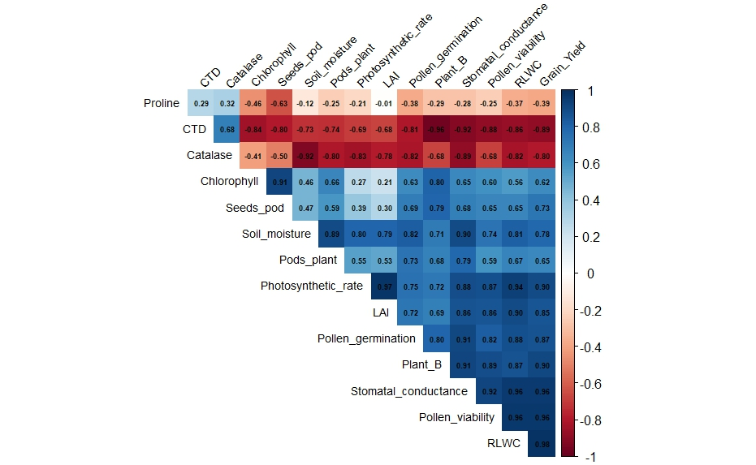
Supplementary Fig. S3. Correlation plot of physiological and reproductive traits.

