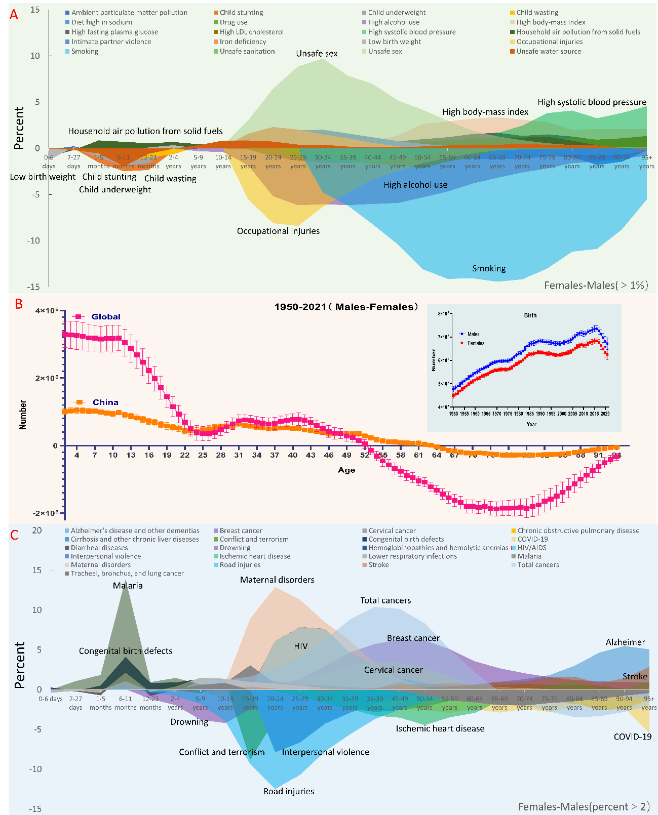
Graphic Abstract: The differing numbers of men and women are influenced by birth rates, whereas the disparities in mortality from injuries, communicable diseases, and cancer contribute to the predominance of women over men in the elderly population. A) Age-related gender differences in risks; B) Global and Chinese male-female population differences from 1950 to 2021; C) Age-related gender differences in causes.

