Supplementary Methods

Extended Framework Details
While the main manuscript describes the modular framework for query formulation, retrieval, and execution, the following details provide additional insights into operational implementation:
Embedding and Indexing
- All patient histories and guideline content were embedded using the multilingual BAAI/bge-m3 model (commit 5617a9f, Jul 3, 2024), based on XLM-RoBERTa, optimized for clinical terminology and German-English translations.
- Hierarchical indexing of guideline corpora was performed with LlamaIndex, creating a multi-level tree structure with chapters, subchapters, tables, and images converted to text for retrieval.
- JSON serialization was applied to all tabular content.
Corpus Preparation
- Two parallel guideline corpora were maintained:
  - Full corpus: complete content from German S3 and NCCN guidelines, including background, epidemiology, and diagnostic details.
  - Curated corpus: filtered to exclude non-actionable content (risk factors, prevention, general diagnostics), emphasizing sections most relevant for Multidisciplinary Tumor Board (MDT) decision-making.
- For each query, up to five chunks were retrieved based on semantic similarity, ensuring focused recommendations while minimizing irrelevant context.
Prompt Engineering
- Prompts were structured according to the C.R.E.A.T.E. framework (Context, Role, Explicit Instruction, Action, Tone, Examples). Examples are shown below and in the public repository.
- The model was consistently assigned the role of a multidisciplinary oncology board, instructed to provide concise, German-language recommendations directly addressing the clinical question.
- For RAG-enabled prompts, retrieved guideline chunks were appended below the case description. Prompts emphasized actionable next steps and discouraged generic or non-committal responses.
Query Rewriting
- GPT-4o-mini was used to generate rewritten queries, converting German clinical notes into structured English text aligned with guideline terminology.
- Rewriting focused on removing ambiguous phrasing, clarifying sequencing of prior therapies, and explicitly stating clinical questions, thereby improving retrieval relevance and model interpretability.

Prompt Examples
To illustrate how prompts were formulated across different configurations, representative examples are provided below based on a single esophageal cancer case. These examples are demonstrative only and show query rewriting, simple requests, ChatGPT-assisted retrieval, and custom RAG prompts.

1. Rewriting Prompt - Used to convert the original German MDT case into a standardized, guideline-aligned English format for retrieval and model input:
“I would like to use the following clinical case in a Retrieval-Augmented Generation (RAG) workflow, referencing oncological guidelines to determine the next therapeutic step.
Please rewrite the case in a concise and standardized format, using clinical terminology and structure typically found in oncology guidelines.
Return only the reformulated case, without additional commentary.
#########
Clinical case: [ORIGINAL CASE]“

2. Simple Request (No Retrieval) - Direct query to the model without guideline retrieval:
“You are a multidisciplinary oncological board with surgeons, oncologists, radiologists, radiation oncologists, and pathologists. Determine the next therapeutic step for the patient. Patient details are enclosed within triple single quotation marks (''' ''').
If a clinical question ('Fragestellung') is present, answer precisely; otherwise, respond based on expertise. Do not suggest referral or further discussion. Answer in German, 1–2 sentences, starting with 'Das Board empfiehlt'.
### Actual case:
'''[ORIGINAL CASE or REWRITTEN CASE]''' “

3. ChatGPT Assistant Prompt - Query using the assistant with full guideline PDFs:
“You are a multidisciplinary oncological board (surgeons, oncologists, radiologists, radiation oncologists, pathologists). Determine the next therapeutic step based on patient details and attached guidelines.
Patient details are enclosed within triple single quotation marks under 'Actual Case' (''' '''). Analyze the case in the context of the guidelines (attached files) and provide a concise German recommendation in 1–2 sentences, starting with 'Das Board empfiehlt'.
### Actual case:
'''[ORIGINAL CASE or REWRITTEN CASE]''' ”

4. Custom RAG Prompt (Full or Selected Corpora) - Retrieval-augmented prompt including selected guideline excerpts:
“You are a multidisciplinary oncological board (surgeons, oncologists, radiologists, radiation oncologists, pathologists). Determine the next therapeutic step for the patient based on:
1. Patient clinical details under 'Actual Case' (''' ''')
2. Relevant guideline excerpts under 'Context' (''' ''')
Formulate a concise German recommendation in 1–2 sentences, starting with 'Das Board empfiehlt'.

### Actual case:
'''[ORIGINAL CASE or REWRITTEN CASE]'''

### Context [example from REWRITTEN CASE]:
'''- Chunk 153 - NCCN Guidelines: Preoperative Chemoradiation for esophageal adenocarcinoma […]
- Chunk 157 - NCCN Guidelines: Follow-up and surveillance […]
- Chunk 151 - NCCN Guidelines: Tumor classification and primary treatment options […]
- Chunk 42 - Surgical principles and preoperative staging […]
- Chunk 83 - Survivorship considerations […]''' ”

Recommendation Classification – Detailed Criteria
MDT and LLM-generated recommendations were independently classified by two clinicians blinded to the study framework and the original recommendations into the nine therapeutic categories listed in Supplementary Table S4. Classification was guided by the dominant therapeutic intent, with accompanying diagnostic or supportive measures not altering the primary category.
Additional notes:
- Multiple recommended therapies: when multiple treatment options were documented by the MDT, LLM recommendations were considered concordant if they matched any accepted option.
- Intended therapeutic plan determines classification:
  - If therapy has already started, classification reflects the current stage.
  - Hypothetical or uncertain tumor resectability is classified according to the intended therapy.
  - Combined diagnostic and planned therapeutic procedures are classified according to the planned therapy.
- Dominant intent guides categorization: Supportive or diagnostic measures accompanying a recommendation do not change the primary category.

Discordant Case Analysis
- To evaluate recommendations where AI differed from the tumor board, discordant outputs were reviewed by two independent board-certified oncologists, blinded to model identity.
- Recommendations were classified as:
  - Off-base: clinically inappropriate or not guideline-supported.
  - Alternative: plausible, guideline-supported options differing from the MDT recommendation.
- Consensus was used as the final classification, providing insight into the clinical validity of AI “errors.”

RAG Chunk Analysis
- For each retrieval configuration, the number of retrieved chunks containing graphical elements (e.g., figures, flowcharts, or schematic diagrams) that had been converted to text was quantified to assess the contribution of graphical information to the generated recommendations.
- Jaccard similarity indices were computed to compare chunk overlap across configurations, evaluating the impact of query rewriting and corpus selection on retrieved evidence.

Framework Performance Stratification
- Concordance per case across all 16 configurations was stratified as:
  - Mostly Wrong (≤30% concordance)
  - Mostly Correct (>90% concordance)
  - Fully Concordant (100% concordance)
- Inter-framework variability was quantified as the number of distinct treatment suggestions generated per case, providing a measure of model consistency and sensitivity to configuration changes.

Implementation Environment
- The framework was executed using Python 3.8, integrating LlamaIndex v0.11.23, pymupdf4llm v1.24, and HuggingFace transformers for embedding.
- GPT models were accessed via the OpenAI API with temperature set at 0.2 and Top P at 1.0 to balance deterministic responses with coverage of plausible clinical recommendations.

Supplementary Results

Performance by Tumor Type, Consultation Context, and Recommendation Category
Detailed subgroup analyses revealed substantial heterogeneity in framework performance across clinical contexts, reflecting differences in treatment pathway standardization, documentation completeness, and decision complexity.

Tumor Type Performance
Concordance varied substantially by cancer type, with tumor entities governed by highly standardized treatment pathways showing superior performance (Supplementary Figure S2). Esophageal and pancreatic cancers achieved 100% concordance in optimal configurations, demonstrating that straightforward guideline-aligned cases can be handled robustly across multiple framework designs. Gastric cancer reached 95% concordance without rewriting but with curated retrieval and GPT-4o.
Colorectal cancer showed the greatest improvement from framework optimization, advancing from 80% concordance at baseline to 90% in optimized configurations. This substantial gain suggests that retrieval augmentation and query reformulation are particularly valuable for tumor types with moderately complex treatment algorithms.
Hepatobiliary cancers proved most challenging across all frameworks. GPT-4o configurations improved from 75% baseline to 95% through systematic optimization, demonstrating that even difficult tumor types can benefit from framework refinement.

Consultation Type Performance
Follow-up consultations demonstrated higher baseline concordance (80% GPT-4o-mini, 88% GPT-4o) than first presentations (78–82%), likely reflecting more complete and structured documentation in follow-up scenarios (Supplementary Figure S3).
Both consultation types improved substantially with framework optimization. First presentations cases reached 92% (GPT-4o-mini) and 94% (GPT-4o) concordance, while follow-up cases achieved 94% and 96% respectively. Optimized frameworks substantially narrowed the performance gap between consultation types, suggesting that appropriate framework design—particularly query rewriting and curated retrieval—can partially compensate for the greater documentation variability and incompleteness typical of initial presentations.
When stratified by both tumor type and consultation context simultaneously, distinct patterns emerged (Supplementary Figure S4). Esophageal cancer showed notably strong performance across both initial and follow-up presentations, with several configurations with GPT-4o achieving 100% concordance at first presentation—particularly when using rewritten queries and curated corpus retrieval.
Gastric cancer exhibited a clear performance gap between first and follow-up presentations. While follow-up cases consistently reached concordance ~90%, first presentations were more variable. Some configurations (e.g., ChatGPT Assistant with query rewriting) dropped as low as 60%, suggesting heightened sensitivity to input formulation and likely greater clinical ambiguity in initial documentation for this tumor type.
Pancreatic cancer was handled robustly across all configurations, with multiple approaches achieving perfect or near-perfect concordance in both presentation contexts—consistent with highly standardized treatment algorithms for this tumor entity.
Colorectal cancer results were more mixed. First presentations showed slightly higher performance in rewritten configurations, whereas follow-up consultations had higher baseline performance with GPT-4o and greater variability. Some frameworks rewriting achieved only 60–70% concordance on cases handled with ChatGPT Assistant, suggesting that unrestricted document ingestion alone is insufficient for reliable clinical decision support.
Hepatobiliary cancer emerged as the most challenging tumor type, especially in initial presentations. Several configurations underperformed in this group, with concordance rates dropping to 50–70% with ChatGPT Assistant. Performance improved substantially at follow-up consultations, with rewritten configurations reaching 100% concordance. This pattern suggests that hepatobiliary cases present unique challenges related to their clinical heterogeneity (cirrhosis, transplant candidacy, multifocal disease) that are partially mitigated as documentation becomes more complete through the treatment course.

Recommendation Type Performance
Performance also varied substantially by treatment recommendation category, reflecting differences in guideline specificity and clinical complexity (Supplementary Figures S5 Part 1 and 2). Systemic therapy recommendations achieved consistently high concordance (≥90% across all configurations), likely reflecting well-codified treatment algorithms with clear eligibility criteria in modern oncology guidelines.
Localized therapies (radiation, ablation) and endoscopic resections were more variable, showing 50–63% concordance at baseline but improving to 88% with optimized approaches. This improvement suggests these treatment modalities benefit particularly from enhanced guideline retrieval, possibly because relevant content is distributed across multiple guideline sections or presented primarily in graphical formats.
Surgical recommendations showed moderate variability (69–90% concordance), with performance depending substantially on framework configuration. This heterogeneity likely reflects the complexity of surgical candidacy assessment, which requires integration of anatomic, functional, and patient-specific factors not fully captured in guideline text.
Multistep therapies (sequential treatment approaches) reached 74–95% concordance, while multimodal therapies (concurrent or integrated approaches) achieved 58–100% concordance. Multimodal therapy recommendations achieved perfect agreement in several optimized configurations. This difference may reflect greater algorithmic complexity in sequencing decisions compared to concurrent treatment selection.
The average number of distinct treatment suggestions generated per case across all frameworks ranged from 1.45 for systemic therapy (indicating high framework consistency) to 2.75 for local therapies.

Supplementary Tables
Baseline Characteristics | Overall  (N = 100) | Esophageal-Ca  (N = 20) | Gastric-Ca  (N = 20) | Pancreatic-Ca  (N = 20) | Hepatobiliary-Ca  (N = 20) | Colorectal-Ca  (N = 20)
Age, Median (IQR) | 64.5 (56-71) | 65 (60-70) | 67 (61-73) | 67 (61-74) | 59 (50-70) | 62 (54-67)
Gender
Male, N (%) | 64 | 15 (75%) | 10 (50%) | 14 (70%) | 13 (65%) | 12 (60%)
Female N (%) | 36 | 5 (25%) | 10 (50%) | 6 (30%) | 7 (35%) | 8 (40%)
Recommended Therapies by the MDT
Best Supportive Care, N (%) | 1 (1.0%) | - | 1 (5.0%) | - | - | -
- FP N (%) | 1 (2.0%) | - | 1 (10.0%) | - | - | -
- FOLLOW-UP N (%) | - | - | - | - | - | -
Diagnostik, N (%) | 1 (1.0%) | - | 1 (5.0%) | - | - | -
- FP N (%) | - | - | - | - | - | -
- FOLLOW-UP N (%) | 1 (2.0%) | - | 1 (10.0%) | - | - | -
Endoscopic Resection, N (%) | 2 (2.0%) | - | 2 (10.0%) | - | - | -
- FP N (%) | - | - | - | - | - | -
- FOLLOW-UP N (%) | 2 (4.0%) | - | 2 (20.0%) | - | - | -
Active Surveillance, N (%) | 4 (4.0%) | - | 1 (5.0%) | - | - | 3 (15.0%)
- FP N (%) | 1 (2.0%) | - | - | - | - | 1 (10.0%)
- FOLLOW-UP N (%) | 3 (6.0%) | - | 1 (10.0%) | - | - | 2 (20.0%)
Multimodal, N (%) | 7 (7.0%) | 7 (35.0%) | - | - | - | -
- FP N (%) | 6 (12.0%) | 6 (60.0%) | - | - | - | -
- follow-up n (%) | 1 (2.0%) | 1 (10.0%) | - | - | - | -
Multistep, N (%) | 19 (19.0%) | 3 (15.0%) | 6 (30.0%) | 1 (5.0%) | 1 (5.0%) | 8 (40.0%)
- FP N (%) | 12 (24.0%) | 2 (20.0%) | 5 (50.0%) | 1 (10.0%) | - | 4 (40.0%)
- FOLLOW-UP N (%) | 7 (14.0%) | 1 (10.0%) | 1 (10.0%) | - | 1 (10.0%) | 4 (40.0%)
Surgery, N (%) | 29 (29.0%) | 3 (15.0%) | 5 (25.0%) | 11 (55.0%) | 7 (35.0%) | 3 (15.0%)
- FP N (%) | 16 (32.0%) | - | 4 (40.0%) | 6 (60.0%) | 4 (40.0%) | 2 (20.0%)
- FOLLOW-UP N (%) | 13 (26.0%) | 3 (30.0%) | 1 (10.0%) | 5 (50.0%) | 3 (30.0%) | 1 (10.0%)
Systemic Therapy, N (%) | 29 (29.0%) | 6 (30.0%) | 4 (20.0%) | 7 (35.0%) | 7 (35.0%) | 5 (25.0%)
- FP N (%) | 11 (22.0%) | 2 (20.0%) | - | 3 (30.0%) | 4 (40.0%) | 2 (20.0%)
- FOLLOW-UP N (%) | 18 (36.0%) | 4 (40.0%) | 4 (40.0%) | 4 (40.0%) | 3 (30.0%) | 3 (30.0%)
Local Therapy N (%) | 8 (8.0%) | 1 (5.0%) | - | 1 (5.0%) | 5 (25.0%) | 1 (5.0%)
- FP N (%) | 3 (6.0%) | - | - | - | 2 (20.0%) | 1 (10.0%)
- FOLLOW-UP N (%) | 5 (10.0%) | 1 (10.0%) | - | 1 (10.0%) | 3 (30.0%) | -

Supplementary Table S1. Patient demographics, baseline clinical characteristics, and tumor board treatment recommendations across tumor subgroups. Values are reported as median (interquartile range) for continuous variables and number (percentage) for categorical variables. Subgroups include patients with esophageal, gastric, pancreatic, hepatobiliary, and colorectal cancers (N = 20 per group). Abbreviations: FP = First Presentation; Ca = Cancer, MDT = Multidisciplinary Tumorboard

Configuration | Model | Concordance (%) | 95% CI (%)
No retrieval | GPT-4o-mini | 79 | 70.02–85.83
No retrieval | GPT-4o | 85 | 76.72–90.69
Assistant with guidelines | GPT-4o-mini | 79 | 70.02–85.83
Assistant with guidelines | GPT-4o | 82 | 73.33–88.30
RAG w/ Full Corpora | GPT-4o-mini | 82 | 73.33–88.30
RAG w/ Full Corpora | GPT-4o | 86 | 77.86–91.47
RAG w/ Selected Corpora | GPT-4o-mini | 84 | 75.58–89.90
RAG w/ Selected Corpora | GPT-4o | 87 | 79.02–92.24
rw-No retrieval | GPT-4o-mini | 87 | 79.02–92.24
rw-No retrieval | GPT-4o | 87 | 79.02–92.24
rw-Assistant with guidelines | GPT-4o-mini | 80 | 71.12–86.66
rw-Assistant with guidelines | GPT-4o | 83 | 74.45–89.11
rw-RAG w/ Full Corpora | GPT-4o-mini | 89 | 81.37–93.75
rw-RAG w/ Full Corpora | GPT-4o | 92 | 85.00–95.89
rw-RAG w/ Selected Corpora | GPT-4o-mini | 93 | 86.25–96.57
rw-RAG w/ Selected Corpora | GPT-4o | 95 | 88.82–97.85
Supplementary Table S2. Concordance of LLM with tumor board recommendations across experimental configurations (n = 100 cases per configuration). RAG: retrieval-augmented generation, rw: rewritten input. 95% confidence intervals were calculated using the Wilson method.

Input Type | Retrieval Method
Original Case | No Retrieval
Original Case | Assistant w/ Guidelines PDF
Original Case | RAG w/ Full Corpora
Original Case | RAG w/ Selected Corpora
Rewritten Case | No Retrieval
Rewritten Case | Assistant w/ Guidelines PDF
Rewritten Case | RAG w/ Full Corpora
Rewritten Case | RAG w/ Selected Corpora

Supplementary Table S3. Overview of the eight framework configurations combining input formulation and retrieval strategies. Each framework was subsequently paired with two model variants (GPT-4o and GPT-4o-mini), resulting in 16 unique experimental settings.

Category | Definition & Key Criteria
1. Best Supportive Care | Palliative or symptom-oriented management only, without intent to modify tumor progression. Includes local stent placement for symptom relief.
2. Further Diagnostic Procedures | Standalone diagnostic measures recommended without a planned therapy. Examples: histological confirmation, endoscopy, EUS-guided biopsy, diagnostic laparoscopy. If a therapeutic plan is outlined after diagnostics (i.e. diagnostic + systemic therapy/surgery), classify according to that therapy.
3. Endoscopic Intervention | Therapeutic endoscopic procedures, e.g., endoscopic resection or full-thickness endoscopic excision. Excludes purely diagnostic endoscopy.
4. Active Surveillance / Follow-up | Ongoing monitoring or imaging without active therapy. Includes routine follow-up after curative surgery if no adjuvant therapy is planned.
5. Multimodal Therapy | Concurrent use of multiple treatment modalities. Example: radiochemotherapy, chemoradiation. Only concurrent treatments; sequential therapies are classified as Multistep.
6. Multistep Therapy | Sequential treatment strategies where multiple interventions are planned before initiation of therapy. Example: neoadjuvant chemotherapy → surgery → (adjuvant therapy).  Rules:  - If therapy already started, classify based on current stage (e.g., surgery or systemic therapy).  - If tumor resectability is uncertain or only hypothetical, classify the recommendation according to the intended therapy rather than as Multistep.  For example, if systemic therapy is given to see whether the tumor shrinks enough to become resectable, classify it as Systemic Therapy, not Multistep.  - Exception: a diagnostic laparoscopy performed with planned subsequent systemic therapy (e.g., laparoscopy + port placement followed by chemotherapy) is classified as Multistep Therapy.
7. Surgery | Invasive procedures requiring general anesthesia, including transplantation. Excludes purely diagnostic laparoscopy (i.e., laparoscopy performed solely for diagnosis, without a planned therapeutic intervention; if surgery is decided intraoperatively based on exploration findings, classify as Surgery).
8. Systemic Therapy | Systemic anti-cancer therapy, including chemotherapy, immunotherapy, targeted therapy, PRRT, or adjuvant systemic therapy following completed surgery; preoperative or neoadjuvant systemic therapy, if no subsequent surgery is already planned, is also classified as Systemic Therapy.
9. Localized Therapy | Local tumor-directed interventions, e.g., radiotherapy, SBRT, RFA, MWA, TACE or SIRT.

Supplementary Table S4. Therapeutic categories and classification criteria. This table summarizes the nine therapeutic categories used to classify tumor board and LLM-generated recommendations. Each category is defined by the type of intervention or management strategy and key criteria for classification. Abbreviations: SBRT, stereotactic body radiotherapy; RFA, radiofrequency ablation; MWA, microwave ablation; TACE, transarterial chemoembolization; SIRT, selective internal radiation therapy.

Supplementary Figures
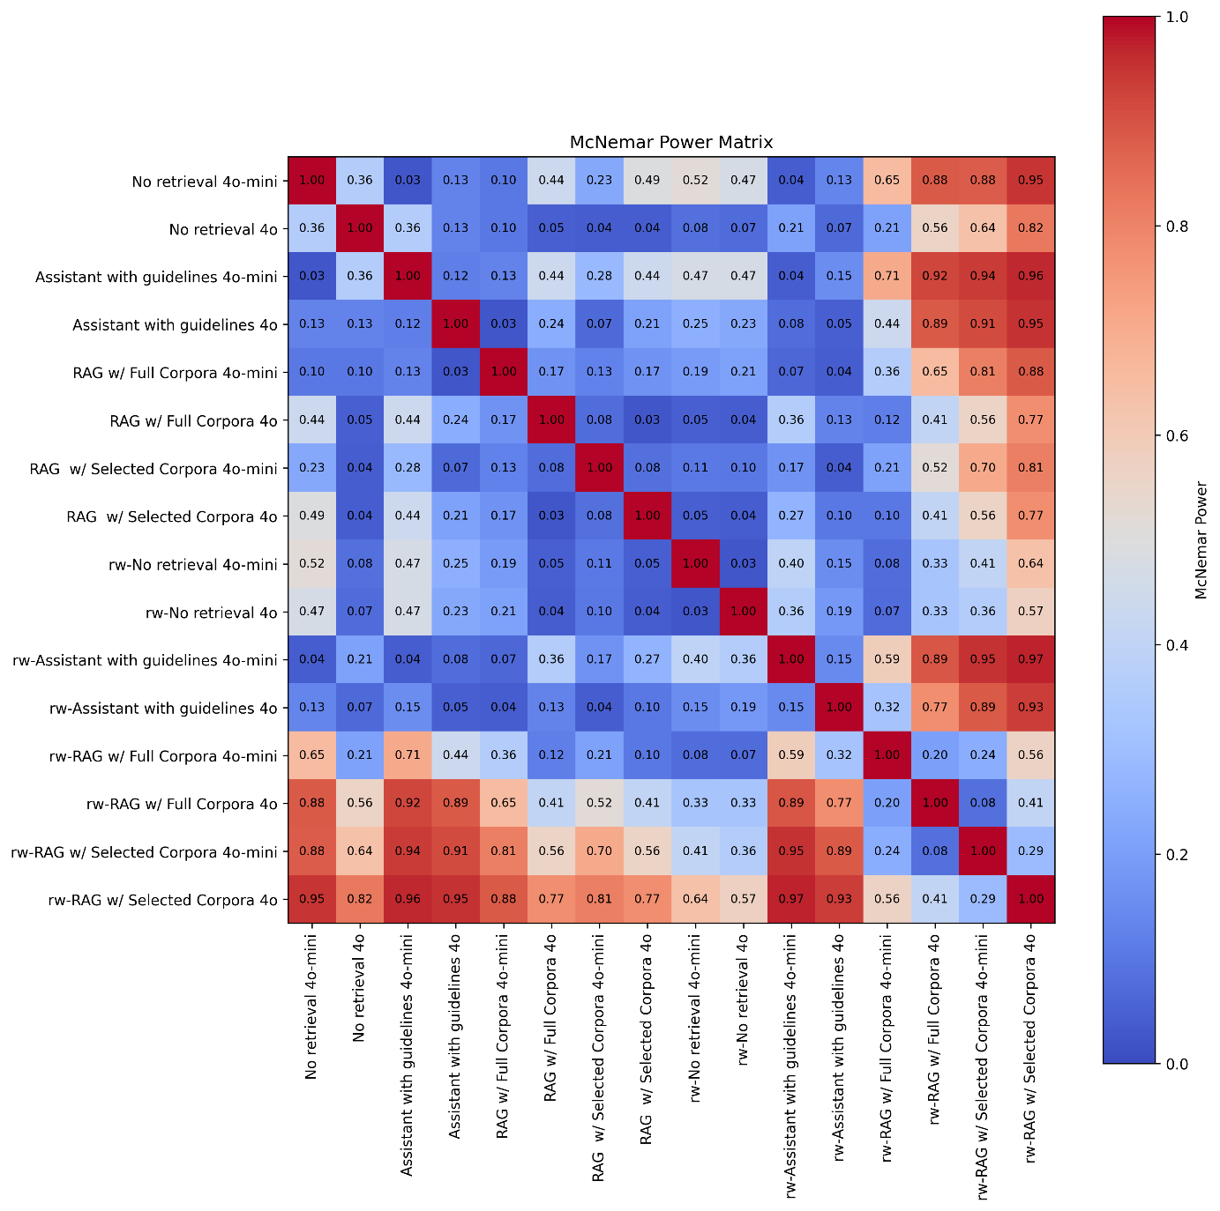
Supplementary Figure S1. McNemar power matrix for pairwise framework comparisons. Each cell shows the estimated statistical power to detect differences between frameworks using McNemar’s test (α = 0.05) based on observed discordant pairs. Reference power values for a sample size of n = 100 are indicated for moderate (20% vs 10%; 0.447) and large (30% vs 10%; 0.885) effects. Higher values indicate greater likelihood of detecting differences between frameworks.

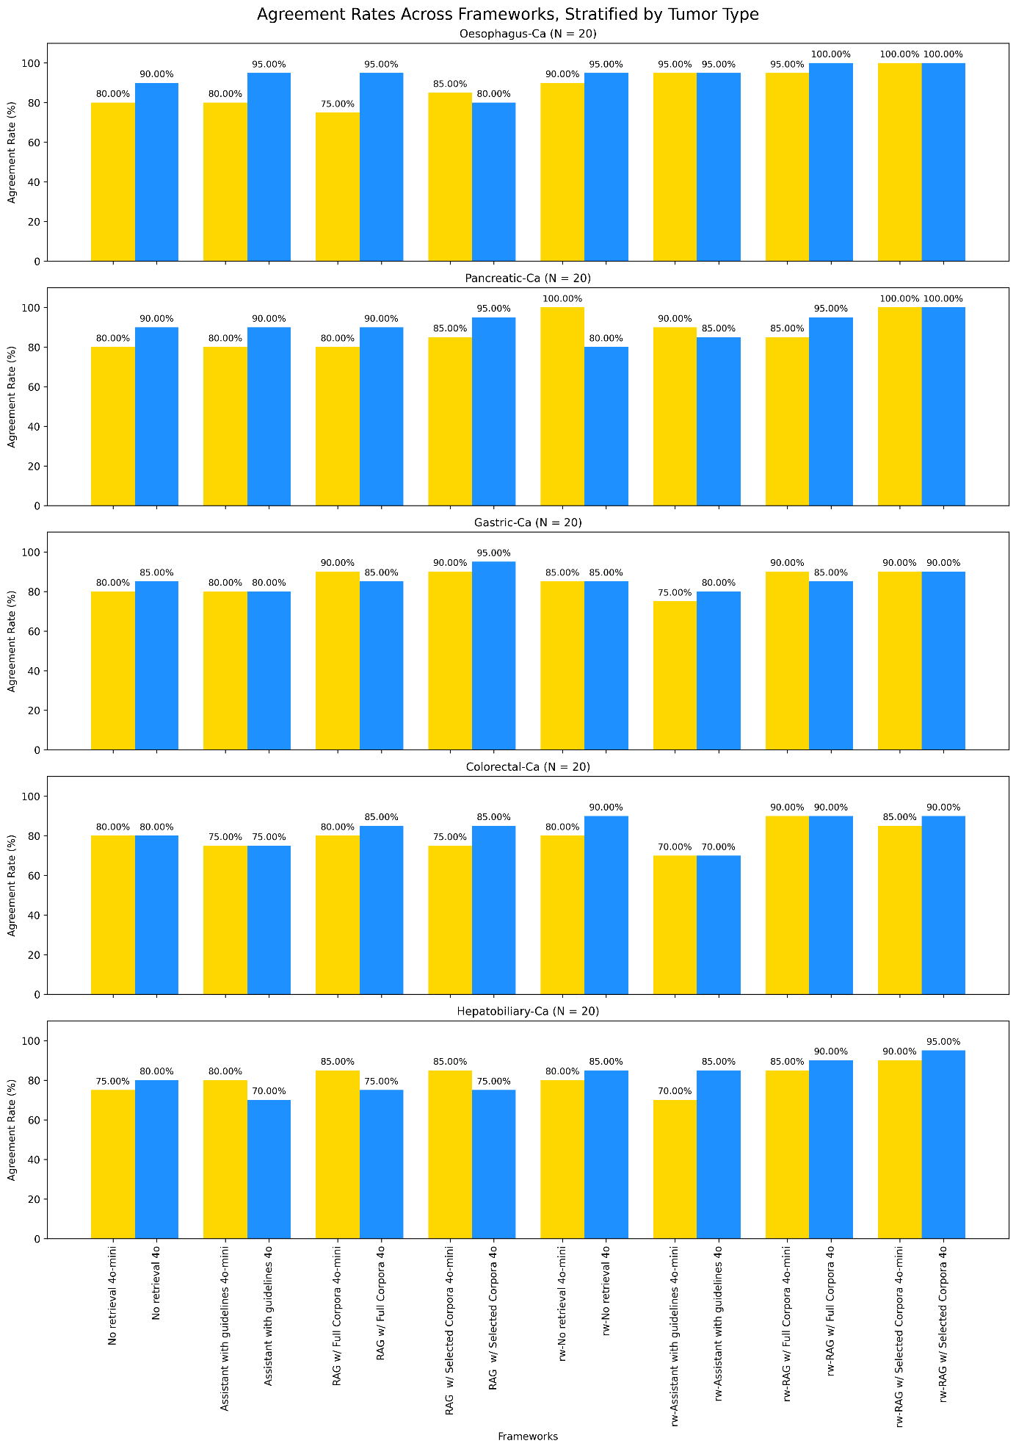
Supplementary Figure S2. Overall concordance rate across 16 framework configurations, stratified by tumor diagnosis. Each concordant or non-concordant answer accounts for 5 percentage points. RAG: retrieval-augmented generation, rw: rewritten input. Yellow bars: GPT-4o-mini, blue bars: GPT-4o.

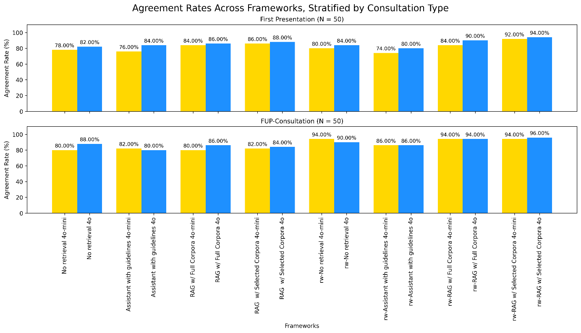
Supplementary Figure S3. Overall concordance rate across 16 framework configurations, stratified by consultation type. Each concordant or non-concordant answer accounts for 2 percentage points. RAG: retrieval-augmented generation, rw: rewritten input. Yellow bars: GPT-4o-mini, blue bars: GPT-4o.

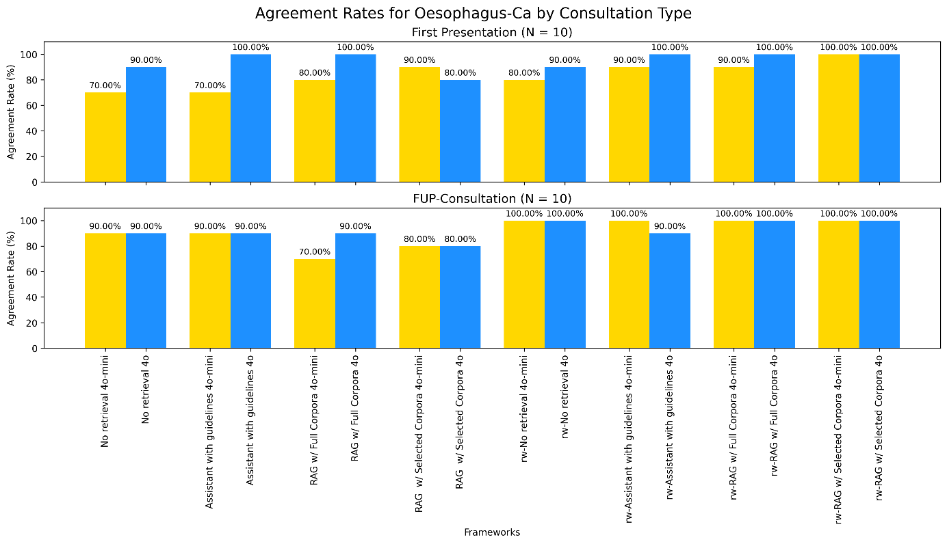
Supplementary Figure S4, Table 1. Esophageal cancer cases by presentation type. Complete legend provided after Table 5.
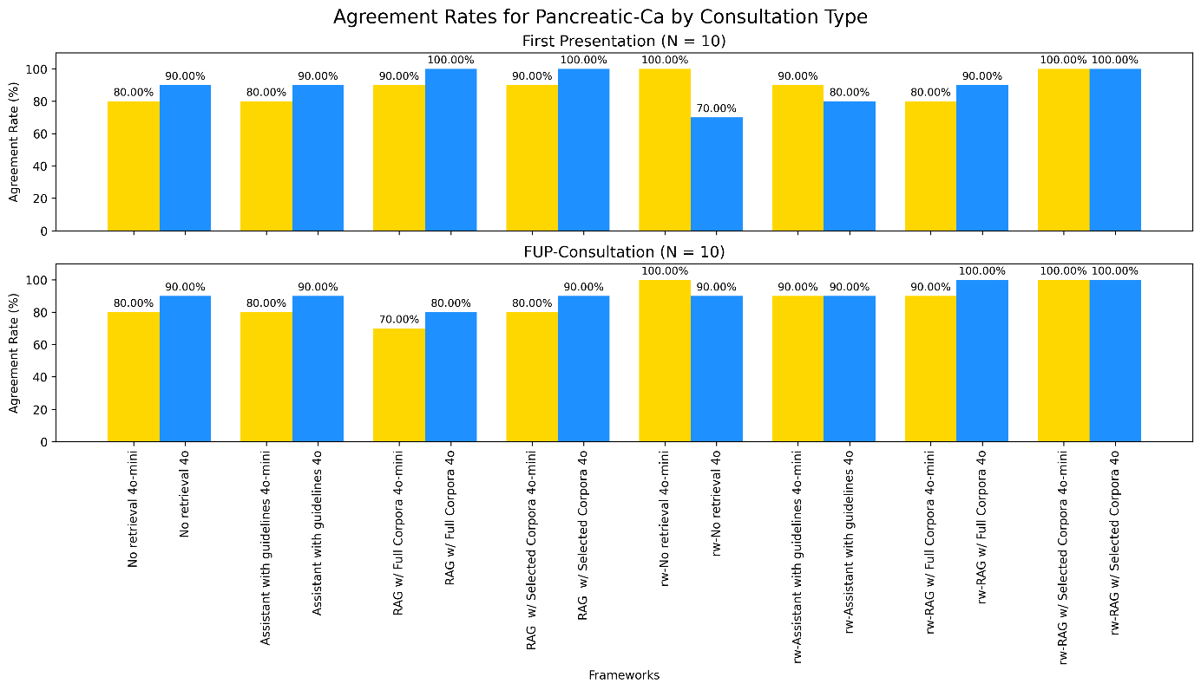
Supplementary Figure S4, Table 2. Pancreatic cancer cases by presentation type. Complete legend provided after Table 5.

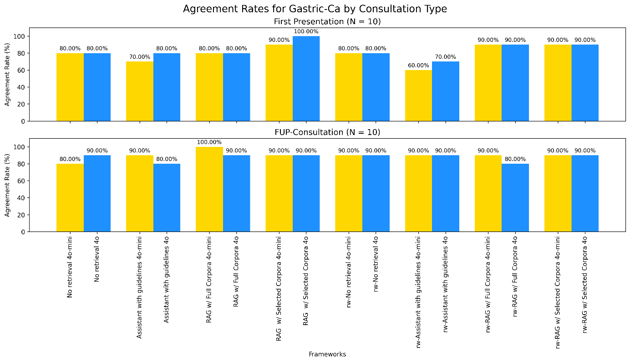
Supplementary Figure S4, Table 3. Gastric cancer cases by presentation type. Complete legend provided after Table 5.

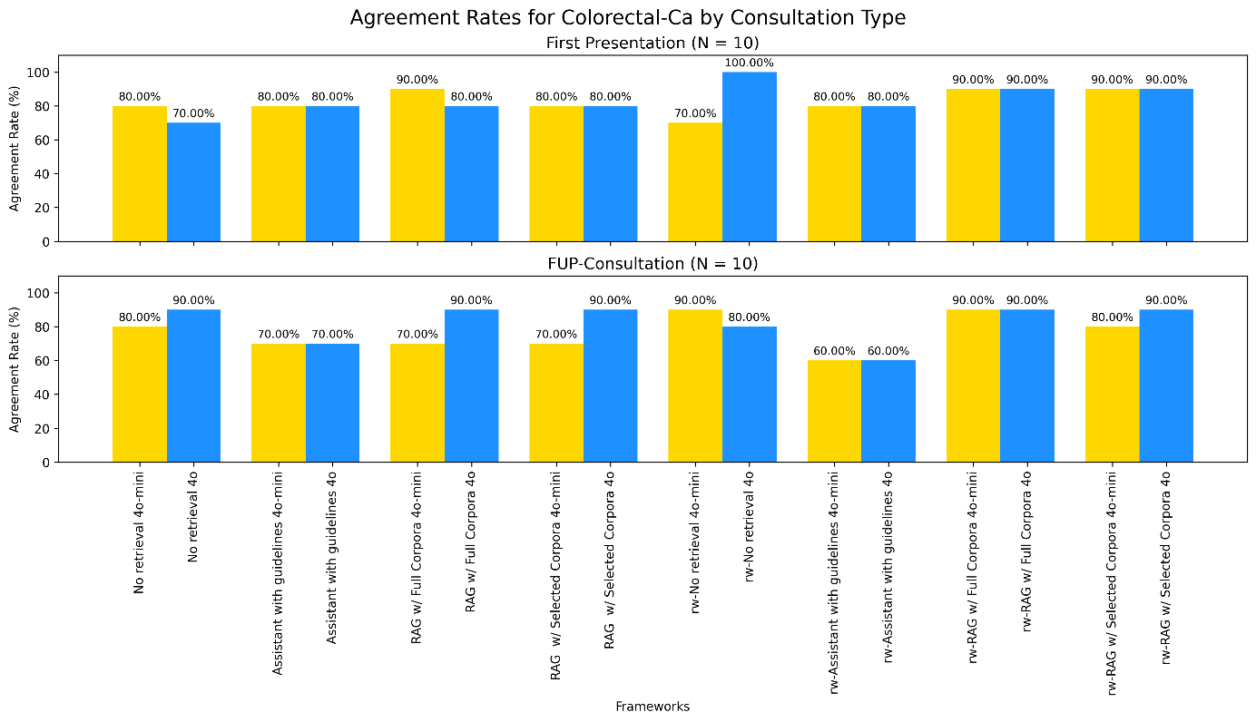
Supplementary Figure S4, Table 4. Colorectal cancer cases by presentation type. Complete legend provided after Table 5.

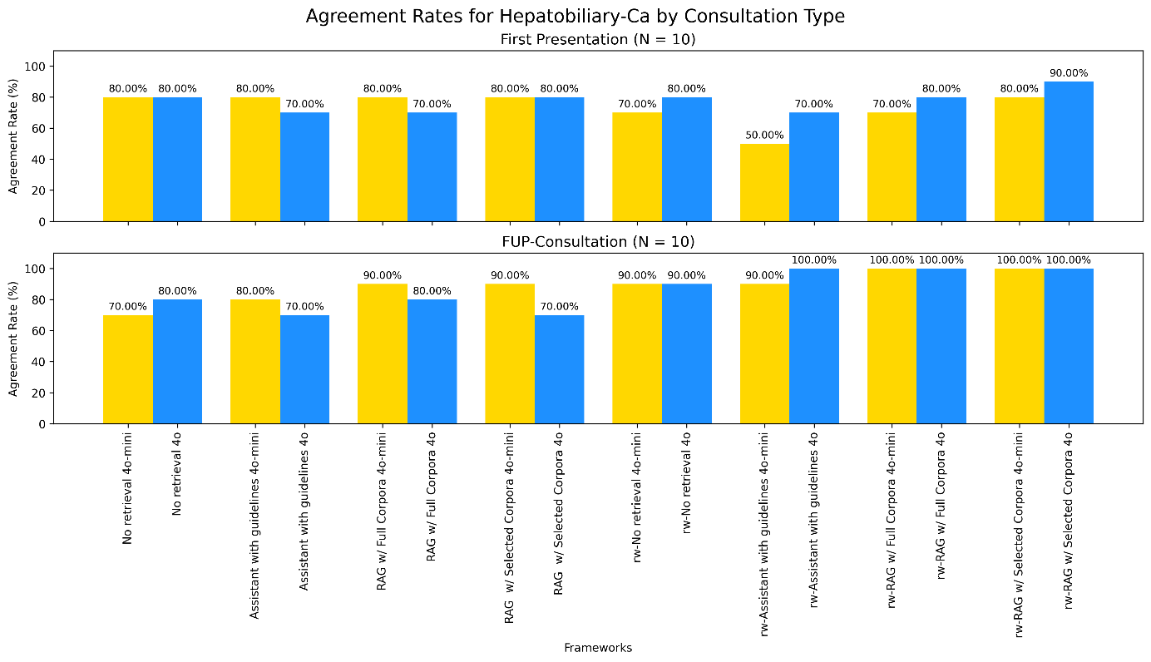
Supplementary Figure S4, Table 5. Hepatobiliary cancer cases by presentation type. Complete legend provided below.
Supplementary Figure S4. Overall concordance rate across 16 framework configurations, stratified by tumor and consultation type. Each concordant or non-concordant answer accounts for 10 percentage points. RAG: retrieval-augmented generation; rw: rewritten input. Yellow bars: GPT-4o-mini, blue bars: GPT-4o.

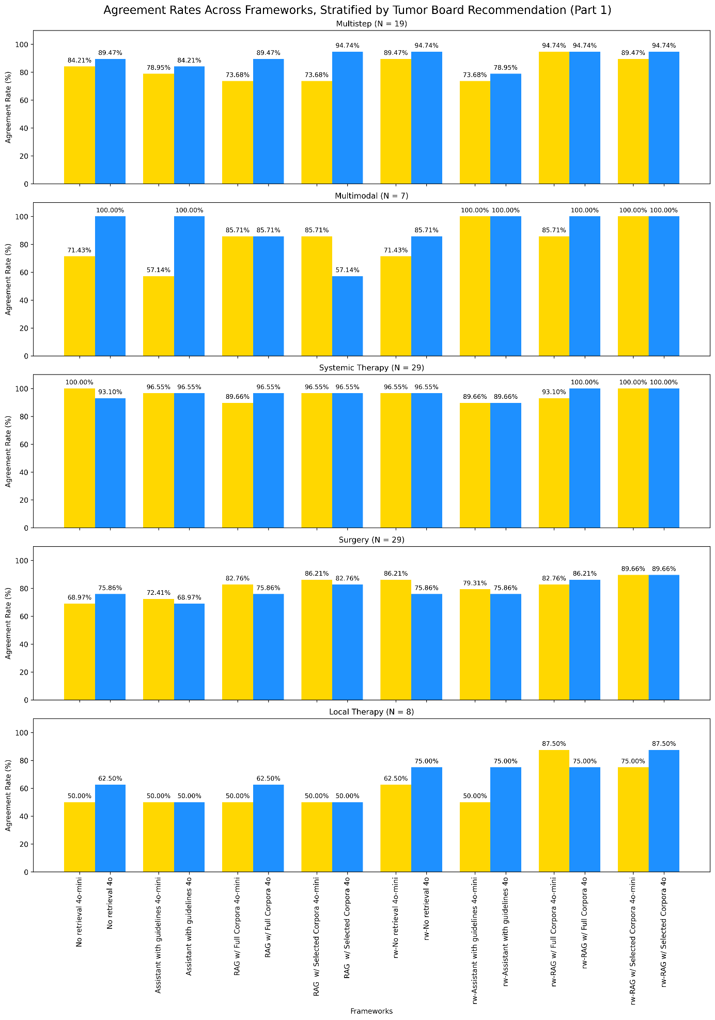
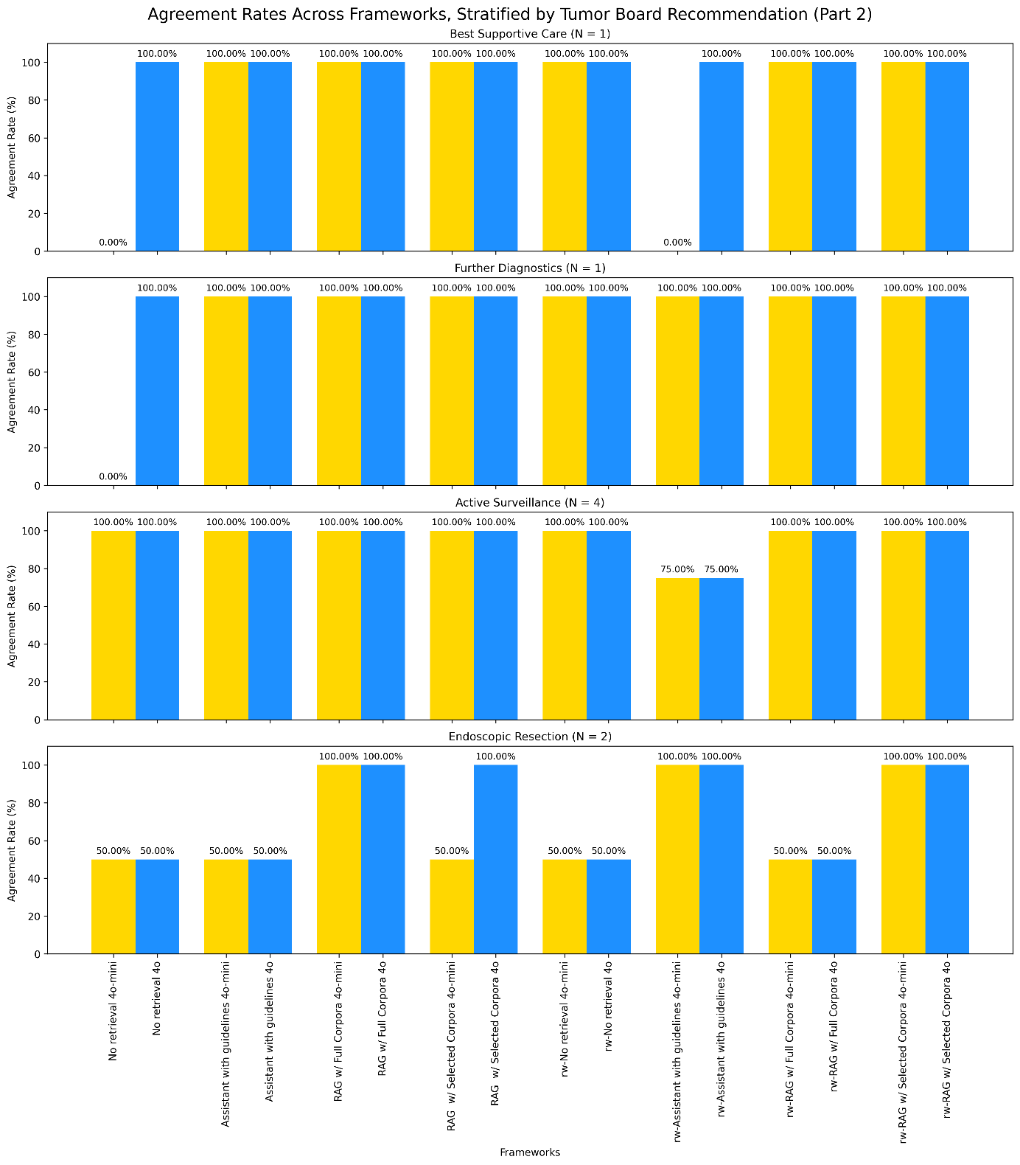
Supplementary Figure S5 Part 1 and 2. Overall concordance rate across 16 framework configurations, stratified by therapeutic recommendation. Each concordant or non-concordant answer contributes proportionally to the total agreement rate, with impact per answer calculated as 100% divided by the number of cases (N) for each therapy category: multistep 5.26%, multimodal 14.29%, systemic therapy 3.45%, surgery 3.45%, local therapy 12.5%, best supportive care 100%, further diagnostics 100%, active surveillance 25%, and endoscopic resection 50%. RAG: retrieval-augmented generation; rw: rewritten input. Yellow bars: GPT-4o-mini, blue bars: GPT-4o.

