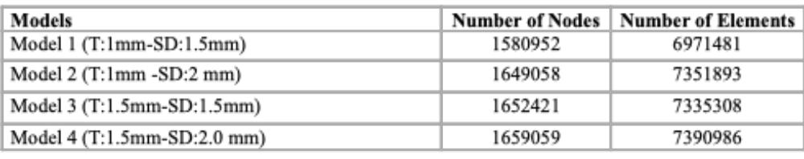
Table 1. Quantitative model parameters for the four generated analyses.
T: Subperiosteal implant thickness; SD: Screw diameter.
Component | Materials | Elastic Modulus (MPa) | Poisson’s Ratio | Reference
Bone | Cortical + Cancellous | 10,000 | 0.30 | [21]
Subperiostal Implant | %60 CFR-PEEK | 150,000 | 0.356 | [22]
Prosthetic Superstructure | Polymethyl methacrylate (PMMA) | 3,000 | 0.34 | [23]

Table 2. Material properties used in the FEA.

Table 3. Finite element analysis results of the maximum total displacement distributions of the subperiosteal implant system under different implant thickness (T) and screw diameter (SD) configurations. The results obtained for three loading protocols (F1: posterior vertical loading, F2: posterior oblique loading, F3: anterior vertical loading) are presented comparatively.)
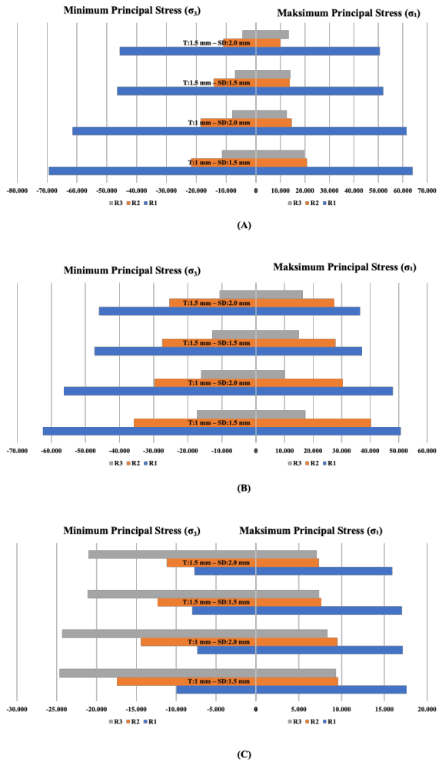
Table 4. presents the maximum and minimum principal stress values observed in the bone tissue under different loading conditions: (A) F1 loading condition, (B) F2 loading condition, and (C) F3 loading condition. Anatomical reference regions used for stress and displacement evaluations in the finite element analysis were defined as R1 (posterior alveolar crest), R2 (premolar alveolar crest), and R3 (periphery of the piriform aperture and adjacent nasal floor).

