SUPPLEMENTARY INFORMATION
Interaction Kinetics of Peptide Lipids-Mediated Gene Delivery
Yinan Zhao¹, Tianyi Zhao², Yanyan Du¹, Yingnan Cao¹, Yang Xuan¹, Huiying Chen¹, Defu Zhi¹, Shutao Guo^{3*}, Fangli Zhong^{4*}, Shubiao Zhang^{1*}
¹ Key Laboratory of Biotechnology and Bioresources Utilization of Ministry of Education, College of Life Sciences, Dalian Minzu University, Dalian 116600, China
² School of Materials Science and Engineering, Zhengzhou University, Zhengzhou 450001, China
³ Key Laboratory of Functional Polymer Materials of Ministry of Education, State Key Laboratory of Medicinal Chemical Biology and Institute of Polymer Chemistry, College of Chemistry, Nankai University, Tianjin 300071, China
⁴ School of Chemistry and Pharmaceutical Engineering, Jilin Institute of Chemical Technology, Jilin 132022, China

* Correspondence: zsb@dlnu.edu.cn; stguo@nankai.edu.cn; fanglizhong@sina.com

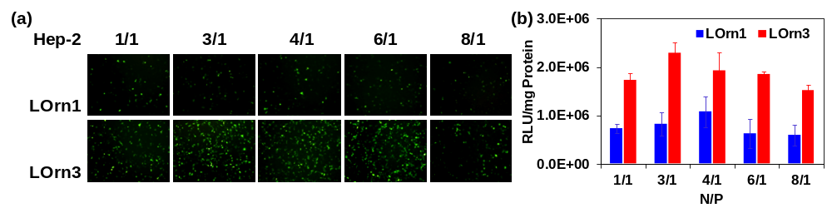
Figure S1. (a) Transfection efficiency of lipoplexes against Hep-2 cells. GFP expression of GFP-N1 was mediated by liposomes LOrn1 and LOrn3 at the N/P ratios of 1:1, 3:1, 4:1, 6:1 and 8:1. The measurement was carried out in cells by using an inverted fluorescence microscope (10×10). (b) Transfection efficiency in Figure (a) was quantified by flow cytometry analysis.

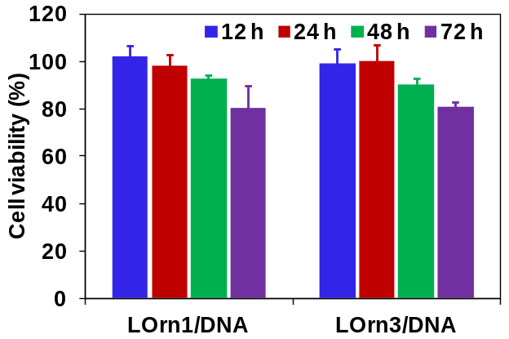
Figure S2. Cell viability assay of HeLa after treating with LOrn1/DNA and LOrn3/DNA lipoplexes for different time by MTT.

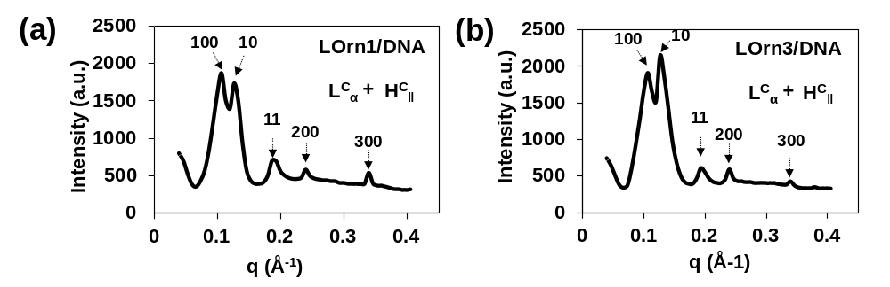
Figure S3. Small angle x-ray scattering patterns of the lamellar L^{C}_{α} and columnar inverted hexagonal H^{C}‖ phases of (a) LOrn1/DNA and (b) LOrn3/DNA lipoplexes at N/P ratios of 4:1 and 3:1, respectively.

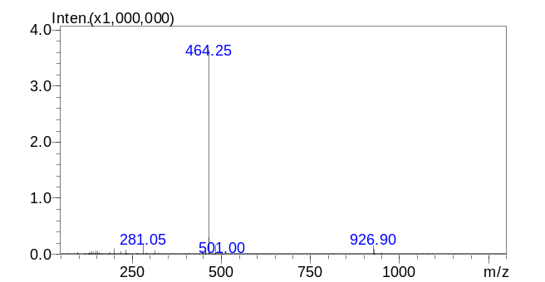
(b)
(a)
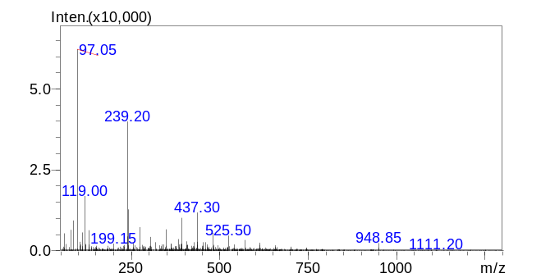
Figure S4. Effect of acid environment on lipid structure was detected by ESI-MS. (a) ESI-MS analysis of lipid under the pH of 7.0, (b) ESI-MS analysis of lipid under the pH of 5.5.

