Fabrication of 2D Bimetallic Metal-Organic Frameworks with Enhanced Oxidase-Like Activity for AA/ALP Sensing and Antibacterial Application
Wei Li¹, Shujing Zhou¹, Jiale Hu¹, Yihong Nan¹, Pei Luo¹, Yun Zhang¹, Ziyuan Li¹, Zhongsheng Yi¹, Jianmei Zou^{1,*}

^{1.}Guangxi Key Laboratory of Electrochemical and Magnetochemical Function Materials, Guilin University of Technology, 12 Jiangan Road, Guilin 541004, China.

* Corresponding author.
E-mail address: 2019136@glut.edu.cn (Jianmei Zou)

Synthesis of Co-MOF and Cu-MOF
1.104 g of Co(NO₃)₂ and 1.8 g of 2-methylimidazole (2-MIM) were separately dissolved in 105 mL of ultrapure deionized water. The two precursor solutions were homogenously mixed and allowed to react under constant magnetic stirring for 2 h. Then, the mixture was transferred to a light-shielded chamber and subjected to static incubation for 24 h. Afterward, the supernatant was decanted, and the precipitate was collected via centrifugation at 5,000 rpm for 5 min. The obtained solid product was sequentially washed twice with deionized water and three times with anhydrous ethanol to remove unreacted precursors and impurities. The product was dried in a vacuum oven at 60°C for 4 h to yield Co-MOF powder, which was thereafter stored in a desiccator for future experimental use.
Cu-MOF was fabricated following the same procedure as Co-MOF, but using an aqueous copper nitrate solution as the metal precursor.
Intracellular protein leakage under Co/Cu-MOF stress
The extent of protein leakage from E. coli and S. aureus under Co/Cu-MOF treatment was quantitatively determined via the Bradford assay[1]. Briefly, the target bacterial strains were exposed to Co/Cu-MOF at a final system concentration of 266.7 μg/mL, followed by incubation at 37°C. The level of protein leakage was measured at two time points (0 h and 24 h). All experimental groups were performed in triplicate under rigorously aseptic conditions to ensure the reliability of the results.
Intracellular nucleic acid leakage under Co/Cu-MOF stress
Agarose gel electrophoresis was employed to analyze nucleic acid leakage and evaluated cell membrane integrity in bacterial. E. coli and S. aureus cells in the logarithmic growth phase were treated with Co/Cu-MOF at final concentrations of 0, 1.0, 2.0, and 4.0×MIC, followed by incubation at 37°C for 24 h. After treatment, bacterial cells were harvested via centrifugation, and nucleic acid was extracted using a commercial DNA extraction kit. The extracted nucleic acid samples were subjected to agarose gel electrophoresis analysis.

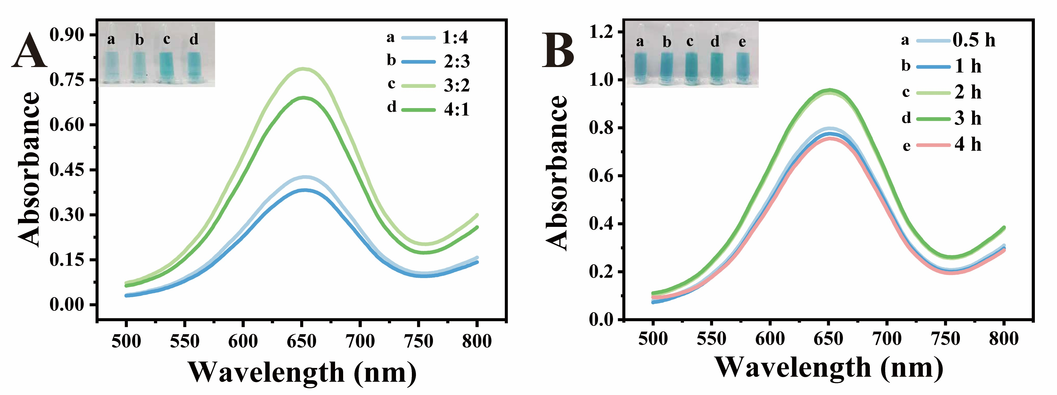
Fig. S1 Optimization of synthesis parameters for Co/Cu-MOF. (A) UV-vis absorption spectra and visual color changes of TMB in the reaction systems with various catalysts at different Co²⁺:Cu²⁺ mass ratio. (B) UV-vis absorption spectra and visual color changes of TMB in the reaction systems containing Co/Cu-MOF synthesized over 0.5, 1, 2, 3, and 4 h.
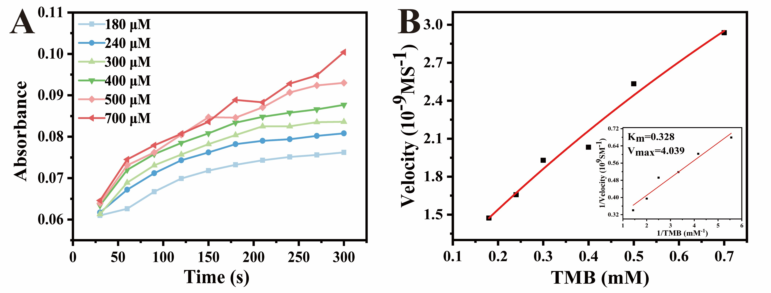
Fig. S2. (A) Changes in the UV-vis absorbance values of the Co-MOF-TMB system at 652 nm with time and TMB concentration. (B) The Michaelis-Menten curve of Co-MOF at different TMB concentrations (inset: corresponding double reciprocal plots).
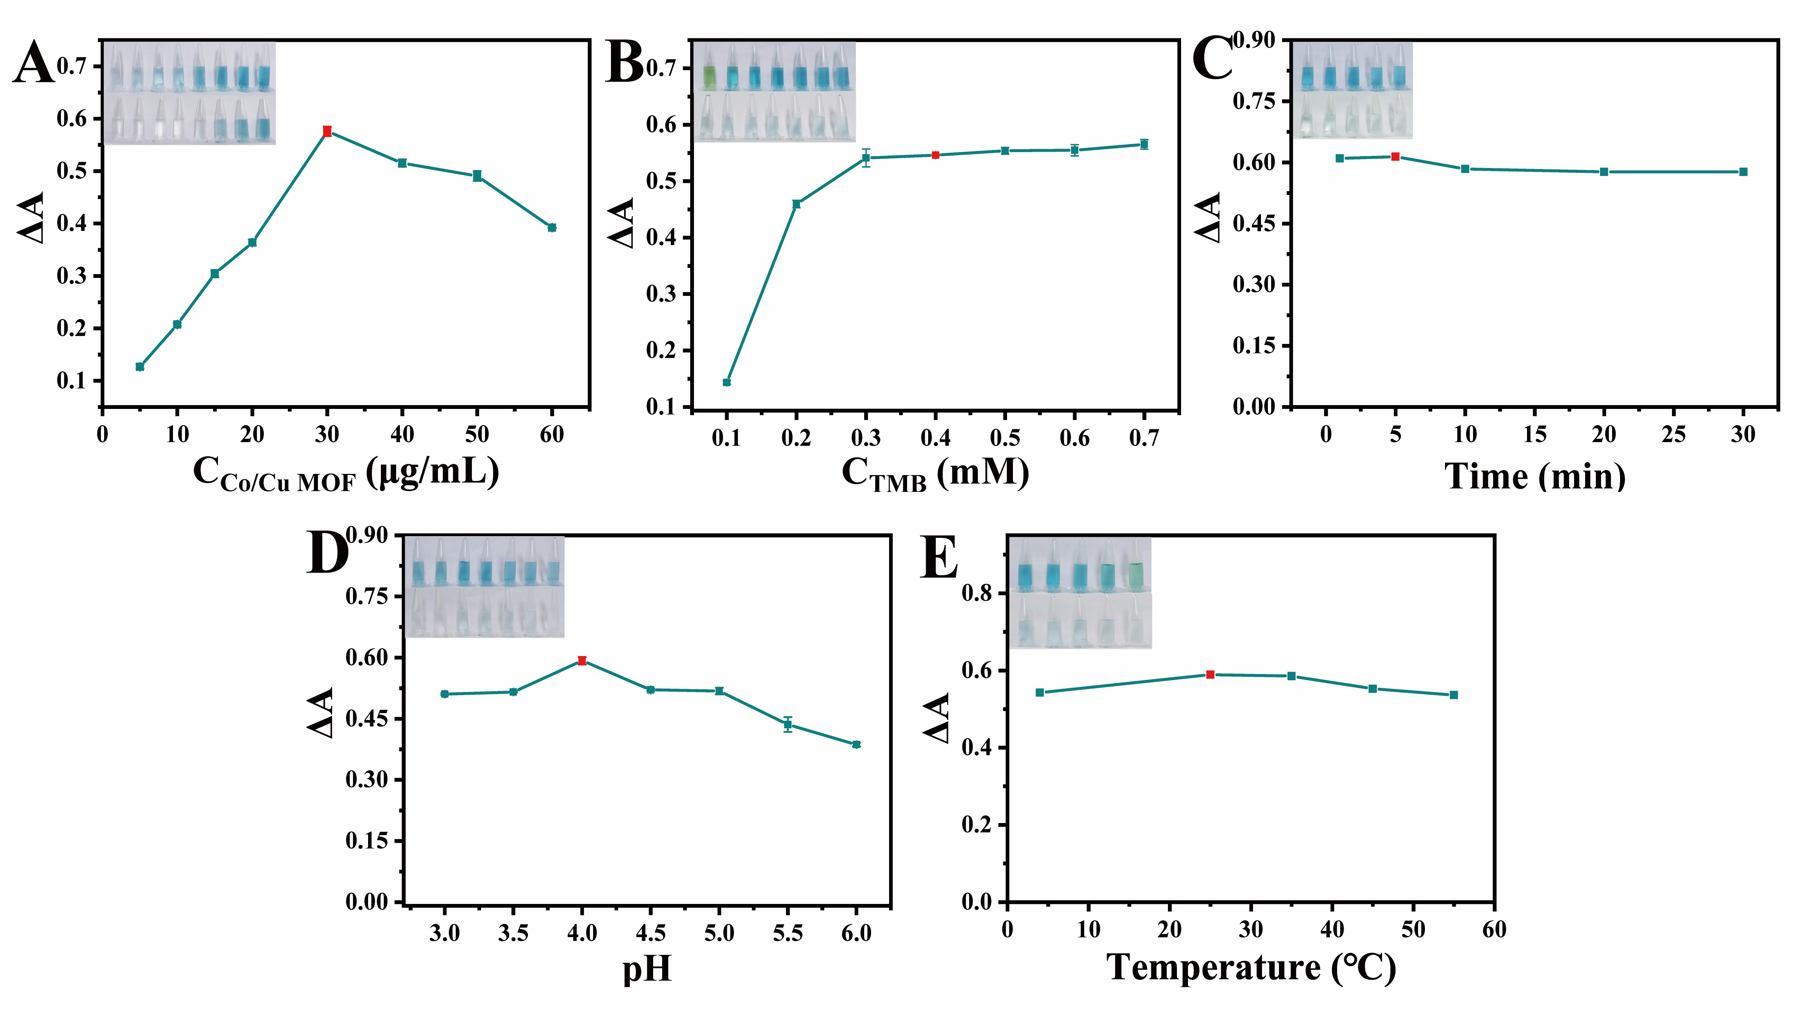
Fig. S3. Parameter optimization for the colorimetric detection system. (A) Effect of Co/Cu-MOF concentration; (B) Effect of TMB concentration; (C) Effect of reaction time; (D) Effect of pH; (E) Effect of reaction temperature. Inset is the corresponding photographs.
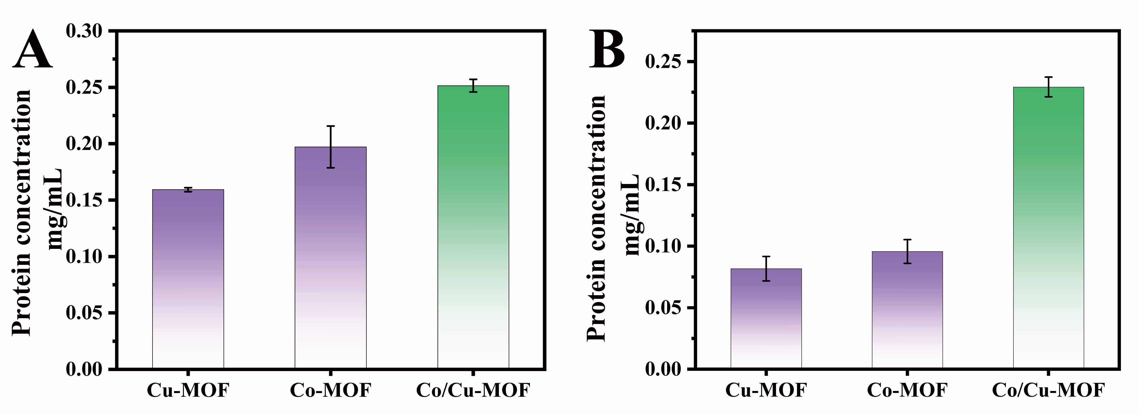
Fig. S4. Leakage of protein from (A) E. coli and (B) S. aureus after the treatment with Cu-MOF, Co-MOF and Co/Cu-MOF.

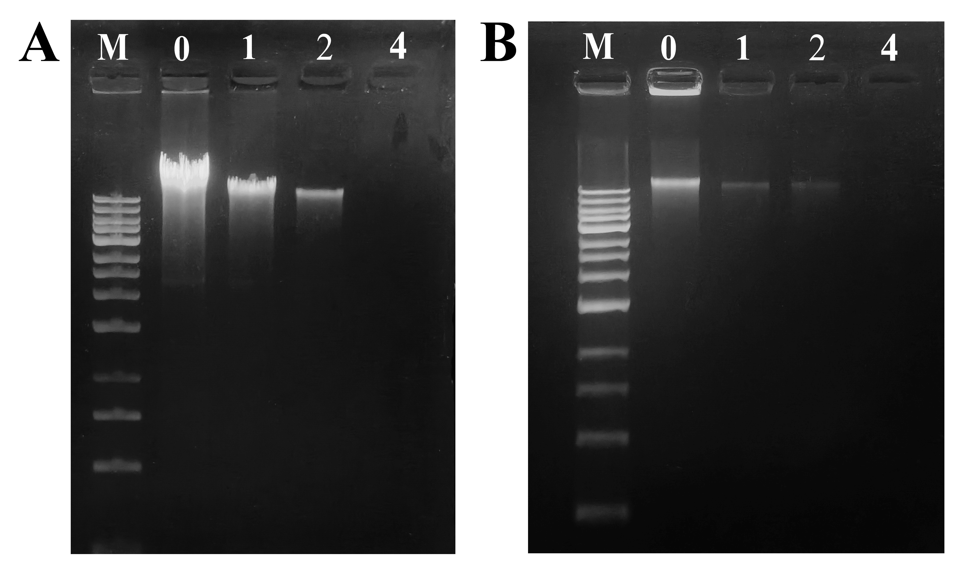
Fig. S5. Agarose gel electrophoresis analysis of genomic DNA from E. coli (A) and S. aureus (B) treated with various concentrations of the Co/Cu-MOF.

Table S1. Comparison of K_{m} and V_{max} of Co/Cu-MOF with some reported nanozymes.
Catalyst | K_{m}（mM） | V_{max}（10⁻⁷ M s⁻¹） | Reference
CuAg nanoflowers | 0.364 | 0.916 | [2]
Ag@ZnS | 4.22 | 0.74 | [3]
Fe-N/P-C SAzymes | 0.823 | 1.6103 | [4]
PDA-PdCu | 0.127 | 0.8611 | [5]
Co/Cu-MOF | 0.122 | 2.591 | This Work

Table S2. Comparison of the present method with recently reported methods for AA detection.
Analytical  method | Material | Linear range (µM) | LOD (µM) | Reference
Colorimetric | scandium-MOF | 0.2-20 | 0.174 | [6]
Colorimetric | Ce-BPyDC | 1-20 | 0.28 | [7]
Colorimetric | MVCM MOF | 20-500 | 3.57 | [8]
Smartphone | Fe-P/N-C SAN | 0.5-100 | 0.315 | [4]
Fluorescence | MnO₂ nanosheets | 1.5-100 | 0.45 | [9]
Fluorescence | Eu MOF | 0-3 | 0.32 | [10]
Colorimetric | Co/Cu-MOF | 0.1-28 | 0.091 | This work

Table S3. Comparison of the present method with recently reported methods for ALP detection.
Analytical  method | Material | Linear range (U/L) | LOD (U/L) | Reference
Fluorescence | AgNCs | 1-100 | 0.63 | [11]
Fluorescence | Fe/Eu-MOF | 1-200 | 0.6 | [12]
Fluorescence | Ce(Ⅳ) | 0-250 | 2.3 | [13]
Fluorescence | Cu-C₃N₄-550 | 1-30 | 0.42 | [14]
Colorimetric | PDA | 1-200 | 2.8 | [15]
Colorimetric | N-CQD | 5-360 | 1.1 | [16]
Colorimetric | Co/Cu-MOF | 0.2-6.5 | 0.12 | This work

Table S4. Results of detecting AA in human serum samples.
Sample | Add (µM) | Total (µM) | Recovery (%) | RSD (%, n=3)
Human serum | 0 | 0.25 | / | 1.06
Human serum | 0.5 | 0.747 | 99.47 | 1.91
Human serum | 5 | 5.198 | 98.95 | 0.43
Human serum | 10 | 9.442 | 91.92 | 3.35

Table S5. Results of detecting ALP in human serum samples.
Sample | Adde (U/L) | Total (U/L) | Recovery (%) | RSD (%, n=3)
 | 0 | 1.53 | / | 0.22
Human serum | 0.5 | 2.06 | 106 | 0.25
Human serum | 1 | 2.6 | 107 | 0.78
 | 2 | 3.7 | 108.5 | 1.89

Reference
[1] Zhao ZY, Li PJ, Xie RS, Cao XY, Su DL, Shan Y (2022) Biosynthesis of silver nanoparticle composites based on hesperidin and pectin and their synergistic antibacterial mechanism. Int J Biol Macromol 214:220-229. https://doi.org/10.1016/j.ijbiomac.2022.06.048.
[2] Sang YC, Wu PC, Ge J, Cao YY, Xiao Y, Yang YH, Wang CY, Li ZH, Cai R (2025) Bimetallic CuAg nanoflowers with high nanozyme activity for detection of acid phosphatase. Microchem J 213:113808. https://doi.org/10.1016/j.microc.2025.113808.
[3] Tian L, Huang ZJ, Lu XH, Wang TJ, Cheng WJ, Yang HM, Huang TZ, Li TX, Li Z, (2023) Plasmon-mediated oxidase-like activity on Ag@ZnS heterostructured hollow nanowires for rapid visual detection of nitrite. Inorg Chem 62:1659-1666. https://doi.org/10.1021/acs.inorgchem.2c04092.
[4] Li Y, Javed R, Li R, Zhang YY, Lang ZY, Zhao HB, Liu X, Cao HM, Ye DX (2023) A colorimetric smartphone-based sensor for on-site AA detection in tropical fruits using Fe-P/NC single-atom nanoenzyme. Food Chem 406:135017. https://doi.org/10.1016/j.foodchem.2022.135017.
[5] Zhang CH, Liu WD, Li Z, Yan BS, Lin JT, Chen CX, Zhang LB, Lu YZ (2022) Accelerated mimetic oxidase activity of polydopamine-dressed PdCu nanozyme for the detection of ascorbic acid related bioenzymes. ACS Sustainable Chem Eng 10:1653-1663. https://doi.org/10.1021/acssuschemeng.1c07568.
[6] Su YQ, Wu HJ, Chen JQ, Li HQ, Lin PC, Xiao W, Cao DL (2023) Novel scandium-MOF nanocrystals as peroxidase-mimicking nanozymes for highly sensitive colorimetric detection of ascorbic acid in human serum. CrystEngComm 25:3472-3483. https://doi.org/10.1039/D2CE01023B.
[7] Luo LP, Huang LJ, Liu XN, Zhang WT, Yao XL, Dou LN, Zhang X, Nian Y, Sun J, Wang JL (2019) Mixed-valence Ce-BPyDC metal-organic framework with dual enzyme-like activities for colorimetric biosensing. Inorg Chem 58:11382-11388. https://doi.org/10.1021/acs.inorgchem.9b00661.
[8] Fu MJ, Xu F, Yan JT, Wang CL, Fan GZ, Song GS, Chai B (2022) Mixed valence state cerium metal organic framework with prominent oxidase-mimicking activity for ascorbic acid detection: Mechanism and performance. Colloids Surf, A 641:128610. https://doi.org/10.1016/j.colsurfa.2022.128610.
[9] Zhang J, Chen RC, Chen QZ, Hu YM, Pan S, Hu XL (2021) Ratiometric fluorescent probe for ascorbic acid detection based on MnO₂ nanosheets, gold nanoclusters and thiamine. Colloids Surf, A 622:126605. https://doi.org/10.1016/j.colsurfa.2021.126605.
[10] Dong XX, Chen TL, Kong XJ, Wu S, Kong FF, Xiao Q (2024) A facile fluorescence Eu MOF sensor for ascorbic acid and ascorbate oxidase detection. Anal Methods 16:704-708. https://doi.org/10.1039/D3AY01978K.
[11] He Y, Jiao BN (2017) Determination of the activity of alkaline phosphatase based on the use of ssDNA-templated fluorescent silver nanoclusters and on enzyme-triggered silver reduction. Microchimica Acta 184:4167-4173. https://doi.org/10.1007/s00604-017-2459-x.
[12] Shi W, Li TZ, Chu N, Liu X, He MQ, Bui B, Chen ML, Chen W (2021) Nano-octahedral bimetallic Fe/Eu-MOF preparation and dual model sensing of serum alkaline phosphatase (ALP) based on its peroxidase-like property and fluorescence. Mater Sci Eng C 129:112404. https://doi.org/10.1016/j.msec.2021.112404.
[13] Song HW, Wang HY, Li X, Peng YX, Pan JM, Niu XH (2018) Sensitive and selective colorimetric detection of alkaline phosphatase activity based on phosphate anion-quenched oxidase-mimicking activity of Ce (Ⅳ) ions. Anal. Chim Acta 1044:154-161. https://doi.org/10.1016/j.aca.2018.09.045.
[14] Song YF, Huang CZ, Li YF (2023) Nanozymes from Cu (II) metal-organic gel and melamine for highly active peroxidase-like activity to detect alkaline phosphatase. ACS Appl Nano Mater 6:1369-1378. https://doi.org/10.1021/acsanm.2c05009.
[15] Chen YW, Zhao L, Zhang BS, Guan YQ, Yao C, Xu X (2023) Fe-N hollow mesoporous carbon spheres with high oxidase-like activity for sensitive detection of alkaline phosphatase. Analyst 148:2825-2833. https://doi.org/10.1039/D3AN00475A.
[16] Wang DE, You SQ, Huo WJ, Han X, Xu HY (2022) Colorimetric detection of alkaline phosphatase activity based on pyridoxal phosphate-induced chromatic switch of polydiacetylene nano-liposomes. Microchimica Acta 189:70. https://doi.org/10.1007/s00604-022-05175-y.

