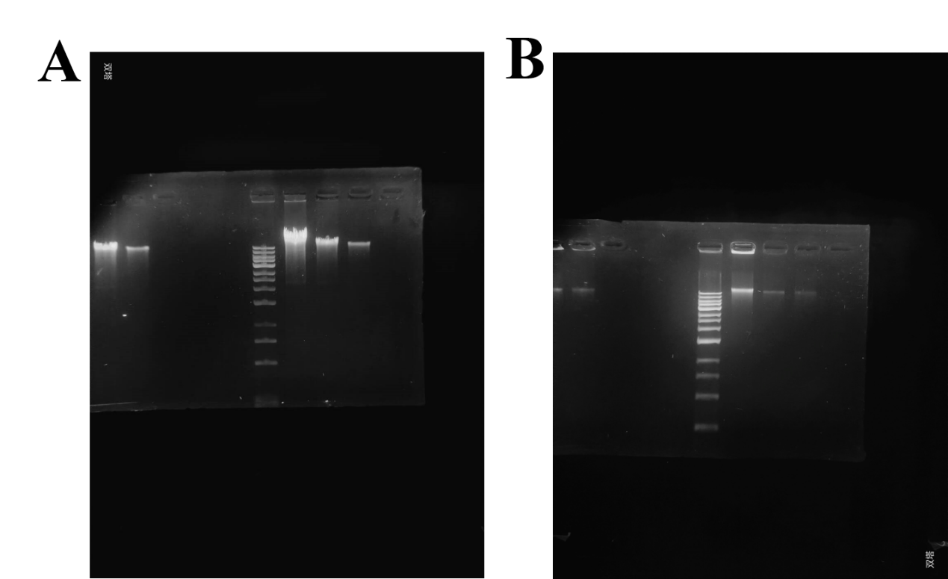
Fig. S5. Agarose gel electrophoresis analysis of genomic DNA from E. coli (A) and S. aureus (B) treated with various concentrations of the Co/Cu-MOF.

