Additional File 3

Figure S1 Pathway analysis between Tai Chi and Control group from baseline to six-month visit
Figure S2 Pathway analysis between Tai Chi and Control group from six-month visit to one-year visit
Figure S3 Pathway analysis between Tai Chi and Control group from baseline to one-year visit
Figure S4 Enrichment analysis between Tai Chi and Control group from baseline to six-month visit
Figure S5 Enrichment analysis between Tai Chi and Control group from six-month visit to one-year visit
Figure S6 Enrichment analysis between Tai Chi and Control group from baseline to one-year visit
Figure S7 Comparison between 3 groups in change of HIP2 mRNA level

Figure S1 Pathway analysis between Tai Chi and Control group from baseline to six-month visit

Figure S2 Pathway analysis between Tai Chi and Control group from six-month visit to one-year visit

Figure S3 Pathway analysis between Tai Chi and Control group from baseline to one-year visit

Figure S4 Enrichment analysis between Tai Chi and Control group from baseline to six-month visit

Figure S5 Enrichment analysis between Tai Chi and Control group from six-month visit to one-year visit

Figure S6 Enrichment analysis between Tai Chi and Control group from baseline to one-year visit

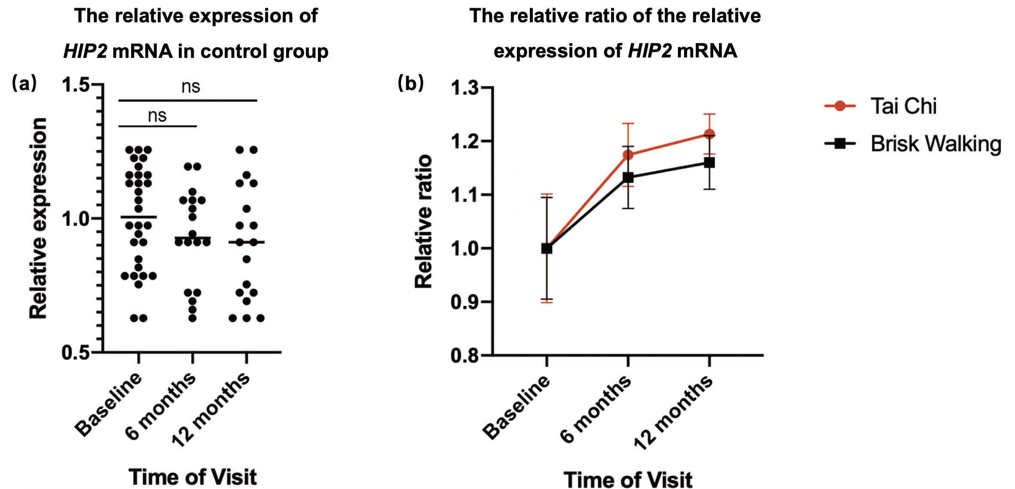

Figure S7 Comparison between 3 groups in change of HIP2 mRNA level
(a) The relative expression of HIP2 mRNA in control group. The mean expression level at baseline was taken as the reference line. The mean values at 3 times of visit were shown as central line. There were nonstatistical significance found among 3 times of visit. (b) The relative ratio of the relative expression of HIP2 mRNA. The relative expression of HIP2 mRNA were referenced to the mean expression of controls at the corresponding time of visit. The relative ratio was then referenced to the relative expression of baseline in each group. Data were shown as mean ± SEM.

