Extended Data Table and Figures
Extended Data Table 1 | AET data collection, processing, reconstruction, refinement and statistics.
 | Particle 1 | Particle 2 | Particle 3 | Particle 4 | Particle 5 | Particle 6 | Particle 7 | CuTa film
Data collection and processing
Voltage (kV) | 200 | 200 | 200 | 200 | 200 | 200 | 200 | 300
Convergence semi-angle (mrad) | 25 | 25 | 25 | 25 | 25 | 25 | 25 | 17.1
Probe size (Å) | 0.8 | 0.8 | 0.8 | 0.8 | 0.8 | 0.8 | 0.8 | 0.7
Detector inner angle (mrad) | 38 | 38 | 38 | 38 | 38 | 38 | 38 | 30
Detector outer angle (mrad) | 190 | 190 | 190 | 190 | 190 | 190 | 190 | 195
Depth of focus (nm) | 8 | 8 | 8 | 8 | 8 | 8 | 8 | 14
Pixel size (Å) | 0.347 | 0.347 | 0.347 | 0.347 | 0.347 | 0.347 | 0.347 | 0.322
# of images | 55 | 51 | 54 | 54 | 53 | 53 | 55 | 40
Tilt range (°) | -69.4 | -69.3 | -72.5 | -71.7 | -69.6 | -71.7 | -69.5 | -67.9
 | +72.6 | +63.4 | +63.4 | +69.4 | +74.0 | +69.4 | +72.0 | +64.9
Total electron dose (10⁵ e/Å²) | 9.5 | 7.1 | 7.6 | 7.6 | 7.4 | 7.4 | 7.7 | 4.8
Reconstruction
Algorithm | RESIRE | RESIRE | RESIRE | RESIRE | RESIRE | RESIRE | RESIRE | RESIRE
Oversampling ratio | 4 | 4 | 4 | 4 | 4 | 4 | 4 | 3
Number of iterations | 200 | 200 | 200 | 200 | 200 | 200 | 200 | 500
Refinement
R₁ (%)ª | 9.54 | 12.32 | 11.57 | 10.90 | 9.38 | 7.62 | 7.65 | 10.58
R (%)^{b} | 6.45 | 9.87 | 8.98 | 7.68 | 7.46 | 5.66 | 5.73 | 8.61
B’ factors (Å²)
Type 1 atoms | 48.9 | 55.4 | 48.4 | 44.0 | 35.5 | 55.6 | 35.5 | 45.2
Type 2 atoms | 46.4 | 47.3 | 44.3 | 44.0 | 34.5 | 58.0 | 34.5 | 45.2
Type 3 atoms | 52.3 | 37.4 | 39.6 | 40.9 | 34.6 | 42.1 | 34.6 | NA
Statistics
# of atoms
Total | 18356 | 2063 | 3447 | 4661 | 7739 | 6648 | 6037 | 14582
Type 1 | 8322 | 648 | 1116 | 1079 | 2158 | 1579 | 1446 | 1808(Cu)
Type 2 | 6896 | 937 | 1327 | 1906 | 2750 | 2430 | 2045 | 12774(Ta)
Type 3 | 3138 | 478 | 1004 | 1676 | 2831 | 2639 | 2546
ªThe R₁-factor is defined as equation 5 in ref. 40. ^{b}The R-factor is defined in equation 4 in Methods.
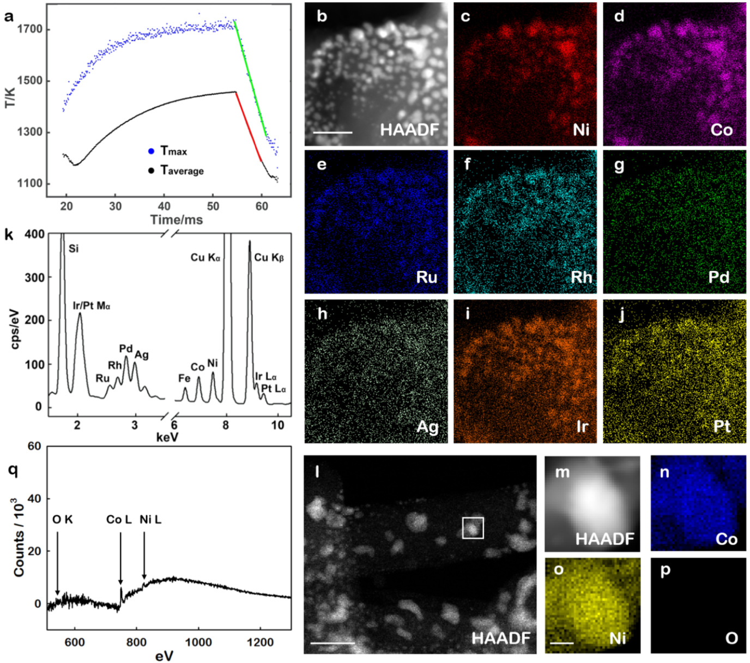
Extended Data Fig. 1 | Cooling rate measurement, energy-dispersive X-ray (EDX) and electron energy loss spectroscopy (EELS) maps of the nanoparticles. a, The cooling rate for the average and maximum temperature curves was measured to be 51000 K/s (the slope of the red line) and 69000 K/s (the slope of the green line), respectively. b, Low-resolution ADF-STEM image of the nanoparticles. EDX maps show the distribution of Ni (c), Co (d), Ru (e), Rh (f), Pd (g), Ag (h), Ir (i) and Pt (j). k, The EDX spectrum of all the elements shown in the images (c-j), where cps stands for counts per second. l, Low-resolution ADF-STEM image of a large area, in which the white square indicates the aggregation of several nanoparticles used for the EELS measurement. m, ADF-STEM image of the white square region. n–p, EELS maps show the distribution of Co (n), Ni (o) and O (p) in the region. q, EELS spectrum obtained from (n–p). No oxygen signal was detected in the EELS map or spectrum. Scale bars, 20 nm in (b), 100 nm in (l) and 10 nm in (o).

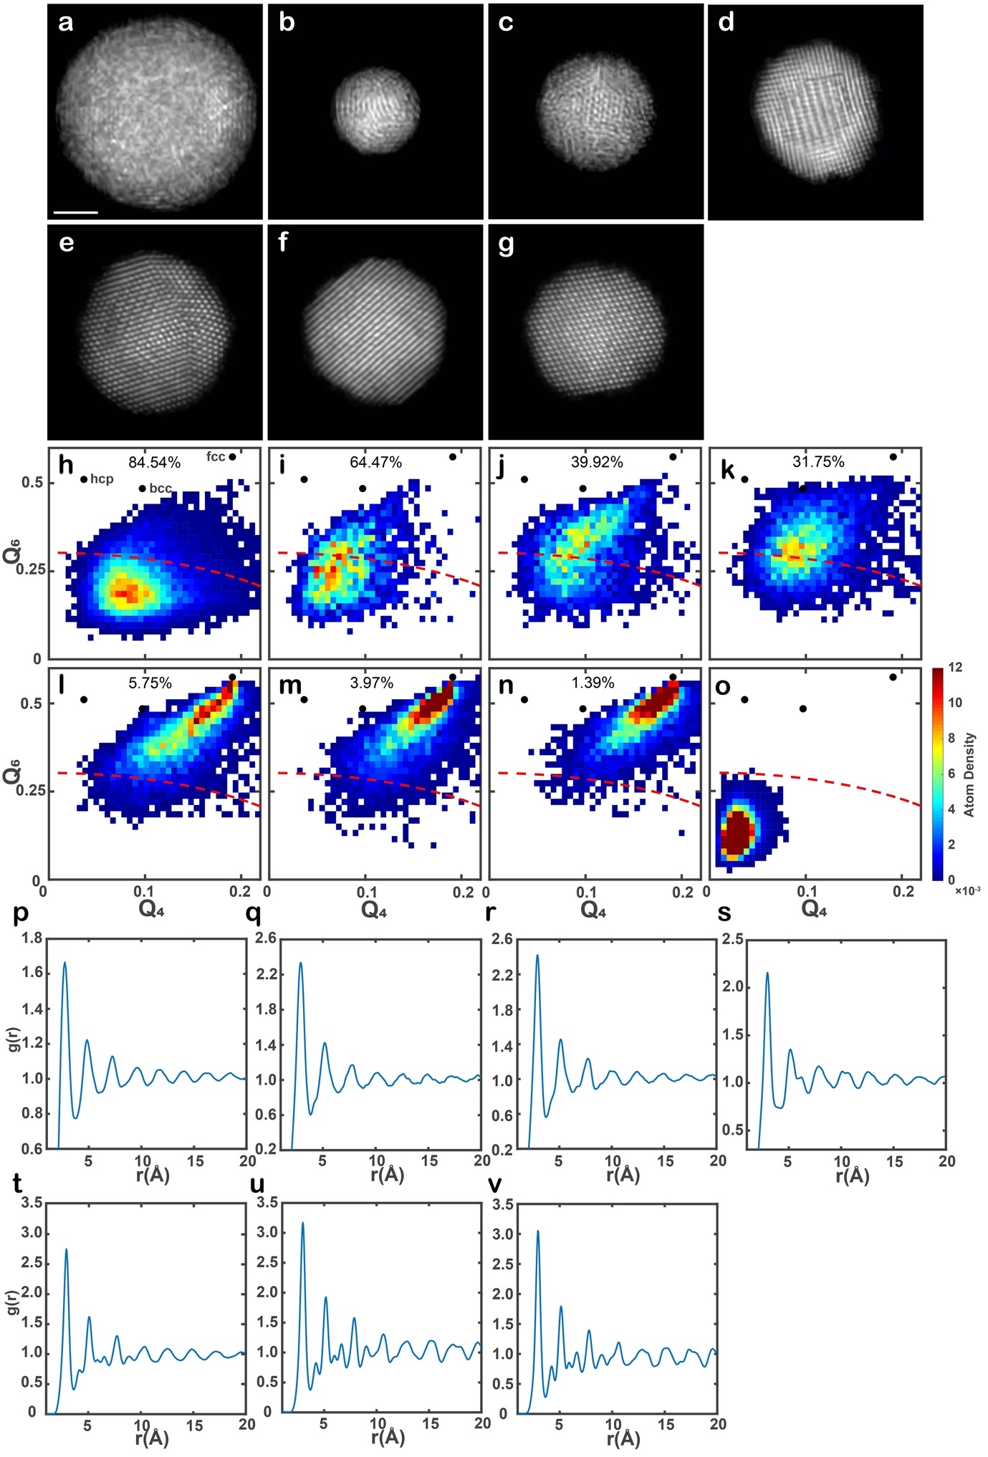
Extended Data Fig. 2 | Analysis of seven multi-component metallic nanoparticles. a-g, Representative ADF-STEM images of particles 1-7, respectively. Scale bar, 2 nm. h-n, Local BOO parameters of all the atoms in particles 1-7, where the dashed red lines correspond to the normalized BOO parameter = 0.5. The percentage on the top of each panel shows the fraction of disordered atoms in each particle. o, Local BOO parameters of a Cu₆₅Zr₃₅ metallic glass obtained from molecular dynamics simulations⁶⁵ as a reference, from which the normalized BOO parameter = 0.5 (dashed red curves) was chosen as a cut-off to separate crystal nuclei from amorphous structure. p-v, RDFs of all the atoms in particles 1-7, respectively. With the decrease of the fraction of disordered atoms in the nanoparticles, the peaks in the RDFs become narrower and new peaks corresponding to different crystal planes appear.
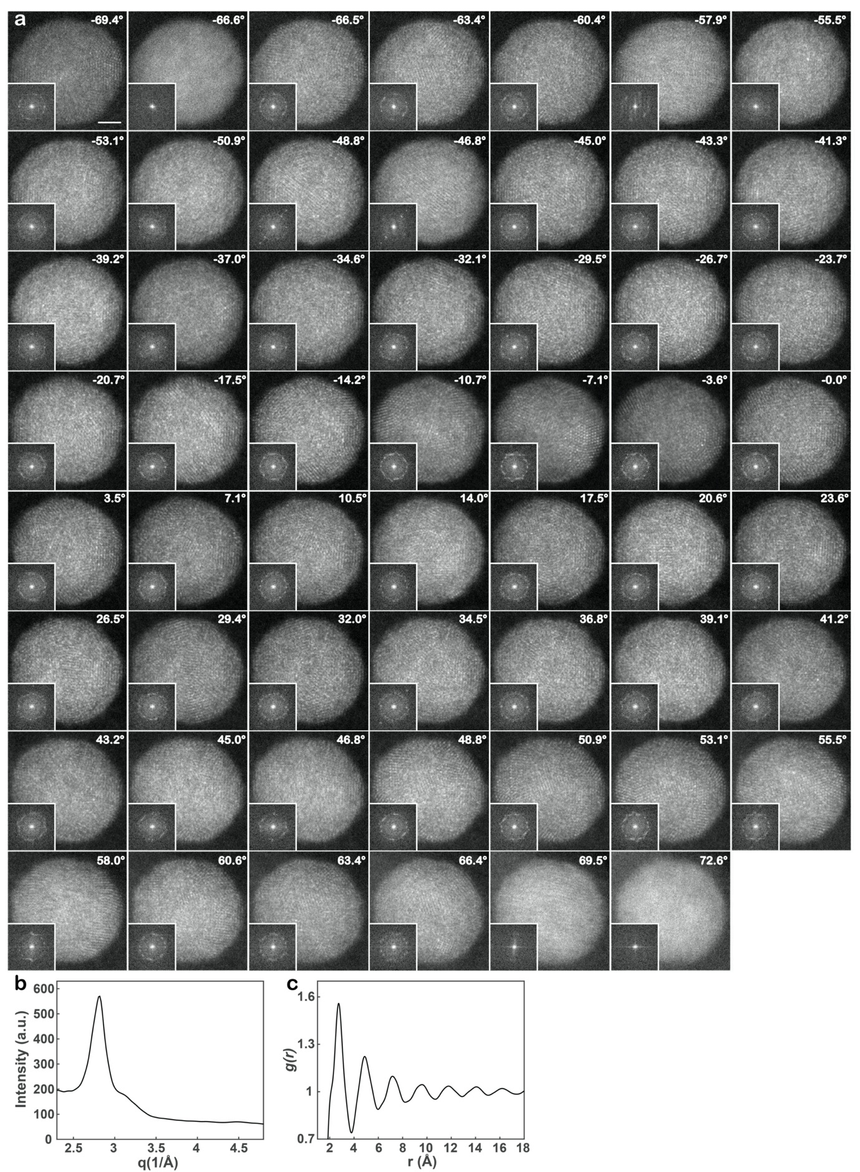
Extended Data Fig. 3 | Experimental tomographic tilt series of the multi-component metallic glass nanoparticle (particle 1) with crystal nuclei. a, 55 raw ADF-STEM images of the nanoparticle with a tilt range from -69.4° to +72.6°. The diffraction patterns of the images are shown in the insets, where the amorphous halo is visible. Some crystalline features are visible in several images and the diffraction patterns. Scale bar, 2 nm. b, Radial intensity distribution as a function of the spatial frequency (q), obtained from the average diffraction pattern (Fig. 1b). c, The RDF of the nanoparticle derived from the radial intensity distribution using the SUePDF software⁷¹. The first, second, third, fourth and fifth peak positions were determined to be 2.74, 4.74, 5.37, 7.12 and 9.6 Å, respectively, which agree well with those in Fig. 1g. The ratios of the second, third, fourth and fifth to the first peak position of the RDF are 1.73, 1.96, 2.60 and 3.50, respectively, which are consistent with those of metallic glasses^{45,46}.

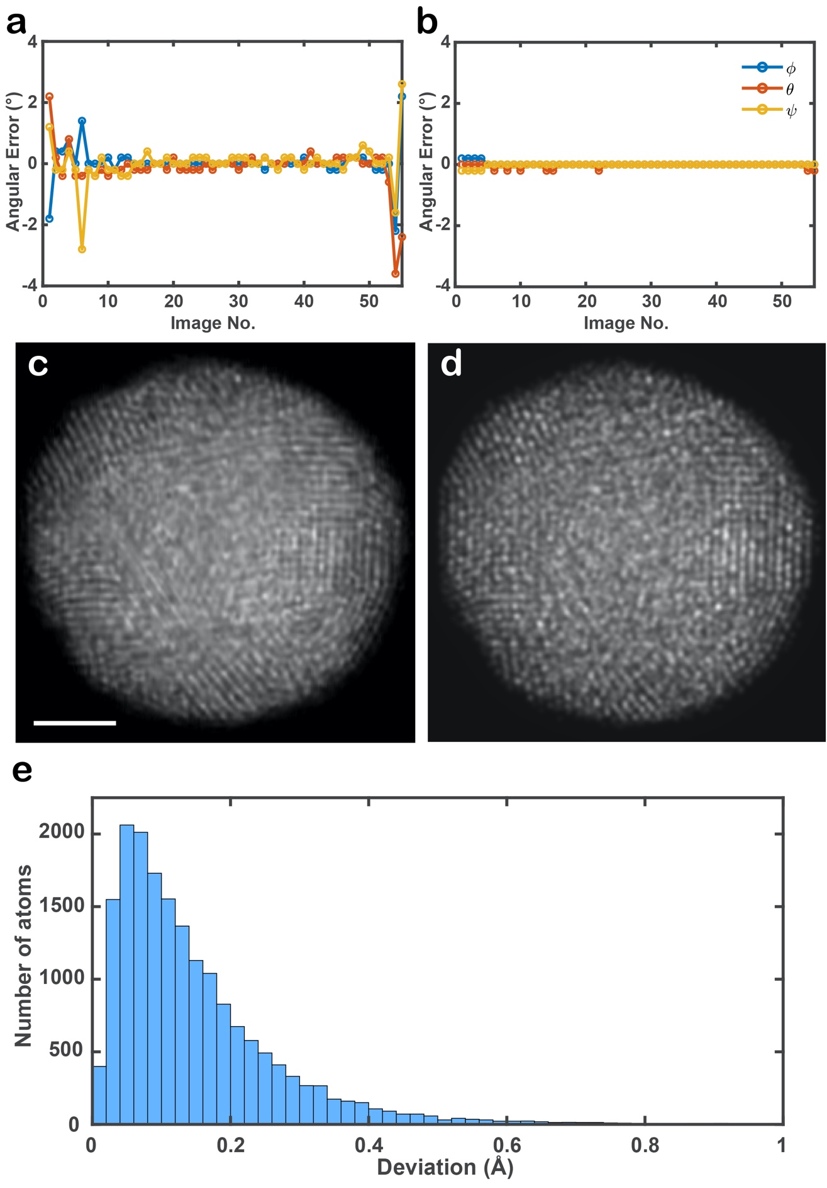
Extended Data Fig. 4 | Angular errors in the experimental images and verification of the experimental 3D atomic model using multislice simulations. a, Angular errors in the experimental images determined by the angular refinement procedure (Methods), where the colour dots and lines represent the deviation of the three Euler angles (φ, θ and ϕ) from the correct ones (0°) at each tilt angle. These angular errors were taken into account in the multislice simulations. b, The angular errors were correctly refined in the 3D reconstruction of the 55 multislice images using RESIRE (Methods). After the angular refinement, the largest error is only 0.2°. Comparison between a representative experimental (after denoising) (c) and a multislice image (d) at 0°. To account for the source size and incoherent effects, each multislice image was convolved with a Gaussian function (Methods). e, Histogram of the root mean square deviation of the atomic positions between the experimental atomic model and that obtained from 55 multislice images. Scale bar, 2 nm.
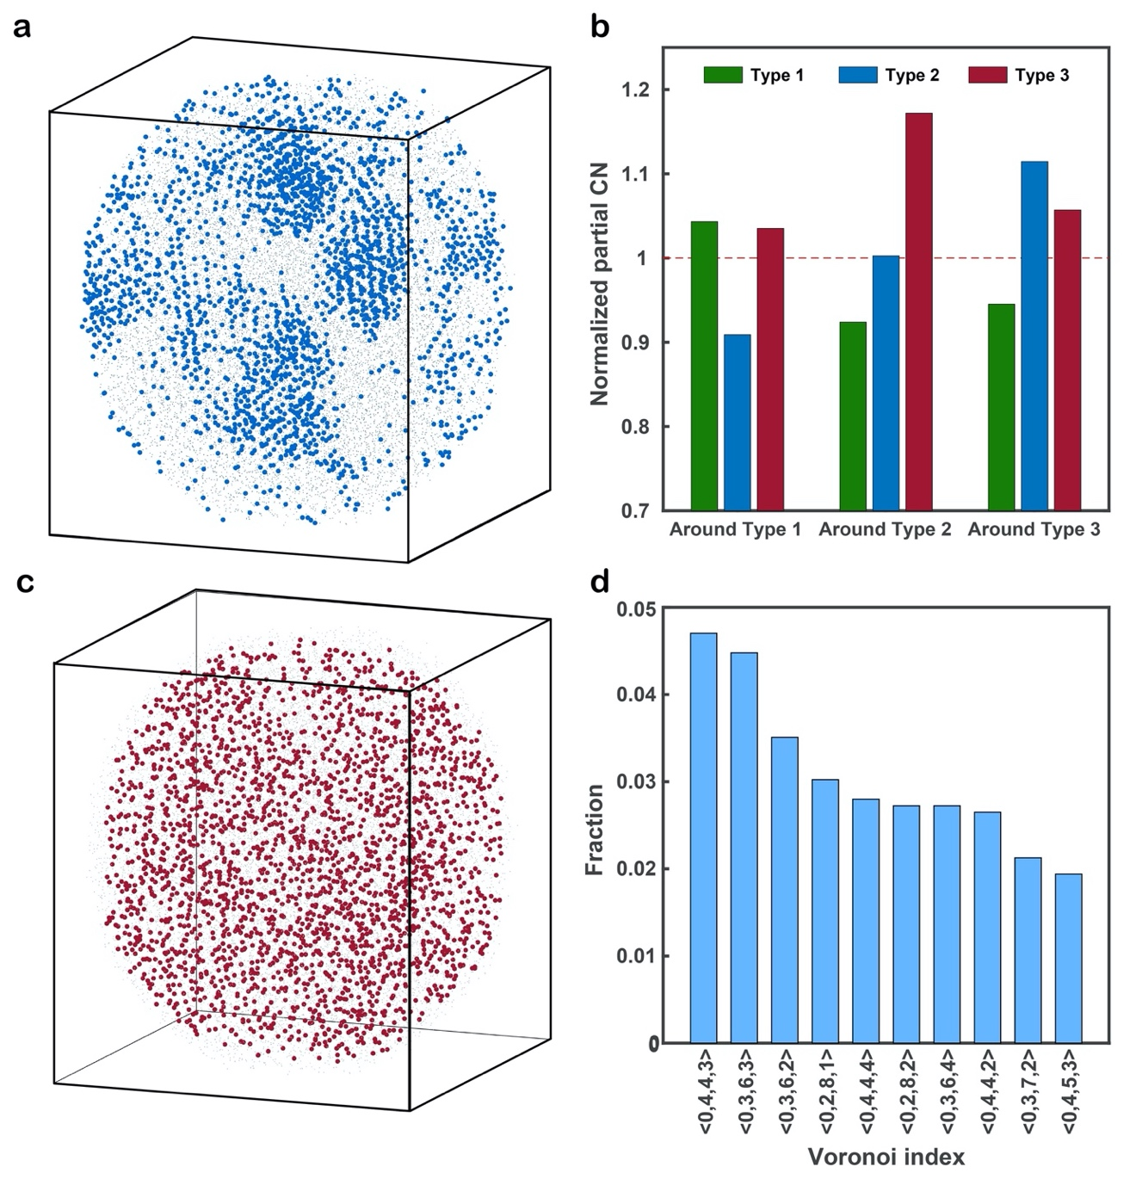
Extended Data Fig. 5 | 3D distribution of the crystal nuclei in the nanoparticle, the partial CNs and the Voronoi polyhedra of the solute-centred clusters. a, 3D distribution of the atoms with the normalized BOO parameter ≥ 0.5, revealing 15.46% of the total atoms forming crystal nuclei in the nanoparticle. b, Normalized partial CNs around type 1, 2 and 3 atoms. c, 3D distribution of the 2682 solute centres (red dots), which are between the first (3.78 Å) and the second minimum (6.09 Å) of the RDF curve (Fig. 1g). d, Ten most abundant Voronoi polyhedra of the solute-centred clusters.
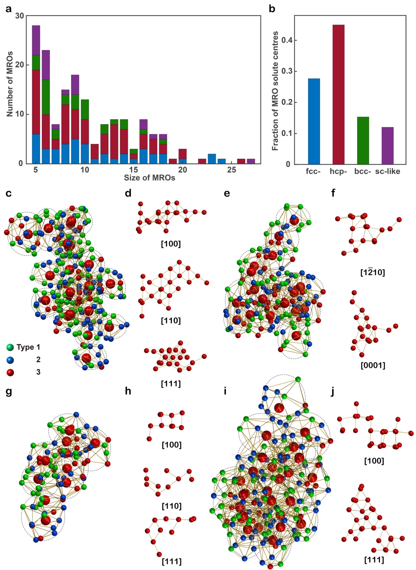
Extended Data Fig. 6 | Identification of MROs with a 1 Å radius cut-off. a, Histogram of the four types of MROs − fcc- (in blue), hcp- (in red), bcc- (in green) and sc-like (in purple) − as a function of the size (i.e. the number of solute centres). b, The fraction of the four MRO solute centre atoms. Representative fcc- (c), hcp- (e), bcc- (g) and sc-like (i) MROs, consisting of 23, 18, 10 and 27 solute centres (large red spheres), respectively. The solute centres are orientated along the fcc (d), hcp (f), bcc (h) and sc (j) zone axes.
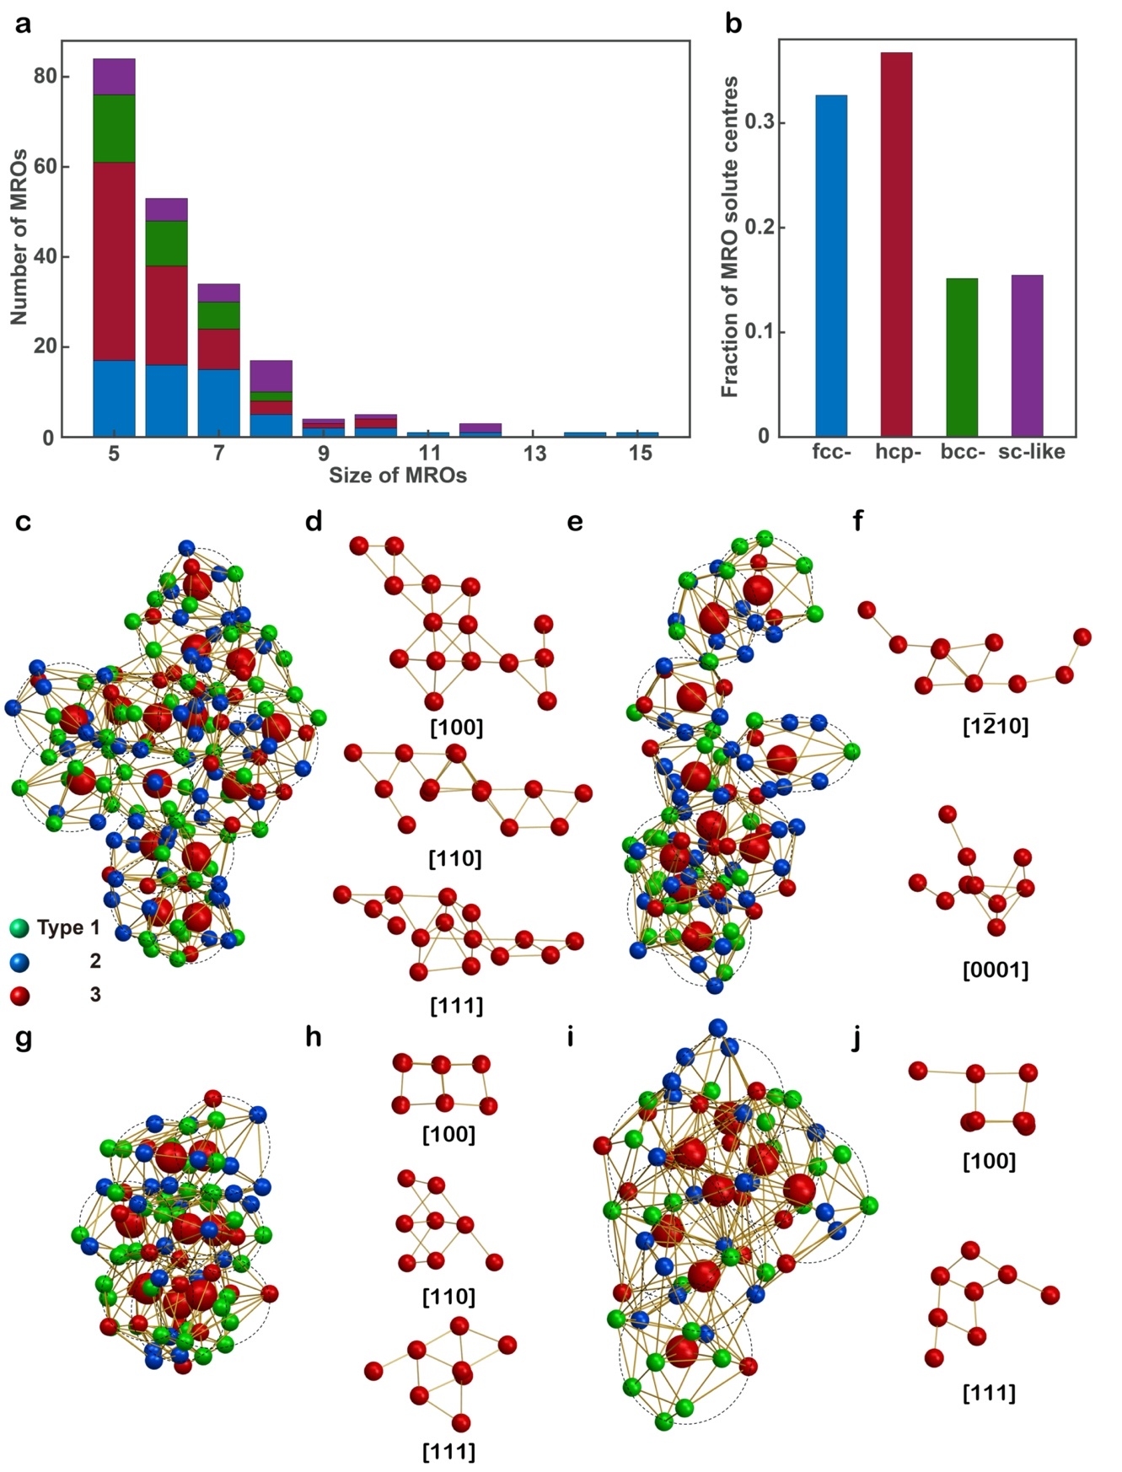
Extended Data Fig. 7 | Identification of MROs with a 0.5 Å radius cut-off. a, Histogram of the four types of MROs − fcc- (in blue), hcp- (in red), bcc- (in green) and sc-like (in purple) − as a function of the size. b, The fraction of the four MRO solute centre atoms. Representative fcc- (c), hcp- (e), bcc- (g) and sc-like (i) MROs, consisting of 15, 10, 8 and 8 solute centres (large red spheres), respectively. The solute centres are orientated along the fcc (d), hcp (f), bcc (h) and sc (j) zone axes.
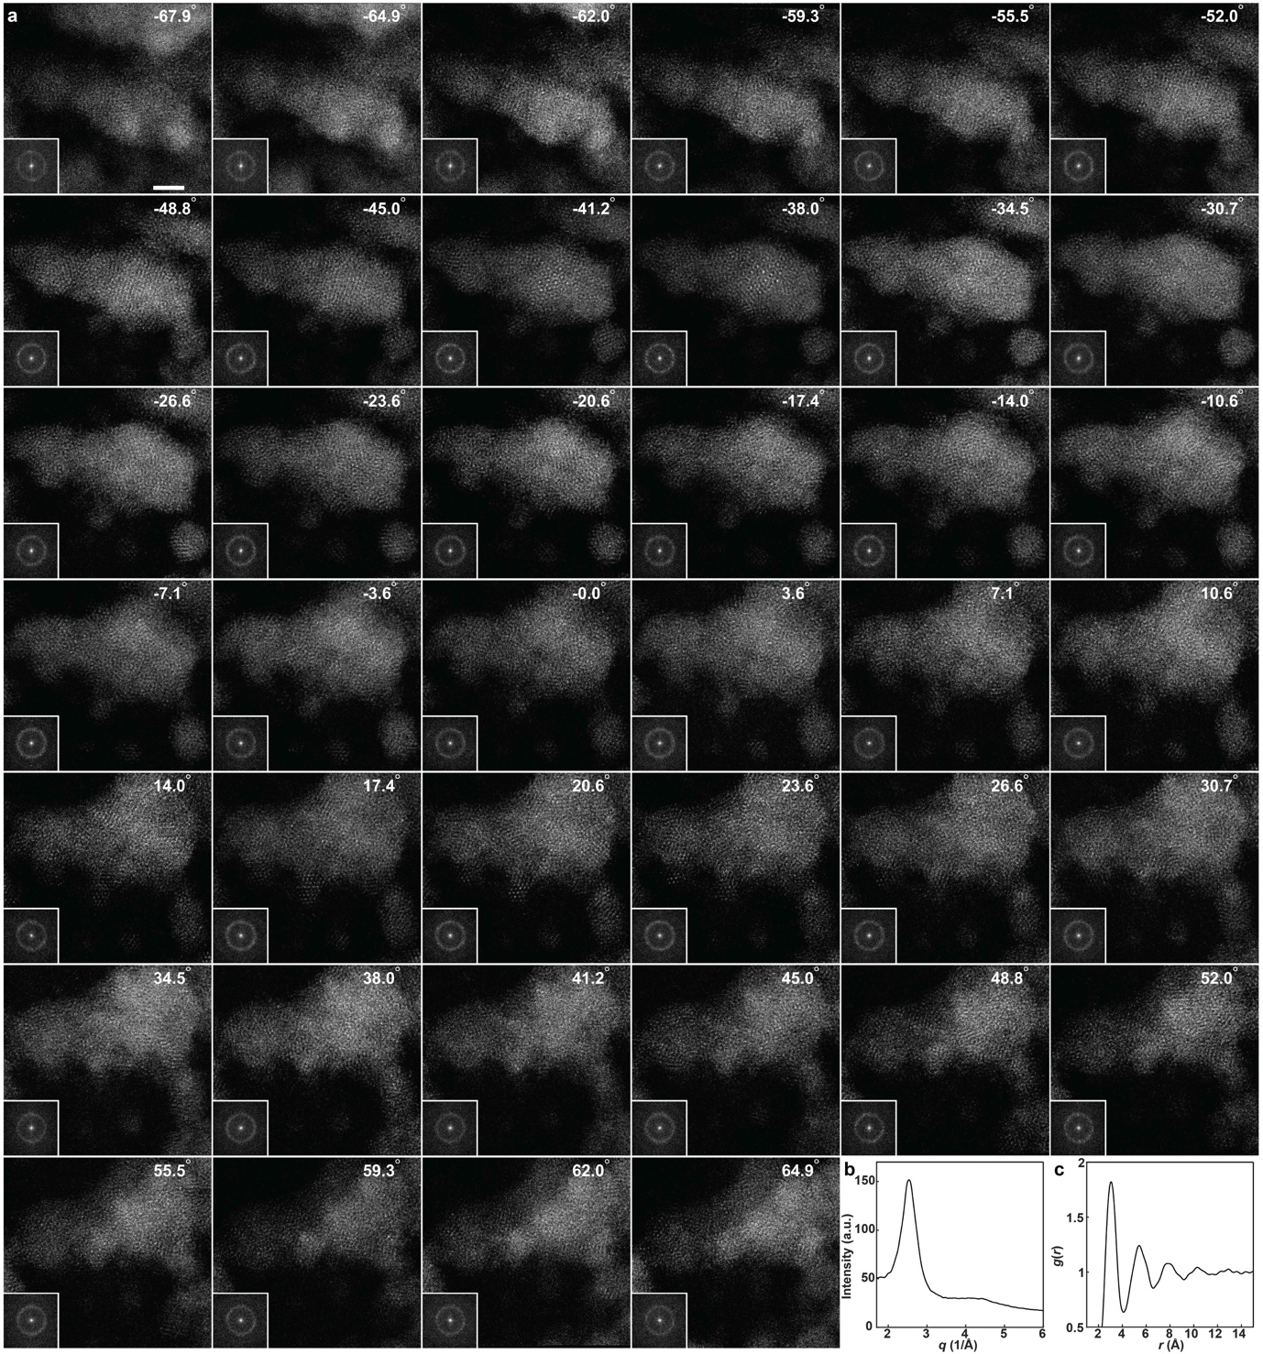
Extended Data Fig. 8 | Tomographic tilt series of an amorphous CuTa thin film. a, ADF-STEM images of a portion of the CuTa thin film. The insets show the diffraction patterns calculated from the experimental images, in which the diffuse halos are clearly visible. b, Radial intensity distribution as a function of the spatial frequency (q), derived by averaging all the diffraction patterns. c, The RDF derived from the radial intensity distribution using the SUePDF software⁷¹. The peak positions of the RDF agree with those in Extended Data Fig. 9g.
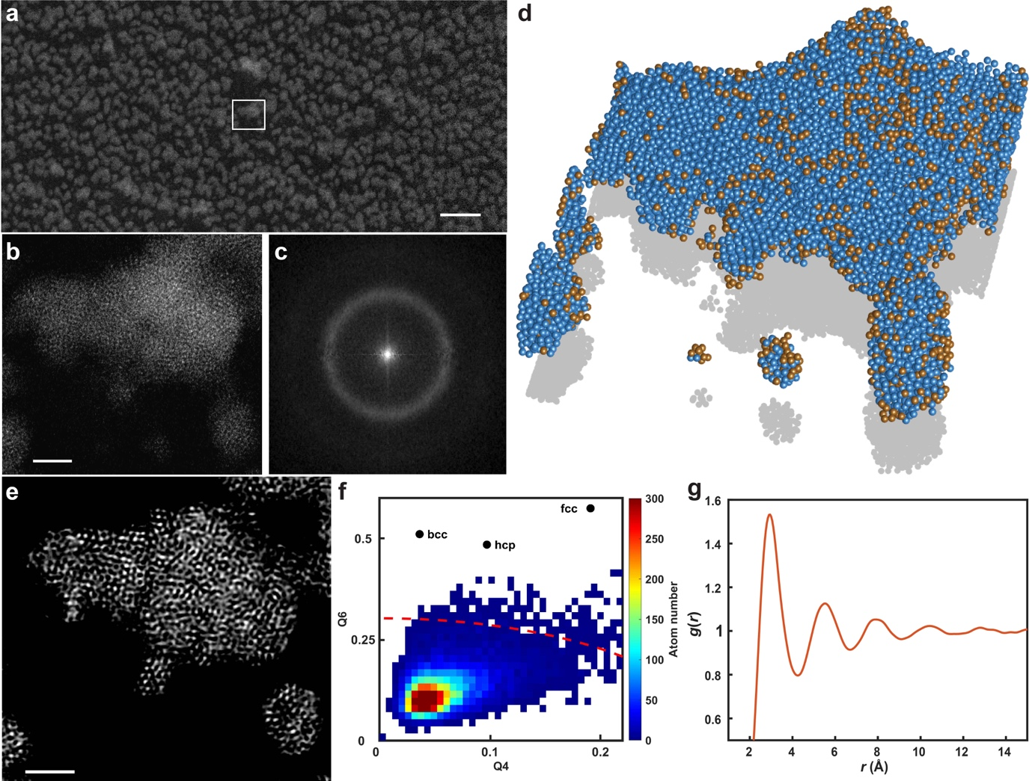
Extended Data Fig. 9 | Determination of the 3D atomic structure of the amorphous CuTa thin film. a, A large field of view of the amorphous CuTa. b, Magnified white square region in (a). c, Average diffraction pattern of all the experimental images. d, 3D atomic model of the portion of the CuTa thin film with a total of 1808 Cu (in gold) and 12774 Ta (in blue) atoms, determined from the tilt series shown in Extended Data Fig. 8a (Methods). As the CuTa film is thinner than ~6 nm, 40 experimental images are sufficient to produce a good 3D reconstruction. e, A 2-Å-thick internal slice of the 3D reconstruction of the amorphous CuTa thin film, showing the disordered atomic structure. f, Local BOO parameters of the 3D atomic model, where only 0.47% of the total atoms with the normalized BOO parameter ≥ 0.5 form crystal nuclei. g, RDF of the disordered atoms with the normalized BOO parameter < 0.5. The peak positions of the RDF agree with those shown in the inset of Extended Data Fig. 8c. Scale bars, 30 nm in (a), 2 nm in (b) and (e).

