Supplementary Information
Influence of crystal thickness on THz phonon dynamics in sodium mesitylene sulfonate (SMS) crystal using terahertz time-domain spectroscopy (THz-TDS)
Yamuna Murtunge∗, †, ‡, Vibhavari Parkar†, Snehal Haldankar†, S.B. Kulkarni* ‡ and S.S. Prabhu∗, †
†Department of Condensed Matter Physics and Material Science, Tata Institute of Fundamental Research, Mumbai, India
‡Department of Physics, Dr Homi Bhabha State University, Institute of Science, Mumbai, India
E-mail: ∗murtungeyamuna31@gmail.com; ∗sbk_physics@yahoo.com; ∗prabhu@tifr.res.in

- Experimental method
Single, monoclinic, non-centrosymmetric, C2 space group, optically transparent, metal-organic sodium mesitylene sulfonate (SMS) crystal was grown using a slow evaporation method [1]. The synthesis process is as follows: the 2,4,6 trimethyl benzene sulphonyl chloride and NaOH were dissolved separately in methanol. The NaOH solution was then added dropwise to the 2,4,6 trimethyl benzene sulphonyl chloride solution in an ice bath environment while stirring [2]. The resulting solution was filtered and transferred to a round bottom flask, covered with a perforated polythene sheet, and placed in a vibration-free environment. 15 days later, two small holes were made in the polythene sheet for the evaporation of the solvent slowly and the formation of a supersaturated solution. This controlled evaporation of the methanol solvent led to the growth of optically high-quality, single, defect-free SMS crystals, with dimensions of 10×5×0.18 mm³, 5×5×0.35 mm³, 5×5×0.65 mm³, 5×5×1.06 mm³ and 10×5×1.27 mm³, respectively. The single crystal X-ray diffraction analysis revealed that these crystals possess a monoclinic crystal structure with a non-centrosymmetric C2 space group. The corresponding lattice parameters are a=8.69A°, b=7.36A°, c= 16.44A° and α=γ=90°, β=103.77° [1].
Terahertz time-domain spectroscopy (THz-TDS) and terahertz time-domain polarimetry (THz-TDP) systems [3] were employed to characterize the THz transmission properties and polarization state of the sodium mesitylene sulphonate crystal, respectively. The experimental setup incorporates a FemtoSource Synergy laser system (10 fs pulse duration, 80 MHz repetition rate, 800 nm central wavelength) and a standard four-parabolic mirror configuration. A beam splitter divides the incident laser beam into a pump beam and a probe beam. The pump beam is directed toward a low-temperature-grown GaAs (LT-GaAs) photoconductive antenna (BATOP GmbH) to generate broadband THz radiation. In contrast, the probe beam is utilized for electro-optic sampling of the transmitted THz field using a 2 mm thick ZnTe (110) crystal [3]. For precise control over the crystal angle, the SMS crystal was mounted on a motorized rotation stage with a resolution of 1 °. The crystal was oriented using Laue diffraction, was oriented with its crystallographic a-axis initially aligned parallel to the incident THz electric field (E ∥ a), while the c-axis ([001] direction) is perpendicular to the THz beam. This configuration allowed the polarisation angle to be systematically varied while maintaining normal incidence of the THz beam on the sample surface. For polarimetry measurements, a pair of wire-grid THz polarisers (Tydex) was used in a polariser–analyzer configuration. The first polariser, placed before the sample, defined the input THz polarisation and was mounted on a motorized rotation stage to vary the polarisation angle (ϕ) with respect to the x-axis. The analyzer was positioned immediately after the sample and fixed along the x-axis to detect the transmitted field component parallel to the incident polarisation. This configuration enables high-precision measurement of the transmitted THz field amplitude and phase as a function of both polarisation angle and crystal thickness, without requiring any rotation of the detection crystal (ZnTe). To suppress atmospheric water vapour absorption, the entire optical setup is enclosed within a nitrogen-purged box.
- Thickness-dependent THz-TDS

Figure S1 (a)THz pulses passing through SMS crystal between 60°-100° (b) corresponding Fourier transformed for 0.18mm thick crystal.
Figure S2 Experimentally obtained real ε ′(red) and imaginary ε ′’(blue) are shown with fitted ε ′(black) and ε ′’(neon) using Lorentz oscillator model.

Figure S3 (a)THz pulses passing through SMS crystal between 0°-60° with air as reference (black)and (b) corresponding Fourier transformed for 0.35 mm thick crystal.

Figure S4 (a)THz pulses passing through SMS crystal between 0°-60° with air as reference (black)and (b) corresponding Fourier transformed for 0.65 mm thick crystal.

Figure S5 (a)THz pulses passing through SMS crystal between 0°-60° with air as reference (black)and (b) corresponding Fourier transformed for 1.06 mm thick SMS crystal.

Figure S6 (a)THz pulses passing through SMS crystal between 0°-60° with air as reference (black)and (b) corresponding Fourier transformed for 1.27mm thick crystal.

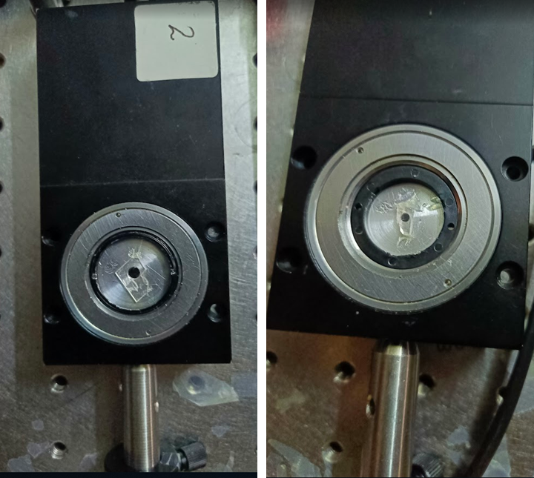
Figure S7 photographs of the SMS crystal for 0.65mm(left) and 1.27mm (right) mounted on controlled polarization rotation stage.

References:
[1] Murtunge, Y., Patil, V., Puranik, R., Pandey, U., SS, J., Bansal, D., ... & Prabhu, S. S. (2025). Synthesis, Growth and Optical Characterization of Sodium Mesitylene Sulphonate (SMS) Crystals for THz Wave Generation. Optical Materials, 117175. doi.org/10.1016/j.optmat.2025.117175.
[2] Marder, S. R.; Perry, J. W.; Yakymyshyn, C. P. Organic salts with large second-order optical nonlinearities. Chemistry of materials 1994, 6, 1137–1147. doi.org/10.1021/cm00044a012.
[3] Punjal, A.; Choudhary, S.; Narayanan, M.; Chemate, D.; Kulkarni, R.; Thamizhavel, A.;
Bhattacharya, A.; Prabhu, S. Terahertz optical properties and birefringence in single crystal vanadium doped (100) β-Ga2O3. Optical Materials Express 2022, 12, 2870–2878. doi.org/10.1364/OME.461521.

