Table S1. Baseline Characteristics of the INSPIRE VATS Lobectomy Cohort Stratified by POAF Status
Variables | no-POAF (n = 3101) | POAF (n = 118) | P value
Hs-CRP, Median (IQR) | 0.1 (0.0, 0.3) | 0.3 (0.1, 2.2) | < 0.001
Demographics
Age, Median (IQR) | 65.0 (55.0, 70.0) | 70.0 (65.0, 75.0) | < 0.001
Male, n (%) | 1716 (55.3) | 88 (74.6) | < 0.001
BMI, Median (IQR) | 23.4 (21.4, 25.7) | 23.9 (22.0, 25.7) | 0.141
Comorbidities, n (%)
Diabetes | 53 (1.7) | 0 (0) | 0.264
Hypertension | 160 (5.2) | 15 (12.7) | < 0.001
Carotid_artery_stenosis | 24 (0.8) | 2 (1.7) | 0.246
Cerebral_infarction | 38 (1.2) | 4 (3.4) | 0.066
CHD | 134 (4.3) | 9 (7.6) | 0.087
COPD | 211 (6.8) | 13 (11) | 0.078
CKD | 22 (0.7) | 0 (0) | 0.999
Medication history, n (%)
ACEI | 6 (0.2) | 1 (0.8) | 0.230
ARB | 81 (2.6) | 1 (0.8) | 0.369
β_blockers | 101 (3.3) | 4 (3.4) | 0.793
CCB | 376 (12.1) | 16 (13.6) | 0.640
DPP_4_inhibitors | 62 (2) | 2 (1.7) | 0.999
Metformin | 18 (0.6) | 1 (0.8) | 0.509
Antiplatelet | 49 (1.6) | 3 (2.5) | 0.438
Anticoagulants | 68 (2.2) | 8 (6.8) | 0.006
Statins | 223 (7.2) | 19 (16.1) | < 0.001
sulfonylureas | 57 (1.8) | 6 (5.1) | 0.026
thiazolidinediones | 9 (0.3) | 0 (0) | 0.999
Insulin | 87 (2.8) | 4 (3.4) | 0.575
Surgical lung lobe, n (%)
Right_upper | 780 (25.2) | 26 (22) | 0.443
Right_lower | 578 (18.6) | 18 (15.3) | 0.353
Right_middle | 208 (6.7) | 6 (5.1) | 0.487
Left_upper | 547 (17.6) | 25 (21.2) | 0.323
Left_lower | 353 (11.4) | 14 (11.9) | 0.872
Complete lobectomy, n (%)
Right | 494 (15.9) | 25 (21.2) | 0.128
Left | 24 (0.8) | 0 (0) | 0.999
Number of lobes resected, n (%)
=2 | 91 (2.9) | 3 (2.5) | 0.999
>2 | 26 (0.8) | 1 (0.8) | 0.999
ASA, n (%) |  |  | < 0.001
<3 | 2920 (94.2) | 96 (81.4)
≥3 | 181 (5.8) | 22 (18.6)
Operating_time, Median (IQR) | 130.0 (95.0, 170.0) | 162.5 (125.0, 220.0) | < 0.001
Anesthesia_time, Median (IQR) | 180.0 (140.0, 230.0) | 215.0 (175.0, 280.0) | < 0.001
Intraoperative_hypotension, n (%) | 29 (0.9) | 1 (0.8) | 0.999
Intraoperative_bradycardia, n (%) | 27 (0.9) | 0 (0) | 0.624
Intraoperative_fluid, Median (IQR) | 800.0 (650.0, 1000.0) | 1000.0 (800.0, 1150.0) | < 0.001
Blood_loss, Median (IQR) | 153.5 (86.7, 260.4) | 213.3 (155.5, 364.6) | < 0.001
Urine_output, Median (IQR) | 159.5 (90.3, 256.7) | 186.9 (116.7, 311.7) | 0.006
Laboratory tests, median (IQR)
HB | 13.2 (12.2, 14.2) | 13.2 (11.9, 14.2) | 0.340
Hct | 39.1 (37.0, 42.0) | 39.1 (35.2, 42.0) | 0.425
Albumin | 4.1 (3.9, 4.3) | 4.0 (3.7, 4.2) | < 0.001
WBC | 6.3 (5.2, 7.5) | 6.7 (5.6, 8.4) | 0.002
Platelet | 233.0 (189.0, 273.0) | 200.0 (169.0, 258.0) | 0.002
Creatinine | 0.8 (0.7, 0.9) | 0.9 (0.7, 1.0) | < 0.001
Aptt | 30.6 (29.1, 33.0) | 30.6 (29.1, 33.0) | 0.671
Fibrinogen | 301.0 (263.0, 341.0) | 327.0 (288.0, 397.0) | < 0.001
Glucose | 110.0 (96.0, 132.0) | 110.0 (96.0, 132.0) | 0.886
Lymphocyte | 28.7 (22.1, 34.1) | 26.4 (18.3, 34.1) | 0.023
Neutrophil | 58.6 (53.1, 67.5) | 61.0 (53.1, 71.7) | 0.045
Values are presented as median (interquartile range, IQR) for continuous variables and number (percentage) for categorical variables. Between-group comparisons were performed using the Mann–Whitney U test for continuous variables and the χ² test or Fisher’s exact test for categorical variables, as appropriate. POAF was defined as new-onset atrial fibrillation occurring during the index hospitalization after thoracoscopic lobectomy. Preoperative hs-CRP was measured on admission.
Abbreviations: POAF, postoperative atrial fibrillation; hs-CRP, high-sensitivity C-reactive protein; BMI, body mass index; CHD, coronary heart disease; COPD, chronic obstructive pulmonary disease; CKD, chronic kidney disease; ACEI, angiotensin-converting enzyme inhibitor; ARB, angiotensin receptor blocker; CCB, calcium channel blocker; DPP-4, dipeptidyl peptidase-4; ASA, American Society of Anesthesiologists physical status classification; HB, hemoglobin; Hct, hematocrit; WBC, white blood cell count; APTT, activated partial thromboplastin time; IQR, interquartile range.

Table S2. Performance Comparison of Machine-Learning Models for Predicting Postoperative Atrial Fibrillation (POAF)
model | accuracy | auc | recall | prection | f1 | kappa | brier
CatBoost Classifier | 0.9738 | 0.9026 | 0.3113 | 0.927 | 0.46 | 0.4502 | 0.0262
Light Gradient Boosting Machine | 0.9731 | 0.8759 | 0.3108 | 0.8705 | 0.4519 | 0.4416 | 0.0269
Random Forest Classifier | 0.9703 | 0.87 | 0.2069 | 0.9429 | 0.3269 | 0.3187 | 0.0297
Extreme Gradient Boosting | 0.9734 | 0.869 | 0.3394 | 0.8248 | 0.4772 | 0.4664 | 0.0266
Extra Trees Classifier | 0.9717 | 0.8637 | 0.2446 | 0.95 | 0.3793 | 0.3704 | 0.0283
Logistic Regression | 0.9641 | 0.8469 | 0.1424 | 0.5076 | 0.2159 | 0.2047 | 0.0359
Naive Bayes | 0.3059 | 0.796 | 0.9056 | 0.0501 | 0.0944 | 0.0268 | 0.6941
Decision Tree Classifier | 0.9406 | 0.6654 | 0.3684 | 0.284 | 0.3174 | 0.2874 | 0.0594
SVM - Linear Kernel | 0.8567 | 0.5641 | 0.1143 | 0.0072 | 0.0136 | -0.0007 | 0.1433
K Neighbors Classifier | 0.961 | 0.5204 | 0 | 0 | 0 | -0.0045 | 0.039
Model performance was evaluated on the test set using standard classification metrics, including accuracy, area under the receiver operating characteristic curve (AUC), recall (sensitivity), precision (positive predictive value), F1 score, Cohen’s kappa, and Brier score. Higher values indicate better performance for accuracy, AUC, recall, precision, F1 score, and kappa; a lower Brier score indicates better probabilistic calibration. The best-performing model in this comparison was the CatBoost classifier (AUC = 0.9026).
Abbreviations: AUC, area under the receiver operating characteristic curve; F1, harmonic mean of precision and recall; POAF, postoperative atrial fibrillation; SVM, support vector machine.

Table S3. Association Between Preoperative hs-CRP and Postoperative Atrial Fibrillation: in patients with complete data
 | Model 1 |  |  | Model 2 |  |  | Model 3
 | OR（95%CI） | P value | P for trend | OR（95%CI） | P value | P for trend | OR（95%CI） | P value | P for trend
POAF
Per SD increase | 1.34 (1.20~1.49) | <0.001 |  | 1.28 (1.14~1.43) | <0.001 |  | 1.18 (1.02~1.36) | 0.024
 |  |  | <0.001 |  |  | <0.001 |  |  | 0.015
Low risk | 1(Ref) |  |  | 1(Ref) |  |  | 1(Ref)
Medium risk | 2.13 (1.19~3.83) | 0.011 |  | 1.73 (0.96~3.14) | 0.070 |  | 1.45 (0.77~2.72) | 0.253
High risk | 3.43 (2.16~5.45) | <0.001 |  | 2.72 (1.68~4.40) | <0.001 |  | 1.86 (1.01~3.42) | 0.045
Odds ratios (ORs) and 95% confidence intervals (CIs) were estimated using logistic regression to evaluate the association between preoperative high-sensitivity C-reactive protein (hs-CRP) and postoperative atrial fibrillation (POAF). hs-CRP was analyzed (i) as a continuous variable per 1 standard deviation (SD) increase and (ii) as a categorical variable using clinically relevant cutoffs: low (<1 mg/L), medium (1–3 mg/L), and high (≥3 mg/L), with the low-risk group as the reference. P for trend was calculated by modeling the hs-CRP category as an ordinal variable.
Model specification. Model 1 was unadjusted. Model 2 was adjusted for key demographic and baseline clinical covariates. Model 3 was fully adjusted for demographic characteristics, comorbidities, medication history, and perioperative factors.

Table S4. Association Between Preoperative hs-CRP Categories and Postoperative Atrial Fibrillation Across Crude, Multivariable-Adjusted, and Matched Analyses
Models | Hs-CRP | OR (95%CI) | P value
Original.crude | Low Risk | Reference
Original.crude | Medium Risk | 2.13 (1.19~3.83) | 0.011
Original.crude | High Risk | 3.43 (2.16~5.45) | <0.001
Multivariable.adjusted | Low Risk | Reference
Multivariable.adjusted | Medium Risk | 1.68 (0.90~3.13) | 0.102
Multivariable.adjusted | High Risk | 2.50 (1.49~4.19) | 0.001
Matched | Low Risk | Reference
Matched | Medium Risk | 2.05 (0.50~8.40) | 0.318
Matched | High Risk | 3.93 (1.07~14.46) | 0.039
Odds ratios (ORs) and 95% confidence intervals (CIs) were estimated to evaluate the association between preoperative high-sensitivity C-reactive protein (hs-CRP) categories and postoperative atrial fibrillation (POAF). hs-CRP categories were defined as low risk (reference), medium risk, and high risk according to prespecified cutoffs. Results are shown for three analytic approaches: (1) Original (crude), unadjusted model; (2) Multivariable-adjusted, logistic regression adjusted for prespecified covariates; and (3) Matched, analysis performed in the matched cohort. P values are two-sided, with statistical significance set at 0.05.

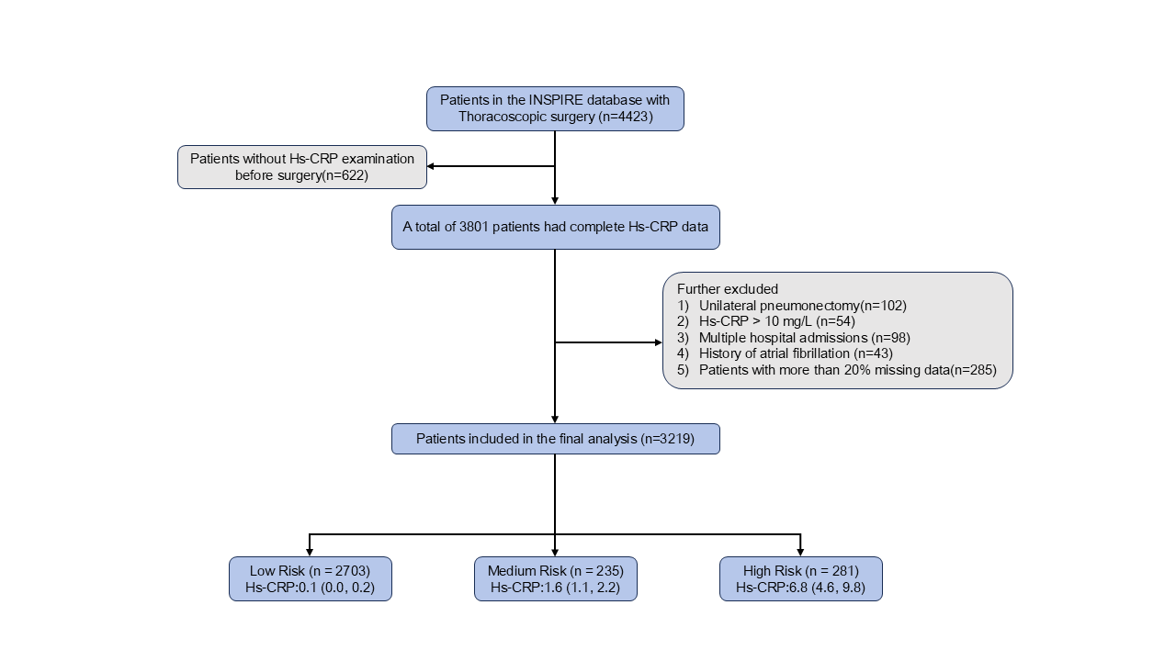
Figure S1. Study flow chart and cohort derivation.
Among 4,423 patients who underwent thoracoscopic surgery in the INSPIRE database, 622 without preoperative high-sensitivity C-reactive protein (hs-CRP) testing were excluded, leaving 3,801 patients with complete hs-CRP data. Additional exclusions were unilateral pneumonectomy (n=102), hs-CRP >10 mg/L (n=54), multiple hospital admissions (n=98), prior atrial fibrillation (n=43), and >20% missing data (n=285), yielding 3,219 patients for the final analysis. Patients were categorized by preoperative hs-CRP level into low risk (<1 mg/L; n=2,703; hs-CRP 0.1 [0.0–0.2]), medium risk (1–3 mg/L; n=235; 1.6 [1.1–2.2]), and high risk (≥3 mg/L; n=281; 6.8 [4.6–9.8]). Values for hs-CRP are presented as median (interquartile range).

