Supplementary Materials
Lactate drives maladaptive metabolic reprogramming via MRS2 in
ischemia–reperfusion-induced acute kidney injury
Zhixin Yan^{1-3#}, Annan Chen^{1-3#}, Fang Li^{1-3#}, Jian Zhang¹⁻³, Qiwen Xie⁴, Gaoxiang Han¹⁻³, Weiran Zhou¹⁻³, Abuduxiukuer Yusufu¹⁻³, Weize Chen¹⁻³, Qiuyu Gu¹⁻³, Shuan Zhao¹⁻³, Yan Yang¹⁻³, Jialin Wang¹⁻³, Yi Fang¹⁻³, Yang Li¹⁻³, Yan Dai¹⁻³, Shi Jin¹⁻³, Yiqin Shi¹⁻³*, Xiaoqiang Ding¹⁻³*, Nana Song¹⁻³*

Table of contents
Supplemental Figure 1. Establishment and validation of the in vivo I/R-AKI model and the in vitro H/R model.
Supplemental Figure 2. Lactate disrupts mitochondrial homeostasis and inhibits TCA cycle.
Supplemental Figure 3. Lactate exacerbates cellular injury during the reoxygenation phase.
Supplemental Figure 4. Efficacy of siMrs2 and oe-Mrs2 in mTECs.
Supplemental Figure 5. Distribution of MRS2 in the kidney.
Supplemental Figure 6. Knockdown of MRS2 attenuates H/R-induced injury.
Supplemental Figure 7. Characterization and in vivo efficacy of siMrs2-LNPs.
Supplemental Figure 8. Renal distribution of MRS2 following siMRS2-LNP administration.
Supplemental Table 1. siRNA sequences.
Supplemental Table 2. Primer sets used for real-time PCR.
Figure S1. Establishment and validation of the in vivo I/R-AKI model and the in vitro H/R model.
(a) Measurement of SCr levels. ***p < 0.001 (n=6). (b) Measurement of BUN levels. ***p < 0.001 (n=6). (c) Representative PAS and TUNEL staining. (d) Representative Western blot of renal tubule injury marker-KIM-1. (e) Schematic of in vitro H/R model. (f) Representative Western blot and quantitative analysis of injury marker and apoptosis. *p < 0.05, **p < 0.01, ***p < 0.001 (n=3). Data were shown as mean ± SD. Statistical analysis was performed by unpaired t test (a,b) and one-way ANOVA with Dunnett's multiple comparisons test (f).

Figure S2. Lactate disrupts mitochondrial homeostasis and inhibits TCA cycle.
The mTECs were treated with 20mM lactic acid for 12h. (a) Assessment of cell viability. **p < 0.01, ***p < 0.001 versus vehicle group (n = 3). (b) Representative Western blot and quantitative analysis. *p < 0.05 (n = 3). (c) Representative immunofluorescence images of mitochondria morphology. (d) Quantitative analysis of JC-1 staining fluorescence intensity (red to green ratio) via microplate reader. ***p < 0.001 versus vehicle group (n = 3). (e) Measurement of ATP content. **p < 0.01 versus vehicle group (n = 3). (f) Quantitative real-time PCR analysis of mRNA levels. Actb was used as the loading control. *p < 0.05, **p < 0.01, ***p < 0.001 versus vehicle group (n = 3). Data were shown as mean ± SD. Statistical analysis was performed by one-way ANOVA with Dunnett's multiple comparisons test (a), one-way ANOVA with Tukey's multiple comparisons test (b), unpaired t test (d, e) and two-way ANOVA with Tukey's multiple comparisons test(f).

Figure S3. Lactate exacerbates cellular injury during the reoxygenation phase.
(a)Representative Western blot and quantitative analysis. ***p < 0.001 (n = 3). (b) Measurement of cell viability. ***p < 0.001 (n = 3). (c) Representative Western blot and quantitative analysis. ***p < 0.001 (n = 3). Data were shown as mean ± SD. Statistical analysis were performed by one-way ANOVA with Tukey's multiple comparisons test (a,c) and two-way ANOVA with Dunnett's multiple comparisons test(b).

Figure S4. Efficacy of siMrs2 and oe-Mrs2 in mTECs.
(a, b) MTECs were transfected with siMrs2 or scramble (as control) and were collected for analysis. (a) Quantitative real-time PCR analysis of mRNA levels. Actb was used as the loading control (n = 3). (b) Representative Western blot and quantitative data of MRS2. (c, d) The mTECs were transfected with scramble (empty vector) and Mrs2-expressing plasmid and were collected for analysis. (c) Quantitative real-time PCR analysis of mRNA levels. Actb was used as the loading control (n = 3). (d) Representative Western blot and quantitative data of MRS2. *p < 0.05, **p < 0.01, ***p < 0.001 versus scramble group (n = 3). Data were shown as mean ± SD. Statistical analysis was performed by unpaired t test.

Figure S5. Distribution of MRS2 in the kidney
(a) Representative immunofluorescence images of MRS2. (b) Schematic of chloropentaammine cobalt (III) chloride (CPACC)-mediated inhibition of MRS2 in vivo and I/R-AKI experimental design.

Figure S6. Knockdown of MRS2 attenuates H/R-induced injury.
(a) Quantitative real-time PCR analysis of mRNA levels. Actb was used as the loading control. *p < 0.05, **p < 0.01, ***p < 0.001 (n = 3). (b) Representative Western blot and quantitative data of MRS2, cleaved-caspase9 and cleaved-caspase3. *p < 0.05, **p < 0.01 (n = 3). (c) Quantitative real-time PCR analysis of Kim1 levels. Actb was used as the loading control. ***p<0.001 (n = 3). (d) Quantitative analysis of JC-1 staining fluorescence intensity (red to green ratio) via microplate reader. *p < 0.05, **p < 0.01, ***p < 0.001 (n = 3). (e) Quantitative analysis of glycolytic pathway. *p < 0.05 versus ctl group(n=3). #p < 0.05, ##p < 0.01 versus H/R group (n = 3). Data were shown as mean ± SD. Statistical analysis was performed by one-way ANOVA with Tukey's multiple comparisons test.

Figure S7. Characterization and in vivo efficacy of siMrs2-LNPs.
(a) Representative TEM images of siMrs2-LNP. (b) Measurement of dynamic light scattering and zeta potential. siRNA-LNPs had an average hydrodynamic diameter of ~100 nm with a PDI of 0.02, indicating uniform size distribution. Zeta potential measurement indicated a near-neutral surface charge (~0 mV), consistent with good colloidal stability and biocompatibility. (c) Quantitative real-time PCR analysis of mRNA levels. Actb was used as the loading control. *p < 0.05, **p < 0.01 (n = 2-4). (d) Representative Western blot and corresponding densitometric quantification of MRS2 expression at the indicated time points. *p < 0.05, **p < 0.01 (n = 3-4). (e) Representative immunoblots showing MRS2 expression at the indicated doses. (f) Measurement of SCr levels (n=6). (g) Measurement of BUN levels (n=6). (h) Representative immunohistochemistry staining of MRS2, PAS and TUNEL staining. (i) Representative Western blot and quantitative data of MRS2 in liver and intestine (n=6). Data were shown as mean ± SD. Statistical analysis was performed by one-way ANOVA with Dunnett's multiple comparisons test(c,d) and unpaired t test.

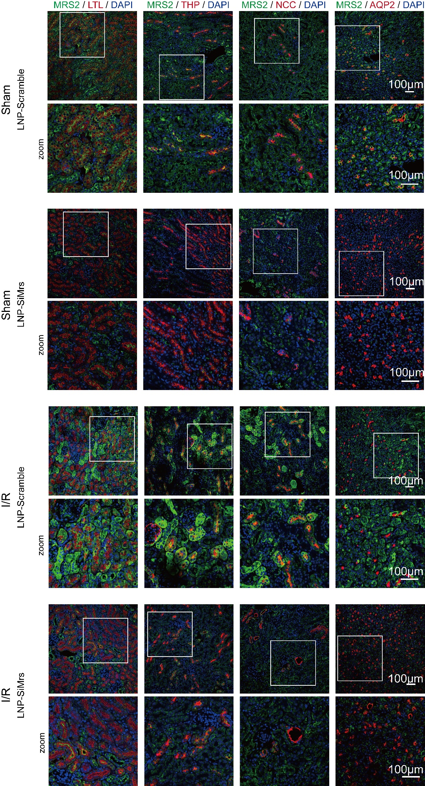
Figure S8. Renal distribution of MRS2 following siMRS2-LNP administration.

Supplemental Table 1. siRNA sequences.
Name | Sense (5’-3’) | Antisense (5’-3’)
Mrs2  siRNA | CCAUUUGAGUUCAGAGCUAUUTT | AAUAGCUCUGAACUCAAAUGGTT
Scramble  siRNA | UUCUCCGAACGUGUCACGUTT | ACGUGACACGUUCGGAGAATT

Supplemental Table 2. Primer sets used for real-time PCR.
Gene | Sense Primer (5’-3’) | Antisense Primer (5’-3’)
mouse  Idh3a | GCAGGACTGATTGGAGGTCTTG | GCCATGTCCTTGCCTGCAATGT
mouse  Cs | ATGCAGAGGGAATGAACCGAGC | GAGTCAATGGCTCCGATACTGC
mouse  Sdhb | TGCGGACCTATGGTGTTGGATG | CCAGAGTATTGCCTCCGTTGATG
mouse  Ogdh | GGTGTCGTCAATCAGCCTGAGT | ATCCAGCCAGTGCTTGATGTGC
mouse  Actb | CATTGCTGACAGGATGCAGAAGG | TGCTGGAAGGTGGACAGTGAGG

