Synergistic Charge Separation in Engineered 2D CoTiO₃/TiO₂ Composites for Superior Photocatalysis
Min Deng#, Shasha Zhang#, Jiayi Liang, Ziyuan Li, Hongbo Jiang∗ , Weiwei Zhao, Jingman Pang, Yan Wang
College of Chemistry and Materials Engineering, Baoji University of Arts and Sciences, 1 Hi-Tech Avenue, Baoji, Shaanxi, 721013 PR China

# These authors contributed equally to this work
∗ Corresponding authors
E-mail addresses: hongbojiang2011@163.com (H. B. Jiang)

Physical characterization

The crystal structure of the samples was analyzed by powder X-ray diffraction (XRD) using a Dmax Ultima IV diffractometer (Japan) with Cu Kα radiation (λ = 0.15418 nm). The XRD patterns were recorded in a scanning range from 5° to 60° at a rate of 5°/min. Raman spectroscopy was employed to investigate molecular vibrational modes, using a Renishaw inVia laser micro-Raman spectrometer with a 532 nm visible laser as the excitation source. Fourier transform infrared (FT-IR) spectroscopy measurements were carried out using a PerkinElmer Spectrum 3 (USA) spectrometer to identify characteristic functional groups and corresponding vibrational modes in the synthesized composites. Morphological features and particle size distributions were characterized through field-emission scanning electron microscopy (FE-SEM) using a Quanta250 FEG system (FEI). X-ray photoelectron spectroscopy (XPS) measurements were performed on a Nexsa spectrometer (Thermo Fisher Inc.) to determine the chemical composition and valence states of elements in the samples. The analysis was conducted with a pass energy of 100 eV and a step size of 0.1 eV. Transmission electron microscopy (TEM) was used to examine the doping sites and types, operating at an acceleration voltage of 300 kV. High-resolution transmission electron microscopy (HRTEM) measurements were conducted using a JEOL JEM-3010, in order to determine the crystallographic characteristics of the samples.

Photocatalytic Catalytic

The photocatalytic activities were evaluated by the degradation of various dyes, including methyl orange (MO), rhodamine B (RhB), methylene blue (MB), green dyes, and blue dyes. RhB was chosen as the representative organic pollutant to explore the catalytic properties of CoTiO₃/TiO₂ composites. The experimental setup consisted of a 300 W LED lamp to simulate ultraviolet irradiation and an ultrasonic device to create piezocatalytic conditions. All reactions were carried out in a thermostatic magnetic stirrer set at 25 °C. To avoid interference from peroxymonosulfate (PMS) dosage, a fixed amount of 0.005 g PMS was used in all experiments. Specifically, a certain amount of CoTiO₃/TiO₂ catalyst with different Ba/Ti molar ratios was added to 50 mL of 20 mg/L RhB solution. Similar to the optimization techniques described in Reference 0, the performance of the catalysts was improved by adjusting the molar ratios of various components. First, the mixture was magnetically stirred in the dark for 30 min to achieve the adsorption - desorption equilibrium of RhB on the catalyst surface. Then, the catalytic reaction was initiated by illuminating the sample with a 300 W LED lamp for 30 minutes. During the reaction, 3.0 mL aliquots were taken every 5 minutes using a syringe, filtered through a 0.22 μm membrane, and the filtrate was transferred to a quartz cuvette for analysis. The residual concentration of RhB was measured using a UV - 8000A ultraviolet - visible spectrophotometer at its maximum absorption wavelength. The degradation efficiency (Y) was calculated according to the following equation:

Y=(C₀ - Ct)/C₀×100% (1)
where C₀ is the initial concentration of the dye, and C_{t} is the residual concentration of RhB at time t.
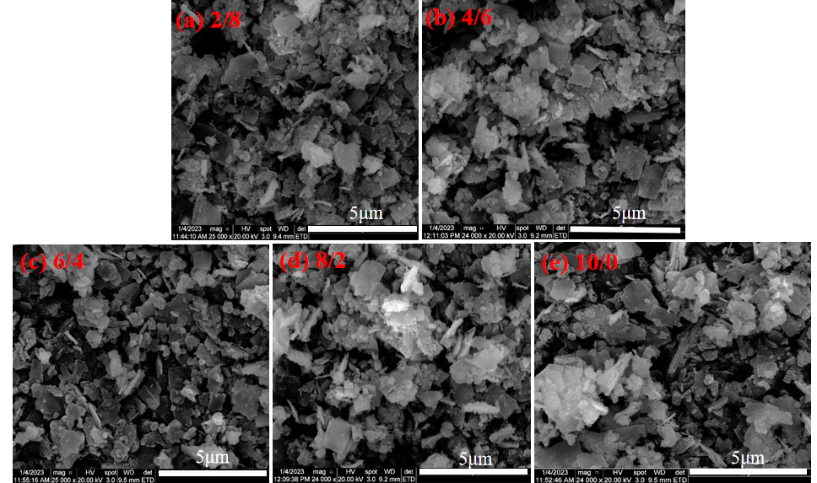
Fig. S1 SEM images of CoTiO₃/TiO₂ at different ratios at 600 °C

