Reconstructing seasonally focused shellfish harvesting strategies of First Nations communities on the northern Great Barrier Reef (Australia) during the Late Holocene
Journal name: Journal of Archaeological Research
Mahsa Alidoostsalimi^{1,2}, Amy L. Prendergast^{1,2*}, Sean Ulm³, Russell N. Drysdale¹, Josephine Brown¹, Ian J. McNiven⁴, Ariana B.J. Lambrides^{3,5}, Michael C. Kneppers^{3,5}, Sarah J. Collins³, Robert M. Klaebe⁶, Nguurruumungu Indigenous Corporation⁷, and Walmbaar Aboriginal Corporation RNTBC⁸

¹ School of Geography, Earth and Atmospheric Sciences, University of Melbourne, Victoria, Australia
²ARC Centre of Excellence for Indigenous and Environmental Histories and Futures, University of Melbourne, Victoria, Australia
³ARC Centre of Excellence for Indigenous and Environmental Histories and Futures, James Cook University, Cairns, Queensland, Australia
⁴ARC Centre of Excellence for Australian Biodiversity and Heritage, Monash Indigenous Studies Centre, Monash University, Clayton, Victoria, Australia
⁵College of Arts, Society and Education, James Cook University, Cairns, Queensland, Australia
⁶Department of Earth Sciences, School of Physics, Chemistry and Earth Sciences, University of Adelaide, South Australia, Australia
⁷ PO Box 886, Cooktown, Queensland, Australia
⁸24 Flierl Street, Hope Vale, Queensland, Australia
*Corresponding Authors:
Amy Prendergast: amy.prendergast@unimelb.edu.au
Postal address: 221 Bouverie St, Carlton, Melbourne, Victoria 3053, Australia.

Supplementary Information (SI)
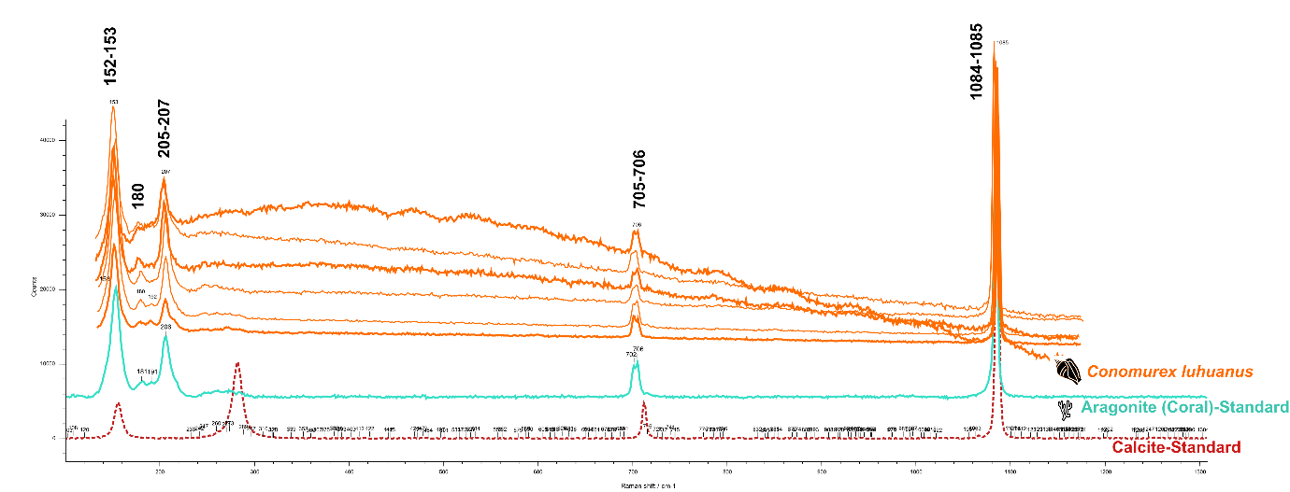
Fig. S1

