Bioactivity of Recombinantly Expressed Human Serglycin Under Different Glycemic Conditions
Shang-Wun Jhang¹, Ya-Ning Chang², Chiu-Chen Huang⁴, Yu-Ting Yan⁵, Bill Cheng²*

Affiliation
¹Department of Neurosurgery, Changhua Christian Hospital, Changhua, Taiwan
²Graduate Institute of Biomedical Engineering, National Chung-Hsing University, Taichung, Taiwan
³Food and Drug Administration, Ministry of Health and Welfare, Taipei, Taiwan
⁴Department of Post-Baccalaureate Veterinary Medicine, Asia University, Taichung, Taiwan
⁵Institute of Biomedical Science, Academia Sinica, Taipei, Taiwan

Correspondence
Bill Cheng, Ph.D.
Graduate Institute of Biomedical Engineering
National Chung-Hsing University
No.145, Xing Da Road, Taichung, 402, Taiwan
Phone: +886-4-22840165 #936
Email: bcheng@dragon.nchu.edu.tw

Supplementary Figures

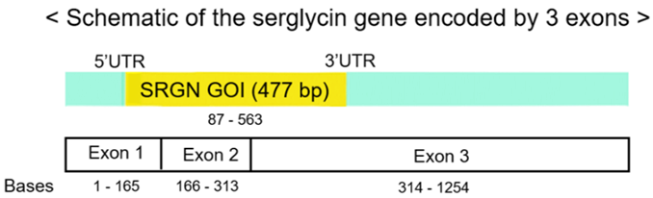
Supplementary Figure 1. Schematic diagram depicting the mRNA of human serglycin. Primers were designed to amplify the gene of interest (GOI, yellow) that was cloned into the pcDNA4/myc-HisA vector. The GOI encompassed the signal peptide sequence of serglycin.

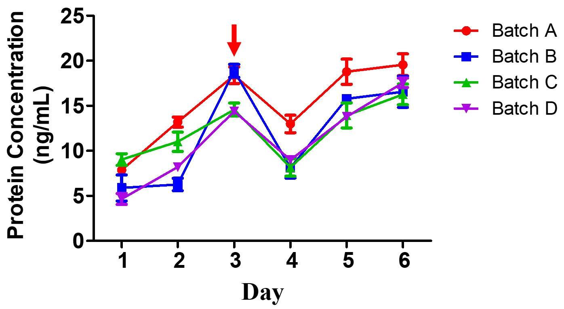
Supplementary Figure 2 The productivity of rhSRGN in each of the four batches over 6 days of culturing. Cells were transfected with pcDNA4/SRGN-HisA on Day 0. After 24 hours of incubation (Day 1), the cells were exposed to 400 μg/mL of zeocin for the rest of the culturing period. At Day 3, cells were passaged at 1×10⁵ cells/mL (red arrow). Aliquots were taken from the collected media of each batch on each day, and the concentration of rhSRGN was quantified with human serglycin sandwich ELISA (N=3)

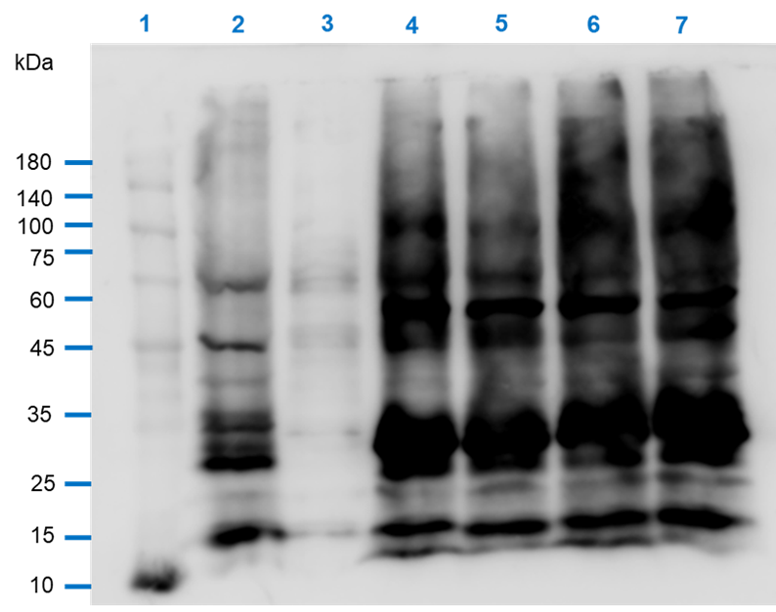
Supplementary Figure 3. Western blotting analysis of the rhSRGN in all four batches. Each lane was loaded with 10 μg/mL of protein samples. Before being loaded into the gel, the protein samples were mixed with a loading dye that contained 0.1M DTT and placed in a 60 °C dry bath for 10 minutes. Lane 1, molecular weight marker; Lane 2, THP-1 cell lysate; Lane 3, HEK293T cell lysate; Lane 4, Batch A rhSRGN; Lane 5, Batch B rhSRGN; Lane 6, Batch C rhSRGN; Lane 7, Batch D SRGN.

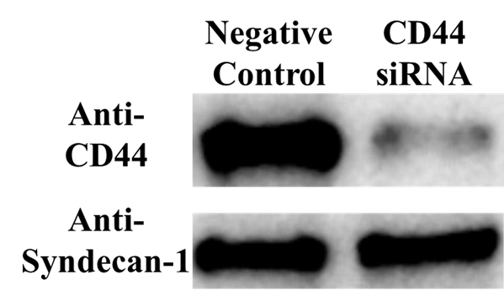
Supplementary Figure 4. Western blotting analysis of the expression of CD44 and syndecan-1 in HaCaT treated with CD44 siRNA. HaCaT cultured in a 2-well insert were transfected with either negative control or CD44 siRNA and were incubated for one overnight. After the cells underwent migration in NG media, the cells were sacrificed, and the expressions of CD44 and synedcan-1 were studied.

The gel and the Western blot presented in Figure 2 is the uncropped form.

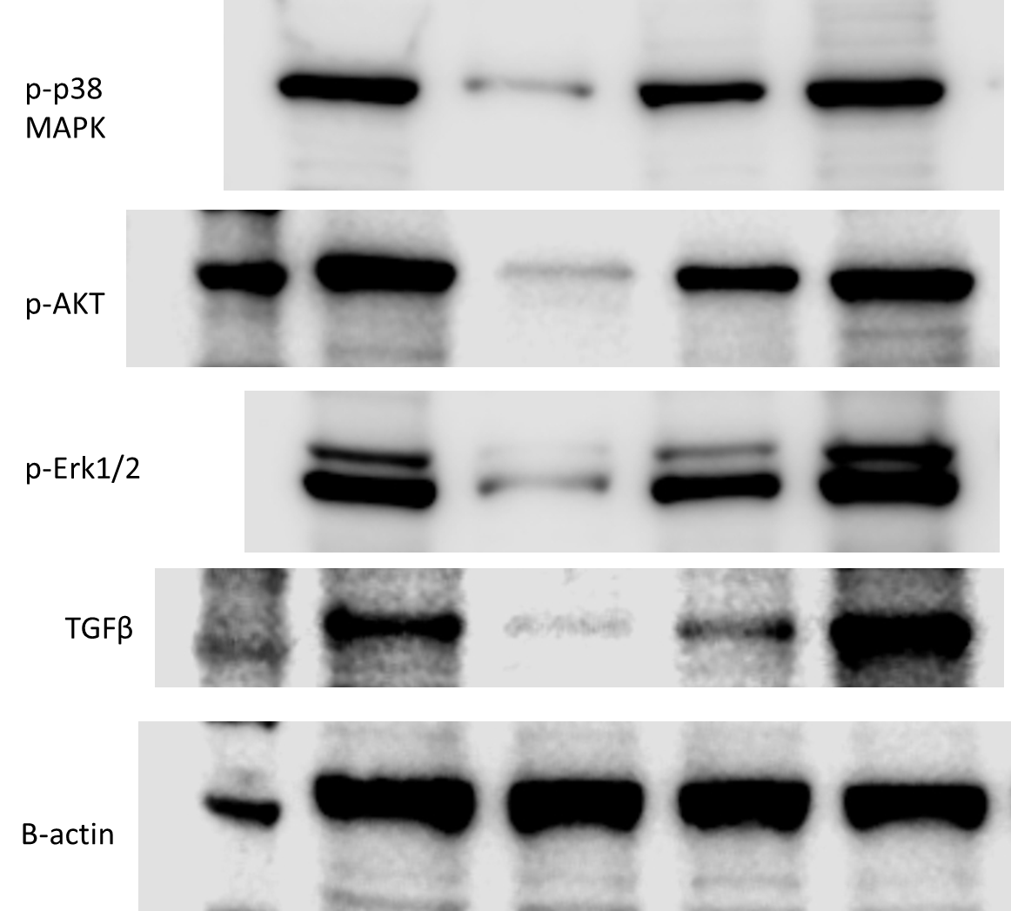
The figure above is the uncropped blot of the Western blot presented in Figure 5.

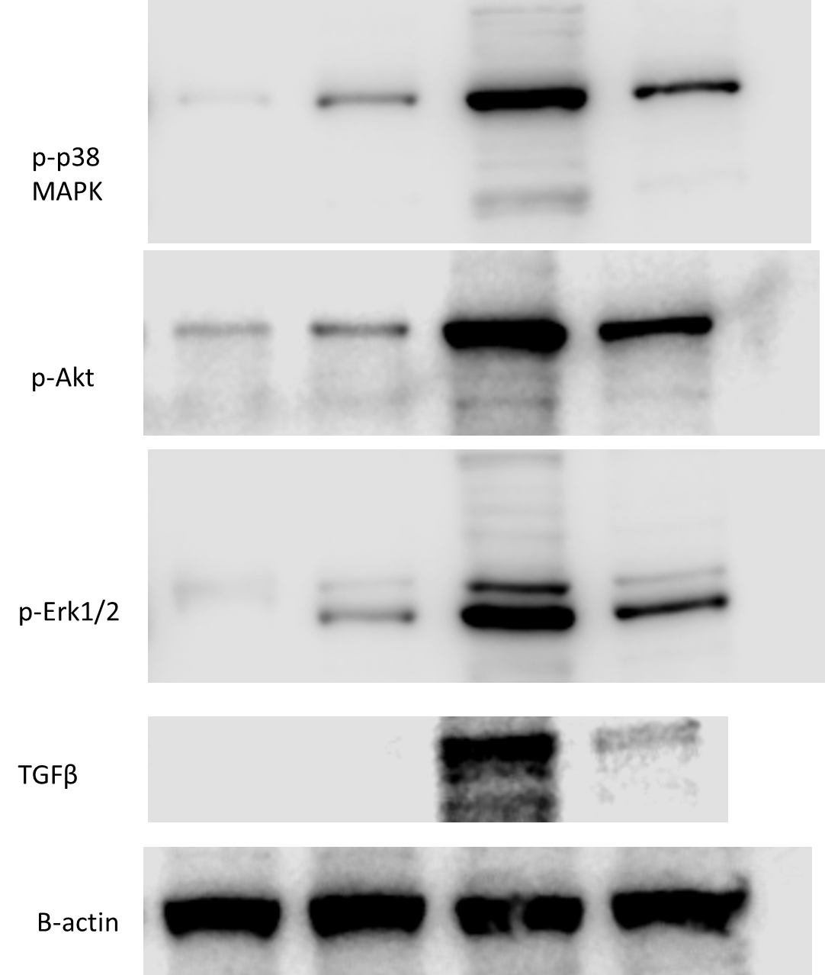
The figure above is the uncropped blot of the Western blot presented in Figure 7.

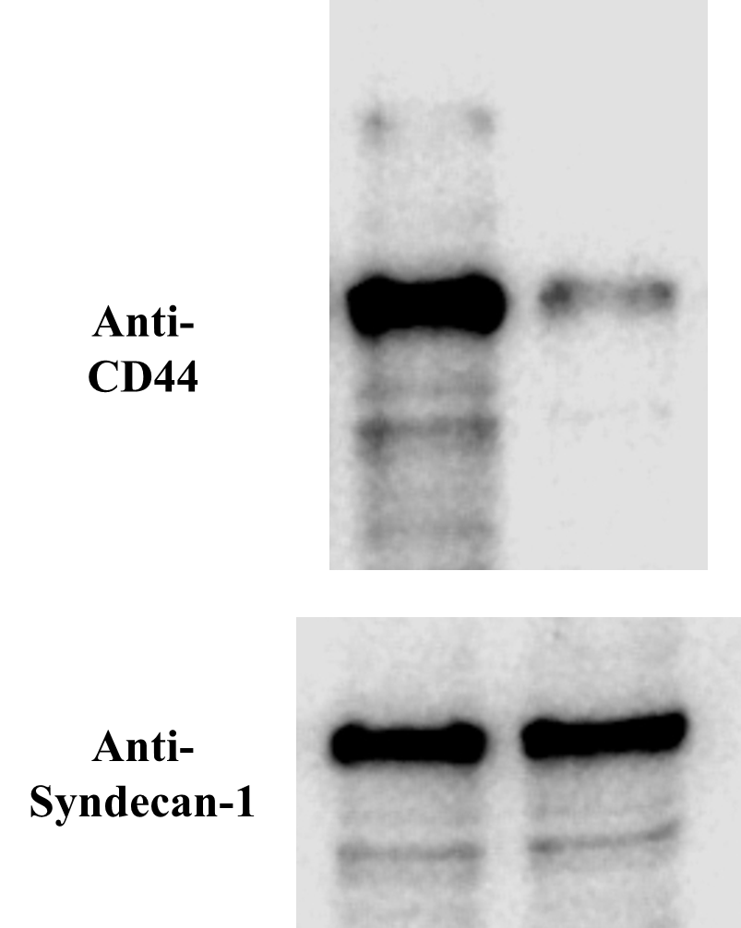
The figure above is the uncropped blot of the Western blot presented in Supplementary Figure 4.

Supplementary Table

Supplemental Table 1. The amount of rhSRGN purified from the conditioned media of each batch. The amount of serglycin purified from 250 mL of conditioned media. The proteins were quantified with a commercially available serglycin sandwich ELISA kit. The cell lysate of human monocytes (THP-1) was used as the positive control.
