Appendix 1. Conducting and Reporting Delphi Studies (CREDES) Checklist.
Section/Topic | Item | Recommendation | Reported on page #
Rationale for Delphi Technique
Justification | 1 | The choice of the Delphi technique as a method of systematically collating expert consultation and building consensus needs to be well justified. | Introduction, 5
Planning and Design
Planning and process | 2 | The Delphi technique is a flexible method and can be adjusted to the respective research aims and purposes. Any modifications should be justified by a rationale and be applied systematically and rigorously | Methods,  5-6
Definition of consensus | 3 | Unless not reasonable due to the explorative nature of the study, an a priori criterion for consensus should be defined. This includes a clear and transparent guide for action on (a) how to proceed with certain items or topics in the next survey round, (b) the required threshold to terminate the Delphi process and (c) procedures to be followed when consensus is (not) reached after one or more iterations | Methods,  6-7
Study Conduct
Informational input | 4 | All material provided to the expert panel at the outset of the project and throughout the Delphi process should be carefully reviewed and piloted in advance in order to examine the effect on experts’ judgements and to prevent bias | Methods, 7
Prevention of bias | 5 | Researchers need to take measures to avoid directly or indirectly influencing the experts’ judgements. If one or more members of the research team have a conflict of interest, entrusting an independent researcher with the main coordination of the Delphi study is advisable | No conflicts reported
Interpretation and processing of results | 6 | Consensus does not necessarily imply the ‘correct’ answer or judgement; (non)consensus and stable disagreement provide informative insights and highlight differences in perspectives concerning the topic in question | Methods,  9-10
External validation | 7 | It is recommended to have the final draft of the resulting guidance reviewed and approved by an external board or authority before publication and dissemination | N/A
Reporting
Purpose and rationale | 8 | The purpose of the study should be clearly defined and demonstrate the appropriateness of the use of the Delphi technique as a method to achieve the research aim. A rationale for the choice of the Delphi technique as the most suitable method needs to be provided | Introduction, 5
Expert panel | 9 | Criteria for the selection of experts and transparent information on recruitment of the expert panel | Methods,  7-9
Description of the methods | 10 | The methods employed need to be comprehensible; this includes information on preparatory steps, piloting of material and survey instruments, design of the survey instrument(s), the number and design of survey rounds, methods of data analysis, processing and synthesis of experts’ responses to inform the subsequent survey round and methodological decisions taken by the research team throughout the process | Methods,  9-10
Procedure | 11 | Flow chart to illustrate the stages of the Delphi process, including a preparatory phase, the actual ‘Delphi rounds’, interim steps of data processing and analysis, and concluding steps | Figure 1, 2
Definition and attainment of consensus | 12 | It needs to be comprehensible to the reader how consensus was achieved throughout the process, including strategies to deal with non-consensus | Methods,  6-7
Results | 13 | Reporting of results for each round separately is highly advisable in order to make the evolving of consensus over the rounds transparent. This includes figures showing the average group response, changes between rounds, as well as any modifications of the survey instrument such as deletion, addition or modification of survey items based on previous rounds | Results, 11-12, Figure 2, Tables 2-5
Discussion of limitations | 14 | Reporting should include a critical reflection of potential limitations and their impact of the resulting guidance | Discussion,  12-16
Adequacy of conclusions | 15 | The conclusions should adequately reflect the outcomes of the Delphi study with a view to the scope and applicability of the resulting practice guidance | Conclusion, 16
Publication and dissemination | 16 | The resulting guidance should be clearly identifiable from the publication, including recommendations for transfer into practice and implementation. A dissemination plan should include endorsement of the  guidance by professional associations and health care authorities to facilitate implementation | This publication and presentation at international conference

Appendix 2. Screening questions

Appendix 3. Initial survey statements. 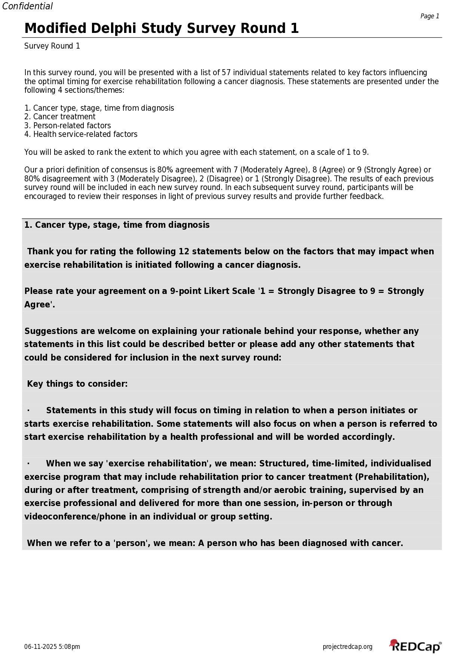
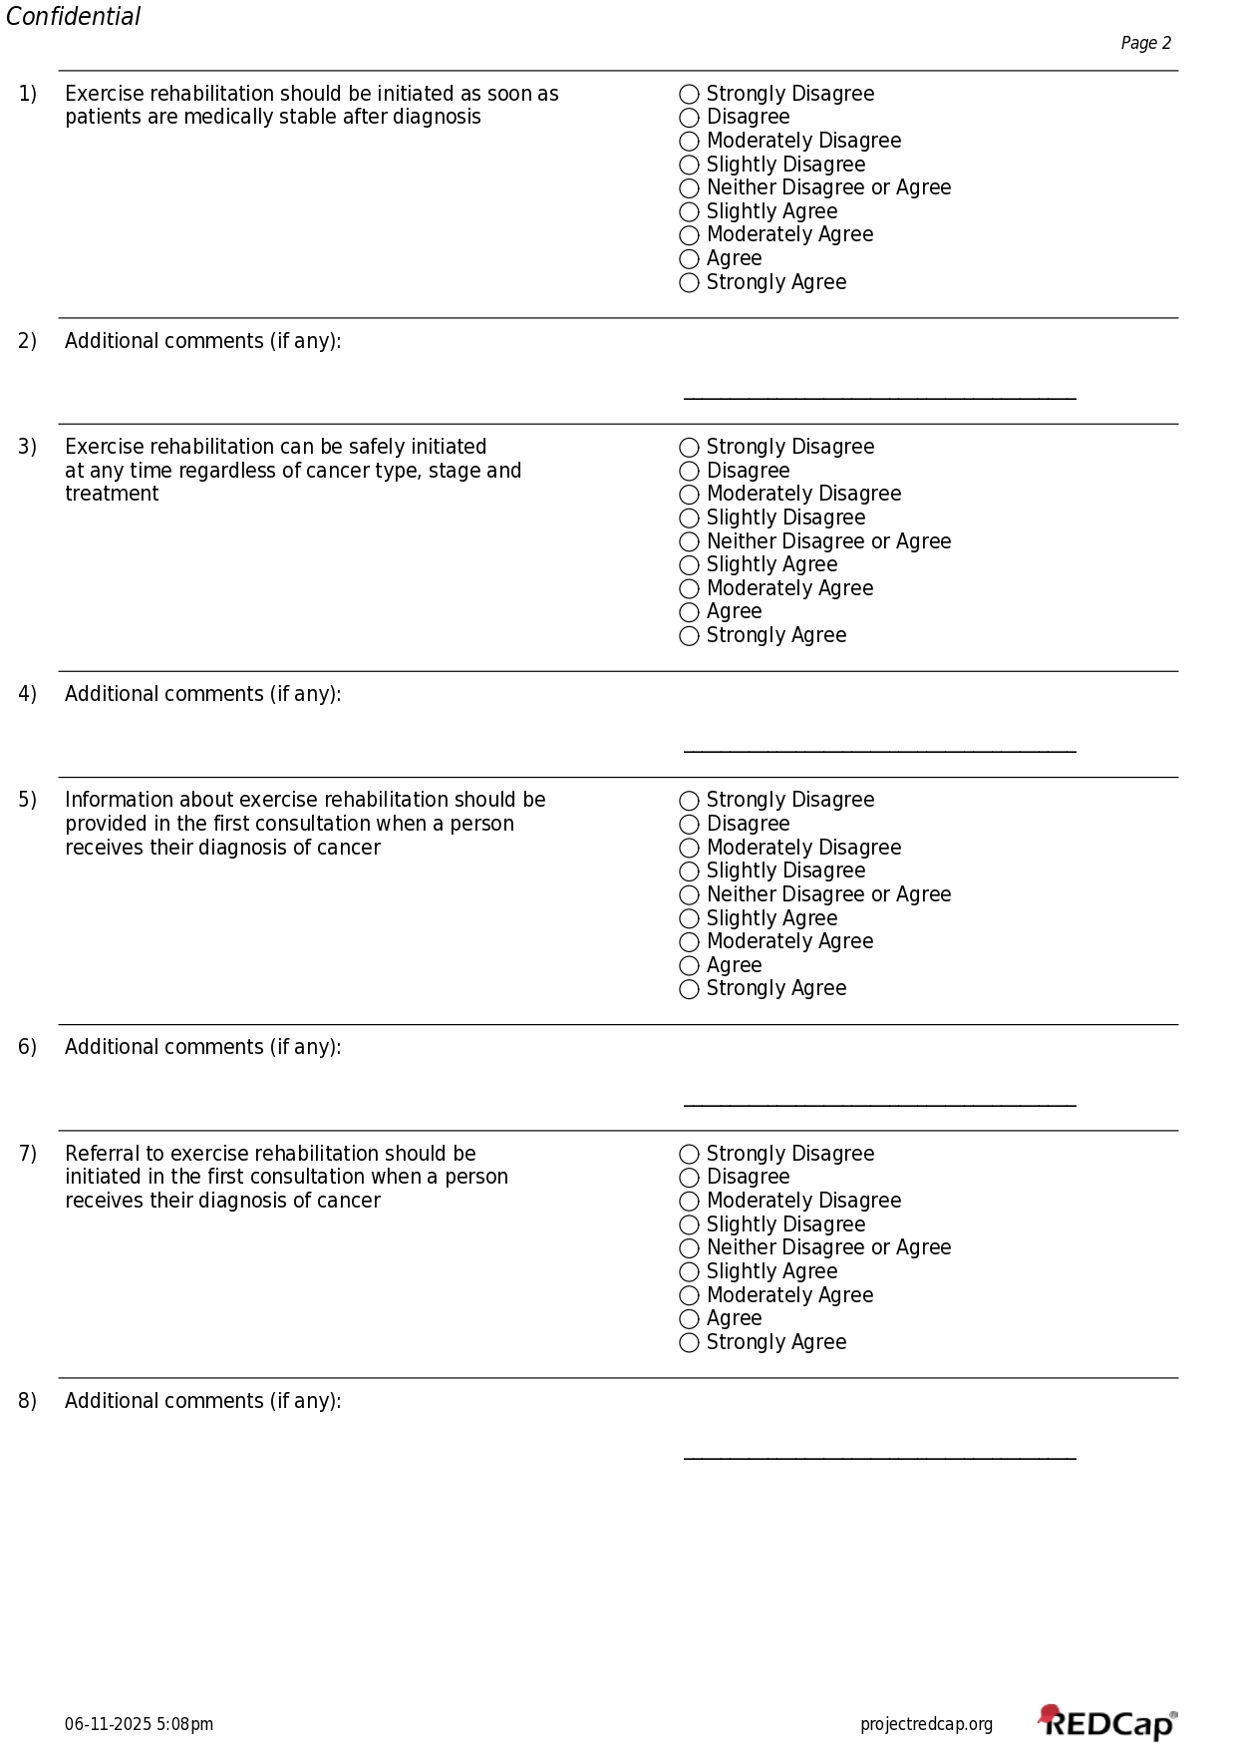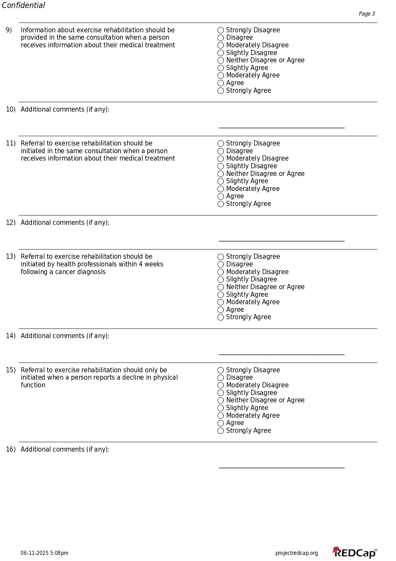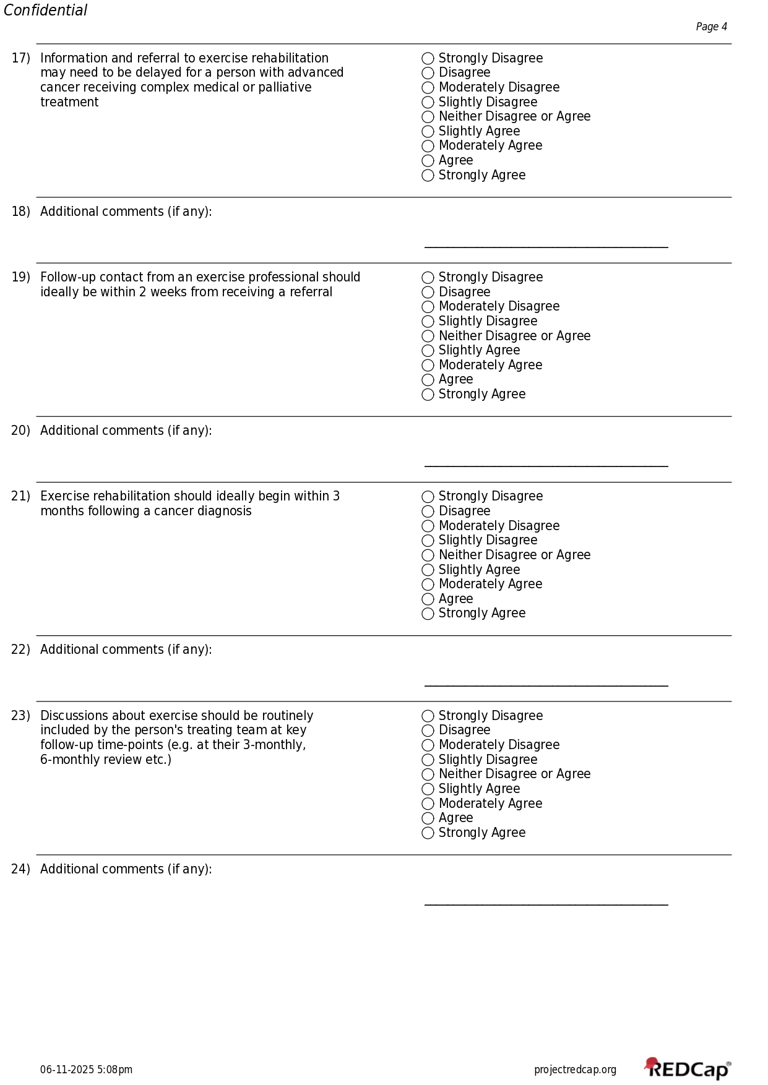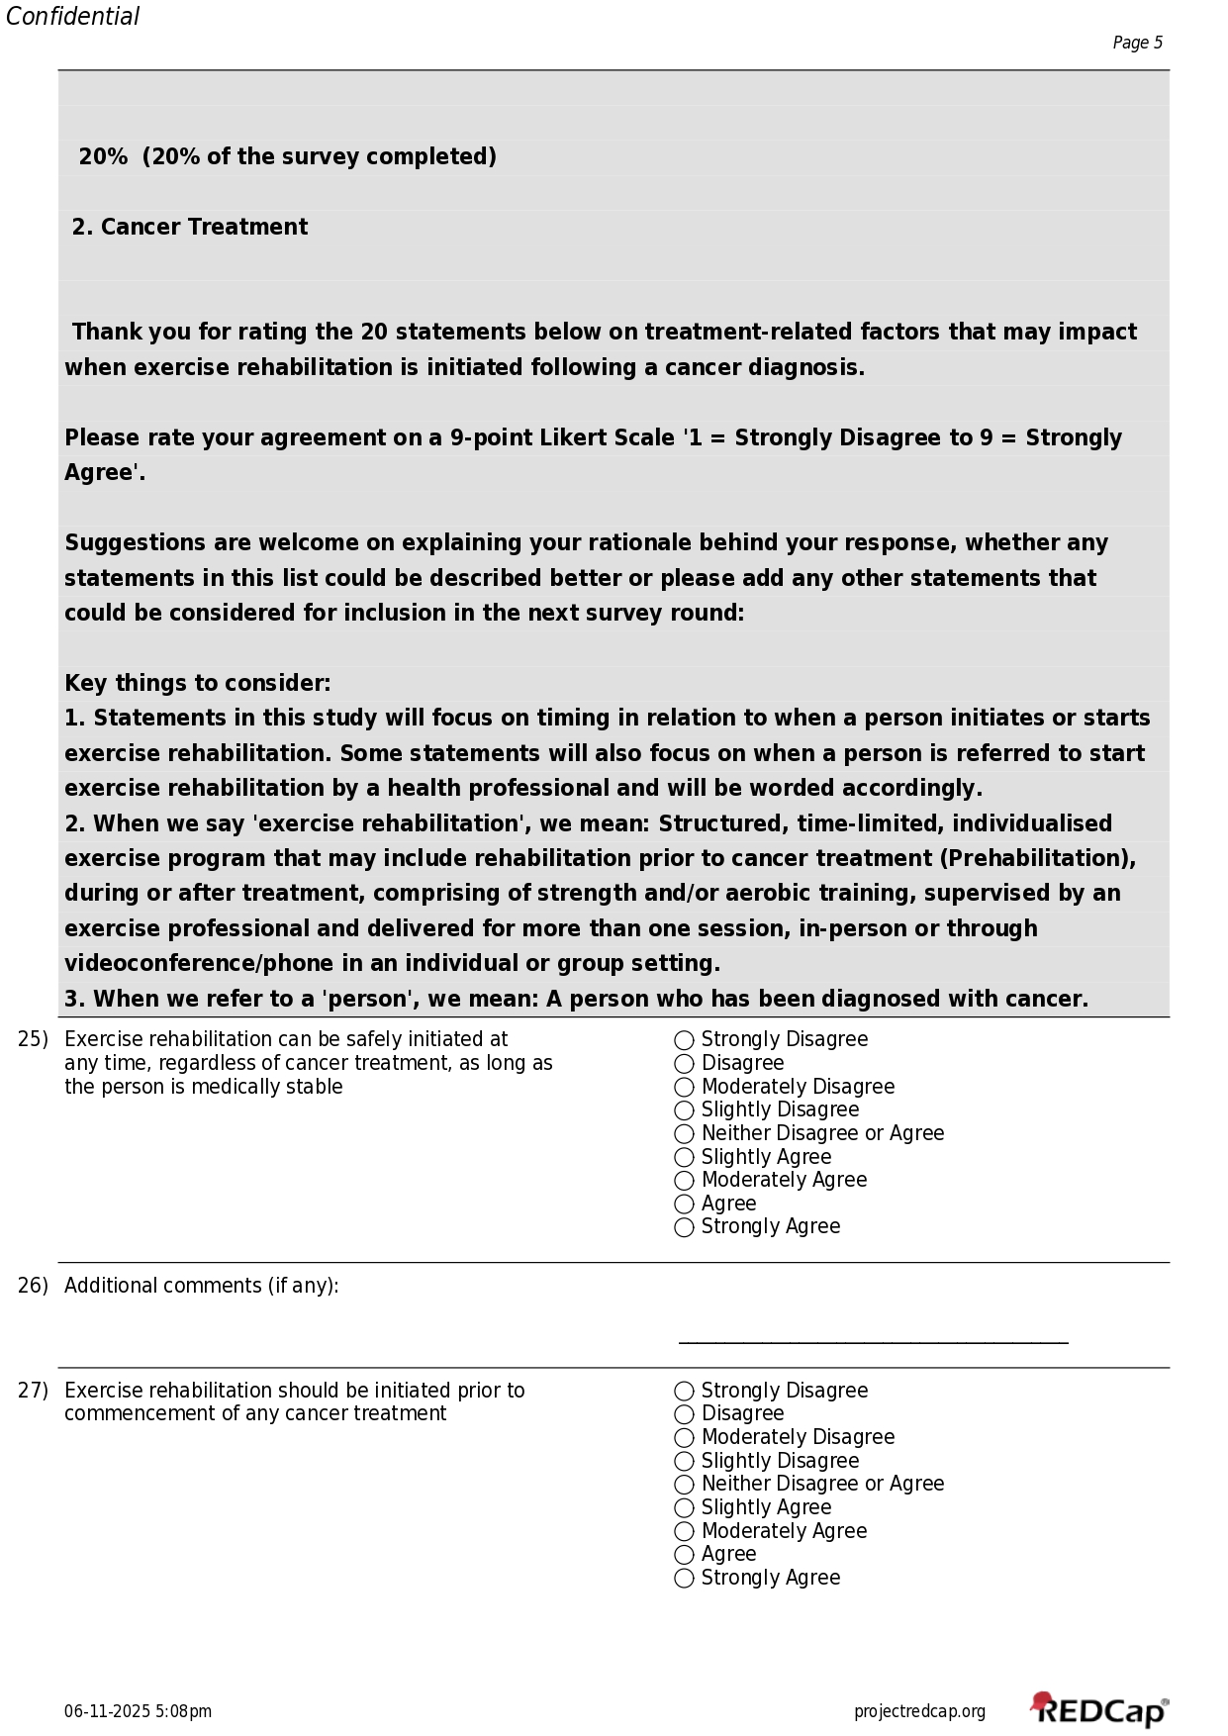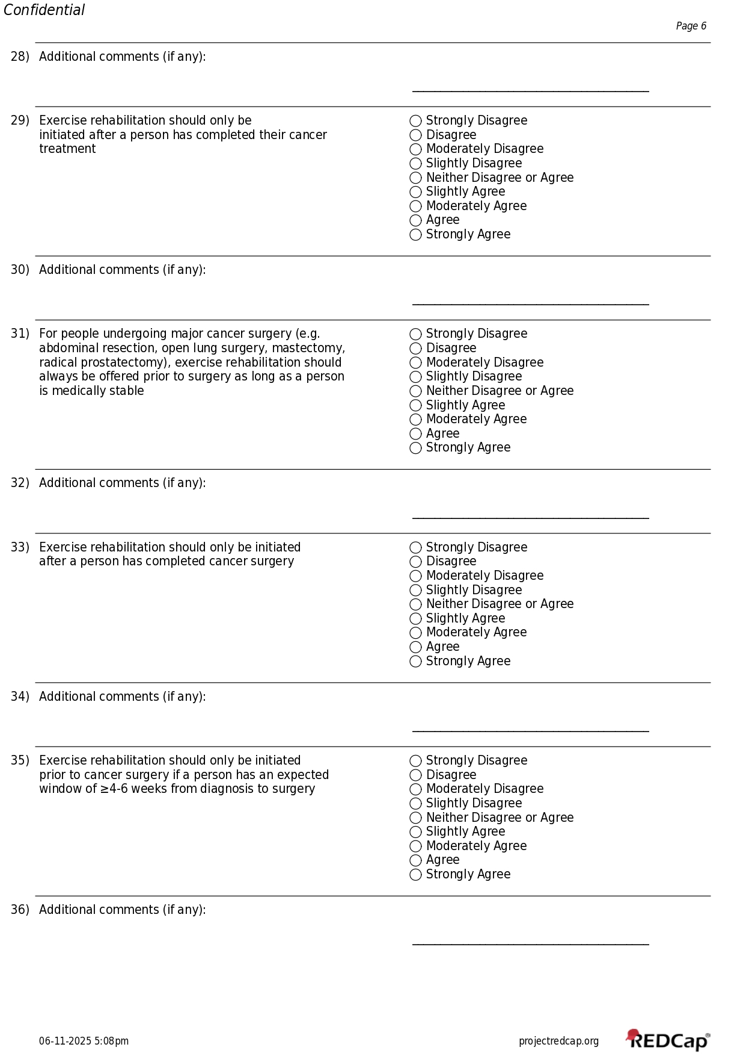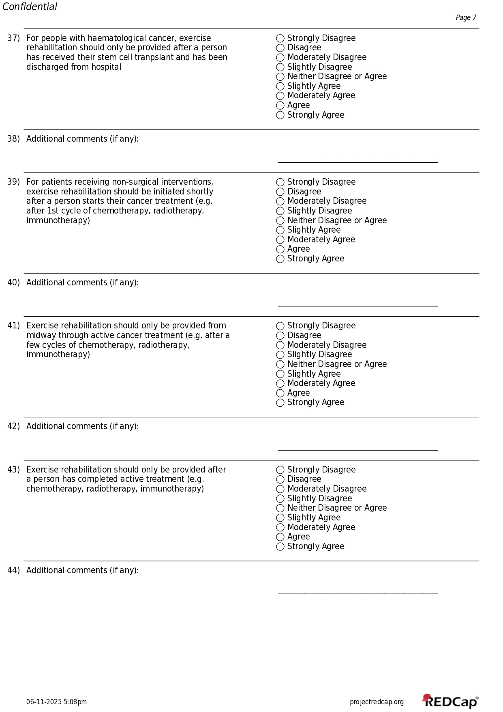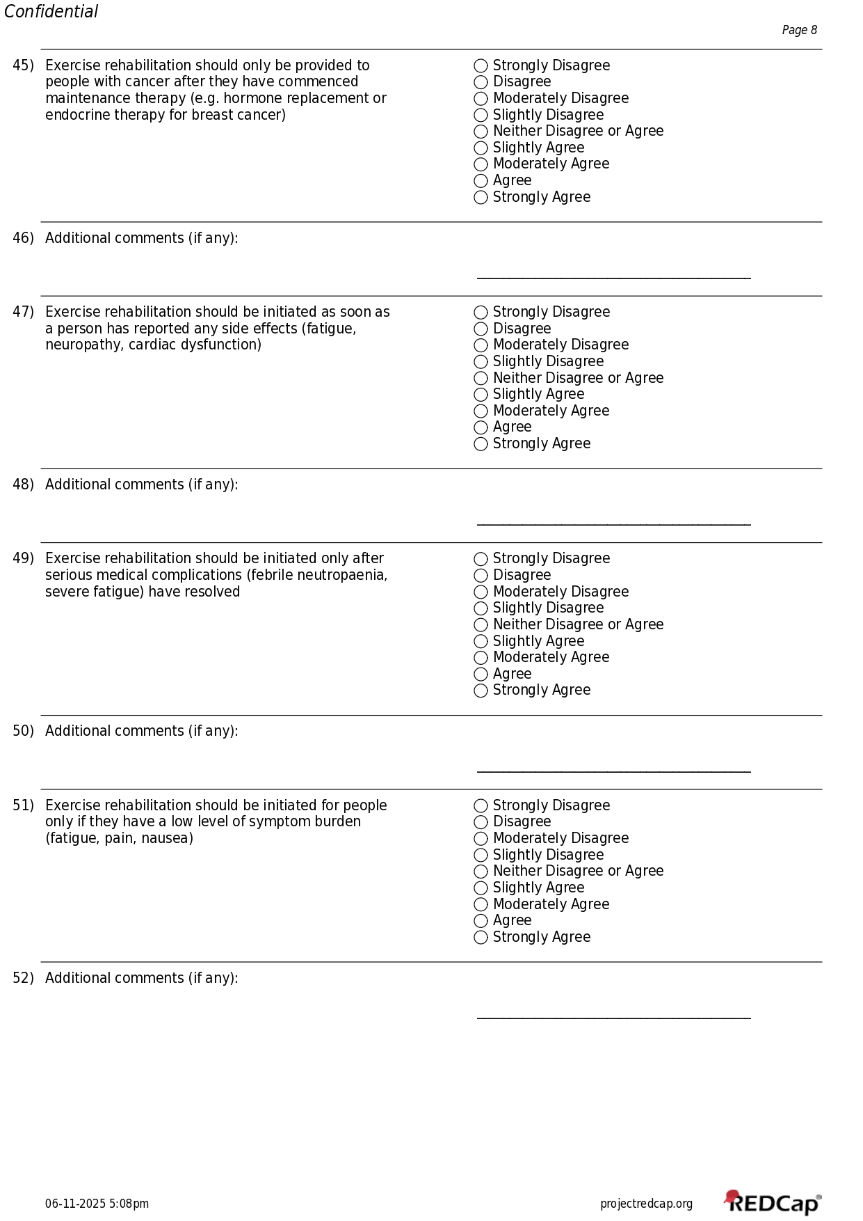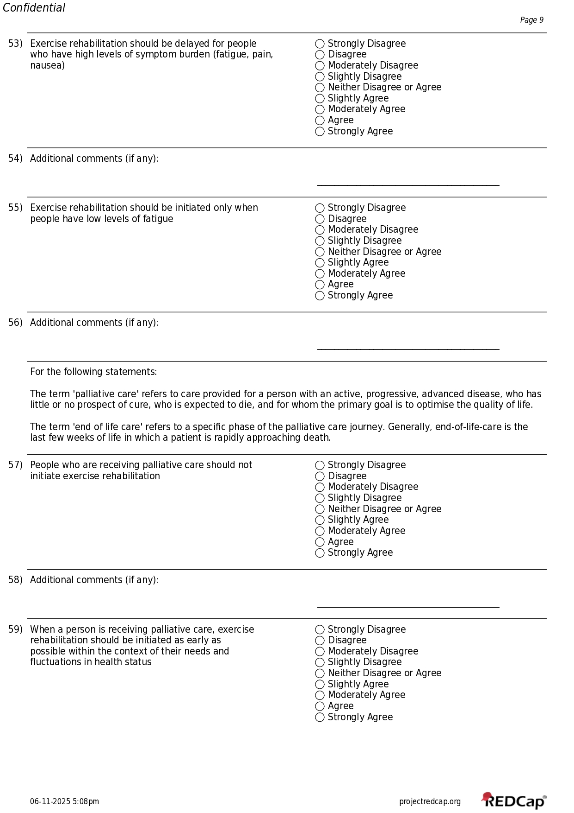
Appendix 4. Summary of Expert Comments from Survey Rounds.
Round 1
Statement | Summary of comments
Cancer type, stage, time from diagnosis
Exercise rehabilitation should be initiated as soon as patients are medically stable after diagnosis | Experts expressed the importance of 1) considering specific variations in the presentation of patients, 2) the requirement of careful clinical assessment by a trained exercise professional to ensure a patient is medically stable and 3) individualised planning to ensure safe initiation of exercise rehabilitation.
Exercise rehabilitation can be safely initiated at any time regardless of cancer type, stage and treatment | Experts acknowledged that the first consultation when a person receives their cancer diagnosis is often overwhelming. While the first consultation is a valuable opportunity to educate behaviour change, clinicians must respect and consider each individual patient's capacity and status to receive information. It is important for clinicians to ensure that this is done sensitively, and any information provided about exercise rehabilitation serves to empower their patient and not further overwhelm them.
Information about exercise rehabilitation should be provided in the first consultation when a person receives their diagnosis of cancer | Experts acknowledged that referral to exercise rehabilitation should consider each individual patient situation such as patient readiness and it might not be appropriate in all cases.
Referral to exercise rehabilitation should be initiated in the first consultation when a person receives their diagnosis of cancer | Experts expressed that information about exercise rehabilitation should be seen as an integrated part of care and treated as part of the entire treatment and process. It is important to include information about exercise rehabilitation alongside medical treatment and that this would be a good time to introduce exercise while using clinical judgement to consider individual patient capacity to receive information.
Information about exercise rehabilitation should be initiated in the same consultation when a person receives information about their medical treatment | Clinicians must respect and consider each individual patient's capacity and status to receive information.  Referral to exercise rehabilitation should be in the plan but timing may need to be individualised.  However, there is greater impact when referral to exercise rehabilitation is initiated by a medical specialist or  oncologist as part of the medical 'package'.
Referral to exercise rehabilitation should be initiated in the same consultation when a person receives information about their medical treatment | It is important to consider the values and preferences of the person and the role of exercise rehabilitation to provide benefit, maintain function and improve/preserve quality of life during this time. Depending on individual patient status, exercise rehabilitation may need to be modified instead of delayed.
Referral to exercise rehabilitation should be initiated by health professionals within 4 weeks following a cancer diagnosis | Experts expressed potential issues with time constraints between diagnosis and treatment, feasibility of initiating exercise rehabilitation in the context of service capacity and waitlists.
2. Cancer Treatment
Exercise rehabilitation should only be initiated prior to cancer surgery if a person has an expected window of ≥4-6 weeks from diagnosis to surgery | Some experts pointed out that even shorter time periods e.g. 2 weeks have shown benefit and in non-cancer  populations, even a single physio session can be beneficial. Emerging evidence suggests that even brief preoperative exercise interventions, 2 to 3 weeks in duration, can improve functional capacity and postoperative recovery.
For people with haematological cancer, exercise rehabilitation should only be provided after a person has received their stem cell tranpslant and has been discharged from hospital | Experts expressed the value of exercise rehabilitation before a person receives their stem cell transplant and during their inpatient stay after they have immediately received their stem cell transplant. 'Prehabilitation' during the pre-transplant window can improve preoperative function and fitness. During the acute transplant phase, patients can still benefit from inpatient rehabilitation but are frequently immunocompromised or medically unstable, making rehabilitation more challenging. It is important for rehabilitation during this phase to be monitored and guided by the whole multidisciplinary team.
For patients receiving non-surgical interventions, exercise rehabilitation should be initiated shortly after a person starts their cancer treatment (e.g. after 1st cycle of chemotherapy, radiotherapy, immunotherapy) | This may be appropriate depending on individual patient status, but it may be ideal for exercise rehabilitation to start before cancer treatment if possible, and through treatment, to mitigate side effects.
Exercise rehabilitation should be initiated as soon as a person has reported any side effects (fatigue, neuropathy, cardiac dysfunction) | Experts acknowledged that prevention is key and it may be better for exercise rehabilitation to be initiated before a person reports any side effects from cancer treatment.
Exercise rehabilitation should be initiated only after serious medical complications (febrile neutropaenia, severe fatigue) have resolved | Some experts expressed the importance of adhering to medical contraindications but had difficulty with answering this statement in Round 1 due to the examples that were provided for serious medical complications (febrile neutropaenia, severe fatigue). While febrile neutropaenia indicated that a patient was medically unstable and would be inappropriate for exercise rehabiltation prior to medical clearance, exercise rehabilitation could potentially be modified to accommodate for a patient's level of fatigue.
Exercise rehabilitation should be delayed for people who have high levels of symptom burden (fatigue, pain, nausea) | Experts pointed out that exercise rehabilitation could be tailored and modified to individual patients' symptom  burden and not necessarily delayed.
People receiving end-of-life care should not initiate exercise rehabilitation | This would be based on individual patient preferences. At the end-of-life stage, the primary focus of care is comfort, dignity, and symptom management. While structured rehabilitation is generally not suitable at this stage, some elements of exercise or physical activity may still have value if carefully adaped and desired by the individual.
3. Person-specific factors
Exercise rehabilitation should be initiated as soon as a person feels physically ready to participate | Some experts disagreed because patients may need prompting, support, education to feel more ready. Relying solely on when a person 'feels' physically ready may delay exercise unnecessarily and overlook its preventative and therapeutic value. Without professional guidance, they may underestimate their readiness or avoid activity due to fear or uncertainty. While a person's perception of readiness should be respected, initiation should ideally be supported by education and clinical assessment to promote earlier engagement where appropriate
Exercise rehabilitation should be initiated as soon as a person feels psychologically ready to participate | Some experts stated that patients won't engage if they were not psychologically ready. In contrast, some experts thought that 1) patients may not necessarily feel psychologically ready to participate but starting exercise might improve their psychological readiness to participate, and 2) people often needed guidance on the benefits and their concerns and fears to be addressed to support them to feel more ready.
A person's personal goals for recovery impact whether they start exercise rehabilitation earlier or later | Goals are important but patients may only know what their potential goals are after they have been informed, and goals need to be determined together with a skilled and experienced clinician.
Exercise rehabilitation should be initiated as early as possible (e.g. before or during treatment) only if a person is motivated to exercise | Some experts pointed out that people may start exercising without being particularly interested or motivated, but find that once they start moving, making connections with others and feeling the benefits, that motivation follows their action. Some experts disagreed because restricting early exercise rehabilitation to those who are motivated introduces a risk of inequity. Motivation can fluctuate and is often shaped by education, support, and prior experiences, not just personal drive. Other experts acknowledged that this was a tricky question to answer as often,  if the patient is not interested in exercise and does not want to try it, it may not be rational to start a program.
A person with co-morbidities or complex health issues (cardiovascular disease, diabetes, osteoporosis etc) may need to delay their initiation of exercise rehabilitation | Some experts expressed that initiation of exercise rehabilitation may need to be delayed only if a person required further tests, medical clearance or were not medically stable and often, this is a patient population that probably most need exercise rehabilitation.
A person with a culturally and linguistically diverse (CALD) or indigenous background should be provided extra support by health professionals to start exercise rehabilitation earlier rather than later | Most experts agreed and acknowledged that people may need more time for their appointments due to needing an interpreter and extra support was often beneficial. One expert suggested that 'tailored' support should be provided instead of extra support.
Having to travel to a different hospital or community gym outside of their main cancer treatment centre may delay a person's initiation of exercise rehabilitation | Some experts mentioned that this may be beneficial during the time period when a patient is receiving medical treatment and that health professionals may remember to refer more to a team that they 'see' co-located within their treatment centre. However, community-based exercise rehabilitation services may improve accessibility and address issues such as transport, travel and parking costs often associated with major treatment centres.
Online resources such as exercise videos and apps support people to initiate exercise rehabilitation earlier rather than later | Experts stated that this can provide a valuable resource however, online resources need to complement rather than replace exercise professional involvement. Engagement with online resources is also often dependent on individual patient motivation.
Having too many other medical appointments or medical appointments that clash with exercise rehabilitation session times prohibits people to start exercise rehabilitation | Experts mostly agreed and stated that this may be difficult to avoid. Potential suggestions to address this issue included 1) the co-location of exercise rehabilitation in cancer treatment centres as it allows appointments to be grouped, 2) booking of medical appointments such as radiotherapy and surgical clinic appointment times around exercise session times and 3) providing more flexible exercise rehabilitation options such as home-based exercise programs.

Round 2
Statement | Summary of comments
1. Cancer type, stage, time from diagnosis
Everyone should be referred to exercise rehabilitation during the first medical consultation when a person receives their diagnosis of cancer | Experts supported early referral to exercise rehabilitation following a cancer diagnosis and suggested that this would be dependent on factors such as patient readiness, appropriateness and clinician judgment. Some felt it would be better to wait until the second consultation or only if the patient brought up questions about exercise.
Everyone should be referred to exercise rehabilitation during medical consultations when a person receives information about medical treatment | Experts commented that referral to an exercise professional should be standard of care for those undergoing treatment and delivered as such so it is seen as a part of treatment and not an adjunct. If exercise was considered medicine, then it needs to be included during the medical consultation. Others also suggested that clinicians must respect and consider each individual patient's capacity and status to receive information and that it was important  for the referral process to reflect this.
2. Cancer Treatment
Exercise rehabilitation should only be initiated prior to cancer surgery if a person is expected to have at least 2-3 weeks to participate prior to surgery | Experts suggested that even shorter preoperative periods can still offer measurable benefits from exercise rehabilitation. Limiting initiation to only those who have at least 2 to 3 weeks before surgery may exclude patients who could benefit from even brief interventions, such as basic mobility training, breathing exercises, or psychological  preparation. Prehabilitation should be adapted to whatever time is available.
For people with haematological cancer, exercise rehabilitation should be initiated before rather than after a person has received their stem cell transplant | Experts suggested that instead of comparing one treatment phase to another, this statement could express the importance of exercise rehabilitation across whole continuum of stem cell transplant: before, during transplant admission, and after transplant as there are studies that indicate benefit at each of these stages. Additionally, this would also take into consideration the much shorter and limited timeframes that some haematological cancers have for prehabilitation before requiring an urgent transplant.
Structured exercise rehabilitation is not usually appropriate for people receiving end-of-life care, unless it is carefully adapted and desired by the person | Experts commented that even at end-of-life care, exercise can still be done but at a very different capacity respecting the patients abilities and carefully adapted and aligned with the person's wishes and goals.
3. Person-specific factors
Exercise rehabilitation should be initiated as soon as a person feels physically ready to participate | Some experts suggested that while a person's sense of physical readiness should be respected, it should not be the sole factor determining when to initiate exercise rehabilitation. Additionally, the role of exercise rehab is to help educate and motivate and empower the person so that they can start exercising, even if they don't "feel" ready.
Exercise rehabilitation should be initiated as soon as a person feels psychologically ready to participate | Similar to the previous statment, experts felt that although patients may not feel psychologically ready to participate, starting exercise could improve their psychological readiness to participate.
Starting exercise rehabilitation early depends on a person's personal goals for recovery | Experts suggested that a person's personal goals are important in guiding the content and focus of exercise rehabilitation. However, the timing of initiation should not depend solely on whether the person has clearly identified goals at the outset. Many people may not yet fully understand the potential benefits of exercise or how it fits intotheir recovery. Health professionals play a key role in helping patients explore and define their goals over time. Early initiation can support this process, rather than waiting for it.
Exercise rehabilitation should be initiated as early as possible (e.g. before or during treatment) regardless of the motivation of the person to exercise | Experts who agreed with this statement felt that exercise rehabilitation should be offered equitably and not be limited to people who are already motivated. Motivation can evolve over time and can be supported through education, encouragement, and early positive experiences. Delaying initiation based on motivation risks creating inequities and missing opportunities to prevent physical decline. However, experts also commented that in instances where a patient is not yet highly motivated, appropriate behavioural change support from trained professionals would be beneficial.
A person with co-morbidities or complex health issues (cardiovascular disease, diabetes, osteoporosis etc) may need to delay their initiation of exercise rehabilitation if they are not medically stable | Experts who agreed with this statement suggested that while co-morbidities such as cardiovascular disease, diabetes, or osteoporosis should not automatically exclude someone from participating in exercise rehabilitation, medical stability is essential. If a person is not medically stable, a short delay may be necessary to ensure safety. However, once cleared, rehabilitation should be tailored to the individual's health conditions rather than avoided.
Round 3
Statement | Summary of comments
It is appropriate to refer a person to exercise rehabilitation during the first medical consultation (at the time of, or immediately following, their diagnosis of cancer) | Some experts commented that while early referral is important, the first medical consultation may be too overwhelming for many patients, and the timing should instead be guided by patient readiness, individual circumstances, and clinician judgment. Overall, participants agreed that referral should occur as soon as appropriate after diagnosis, with flexibility to introduce it during or shortly after initial treatment planning.
Everyone should be offered a referral to exercise rehabilitation during medical consultations when a person receives information about medical treatment | Experts agreed that exercise should be included into routine care discussions, but opinions differed on whether it should be offered or automatically referred. Some preferred universal referral, viewing exercise as a standard part of treatment, while others felt timing should still be guided by patient readiness and clinician–patient agreement.
Exercise rehabilitation should be initiated prior to cancer surgery, regardless of the time a patient has from diagnosis to surgery | Some experts commented that that referral should still be offered, but actual initiation may not be practical or effective when the pre-surgery window is very short.
For people with haematological cancer, exercise rehabilitation should be initiated prior to their stem cell transplant, regardless of the time to transplant | Some experts agreed that exercise rehabilitation is important for people undergoing stem cell transplant but noted that timing should consider transplant type (autologous vs allogenic), treatment intensity, and potential toxicities. While early initiation is valuable, many felt it should occur as soon as feasible across the treatment continuum, rather than strictly before transplant when time or clinical factors may limit benefit.
Exercise rehabilitation tailored to individual needs and goals is appropriate for patients receiving end-of-life care | Some experts commented that exercise rehabilitation in end-of-life care should be further framed as optional and patient-driven, focused on short-term, meaningful benefits such as maintaining function or addressing current problems. Some experts also provided feedback that exercise rehabilitation can be appropriate when aligned with the person’s goals and quality of life, rather than implying it is routinely indicated for all patients.
An appointment to exercise rehabilitation should not be offered until a person feels physically and psychologically ready to participate | Feedback provided by experts reflected disagreement with delaying the offer of an exercise rehabilitation appointment until a person feels “ready,” emphasising that all patients should be offered education and an initial appointment early, regardless of perceived physical or psychological readiness. Experts commented that readiness should be assessed and supported through the rehabilitation process itself by using education, motivational interviewing, and rapport-building with the aim that patients are informed, supported, and do not miss opportunities due to uncertainty, evolving readiness, or system delays.
An appointment to exercise rehabilitation should be offered only when a person has identified goals | Experts provided comments reflecting disagreement with limiting exercise rehabilitation appointments to only those who have already identified goals, noting that many patients do not understand what goals are possible or relevant before engaging with rehabilitation. Instead, goal identification should be a collaborative part of the exercise rehabilitation process itself, and appointments should be offered early to support education, exploration, and development of meaningful, achievable goals over time.
An appointment to exercise rehabilitation should be offered as early as possible (e.g. before or during treatment) regardless of the motivation of the person to exercise | The feedback largely supports offering exercise rehabilitation as early as possible, emphasising that motivation should not be a prerequisite because it often develops through education, supportive engagement, and early participation, and clinician judgement of motivation may be biased. Some experts suggested expanding the wording to highlight the role of education and motivational support, ensuring programmes are delivered by appropriately skilled exercise professionals, and revisiting the offer over time if initially declined.
A person with co-morbidities or complex health issues (cardiovascular disease, diabetes, osteoporosis etc) may need to delay their initiation of exercise rehabilitation if they are not medically stable | Experts mostly agreed that medical instability may require delaying exercise rehabilitation but commented that this may be further dependent on system support and should not mean avoidance of exercise altogether. Once medically cleared, rehabilitation should be tailored to the person’s co-morbidities, with appropriate modifications and specialist support rather than unnecessary delay.

