Supplemental Material
Title: Investigating EEG Markers of Responsiveness to Surgical Noxious Stimuli under Propofol Anaesthesia
Vidushani Dhanawansa B.Sc. (Hons)¹, Jamie Sleigh², Amy Gaskell MBChB PhD², Adeel Razi PhD^{3,4}, Levin Kuhlmann PhD¹
¹Department of Data Science and AI, Faculty of IT, ³Monash Biomedical Imaging, ⁴School of Psychological Sciences and Turner Institute for Brain and Mental Health, Monash University, Clayton, VIC
²Department of Anaesthesia, Waikato Clinical Campus, University of Auckland, Hamilton, New Zealand

This file includes:
Figures S1 to S3
Tables S1 to S2

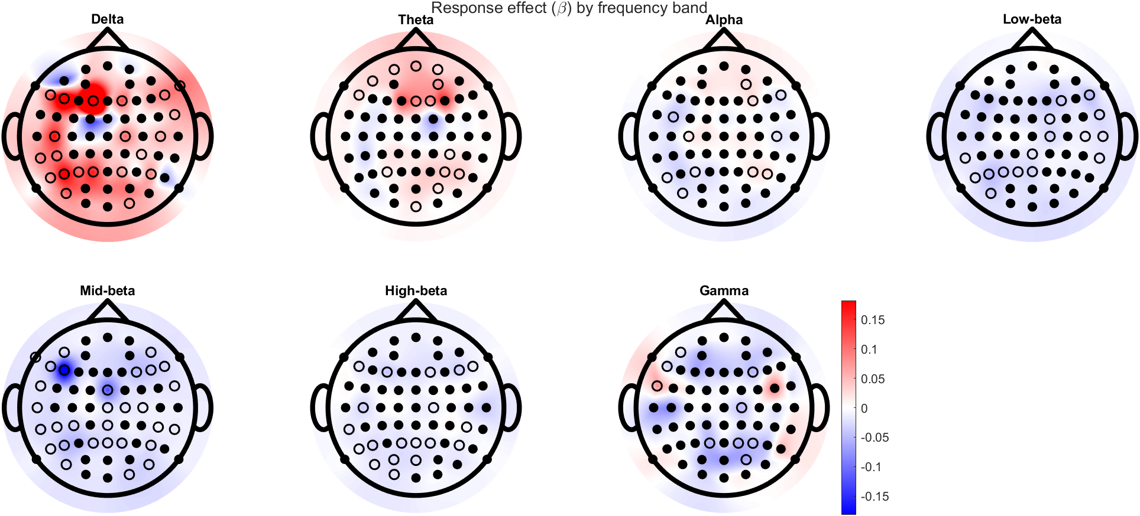

Figure S1: Topographic maps showing population response effect (β) by frequency band with common colour scale across all bands (unfilled channels: p < 0.05, corrected for multiple comparisons).

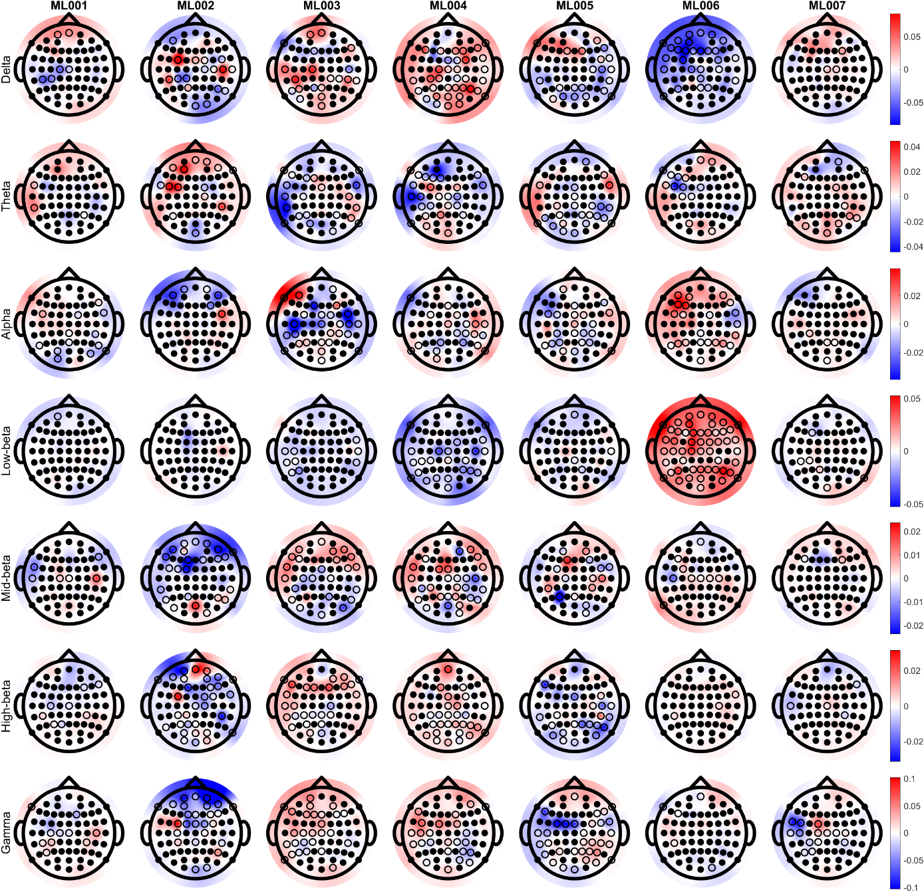

Figure S2: Topographic maps showing subject-specific noxious stimulation effect (β) with individual colour scales for each frequency band. Frequency bands span across 1-47 Hz (unfilled channels: p < 0.05, corrected for multiple comparisons).

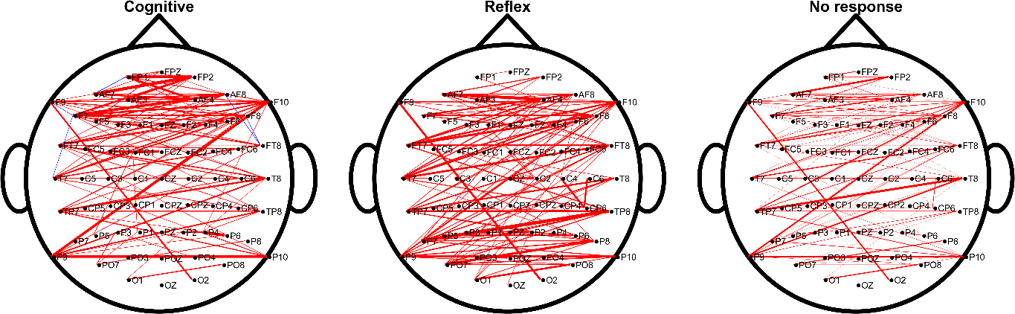

Figure S3: Group level figure for response categories showing top 95% connections (mean wSMI) between all channels. Red and blue connections indicate positive and negative baseline-corrected wSMI, respectively. The widths of the connections are proportional to the magnitude.

Table S1: p-values of non-parametric tests between desynchronization/ synchronization (ERD/ERS) of different response categories for identified channels of importance. Frequency bands span across 1-47 Hz (*p < 0.05, **p < 0.05 and survived multiple comparisons).
 | Cognitive vs Reflex |  |  |  |  |  |  | Cognitive vs No response
 | Delta | Theta | Alpha | Low-beta | Mid-beta | High-beta | Gamma | Delta | Theta | Alpha | Low-beta | Mid-beta | High-beta | Gamma
C1 | 6.67E-01 | 3.33E-02 * | 1.17E-01 | 1.00E+00 | 2.67E-01 | 3.83E-01 | 1.83E-01 | 6.27E-01 | 5.85E-01 | 9.03E-01 | 8.08E-01 | 2.25E-01 | 1.45E-01 | 3.31E-01
C3 | 3.33E-02 * | 3.33E-02 * | 5.17E-01 | 6.67E-02 | 1.83E-01 | 1.67E-02 ** | 1.67E-02 ** | 8.91E-02 | 5.85E-01 | 2.49E-01 | 8.91E-02 | 3.62E-01 | 2.47E-02 * | 1.08E-02 *
C5 | 1.83E-01 | 1.67E-02 ** | 1.83E-01 | 1.67E-02 ** | 6.67E-02 | 1.67E-02 ** | 1.67E-02 ** | 5.85E-01 | 5.98E-02 | 2.49E-01 | 1.29E-01 | 6.27E-01 | 5.98E-02 | 3.90E-02 *
T7 | 1.67E-02 * | 1.17E-01 | 3.83E-01 | 3.33E-02 * | 1.67E-02 ** | 1.67E-02 ** | 1.67E-02 ** | 7.61E-01 | 5.44E-01 | 8.08E-01 | 4.30E-01 | 6.85E-02 | 1.08E-02 * | 1.52E-02 *
C2 | 1.83E-01 | 1.00E+00 | 1.67E-02 ** | 1.83E-01 | 8.33E-01 | 2.67E-01 | 1.83E-01 | 1.63E-01 | 8.91E-02 | 9.52E-01 | 3.90E-02 * | 1.29E-01 | 1.29E-01 | 2.88E-02 *
C4 | 3.83E-01 | 6.67E-01 | 1.67E-02 ** | 1.17E-01 | 1.00E+00 | 1.17E-01 | 6.67E-01 | 3.95E-01 | 5.85E-01 | 8.91E-02 | 6.27E-01 | 3.95E-01 | 9.03E-01 | 1.00E+00
C6 | 8.33E-01 | 2.67E-01 | 3.83E-01 | 3.83E-01 | 3.33E-02 * | 1.67E-02 ** | 1.67E-02 ** | 4.30E-01 | 2.02E-01 | 2.74E-01 | 2.49E-01 | 2.74E-01 | 1.82E-01 | 1.52E-02 *
T8 | 1.83E-01 | 3.33E-02 * | 1.00E+00 | 5.17E-01 | 1.17E-01 | 3.33E-02 * | 1.83E-01 | 9.03E-01 | 3.95E-01 | 5.04E-01 | 7.61E-01 | 6.71E-01 | 2.49E-01 | 5.20E-02
TP7 | 6.67E-02 | 1.67E-02 ** | 2.67E-01 | 2.67E-01 | 1.67E-02 ** | 1.67E-02 ** | 1.67E-02 ** | 6.27E-01 | 5.04E-01 | 2.02E-01 | 8.08E-01 | 6.27E-01 | 2.47E-02 * | 2.10E-02 *

 | Reflex vs No response
 | Delta | Theta | Alpha | Low-beta | Mid-beta | High-beta | Gamma
C1 | 1.00E+00 | 2.39E-02 * | 5.98E-03 * | 3.09E-01 | 6.24E-01 | 1.00E+00 | 2.43E-01
C3 | 2.28E-01 | 1.44E-02 * | 2.16E-02 * | 8.21E-01 | 1.14E-01 | 4.51E-01 | 4.29E-01
C5 | 4.21E-03 ** | 3.74E-03 ** | 5.47E-01 | 7.68E-02 | 2.39E-02 * | 1.04E-02 * | 9.76E-02
T7 | 3.74E-03 ** | 3.18E-02 * | 5.98E-01 | 1.42E-01 | 4.62E-04 ** | 1.56E-03 ** | 4.20E-02 *
C2 | 5.72E-01 | 3.74E-03 ** | 7.51E-03 * | 7.63E-01 | 5.48E-02 | 6.24E-01 | 3.50E-02 *
C4 | 7.07E-01 | 8.32E-02 | 1.42E-01 | 1.32E-01 | 8.32E-02 | 1.23E-01 | 6.24E-01
C6 | 3.66E-01 | 9.40E-01 | 6.24E-01 | 9.40E-01 | 7.68E-02 | 1.23E-01 | 7.35E-01
T8 | 5.97E-02 | 5.02E-02 | 6.24E-01 | 2.59E-01 | 2.63E-02 * | 2.39E-02 * | 6.79E-01
TP7 | 1.16E-02 * | 2.02E-03 ** | 6.51E-01 | 4.60E-02 * | 1.37E-03 ** | 9.02E-02 | 4.51E-01

Table S2: Differences of median wSMI between response categories, for specified regions pairs and temporal resolutions (τ) (* indicates p<0.05 with non-parametric testing).
τ | Region pair | Cognitive vs Reflex | Cognitive vs No response | Reflex vs No response
2 | Frontal - parietal | 3.73E-03 | 1.43E-03 | -2.30E-03
2 | Frontal - occipital | 3.93E-03 | 3.97E-03 * | 3.72E-05
4 | Frontal - parietal | 4.83E-03 | 2.21E-03 | -2.62E-03 *
4 | Frontal - occipital | 1.36E-03 | 5.26E-04 | -8.37E-04
8 | Frontal - parietal | 3.17E-03 | -2.71E-03 | -5.88E-03 *
8 | Frontal - occipital | 8.96E-04 | 3.96E-03 | 3.07E-03

